Supplementary Information for

A Convenient Palladium-Catalyzed Aerobic Oxidation of Alcohols at Room Temperature

Mitchell J. Schultz, Candice C. Park, and Matthew S. Sigman*

Department of Chemistry, University of Utah, Salt Lake City, Utah, 84124

Table of Contents

S2: Screening Procedures

S3: Solvent Screen and Pd Source Screen

S4: In-Situ IR Studies

S5: In-Situ IR and NMR Studies

S6: NMR Studies

General: For the solvent screen, dichloroethane (DCE) and dioxane were purified by distillation from CaH₂. Toluene and THF were purified using a solvent column.1 All alcohols were purchased from Aldrich or Acros and purified by literature methods before use. Pd sources were purchased from Strem and used as received. GC analysis was performed with a HP 6890 Series GC equipped with a HP-1 methyl siloxane column.

Additive Screen: In 5 ml round bottom flasks equipped with a sidearm and stirbar, 1.0 ml of DCE, 5.6 mg (0.025 mmol, 0.05 equiv.) Pd(OAc)₂, 0.1 mmol (0.2 equiv.) of each additive were combined. The flasks were attached to the bottom of the screening apparatus, a 10-neck cow. A balloon filled with oxygen was attached to the top of the screening apparatus. The screening apparatus was evacuated and refilled with oxygen from the balloon (three times). The reaction mixture was allowed to stir for 30 minutes at room temperature. 0.052 ml (0.5 mmol, 1.0 equiv.) of benzyl alcohol along with a small amount of undecane (approximately 0.005 ml) as an internal standard for GC analysis was added by syringe through a septum on the sidearm of each flask. Aliquots (0.03 ml) of each reaction were periodically taken via syringe. The aliquots were placed on a short pad of silica and the alcohol, aldehyde, and undecane were eluted using ethyl acetate. The samples were analyzed using GC. Conversions were measured relative to the undecane internal standard.

Exogenous Base Screen: In 5 ml round bottom flasks equipped with a sidearm and stirbar, 1.0 ml of DCE, 5.6 mg (0.025 mmol, 0.05 equiv.) Pd(OAc)₂, 6.3 mg (0.025 mmol, 0.05 equiv.) Tröger’s base, and 0.05 mmol (0.1 equiv.) of external additive were combined. The flasks were attached to the bottom of the screening apparatus, a 10-neck cow. A balloon filled with oxygen was attached to the top of the screening apparatus. The screening apparatus was evacuated and refilled with oxygen from the balloon (three times). The reaction mixture was allowed to stir for 30 minutes at room temperature. 0.052 ml (0.5 mmol, 1.0 equiv.) of benzyl alcohol along with a small amount of undecane (approximately 0.005 ml) as an internal standard for GC analysis was added by syringe through a septum on the sidearm of each flask. Aliquots (0.03 ml) of each reaction were periodically taken via syringe. The aliquots were placed on a short pad of silica and the alcohol, aldehyde, and undecane were eluted using ethyl acetate. The samples were analyzed using GC. Conversions were measured relative to the undecane internal standard.

Solvent Screen: In 5 ml round bottom flasks equipped with a sidearm and stirbar, 1.0 ml of each solvent, 5.6 mg (0.025 mmol, 0.05 equiv.) Pd(OAc)₂, and 0.007 ml (0.05 mmol, 0.1 equiv.) triethylamine were combined. The flasks were attached to the bottom of the screening apparatus, a 10-neck cow. A balloon filled with oxygen was attached to the top of the screening apparatus. The screening apparatus was evacuated and refilled with oxygen from the balloon (three times). The reaction mixture was allowed to stir for 30 minutes at room temperature. 0.052 ml (0.5 mmol, 1.0 equiv.) of benzyl alcohol along with a small amount of undecane (approximately 0.005 ml) as an internal standard for GC analysis was added by syringe through a septum on the sidearm of each flask. Aliquots (0.03 ml) of each reaction were periodically taken via syringe. The aliquots were placed on a short pad of silica and the alcohol, aldehyde, and undecane were eluted using ethyl acetate. The samples were analyzed using GC. Conversions were measured relative to the undecane internal standard. For results see Figure S1.

Figure S1: Solvent Screen, Oxidation of Benzyl Alcohol

Evaluation of Pd Sources: In 5 ml round bottom flasks equipped with a sidearm and stirbar, 1.0 ml of THF, 0.025 mmol (0.05 equiv.) of Pd source, and 0.007 ml (0.05 mmol, 0.1 equiv.) of triethylamine were combined. The flasks were attached to the bottom of the screening apparatus, a 10-neck cow. A balloon filled with oxygen was attached to the top of the screening apparatus. The screening apparatus was evacuated and refilled with oxygen from the balloon (three times). The reaction mixture was allowed to stir for 30 minutes at room temperature. 0.052 ml (0.5 mmol, 1.0 equiv.) of benzyl alcohol along with a small amount of undecane (approximately 0.005 ml) as an internal standard for GC analysis was added by syringe through a septum on the sidearm of each flask. Aliquots (0.03 ml) of each reaction were periodically taken via syringe. The aliquots were placed on a short pad of silica and the alcohol, aldehyde, and undecane were eluted using ethyl acetate. The samples were analyzed using GC. Conversions were measured relative to the undecane internal standard. For results see Figure S2.

Figure S2: Palladium Screen

Standard Conditions:

Oxidation of sec-phenethylalcohol: Pd(OAc)₂ (8.1 mg, 0.036 mmol, 0.03 equiv., 3 mol%), toluene (3.4 ml), THF (0.6 ml), triethylamine (0.01 ml, 0.072 mmol, 0.06 equiv., 6 mol%), 3Å molecular sieves (200 mg), and a magnetic stir bar are placed in a 25 ml schlenk flask. A balloon attached to a three-way valve is placed on the flask and the vessel is evacuated then filled with oxygen. The purge is repeated three times using a water aspirator. The mixture is allowed to stir at room temperature under an oxygen atmosphere for 30 minutes. At this time, the sec-phenethyl alcohol (0.145 ml, 1.2 mmol, 1.0 equiv.) is syringed into the flask. Upon addition of the alcohol the color of the mixture changed from yellow to orange. The reaction mixture is allowed to stir for 12 hours. A 0.03 ml aliquot is syringed out of the vessel and GC analysis is performed. Upon completion of reaction, the reaction mixture is loaded directly on a small pad of silica. The plug is then flushed with hexanes to remove the toluene and the product is eluted with dichloromethane. The solvent is removed in vacuo to yield acetophenone (137 mg, 95% yield). Purity confirmed by GC and NMR.

In-Situ IR of Cinnamaldehyde Inhibition of 2-decanol Oxidation: The ASI Applied Systems ReactIR 1000 is aligned and equipped with a 50 ml, 3-necked reaction flask. Pd(OAc)₂ (6.7 mg, 0.03 mmol, 0.05 equiv., 5 mol%), toluene (1.7 ml), THF (0.3 ml), triethylamine (0.008 ml, 0.06 mmol, (0.1 equiv., 10 mol%), and 3Å molecular sieves (200 mg) were placed in a 50 ml 3-necked reaction flask. A balloon attached to a three-way valve is placed on the flask and the vessel is evacuated then filled with oxygen. The purge is repeated three times using a water aspirator. The mixture is allowed to stir at room temperature under an oxygen atmosphere for 30 minutes. At this time, the IR was programmed to begin collecting spectra every 30 seconds. After the first scan, 2-decanol (0.115 ml, 0.6 mmol) was syringed into the reaction flask and the reaction was allowed to proceed for 2 hours. For the inhibition curve, cinnamaldehyde (0.076 ml, 0.6 mmol) was syringed into the reaction flask after the first 30 minutes. For results see Figure S3

Figure S3: Cinnamaldehyde Inhibition 2-decanol Oxidation

In-Situ IR Study of TEA Dependence: The ASI Applied Systems ReactIR 1000 is aligned and equipped with a 50 ml, 3 necked reaction flask. Pd(OAc)₂ (4.0 mg, .018 mmol, 3 mol%), TEA, 3Å molecular sieves (200 mg), toluene (1.65 ml), THF (0.29 ml), and a stir bar were place in the 50 ml reaction flask. A balloon attached to a three-way valve is placed on the flask and the vessel is evacuated then filled with oxygen. The purge is repeated three times using a water aspirator. The mixture is allowed to stir at room temperature under an oxygen atmosphere for 30 minutes. At this time, the IR was programmed to begin collecting spectra every 30 seconds. After the first scan, benzyl alcohol (0.62 ml, 0.6 mmol) was syringed into reaction flask and the reaction was monitored for three hours.

Figure S4: TEA Dependence on Oxidation of Benzyl Alcohol

NMR Study of reaction conditions Pd(OAc)₂/TEA system: Pd(OAc)₂ (2.0 mg, 0.009mmol) was place in an NMR tube. 1 ml of a 0.018M TEA in toluene-d8 was added to the NMR tube and the mixture was shaken for 30 minutes. A ¹H NMR was than performed on the reaction mixture.

NMR Study of reaction conditions (Pd(OAc)₂/TEA system: Pd(OAc)₂ (0.8 mg, 0.0035 mmol) was place in an NMR tube. 0.7 ml of a 0.02M pyridine in toluene-d8 was added to the NMR tube and the mixture was shaken for 30 minutes. A ¹H NMR was than performed on the reaction mixture at 80 ˚C.

Figure S5: Pd(OAc)₂/TEA NMR
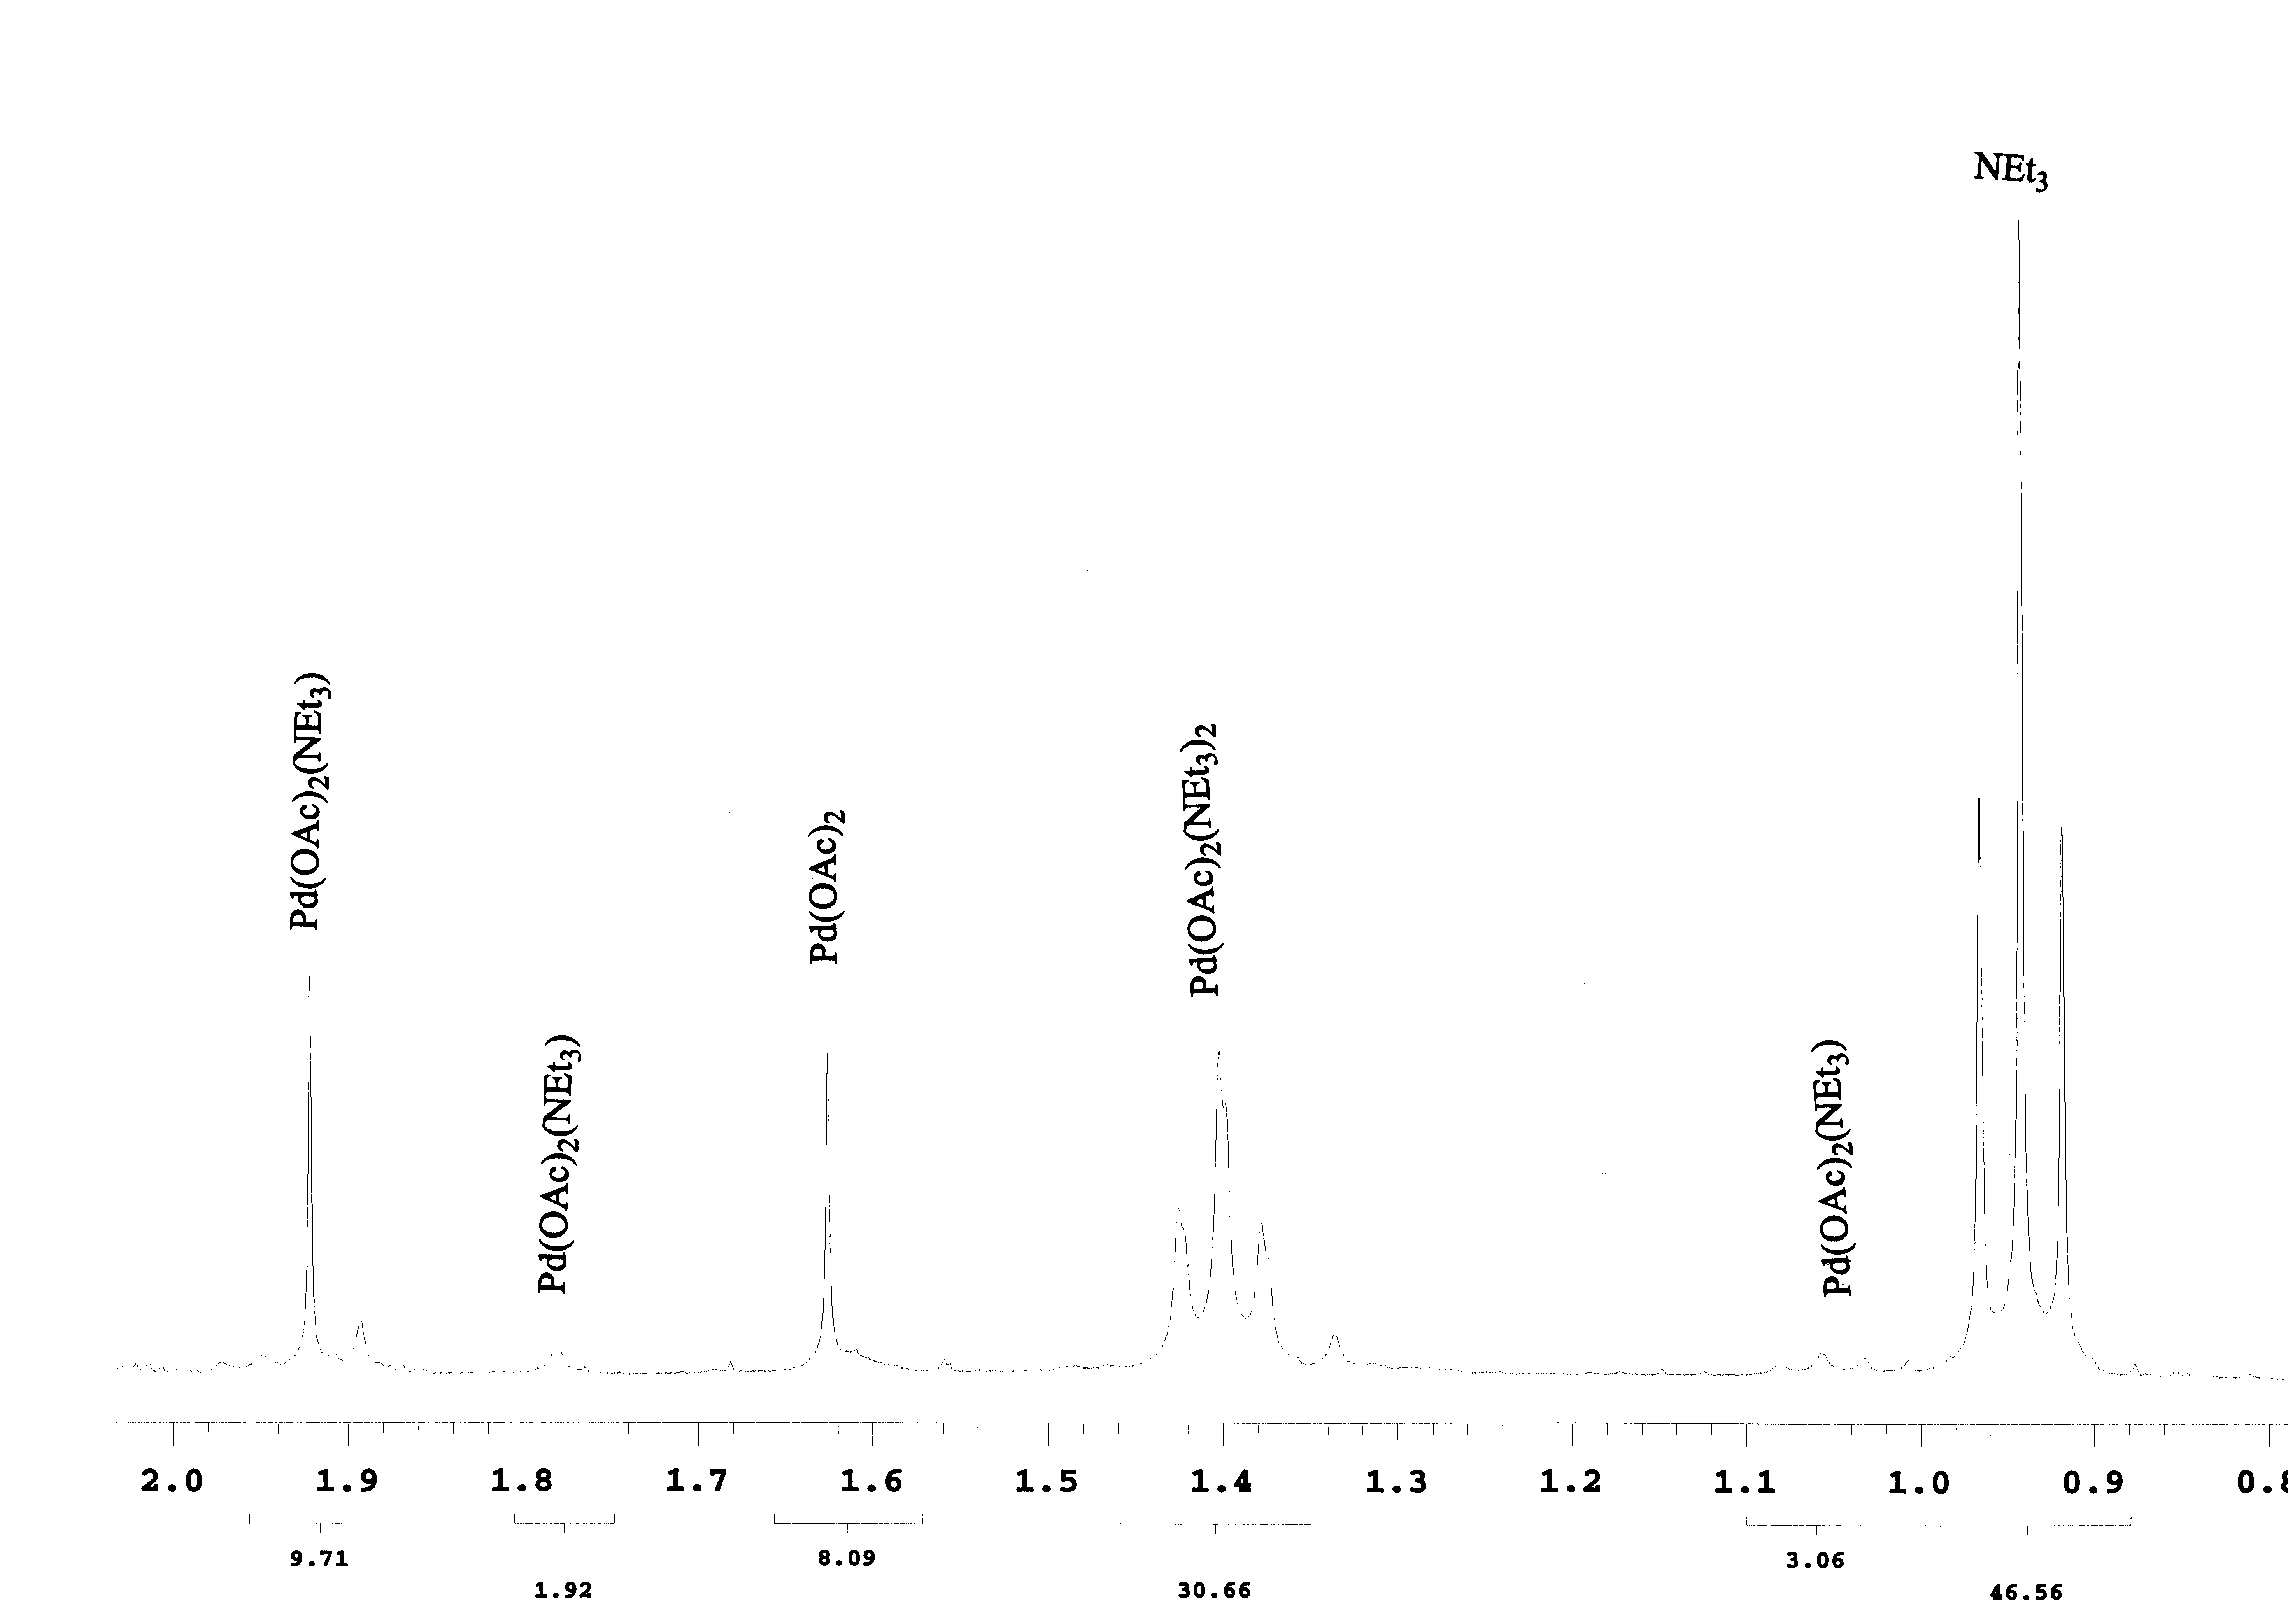

Figure S6: Pd(OAc)₂/pyridine NMR
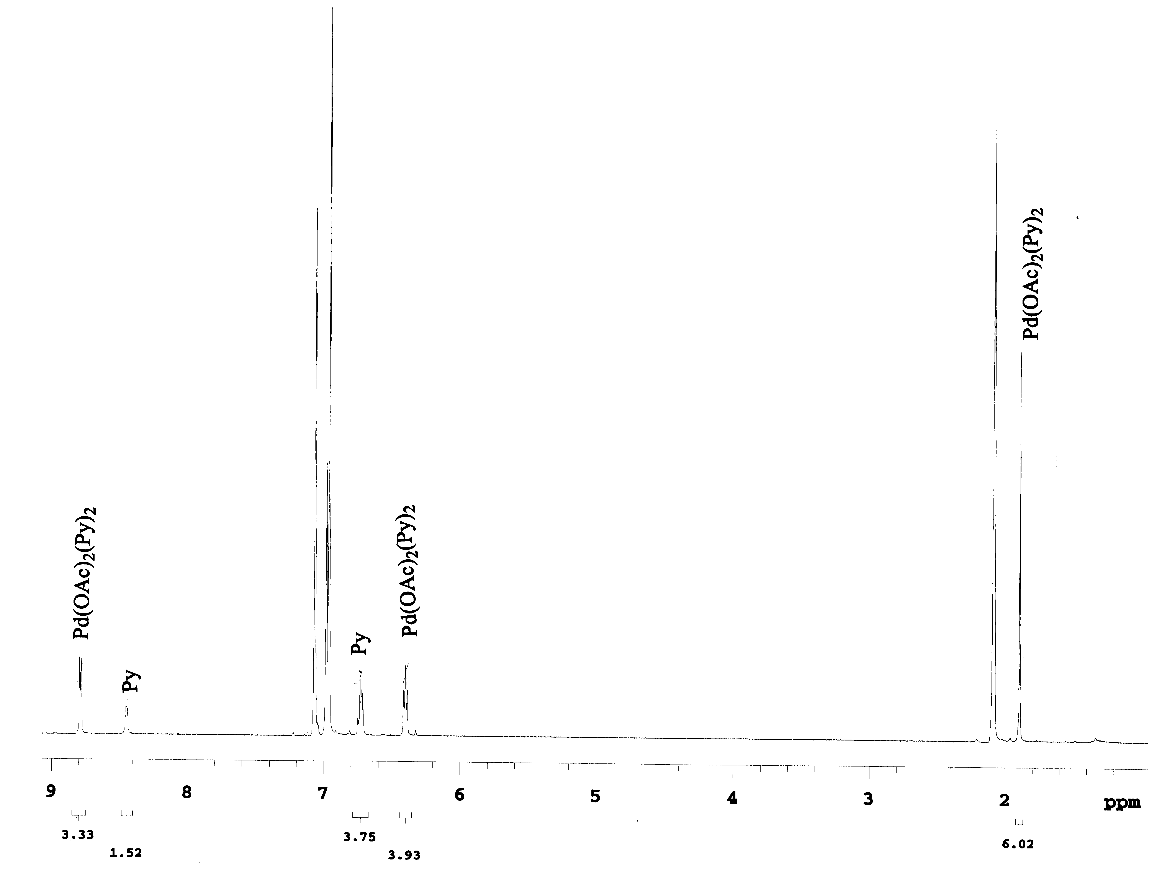

1 The solvent columns are composed o activated alumina (A-2) and a supported copper redox catalyst (Q-5 reactant). Pangborn, A. B.; Giardello, M. A.; Grubbs, R. H.; Rosen, R. K.; Timmers, F. J. Organometallics 1996, 15, 1518.

