Supporting Information to accompany manuscript entitled:

The nature of the DNA template (single-stranded versus double-stranded) affects the rate of aquation of a dinuclear Pt anticancer drug

Murray S. Davies,^{a, c} Susan J. Berners-Price,^{*a} John W. Cox^{b} and Nicholas Farrell^{*b}
ª Department of Chemistry, University of Western Australia, Crawley WA, 6009, Australia.
Fax: 61-8 9380 1005, Tel: 61-8-9380-3258, E-Mail: sbp@chem.uwa.edu.au
^{b} Department of Chemistry, Virginia Commonwealth University, Richmond VA, 23284-2006, USA
Fax:1-804-828-8599, Tel: 1-804-828-6320, E-Mail: nfarrell@saturn.vcu.edu
^{c} School of Pharmacy and Molecular Sciences, James Cook University, Townsville QLD, 4811, Australia
________________________________________________________________________________
S1 Structures of 1,1/t,t and BBR3464
S2 NMR experimental conditions
S3 Treatment of experimental data and calculation of rate constants
S4 Scientist kinetic model 1,1/t,t + single and double stranded DNA
S5 [¹H,¹⁵N] HSQC NMR spectra (298 K) of the final reaction product of 1,1/t,t + (a) single strand I, (b) single strand I on addition of the complementary strand II, and (c) duplex III

S1 Structures of 1,1/t,t and BBR3464

S2 NMR experimental conditions:

Stock solutions of 5´-d(ATACATGGTACATA)-3´ (I) (16.9 mM,) and 5´-d(TATGTACCATGTAT)-3´ (II) (20.8 mM) were prepared in 500 μL of 5% D₂O in H₂O. The concentrations were determined using extinction coefficients (ε₂₆₀) of 110.3 × 10³ M⁻¹ cm⁻¹ (I) and 101.4 × 10³ M⁻¹ cm⁻¹ (II), calculated according to the method of Kallansrud and Ward.

Reaction of single strand (I) and duplex (III) with ¹⁵N-1
Into two 5 mm Shigemi NMR tubes were placed I single strand stock solution (63.8 μL, 1.08 μmol), phosphate buffer (30 μL, 200 mM, pH 5.3), TSP (sodium 3-trimethylsilyl-d₄-propionate) (2 μL, 13,3 mM in 5% D₂O in H₂O) and 5% D₂O in H₂O (230.3 μL). II stock solution (53.9 μL, 1.12 μmol, 1.04 equiv.) was added to tube (i), and the same volume of 5% D₂O in H₂O was added to tube (ii). The pH of both solutions were found to be 5.4. A volume of 5 μL was used for the pH measurement giving reaction mixtures of volume 375 μL. To each tube was added a 20 μL aliquot of freshly prepared chilled solutions of ¹⁵N-1 (i) 1.11 mg, 1.43 μmol in 5%/95% D₂O/H₂O (44.7 μL); (ii) 1.47 mg, 1.90 μmol in 55%/95% D₂O/H₂O (59.2 μL). This gave reactant and buffer concentrations of single strand I or duplex III (2.69 mM), phosphate buffer (15 mM) and ¹⁵N-1 (i) 1.60 mM or (ii) 1.62 mM). The reactions at 298 K were followed by a series of ¹H and [¹H,¹⁵N] NMR spectra over a period of 0- ca 40 h according to the previously described procedures.2

S3 Treatment of experimental data and calculation of rate constants
The kinetic analysis of the reactions was undertaken by measuring peak volumes in the Pt-NH₃ region of the [¹H,¹⁵N] HSQC NMR spectra and calculating relative concentrations of the various {Pt₂} species at each time point, as described previously.² All species other than ¹⁵N-1 give rise to two [!H,¹⁵N] peaks due to the non-equivalent {PtN₃Y} groups. In cases where only one of the pair is overlapped (e.g. the peak for the non-aquated {PtN₃Cl group of the monoaqua monochloro species (2) is overlapped with the peak for 1 (Figure 1)), reliable intensities are obtained by doubling the volume of the second (discrete) peak. For the reaction with the duplex (III) all species could be measured by this approach³ but for the single strand (I) there was significant overlap of peaks for the monofuctional and final adducts. Therefore, the two monofunctional adducts could not be treated separately but their total contribution was determined by doubling the volume of the peak (3b/4b) representing the unbound {PtN₃Cl} end in each adduct. The total product was then obtained from sum of the volume of all the ‘DNA bound’ peaks minus the monofunctional contribution. All normalised percentage totals for the different species were converted to concentration by assuming that all the input {Pt₂} is represented by the summation of the peaks.
To allow a comparison of the rate constants for the reactions of ¹⁵N-1 with I and III the concentration data were subjected to kinetic analysis on the basis of the same reaction pathway :
Cl/Cl (1) → H₂O/Cl (2) → total monofunctional adducts (3/4)→ total bifunctional products (5).
In order to model the time dependent profile of the monofunctional adducts it was necessary to include a ‘dummy’ parameter (k_{P}) that describes the conversion of the total monofunctional adducts into the total product. For the reaction with the duplex (III) a more comprehensive kinetic study which includes the contributions of the individual mono- and bifunctional adducts is reported elsewhere.³
(2) J. W.Cox, S. J. Berners-Price, M. S. Davies, N. Farrell, Y. Qu, . J. Am. Chem. Soc. 2001, 123, 1316-1326.
(3) S. J. Berners-Price, M. S. Davies, J. W. Cox, D. S. Thomas, N. Farrell, Chem. – Eur. J., 2002, in press.

S4 Scientist kinetic model 1,1/t,t + single and double stranded DNA
// MicroMath Scientist Model File
// 11tt + GG single strand
// irreversible aquation model
IndVars: T
DepVars: A, B, C, D, L
Params: KAB, KBC, KCD
A'=-KAB*A
B'=KAB*A-KBC*B*L
C'=KBC*B*L-KCD*C
D'=KCD*C
L'=-KBC*B*L
// A=11tt, B=aqua/Cl, C = sum monofunctional , D= sum product
//L=GG single strand
// Initial conditions
T=0.0
A=0.00160
B=0.00000
C=0.0
D=0.0
L=0.00269
***

S5
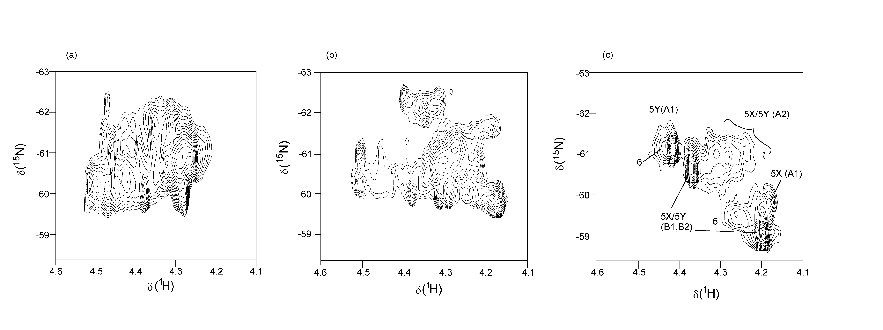
[¹H,¹⁵N] HSQC NMR spectra (298 K) of the final products of the reactions of ¹⁵N-1 with (a) single strand I and (c) duplex III. (b) shows the spectrum of the single-strand product in (a) after the addition of one equivalent of the complementary strand II. The analysis of the spectrum in (c) is described elsewhere³ and arises from two conformers (X and Y) of the 5'-5' 1,4-interstrand G(8)G(18) crosslink (5) plus a minor product (6) which may be the 3'-3' G(7)G(25) adduct. For the reaction with I the multitude of overlapped peaks suggest a variety of different products form, which may include the 1,2-G(7)G(8) bifunctional adduct. The spectrum in (b) shows that the product formed on addition of the complementary strand is different to the adducts produced by direct reaction with the duplex.
(3) S. J. Berners-Price, M. S. Davies, J. W. Cox, D. S. Thomas, N. Farrell, Chem. – Eur. J., 2002, in press.

(1) G. Kallansrud, B. Ward,. Anal. Biochem. 1996, 236, 134-138.
2(2) J. W.Cox, S. J. Berners-Price, M. S. Davies, N. Farrell, Y. Qu, . J. Am. Chem. Soc. 2001, 123, 1316-1326.

