Supplementary data

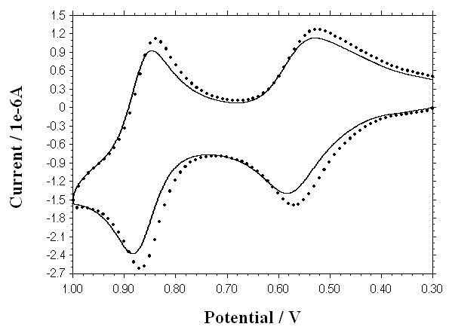

CV data for dendrimer 1 recorded in the absence (____) of and in the presence (…..) of an excess of 1,4-dimethoxybenzene

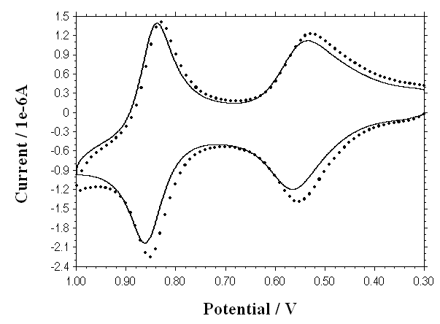

CV data for dendrimer 2 recorded in the absence (____) of and in the presence (…..) of an excess of 1,4-dimethoxybenzene

