Supplementary data
Typical experimental procedure of the reaction using entry 1 of table 1 as example:
General procedure: A solution of AlEt₃ (4M in THF, 0.27ml) was added dropwise to a solution of entry 1 (Table1) (80mg, 0.36mmol) in 3 ml dry THF under an argon atmosphere. The reaction mixture was stirred under reflux for 11h, after which TLC analysis showed the reaction was complete. Then the reaction mixture was poured into 2N HCl (10 ml) and extracted with Diethyl ether (3 × 50 ml). The combined extracts were dried over anhydrous Na₂SO₄. Evaporation of the solvent and column chromatography of the crude product on silica gel (petroleum/ethyl acetate 9/1) afforded the desired product (72mg, 92%).
General:
The ¹H NMR and ¹³C NMR data were recorded in CDCl₃ solution with Bruker ADANCE DXR-200 or AM-400 spectrometers. The chemical shifts were reported in ppm relative to TMS or CDCl₃. MS were measured on a HP-5988 spectrometer by direct inlet at 70ev, and signals given in m/z with relative intensity (%) in brackets. HRMS were measured with ESI or EI technique. Optical rotations were determined on Perkin Elmer Model 341. IR spectra were measured with Nicolet NEXUS 670 FT-IR. Column chromatographies were generally performed on silica gel (200-300 mesh) eluting with petroleum ether (bp. 60-90⁰C) and EtOAc.

Spectral data of compounds:

Compounds in Table 1:
Substrate 1. ¹H NMR (400 MHz, CDCl₃) δ= 7.41-7.27 (m, 5H), 4.69 (s, 2H), 3.80 (m, 1H), 3.15 (d, J = 1.9 Hz, 1H), 1.84-1.82 (m, 1H), 1.69-1.54 (m, 4H), 1.34 (s, 3H), 1.24-1.20 (m, 1H). ¹³C NMR (100 MHz, CDCl₃) δ= 138.5, 128.2 (2C), 127.5 (2C), 127.3, 74.0, 69.9, 60.1, 59.8, 28.2, 24.6, 23.9, 19.2. EI-MS m/z (%): 205(M-13, <1), 200 (M-18, <1), 180 (<1), 129 (<1), 97 (27), 91 (100), 65 (20), 43 (60).

Product 1. ¹H NMR (400 MHz, CDCl₃) δ= 7.34-7.27 (m, 5H), 7.61 (d, J = 11.8 Hz, 1H), 4.45 (d, J = 11.8 Hz, 1H), 3.69 (dd, J = 7.4 Hz, 1H), 3.45 (s, 2H), 2.04-1.98 (m, 2H), 1.77-1.39 (m, 4H), 1.05 (s, 3H). ¹³C NMR (100 MHz, CDCl₃) δ= 138.9, 128.2 (2C), 127.4, 127.3 (2C), 84.3, 71.5, 70.9, 46.1, 33.3, 29.1, 19.3, 17.1. EI-MS m/z (%): 220 (M⁺, <1), 169 (<1), 159 (<1), 91 (100), 65 (47), 55 (64), 43 (69), 39 (62). HRMS: m/z calcd. for C₁₄H₂₀O₂Na (M+Na) 243.1356, found 243.1353.

Substrate 2. ¹H NMR (400 MHz, CDCl₃) δ= 7.41-7.27 (m, 5H), 4.69 (s, 2H), 3.78 (m, 1H), 3.14 (d, J = 1.4 Hz, 1H), 1.78-1.15 (m, 12H), 0.90 (dd, J = 7.1 Hz, 6.8 Hz, 3H). ¹³C NMR (100 MHz, CDCl₃) δ= 138.7, 128.2 (2C), 127.5 (2C), 127.4, 74.5, 69.9, 62.7, 59.3, 37.4, 26.9, 26.5, 24.8, 22.6, 19.7, 13.9.

Product 2. ¹H NMR (200 MHz, CDCl₃) δ= 7.36-7.26 (m, 5H), 4.62 (d, J = 12.0 Hz, 1H), 4.43 (d, J = 11.8 Hz, 1H), 3.74 (dd, J = 6.6 Hz, 6.6 Hz, 1H), 3.57 (d, J = 10.6 Hz, 1H), 3.36 (d, J = 10.8 Hz, 1H), 2.03-1.23 (m, 12H), 0.92 (dd, d, J = 7.0Hz, 6.8Hz, 3H ). ¹³C NMR (50 MHz, CDCl₃) δ= 138.7, 128.3 (2C), 127.5 (3C), 85.9, 71.4, 68.2, 49.0, 30.3, 29.1, 28.3, 26.3, 23.7, 19.8, 14.2. EI-MS m/z (%): 260 (M⁺, <1), 242 (<1), 171 (<1), 91 (100), 81 (14), 67 (23), 55 (39), 41 (44). HRMS(EI): m/z calcd. for C₁₇H₂₆O₂ 262.1933, found 262.1939.

Substrate 3. ¹H NMR (400 MHz, CDCl₃) δ= 7.41-7.28 (m, 10H), 4.74 (d, J = 12.1 Hz, 1H), 4.70 (d, J = 12.1 Hz, 1H), 3.93 (m, 1H), 3.26 (d, J = 2.3 Hz, 1H), 2.30 (m, 1H), 2.25 (m, 1H), 1.80 (m, 1H), 1.72 (m, 2H), 1.42 (m, 1H). ¹³C NMR (100 MHz, CDCl₃) δ= 141.6, 138.5, 128.3 (3C), 127.6 (2C), 127.5, 127.3, 125.3 (3C), 73.4, 70.1, 62.5 (2C), 28.0, 25.3,19.5. EI-MS m/z (%): 280 (M⁺, <1), 262 (<1), 223 (<1), 160 (6), 105 (16), 91 (100), 77 (17), 65 (14).

Product 3. ¹H NMR (200 MHz, CDCl₃) δ= 7.45-7.21 (m, 10H), 4.73 (d, J = 11.6 Hz, 1H), 4.56 (d, J = 11.6 Hz, 1H), 4.40 (dd, J = 6.4 Hz, 6.2 Hz, 1H), 3.97 (d, J = 11.2 Hz, 1H), 3.82 (d, J = 11.2 Hz, 1H), 2.97 (br s, 1H), 2.23-1.63 (m, 6H). ¹³C NMR (50 MHz, CDCl₃) δ= 145.5, 137.9, 128.4 (2C), 128.1 (2C), 127.7, 127.5 (2C), 126.7 (2C), 126.1, 88.0, 71.7, 68.8, 54.1, 32.9, 29.9, 20.3. EI-MS m/z (%): 223 (M-59, <1), 208 (<1), 205 (<1), 202 (<1), 129 (16), 105 (12), 91 (100), 65 (12). HRMS: m/z calcd. for C₁₉H₂₂O₂Na (M+Na) 305.1512, found 305.1494.

Substrate 4. ¹H NMR (400 MHz, CDCl₃) δ= 7.42-7.23 (m, 10H), 4.69 (s, 2H), 3.83 (m, 1H), 3.26 (d, J = 1.8 Hz, 1H), 2.91 (d, J = 14.3 Hz, 1H), 2.84 (d, J = 14.2 Hz, 1H), 1.73-1.54 (m, 5H), 1.17-1.12 (m, 1H). ¹³C NMR (100 MHz, CDCl₃) δ= 138.6, 136.8, 129.4 (2C), 128.3 (4C), 127.6 (2C), 127.4, 126.5, 74.4, 70.0, 62.6, 59.1, 43.8, 26.3, 24.8, 19.5. EI-MS m/z (%): 294 (M⁺, <1), 293 (<1), 276 (<1), 187 (<1), 105 (9), 97 (40), 91 (100), 65 (16).

Product 4. ¹H NMR (200 MHz, CDCl₃) δ= 7.39-7.19 (m, 10H), 4.67 (d, J = 11.8 Hz, 1H), 4.50 (d, J = 12.0 Hz, 1H) 3.90 (dd, J = 6.6 Hz, 6.4 Hz, 1H), 3.47 (d, J = 11.0 Hz, 1H), 3.27 (d, J = 10.8 Hz, 1H), 3.18 (d, J = 13.4 Hz, 1H), 2.63 (d, J = 13.6 Hz, 1H), 2.09-1.54 (m, 5H ), 1.17-1.09 (m, 1H). ¹³C NMR (50 MHz, CDCl₃) δ= 139.1, 138.6, 130.5 (2C), 128.4 (2C), 128.0 (2C), 127.5, 127.4(2C), 125.8, 85.9, 71.3, 67.6, 50.6, 34.1, 29.4, 28.6, 19.5. EI-MS m/z (%): 296 (M⁺, <1), 278 (<1), 260 (<1), 205 (<1), 91 (100), 83 (13), 65 (15), 49 (27). HRMS: m/z calcd. for C₂₀H₂₄O₂Na (M+Na) 319.1669, found 319.1677.

Substrate 5. ¹H NMR (400 MHz, CDCl₃) δ=7.40-7.27 (m, 5H), 4.70 (d, J = 11.0 Hz, 1H), 4.66 (d, J = 11.0 Hz, 1H), 3.81 (m, 1H), 3.14 (s, 1H), 1.76 (m, 1H), 1.62 (m, 1H), 1.44 (m, 2H), 1.32 (s, 3H), 1.27 (m, 1H), 0.89 (d, J = 5.8 Hz, 3H). ¹³C NMR (100 MHz, CDCl₃) δ= 138.7, 128.3 (2C), 127.5 (2C), 127.4, 75.4, 69.9, 60.6, 59.8, 36.9, 31.9, 27.9, 24.2, 21.5. EI-MS m/z (%): 232 (M⁺, <1), 219 (<1), 197 (1), 180 (2), 160 (2), 91 (100), 69 (18), 43 (25). [α]_{D}²⁵ + 5° (c 0.43, CHCl₃).

Product 5. ¹H NMR (400 MHz, CDCl₃) δ= 7.35-7.28 (m, 5H), 4.60 (d, J = 12.0Hz, 1H), 4.56 (d, J = 12.0Hz, 1H), 3.68 (dd, J = 9.5Hz, 6.2Hz, 1H), 3.41 (bs, 2H), 2.17 (m, 1H), 1.73(m, 1H), 1.38-1.23 (m, 3H), 1.08 (s, 3H), 1.08 (s, 3H), 1.03 (d, J = 6.6Hz, 3H). ¹³C NMR (100 MHz, CDCl₃) δ= 138.9, 128.3 (2C), 127.3, 127.2 (2C), 84.0, 71.5, 71.2, 46.2, 42.9, 39.1, 28.4, 19.4, 19.1. EI-MS m/z (%): 234 (M⁺, <1), 185 (<1), 171 (<1), 149 (<1), 91 (100), 55 (43), 43 (58), 41 (46). HRMS: m/z calcd. for C₁₅H₂₂O₂Na (M+Na) 257.1512, found 257.1501. [α]_{D}²⁵ + 25° (c 0.71, CHCl₃).

Substrate 6. ¹H NMR (200 MHz, CDCl₃) δ= 7.40-7.24 (m, 5H), 4.67 (s, 2H), 3.92 (m, 1H), 3.17 (d, J = 1.8 Hz, 1H), 1.72-1.38 (m, 4H), 1.33 (s, 3H), 0.90 (s, 3H), 0.83 (s, 3H). ¹³C NMR (100 MHz, CDCl₃) δ= 138.5, 128.1 (2C), 127.4 (2C), 127.3, 73.0, 70.0, 59.3, 59.1, 42.3, 36.4, 31.3, 30.8, 26.5, 24.7. EI-MS m/z (%): 213 (M⁺-33, <1), 202 (<1), 159 (<1), 149 (<1), 125 (15), 91 (99), 65 (18), 43 (100).

Product 6. ¹H NMR (200 MHz, CDCl₃) δ= 7.40-7.22 (m, 5H), 4.59 (d, J = 12.0 Hz, 1H), 4.44 (d, J = 11.8 Hz, 1H), 3.84 (dd, J = 10.0 Hz, 6.4 Hz, 1H), 3.46 (d, J = 10.6Hz, 1H), 3.40 (d, J = 10.6 Hz, 1H), 1.95-1.67 (m, 2H), 1.37 (dd, J = 18.0 Hz, 13.6 Hz, 2H), 1.13 (s, 2H), 1.09 (s, 3H), 0.99 (s, 3H). ¹³C NMR (50 MHz, CDCl₃) δ= 138.9, 128.3 (2C), 127.4, 127.2 (2C), 83.7, 71.5 (2C), 48.7, 47.1, 44.2, 33.7, 32.4 (2C), 18.6. EI-MS m/z (%): 248 (M⁺, <1), 230 (<1), 175 (1), 139 (1), 124 (15), 91 (100), 55 (20), 43 (32). HRMS: m/z calcd. for C₁₆H₂₄O₂Na (M+Na) 271.1669, found 271.1662.

Substrate 7. ¹H NMR (400 MHz, CDCl₃) δ= 7.39-7.25 (m, 5H), 4.86 (s, 1H), 4.81 (d, J = 12.3 Hz, 1H), 4.75 (s, 1H), 4.60 (d, J = 12.3 Hz, 1H), 3.94 (dd, J = 4.8 Hz, 4.6 Hz, 1H), 3.16 (d, J = 4.6 Hz, 1H), 2.15-2.10 (m, 1H), 1.75 (s, 3H), 1.91-1.63 (m, 3H), 1.37 (s, 3H), 1.37-1.33 (m, 1H). ¹³C NMR (100 MHz, CDCl₃) δ= 145.7, 138.6, 128.1 (2C), 127.6 (2C), 127.3, 111.0, 71.6, 70.6, 59.0, 58.5, 46.2, 30.9, 22.8, 21.8, 19.1. EI-MS m/z (%): 257 (M-1, <1), 241 (<1), 200 (<1), 167 (1), 109 (8), 91 (100), 65 (6), 43 (40). [α]_{D}²⁵ + 170° (c 0.91, CHCl₃).

Product 7. ¹H NMR (400 MHz, CDCl₃) δ= 7.34-7.27 (m, 5H), 4.89 (s, 1H), 4.87 (s, 1H), 4.54 (d, J = 11.5 Hz, 1H), 4.50 (d, J = 16.5 Hz, 1H), 3.78 (d, J = 5.3 Hz, 1H), 3.39 (s, 2H), 2.60-2.54 (m, 1H), 2.03-1.99 (m, 1H), 1.82 (s, 3H), 1.70-1.63 (m, 1H), 1.53-1.47 (m, 1H),1.40-1.32 (m, 1H), 1.13 (s, 3H). ¹³C NMR (100 MHz, CDCl₃) δ= 144.7, 139.0, 128.1 (2C), 127.6 (2C), 127.2, 111.4, 85.1, 73.8, 71.0, 51.2, 48.8, 34.4, 26.6, 23.0, 19.3. EI-MS m/z (%): 260 (M⁺, <1), 259 (<1), 172 (1), 91 (100), 81 (47), 65 (22), 55 (20), 43 (30). HRMS: m/z calcd. for C₁₇H₂₄O₂Na (M+Na) 283.1669, found 283.1655. [α]_{D}²⁵ –18° (c 1.17, CHCl₃).

Substrate 8. ¹H NMR (200 MHz, CDCl₃) δ= 7.40-7.24 (m, 10H), 4.78 (d, J = 11.8 Hz, 1H), 4.62 (d, J = 11.6 Hz, 1H), 3.59 (m, 1H), 3.24 (d, J = 5.6 Hz, 1H), 2.59 (m, 1H), 1.91-1.71 (m, 4H), 1.65-1.25 (m, 3H). ¹³C NMR (50 MHz, CDCl₃) δ= 141.4, 138.2, 128.3 (4C), 127.7 (2C), 127.5 (2C), 124.7 (2C), 80.4, 71.0, 68.6, 60.7, 34.5, 32.4, 27.2, 24.5. EI-MS m/z (%): 294 (M⁺, <1), 276 (<1), 203 (2), 157 (3), 105 (12), 91 (100), 77 (10), 65 (11).

Product 8. ¹H NMR (400 MHz, CDCl₃) δ= 7.67 (s, 1H), 7.65 (s, 1H), 7.38-7.23 (m, 8H), 4.74 (d, J = 11.6 Hz, 1H), 4.41 (d, J = 11.6 Hz, 1H), 3.80 (dd, J = 9.4 Hz, 3.2Hz, 1H), 3.78 (d, J = 11.1 Hz, 1H), 3.71 (d, J = 11.0 Hz, 1H), 2.24-2.19 (m, 1H), 1.93-1.37 (m, 7H). ¹³C NMR (100 MHz, CDCl₃) δ= 142.1, 138.4, 128.6 (2C), 128.3 (2C), 128.1 (2C), 127.5 (2C), 126.0, 83.3, 70.9 (2C), 49.0, 30.8, 25.7, 23.6, 21.2. EI-MS m/z (%): 296 (M⁺, <1), 278 (<1), 265 (<1), 223 (<1), 169 (9), 105 (11), 91 (100), 65 (10). HRMS: m/z calcd. for C₂₀H₂₄O₂Na (M+Na) 319.1669, found 319.1663.

Substrate 9. ¹H NMR (400 MHz, CDCl₃) δ= 7.40-7.27 (m, 5H), 4.81 (d, J = 11.7 Hz, 1H), 4.61 (d, J = 11.8 Hz, 1H), 3.39 (m, 1H), 2.83 (d, J = 7.9 Hz, 1H), 1.35 (s, 3H), 1.27 (S, 3H), 1.25 (d, J = 6.5 Hz, 3H). ¹³C NMR (50 MHz, CDCl₃) δ=138.5, 128.3 (2C), 127.2 (2C), 127.3, 74.3, 71.1, 67.5, 55.7, 24.8, 19.2,17.5. EI-MS m/z (%): 206 (M⁺, <1), 205 (<1), 180 (2), 161 (4), 131 (2), 91 (100), 85 (19), 59 (24).

Product 9. ¹H NMR (400 MHz, CDCl₃) δ= 7.38-7.27 (m, 5H), 4.67 (d, J = 11.5 Hz, 1H), 4.39 (d, J = 11.5 Hz, 1H), 3.58 (d, J = 10.8 Hz, 1H), 3.47 (q, J = 6.0 Hz, 1H), 3.37 (d, J = 10.8 Hz, 1H), 2.97 (br s, 1H, OH), 1.20 (d, J = 6.2 Hz, 3H), 0.96 (s, 3H), 0.89 (s, 3H). ¹³C NMR (50 MHz, CDCl₃) δ= 138.2, 128.4 (2C), 127.6 (3C), 82.5, 71.1, 71.0, 38.9, 22.9, 19.5, 13.5. EI-MS m/z (%): 208 (M⁺, <1), 207 (<1), 190 (<1), 180 (<1), 91 (100), 65 (22), 55 (37), 43 (35). HRMS: m/z calcd. for C₁₃H₂₀O₂Na (M+Na) 231.1356 found 231.1332.

Substrate 10. ¹H NMR (200 MHz, CDCl₃) δ= 7.46-7.20 (m, 10H), 4.60 (s, 2H), 4.26(d, J = 8.2 Hz, 1H), 3.12(d, J = 8.2 Hz, 1H), 1.33 (s, 3H), 1.26 (s, 3H). ¹³C NMR (100 MHz, CDCl₃) δ=138.6, 138.2, 128.6 (2C), 128.2 (2C), 127.6 (2C), 127.4 (2C), 126.9 (2C), 80.3, 70.5, 66.9, 57.4, 24.7, 19.7. EI-MS m/z (%): 197 (M-59, 2), 162 (4), 147 (4), 103 (6), 91 (100), 77 (12), 65 (13), 51 (7).

Product 10. ¹H NMR (400 MHz, CDCl₃) δ= 7.41-7.27 (m, 10H), 4.48 (d, J = 11.7 Hz, 1H), 4.31(s, 1H), 4.19 (d, J = 11.6Hz, 1H), 3.57 (d, J = 10.6Hz, 1H), 3.39 (d, J = 10.8Hz, 1H), 2.98 (bs, 1H, OH), 0.90 (s, 3H), 0.84 (s, 3H). ¹³C NMR (100 MHz, CDCl₃) δ=138.1, 137.9, 128.4 (3C), 127.8 (4C), 127.7 (2C), 108.8, 88.6, 71.2, 70.9, 39.5, 22.8, 19.8. EI-MS m/z (%): 270 (M⁺, <1), 215 (<1), 197 (15), 105 (7), 91 (100), 77 (8), 65 (12), 55 (7). HRMS: m/z calcd. for C₁₈H₂₂O₂Na (M+Na) 293.1512, found 293.1504.

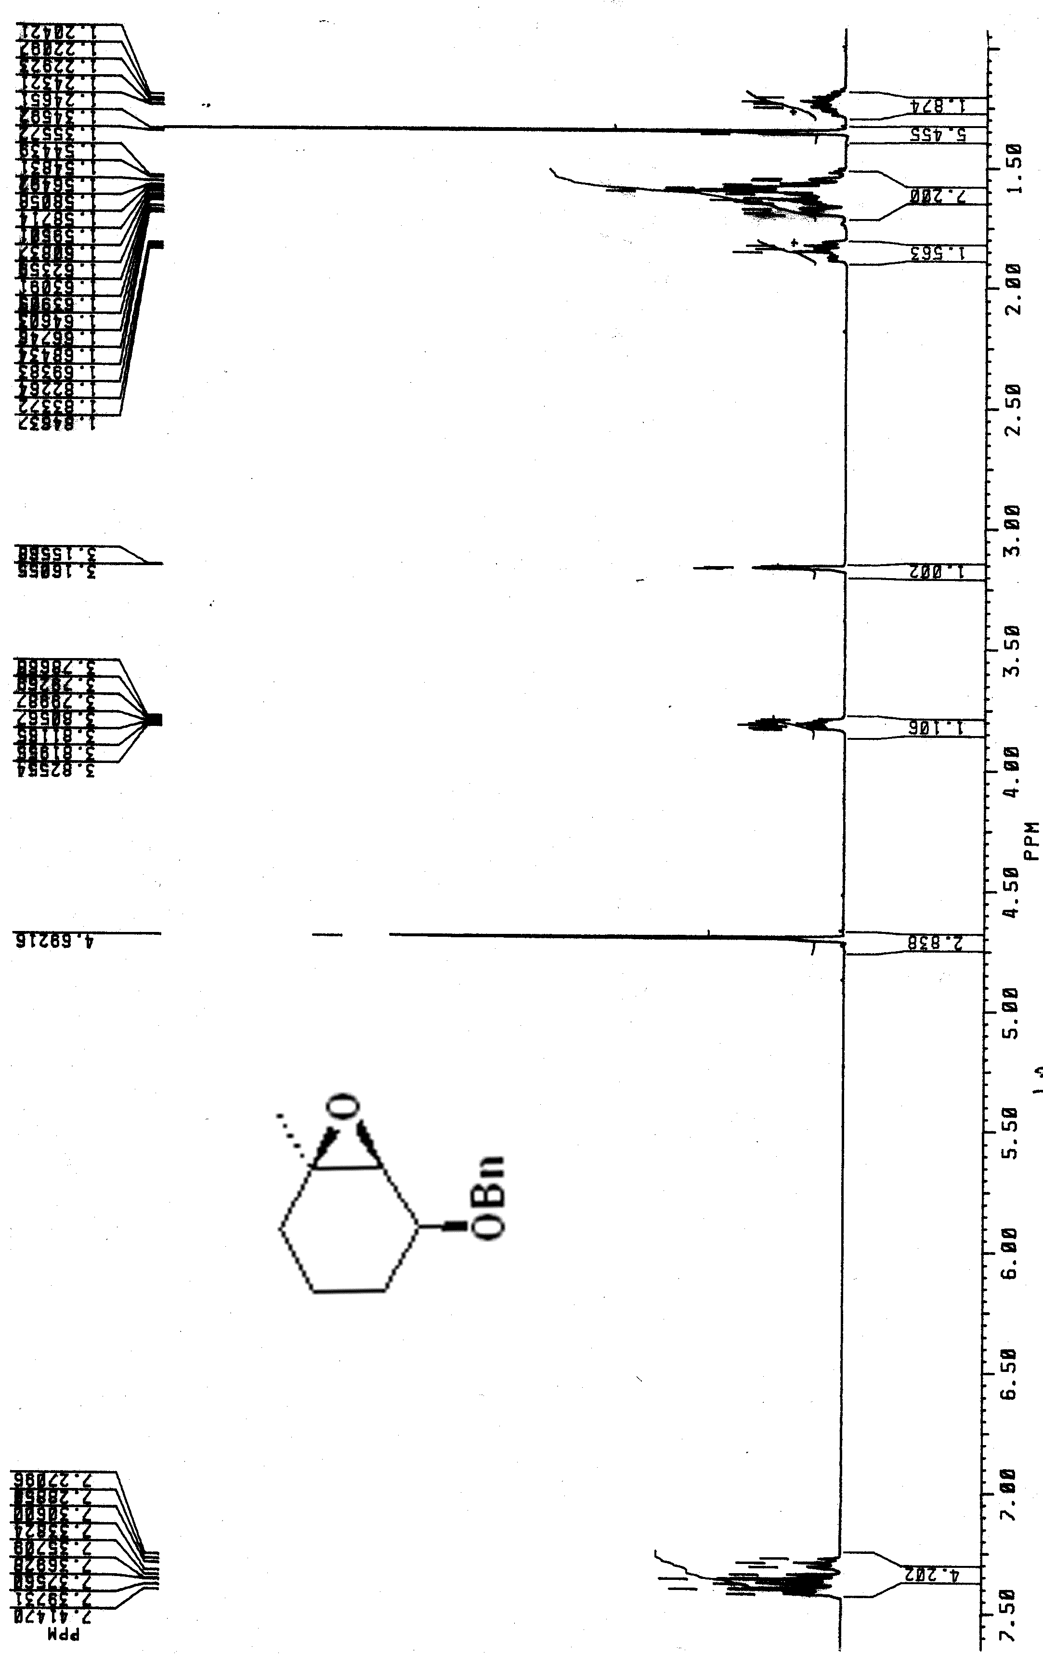
sub1
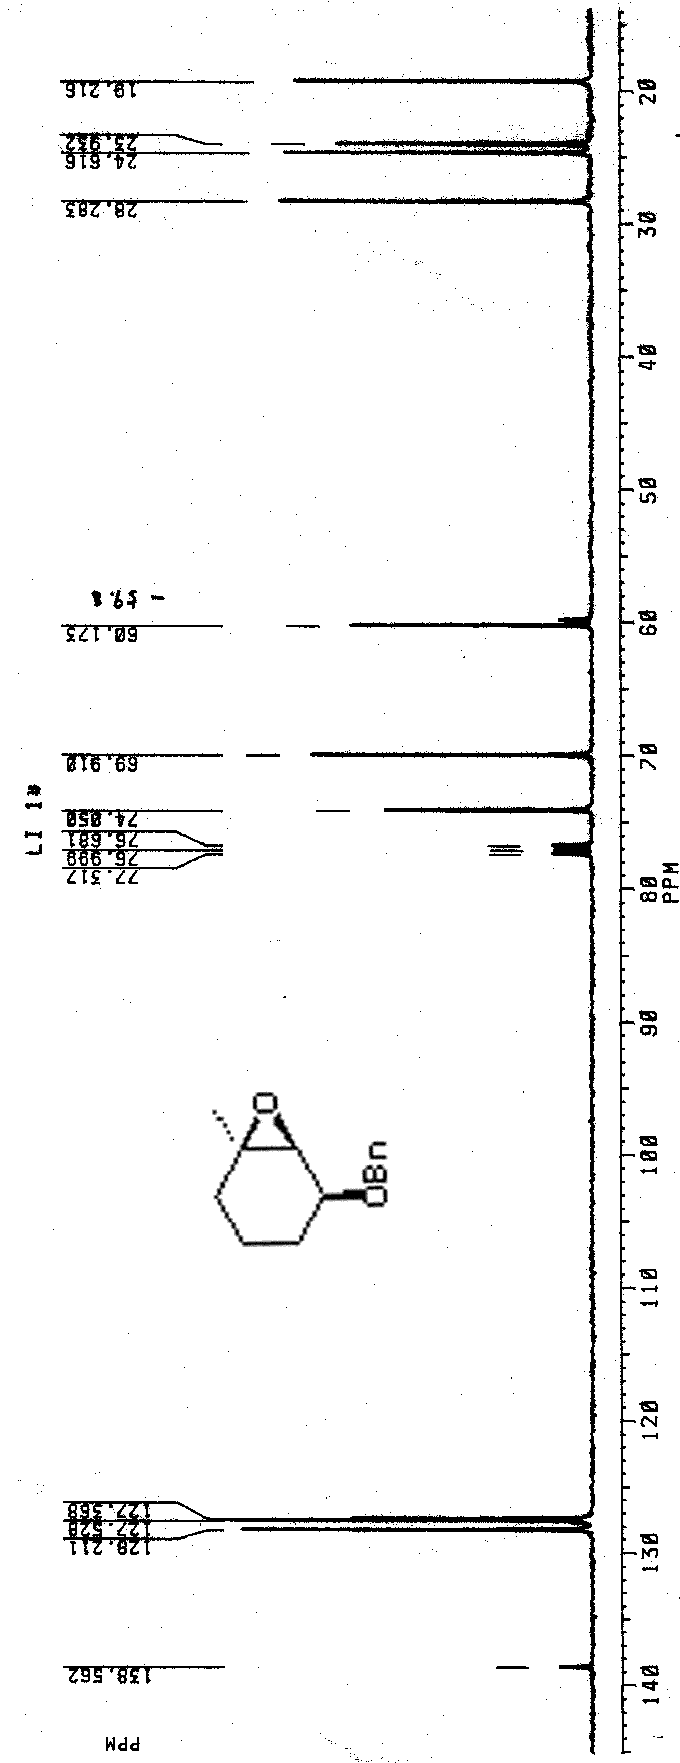 Sub 