SUPPLEMENTARY DATA
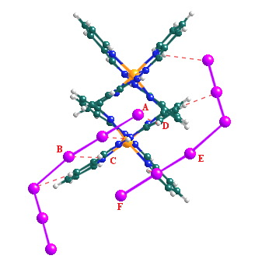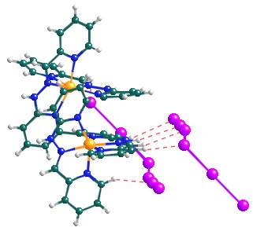

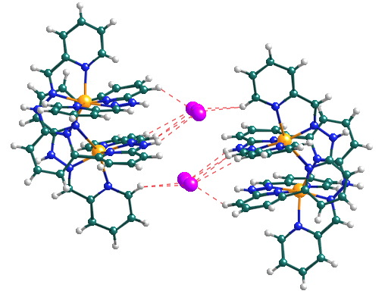
Figure S1. Two views of the C-H•••I interactions in 2 between the cations and the I₆²⁻ fragment I(1)-I(6). The I•••H distances range from 3.07Å to 3.24 Å and the C-H•••I angles from 131.4° to 177.4°. The torsion angles A-B-C-D and C-D-E-F are 0.48° and 3.48° respectively.

Figure S2: A view of the C-H•••I interactions in 2 between two cations and two I₃⁻ fragments I7-I8-I9 in 2. The •••H distances range from 3.19Å to 3.32Å and the C-H•••I angles from 130.9° to 148.5°.

Synthesis: The ligand L was prepared by reaction of 6,6’-dihydrazino-2,2’-bipyridine with 2 molar equivalents of pyridine-2-carboxaldehyde in methanol solution. [Ni₂L₂][BF₄]₄ was prepared by reaction of Ni(BF₄)₂.6H₂O with one equivalent of ligand in acetonitrile solution, then precipitated using diethyl ether. Crystalline 1 was prepared by the slow diffusion of diethyl ether vapour into a reaction mixture of [Ni₂(L)₂][BF₄]₄ (6mg) with 20 mole equivalents of NaI and 30 mole equivalents of I₂ in acetonitrile solution (2cm³). Crystalline 2 was prepared in the same manner, but with a fivefold increase in scale, ie. 30mg [Ni₂L₂][BF₄]₄ with 20 mole equivalents of NaI and 30 mole equivalents of I₂ in acetonitrile solution (10cm³).
‡ Crystal Data for 1: C₂₆H₂₄I₁₂N₁₀Ni, M = 2058.06, monoclinic, space group C2/c (no. 15), red-black irregular blocks, a = 13.497(2), b = 35.962(6), c = 20.498(4) Å, β = 108.127(3) º, U = 9456(3) Å³, Z = 8, D_{c} = 2.891 g.cm⁻³, μ(Mo-K_{α}) = 8.278 mm⁻¹, T = 150(2) K. 9308 unique reflections [R_{int} = 0.117], 5350 with I>2σ(I). Final R₁ = 0.0949, wR₂ (all data) = 0.239.
Crystal Data for 2: C₄₈H₄₂I₁₃N₁₈Ni₂, M = 2638.12, triclinic, space group P-1 (no. 2), dark red sphenoids, a = 13.429(1), b = 15.266(1), c = 18.172(1) Å, α = 79.363(1), β = 86.971(1), γ = 73.100(1)º, U = 3503(1) Å³, Z = 2, D_{c} = 2.501 gcm⁻³, μ(Mo-K_{α}) = 6.312 mm⁻¹, T = 150(2) K. 16910 unique reflections [R_{int} = 0.067], 13360 with I>2σ(I). Final R₁ = 0.0407, wR₂ (all data) = 0.102.

¹H NMR spectrum of free ligand in d-DMSO
11.26ppm, singlet, 1H, 8.55 ppm, doublet, 1H J=5.0 Hz, 8.14ppm, singlet, 1H, 7.99ppm, doublet, 1H J= 8.0 Hz, 7.81ppm, multiplet, 3H, 7.37ppm, doublet, 1H J=8.0 Hz, 7.26ppm, triplet, 1H J=6.1 Hz

Mass spec results for [Ni₂L₂](BF₄)₄:
Electrospray: m/z 901 [Ni₂L₂-3H]⁺ m/z 989 [Ni₂L₂-3H][BF₄]⁺, m/z 451 [Ni₂L₂-2H]²⁺ Note - isotope profiles support the formula [Ni₂L₂]²⁺ rather than [NiL]⁺

