Supporting Information

Construction of extended networks with a pyrazole trimeric synthon

Ishtvan Boldog,ª Eduard B. Rusanov, ª Joachim Sieler, ^{b} Steffen Blaurock, ^{b} and
Konstantin V. Domasevitch^{∗a #}

ª Inorganic Chemistry Department, Kiev University, Volodimirska Street 64, Kiev 01033,
Ukraine, # E-mail dk@anorgchemie.univ.kiev.ua
^{b} Institut für Anorganische Chemie, Universität Leipzig, Linnéstraße 3,
D-04103 Leipzig, Deutschland

Content:

1. Synthesis
2. Comments on solvent depended polymorphism of the compound
3. Comments on possible templating effect of metal ions for crystallization
4. Crystallography: experimental
5. Crystallography: refinement
- Refinement and proceeding of disorder in structure 1
- Refinement of structure 2
- Refinement and proceeding of disorder in structure 3
6. Statement of why structure 1 have to be published in its present form
7. Atom numbering schemes
8. Crystallography: Crystal tables
- for structure 1
- for structure 2
- for structure 3

1. Synthesis
3,3’,5,5’-Tetramethyl-4,4’-bipyrazolyl (W.L. Mosby, J. Chem. Soc. 1957, 3997-4003):
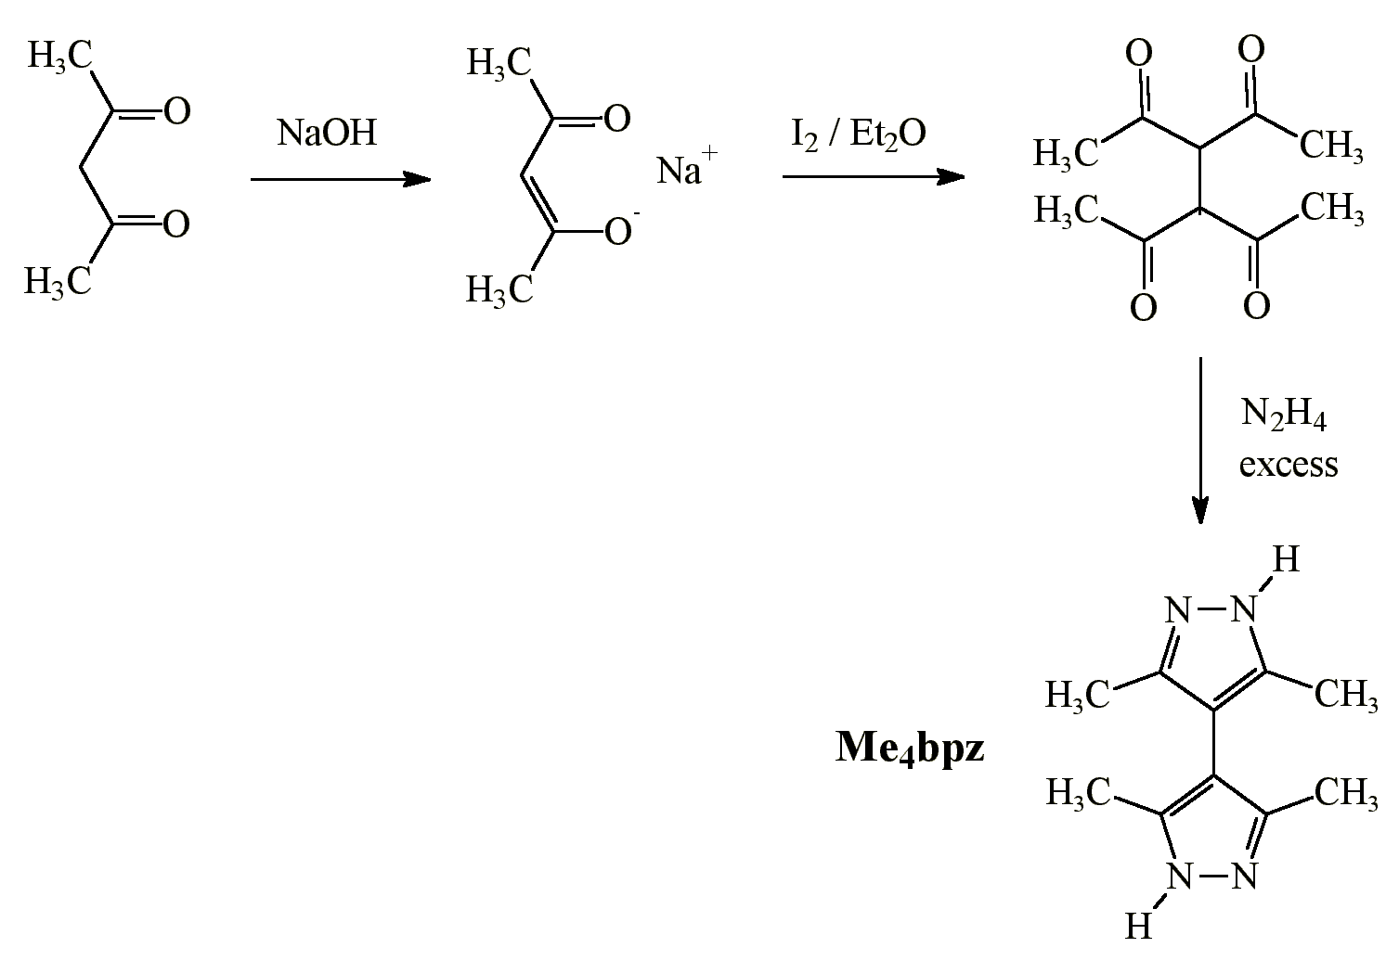
Sublimed (170 ºC, 5 mm Hg) product is a monoclinic α-polymorph Me₄bpz.

2. Solvent-depended poly- and pseudopolymorphism of Me₄bpz.
Using of wet solvents or crystallization by slow evaporation of the solutions in air usually led to isolation of semihydrate Me₄bpz⋅0.5H₂O. This compound possesses spectacular tetragonal structure in which Me₄bpz molecules associate by tetrameric motif (manuscript is under preparation). This structure itself underlines further possibilities for construction of network solids using the bipyrazolyl tecton, and also has fundamental interest as controversive fact for recent generazitions on supramolecular structures of pyrazoles (Acta Crystallogr. B, 2000, 56, 1018-1028). Being recrystallized from hot water and from absolute chloroform, Me₄bpz afforded the same crystalline material, monoclinic α-polymorph. These cases are only example for isolation of the same Me₄bpz product from different systems. The ability of the substance to afford polymorphs and different solvated products and co-crystals is really astonishable and outstanding. Hexagonal β-form may be crystallized from acetonitrile. Isomorphous solvates 3(Me₄bpz)⋅H₂O⋅Solv [Solv = Acetone, Ethylacetate, THF (dimorphic)] (see Angew. Chem., Int. Ed. 2001, 40, 3435-3438) are available from corresponding solvents under ambient conditions, Me₄bpz⋅2HCONH₂ – from formamide, 3MeOH⋅MeOH – from methanol, adducts with morpholine, dioxane, ethanol, tert-butanol, 6 phenols and diphenols as well as adducts with simple molecular inorganics like H₃BO₃, H₆TeO₆, H₅IO₆ are also prepared.
Crystallization from chloroform. 1) Solvate Me₄bpz⋅CHCl₃ 1. 20 ml of commercial chloroform (Aldrich, item number 31,998-8, stabilized with 0.5-1% Ethanol) was heated to reflux and saturated with Me₄bpz. Some remaining material was filtered off and the solution was allowed to stand overnight giving prismatic crystals of the product. They are not stable under solution and eventually became opaque. The compound is totally unstable outside the mother liquor, and decomposes within some seconds with loss of accumulated guests and disintegration of the structure. 2) Me₄bpz⋅0.5H₂O: The same solvent was 2 times washed with water, and then used for recrystallization of the compound. 3) The same commercial chloroform was absolutized by refluxing and distillation over phosphorus pentoxide under argon. Sublimed Me₄bpz was recrystallized under absence of air using standard Schlenck procedure, that has resulted in preparation of α-Me₄bpz in the form of large prisms.
Crystallization from water. 1) For crystallization of γ-polymorph 2, 0.190 g (1 mmol) Me₄bpz, 0.003 g (0.01 mmol) Ni(NO₃)₂⋅6H₂O and 5 ml water, in a teflon vessel, were placed in steel bomb, heated to 180ºC for 10 h and then cooled to r.t. over the period of 72 h. This afforded large slightly-yellow prisms of γ-Me₄bpz. The same effect was observed using ca. 0.00014 g (!!) Ni(NO₃)₂⋅6H₂O in the experiment (solution was prepared by 100 times dilution of 0.014 g Ni(NO₃)₂⋅6H₂O in 5 ml water). The same product was obtained by recrystallization also in the presence of 5 mol % of ZnO (that proves principal role of metal ions, not of anion), while nickel and cobalt acetates were inactive. 2) Under the same hydrothermal conditions and in absence of metal salts, product was monohydrate Me₄bpz⋅H₂O. 3) Saturated at 90ºC solution of Me₄bpz in water was cooled to 50ºC overnight and then crystals of α-Me₄bpz were filtered. 4) Saturated at r.t. solution of the compound was allowed to evaporate slowly in air giving semihydrate Me₄bpz⋅0.5H₂O.

3. Towards possible templating effect of metal ions in the solution

Bipyrazolyl is able to serve as a ligand and to form a number of coordination polymers:
[1] Ponomarova V.V., Komarchuk V.V., Boldog I., Chernega A.N., Sieler J., Domasevitch K.V., Mixed- Anion Complexes with a Bipyrazolyl Ligand. A New Entry to a Realm of Three-Dimensional Five-Connected Coordination Topologies, Chem. Commun., 2002, 436-437.
[2] Boldog I., Rusanov E.B., Chernega A.N., Sieler J., Domasevitch K.V. , Coordination polymers of Co^{II} and 3,3’,5,5’-tetramethyl-4,4’-bipyrazolyl: a novel metal-organic three-dimensional network with four-coordinated planar vertices. J. Chem. Soc. Dalton Trans., 2001, 893-897.
[3] Boldog I., Rusanov E.B., Chernega A.N., Sieler J., Domasevitch K.V., One- and two-dimensional coordination polymers of 3,3’,5,5’-tetramethyl-4,4’-bipyrazolyl, a new perspective crystal engineering module. Polyhedron, 2001, 20, 887-897.

We suppose formation in aqueous solutions of molecular complexes with Me₄bpz as monodentate ligand. Hydrated complexes of the type M(Me₄bpz)₃²⁺ and M(Me₄bpz)₄²⁺ may possess the size and shape that are very similar to ones of pyrazole trimers (Me₄bpz)₃ and tetramers (Me₄bpz)₄, and thus presumably may serve as suitable templates for nucleation and crystal growth.
That the geometry and side functionality of (Me₄bpz)₄ and [M(Me₄bpz)₄(H₂O)₂]²⁺ are closely related, may be demonstrated from a comparison of crystal structures Me₄bpz⋅0.5H₂O and [Ni(Me₄bpz)₄(H₂O)₂](NO₃)₂⋅2H₂O⋅2CHCl₃ (mns is under preparation). First of them includes tetramers (Me₄bpz)₄ that form with water molecules (N-H---O, O-H---N), in 1:2 proportion, 3D network and two identical networks interpenetrate. Second one includes complex cations [Ni(Me₄bpz)₄(H₂O)₂]²⁺, that possess the same shape, size and N/NH periphery functionality as the above tetramers (Me₄bpz)₄; these cations and 2 equivalents of water molecules form the same type Hydrogen-bonded framework (solvate
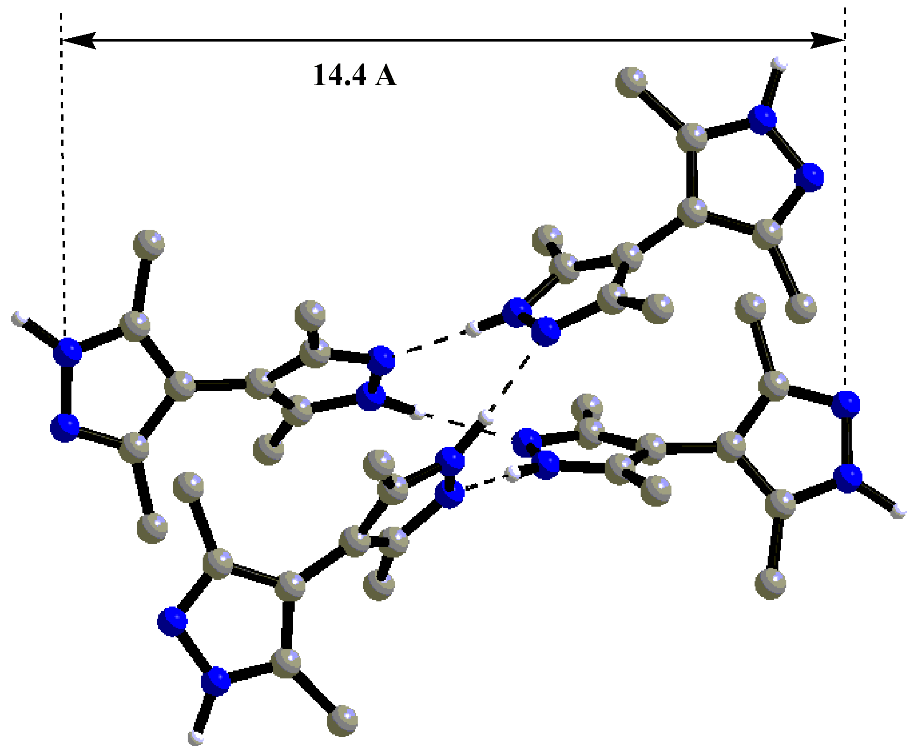  A | 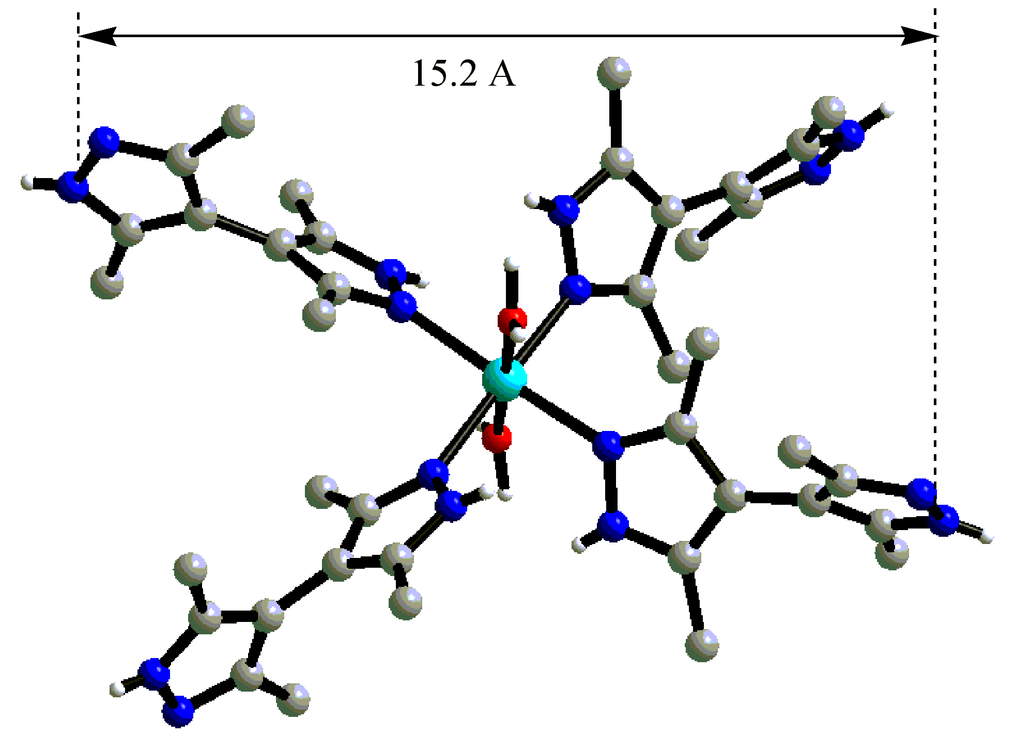  B
Fig. 1. Structure of (Me₄bpz)₄ tetramer (A) and [Ni(Me₄bpz)₄(H₂O)₂]²⁺ cation (B).
chloroform and nitrate anions are situated inside the holes). It should not be considered counterintuitive that such two very different compounds possess actually the same supramolecular structure.

4. Crystallography: Experimental

The intensity data for 1, 3 were collected at 173K on a Stoe Image Plate Diffraction System [1] using MoKα graphite monochromated radiation (λ = 0.71073 Å): Image plate distance 70mm, φ oscillation scans 0 – 188.5°, step Δφ = 1.1°, θ range 2.52 – 25.88°, d_{max} -d_{min} = 12.45 - 0.81 Å. Measurements for structure 2 were made at 223K using a Siemens SMART CCD area-detector diffractometer (graphite monochromated Mo-Kα radiation, λ = 0.71073 Å, omega scans, Δω 0.2º, exposition time 30 sec per frame, empirical absorption corrections using SADABS). The data frames were integrated using SAINT. The structures were solved by direct methods and refined by least-squares techniques using SHELXS-86 [2] and SHELXL-93 [3]. Details are given below.
Compound 1, Me₄bpz⋅CHCl₃, is unstable under solution (loss of crystallinity followed by dissolution and crystallization of α-Me₄bpz), but in air it decomposes within seconds, the sample momentally became opaque and completely looses crystallinity. It was even difficult to transfer sample from the solution to the diffractometer head. Our continuous experiments attempting to measure diffraction from sample in the capillary, under mother solution, gave no any improvements. Diffraction for all of ca. 30 tested crystalls was very weak, and relatively strong reflections were observed only to theta maximum 15-20º. In this reason recollection of the data was carried out with relatively large crystal (0.60 0.60 0.50 mm), this allowed somewhat minimize decomposition of the substance during selection of the crystal (that was detectable even at –50ºC!) and to get better diffraction pattern.
Graphical representation of the crystal structures was made using program Diamond [4].
1. Stoe & Cie (2000). IPDS Software. Stoe & Cie GmbH, Darmstadt, Germany.
2. G.M. Sheldrick, Acta Crystallogr., 1990, A46, 467.
3. G.M. Sheldrick, SHELXL93, A system of computer programs for X-ray structure determination, University of Göttingen, Göttingen, Germany, 1993.
4. K. Brandenburg, Diamond 2.1c, Crystal Impact GbR, Bonn, 1999.

5. Crystallography: refinement

Refinement and proceeding of disorder in structure 1

In addition to complete instability of the compound and poor diffraction pattern, the structure also contain ca. 40 mas % of solvate chloroform that is badly disordered. Firstly, all non-hydrogen atoms of the bipyrazole portion were located and refined anisotropically that resulted in convergence at R1=0.25 level. Then examination of residual electron density allowed to locate three unique molecules of solvate chloroform. All of them are disordered by very characteristic and typical scheme, as the superposition of orientations of the chlorine atoms (See Fig. 2). Two such orientations for each of three molecules were determined from electron density map. A set of geometry constraints was employed to improve the refinement stability: All carbon-chlorine separations were constrained at 1.74(2) Å, and Cl---Cl contacts within a single molecule were 2.87(2) Å. Then partial contributions of the disordering components were refined separately, and were found to be 0.80 and 0.20 (1), 0.60 and 0.40 (2), 0.40 and 0.60 (3). For two molecules of the solvent, the carbon and chlorine atoms of the major component were refined anisotropically for the sake of overall convergence. For chlorine atoms of the minor component within each molecule the isotropic thermal values were set to be uniform and were refined as two additional free variables. Resulting thermal parameters are reasonable and typical for solvate molecules that are disordered inside large cavities: U(eq) = 0.14 to 0.38 Å² and 0.48 Å² for C32. All atoms of the third molecule were left isotropic, U(iso) = 0.24 to 0.46 Å². These approaches afforded a stable and refinable model. Finally, the hydrogen atoms of all CH₃ groups were added geometrically with invariant thermal parameters U(iso) at 0.08 Å². H-atoms of pyrazole NH groups were not located and were not included. Also, hydrogen atoms of disordered CHCl₃ were not included.
The final convergence was reached at R1=0.127 (obs) level. See also Part 6.
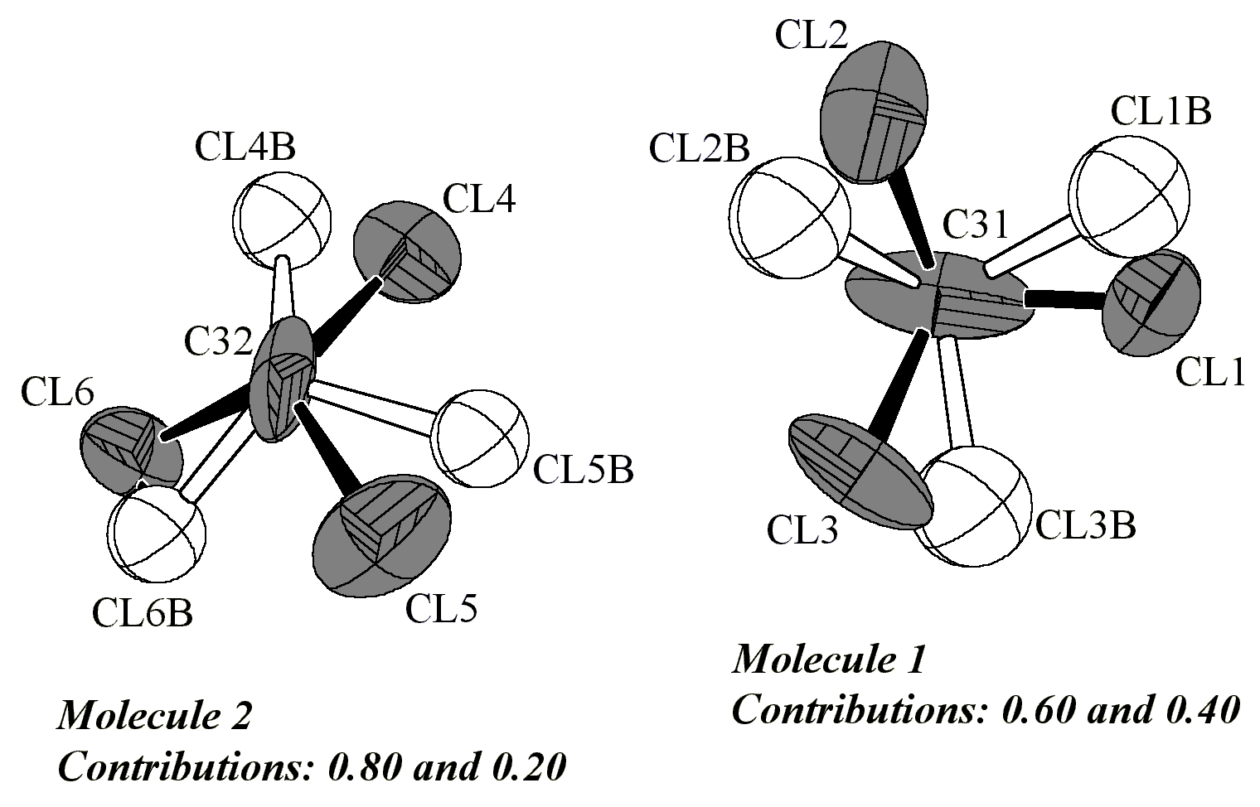 | 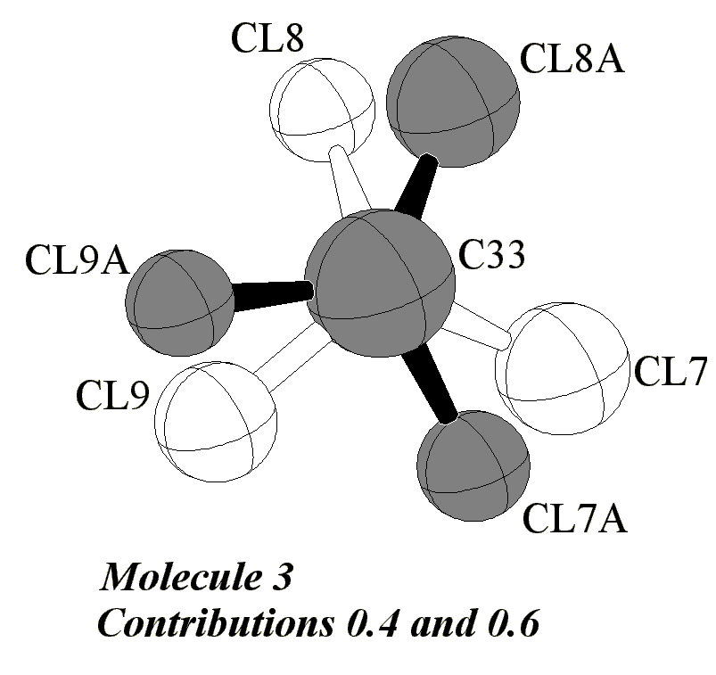
Fig. 2. Refined disordering models for all three unique chloroform molecules in structure 1. Atoms that were refined anisotropically are presented with octand ellipsoids, isotropic atoms are show as crossed spheres. Thermal ellipsoids are drawn at 30% level, atoms of the major component are shown in grey.

Refinement of structure 2

The refinement was standard. All non-hydrogen atoms were refined anisotropically, all NH hydrogens were located and refined isotropically. CH₃ hydrogens were placed in calculated positions with invariant U_{iso} at 0.08 Å².

Refinement and proceeding of disorder in structure 3

All carbon and nitrogen atoms were refined anisotropically. Examination of electron density revealed two sorts of disorder: 1) oxygen atom of methanol molecule is disordered over two positions with partial contributions 0.90 and 0.10; 2) It was possible to locate all NH hydrogen atoms, and for the part of pyrazole cycles (that form trimer without methanol) NH hydrogens are equally disordered between two nitrogen atoms (see Fig. 3 below). This situation is typical for pyrazoles (for overview, Acta Crystallogr. B, 2000, 56, 1018-1028) and is contrary to one observed in structure 2, where NH hydrogens within a trimer are ordered. For disordered methanol, no geometry constraints were applied, carbon and major contribution of oxygen atom were refined anisotropically, minor oxygen was left isotropic. OH hydrogen atom was located and then fixed, CH₃ hydrogens were placed in calculated positions considering major orientation of oxygen atom. Although all NH hydrogens were located, some of N-H separations were poor (0.65 and 1.10 Å), and thus all NH hydrogen atoms were fixed. Within a trimer shown in Fig. B, occupancies of hydrogen atoms were 0.5. Pyrazole CH₃ hydrogen atoms also were added from geometry considerations. All hydrogen atoms were included with U values 1.2 times greater than U(eq) value of corresponding non-hydrogen atom.
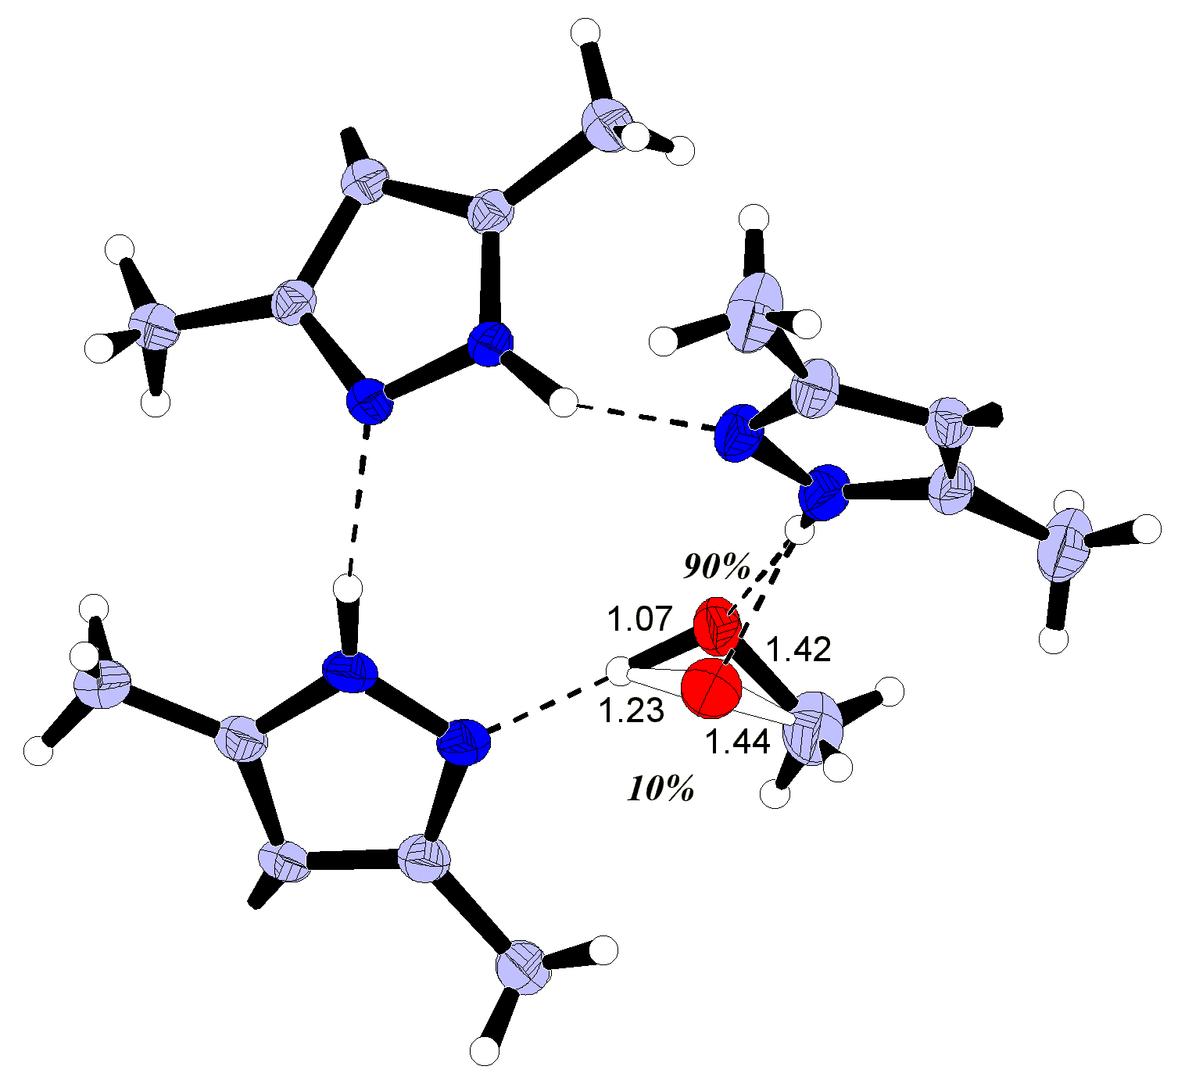  A | B
Fig. 3. Refined disordering models in structure 3: A – disordering of methanol molecule; B – Disordering of hydrogen atoms within pyrazole trimer.

6. Statement of why structure 1 have to be published in its present form

The reasons for relatively bad overall convergence in this structure are very obvious and objective. In part this is due to the total instability of the crystals towards loss of initially accumulated solvent (See also Section 4) and weak diffraction (that also influences relatively high R(int) value as well as final convergence for all data), and in part due to disordering of the solvent (that is 39.6 mas % of the sample). It was not possible to improve present convergence, although more then 10 different datasets were collected in total (and more then 30 crystals were examined) under different conditions, using either SMART CCD and IPDS Stoe, varying the crystal size, exposition and data reduction parameters.
We note, however, that the structure is very principal for the study and for discussion in the manuscript. Discovery of the bipyrazole network in this compound allowed us to predict a novel polymorph of the bipyrazole, and even to outline possible experimental conditions for the successful synthesis. Thus the structure has clear chemical significance and was a basis for the entire scenario of the study. In this context the structure significantly contributes to the manuscript and allows to demonstrate completely all stages of the research and how we have reached conclusion for existence of third polymorphic modification of the compound. It is also important that principal part of this structure – the bipyrazole linkage, - is completely ordered and unambiguous, with all structural parameters being highly reasonable, all e.s.d. values for carbon-carbon and carbon-nitrogen bonds are satisfactory (0.01-0.02 Å).

7. Atom numbering schemes

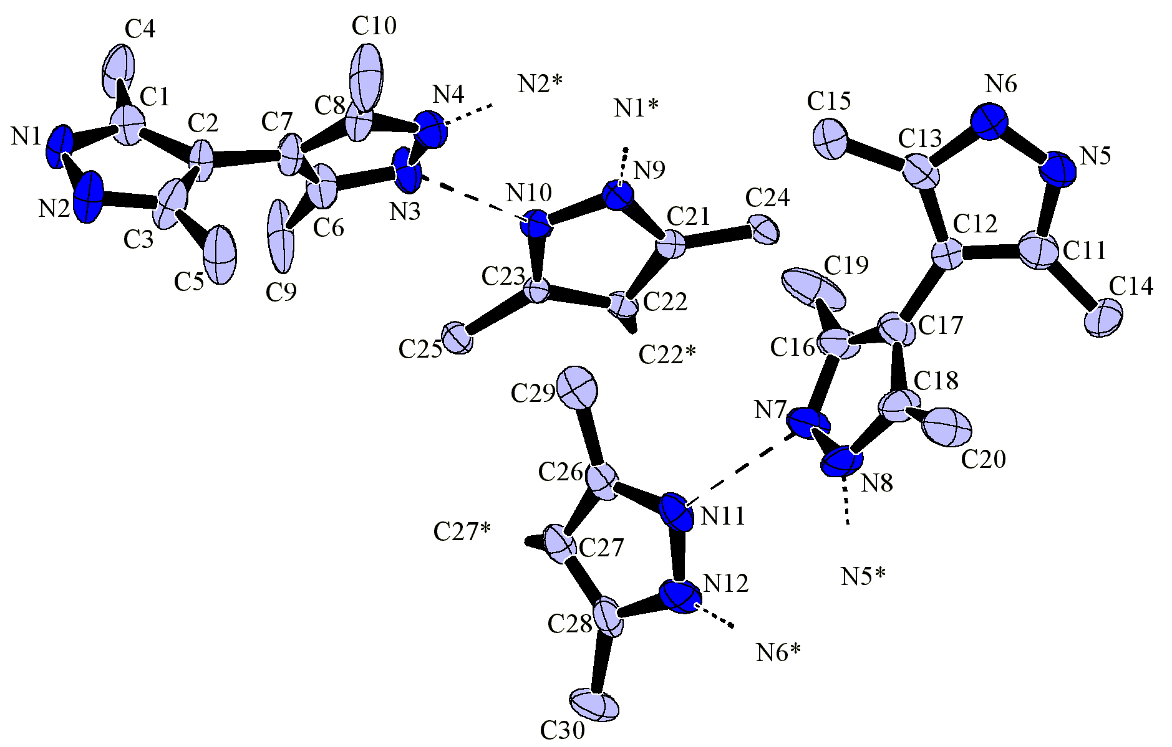

Fig. 4. Bipyrazole portion in 1 (Chloroforms are in Fig. 2). 40% probability ellipsoids.

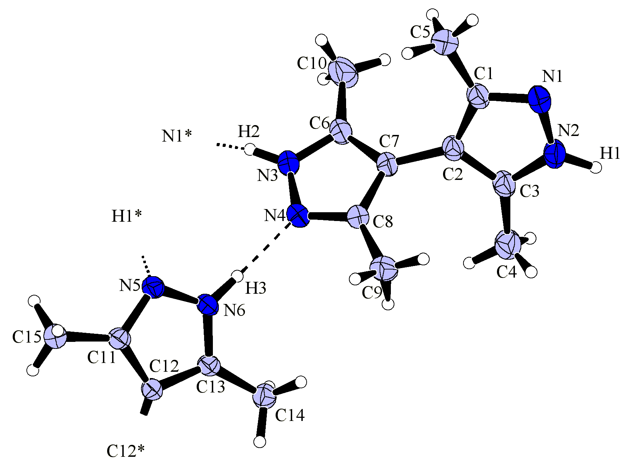

Fig. 5. Unique part in structure 2. 40% probability ellipsoids.

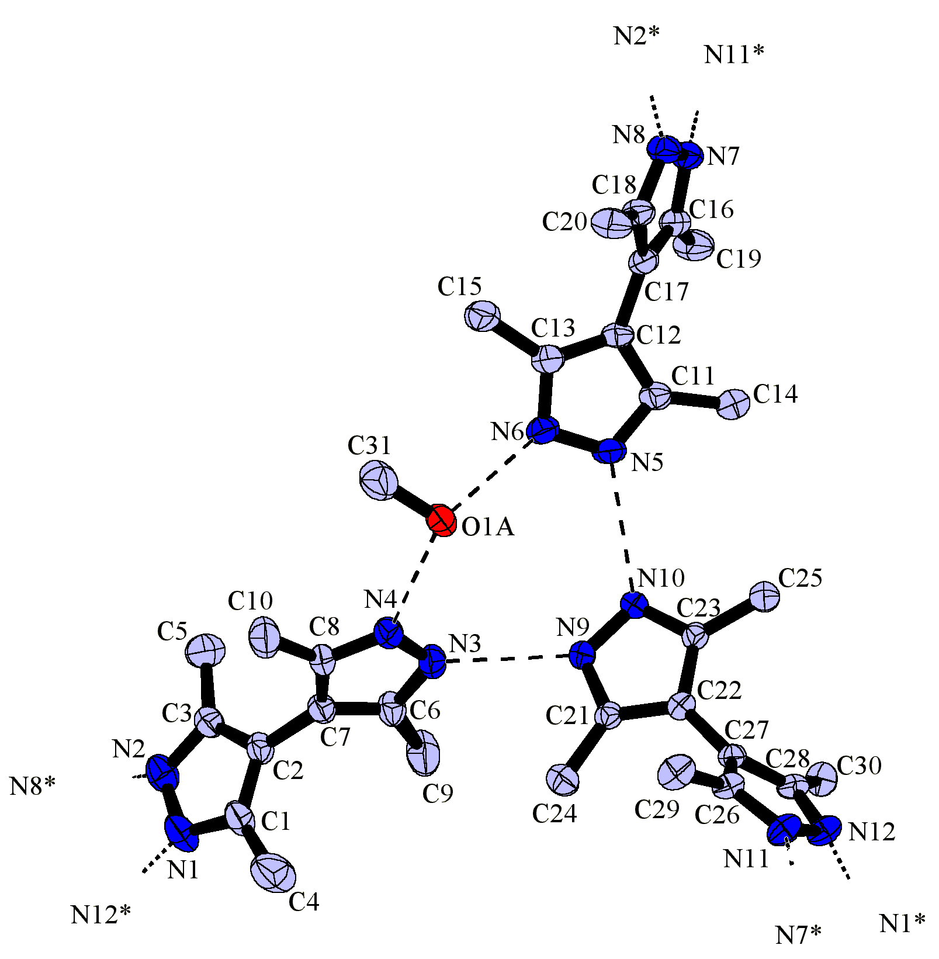
Fig. 6. Unique part in structure 3. Minor component of disordered oxygen atom (O1B) is not
shown. 40% probability thermal ellipsoids.

8. Crystallography: Crystal tables

Table 1. Crystal data and structure refinement for 1.

Identification code dpzn
Empirical formula C11 H15 Cl3 N4
Formula weight 309.62
Temperature 173(2) K
Wavelength 0.71073 A
Crystal system Tetragonal
Space group I4(1)/a
Unit cell dimensions a = 29.196(2) A alpha = 90 deg.
b = 29.196(2) A beta = 90 deg.
c = 22.406(2) A gamma = 90 deg.
Volume 19099(3) A^3
Z 48
Density (calculated) 1.292 Mg/m^3
Absorption coefficient 0.565 mm^-1
F(000) 7680
Crystal size 0.60 x 0.60 x 0.50 mm
Theta range for data collection 2.07 to 26.01 deg.
Index ranges -10<=h<=33, -29<=k<=35, -27<=l<=25
Reflections collected 16913
Independent reflections 7333 [R(int) = 0.1213]
Refinement method Full-matrix least-squares on F^2
Data / restraints / parameters 5091 / 42 / 500
Goodness-of-fit on F^2 0.844
Final R indices [I>2sigma(I)] R1 = 0.1270, wR2 = 0.2836
R indices (all data) R1 = 0.3327, wR2 = 0.4376
Extinction coefficient 0.011(2)
Largest diff. peak and hole 0.330 and -0.310 e.A^-3

Table 2. Atomic coordinates ( x 10^4) and equivalent isotropic
displacement parameters (A^2 x 10^3) for 1. U(eq) is defined
as one third of the trace of the orthogonalized Uij tensor.
________________________________________________________________

x y z U(eq)
________________________________________________________________
C(1) 5831(5) 4512(5) -1442(4) 61(4)
C(2) 6031(4) 4938(4) -1562(4) 58(3)
C(3) 6161(5) 4908(5) -2169(4) 81(5)
C(4) 5645(6) 4321(5) -878(4) 92(5)
C(5) 6373(7) 5262(6) -2544(5) 109(6)
C(6) 5746(5) 5579(5) -878(5) 68(4)
C(7) 6094(5) 5325(4) -1155(4) 60(3)
C(8) 6504(5) 5525(5) -973(4) 63(3)
C(9) 5258(7) 5537(8) -928(9) 139(9)
C(10) 6983(6) 5427(7) -1124(10) 129(7)
C(11) 7878(5) 8948(6) -123(5) 80(4)
C(12) 7679(5) 8548(5) -379(4) 71(4)
C(13) 7928(5) 8184(6) -148(4) 79(4)
C(14) 7787(7) 9435(6) -223(9) 118(6)
C(15) 7866(7) 7687(6) -264(7) 103(5)
C(16) 6866(6) 8341(5) -743(4) 77(5)
C(17) 7299(5) 8548(5) -805(4) 69(4)
C(18) 7282(5) 8765(5) -1346(5) 75(4)
C(19) 6684(6) 8093(9) -250(5) 128(8)
C(20) 7660(6) 9025(7) -1663(6) 111(6)
C(21) 5635(4) 7355(4) 481(3) 43(3)
C(22) 5188(4) 7321(4) 249(3) 43(3)
C(23) 5163(4) 6884(4) -20(3) 41(3)
C(24) 5844(4) 7729(4) 825(3) 49(3)
C(25) 4758(4) 6669(4) -351(4) 55(3)
C(26) 5599(4) 7696(5) -1596(4) 60(4)
C(27) 5164(4) 7689(5) -1832(4) 62(4)
C(28) 5084(5) 8122(6) -2061(4) 80(4)
C(29) 5846(5) 7307(5) -1283(4) 81(4)
C(30) 4685(5) 8328(6) -2384(6) 96(5)
N(1) 5848(4) 4254(3) -1948(3) 64(3)
N(2) 6051(4) 4510(4) -2392(4) 81(4)
N(3) 5938(4) 5905(4) -540(3) 73(3)
N(4) 6398(4) 5881(4) -605(3) 63(3)
N(5) 8223(4) 8785(5) 227(4) 81(4)
N(6) 8268(5) 8344(5) 212(4) 89(4)
N(7) 6625(4) 8432(4) -1238(4) 79(4)
N(8) 6892(5) 8675(4) -1637(4) 86(4)
N(9) 5857(3) 6966(3) 361(3) 48(2)
N(10) 5555(3) 6682(3) 65(3) 47(2)
N(11) 5796(4) 8108(4) -1678(3) 65(3)
N(12) 5463(4) 8389(4) -1950(3) 76(3)
C(31) 6185(6) 8285(6) -3224(7) 285(31)
Cl(1) 5827(4) 8632(4) -3631(4) 143(4)
Cl(2) 6757(3) 8384(6) -3454(4) 204(7)
Cl(3) 6004(7) 7733(3) -3282(4) 252(10)
Cl(1B) 6136(9) 8735(13) -3751(21) 380(18)
Cl(2B) 6701(8) 8000(13) -3375(24) 380(18)
Cl(3B) 5721(8) 7908(10) -3371(24) 380(18)
C(32) 7106(7) 7001(5) -1990(7) 485(67)
Cl(4) 7077(3) 7580(3) -1906(3) 134(3)
Cl(5) 6704(4) 6772(6) -2445(7) 250(7)
Cl(6) 7089(3) 6795(3) -1221(3) 144(3)
Cl(6B) 6993(11) 6528(6) -1636(8) 143(6)
Cl(4B) 7366(8) 7442(7) -1674(11) 143(6)
Cl(5B) 6699(9) 7150(9) -2543(10) 143(6)
C(33) 6268(5) 10201(6) -795(11) 456(52)
Cl(7) 6649(9) 9771(11) -608(18) 364(23)
Cl(8) 6498(8) 10532(8) -1391(10) 222(8)
Cl(9) 5736(7) 9994(11) -993(14) 298(14)
Cl(7A) 6321(9) 9618(6) -668(7) 253(7)
Cl(8A) 6728(7) 10512(10) -986(14) 353(13)
Cl(9A) 5723(5) 10386(8) -943(6) 237(6)
________________________________________________________________
Table 3. Bond lengths [A] and angles [deg] for 1.
_____________________________________________________________
C(1)-N(1) 1.363(13)  C(1)-C(2) 1.40(2)  C(1)-C(4) 1.48(2)  C(2)-C(3) 1.414(12)  C(2)-C(7) 1.46(2)  C(3)-N(2) 1.31(2)  C(3)-C(5) 1.47(2)  C(6)-N(3) 1.34(2)  C(6)-C(7) 1.40(2)  C(6)-C(9) 1.44(2)  C(7)-C(8) 1.39(2)  C(8)-N(4) 1.36(2)  C(8)-C(10) 1.47(2)  C(11)-N(5) 1.36(2)  C(11)-C(12) 1.42(2)  C(11)-C(14) 1.46(2)  C(12)-C(13) 1.39(2)  C(12)-C(17) 1.46(2)  C(13)-N(6) 1.36(2)  C(13)-C(15) 1.48(2)  C(16)-N(7) 1.342(14)  C(16)-C(17) 1.41(2)  C(16)-C(19) 1.42(2)  C(17)-C(18) 1.37(2)  C(18)-N(8) 1.34(2)  C(18)-C(20) 1.52(2)  C(21)-N(9) 1.335(12) | C(21)-C(22) 1.408(14)  C(21)-C(24) 1.47(2)  C(22)-C(23) 1.413(14)  C(22)-C(22)#1 1.52(2)  C(23)-N(10) 1.301(12)  C(23)-C(25) 1.53(2)  C(26)-N(11) 1.346(14)  C(26)-C(27) 1.37(2)  C(26)-C(29) 1.52(2)  C(27)-C(28) 1.38(2)  C(27)-C(27)#1 1.46(2)  C(28)-N(12) 1.38(2)  C(28)-C(30) 1.50(2)  N(1)-N(2) 1.377(13)  N(3)-N(4) 1.352(14)  N(5)-N(6) 1.30(2)  N(7)-N(8) 1.38(2)  N(9)-N(10) 1.379(12)  N(11)-N(12) 1.41(2)  C(31)-Cl(3) 1.70(2)  C(31)-Cl(1) 1.72(2)  C(31)-Cl(2B) 1.75(2)  C(31)-Cl(2) 1.77(2)  C(31)-Cl(1B) 1.77(2)  C(31)-Cl(3B) 1.78(2)  Cl(1)-Cl(1B) 0.99(2)  Cl(1)-Cl(3B) 2.22(3) |  | Cl(2)-Cl(2B) 1.15(3)  Cl(2)-Cl(1B) 2.19(3)  Cl(3)-Cl(3B) 0.99(2)  Cl(3)-Cl(2B) 2.19(3)  C(32)-Cl(6B) 1.63(2)  C(32)-Cl(4B) 1.65(2)  C(32)-Cl(5) 1.69(2)  C(32)-Cl(4) 1.70(2)  C(32)-Cl(5B) 1.77(2)  C(32)-Cl(6) 1.83(2)  Cl(4)-Cl(4B) 1.07(2)  Cl(4)-Cl(5B) 2.20(2)  Cl(5)-Cl(5B) 1.12(2)  Cl(5)-Cl(6B) 2.12(3)  Cl(6)-Cl(6B) 1.24(2)  Cl(6)-Cl(4B) 2.29(2)  C(33)-Cl(8A) 1.677(10)  C(33)-Cl(9A) 1.712(10)  C(33)-Cl(9) 1.724(10)  C(33)-Cl(7) 1.730(10)  C(33)-Cl(7A) 1.734(10)  C(33)-Cl(8) 1.779(11)  Cl(7)-Cl(7A) 1.07(2)  Cl(7)-Cl(8A) 2.33(3)  Cl(8)-Cl(8A) 1.13(2)  Cl(9)-Cl(9A) 1.15(2)  Cl(9)-Cl(7A) 2.16(2)
N(1)-C(1)-C(2) 108.4(8)  N(1)-C(1)-C(4) 121.1(12)  C(2)-C(1)-C(4) 130.5(9)  C(1)-C(2)-C(3) 104.0(8)  C(1)-C(2)-C(7) 128.2(8)  C(3)-C(2)-C(7) 127.8(11)  N(2)-C(3)-C(2) 110.9(10)  N(2)-C(3)-C(5) 120.8(9)  C(2)-C(3)-C(5) 128.3(11)  N(3)-C(6)-C(7) 108.8(12)  N(3)-C(6)-C(9) 121.3(11)  C(7)-C(6)-C(9) 129.9(11)  C(8)-C(7)-C(6) 105.7(10)  C(8)-C(7)-C(2) 128.0(11)  C(6)-C(7)-C(2) 126.3(12)  N(4)-C(8)-C(7) 107.7(11)  N(4)-C(8)-C(10) 120.4(12)  C(7)-C(8)-C(10) 131.9(11)  N(5)-C(11)-C(12) 104.4(13)  C(12)-C(11)-C(14) 131.4(12)  C(13)-C(12)-C(11) 105.4(11)  C(13)-C(12)-C(17) 129.7(13)  C(11)-C(12)-C(17) 124.9(12)  N(6)-C(13)-C(12) 109.8(14)  N(6)-C(13)-C(15) 121.9(13)  C(12)-C(13)-C(15) 128.3(12)  N(7)-C(16)-C(17) 107.8(9)  N(7)-C(16)-C(19) 123.1(14)  C(17)-C(16)-C(19) 129.1(11)  C(18)-C(17)-C(16) 104.7(10)  C(18)-C(17)-C(12) 127.2(14)  C(16)-C(17)-C(12) 128.1(10)  N(8)-C(18)-C(17) 111.8(13)  N(8)-C(18)-C(20) 119.4(10)  C(17)-C(18)-C(20) 128.3(13)  N(9)-C(21)-C(22) 108.3(9)  N(9)-C(21)-C(24) 122.5(9)  C(22)-C(21)-C(24) 129.2(9)  C(21)-C(22)-C(23) 105.6(9) |  | C(21)-C(22)-C(22)#1 128.4(11)  C(23)-C(22)-C(22)#1 125.9(11)  N(10)-C(23)-C(22) 107.6(8)  N(10)-C(23)-C(25) 124.4(9)  C(22)-C(23)-C(25) 128.0(10)  N(11)-C(26)-C(27) 110.7(11)  N(11)-C(26)-C(29) 121.9(11)  C(27)-C(26)-C(29) 127.4(12)  C(26)-C(27)-C(28) 106.6(12)  C(26)-C(27)-C(27)#1 128(2)  C(28)-C(27)-C(27)#1 125(2)  N(12)-C(28)-C(27) 108.3(13)  N(12)-C(28)-C(30) 119.0(13)  C(27)-C(28)-C(30) 132.7(13)  C(1)-N(1)-N(2) 108.4(10)  C(3)-N(2)-N(1) 108.3(7)  C(6)-N(3)-N(4) 108.5(9)  N(3)-N(4)-C(8) 109.3(9)  N(6)-N(5)-C(11) 113.9(12)  N(5)-N(6)-C(13) 106.6(12)  C(16)-N(7)-N(8) 109.8(11)  C(18)-N(8)-N(7) 105.5(9)  C(21)-N(9)-N(10) 107.4(8)  C(23)-N(10)-N(9) 111.0(8)  C(26)-N(11)-N(12) 106.5(10)  C(28)-N(12)-N(11) 107.6(11)  Cl(3)-C(31)-Cl(1) 109.3(11)  Cl(3)-C(31)-Cl(2) 115.2(10)  Cl(1)-C(31)-Cl(2) 108.8(10)  Cl(2B)-C(31)-Cl(1B) 107.0(14)  Cl(2B)-C(31)-Cl(3B) 109.1(14)  Cl(1B)-C(31)-Cl(3B) 106.0(14)  Cl(6B)-C(32)-Cl(4B) 123.0(12)  Cl(5)-C(32)-Cl(4) 115.1(11)  Cl(6B)-C(32)-Cl(5B) 114.5(12)  Cl(4B)-C(32)-Cl(5B) 114.7(12)  Cl(5)-C(32)-Cl(6) 114.8(11)  Cl(4)-C(32)-Cl(6) 102.7(10)  Cl(8A)-C(33)-Cl(9A) 121.6(11)  Cl(9)-C(33)-Cl(7) 112.9(9)  Cl(8A)-C(33)-Cl(7A) 120.1(12)  Cl(9A)-C(33)-Cl(7A) 115.1(9)  Cl(9)-C(33)-Cl(8) 109.7(9)  Cl(7)-C(33)-Cl(8) 109.4(9)
_____________________________________________________________
Symmetry transformations used to generate equivalent atoms:
#1 -x+1,-y+3/2,z+1-1

Table 4. Anisotropic displacement parameters (A^2 x 10^3) for 1.
The anisotropic displacement factor exponent takes the form:
-2 pi^2 [ h^2 a*^2 U11 + ... + 2 h k a* b* U12 ]

_______________________________________________________________________

U11 U22 U33 U23 U13 U12
_______________________________________________________________________

C(1) 60(9) 64(10) 59(5) -11(5) 17(4) 3(7)
C(2) 67(9) 48(9) 59(5) -19(4) 17(5) -23(7)
C(3) 122(13) 59(10) 63(6) -15(6) 49(6) -20(9)
C(4) 141(15) 65(11) 71(6) -19(5) 32(7) -38(10)
C(5) 183(18) 77(12) 68(6) -19(6) 35(8) -58(12)
C(6) 39(10) 68(10) 96(7) -28(6) 13(5) -7(7)
C(7) 74(10) 46(8) 59(5) -20(4) 14(5) -10(7)
C(8) 58(10) 50(9) 82(6) -14(5) 19(6) -10(7)
C(9) 92(17) 118(17) 205(15) -122(14) 37(12) -48(13)
C(10) 63(14) 82(15) 243(17) -95(13) 24(11) -7(10)
C(11) 56(11) 73(13) 112(8) -2(7) -16(7) 5(8)
C(12) 74(11) 65(10) 75(6) -4(6) -23(6) -2(8)
C(13) 84(11) 81(12) 72(6) -11(6) -30(6) 8(9)
C(14) 76(14) 71(15) 206(15) -21(10) -70(11) 29(10)
C(15) 105(15) 73(13) 131(10) 7(8) -49(9) -14(10)
C(16) 74(12) 96(12) 62(6) 26(6) -15(5) -11(9)
C(17) 50(10) 87(12) 71(6) 8(5) -13(5) -10(8)
C(18) 58(11) 67(11) 99(8) 23(6) -13(6) 1(8)
C(19) 66(12) 245(25) 71(7) 39(9) -7(6) -28(13)
C(20) 96(14) 117(16) 120(9) 49(9) -29(8) -59(12)
C(21) 34(7) 52(8) 42(4) 6(4) 3(4) -2(6)
C(22) 46(8) 49(8) 35(4) 2(3) 3(4) 2(5)
C(23) 40(8) 46(7) 38(4) 3(4) -5(4) -4(5)
C(24) 40(7) 65(8) 41(4) -6(4) -9(4) 4(6)
C(25) 46(8) 58(9) 61(5) -13(4) -8(4) 8(6)
C(26) 56(9) 77(11) 48(5) 1(5) 4(5) -26(8)
C(27) 63(11) 73(11) 50(5) -2(5) 2(5) -18(7)

C(28) 85(12) 92(13) 62(6) -4(6) -16(6) -38(9)
C(29) 72(11) 100(12) 71(6) -8(6) 10(5) -9(9)
C(30) 55(11) 122(15) 109(8) 49(8) -37(7) -29(9)
N(1) 85(9) 45(7) 61(4) -13(4) 16(4) -21(6)
N(2) 102(10) 70(9) 72(5) -24(5) 37(5) -31(7)
N(3) 72(9) 76(9) 72(5) -41(5) 7(5) -6(7)
N(4) 51(8) 71(8) 67(4) -12(4) 3(4) -5(6)
N(5) 63(9) 82(11) 97(6) -21(5) -27(5) 25(7)
N(6) 109(12) 65(11) 92(6) -8(5) -27(6) 10(8)
N(7) 69(9) 93(10) 74(5) 35(5) -19(5) -20(7)
N(8) 90(11) 64(9) 105(6) 48(5) -23(6) -26(7)
N(9) 42(6) 48(7) 53(4) -7(3) 3(3) 12(5)
N(10) 46(7) 51(6) 44(4) -3(3) -2(3) 10(5)
N(11) 52(7) 88(9) 55(4) -4(4) 0(4) -20(7)
N(12) 89(9) 101(9) 39(4) 12(4) -3(4) -5(8)
C(31) 392(61) 216(38) 247(30) -150(30) 243(41) -145(41)
Cl(1) 128(9) 136(10) 164(6) -17(5) -30(5) 16(7)
Cl(2) 125(9) 362(21) 125(5) 70(8) 51(5) 70(10)
Cl(3) 543(30) 103(8) 108(5) 1(5) 101(10) -55(12)
C(32) 35(17) 637(108) 785(108) 651(106) 25(31) 18(31)
Cl(4) 142(7) 129(6) 131(4) -6(3) 37(3) 3(5)
Cl(5) 167(11) 238(16) 345(13) -173(13) -49(9) 32(10)
Cl(6) 145(7) 122(6) 165(4) 35(4) 18(4) -17(5)
_______________________________________________________________________

Table 5. Hydrogen coordinates ( x 10^4) and isotropic
displacement parameters (A^2 x 10^3) for 1.
________________________________________________________________
x y z U(eq)
________________________________________________________________
H(4A) 5536(6) 4016(5) -949(4) 80
H(4B) 5877(6) 4315(5) -574(4) 80
H(4C) 5396(6) 4511(5) -750(4) 80
H(5A) 6428(7) 5150(6) -2941(5) 80
H(5B) 6164(7) 5516(6) -2561(5) 80
H(5C) 6657(7) 5361(6) -2371(5) 80
H(9A) 5110(7) 5757(8) -674(9) 80
H(9B) 5176(7) 5595(8) -1336(9) 80
H(9C) 5161(7) 5234(8) -819(9) 80
H(10A) 7183(6) 5634(7) -917(10) 80
H(10B) 7052(6) 5118(7) -1010(10) 80
H(10C) 7026(6) 5461(7) -1547(10) 80
H(14A) 7989(7) 9616(6) 19(9) 80
H(14B) 7835(7) 9507(6) -636(9) 80
H(14C) 7475(7) 9501(6) -117(9) 80
H(15A) 8094(7) 7513(6) -54(7) 80
H(15B) 7567(7) 7601(6) -125(7) 80
H(15C) 7889(7) 7626(6) -684(7) 80
H(19A) 6374(6) 8011(9) -343(5) 80
H(19B) 6867(6) 7821(9) -216(5) 80
H(19C) 6691(6) 8258(9) 121(5) 80
H(20A) 7668(6) 8955(7) -2081(6) 80
H(20B) 7949(6) 8957(7) -1477(6) 80
H(20C) 7600(6) 9345(7) -1598(6) 80
H(24A) 6154(4) 7652(4) 924(3) 80
H(24B) 5841(4) 8003(4) 586(3) 80
H(24C) 5673(4) 7780(4) 1184(3) 80
H(25A) 4846(4) 6369(4) -483(4) 80
H(25B) 4500(4) 6644(4) -88(4) 80
H(25C) 4676(4) 6853(4) -690(4) 80
H(29A) 6145(5) 7414(5) -1171(4) 80
H(29B) 5679(5) 7221(5) -931(4) 80
H(29C) 5875(5) 7046(5) -1541(4) 80
H(30A) 4751(5) 8644(6) -2469(6) 80
H(30B) 4639(5) 8165(6) -2751(6) 80
H(30C) 4412(5) 8309(6) -2145(6) 80
________________________________________________________________

Table 6. Crystal data and structure refinement for 2.

Identification code c1214
Empirical formula C10 H14 N4
Formula weight 190.25
Temperature 223(2) K
Wavelength 0.71073 A
Crystal system Tetragonal
Space group I4(1)cd
Unit cell dimensions a = 27.619(3) A alpha = 90 deg.
b = 27.619(3) A beta = 90 deg.
c = 8.6029(11) A gamma = 90 deg.
Volume 6562.5(13) A^3
Z 24
Density (calculated) 1.155 Mg/m^3
Absorption coefficient 0.074 mm^-1
F(000) 2448
Crystal size 0.40 x 0.25 x 0.25 mm
Theta range for data collection 2.09 to 28.27 deg.
Index ranges -30<=h<=36, -36<=k<=35, -9<=l<=11
Reflections collected 19799
Independent reflections 3706 [R(int) = 0.0295]
Refinement method Full-matrix least-squares on F^2
Data / restraints / parameters 2960 / 1 / 208
Goodness-of-fit on F^2 1.164
Final R indices [I>2sigma(I)] R1 = 0.0461, wR2 = 0.1034
R indices (all data) R1 = 0.0658, wR2 = 0.1256
Absolute structure parameter 3(2)
Largest diff. peak and hole 0.161 and -0.130 e.A^-3

Table 7. Atomic coordinates ( x 10^4) and equivalent isotropic
displacement parameters (A^2 x 10^3) for 2. U(eq) is defined
as one third of the trace of the orthogonalized Uij tensor.
________________________________________________________________

x y z U(eq)
________________________________________________________________

N(1) 1539(1) 1463(1) 3100(2) 40(1)
N(2) 1574(1) 980(1) 2843(2) 41(1)
N(3) 2898(1) 1125(1) 8070(3) 42(1)
N(4) 3188(1) 931(1) 6980(2) 39(1)
N(5) 4470(1) 917(1) 8153(2) 31(1)
N(6) 4149(1) 614(1) 7477(2) 31(1)
C(1) 1844(1) 1558(1) 4252(3) 35(1)
C(2) 2074(1) 1133(1) 4766(2) 32(1)
C(3) 1889(1) 771(1) 3812(3) 36(1)
C(4) 1985(1) 238(1) 3806(3) 50(1)
C(5) 1911(1) 2064(1) 4830(3) 47(1)
C(6) 2457(1) 1222(1) 7492(3) 40(1)
C(7) 2460(1) 1085(1) 5942(2) 33(1)
C(8) 2928(1) 902(1) 5681(2) 32(1)
C(9) 3149(1) 707(1) 4224(3) 46(1)
C(10) 2061(1) 1427(1) 8478(4) 65(1)
C(11) 4884(1) 667(1) 8281(2) 29(1)
C(12) 4824(1) 199(1) 7673(2) 26(1)
C(13) 4342(1) 184(1) 7156(2) 27(1)
C(14) 4070(1) -202(1) 6330(2) 34(1)
C(15) 5320(1) 886(1) 9025(3) 38(1)
________________________________________________________________

Table 8. Bond lengths [A] and angles [deg] for 2.
_____________________________________________________________

N(1)-C(1) 1.326(3)  N(1)-N(2) 1.356(3)  N(2)-C(3) 1.336(3)  N(3)-C(6) 1.342(3)  N(3)-N(4) 1.345(3)  N(4)-C(8) 1.331(3)  N(5)-C(11) 1.342(2)  N(5)-N(6) 1.350(3) | N(6)-C(13) 1.329(2)  C(1)-C(2) 1.407(3)  C(1)-C(5) 1.495(3)  C(2)-C(3) 1.392(3)  C(2)-C(7) 1.476(3)  C(3)-C(4) 1.496(3)  C(6)-C(7) 1.386(3)  C(6)-C(10) 1.495(3) | C(7)-C(8) 1.405(3)  C(8)-C(9) 1.495(3)  C(11)-C(12) 1.403(3)  C(11)-C(15) 1.492(3)  C(12)-C(13) 1.403(3)  C(12)-C(12)#1 1.470(3)  C(13)-C(14) 1.486(3)

C(1)-N(1)-N(2) 105.8(2)  C(3)-N(2)-N(1) 111.7(2)  C(6)-N(3)-N(4) 111.2(2)  C(8)-N(4)-N(3) 106.7(2)  C(11)-N(5)-N(6) 105.9(2)  C(13)-N(6)-N(5) 112.4(2)  N(1)-C(1)-C(2) 110.8(2)  N(1)-C(1)-C(5) 120.9(2)  C(2)-C(1)-C(5) 128.3(2)  C(3)-C(2)-C(1) 104.4(2)  C(3)-C(2)-C(7) 127.3(2)  C(1)-C(2)-C(7) 128.1(2)  N(2)-C(3)-C(2) 107.3(2)  N(2)-C(3)-C(4) 122.6(2)  C(2)-C(3)-C(4) 130.1(2)  N(3)-C(6)-C(7) 107.3(2)  N(3)-C(6)-C(10) 121.9(2) | C(7)-C(6)-C(10) 130.8(2)  C(6)-C(7)-C(8) 104.9(2)  C(6)-C(7)-C(2) 129.1(2)  C(8)-C(7)-C(2) 125.9(2)  N(4)-C(8)-C(7) 109.9(2)  N(4)-C(8)-C(9) 120.4(2)  C(7)-C(8)-C(9) 129.7(2)  N(5)-C(11)-C(12) 110.1(2)  N(5)-C(11)-C(15) 120.9(2)  C(12)-C(11)-C(15) 129.0(2)  C(13)-C(12)-C(11) 104.95(14)  C(13)-C(12)-C(12)#1 127.3(2)  C(11)-C(12)-C(12)#1 127.6(2)  N(6)-C(13)-C(12) 106.7(2)  N(6)-C(13)-C(14) 122.5(2)  C(12)-C(13)-C(14) 130.7(2)
_____________________________________________________________
Symmetry transformations used to generate equivalent atoms:
#1 -x+1,-y+1-1,z+1-1

Table 9. Anisotropic displacement parameters (A^2 x 10^3) for 2.
The anisotropic displacement factor exponent takes the form:
-2 pi^2 [ h^2 a*^2 U11 + ... + 2 h k a* b* U12 ]
_______________________________________________________________________

U11 U22 U33 U23 U13 U12
_______________________________________________________________________

N(1) 36(1) 46(1) 39(1) 3(1) -9(1) 2(1)
N(2) 37(1) 43(1) 43(1) -3(1) -14(1) -5(1)
N(3) 33(1) 55(1) 38(1) -12(1) -10(1) 10(1)
N(4) 31(1) 45(1) 40(1) -6(1) -7(1) 8(1)
N(5) 32(1) 36(1) 26(1) -2(1) -2(1) 8(1)
N(6) 26(1) 39(1) 29(1) -1(1) -3(1) 10(1)
C(1) 27(1) 43(1) 34(1) -1(1) -2(1) 3(1)
C(2) 23(1) 44(1) 30(1) -3(1) -1(1) -1(1)
C(3) 28(1) 43(1) 38(1) -2(1) -4(1) -1(1)
C(4) 49(1) 42(1) 61(2) -3(1) -15(1) -4(1)
C(5) 43(1) 45(1) 53(2) -10(1) -6(1) 8(1)
C(6) 32(1) 54(1) 35(1) -6(1) -6(1) 10(1)
C(7) 27(1) 38(1) 33(1) -4(1) -4(1) 2(1)
C(8) 29(1) 34(1) 34(1) -3(1) -4(1) 1(1)
C(9) 40(1) 55(1) 44(1) -8(1) 1(1) 11(1)
C(10) 48(1) 106(2) 42(2) -11(2) -1(1) 29(1)
C(11) 30(1) 32(1) 24(1) 0(1) 0(1) 6(1)
C(12) 25(1) 32(1) 21(1) 2(1) 1(1) 3(1)
C(13) 26(1) 33(1) 21(1) 1(1) 3(1) 5(1)
C(14) 33(1) 39(1) 31(1) -1(1) -1(1) 0(1)
C(15) 38(1) 37(1) 39(1) -6(1) -8(1) 4(1)
_______________________________________________________________________

Table 10. Hydrogen coordinates ( x 10^4) and isotropic
displacement parameters (A^2 x 10^3) for 2.
________________________________________________________________
x y z U(eq)
________________________________________________________________

H(4A) 2204(6) 158(1) 4648(16) 80
H(4B) 2130(7) 146(2) 2823(10) 80
H(4C) 1683(1) 64(1) 3943(24) 80
H(5A) 2248(2) 2115(2) 5099(22) 80
H(5B) 1711(6) 2115(2) 5743(14) 80
H(5C) 1817(7) 2291(1) 4025(9) 80
H(9A) 2979(4) 837(5) 3330(3) 80
H(9B) 3123(6) 356(1) 4220(10) 80
H(9C) 3487(2) 800(6) 4176(11) 80
H(10A) 1763(2) 1439(7) 7883(8) 80
H(10B) 2149(3) 1751(3) 8808(19) 80
H(10C) 2015(5) 1223(4) 9385(12) 80
H(14A) 4287(2) -466(3) 6076(19) 80
H(14B) 3932(6) -71(2) 5382(11) 80
H(14C) 3812(4) -321(5) 6994(9) 80
H(15A) 5465(4) 1119(5) 8320(10) 80
H(15B) 5553(3) 634(1) 9261(21) 80
H(15C) 5225(1) 1048(6) 9978(12) 80
H(1) 1383(11) 833(11) 2285(37) 55(8)
H(2) 3037(12) 1247(11) 8903(44) 68(9)
H(3) 3907(11) 675(9) 7296(32) 41(7)
________________________________________________________________

Table 11. Crystal data and structure refinement for 3.

Identification code pz
Empirical formula C31 H46 N12 O
Formula weight 602.80
Temperature 173(2) K
Wavelength 0.71073 A
Crystal system Orthorhombic
Space group Pbca
Unit cell dimensions a = 26.1826(13) A alpha = 90 deg.
b = 9.6386(4) A beta = 90 deg.
c = 27.420(2) A gamma = 90 deg.
Volume 6919.7(7) A^3
Z 8
Density (calculated) 1.157 Mg/m^3
Absorption coefficient 0.075 mm^-1
F(000) 2592
Crystal size 0.40 x 0.20 x 0.20 mm
Theta range for data collection 2.15 to 25.90 deg.
Index ranges -29<=h<=32, -10<=k<=11, -33<=l<=33
Reflections collected 32494
Independent reflections 6692 [R(int) = 0.1321]
Refinement method Full-matrix least-squares on F^2
Data / restraints / parameters 5770 / 0 / 403
Goodness-of-fit on F^2 0.772
Final R indices [I>2sigma(I)] R1 = 0.0475, wR2 = 0.0956
R indices (all data) R1 = 0.1368, wR2 = 0.1148
Extinction coefficient 0.00071(13)
Largest diff. peak and hole 0.268 and -0.263 e.A^-3

Table 12. Atomic coordinates ( x 10^4) and equivalent isotropic
displacement parameters (A^2 x 10^3) for 3. U(eq) is defined
as one third of the trace of the orthogonalized Uij tensor.
________________________________________________________________
x y z U(eq)
________________________________________________________________
C(1) -606(1) 6975(3) 517(1) 37(1)
C(2) -527(1) 7782(3) 930(1) 29(1)
C(3) -870(1) 7265(3) 1277(1) 31(1)
C(4) -355(2) 7048(4) 30(1) 64(1)
C(5) -945(1) 7693(3) 1794(1) 45(1)
C(6) 357(1) 8787(3) 1145(1) 33(1)
C(7) -156(1) 8916(3) 1009(1) 30(1)
C(8) -249(1) 10332(3) 993(1) 34(1)
C(9) 672(1) 7510(4) 1201(1) 54(1)
C(10) -722(1) 11107(4) 864(1) 54(1)
C(11) 1817(1) 4910(3) 2385(1) 31(1)
C(12) 1471(1) 5834(3) 2591(1) 28(1)
C(13) 997(1) 5452(3) 2399(1) 32(1)
C(14) 2383(1) 4805(4) 2449(1) 43(1)
C(15) 479(1) 6016(4) 2524(1) 46(1)
C(16) 1800(1) 6759(3) 3415(1) 31(1)
C(17) 1575(1) 6926(3) 2954(1) 28(1)
C(18) 1440(1) 8321(3) 2932(1) 32(1)
C(19) 2016(1) 5490(3) 3653(1) 42(1)
C(20) 1206(1) 9132(3) 2525(1) 42(1)
C(21) 3185(1) 5681(3) 745(1) 25(1)
C(22) 2694(1) 6213(3) 763(1) 25(1)
C(23) 2650(1) 6845(3) 1224(1) 25(1)
C(24) 3450(1) 4853(3) 359(1) 36(1)
C(25) 2206(1) 7617(4) 1428(1) 39(1)
C(26) 2363(1) 6737(3) -96(1) 28(1)
C(27) 2310(1) 6179(3) 370(1) 24(1)
C(28) 1827(1) 5560(3) 376(1) 26(1)
C(29) 2790(1) 7561(3) -315(1) 39(1)
C(30) 1573(1) 4723(3) 766(1) 34(1)
C(31) -122(1) 4265(4) 1431(1) 55(1)
N(1) -968(1) 6031(3) 617(1) 42(1)
N(2) -1133(1) 6213(3) 1084(1) 39(1)
N(3) 563(1) 10048(3) 1222(1) 36(1)
N(4) 186(1) 10968(3) 1125(1) 37(1)
N(5) 1548(1) 4066(3) 2089(1) 33(1)
N(6) 1043(1) 4379(3) 2091(1) 33(1)
N(7) 1798(1) 7970(3) 3649(1) 32(1)
N(8) 1576(1) 8935(3) 3355(1) 34(1)
N(9) 3411(1) 5998(3) 1174(1) 27(1)
N(10) 3090(1) 6711(2) 1476(1) 28(1)
N(11) 1933(1) 6483(3) -345(1) 33(1)
N(12) 1602(1) 5765(3) -58(1) 32(1)
O(1A) 371(1) 3749(3) 1320(1) 38(1)
O(1B) 274(9) 3379(28) 1623(12) 44(10)
________________________________________________________________

Table 13. Bond lengths [A] and angles [deg] for 3.
_____________________________________________________________

C(1)-N(1) 1.342(4)  C(1)-C(2) 1.389(4)  C(1)-C(4) 1.490(4)  C(2)-C(3) 1.402(4)  C(2)-C(7) 1.478(4)  C(3)-N(2) 1.336(4)  C(3)-C(5) 1.490(4)  C(6)-N(3) 1.346(4)  C(6)-C(7) 1.401(4)  C(6)-C(9) 1.489(4)  C(7)-C(8) 1.387(4)  C(8)-N(4) 1.343(3)  C(8)-C(10) 1.487(4)  C(11)-N(5) 1.347(3)  C(11)-C(12) 1.390(4)  C(11)-C(14) 1.496(4) | C(12)-C(13) 1.398(4)  C(12)-C(17) 1.475(4)  C(13)-N(6) 1.342(3)  C(13)-C(15) 1.499(4)  C(16)-N(7) 1.332(3)  C(16)-C(17) 1.403(4)  C(16)-C(19) 1.498(4)  C(17)-C(18) 1.392(4)  C(18)-N(8) 1.350(3)  C(18)-C(20) 1.494(4)  C(21)-N(9) 1.350(3)  C(21)-C(22) 1.385(4)  C(21)-C(24) 1.496(4)  C(22)-C(23) 1.409(3)  C(22)-C(27) 1.473(3)  C(23)-N(10) 1.348(3) | C(23)-C(25) 1.488(4)  C(26)-N(11) 1.340(3)  C(26)-C(27) 1.393(3)  C(26)-C(29) 1.496(4)  C(27)-C(28) 1.398(4)  C(28)-N(12) 1.343(3)  C(28)-C(30) 1.496(4)  C(31)-O(1A) 1.418(4)  C(31)-O(1B) 1.44(3)  N(1)-N(2) 1.362(3)  N(3)-N(4) 1.355(3)  N(5)-N(6) 1.355(3)  N(7)-N(8) 1.361(3)  N(9)-N(10) 1.367(3)  N(11)-N(12) 1.359(3)  O(1A)-O(1B) 0.94(3)

N(1)-C(1)-C(2) 108.6(2)  N(1)-C(1)-C(4) 121.8(3)  C(2)-C(1)-C(4) 129.6(3)  C(1)-C(2)-C(3) 105.0(3)  C(1)-C(2)-C(7) 129.2(3)  C(3)-C(2)-C(7) 125.8(2)  N(2)-C(3)-C(2) 109.3(2)  N(2)-C(3)-C(5) 121.4(3)  C(2)-C(3)-C(5) 129.3(3)  N(3)-C(6)-C(7) 110.2(3)  N(3)-C(6)-C(9) 120.6(3)  C(7)-C(6)-C(9) 129.1(3)  C(8)-C(7)-C(6) 105.3(3)  C(8)-C(7)-C(2) 127.5(3)  C(6)-C(7)-C(2) 127.1(3)  N(4)-C(8)-C(7) 107.0(3)  N(4)-C(8)-C(10) 122.7(3)  C(7)-C(8)-C(10) 130.3(3)  N(5)-C(11)-C(12) 106.9(3)  N(5)-C(11)-C(14) 123.2(3)  C(12)-C(11)-C(14) 129.9(3)  C(11)-C(12)-C(13) 104.9(2)  C(11)-C(12)-C(17) 127.7(3)  C(13)-C(12)-C(17) 127.3(3)  N(6)-C(13)-C(12) 111.0(3)  N(6)-C(13)-C(15) 120.4(3)  C(12)-C(13)-C(15) 128.4(3)  N(7)-C(16)-C(17) 109.3(3)  N(7)-C(16)-C(19) 120.5(2)  C(17)-C(16)-C(19) 130.2(3)  C(18)-C(17)-C(16) 104.9(2)  C(18)-C(17)-C(12) 127.8(3)  C(16)-C(17)-C(12) 127.1(3) | N(8)-C(18)-C(17) 108.6(3)  N(8)-C(18)-C(20) 121.4(3)  C(17)-C(18)-C(20) 130.0(3)  N(9)-C(21)-C(22) 107.1(2)  N(9)-C(21)-C(24) 122.2(2)  C(22)-C(21)-C(24) 130.7(2)  C(21)-C(22)-C(23) 105.4(2)  C(21)-C(22)-C(27) 126.9(2)  C(23)-C(22)-C(27) 127.6(2)  N(10)-C(23)-C(22) 110.4(2)  N(10)-C(23)-C(25) 121.5(2)  C(22)-C(23)-C(25) 128.0(2)  N(11)-C(26)-C(27) 108.2(2)  N(11)-C(26)-C(29) 121.3(2)  C(27)-C(26)-C(29) 130.4(2)  C(26)-C(27)-C(28) 105.4(2)  C(26)-C(27)-C(22) 126.4(2)  C(28)-C(27)-C(22) 128.2(2)  N(12)-C(28)-C(27) 108.9(2)  N(12)-C(28)-C(30) 121.2(2)  C(27)-C(28)-C(30) 129.8(2)  O(1A)-C(31)-O(1B) 38.3(13)  C(1)-N(1)-N(2) 109.2(2)  C(3)-N(2)-N(1) 107.9(2)  C(6)-N(3)-N(4) 105.5(2)  C(8)-N(4)-N(3) 111.9(3)  C(11)-N(5)-N(6) 111.9(2)  C(13)-N(6)-N(5) 105.3(2)  C(16)-N(7)-N(8) 108.4(2)  C(18)-N(8)-N(7) 108.8(2)  C(21)-N(9)-N(10) 111.8(2)  C(23)-N(10)-N(9) 105.3(2)  C(26)-N(11)-N(12) 109.5(2)  C(28)-N(12)-N(11) 107.9(2)

_____________________________________________________________

Symmetry transformations used to generate equivalent atoms:

Table 14. Anisotropic displacement parameters (A^2 x 10^3) for 3.
The anisotropic displacement factor exponent takes the form:
-2 pi^2 [ h^2 a*^2 U11 + ... + 2 h k a* b* U12 ]

_______________________________________________________________________

U11 U22 U33 U23 U13 U12
_______________________________________________________________________

C(1) 35(2) 43(2) 33(2) 0(2) -4(1) -14(2)
C(2) 26(2) 27(2) 36(2) 1(1) -1(1) -5(2)
C(3) 30(2) 29(2) 34(2) -1(1) -3(1) -3(2)
C(4) 78(3) 73(3) 41(2) -9(2) 10(2) -30(2)
C(5) 54(2) 37(2) 44(2) -2(2) 12(2) -4(2)
C(6) 28(2) 29(2) 42(2) 4(2) -1(1) -6(2)
C(7) 28(2) 31(2) 30(2) -1(1) 0(1) -4(2)
C(8) 24(2) 36(2) 42(2) -8(2) 0(1) -4(2)
C(9) 36(2) 38(2) 87(3) 5(2) -9(2) -1(2)
C(10) 32(2) 43(2) 88(3) -10(2) -6(2) 0(2)
C(11) 34(2) 33(2) 24(1) -2(1) 1(1) 0(2)
C(12) 36(2) 29(2) 20(1) -3(1) 0(1) 3(2)
C(13) 35(2) 32(2) 28(2) -2(1) -2(1) 5(2)
C(14) 36(2) 49(2) 43(2) -14(2) 3(2) 3(2)
C(15) 39(2) 55(3) 45(2) -19(2) -10(2) 12(2)
C(16) 31(2) 32(2) 30(1) -6(1) -1(1) 3(2)
C(17) 28(2) 31(2) 26(1) -4(1) 2(1) 5(2)
C(18) 36(2) 35(2) 24(2) -4(1) 2(1) 2(2)
C(19) 53(2) 36(2) 38(2) -5(2) -7(2) 10(2)
C(20) 57(2) 31(2) 38(2) -5(2) -4(2) 5(2)
C(21) 24(2) 24(2) 28(2) 0(1) -1(1) -3(1)
C(22) 25(2) 26(2) 25(1) 2(1) -1(1) -2(2)
C(23) 23(2) 23(2) 28(1) -1(1) -1(1) -1(1)
C(24) 36(2) 39(2) 34(2) -4(2) 2(1) 4(2)
C(25) 32(2) 52(2) 32(2) -12(2) -3(1) 5(2)
C(26) 32(2) 25(2) 27(1) -1(1) -5(1) -5(2)
C(27) 26(2) 22(2) 24(1) -3(1) -2(1) 0(1)
C(28) 33(2) 23(2) 22(1) -1(1) -5(1) -1(2)
C(29) 43(2) 43(2) 32(2) 7(2) -3(1) -9(2)
C(30) 33(2) 34(2) 35(2) 4(1) 0(1) -1(2)
C(31) 49(2) 38(2) 77(2) -9(2) -11(2) 2(2)
N(1) 45(2) 47(2) 35(1) 2(1) -7(1) -20(2)
N(2) 41(2) 37(2) 38(1) 7(1) -4(1) -11(1)
N(3) 26(1) 33(2) 48(2) -2(1) 1(1) -4(1)
N(4) 30(1) 30(2) 50(2) -8(1) 2(1) -5(1)
N(5) 37(2) 33(2) 28(1) -9(1) 2(1) 5(1)
N(6) 33(2) 35(2) 32(1) -6(1) 1(1) 7(1)
N(7) 33(1) 34(2) 30(1) -7(1) -5(1) 6(1)
N(8) 38(2) 29(2) 34(1) -5(1) -5(1) 6(1)
N(9) 24(1) 29(2) 28(1) -2(1) -3(1) 3(1)
N(10) 27(1) 28(2) 28(1) -5(1) 0(1) 3(1)
N(11) 36(2) 29(2) 33(1) 6(1) -8(1) -8(1)
N(12) 36(2) 27(2) 33(1) 2(1) -8(1) -8(1)
O(1A) 31(2) 35(2) 48(2) -10(1) -8(1) 0(1)
_______________________________________________________________________

Table 15. Hydrogen coordinates ( x 10^4) and isotropic
displacement parameters (A^2 x 10^3) for 3.
________________________________________________________________
x y z U(eq)
________________________________________________________________
H(4A) -54(2) 6479(4) 35(1) 77
H(4B) -260(2) 7986(4) -44(1) 77
H(4C) -581(2) 6720(4) -221(1) 77
H(5A) -1272(1) 7384(3) 1911(1) 54
H(5B) -924(1) 8686(3) 1813(1) 54
H(5C) -677(1) 7314(3) 1992(1) 54
H(9A) 927(1) 7642(4) 1448(1) 64
H(9B) 832(1) 7299(4) 895(1) 64
H(9C) 455(1) 6745(4) 1287(1) 64
H(10A) -650(1) 11724(4) 598(1) 65
H(10B) -840(1) 11634(4) 1139(1) 65
H(10C) -986(1) 10472(4) 769(1) 65
H(14A) 2551(1) 5032(4) 2148(1) 51
H(14B) 2472(1) 3878(4) 2545(1) 51
H(14C) 2493(1) 5429(4) 2701(1) 51
H(15A) 217(1) 5377(4) 2426(1) 56
H(15B) 437(1) 6888(4) 2360(1) 56
H(15C) 461(1) 6187(4) 2868(1) 56
H(19A) 1809(1) 4703(3) 3571(1) 51
H(19B) 2024(1) 5608(3) 4001(1) 51
H(19C) 2360(1) 5340(3) 3543(1) 51

H(20A) 1165(1) 8570(3) 2238(1) 51
H(20B) 1423(1) 9912(3) 2458(1) 51
H(20C) 882(1) 9486(3) 2632(1) 51
H(24A) 3217(1) 4621(3) 102(1) 44
H(24B) 3586(1) 4021(3) 502(1) 44
H(24C) 3730(1) 5383(3) 231(1) 44
H(25A) 1949(1) 7757(4) 1183(1) 46
H(25B) 2326(1) 8491(4) 1550(1) 46
H(25C) 2070(1) 7104(4) 1698(1) 46
H(29A) 3079(1) 7571(3) -100(1) 47
H(29B) 2673(1) 8490(3) -374(1) 47
H(29C) 2882(1) 7161(3) -624(1) 47
H(30A) 1607(1) 5185(3) 1075(1) 41
H(30B) 1726(1) 3819(3) 783(1) 41
H(30C) 1218(1) 4608(3) 688(1) 41
H(31A) -293(1) 3625(4) 1644(1) 66
H(31B) -315(1) 4383(4) 1136(1) 66
H(31C) -92(1) 5157(4) 1584(1) 66
H(1A) -1083(1) 5382(3) 408(1) 51
H(2A) -1378(1) 5717(3) 1235(1) 46
H(4D) 222(1) 11894(3) 1146(1) 44
H(5D) 1687(1) 3378(3) 1911(1) 39
H(7A) 1922(1) 8122(3) 3950(1) 38
H(8A) 1528(1) 9835(3) 3429(1) 41
H(11A) 1874(1) 6751(3) -654(1) 39
H(12A) 1288(1) 5476(3) -144(1) 38
H(1) 3770 5813 1292 53
H(2) 628 4213 1577 53
________________________________________________________________

