Supplementary Material for Chemical Communications
This journal is © The Royal Society of Chemistry 2003
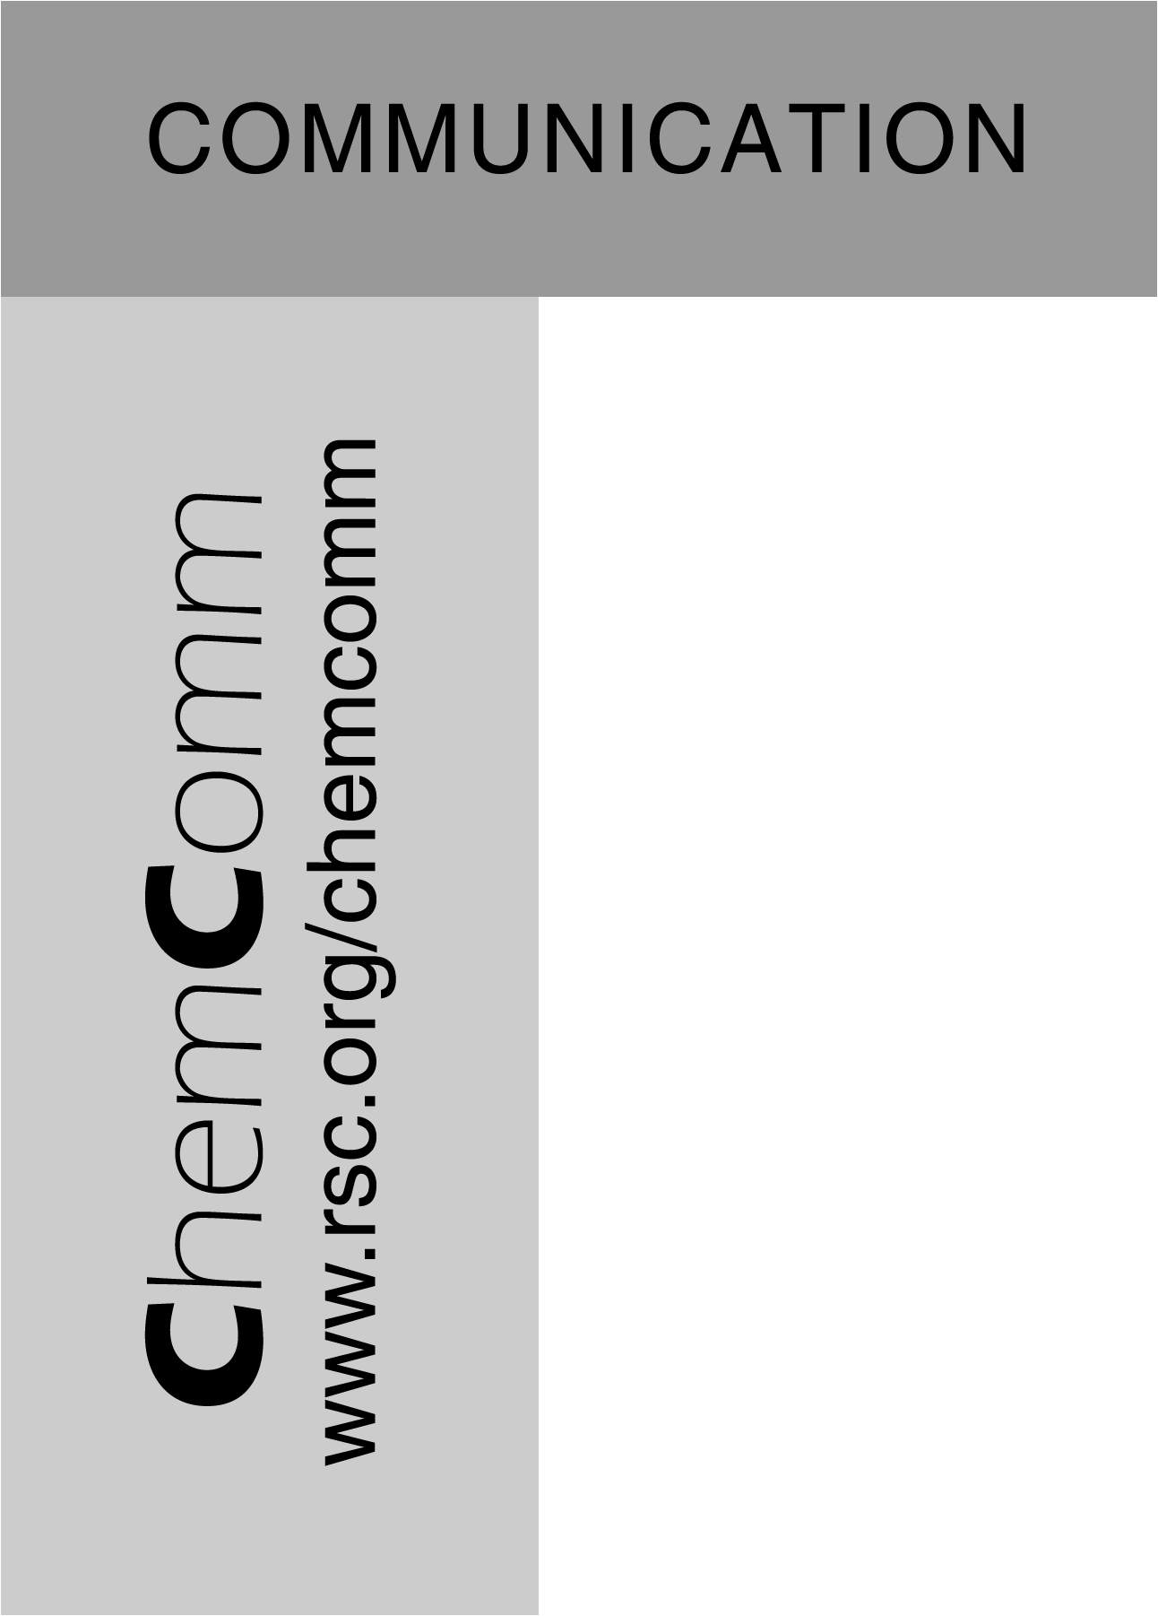
Diastereoselective formation of a dipalladium(I) complex supported by a bridging tetradentate ligand, and oxidative addition of RS–H across a phosphine-bridged Pd^{I}–Pd^{I} bond

S. Jo Ling Foo, Nathan D. Jones, Brian O. Patrick and Brian R. James*
Department of Chemistry, University of British Columbia, Vancouver, Canada V6T 1Z1
Fax: 1-604-822-2847; Tel: 1-604-822-6645; E-mail: brj@chem.ubc.ca

SUPPLEMENTARY DATA

1. Syntheses
rac-Pd₂Cl₂(μ-N,P,P,N-dmapm) (rac-1). To a Schlenk tube containing trans-PdCl₂(PhCN)₂ (32 mg, 0.083 mmol) and dmapm (47 mg, 0.084 mmol) was added CH₂Cl₂ (10 mL), and the resulting yellow solution was stirred at room temperature (r.t., ~20 ºC) for 15 min. Pd₂(dba)₃⋅CHCl₃ (44 mg, 0.043 mmol) was then added and the resulting purple solution was refluxed for 3 h during which it became orange. All but 1 mL of solvent was removed in vacuo, and Et₂O (20 mL) was added to give an orange powder that was collected, washed with Et₂O (3 × 5 mL) and dried under vacuum. Yield: 54 mg (76 %). Anal. Calcd for C₃₃H₄₂N₄Cl₂P₂Pd₂: C, 47.2; H, 5.0; N, 6.7. Found: C, 47.5; H, 5.1; N, 6.6. ¹H NMR (300 MHz, CDCl₃, 300 K) : δ 2.44 (s, 12H, NCH₃), 2.89 (s, 6H, NCH₃), 3.07 (s, 6H, NCH₃), 3.72 (t, 2H, CH₂, ²J_{HP} = 11.3 Hz), 6.99 (pt, 2H, Ar), 7.22 (m, 6H, Ar), 7.45 (m, 4H, Ar), 7.60 (m, 4H, Ar). ³¹P{¹H} NMR (121 MHz, CDCl₃, 300 K): δ −29.9 (s). Crystals of rac-1∙2 CDCl₃ suitable for study by X-ray diffraction were grown by slow evaporation of a CDCl₃ solution.
rac-[Pd₂Cl₂(μ-SR)(μ-N,P,P,N-dmapm)][OTf]
R = Me (2a⁺OTf⁻). To a CH₂Cl₂ solution (5 mL) containing rac-1 (50 mg, 0.059 mmol), excess MeSH (by vacuum transfer) and triflic acid (0.003 mL, 0.059 mmol) were added. The solution was stirred for 24 h at r.t. and filtered through a plug of Celite 545 and MgSO₄. The volume of the yellow filtrate was reduced in vacuo to ~1 mL and Et₂O (20 mL) was added to give the yellow product that was collected, washed with Et₂O (3 x 3 mL) and dried in vacuo. Yield: 24 mg (40 %). Anal. Calcd. for C₃₅H₄₅N₄Cl₂F₃O₃P₂Pd₂S₂: C, 40.6; H, 4.4; N, 5.4. Found: C, 40.8; H, 4.4; N, 5.3 %. ¹H NMR (300 MHz, 300 K, CD₃OD): δ 1.9 (s, 3H, CH₃S), 2.9 (br s, 24 H, NCH₃), 4.0 (t, 2H, ²J_{HP} = 10.4, PCH₂P), 7.6 (m, 4H, Ar), 7.8 (m, 12H, Ar). ³¹P^{{1}H} NMR (121 MHz, CD₃OD, 300 K): δ 50.3 (s). ¹⁹F{¹H} NMR (282 MHz, CD₃OD, 300 K): δ –3.4 (s). Λ_{M} (CH₃CN, 298 K): 116 Ω⁻¹ mol⁻¹ cm². UV-vis (CH₃OH): 372 nm, ε = 5,800 M⁻¹ cm⁻¹.

The triflates of the R = Et (2b⁺), ^{n}Pr (2c⁺), ^{n}Bu (2d⁺), Bz (2e⁺) and Ph (2f⁺) cations were made in exactly the same manner as for the R = Me (2a⁺) compound, but using a 10-fold excess of the appropriate thiol.
R = Et (2b⁺OTf⁻). Yield 68 % of a yellow powder. Anal. Calcd. for C₃₆H₄₇N₄Cl₂F₃O₃P₂Pd₂S₂: C, 41.2; H, 4.5; N, 5.3. Found: C, 40.9; H, 4.5; N, 5.2 %. ¹H NMR (300 MHz, 300 K, CD₃OD): δ 1.1 (t, 3H, ³J_{HH} = 7.3, CH₃CH₂S), 2.6 (q, 2H, ³J_{HH} = 7.3, CH₃CH₂S), 2.9 (br s, 24H, NCH₃), 7.5 (m, 4H, Ar), 7.8 (m, 12H, Ar). ³¹P{¹H} NMR (121 MHz, CD₃OD, 300 K): δ 48.9 (s). ¹⁹F{¹H} NMR (282 MHz, CD₃OD, 300 K) δ –3.5 (s). Λ_{M} (CH₃CN, 298 K): 112 Ω⁻¹ mol⁻¹ cm². UV-vis (CH₃OH): 370 nm, ε = 5,520 M⁻¹ cm⁻¹.
R = ^{n}Pr (2c⁺OTf⁻). Yield 68 % of a pale green powder. Anal. Calcd for C₃₇H₄₉N₄Cl₂F₃O₃P₂Pd₂S₂: C, 41.7; H, 4.6; N, 5.3. Found: C, 41.5; H, 4.6; N, 5.1. ¹H NMR (300 MHz, CD₃OD, 300 K): δ 0.7 (t, 3H, ³J_{HH} = 7.3, CH₃CH₂CH₂S), 1.6 (m, 2H, CH₃CH₂CH₂S), 2.5 (t, 2H, ³J_{HH} = 7.3, CH₃CH₂CH₂S), 2.9 (br s, 24H, NCH₃), 4.0 (t, 2H, ²J_{HP} = 10.1, PCH₂P), 7.5 (m, 4H, Ar), 7.8 (m, 12H, Ar). ³¹P{¹H} NMR (121 MHz, CD₃OD, 300 K): δ 49.2 (s). ¹⁹F{¹H} NMR (282 MHz, CD₃OD, 300 K): δ –3.4 (s). Λ_{M} (CH₃CN, 298 K): 114 Ω⁻¹ mol⁻¹ cm². UV-vis (CH₃OH): 372 nm, ε = 4,870 M⁻¹ cm⁻¹.
R = ^{n}Bu (2d⁺OTf⁻). Yield 68 % of a yellow powder. Anal. Calcd for C₃₈H₅₁N₄Cl₂F₃O₃P₂Pd₂S₂: C, 42.3; H, 4.8; N 5.2. Found: C 42.0, H 5.0, N 5.1. ¹H NMR (300 MHz, CD₃OD, 300 K): δ 0.68 (t, 3H, CH₃CH₂CH₂CH₂S, ²J_{HH} = 7.3), 1.07 (m, 2H, CH₃CH₂CH₂CH₂S), 1.47 (m, 2H, CH₃CH₂CH₂CH₂S), 2.45 (t, 2H, CH₃CH₂CH₂CH₂S), 2.86 (br s, 24 H, NCH₃), 7.89 (t, 4H, Ar, ²J_{HH} = 7.4), 7.77 (m, 12H, Ar). ³¹P{¹H} NMR (121 MHz, CD₃OD, 300 K): δ 48.8 (s). ¹⁹F{¹H} NMR (282 MHz, CD₃OD, 300 K): δ –3.4 (s). Λ_{M} (MeOH, 298 K): 63 Ω⁻¹ mol⁻¹ cm². UV-vis (MeOH, r.t.): 370 nm, ε = 6,010 M⁻¹ cm⁻¹.
R = Bz (2e⁺OTf⁻). Yield 68 % of a yellow powder. Anal. Calcd. For C₄₀H₅₂N₄Cl₂F₃O₃P₂Pd₂S₂: C, 44.3; H, 4.4; N, 5.0. Found: C, 44.5; H, 4.5; N, 5.0. ¹H NMR (300 MHz, CDCl₃, 300 K): δ 1.90 (br s, 12H, NCH₃), 2.90 (s, 2H, SCH₂C₆H₅), 3.44 (br s, 6H, NCH₃), 3.67 (br s, 6H, NCH₃), 4.05 (t, 2H, PCH₂P, ²J_{PH} = 10.0), 6.71 (m, 2H, SCH₂-m-Ph,), 6.86 (m, 2H, SCH₂-o-Ph), 7.01 (t, 1H, SCH₂-p-Ph), 7.40−8.30 (m, 16H, Ar). ³¹P{¹H} NMR (121 MHz, CD₃OD, 300 K): δ 51.4 (s). ¹⁹F{¹H} NMR (282 MHz, CD₃OD, 300 K): δ –3.4 (s).
R = Ph (2f⁺OTf⁻). Yield 50 % of a yellow powder. Anal. Calcd. for C₄₀H₄₇N₄Cl₂F₃O₃Pd₂P₂S₂: C, 43.7; H, 4.3; N, 5.1. Found: C, 43.5; H, 4.4; N, 5.2. ¹H NMR (300 MHz, 300 K, CD₃OD): δ 2.0 (br s, 12H, NCH₃), 3.5 (br s, 12H, NCH₃), 4.0 (t, PCH₂P, ²J_{HP} =10.3), 6.7 (m, 2H, m-C₆H₅S), 6.9 (m, 2H, o-C₆H₅S), 7.0 (m, 1H, p-C₆H₅S), 7.3−8.4 (br, 16H, Ar). ³¹P^{{1}H} NMR (121 MHz, CD₃OD, 300 K): δ 51.4 (s). ¹⁹F{¹H} NMR (282 MHz, CD₃OD, 300 K): δ –3.4 (s). Λ_{M} (CH₃CN, 298 K): 116 Ω⁻¹ mol⁻¹ cm². UV-vis (CH₃OH): 388 nm, ε = 6,800 M⁻¹ cm⁻¹.
rac-[Pd₂Cl₂(μ-SR)(μ-N,P,P,N-dmapm)][Cl]
R = Et (2b⁺Cl⁻). This compound was made in the same manner as 2b⁺OTf⁻ except that triflic acid was not added. Yield 33 % of a yellow powder. Anal. Calcd. For C₃₅H₄₇N₄Cl₃P₂Pd₂S: C, 44.9; H, 5.1; N, 6.0. Found: C, 45.2; H, 5.1; N, 5.9. ¹H NMR (300 MHz, CDCl₃, 300 K): δ 1.14 (s, 3H, CH₃CH₂S), 2.66 (s, 2H, CH₃CH₂S), 2.89 (br s, 24 H, NCH₃), 4.76 (t, 2H, PCH₂P, ²J_{PH} = 10.8). 7.65 to 8.04 (m, 16H, Ar). ³¹P{¹H} NMR (121 MHz, CDCl₃, 300 K): δ 49.0 (s). Λ_{M} (CH₃CN, 298 K): 136 Ω⁻¹ mol⁻¹ cm².
R = ^{n}Pr (2c⁺Cl⁻). This compound was made in the same manner as 2c⁺OTf⁻ except that triflic acid was not added. Yield 79% of a yellow powder. Anal. Calcd. for C₃₆H₄₉N₄Cl₃P₂Pd₂S: C, 45.5; H, 5.2; N, 5.9. Found: C, 45.3; H, 5.4; N, 5.4. ¹H NMR (300 MHz, CDCl₃, 300 K): δ 0.7 (t, 3H, CH₃CH₂CH₂S, ³J_{HH} = 7.3), 1.6 (m, 2H, CH₃CH₂CH₂S), 2.7 (t, 2H, CH₃CH₂CH₂S), 3.0 (br s, 12 H, NCH₃), 4.7 (t, 2H PCH₂P), 7.4−8.1 (br m, 16 H, Ar). ³¹P{¹H} NMR (121 MHz, CDCl₃, 300 K): δ 49.3 (s). Λ_{M} (CH₃CN): 98 Ω⁻¹ mol⁻¹ cm². Crystals of 2c⁺Cl⁻∙H₂O suitable for X-ray analysis were isolated from a CH₂Cl₂ solution of the complex layered with Et₂O.

2. Crystallographic data
Table 1. Selected bond distances (Å) and angles (º) for 1·2 CDCl₃
Pd(1)—Pd(2) | 2.527(1) | Pd(1)—Cl(1) | 2.384(4)
Pd(1)—P(1) | 2.153(4) | Pd(1)—N(1) | 2.23(1)
Pd(2)—Cl(2) | 2.364(3) | Pd(2)—Cl(2) | 2.184(3)
Pd(2)—N(3) | 2.26(1) | P(1)—Pd(1)—N(1) | 85.8(3)
N(1)—Pd(1)—Pd(2) | 164.4(3) | P(2)—Pd(2)—N(3) | 86.3(3)
N(3)—Pd(2)—Pd(1) | 165.5(3) | P(1)—Pd(1)—Pd(2) | 78.7(1)
P(2)—Pd(2)—Pd(1) | 86.99(9) | Cl(1)—Pd(1)—Pd(2) | 98.86(9)
Cl(2)—Pd(2)—Pd(1) | 92.12(9) | P(1)—C(17)—P(2) | 102.9(6)

Table 2. Selected bond distances (Å) and angles (º) for 2c⁺Cl⁻∙H₂O.
Pd(1)−S(1) | 2.3030(10) | Pd(2)−S(1) | 2.3150(10)
Pd(1)−P(1) | 2.1925(8) | Pd(2)−P(2) | 2.2011(7)
Pd(1)−Cl(1) | 2.3545(8) | Pd(2)−Cl(2) | 2.3840(7)
Pd(1)−N(1) | 2.161(2) | Pd(2)−N(3) | 2.154(3)
S(1)−C(34) | 1.830(4) | P(1)−C(17) | 1.835(3)
P(2)−C(17) | 1.840(3)
Pd(1)−S(1)−Pd(2) | 118.76(5) | P(1)−C(17)−P(2) | 112.89(14)
P(1)−Pd(1)−N(1) | 85.16(7) | P(2)−Pd(2)−N(3) | 85.57(7)
P(1)−Pd(1)−S(1) | 86.45(3) | P(2)−Pd(2)−S(1) | 94.57(4)
P(1)−Pd(1)−Cl(1) | 174.86(3) | P(2)−Pd(2)−Cl(2) | 176.73(3)
N(3)−Pd(2)−S(1) | 176.67(8) | N(1)−Pd(2)−S(1) | 164.86(8)

