Supplementary data
A Novel Left-handed Double Helicate Constructed from Tartaric Acid Bridged Molybdenum(VI) and Gadolinium(III) Atoms

Chuan-De Wu, Can-Zhong Lu,* Xiang Lin, Ding-Ming Wu, Shao-Fang Lu, Hong-Hui Zhuang and Jin-Shun Huang

The State Key Laboratory of Structural Chemistry, Fujian Institute of Research on the Structure of Matter, the Chinese Academy of Sciences, Fuzhou, Fujian 350002, P. R. China (E-mail: czlu@ms.fjirsm.ac.cn)

Table S1. Crystal data and structure refinement for [NH₄][Mo₂O₄Gd(H₂O)₆(L-C₄H₂O₆)₂]·4H₂O (1)
 | 1
Formula | C₈H₂₈GdMo₂NO₂₆
Formula weight | 903.44
Crystal size (mm³) | 0.20 × 0.12 × 0.06
Crystal color | Colorless
Crystal system | Hexagonal
Space group | P6₅22
Unit cell dimensions | a = 15.298(1) Å
 | c = 18.661(1) Å
Volume (Å³) | 3782.2(1)
Z | 6
Calculated density (g·cm⁻³) | 2.380
F(000) | 2634
Temperature (K) | 293(2)
Wavelength (Å) | 0.71073
Absorption coefficient (mm⁻¹) | 3.692
θ for data collection (º) | 2.66 to 25.09
Limiting indices | -18≤h≤18, -18≤k≤18, -9≤l≤22
Reflections collected | 11499
Unique reflections (R(int)) | 2253 [R(int) = 0.0382]
Refinement method | Full-matrix least-squares on F²
Absorption correction | SADABS
Data / restraints / parameters | 2253 / 0 / 187
Goodness-of-fit on F² | 1.087
Final R indices [I > 2σ(I)] | R1 = 0.0257, wR2 = 0.0597
R indices (all data) | R1 = 0.0333, wR2 = 0.0629
Largest diff. peak and hole (e·Å³) | 0.513 and -0.409
R1 = ∑(|F_{o}| − |F_{c}|) / ∑|F_{o}|, wR2 = [∑w(F_{o}² − F_{c}²)² / ∑w(F_{o}²)²]^{0.5}.

Table S2. Atomic coordinates (x 10⁴) and equivalent isotropic displacement parameters (Å²x 10³) for 1.
Atom x y z U(eq) | Atom x y z U(eq)
Gd 2724(1) -4552(1) 2500 25(1)  Mo 1268(1) -7204(1) -214(1) 30(1)  O(1) 1708(3) -6062(4) 655(2) 36(1)  O(2) 2967(3) -5036(3) 1360(2) 36(1)  O(3) 2707(3) -6675(3) -73(2) 31(1)  O(4) 2979(3) -7123(3) 1385(2) 34(1)  O(5) 5035(3) -6212(4) 174(2) 43(1)  O(6) 4194(3) -7599(3) 827(2) 37(1)  O(7) 709(4) -8157(4) 393(2) 46(1)  O(8) 1242(4) -7803(4) -985(2) 50(1)  O(9) 4453(4) -3955(5) 2752(3) 70(2) | O(10) 2916(6) -5982(5) 2675(3) 87(2)  O(11) 3655(5) -3086(4) 1735(3) 79(2)  O(101) 5625(7) -5028(7) -998(4) 114(3)  O(102) 7160(20) -1422(10) 4167 147(11)  O(103) 6280(13) -2984(14) 3773(7) 113(6)  O(104) 329(11) -9836(6) -833 250(20)  N(1) 2197(5) -7803(5) 3333 51(2)  C(1) 2599(5) -5661(4) 850(3) 29(1)  C(2) 3272(5) -5945(5) 452(3) 26(1)  C(3) 3745(5) -6353(5) 979(3) 28(1)  C(4) 4381(5) 6748(6) 618(3) 35(2)

Table S3. Selected bond lengths [Å] for 1.
Bond distances | Bond distances | Bond distances
Gd-O(2) 2.343(4)  Gd-O(2)#1 2.343(4)  Gd-O(10) 2.372(5)  Gd-O(10)#1 2.372(5)  Gd-O(9) 2.374(5)  Gd-O(9)#1 2.374(5)  Gd-O(11)#1 2.430(5)  Gd-O(11) 2.430(5) | Mo-O(8) 1.695(4)  Mo-O(7) 1.701(4)  Mo-O(4)#2 1.944(4)  Mo-O(3) 1.946(4)  Mo-O(6)#2 2.205(4)  Mo-O(1) 2.227(4)  O(1)-C(1) 1.238(7)  O(2)-C(1) 1.264(7) | O(3)-C(2) 1.410(7)  O(4)-C(3) 1.397(7)  O(5)-C(4) 1.241(7)  O(6)-C(4) 1.247(8)  C(1)-C(2) 1.499(8)  C(2)-C(3) 1.527(8)  C(3)-C(4) 1.535(9)

Table S4. Selected angles [º] for 1
Atom1-atom2-atom3 angles | Atom1-atom2-atom3 angles | Atom1-atom2-atom3 angles
O(2)-Gd-O(2)#1 148.2(2)  O(2)-Gd-O(10) 73.80(17)  O(2)#1-Gd-O(10) 80.88(17)  O(2)-Gd-O(10)#1 80.88(17)  O(2)#1-Gd-O(10)#1 73.80(17)  O(10)-Gd-O(10)#1 73.9(4)  O(2)-Gd-O(9) 88.82(17)  O(2)#1-Gd-O(9) 101.70(16)  O(10)-Gd-O(9) 72.5(3)  O(10)#1-Gd-O(9) 146.4(2)  O(2)-Gd-O(9)#1 101.70(16)  O(2)#1-Gd-O(9)#1 88.82(17)  O(10)-Gd-O(9)#1 146.4(2)  O(10)#1-Gd-O(9)#1 72.5(3)  O(9)-Gd-O(9)#1 141.1(3)  O(2)-Gd-O(11)#1 142.39(16)  O(2)#1-Gd-O(11)#1 69.25(16)  O(10)-Gd-O(11)#1 129.1(2)  O(10)#1-Gd-O(11)#1 130.30(19)  O(9)-Gd-O(11)#1 74.5(2) | O(9)#1-Gd-O(11)#1 74.7(2)  O(2)-Gd-O(11) 69.25(16)  O(2)#1-Gd-O(11) 142.4(2)  O(10)-Gd-O(11) 130.3(2)  O(10)#1-Gd-O(11) 129.1(2)  O(9)-Gd-O(11) 74.7(2)  O(9)#1-Gd-O(11) 74.5(2)  O(11)#1-Gd-O(11) 73.9(3)  O(8)-Mo-O(7) 103.7(2)  O(8)-Mo-O(4)#2 104.3(2)  O(7)-Mo-O(4)#2 93.5(2)  O(8)-Mo-O(3) 93.2(2)  O(7)-Mo-O(3) 104.3(2)  O(4)#2-Mo-O(3) 151.3(2)  O(8)-Mo-O(6)#2 88.5(2)  O(7)-Mo-O(6)#2 165.2(2)  O(4)#2-Mo-O(6)#2 74.96(16)  O(3)-Mo-O(6)#2 83.14(16)  O(8)-Mo-O(1) 163.4(2)  O(7)-Mo-O(1) 90.7(2) | O(4)#2-Mo-O(1) 82.68(16)  O(3)-Mo-O(1) 74.93(15)  O(6)#2-Mo-O(1) 78.69(16)  C(1)-O(1)-Mo 115.4(4)  C(1)-O(2)-Gd 147.3(4)  C(2)-O(3)-Mo 122.8(3)  C(3)-O(4)-Mo#3 123.1(4)  C(4)-O(6)-Mo#3 116.4(4)  O(1)-C(1)-O(2) 124.0(6)  O(1)-C(1)-C(2) 117.2(5)  O(2)-C(1)-C(2) 118.8(6)  O(3)-C(2)-C(1) 109.6(5)  O(3)-C(2)-C(3) 110.7(5)  C(1)-C(2)-C(3) 109.5(5)  O(4)-C(3)-C(2) 109.0(5)  O(4)-C(3)-C(4) 109.6(5)  C(2)-C(3)-C(4) 113.6(5)  O(5)-C(4)-O(6) 126.0(6)  O(5)-C(4)-C(3) 119.5(6)  O(6)-C(4)-C(3) 114.4(6)
Symmetry transformations used to generate equivalent atoms: #1: -x+y+1, y,-z+1/2; #2: x-y-1, x-1, z-1/6; #3: y+1, -x+y, z+1/6

Table S5. Anisotropic displacement parameters (Å² x 10³) for 1.
_______________________________________________________________________
U11 U22 U33 U23 U13 U12
_______________________________________________________________________
Gd 27(1) 24(1) 25(1) 0 4(1) 12(1)
Mo 31(1) 33(1) 25(1) -1(1) -3(1) 15(1)
O(1) 36(3) 49(3) 29(2) -9(2) -3(2) 26(2)
O(2) 45(3) 32(3) 31(2) -5(2) 0(2) 20(2)
O(3) 32(2) 46(3) 22(2) -10(2) -9(2) 25(2)
O(4) 41(3) 41(3) 27(2) 14(2) 8(2) 26(2)
O(5) 35(3) 60(3) 40(3) 14(2) 12(2) 28(3)
O(6) 45(3) 41(3) 38(2) 12(2) 8(2) 32(2)
O(7) 50(3) 42(3) 44(3) 16(2) 3(2) 20(3)
O(8) 49(3) 57(3) 37(3) -16(2) -8(2) 21(3)
O(9) 39(3) 102(5) 57(3) 12(3) 0(3) 27(3)
O(10) 140(6) 96(5) 77(4) 53(4) 70(4) 98(5)
O(11) 115(5) 43(3) 94(4) 31(3) 77(4) 50(4)
O(101) 172(9) 135(7) 80(5) 10(5) 9(5) 109(7)
O(102) 150(20) 240(20) 19(7) 27(12) 0 77(11)
O(103) 135(15) 139(15) 62(8) 55(9) 2(8) 66(12)
O(104) 25(9) 10(6) 710(70) 39(18) 0 12(5)
N(1) 43(4) 43(4) 59(5) -14(2) 14(2) 16(4)
C(1) 39(4) 31(4) 22(3) 2(3) -2(3) 22(3)
C(2) 29(3) 28(3) 24(3) 4(3) 1(3) 17(3)
C(3) 31(4) 34(4) 22(3) 1(2) -4(2) 19(3)
C(4) 32(4) 51(5) 29(3) 4(3) -6(3) 26(3)
_______________________________________________________________________

Table S6. Selected Hydrogen Bonds Lengths (Å) for 1
D d(D..A) A | D d(D..A) A
O9 2.932 O6^{i}  O9 2.772 O101^{ii}  O9 3.094 O101^{iii}  O9 3.081 O103  O10 2.995 O101^{iii}  O10 3.003 O4  O10 2.723 N1  O11 2.725 O5^{iv}  O101 2.994 O101^{v} | O101 2.950 O103^{vi}  O101 3.064 O9^{iii}  O101 2.694 O5  O102 2.930 O8^{vii}  O103 2.852 O3^{ii}  O103 2.175 O103^{viii}  O104 3.140 O104^{ix}  N1 2.720 O10^{viii}  N1 2.772 O7^{x}
Symmetry transformations used to generate equivalent atoms: i: -x+1, -x+y+1, -z+1/3; ii: -x+1, -y-1, z+1/2; iii: -y, -x, -z+1/6; iv: y+1, -x+y+1, z+1/6; v: y+1, x-1, -z-1/3; vi: -x+1, -y-1, z-1/2; vii: -y, x-y-1, z+2/3; viii: y+1, x-1, -z+2/3; ix: x-y-1, x-1, z-1/6; x: -x+y+1, y, -z+1/2
Figures:

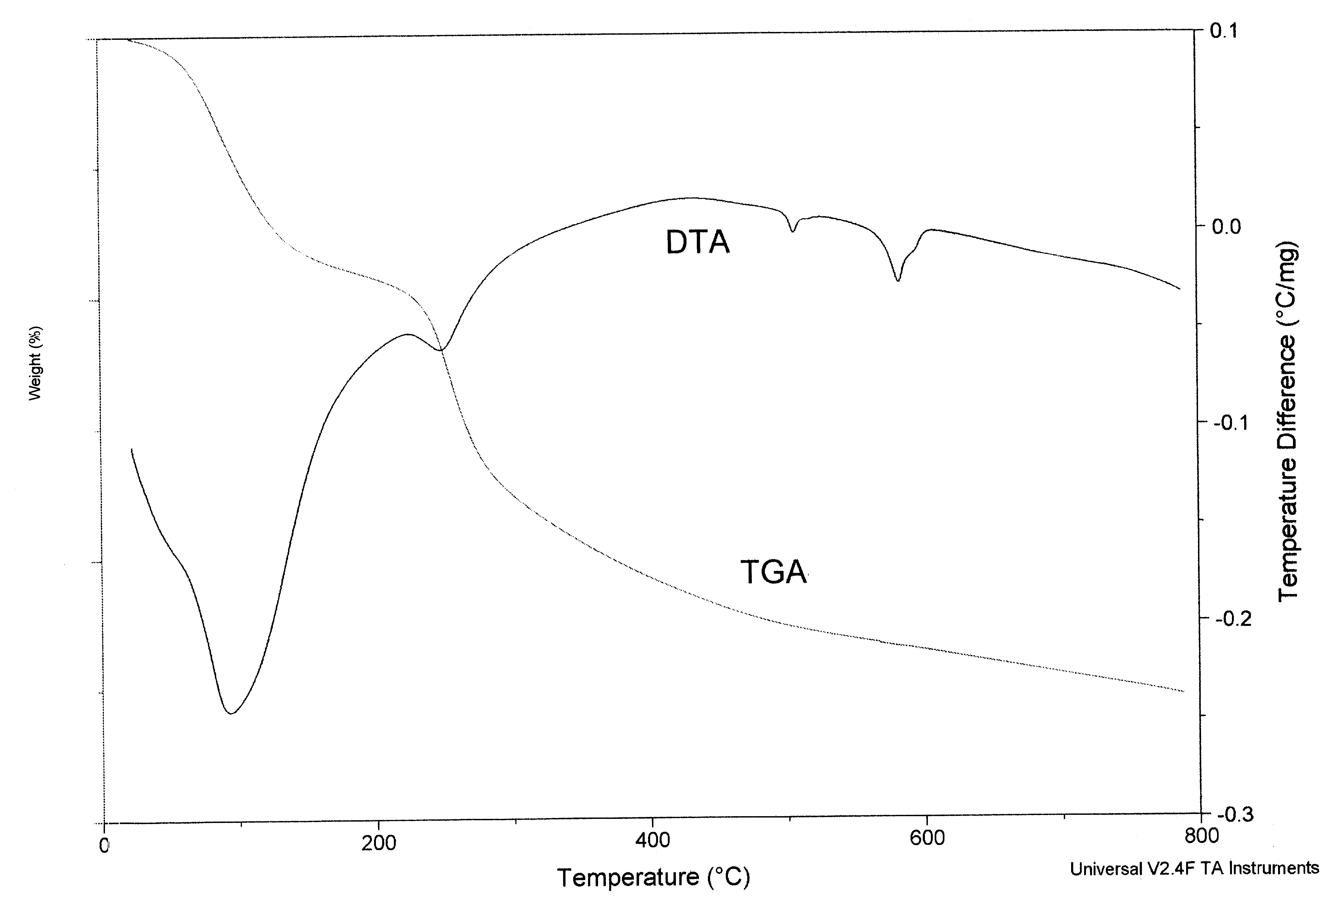
Figure S1. Thermogravimetric analyses (TGA) for 1 between 30 and 800ºC

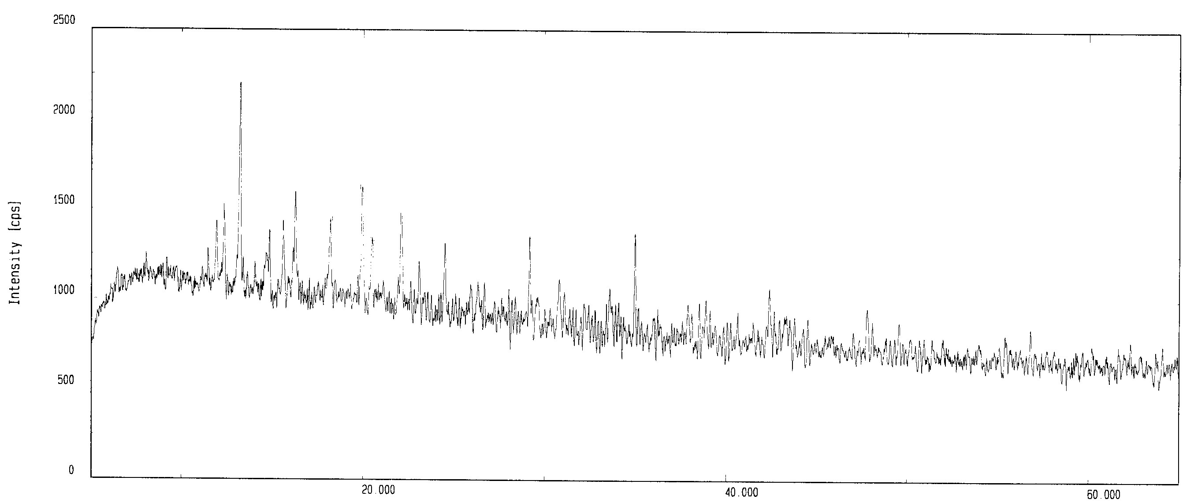

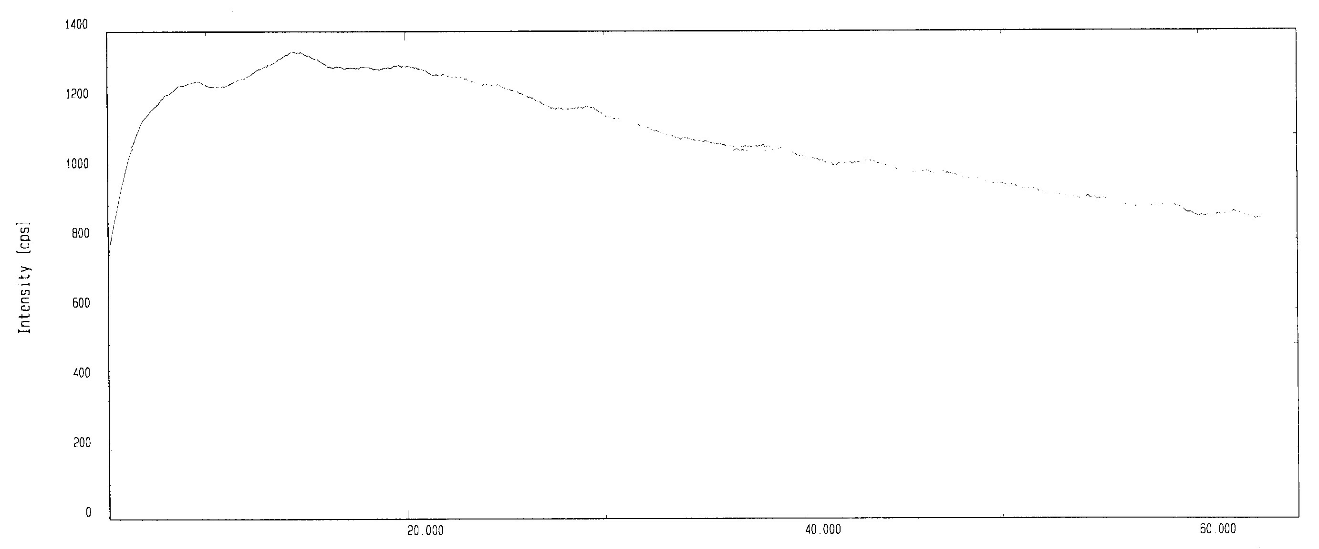

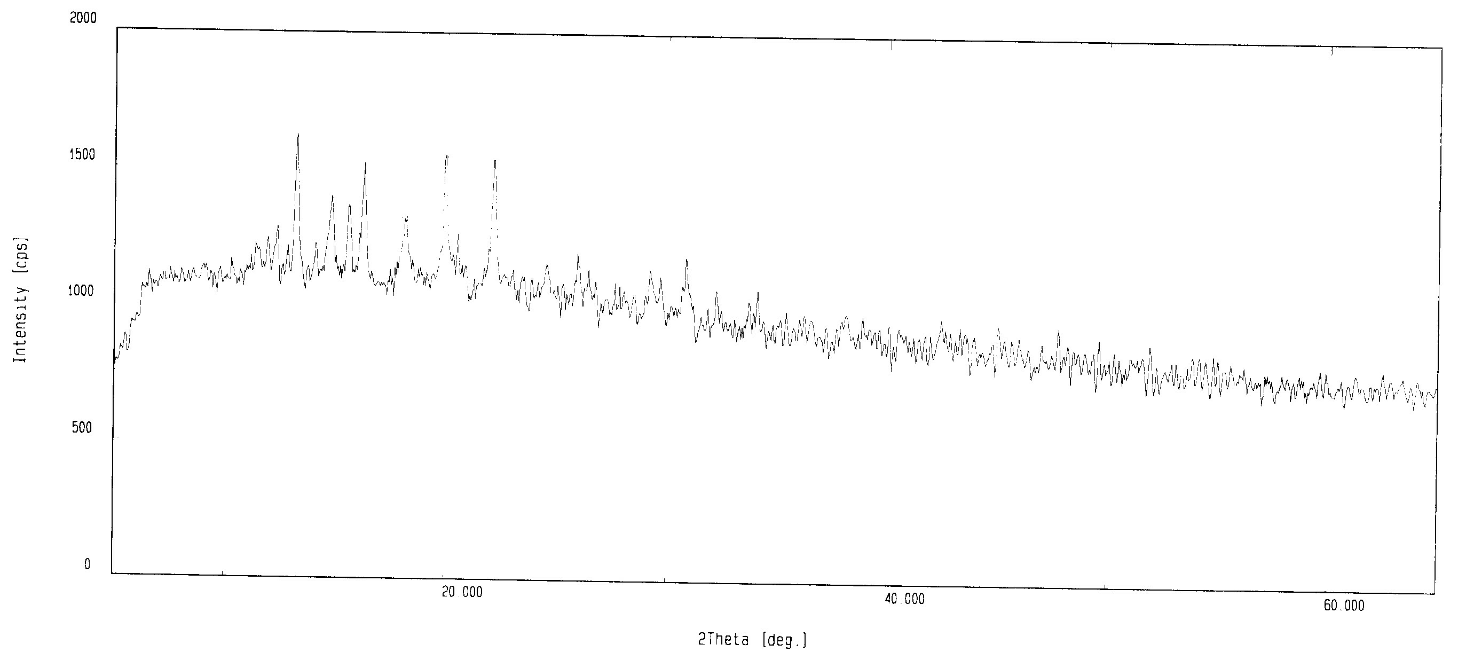
Figure S2. Powder X-ray diffraction patterns for before (top), after (middle) the removal of the water molecules and aqua ligands as well as after the solids of the evacuated samples were immersed in water (bottom) for 1.

Figure S3. ORTEP representation of the symmetry expanded local structure for 1 (30% probability ellipsoids).

Figure S4. The χ_{M}T and χ_{M} vs. T plots for 1.

