Supplementary data

Poly (9,9’-spirobifluorene-manganese porphyrin): a new catalytic material for oxidation of alkenes by iodosylbenzene and iodobenzene diacetate

Cyril Porielª, Yann Ferrandª, Paul Le Mauxª, Joëlle Rault-Berthelot^{b*} and Gérard Simonneauxª*
^{l}Laboratoire de Chimie Organométallique et Biologique, UMR CNRS 6509 and ^{b}Laboratoire de Synthèse et électrosynthèse organiques, UMR CNRS 6510, Université de Rennes 1, 35042 Rennes cedex, France.

General Experiments: All reactions were performed under argon and were magnetically stirred. Solvents were distilled from appropriate drying agent prior to use: Et₂O and THF from sodium and benzophenone, toluene from sodium, CH₂Cl₂ from CaH_{2,} CHCl₃ from P₂O₅ and all other solvents were HPLC grade. Commercially available reagents were used without further purification unless otherwise stated. All reactions were monitored by TLC with Merck pre-coated aluminium foil sheets (Silica gel 60 with fluorescent indicator UV₂₅₄). Compounds were visualized with UV light at 254 nm and 365 nm. Column chromatography was carried out using silica gel from Merck (0.063-0.200 mm). ¹H NMR and ¹³C NMR in CDCl₃ and Toluene d8 were recorded using Bruker (Advance 500dpx and 300dpx spectrometers) at 500 MHz and 75 MHz respectively. High-resolution mass spectra were recorded on a ZabSpec TOF Micromass spectrometer in FAB mode or ESI positif mode at the CRMPO.
All electrochemical experiments were performed using a Pt disk electrode (diameter 1mm), the counter electrode was a vitreous carbon rod and the reference electrode was a silver wire in a 0.1M AgNO₃ solution in CH₃CN. Ferrocene was added to the electrolyte solution at the end of a series of experiments. The ferrocene/ferrocenium (Fc/Fc⁺) couple served as internal standard and all reported potentials are referenced to its reversible formal potential. Activated Al₂O₃ was added in the electrolytic solution to remove excess moisture. The three electrodes cell was connected to a PAR Model 173 potentiostat monitored with a PAR Model 175 signal generator and a PAR Model 179 signal coulometer. The cyclic voltammetry traces (CVs) were recorded on an XY SEFRAM-type TGM 164.
Acetonitrile with less than 5‰ of water (ref.SDS00610S21) and dichloromethane with less than 100 ppm of water (ref. SDS 02910E21) were used without purification. Tetrabutylammonium hexafluorophosphate from FLUKA was used without any purification. Aluminium oxide was obtained from Woëlm, activated by heating at 300°C under vacuum for 12h and used at once under argon pressure.
Liquid UV-visible spectra were recorded on a UVIKON XL from Biotech. Solid UV-visible spectra were recorded using a Guided Wave model 150 spectrophotometer with optical fibres; a concave platinum surface acts as a reflector for the optical beam.
Melting points were measured on a system KOFLER type WME HEIZBANK.

All catalytic reactions were controlled on a Varian CP-3380 Gas Chromatograph equipped with a CP-Chirasil-Dex Column.
Scanning Electron Microscopy was performed on JEOL JSM 301F.
Electronic Microanalysis were performed on JEOL JSM 6400 using an Energy Dispersive spectrometry (EDS) detector Oxford-Link Isis.

9,9'-spirobi[fluorene]-2-carbaldehyde

To a solution of 9,9’-spirobifluorene (12.7 mmol) in 100 mL of distilled and degassed dichloromethane, cooled at 0°C, is added α,α-dichloro-methyl-methylether (31,6 mmol) in one portion. After five minutes titanium tetrachloride (31.6 mmol in 50 mL dichloromethane) is added drop wise over a period of 45 minutes. The dark green solution is then stirred at room temperature for 75 minutes and 250 g of ice is then added and let under vigorous stir for 30 minutes.
The two layers are then separated and the aqueous layer is extracted two times with 100 mL of dichloromethane. The organic layers are then washed with a saturated solution of sodium bicarbonate, sodium chloride, water and dried on magnesium sulphate. The solvents are removed under vacuum and the crude product is chromatographied on silica gel (CHCl₃/Pentane: 6/4).

Yield: 70 %

UV-VIS (CH₂Cl₂): λ max/nm (log ε): 328 (4.08), 303 (4.38), 292 (4.32), 282 (4.31), 225 (4.59).
Mass (FAB) (m/z): calculated for C₂₆H₁₆ O (M^{.+}): 344,1201 found: 344,1199

¹ H NMR (500Mhz, CDCl₃): δ 6.74 (H_{1’}, ddd, 2H), 6.82 (H₈, ddd, 1H), 7.14 (H_{2’}, td, 2H), 7.22 (H₇, td, 1H), 7.30 (H₁, sdd, 1H), 7.43 (H₃’, td, 2H), 7.47 (H₆, td, 1H), 7.91 (H_{4’}, ddd, 2H), 7.94 (H₃, dd, 1H), 7.96 (H₅, ddd, 1H), 8.04 (H₄, dd, 1H), 9.84 (CHO, s, 1H).

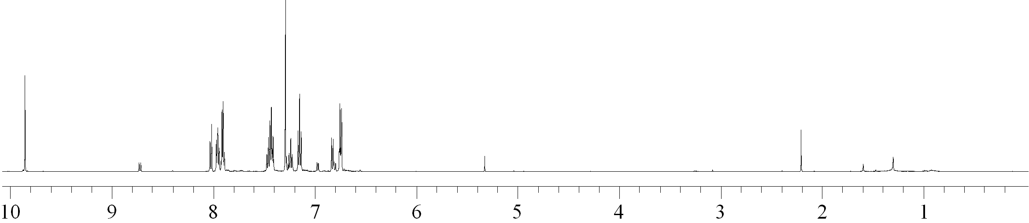

¹³C NMR (75Mhz, CDCl₃): δ 65,6 (C₉); 120,2; 120,3; 121,1; 123,8; 124,3; 124,5; 125,2; 127,9; 128; 129,5; 130,2; 135,9; 140,1; 141,8; 147,4; 147,8; 149,7; 150 (aromatic C); 191,6 (C=O)

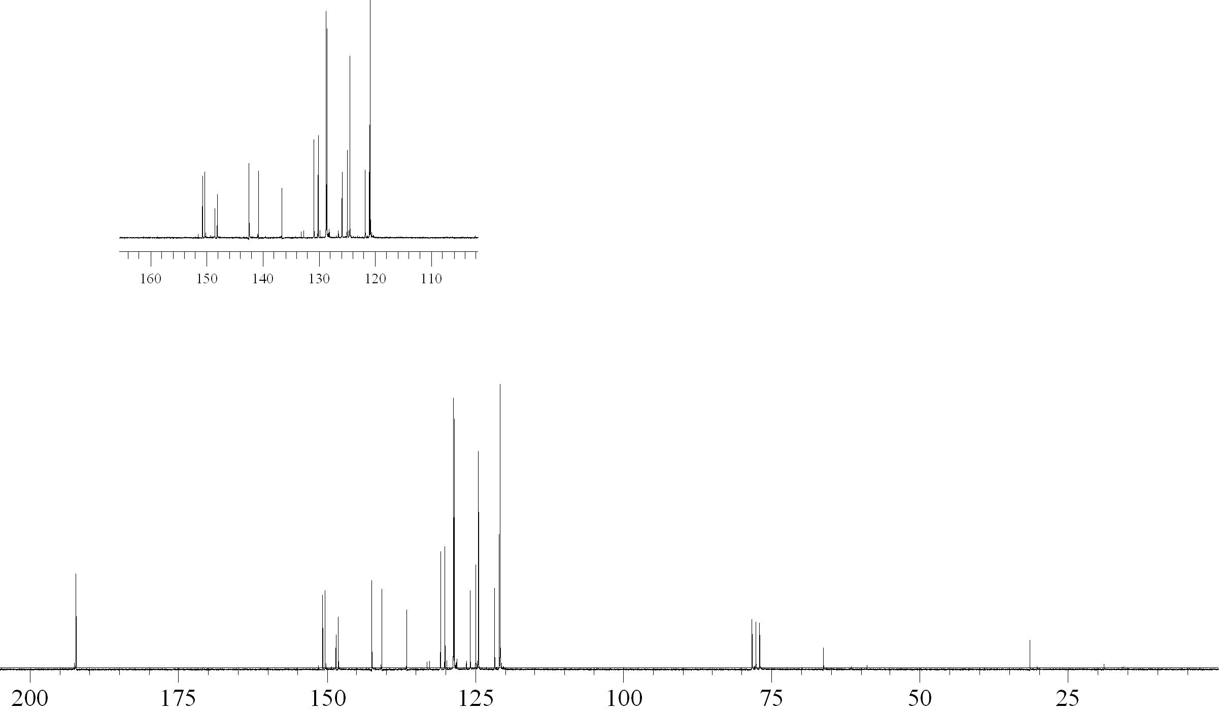

Mp : 209°C
CV (CH₂Cl₂ 0.2M/ Bu₄NPF₆, Fc/Fc⁺) : 1.34, 1.66.
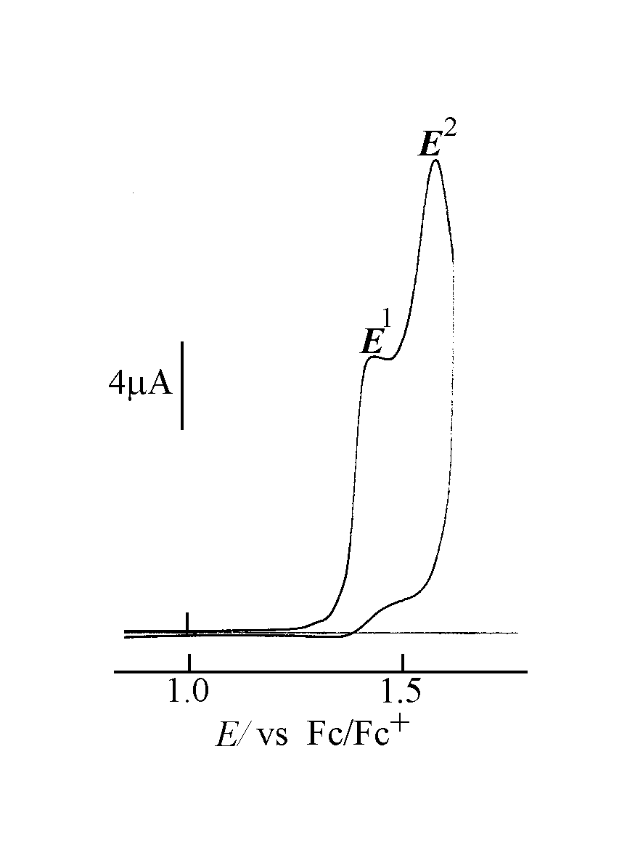

Pyrrole (7.5 mmol) and 9,9'-spirobi[fluorene]-2-carbaldehyde (7.5 mmol) are allowed to react at room temperature in dry and degassed dichloromethane (750 mL) under an argon atmosphere and protected from light with trace acid catalysis (BF₃(OEt)₂ 48%: 0.75 mmol). Under these conditions the reaction reaches equilibrium in about 3 hours. A stoichiometric amount of p-chloranil is added to irreversibly oxidize the tetra-spiroporphyrinogene. After addition of several drops of triethylamine and the ordinary work-up, concentration, washing, drying, the crude reaction mixture is chromatographied twice on silica gel (first: dichloromethane; second: cyclohexane/ dichloromethane: 1/3) to afford a purple powder of meso-Tetrakis 5,10,15,20-(spirobifluoren-2-yl) porphyrin.
Yield : 40 %
UV-VIS (CH₂Cl₂): λ max/nm (log ε ): 652 (3.44), 594 (3.42), 556 (3.84), 520 (3.98), 427 (5.39), 342 (4.07) 309 (4.53), 297 (4.50), 228 (5.21).

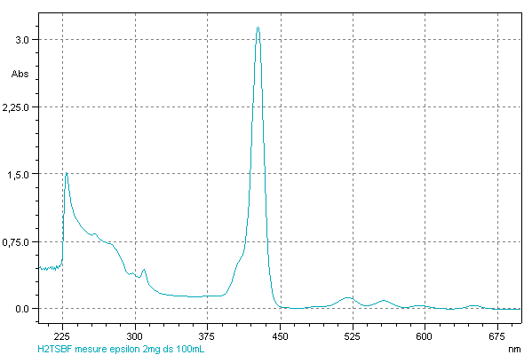

Mass (FAB) (m/z): calculated for C₁₂₀ H₇₁ N₄ (M+H)⁺: 1567.5634 found: 1567.5600

¹H NMR (500MHz, CDCl₃): δ 8.57 (H β  pyrrole, s, 4H), 8.55 (H β  pyrrole, s, 4H), 8.15-8.07 (m, 12H), 7.75-7.69 (m, 8H), 7.53- 7.42 (m, 8H), 7.34-7.32 (m, 9H), 7.27-7.18 (m, 11H), 7.09-7.05 (m, 8H), 6.88 (d, 4H), -3.13 (s, 2H, NH).

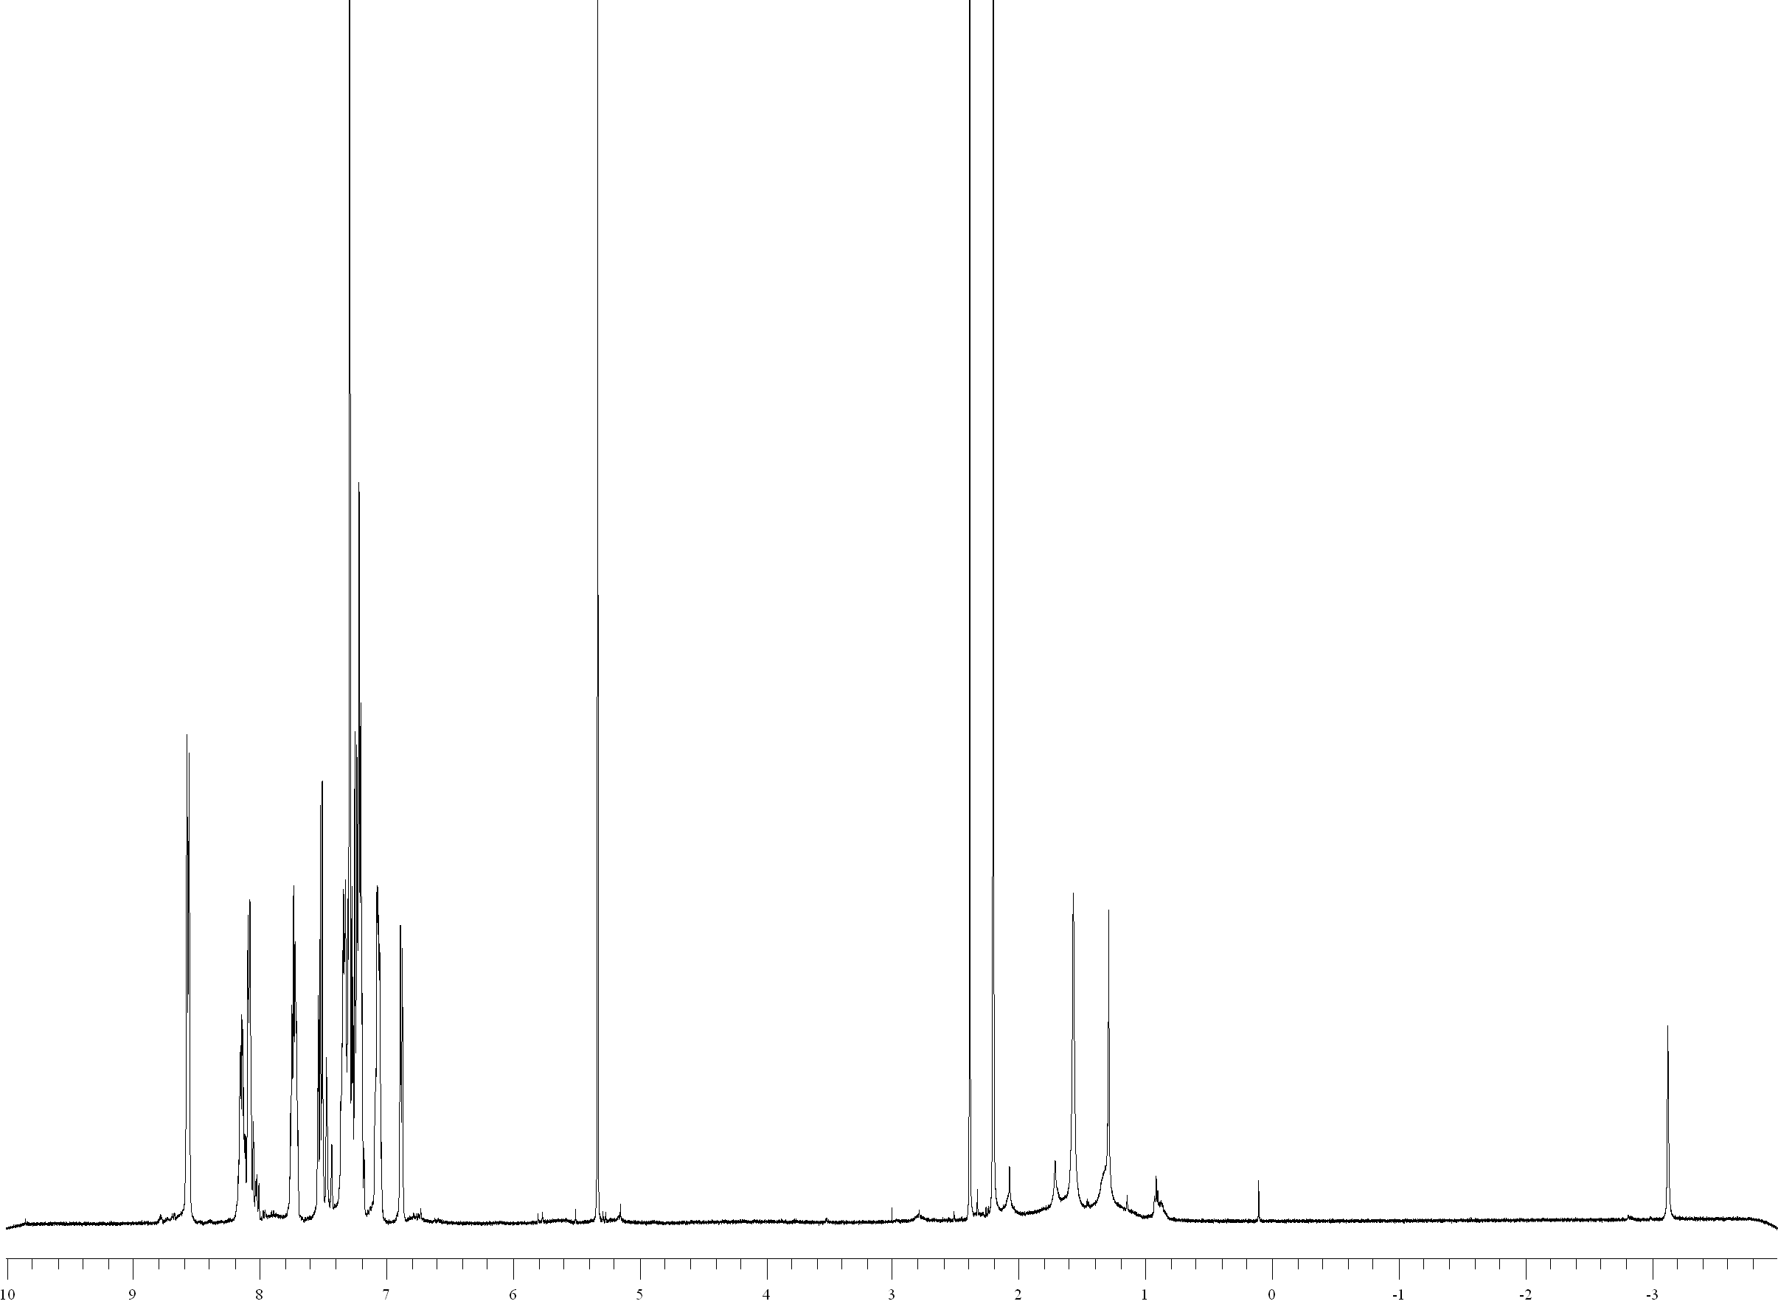
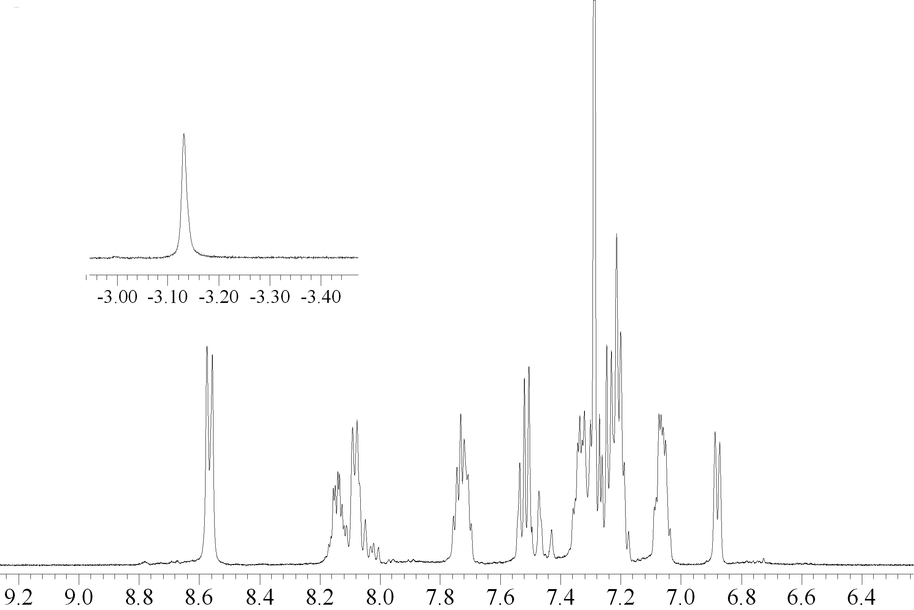

CV (CH₂Cl₂ 0.2M/ Bu₄NPF₆, Fc/Fc⁺): 0.585, 0.915, 1.395 (shoulder), 1.505

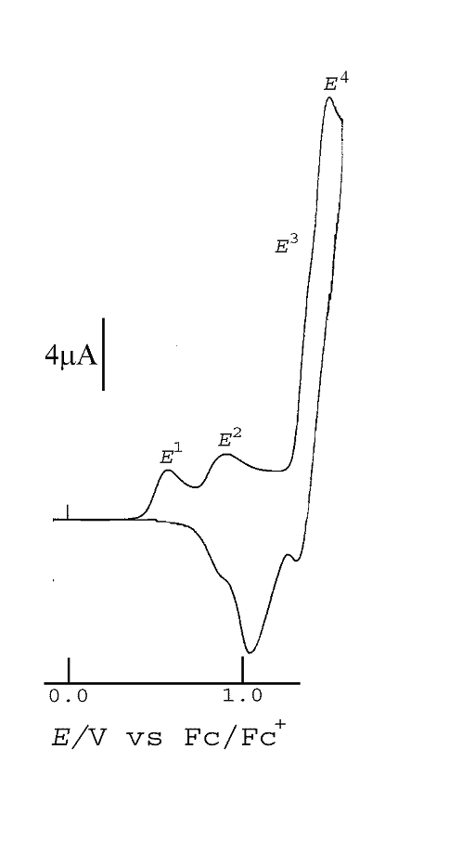

To a solution of (TSP)H₂ (191 mmol) dissolved in distilled and degassed chloroform is added several drops of 2,6 lutidine, anhydrous MnCl₂ (2.68 mol) and dry methanol. The mixture is stirred under an argon atmosphere for 34 hours until the reaction is completed. The solvent is removed under vacuum, one drop of concentrated hydrochloric acid is added and the crude product is chromatographied on silica gel using a mixture of pentane/dichloromethane (1/1), dichloromethane and dichloromethane/methanol (7/1). The major green band is collected and dried under vacuum to afford a green powder of meso-Tetrakis 5,10,15,20(spirobifluoren-2-yl) porphyrinato Manganese chloride.

Yield: 85 %
UV-VIS (CH₂Cl₂): λ max/nm (log ε): 625 (4.11), 587 (3.92), 481 (5.04), 407 (4.67), 382 (4.67), 336 (4.63), 309 (4.79), 297 (4.74), 228 (5.21).

Mass (ESI, CH₂Cl₂/MeOH 9/1) (m/z): calculated for C₁₂₀ H₆₈ N₄ Mn (M-Cl)⁺: 1620.4858 found: 1620.4874

CV (CH₂Cl₂ 0.2M/ Bu₄NPF₆, Fc/Fc⁺): 0.66, 1.18, 1.33
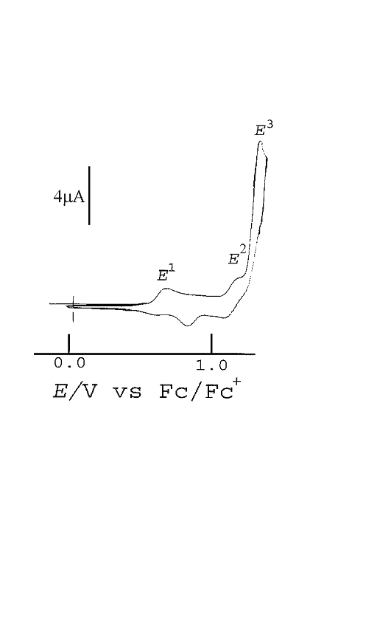

Catalytic procedure:

Two different catalytic conditions were used depending on the nature of the oxidant: iodobenzene diacetate (condition A) or iodosylbenzene (condition B). These different catalytic conditions are described below and also in the experimental part.

Condition A: Using an excess of alkene (10 equivalents versus iodobenzenediacetate): addition of iodobenzenediacetate (100 equivalents relative to catalyst) and 10 μL of water to a mixture of (P)MnCl/imidazole/alkene (1/10/1000) in dichloromethane/acetonitrile (2:1) under anaerobic conditions. Time reaction is 90 minutes for both poly (1) and 1.

Conditions B: Using an excess of alkene (10 equivalents versus iodosylbenzene): addition of iodosylbenzene (100 equivalents relative to catalyst) to a mixture of (P)MnCl/imidazole/alkene (1/10/1000) in dichloromethane under anaerobic conditions. Time reaction is 90 minutes for 1 and 3 hours for poly (1).

The contents of (TSP)MnCl in poly(1) were calculated from the Mn contents in the heterogen catalysts determined by scanning electron microscopy and electronic microanalysis.

- (TSP) Mn^{III}(Cl)

Iodosylbenzene oxidation:
To a solution 1mM of (TSP)Mn^{III}(Cl) (1μmol) in dichloromethane (1 mL) is added imidazole (10 μmol), alkene (1000 μmol) and iodosylbenzene (100 μmol). The mixture is stirred under an argon atmosphere for 90 minutes. The alkene epoxidation reaction is monitored by gas chromatography.

Iodobenzene diacetate oxidation:
To a solution 1mM of (TSP)Mn^{III}(Cl) (1μmol) in dichloromethane (0.66 mL) and acetonitrile (0.33 mL) is added imidazole (10 μmol), alkene (1000 μmol), iodobenzene diacetate (100 μmol) and 10 μL of water. The mixture is stirred under an argon atmosphere for 90 minutes. The alkene epoxidation reaction is monitored by gas chromatography.

- Poly (1)

After scratching the film out of the electrode, the polymer was crushed to obtain a fine powder which is stored under nitrogen. The material was used without any further treatment for all catalytic experiments.

Iodosylbenzene oxidation:
To a mixture of Poly (1) (3mg) in dichloromethane (1mL) is added imidazole (10 μmol) and the reaction is stirred under an argon atmosphere for 15 minutes. Alkene (1000 μmol) and iodosylbenzene (100 μmol) are then added and the mixture is stirred for 3 hours. The alkene epoxidation reaction is monitored by gas chromatography. The mixture is then filtered and the residue is washed several times by dichloromethane, dimethylformamide, water and acetone. The polymer is dried under vacuum and used for another run in the same experimental conditions.

Iodobenzene diacetate oxidation:
To a mixture of Poly (1) (3 mg) in dichloromethane (0.66 mL) and acetonitrile (0.33 mL) is added imidazole (10 μmol), and the reaction is stirred under an argon atmosphere for 15 minutes. Alkene (1000 μmol), iodobenzene diacetate (100 μmol) and 10 μL of water are then added and the mixture is stirred for 90 minutes. The alkene epoxidation reaction is monitored by gas chromatography. The mixture is then filtered and the residue is washed several times by dichloromethane, water and acetone. The polymer is dried under vacuum and used for another run in the same experimental conditions.

Scanning Electron Microscopy on Poly (1)
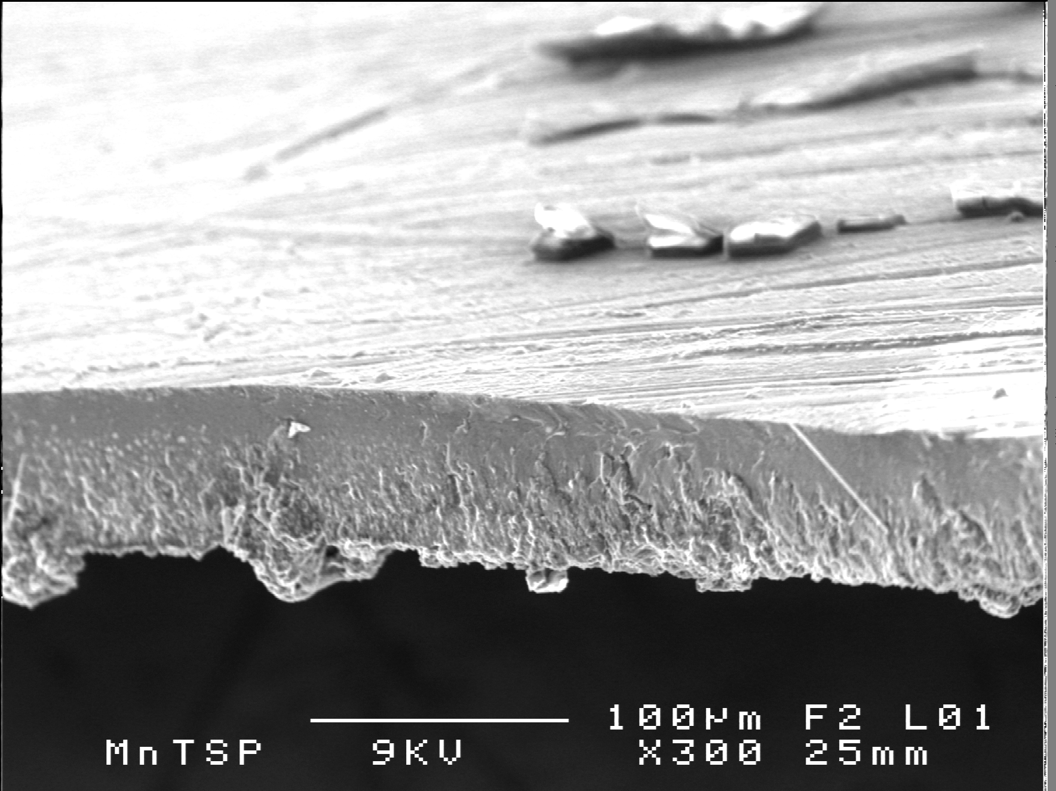
Side view of poly (1) (x1000)
Side view of poly (1) (x300)

*

