Supplemental Scheme 1. Synthesis of modified DNA tethering Naphthyl Red moiety.

(a) 4-aminobenzoic acid, NaNO₂, HCl, 0 ºC, 90%; (b) D-threoninol, DCC, HOBt, DMF, 25 ºC, 89%; (c) DMT-Cl, CH₂Cl₂, Pyridine, 0→25 ºC, 44%; (d) 2-cyanoethyl N,N,N',N'-tetraisopropylphosphorodiamidite, CH₃CN, quant.; (e) DNA synthesizer.

The phosphoramidite monomer tethering Naphthyl Red was synthesized as follows: 4-aminobenzoic acid was dissolved into the aqueous NaNO₂ solution under acidic (HCl) conditions. To this solution was added N,N-dimethyl-1-naphthylamine at 0 ºC to afford dark purple powder of compound 1 (4-[4-(dimethylamino)naphthylazo]benzoic acid, yield 90%)).
D-Threoninol was coupled with 1 in the presence of dicyclohexylcarbodiimide and 1-hydroxybenzotriazole in DMF. After the reaction mixture was stirred at room temperature for 24 h, the solvent was removed and the remained oil was subjected to silica gel column chromatography (CH₃OH : CHCl₃ = 20:1, R_{f} = 0.14) to afford compound 2 (yield 89%).
Dry pyridine solution containing 2 was cooled on ice under nitrogen, and 4,4’-dimethoxytrityl chloride (DMT-Cl) in CH₂Cl₂ was added to the above mixture. After 24 h of vigorous stirring, the solvent was removed by evaporation, followed by silica gel column chromatography (hexane : AcOEt : Et₃N = 50:50:3, R_{f} = 0.26) to afford 3 (yield 44 %): ¹H NMR for 3 [500 MHz, CDCl₃(TMS)]: δ = 9.03-6.79 (m, 24H, aromatic protons of DMT, Naphthyl Red, and -NHCO-), 4.25 (m, 1H, -CH(OH)CH₃), 4.15 (m, 1H, -OCH₂CH(NHCO-)-), 3.77 and 3.76 (s, 6H, -C₆H₄-OCH₃), 3.62 and 3.41 (dd, 2H, -CH₂-ODMT), 3.04 (s, 6H,-N(CH₃)₂), 1.25 (d, 3H, -CH(OH)CH₃)
In dry acetonitrile (10 mL) under nitrogen, 3 and 2-cyanoethyl N,N,N',N'-tetraisopropylphosphorodiamidite were reacted with 1H-tetrazole. Prior to the reaction, 3 and 1H-tetrazole were dried by coevaporation with dry acetonitrile (twice). After 2 h, the product was taken into ethyl acetate. The organic solution was washed with saturated aqueous solution of NaHCO₃ and of NaCl, and dried over Na₂SO₄. Finally the solvent was removed in vacuo, and the oily product 4 was directly used for the DNA synthesis.
All the modified oligonucleotides in Scheme 1 in the main text were synthesized on an automated DNA synthesizer by using the phosphoramidite monomer 4 and other conventional ones from GLEN RESEARCH Co. Coupling efficiency of the monomer 4 was as high as the conventional ones as judged from the coloration of released trityl cation. After the recommended work-up, they were purified by the reversed-phase HPLC; a Merck LiChrospher 100 RP-18(e) column, 0.5 mL/min, a linear gradient 5-25 % (25 min) acetonitrile/water containing 50 mmol dm⁻³ ammonium formate, detection at 260 nm.
MALDI-TOFMS for CXG: Obsd. 4112, (Calcd. for [CXG-H⁺]: 4111). CXT: Obsd. 4087, (Calcd. for [CXT-H⁺]: 4086) GXG: Obsd. 4153, (Calcd. for [GXG-H⁺]: 4151).

Supplemental Table 1. Effect of mismatch on the chromism of Naphthyl Red moiety.^{a)}

Sequence ^{b,c)} T_{m}/ºC Absorption maximum/nm
A: 3'-CCA-TAG-CGT-TAG-5'(full match) 44.5 515
B: 3'-CCA-TAG-AGT-TAG-5' 30.4 465
C: 3'-CCA-TAG-TGT-TAG-5' 32.9 466
D: 3'-CCA-TAC-CGT-TAG-5' 31.2 462
a) Solution conditions: 40 ºC, pH 7.0 (10 mM phosphate buffer), [NaCl] = 100 mM, [DNA] = 5 μM.
b) Sequence of the probe DNA: 5'-GGT-ATC-X-GCA-ATC-3' (identical with CXG in the main text)
c) Mismatched nucleotide is designated as bold italic character in the sequence.

(A) (B)
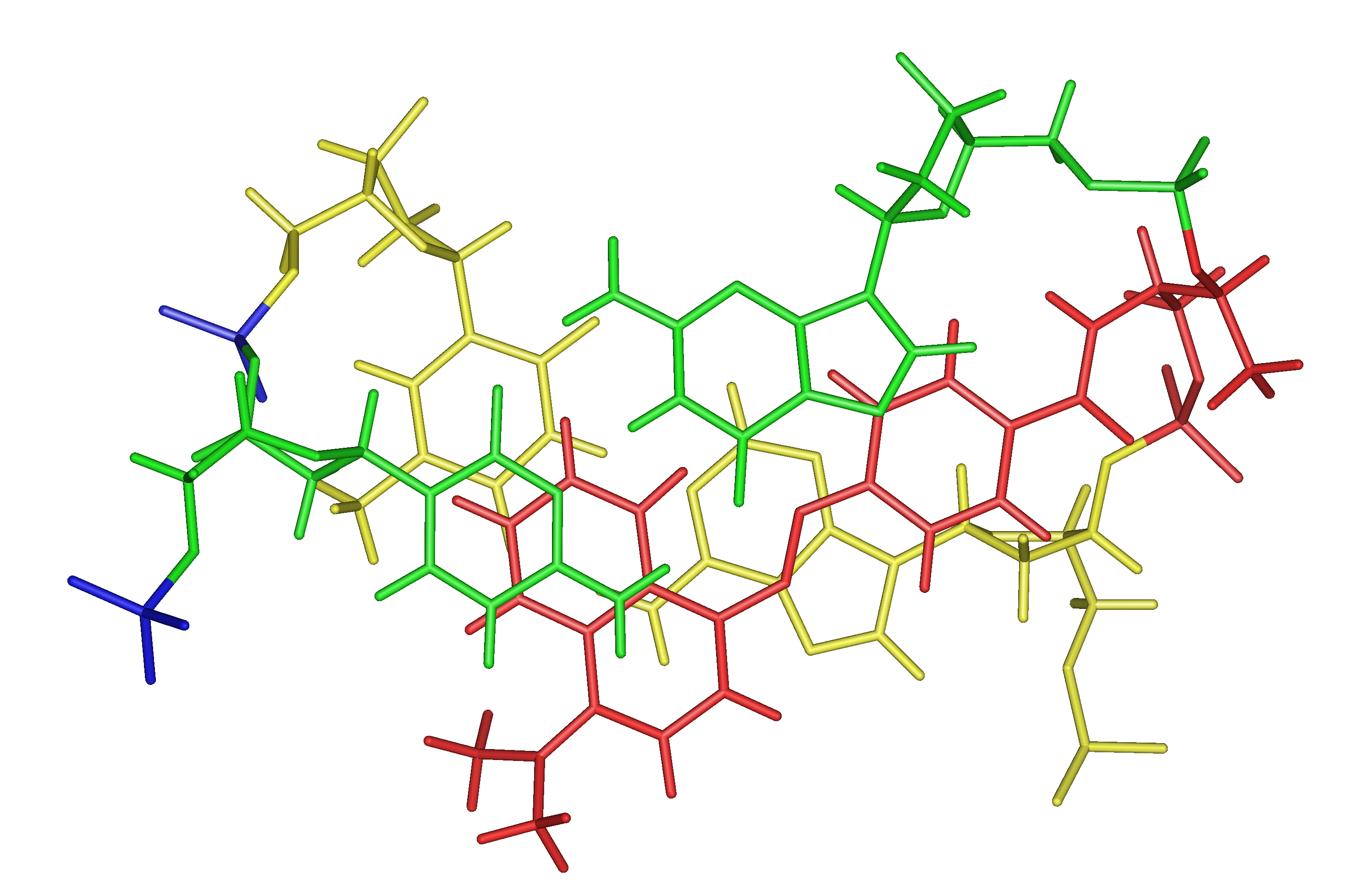
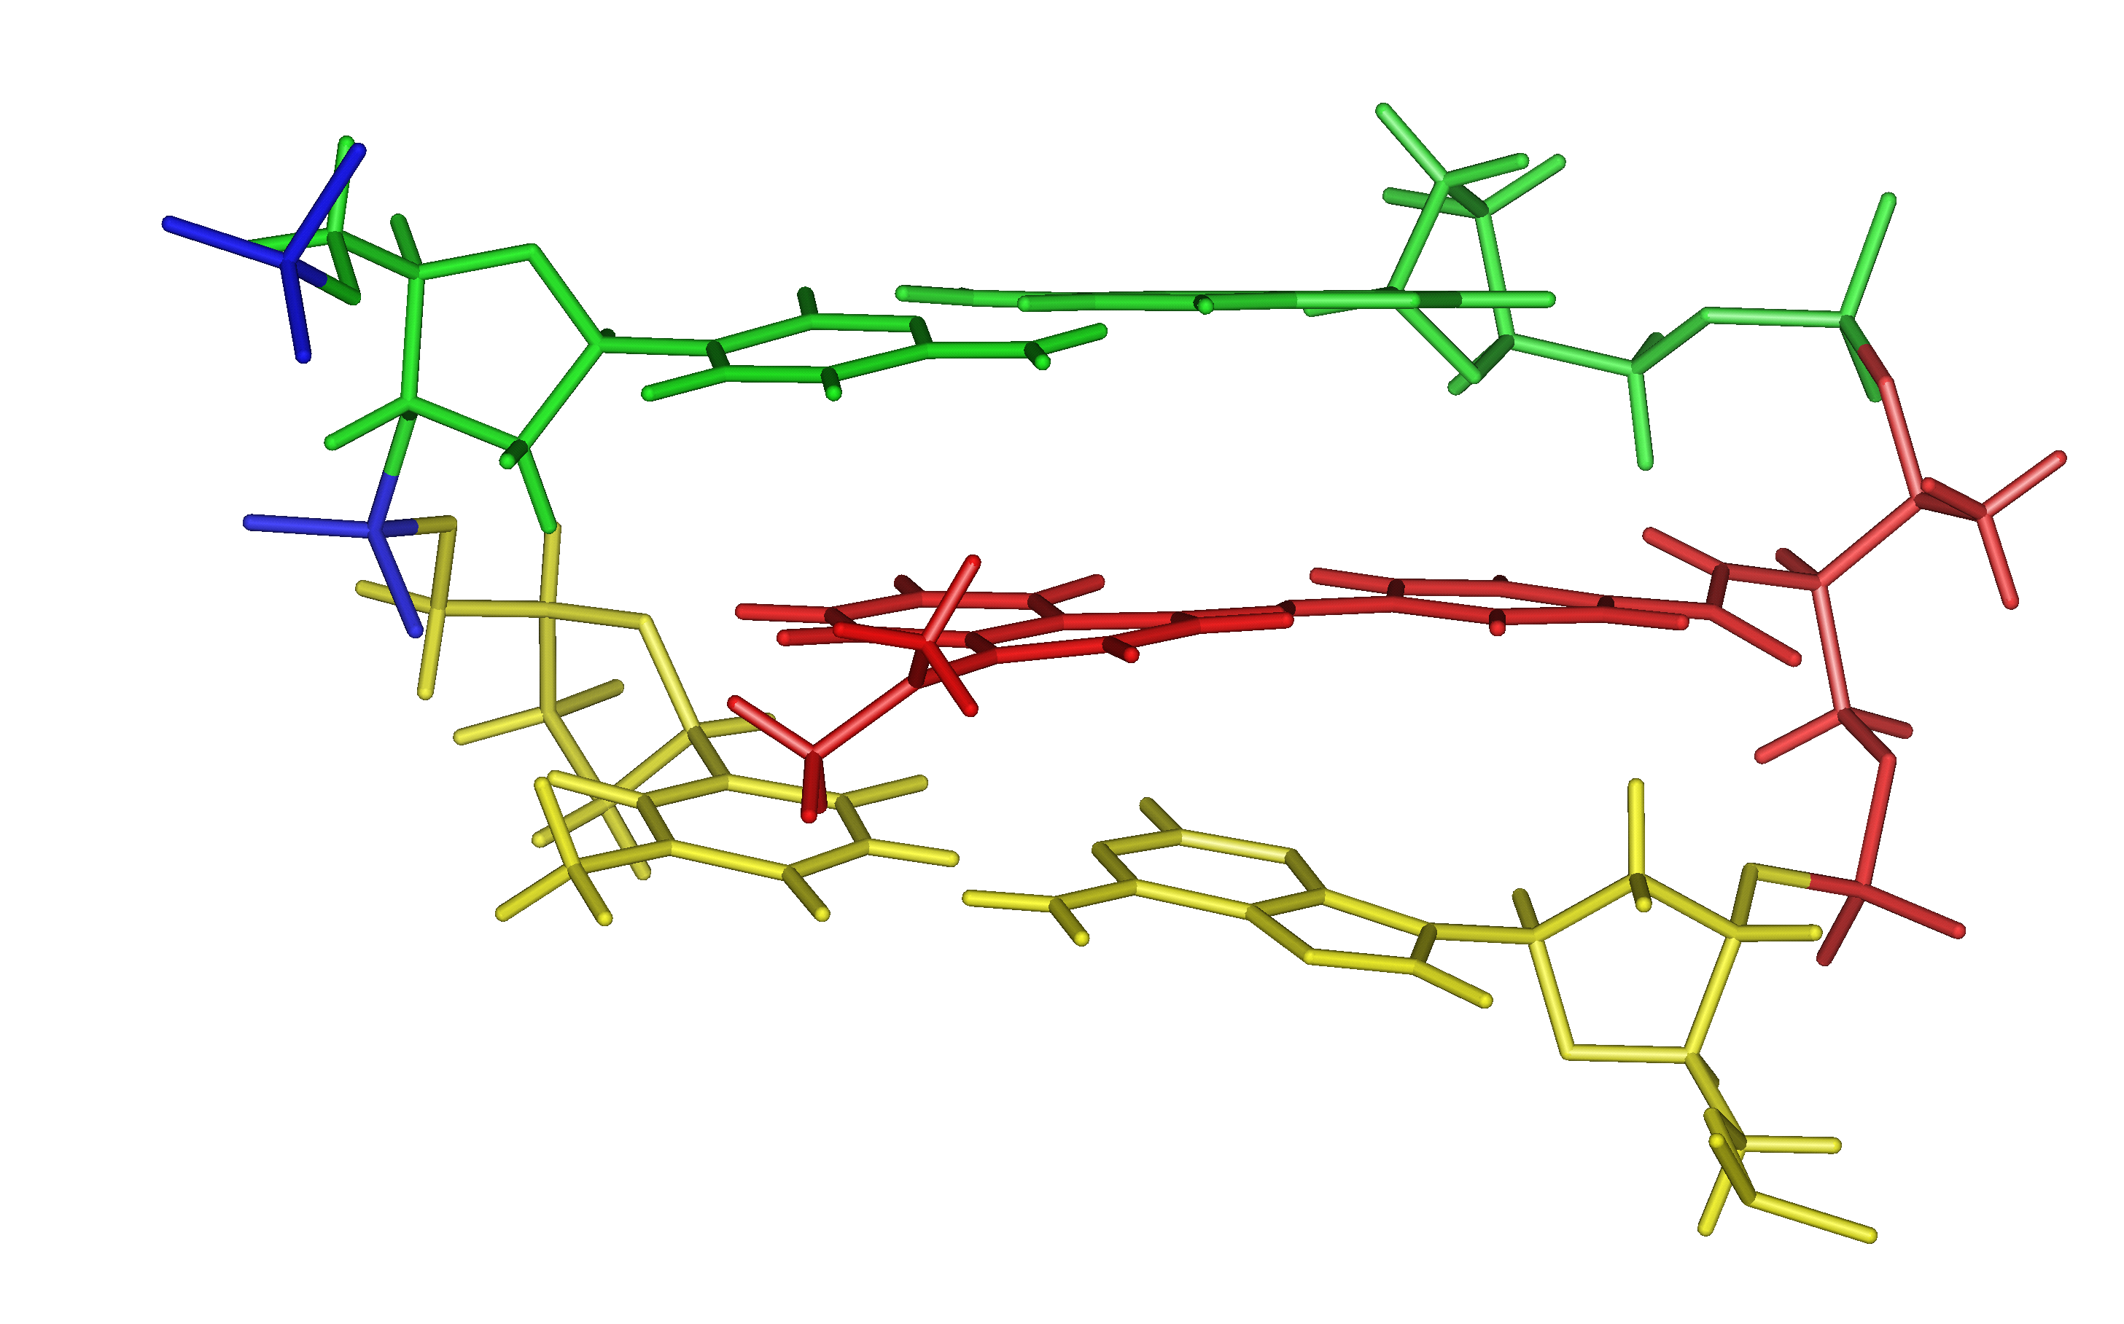

Supplemental Figure 1. Location of Naphthyl Red moiety in the 5'-CGAXGTC-3'/3'-GCT-CAG-5' duplex viewed along the helix axis (A) and from major-groove side (B), calculated by InsightII/Discover on the basis of NOESY analyses. In order to make the figure persuasive, only 5’-...AXG...-3’/3’...TC...5’ part is depicted. Green and yellow molecules correspond to the G-C and A-T base-pairs, respectively. Naphthyl Red moiety located between these base-pairs is red-colored and two phosphodiester linkages (3’...TpCp...5’) which come near the dimethylamino group are colored with blue. In the modified complementary GC_{pm} (3'-CCA-TAG_{pm}-C_{pm}GT-TAG-5'), two phosphodiesters corresponding to these positions are replaced with methyl phosphonates. Above structure is based on the following distinct NOEs between
1) imino protons of A-T, G-C pairs and 6H of Naphthalene ring,
2) CH₃ of thymine at 5 position (green-colored pyrimidine base in the figure) and (CH₃)₂N of Naphthalene ring,
3) 5H of cytosine (yellow-colored pyrimidine base) and (CH₃)₂N,
Numbering of protons in Naphthalene ring is shown below:

NMR measurements (2D-NOESY (mixing time, 200 ms), 2D-DQFCOSY, and 2D-TOCSY (mixing time, 60 ms)) were carried out on Avance600 (Bruker biospin) spectrometer at ¹H frequency of 600 MHz using jump-and-return scheme and gradient pulse for water suppression.
Sample conditions for the NMR measurement: [DNA] = 1 mM, [NaCl] = 200 mM, H₂O/D₂O=9/1, pH 7.0 (10 mM phosphate buffer).

