Supporting Information

Figure S1. ESI-mass spectra of 1 (a) in the absence and (b) in the presence of K⁺ in CH₂Cl₂:CH₃OH (1:1 v/v).

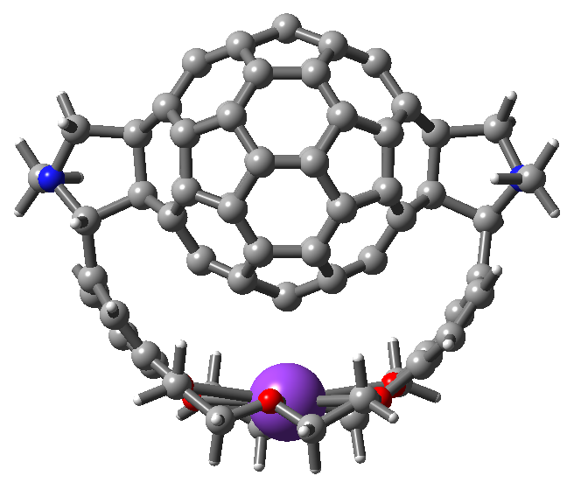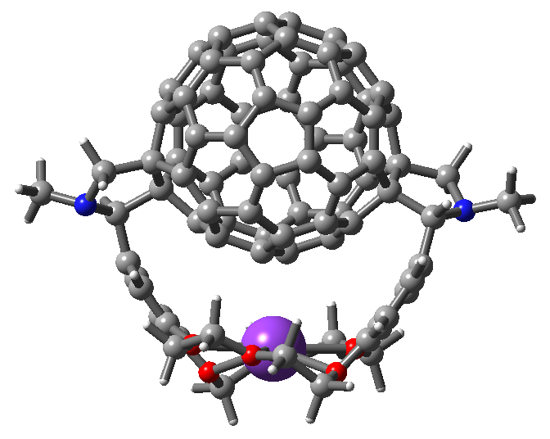
Trans-1 Trans-2

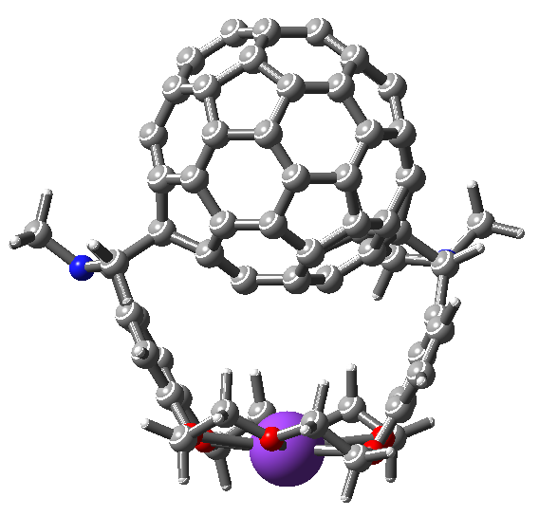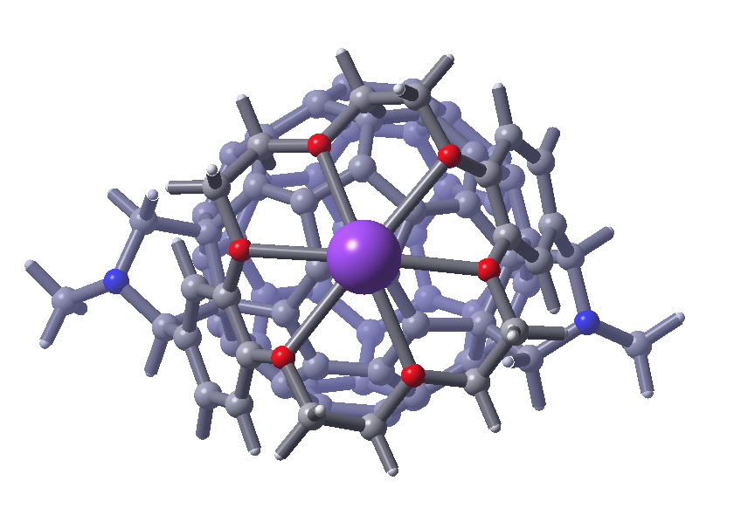
Trans-4

Figure S2. Energy optimized structure of Trans-1 (HF/STO-2G), Trans-2 (HF/STO-2G) and Trans-4 (B3LYP/3-21G(*), two orientations) isomers of 1.

