Anion complexation properties of 2,2’-bisamidodipyrrolylmethanes
Ismael El Drubi Vega, Salvatore Camiolo, Philip A. Gale,* Michael B. Hursthouse and Mark E. Light
School of Chemistry, University of Southampton, Southampton, SO17 1BJ, UK. Fax: +44 23 80596805; Tel: +44 23 80593332; E-mail: philip.gale@soton.ac.uk

SUPPLEMENTARY INFORMATION
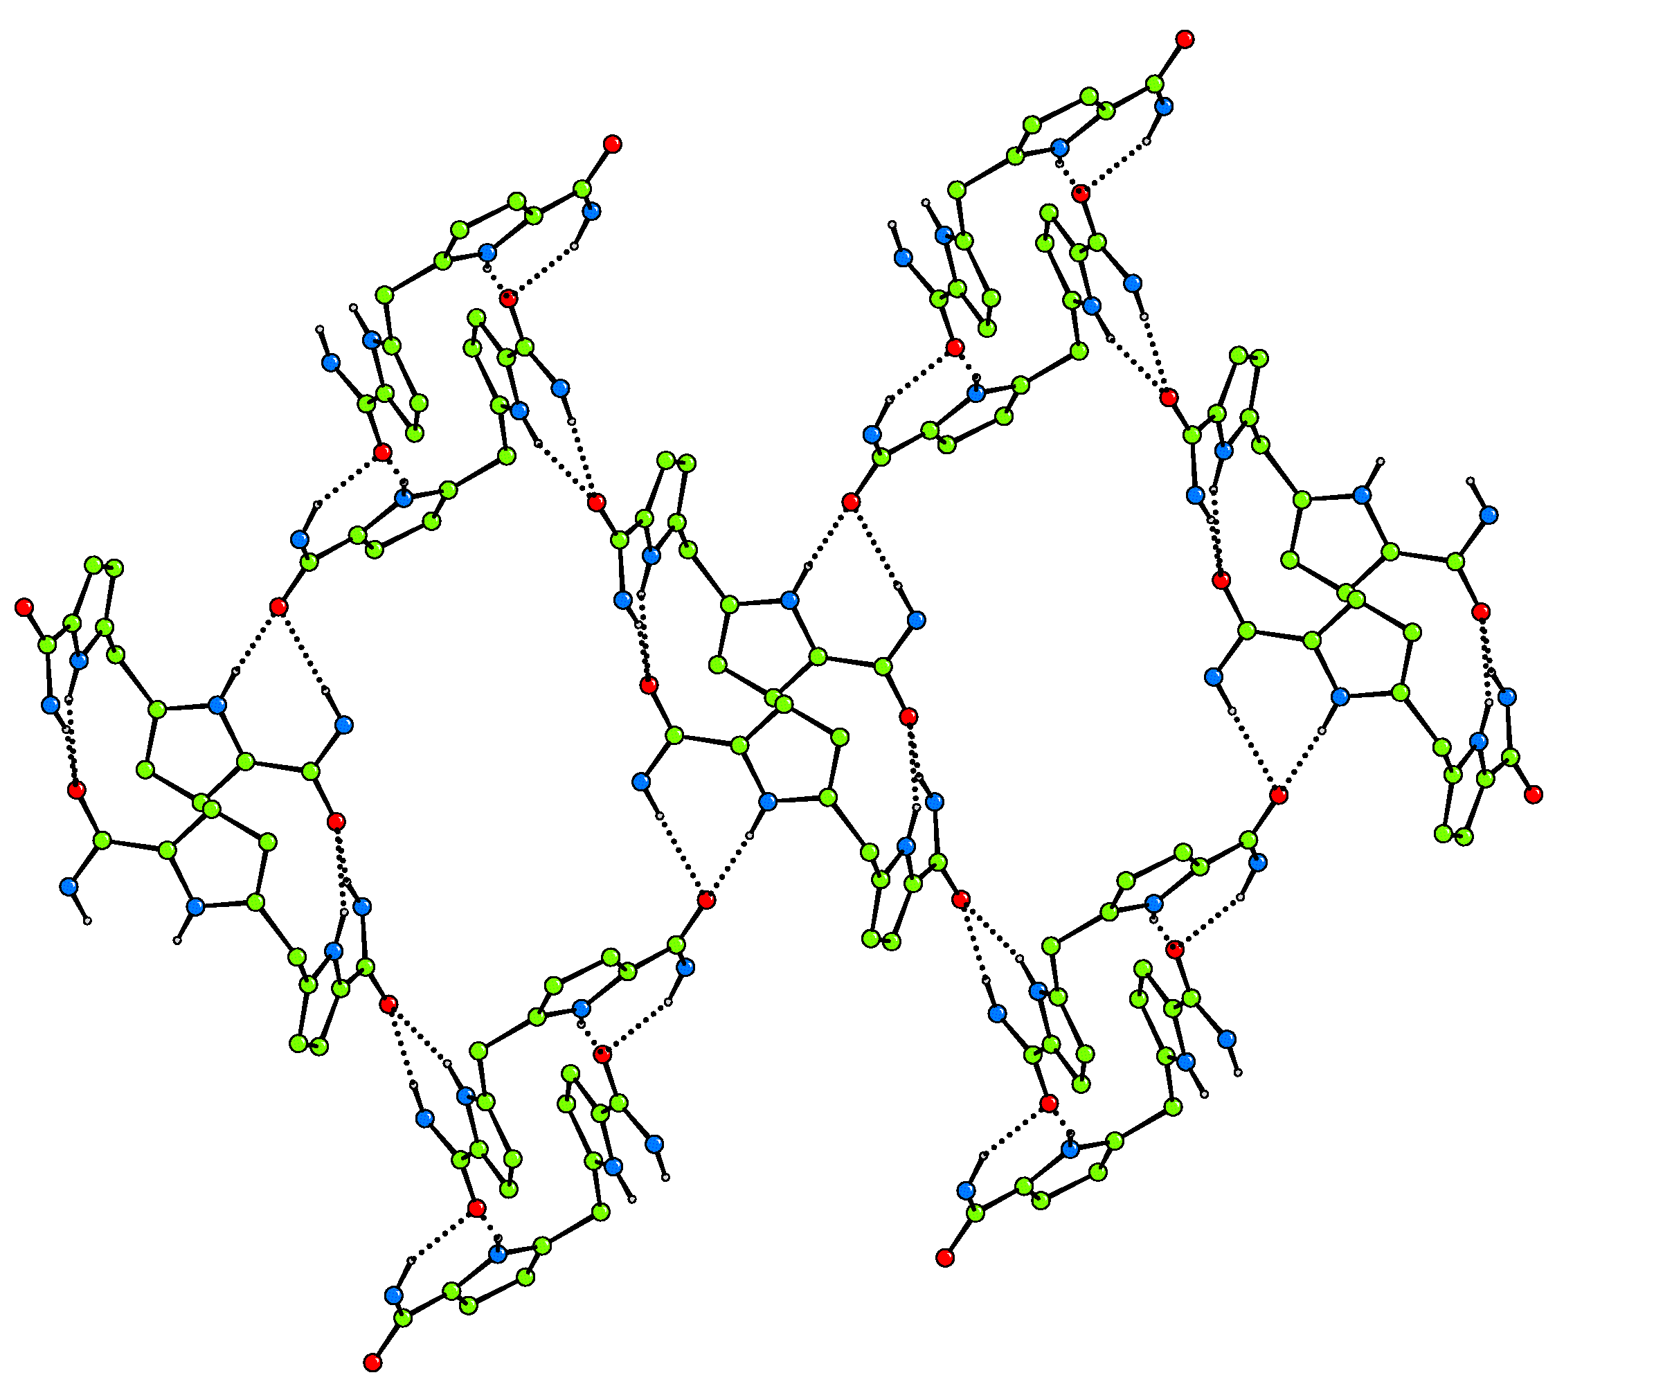
Figure S1 Hydrogen bonded sheets formed in the solid state by compound 1. Side chain ethyl, methyl and butyl groups and non-acidic hydrogen atoms have been omitted for clarity.

Figure S2 ¹H NMR spectrum of compound 1 in DMSO-d₆
Figure S3 ¹³C NMR spectrum of compound 1 in DMSO-d₆
Figure S4 ES+ MS spectrum of compound 1
Figure S5 ¹H NMR spectrum of compound 2 in DMSO-d₆
Figure S6 ¹³C NMR Spectrum of 2 in DMSO-d₆

Figure S7 ES⁺ MS of compound 2.

Figure S8 ¹H NMR titration of compound 1 with fluoride in DMSO-d₆/5% water.
Figure S9 ¹H NMR titration of compound 1 with chloride in DMSO-d₆/5% water.
Figure S10 ¹H NMR titration of compound 1 with bromide in DMSO-d₆/5% water.
Figure S11 ¹H NMR titration of compound 1 with benzoate in DMSO-d₆/5% water.
Figure S12 ¹H NMR titration of compound 1 with dihydrogen phosphate in DMSO-d₆/25% water.

Figure S13 ¹H NMR titration of compound 2 with fluoride in DMSO-d₆/5% water.
Figure S14 ¹H NMR titration of compound 2 with chloride in DMSO-d₆/5% water.
Figure S15 ¹H NMR titration of compound 2 with bromide in DMSO-d₆/5% water.

Figure S16 ¹H NMR titration of compound 2 with benzoate in DMSO-d₆/5% water.
Figure S17 ¹H NMR titration of compound 2 with dihydrogen phosphate in DMSO-d₆/25% water.

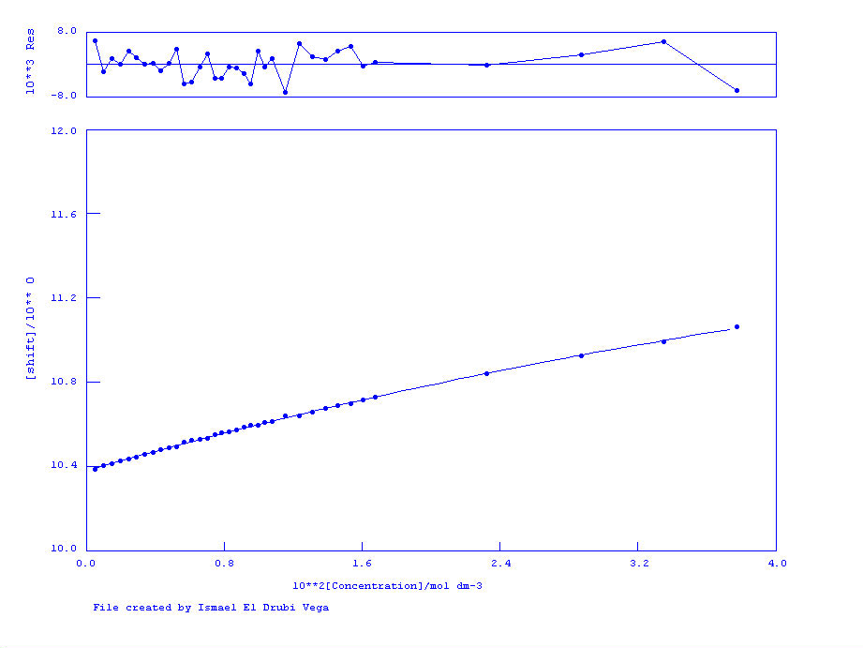
Figure S18 ¹H NMR titration of compound 1 with fluoride in DMSO-d₆/25% water.
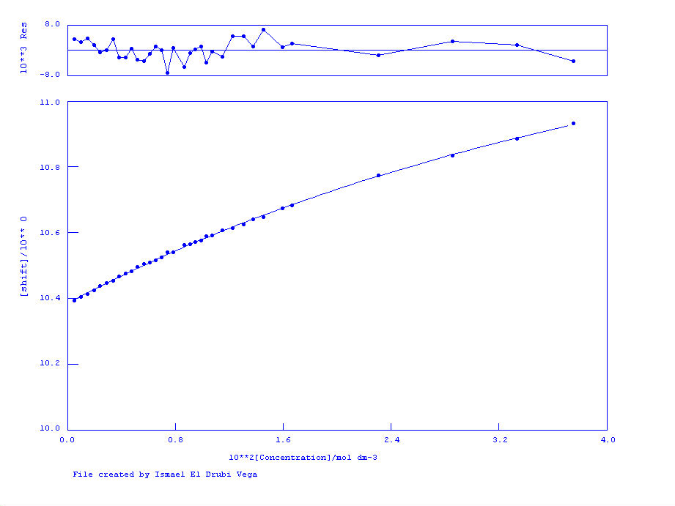

Figure S19 ¹H NMR titration of compound 2 with fluoride in DMSO-d₆/25% water.

