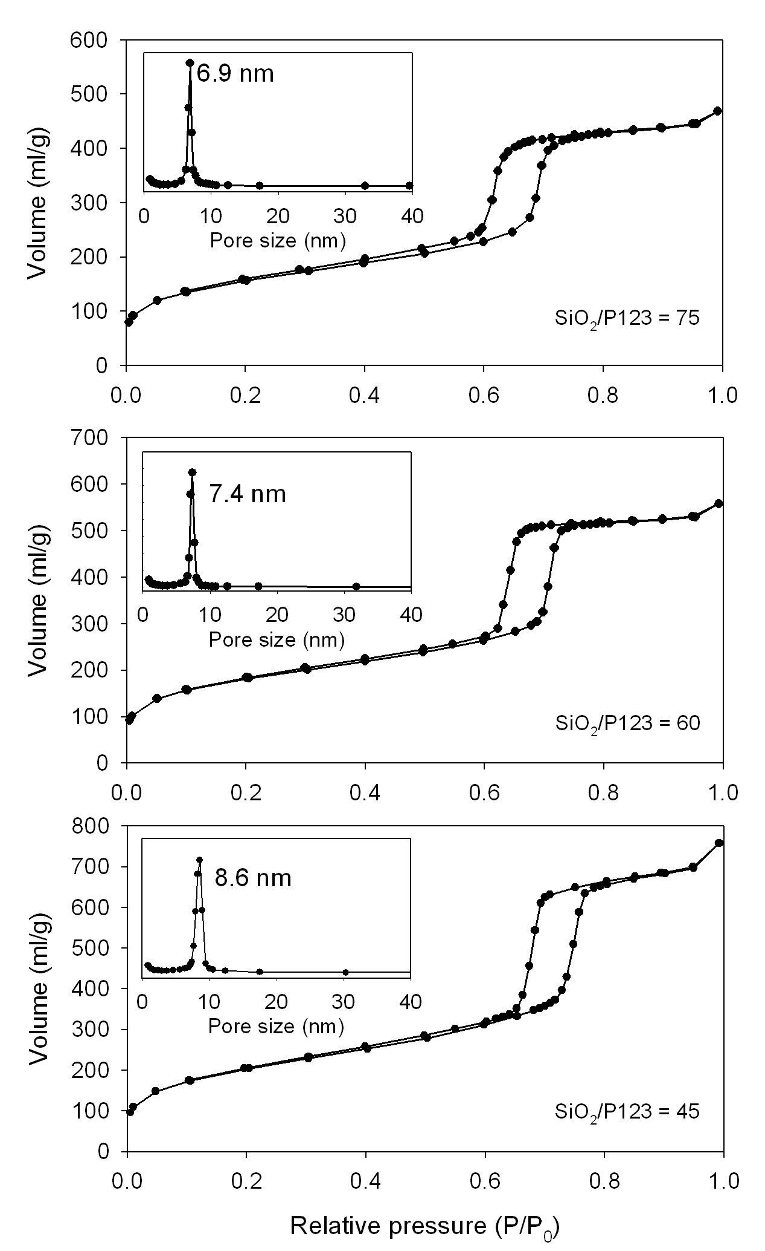
Fig. Supplementary Information N₂ adsorption-desorption isotherms at 77 K and pore size distributions for the SBA-15 samples with SiO₂/P123 = 45, 60 and 75 (Quantachrome Autosorb-1). The pore size was analysed with the adsorption branch using the BJH algorithm.

