Supporting information for

Development of Novel Cell-permeable DNA Sensitive Dyes Using Combinatorial Synthesis and Cell-based Screening

Jae Wook Lee, Michelle Jung, Gustavo R. Rosania, Young-Tae Chang*

Experimental Section
General: Unless otherwise noted, starting materials and solvents were purchased from Aldrich and Acros organics, and used without purification. Ethanol (EtOH) and ethyl acetate (EA) from Acros organics were used as the reaction solvents without any prior purification. Salmon testes solid dsDNA, and phosphate buffered saline (PBS) (NaCl 120 mM, KCl 2.7 mM, and phosphate buffer 10 mM, pH=7.4 at 24 ºC) were purchased from Sigma-Aldrich and needed no further purification. Fluorescence intensities were measured by a Jobin Yvon Horiba Fluoro MAX-3 fluorimeter with a quartz cuvette cell (10 mm×10 mm×4.5 cm; Starna (Atascadero, CA)). ¹H-NMR (200 MHz) spectra were determined on Varian Genini 200 spectrometer. Chemical shifts were reported in parts per million (ppm) relative to the line of a singlet at 2.50 ppm for DMSO-d₆ and coupling constants (J) are in Hertz (Hz). The following abbreviations are used for spin multiplicity: s=singlet, d=doublet, t=triplet, m=multiplet, and b=broad. All dye products were identified by LC-MS from Agilent Technology, using a C18 column (20×4.0 mm), with 4 minutes elution using a gradient of 5-95% CH₃CN (containing 1% acetic acid)-H₂O (containing 1% acetic acid), with UV detector at λ=400 nm and an electrospray ionization source.

Preparation of 2-[4-[5-(trimethyoxy)phenyl]-ethenyl-1-adamantyl]-4-methylpyridinium bromide (1):
1-(1-adamantyl)-4-methylpyridinium bromide (20 mg, 0.06 mmol) and 2,4,5-trimethoxybenzaldehyde (30mg, 0.15 mmol) were dissolved in ethanol (4 mL). piperidine (0.4 mL) was added to the reaction mixture. The reaction mixture was refluxed for 3 hours. After the reaction was completed, the mixture stood at 0ºC overnight. Orange solid was filtered and washed with EtOAc (10 mL) yielding 1 (23.4mg, 80%) as yellow solid. LC-MS: RT=1.87 m/z: 406.2 [M]⁺ ; ¹H-NMR (DMSO-d₆): δ 1.75 (s, 6H), 2.24 (s 9H), 3.80 (s, 3H, OCH₃), 3.89 (s, 3HOCH₃), 3.9 (s, 3H, OCH₃) 6.78 (s, 1H), 7.39 (s, 1H), 7.44 (d, 1H, J=12 Hz), 8.1 (m, 3H), 9.1 (d, 2H, J=6Hz)

Preparation of 3-[4-[5-(trimethyoxy)phenyl]-ethenyl-1-adamantyl]-4-methylpyridinium bromide (2):
1-(1-adamantyl)-4-methylpyridinium bromide (30 mg, 0.1 mmol) and 3,4,5-trimethyoxybenzaldehyde (57.3 mg, 0.3 mmol) were dissolved in ethanol (5 mL). piperidine (0.4 mL) was added to the reaction mixture. The reaction mixture was refluxed for 2 hours. After the reaction was completed, the mixture stood at 0ºC overnight. The yellow solid was filtered and washed with EtOAc (10mL) yielding 2 (11.2 mg, 23%) as yellow solid. LC-MS: RT=1.809 m/z: 406.2 [M]⁺; ¹H-NMR (DMSO-d₆): δ 1.75 (s, 6H), 2.30 (s 9H), 3.74 (s, 3H, OCH₃), 3.89 (s, 6H, OCH₃), 7.15 (s, 2H), 7.60 (d, 1H, J=14 Hz), 8.07 (d, 1H, J=14 Hz), 8.2 (d, 3H, J=6Hz), 9.2 (d, 2H, J=6Hz)

Preparation of 2-[3-[4-(trimethyoxy)phenyl]-ethenyl-1-adamantyl]-4-methylpyridinium bromide (3):
1-(1-adamantyl)-4-methylpyridinium bromide (30 mg, 0.1 mmol) and 2,3,4-trimethyoxybenzaldehyde (57.3 mg, 0.3 mmol) were dissolved in absolute ethanol (5 mL). piperidine (0.2 mL) was added to the reaction mixture. The reaction mixture was refluxed for 2 hours. After the reaction was completed, the mixture stood at 0ºC overnight. Solid was filtered and washed with EtOAc (10 mL) yielding 3 as a yellow solid (14.9 mg, 30%). LC-MS: RT=1.833 m/z: 406.2 [M]⁺; ¹H-NMR (DMSO-d₆): δ 1.75 (s, 6H), 2.28 (s 9H), 3.80 (s, 3H, OCH₃), 3.89 (s, 6H, OCH₃), 6.96 (d, 1H, J=6Hz), 7.49 (d, 1H, J=14 Hz), 8.55 (d, 1H, J=6 Hz), 8.0 (d, 1H, J=14Hz), 8.23 (d, 2H, J=6Hz), 9.15 (d, 2H, J=6Hz)

Preparation of 1-Methyl-4[2-(2,4,5-trimethoxy-phenyl)-vinyl]pyridinium iodide (4)
1,4-dimethyl pyridinium iodide (20 mg, 0.085 mmol) and 2,4,5-trimethoxybenzaldehyde (49 mg, 0.25mmol) were dissolved in absolute ethanol (5 mL). piperidine (0.13 mL) was added to the reaction mixture. The reaction mixture was refluxed for 3 hours. After the reaction was completed, the mixture stood at 0 ºC overnight. The solid was filtered and washed with EtOAc (10 mL) yielding 4 as a light yellow solid (6.2 mg, 17.7 %). LC-MS: RT=1.56 m/z: 286.1 [M]⁺; ¹H-NMR (DMSO-d₆): δ 3.80 (s, 3H, OCH₃), 3.89 (s, 3H, OCH₃), 3.89 (s, 3H, OCH₃), 4.20 (s, 3H, CH₃), 6.79 (s, 1H), 7.34 (s, 1H), 7.41 (d, 1H, J=14 Hz), 8.04 (d, 1H, J=14 Hz), 8.11 (d, 2H, J=6Hz), 8.75 (d, 2H, J=6Hz).

Figure S1. LC-MS diagram of compound 1
LC data (400 nm)

MS data

Figure S2. LC-MS diagram of compound 2
LC data (400 nm)

MS data

Figure S3. LC-MS diagram of compound 3
LC data (400 nm)

MS data

Figure S4. LC-MS diagram of compound 4
LC data (400 nm)
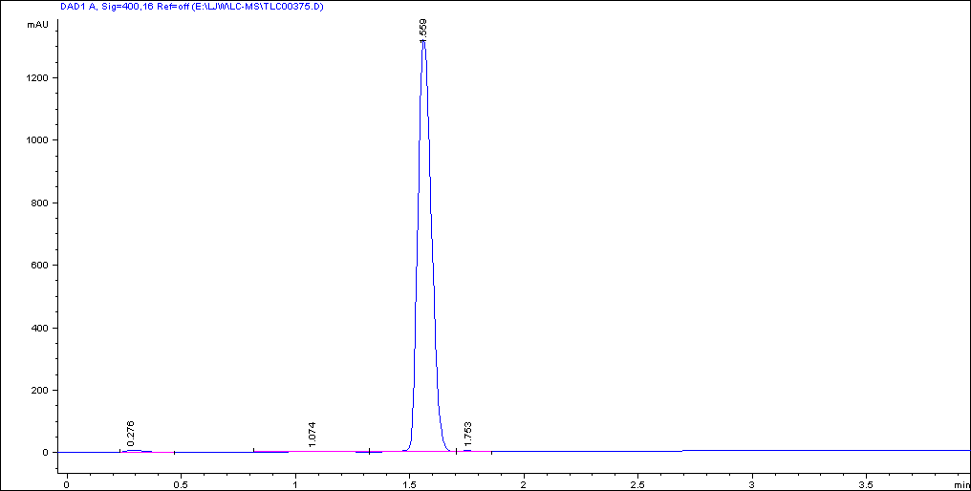

MS data

Scheme S1. General procedure of the synthesis and screening of the styryl dyes in 96-well format

