Supplementary material (ESI) for Chemical Communications b304505f

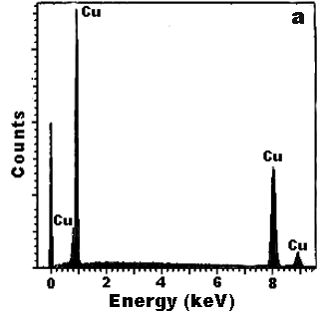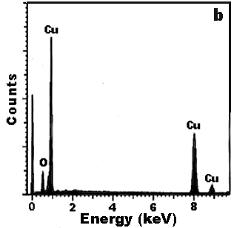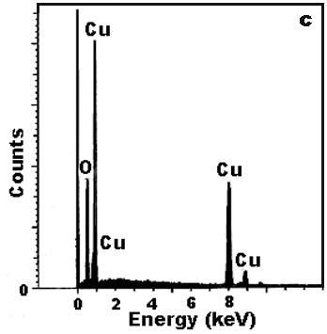

Fig. S1 EDS patterns of (a) Cu nanotubes, (b) Cu₂O nanotubes, (c) CuO nanotubes.

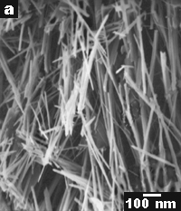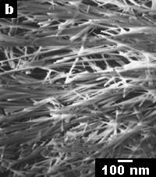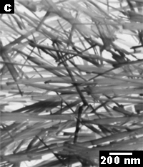

Fig. S2 SEM images of nanorods of (a) Cu, (b) Cu₂O, (c) CuO.

