Electronic Supplementary Information

Scanning electron micrograph of the dried polystyrene latex particles prepared using the DMA-MMA diblock copolymer stabiliser. The particles are spherical and have a reasonably uniform size distribution (Scale bar = 300 nm).
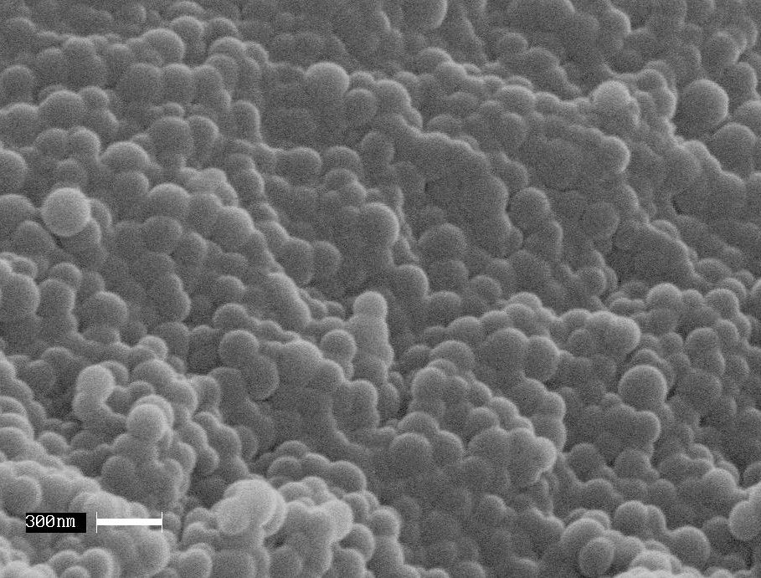

¹H NMR spectrum of the polystyrene latex dissolved in CDCl₃. The signals due to the DMA-MMA diblock copolymer stabiliser are assigned. The stabiliser content of this latex was approximately 8 % by mass.

