Electronic Supplementary Information

Conjugation of Poor Inhibitors of Carbonic Anhydrase with Surface Binding Groups: A Strategy to Improve Inhibitor Efficiency

Bidhan C. Roy, Ryan Hegge, Theresa Rosendahl, Xiao Jia, Rachael Lareau, Sanku Mallik* and D. K. Srivastava

Department of Chemistry & Molecular Biology
North Dakota State University
Fargo, North Dakota 58105

Tel: 701-231-8829
Fax: 701-231-8831
E-mail: sanku.mallik@ndsu.nodak.edu
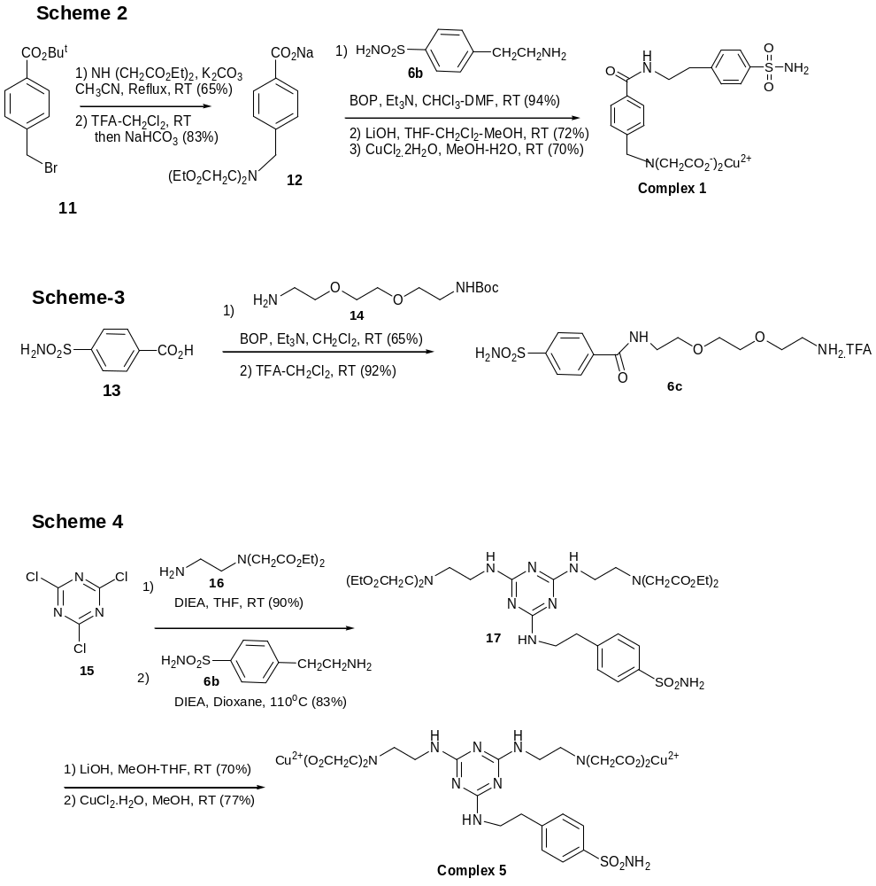
Experimental Details:

Compound 12: Br-^{t}But ester 11¹ (7.73 g, 28.54 mmol), diethyliminodiacetate (4.50 g, 23.78 mmol) and K₂CO₃ (12.0 g, 85.7 mmol) were mixed together in CH₃CN. The resultant mixture was refluxed for 12 h. Solid was filtered and washed with CH₃CN. The solvent was removed in vacuo. The crude product was purified by silica gel column chromatography with 20% ethyl acetate in hexane (R_{f} = 0.6) to afford a viscous liquid. Yield: 7.0 g (77%). ¹H NMR (300 MHz, CDCl₃) δ 1.31 (t, 6H, J = 7.0 Hz), 1.64 (s, 9H), 3.58 (s, 4H), 4.02 (s, 2H), 4.21 (q, 4H, J = 7.0 Hz), 7.49 (d, 2H, J = 8.0 Hz), 7.80 (d, 2H, J = 8.0 Hz).
The resultant ester (4.80 g, 12.66 mmol) was dissolved in CH₂Cl₂ (20 mL) and ice-cold TFA (20 mL) was added. It was stirred at room temperature for 5 h. The excess TFA was removed in vacuo and it was again dissolved in CH₂Cl₂ and washed with ice-cold NaHCO₃ solution. It was dried over Na₂SO₄. The solvent was removed in vacuo to obtain a white solid. Yield: 3.65 g ( 83%). ¹H NMR (300 MHz, CDCl₃) δ 1.32 (t, 6H, J = 7.0 Hz), 3.60 (s, 4H), 4.05 (s, 2H), 4.21 (q, 4H, J = 7.0 Hz), 7.56 (d, 2H, J = 8.0 Hz), 8.11 (d, 2H, J = 8.0 Hz).

Complex 1: The Na-salt of acid 12 (0.80 g, 2.32 mmol) and 4-(aminoethyl) benzenesulfonamide hydrochloride 6b (0.465 g, 2.32 mmol) were then coupled with BOP reagent (1.03 g, 2.32 mmol) and Et₃N (0.65 mL, 4.67 mmol) in CHCl₃/DMF (10/5 mL). The reaction was allowed to continue at room temperature for 10 h. The reaction was quenched with saturated brine solution. The organic solvent was removed in vacuo and the compound was precipitated as a white solid in water. It was filtered and washed with water. Yield: 1.1 g (94%), mp: 110-112 ºC. ¹H NMR (300 MHz, CDCl₃) δ 1.30 (t, 6H, J = 7.0 Hz), 3.03 (t, 2H, J = 7.0 Hz), 3.21 (bs, 2H), 3.54 (s, 4H), 3.64 (q, 2H, J = 7.0 Hz), 3.97 (s, 2H), 4.20 (q, 4H, J = 7.0 Hz), 7.04 (bs, 1H), 7.38 (d, 2H, J = 8.0 Hz), 7.46 (d, 2H, J = 8.5 Hz), 7.82-7.88 (m, 4H).
The ester (0.40 g, 0.79 mmol) was dissolved in CH₂Cl₂/MeOH (6/6 mL) and solid LiOH (0.11 g, 2.62 mmol) was added. The reaction mixture was stirred at room temperature for 15 h. The solution was acidified by concentrated HCl to pH = 3.0. The white solid was filtered and washed with MeOH/CH₂Cl₂ (40/60) to provide 255 mg of acid (72%). ¹H NMR (300 MHz, D₂O) δ 2.98 (t, 2H, J = 6.5 Hz), 3.65 (t, 2H, J = 6.5 Hz), 3.85 (s, 4H), 4.48 (s, 2H), 7.44 (d, 2H, J = 8.5 Hz), 7.52 (d, 2H, J = 8.5 Hz), 7.60 (d, 2H, J = 8.0 Hz), 7.78 (d, 2H, J = 8.0 Hz). ¹³C NMR (100 MHz, D₂O) δ 25.71, 32.05, 48.42, 49.07, 116.39, 118.18, 120.59, 121.39, 123.97, 132.73, 133.74, 135.77, 161.94, 170.60.
The acid (0.15 g, 0.30 mmol) was dissolved in MeOH/H₂O (5/2 mL) and CuCl₂.2H₂O (52.5 mg, 0.30 mmol) was added in MeOH (5 mL). The reaction mixture was stirred at room temperature for 6 h. The precipitated solid was filtered and washed with MeOH to afford 120 mg (70%) of complex 1 as a blue solid. Anal. Calcd. for C₂₀H₂₁CuN₃O₇S: C, 46.79; H, 4.11; N, 8.21. Found: C, 46.64; H, 4.11; N, 8.18.

Compound 8a: The Na-salt of acid 7 (0.60 g, 1.1 mmol) was coupled with 4-(aminomethyl)benzene sulfonamide hydrochloride 6a (0.225 g, 1.1 mmol) in presence of BOP reagent (0.49 g, 1.1 mmol) and Et₃N (0.3 mL, 2.15 mmol) in CHCl₃/DMF (20/5 mL). The reaction was carried out at room temperature for 12 h. The work up procedure was the same as described for complex 1 (BOP coupling). Yield: 0.76 g (98%); mp: 126-128 ºC. ¹H NMR (300 MHz, CDCl₃) δ 1.26 (t, 12H, J = 7.0 Hz), 3.54 (s, 8H), 3.94 (s, 4H), 4.11-4.22 (m, 8H), 4.65 (d, 2H, J = 6.0 Hz), 5.20 (bs, 2H), 5.73 (bs, 1H), 7.41 (d, 2H, J = 8.0 Hz), 7.53 (s, 1H), 7.79 (d, 2H, J = 8.0 Hz), 7. 88 (s, 2H).

Compound 9a: The saponification of ester 8a (0.34 g, 0.487 mmol) was achieved with LiOH (140 mg, 3.33 mmol) in THF/CH₂Cl₂/MeOH (4/4/4 mL) at room temperature for 12 h. The pH of the solution was adjusted to 3.0 by adding concentrated HCl. The white solid was filtered and washed with absolute ethanol. Yield: 320 mg (93%). ¹H NMR (300 MHz, D₂O) δ 3.43 (s, 8H), 4.12 (s, 4H), 4.66 (s, 2H), 7.56 (d, 2H, J = 8.5 Hz), 7.67 (s, 1H), 7.83-7.89 (m, 4H).¹³C NMR (125 MHz, D₂O) δ 45.95, 51.69, 60.07, 60.66, 129.01, 130.69, 132.19, 137.00, 138.88, 142.75, 146.40, 172.79.

Complex 2: The acid 9a (150 mg, 0.25 mmol) was dissolved in MeOH/H₂O (5/2 mL) and CuCl₂.2H₂O (90 mg, 0.53 mmol) was added. It was stirred at room temperature for 8 h. Solvents were removed in vacuo and the solid was triturated with absolute ethanol. The precipitate was filtered and washed with ethanol. Yield: 180 mg (93%). Anal. Calcd. for C₂₄H₂₆Cu₂N₄O₁₁S.2HCl. 4H₂O: C, 33.94; H, 4.00; N, 6.60. Found: C, 34.02, H, 3.91; N, 6.53.

Compound 8b: The coupling of acid 6 (0.70 g, 1.28 mmol) and 4-(aminoethyl)benzene sulfonamide hydrochloride 6b (0.26 g, 1.28 mmol) was carried out with BOP reagent (0.57 g, 1.28 mmol) and Et₃N (0.5 mL, 3.6 mmol) in CHCl₃/DMF (20/5 mL). The work up procedure was the same as described for Complex 1 (BOP coupling). The crude product was purified by silica gel column chromatography with 8% MeOH in CHCl₃ (R_{f} = 0.4) to afford a viscous liquid. Yield: 0.85 g (94%). ¹H NMR (300 MHz, CDCl₃) δ 1.28 (t, 12H, J = 7.0 Hz), 2.98-3.04 (m, 2H), 3.51 (s, 8H), 3.70 (d, 2H, J = 6.5 Hz), 3.91 (s, 4H), 4.10-4.21 (m, 8H), 5.44 (bs, 2H), 6.00 (t, 1H, J = 6.0 Hz, NH), 7.38 (d, 2H, J = 8.5 Hz), 7.49 (s, 1H), 7.72 (s, 2H), 7.88 (d, 2H, J = 8.5 Hz).

Compound 9b: The ester 8b (0.49 g, 0.695 mmol) was hydrolyzed by LiOH (0.11 g, 4.52 mmol) in THF-CH₂Cl₂-MeOH (4/4/8 mL) at room temperature for 10 h. The work up procedure was the same as described for compound 9a. Yield: 0.34 g (82%). ¹H NMR (300 MHz, D₂O) δ 2.98 (t, 2H, J = 6.2 Hz), 3.62-3.70 (m, 2H), 3.82 (s, 8H), 4.50 (s, 4H), 7.45 (d, 2H, J = 8.0 Hz), 7.74-7.81 (m, 5H). ¹³C NMR (125 MHz, D₂O) δ 27.74, 37.31, 43.44, 58.97, 60.84, 70.57, 128.74, 132.74, 133.59, 134.03, 138.66, 139.74, 141.97, 147.84, 171.52, 172.53. Anal. Calcd. for C₂₅H₃₀N₄O₁₁S.2HCl.H₂O: C, 43.75; H, 4.96; N, 8.17. Found: C, 43.42; H, 5.09; N, 8.12.

Complex 3: The complex 3 was prepared by dissolving of acid 9b (0.15 g, 0.252 mmol) in MeOH/H₂O (4/2 mL), and followed by the addition of CuCl₂.2H₂O (86 mg, 0.504 mmol). The same work up procedure was followed as described for complex 1. Yield: 170 mg (82%). Anal. Calcd. for C₂₅H₂₆Cu₂N₄O₁₁S. 2HCl.2H₂O: C, 36.33; H, 3.90; N, 6.78. Found: C, 36.23; H, 4.05; N, 6.72.

Compound 6c: 4-Carboxybenzenesulfonamide (2.00 g, 9.94 mmol) was dissolved in CH₂Cl₂ (50 mL) in presence of Et₃N (4.1 mL, 29.47 mmol), followed by the addition of amine 14² (2.46 g, 9.94 mmol) in CH₂Cl₂ (10 mL) and BOP reagent (4.40 g, 9.94 mmol). Stirring was continued for 12 h at room temperature. The reaction was quenched with saturated NaCl solution and solvent was removed in vacuo. The compound was extracted by ethyl acetate and the organic layer was washed with water. The purification was achieved by silica gel column chromatography with 15% MeOH in CHCl₃ (R_{f} = 0.5) to afford white solid. Yield: 2.89 g (65%). Mp: 131-132º C. ¹H NMR (300 MHz, CDCl₃) δ 1.45 (s, 9H), 2.26 (bs, 2H), 3.20-3.24 (m, 2H), 3.30-3.36 (m, 2H), 3.48-3.58 (m, 2H), 3.60-3.70 (m, 6H), 5.09 (bs, 1H), 5.99 (bs, 1H), 7.86 (m, 4H).

The amine-Boc compound (3.0 g, 6.95 mmol) was dissolved in dry CH₂Cl₂ (20 mL) and cold TFA (15 mL) was added. It was stirred at room temperature for 3 h. The excess TFA was removed in vacuo to afford viscous liquid 2.85 g (92%). ¹H NMR (400 MHz, D₂O) δ 3.11 (t, 2H, J = 4.8 Hz), 3.56 (t, 2H, J = 5.4 Hz), 3.60-3.72 (m, 8H), 7.83-7.87 (m, 2H), 7.90-7.95 (m, 2H).
Compound 8c: The Na-salt of acid 7 (0.50 g, 0.915 mmol) was coupled with amine-TFA 6c (0.57 g, 1.72 mmol) with HBTU (0.35 g, 0.923 mmol), HOBT (0.125 g, 0.925 mmol) and Et₃N (0.7 mL, 5.03 mmol) in DMF (20 mL). The reaction mixture was stirred at room temperature for 10 h. The work up procedure was the same as described for 6c (amine-Boc). The crude product was purified by silica gel column chromatography with 10% MeOH in CHCl₃ (R_{f} = 0.4) to obtain a viscous liquid (0.45 g, 54%). ¹H NMR (500 MHz, CDCl₃) δ 1.27 (t, 12H, J = 7.1 Hz), 3.50-3.55 (m, 10H), 3.65-3.75 (m, 10H), 3.89 (s, 4H), 4.17 (q, 8H, J = 7.1 Hz), 6.02 (bs, 2H), 7.21 (bs, 1H), 7.38 (bs, 1H), 7.43 (s, 1H), 7.75 (s, 2H), 7.82 (m, 4H).

Compound 9c: The ester 8c (0.18 g, 0.195 mmol) was hydrolyzed by LiOH (50 mg, 1.19 mmol) in THF-MeOH (4/8 mL) at room temperature for 8 h. The work up procedure was the same as described for compound 9a. Yield (white solid): 130 mg (82 %). ¹H NMR (400 MHz, D₂O) δ 3.59 (s, 4H), 3.70-3.78 (m, 8H), 3.98 (s, 8H), 4.57 (s, 4H), 7.82-7.88 (m, 3H), 7.90-7.96 (m, 4H). ¹³C NMR (100 MHz, D₂O) δ 30.94, 47.05, 49.54, 59.95, 60.02, 60.80, 117.48, 119.44, 121.91, 123.04, 126.87, 128.65, 128.99, 135.35, 159.89, 160.40, 160.67.

Complex 4: The acid 9c (70 mg, 0.087 mmol) was combined with CuCl₂.2H₂O (30 mg, 0.175 mmol) in MeOH/H₂O (4/6 mL) at room temperature. The rest of the procedure was the same as described for complex 1. Yield: 48 mg (57%). Anal Calcd. for C₃₀H₃₅Cu₂N₅O₁₄S.2HCl.2H₂O: C, 37.72; H, 4.31; N, 7.31. Found: 38.02; H, 4.45; N, 7.35.

Compound 17: Cyanuric chloride (2.00 g, 6.55 mmol) was dissolved in THF (20 mL), followed by the addition of DIEA (6.8 mL, 39.11 mmol) and amine-2HCl salt 16³ (1.17 g, 6.34 mmol) in THF (10 mL). The stirring was continued for another 8 h at room temperature. The product was extracted with CH₂Cl₂ and the organic layer was washed with water. The pure product was obtained by silica gel column chromatography with 4% MeOH in CHCl₃ (R_{f} = 0.7) to get a reddish viscous oil. Yield: 1.70 g (90%). ¹H NMR (300 MHz, CDCl₃) δ 1.27 (t, 12H, J = 7.0 Hz), 2.95-2.98 (m, 4H), 3.41-3.48 (m, 4H), 3.54 (s, 8H), 4.15-4.22 (q, 8H, J = 7.0 Hz), 7.68 (bs, 2H). ¹³C NMR (125 MHz, CDCl₃) δ 14.42, 39.55, 51.99, 55.29, 61.27, 165.66, 169.96, 170.80, 171.81.
The ester (0.31 g, 0.533 mmol) and 4-(aminoethyl)benzene sulfonamide hydrochloride 6b (0.106 g, 0.533 mmol) and DIEA (0.20 mL, 1.15 mmol) were mixed in 1,4-dioxane (10 mL) and was warmed in a sealed tube at 110 ºC for 48 h. After cooling to room temperature, the solvent was removed and product was purified by silica gel column chromatography with 6 % MeOH in CHCl₃ (R_{f} = 0.3). Yield: 330 mg (83%). ¹H NMR (300 MHz, CDCl₃) δ 1.29 (m, 12H), 2.88-2.92 (bs, 2H), 2.95-2.99 (m, 4H), 3.32-3.44 (m, 4H), 3.60 (s, 8H), 3.69-3.78 (m, 4H), 4.18-4.24 (m, 8H), 5.60 (bs, 2H), 6.76 (bs, 1H), 7.34 (t, 2H, J = 8.0), 7.72-7.78 (m, 2H).

Complex 5: The ester 17 (0.15 g, 0.20 mmol) was hydrolyzed with LiOH (56 mg, 1.3 mmol) in MeOH/THF (4/4 mL). The reaction mixture was stirred at room temperature for 15 h. The work up procedure was the same as described for 9a. Yield: 120 mg (70%). ¹H NMR (400 MHz, D₂O) δ 2.98-3.03 (m, 4H), 3.40-3.45 (m, 4H), 3.66-3.70 (m, 4H), 3.85 (s, 8H), 7.50 (d, 2H, J = 8.0 Hz), 7.82 (d, 2H, J = 8.0 Hz).
The metal complex 5 was prepared by dissolving the above acid (70 mg, 0.11 mmol) and CuCl₂.2H₂O (40 mg, 0.23 mmol) in MeOH (5 mL). It was stirred at room temperature for 8 h. The same work up procedure was followed as described for complex 1. Yield: 70 mg (77%). Anal. Calcd. for C₂₃H₂₉Cu₂N₉O₁₀S.3HCl.2H₂O: C, 30.83; H, 4.05; N, 14.07. Found: C, 30.65; H, 3.88; N, 13.85.

References for the Experimental Details:

(1) Shirai, N., Watanabe, Y. Sato, Y. J. Org. Chem. 1990, 55, 2767-2770.
(2) Roy, B. C.; Mallik, S. J. Org. Chem. 1999, 64, 2969-2974.
(3) Sun. S.; Fazal, M. D.; Roy, B. C. Mallik, S. Org. Lett. 2000, 2, 911-914.

Titration procedure employing isothermal titration calorimetry::

The titrations were carried out employing the instrument ITC-4200 (Calscorp Inc., Provo, UT). The reference cell (volume: 1.32 mL) was filled with 25 mM HEPES buffer, pH = 7.0. Carbonic anhydrase was taken in the sample cell (1.32 mL, 100 μM protein in 25 mM HEPES buffer, pH = 7.0). The copper complexes (1 mM) were dissolved in the same buffer and were added to the enzyme solution (42 x 5 μL injections). Heats of dilution for the complexes were separately determined by injecting the solution of the complexes in buffer (taken in the sample cell). The heats of dilution were subtracted from the titration data files and the resultant data were processed by the software provided by the manufacturer (Bind Works 3.0). Each titration was repeated at least three times and the average of the three are shown in the manuscript.

Titration of complex 3 with carbonic anhydrase employing UV-Vis spectrometry:

A solution of complex 3 (250 μM, 1 mL) in 25 mM HEPES buffer (pH = 7.0) was taken in the cuvet and 20 μL portions of a solution of the enzyme (750 μM in 25 mM HEPES buffer, pH = 7.0) was added to this solution (temperature: 24 ⁰C). The absorbance maximum was found to shift upon addition of the enzyme to the complex (Figures S1 and S2).

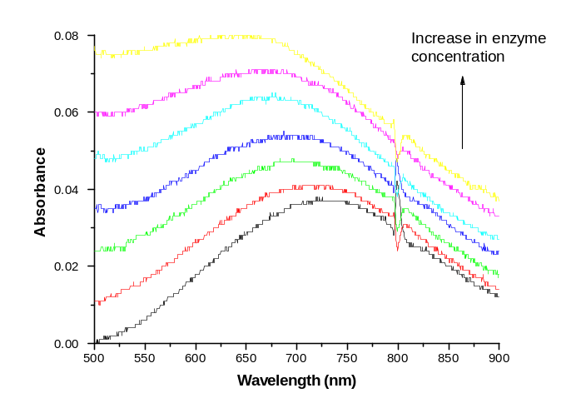

Figure S1. Changes in the UV-Vis spectra for the complex 3 upon addition of carbonic anhydrase.

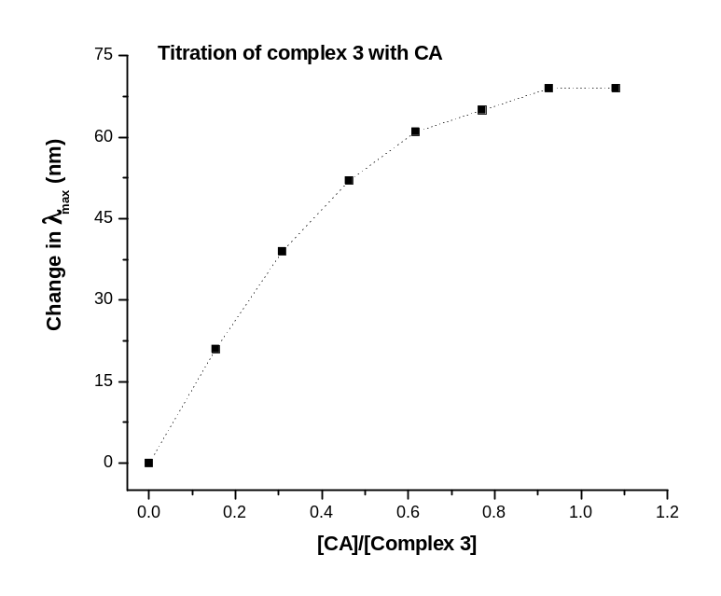

Figure S2. Changes in the absorption maxima are plotted against the ratio of enzyme to complex 3. The dotted line is connecting the data points; it is not a fitted curve.
Inhibition data for the complexes:

For determining the K_{i} values of complexes 2-4, the concentrations of different compounds required to achieve about 50% inhibition of the enzyme (2.5 μM) in the presence of 75 μM substrate (p-nitrophenyl acetate) were first determined (25 mM HEPES buffer, pH = 7.0; absorbance followed at 450 nm). The kinetic data were analyzed via the double reciprocal plots of the initial rates of the enzyme catalyses and the substrate concentrations in the presence of different concentrations of inhibitors. For clarity, such plots are shown only for selected concentrations of inhibitors (Figure S3). The double reciprocal plots revealed that all inhibitors (complexes 2-4) were competitive types. However, since the concentration of the enzyme utilized during the above experiments was comparable to those of different inhibitors, the free concentrations of inhibitors were calculated via the complete solution of the quadratic equation describing the enzyme-inhibitor interaction. For such calculations, the association constants of the individual enzyme-inhibitor complexes (determined via the isothermal titration microcalorimetry) were taken into account.
The enzyme activity was measured in a 25 mM HEPES buffer, pH 7.0, by addition of an appropriately diluted enzyme (2.5 μM) to the substrate solution (prepared in 15% acetonitrile), followed by measuring the increase in absorption at 450 nm. The initial (steady-state) rates of the enzyme catalyzed reaction as a function of substrate concentration were analyzed according to the Michaelis-Menten equation to obtain the K_{m} and V_{max} values. The K_{i} values of the enzyme-inhibitor complexes were determined according the following relationship: K_{i} = [I]/(K_{p}/K_{m}-1), where K_{p} and K_{m} Michaelis constants in the absence and presence of inhibitor.
All the inhibition data were analyzed according to the non-linear regression analysis package Grafit 4.0 (of Dr. Leatherbarrow, who initially wrote the widely utilized steady-state kinetic software package, “Enzfitter”), and presented the data in the form of the double reciprocal plots. The analyses of the data exclusively conformed to the competitive type of inhibition model. As can be visually seen from the data of Figure 3S, the K_{m} value in the presence of inhibitor is much higher than in its absence (eliminating the possibility of “uncompetitive inhibition”), and the V_{max} value remains unchanged (eliminating the possibility of “non-competitive inhibition”). Admittedly, due to solubility problems, we could not perform the inhibition studies at higher inhibitor concentrations to show the intersecting patterns at the Y-Axis for each inhibitor. However, since the K_{i} values derived from the inhibition studies are similar to the corresponding dissociation constants of the enzyme-inhibitor complexes, it attests to the internal consistency of our competitive inhibition model.

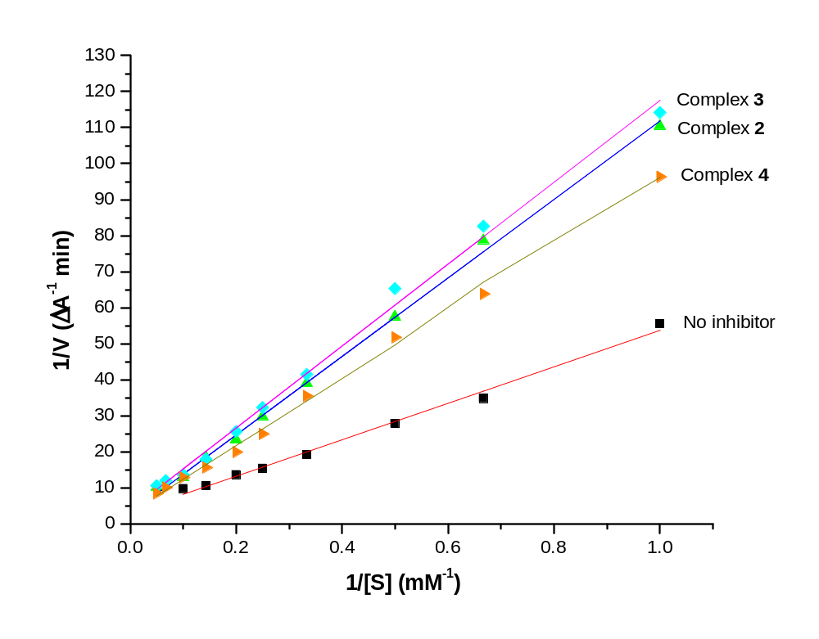
Figure S3. Double-reciprocal plots for the enzyme activity in presence of the inhibitors. The straight lines represent the fitted lines through the data points.

