Supplementary data

Poly(ruthenium carbonyl spirobifluorenylporphyrin) : a new polymer used as catalytic device for carbene transfer.

Cyril Poriel, ª Yann Ferrand, ª Paul le Maux, ª Christine Paul, ª Joëlle Raul-Berthelot, *^{b} and Gerard Simonneaux*ª

ªLaboratoire de Chimie Organométallique et Biologique, UMR CNRS 6509,Université de Rennes I, 35042 Rennes cedex, France. Fax: 02 23 23 56 37; Tel: 02 23 23 62 85; E-mail: gerard.simonneaux@univ-rennes1.fr

^{b}Laboratoire d’Electrochimie Moléculaire et Macromoléculaire, UMR CNRS 6510,Université de Rennes I, 35042 Rennes cedex, France. Fax: 02 23 23 67 32; Tel: 02 23 23 59 40; E-mail: joelle.rault@univ-rennes1.fr

General Experiments: All reactions were performed under argon and were magnetically stirred. Solvents were distilled from appropriate drying agent prior to use: Et₂O and THF from sodium and benzophenone, toluene from sodium, CH₂Cl₂ from CaH_{2,} CHCl₃ from P₂O₅ and all other solvents were HPLC grade. Commercially available reagents were used without further purification unless otherwise stated. All reactions were monitored by TLC with Merck pre-coated aluminium foil sheets (Silica gel 60 with fluorescent indicator UV₂₅₄). Compounds were visualized with UV light at 254 nm and 365 nm. Column chromatography was carried out using silica gel from Merck (0.063-0.200 mm). ¹H NMR and ¹³C NMR in CDCl₃ and Toluene d8 were recorded using Bruker (Advance 500dpx and 300dpx spectrometers) at 500 MHz and 75 MHz respectively. High-resolution mass spectra were recorded on a ZabSpec TOF Micromass spectrometer in FAB mode or ESI positif mode at the CRMPO.
All electrochemical experiments were performed using a Pt disk electrode (diameter 1mm), the counter electrode was a vitreous carbon rod and the reference electrode was a silver wire in a 0.1M AgNO₃ solution in CH₃CN. Ferrocene was added to the electrolyte solution at the end of a series of experiments. The ferrocene/ferrocenium (Fc/Fc⁺) couple served as internal standard and all reported potentials are referenced to its reversible formal potential. Activated Al₂O₃ was added in the electrolytic solution to remove excess moisture. The three electrodes cell was connected to a PAR Model 173 potentiostat monitored with a PAR Model 175 signal generator and a PAR Model 179 signal coulometer. The cyclic voltammetry traces (CVs) were recorded on an XY SEFRAM-type TGM 164.
Acetonitrile with less than 5‰ of water (ref.SDS00610S21) and dichloromethane with less than 100 ppm of water (ref. SDS 02910E21) were used without purification. Tetrabutylammonium hexafluorophosphate from FLUKA was used without any purification. Aluminium oxide was obtained from Woëlm, activated by heating at 300°C under vacuum for 12 h and used at once under argon pressure.
Liquid UV-visible spectra were recorded on a UVIKON XL from Biotech. Solid UV-visible spectra were recorded using a Guided Wave model 150 spectrophotometer with optical fibres; a concave platinum surface acts as a reflector for the optical beam.

All catalytic reactions were controlled on a Varian CP-3380 Gas Chromatograph equipped with a CP-Chirasil-Dex Column.
Scanning Electron Microscopy was performed on JEOL JSM 301F.
Electronic Microanalyses were performed on JEOL JSM 6400 using an Energy Dispersive spectrometry (EDS) detector Oxford-Link Isis.
Spectroelectrochemical experiments were performed on a JASCO- V570 Spectrophotometer.
Infra Red spectra were performed in KBr disk in a IFS 28 Bruker.

Synthesis and characterization

Synthesis of (TSP)H₂ :

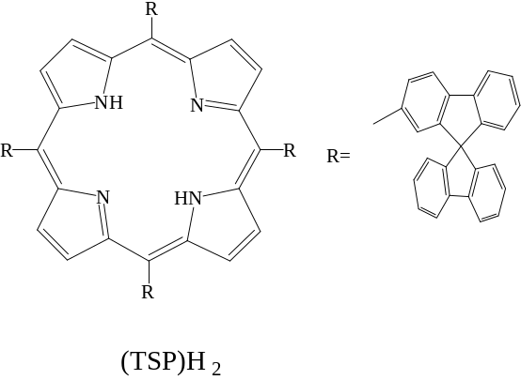

Pyrrole (7.5 mmol) and 9,9'-spirobi[fluorene]-2-carbaldehyde (7.5 mmol) are allowed to react at room temperature in dry and degassed dichloromethane (750 mL), under an argon atmosphere and protected from light, with trace acid catalysis (BF₃(OEt)₂ 48%: 0.75 mmol). Under these conditions the reaction reaches equilibrium in about 3 hours. A stoichiometric amount of p-chloranil is added to irreversibly oxidize the tetra-spiroporphyrinogene. After addition of several drops of triethylamine and the ordinary work-up, concentration, washing, drying, the crude reaction mixture is chromatographied twice on silica gel (first: dichloromethane; second: cyclohexane/ dichloromethane: 1/3) and crystallize in toluene for one night to afford a purple powder of meso-tetrakis 5,10,15,20-(spirobifluoren-2-yl) porphyrin.

Yield : 40 %

UV-VIS (CH₂Cl₂): λ max/nm (log ε ): 652 (3.44), 594 (3.42), 556 (3.84), 520 (3.98), 427 (5.39), 342 (4.07) 309 (4.53), 297 (4.50), 228 (5.21).

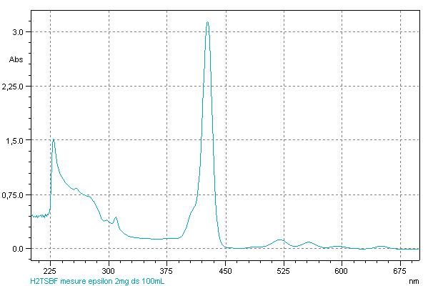

Mass (FAB) (m/z): calculated for C₁₂₀ H₇₁ N₄ (M+H)⁺: 1567.5634 found: 1567.5600

¹H NMR (500MHz, CDCl₃): δ 8.57 (H β  pyrrole, s, 4H), 8.55 (H β  pyrrole, s, 4H), 8.15-8.07 (m, 12H), 7.75-7.69 (m, 8H), 7.53- 7.42 (m, 8H), 7.34-7.32 (m, 9H), 7.27-7.18 (m, 11H), 7.09-7.05 (m, 8H), 6.88 (d, 4H), -3.13 (s, 2H, NH).

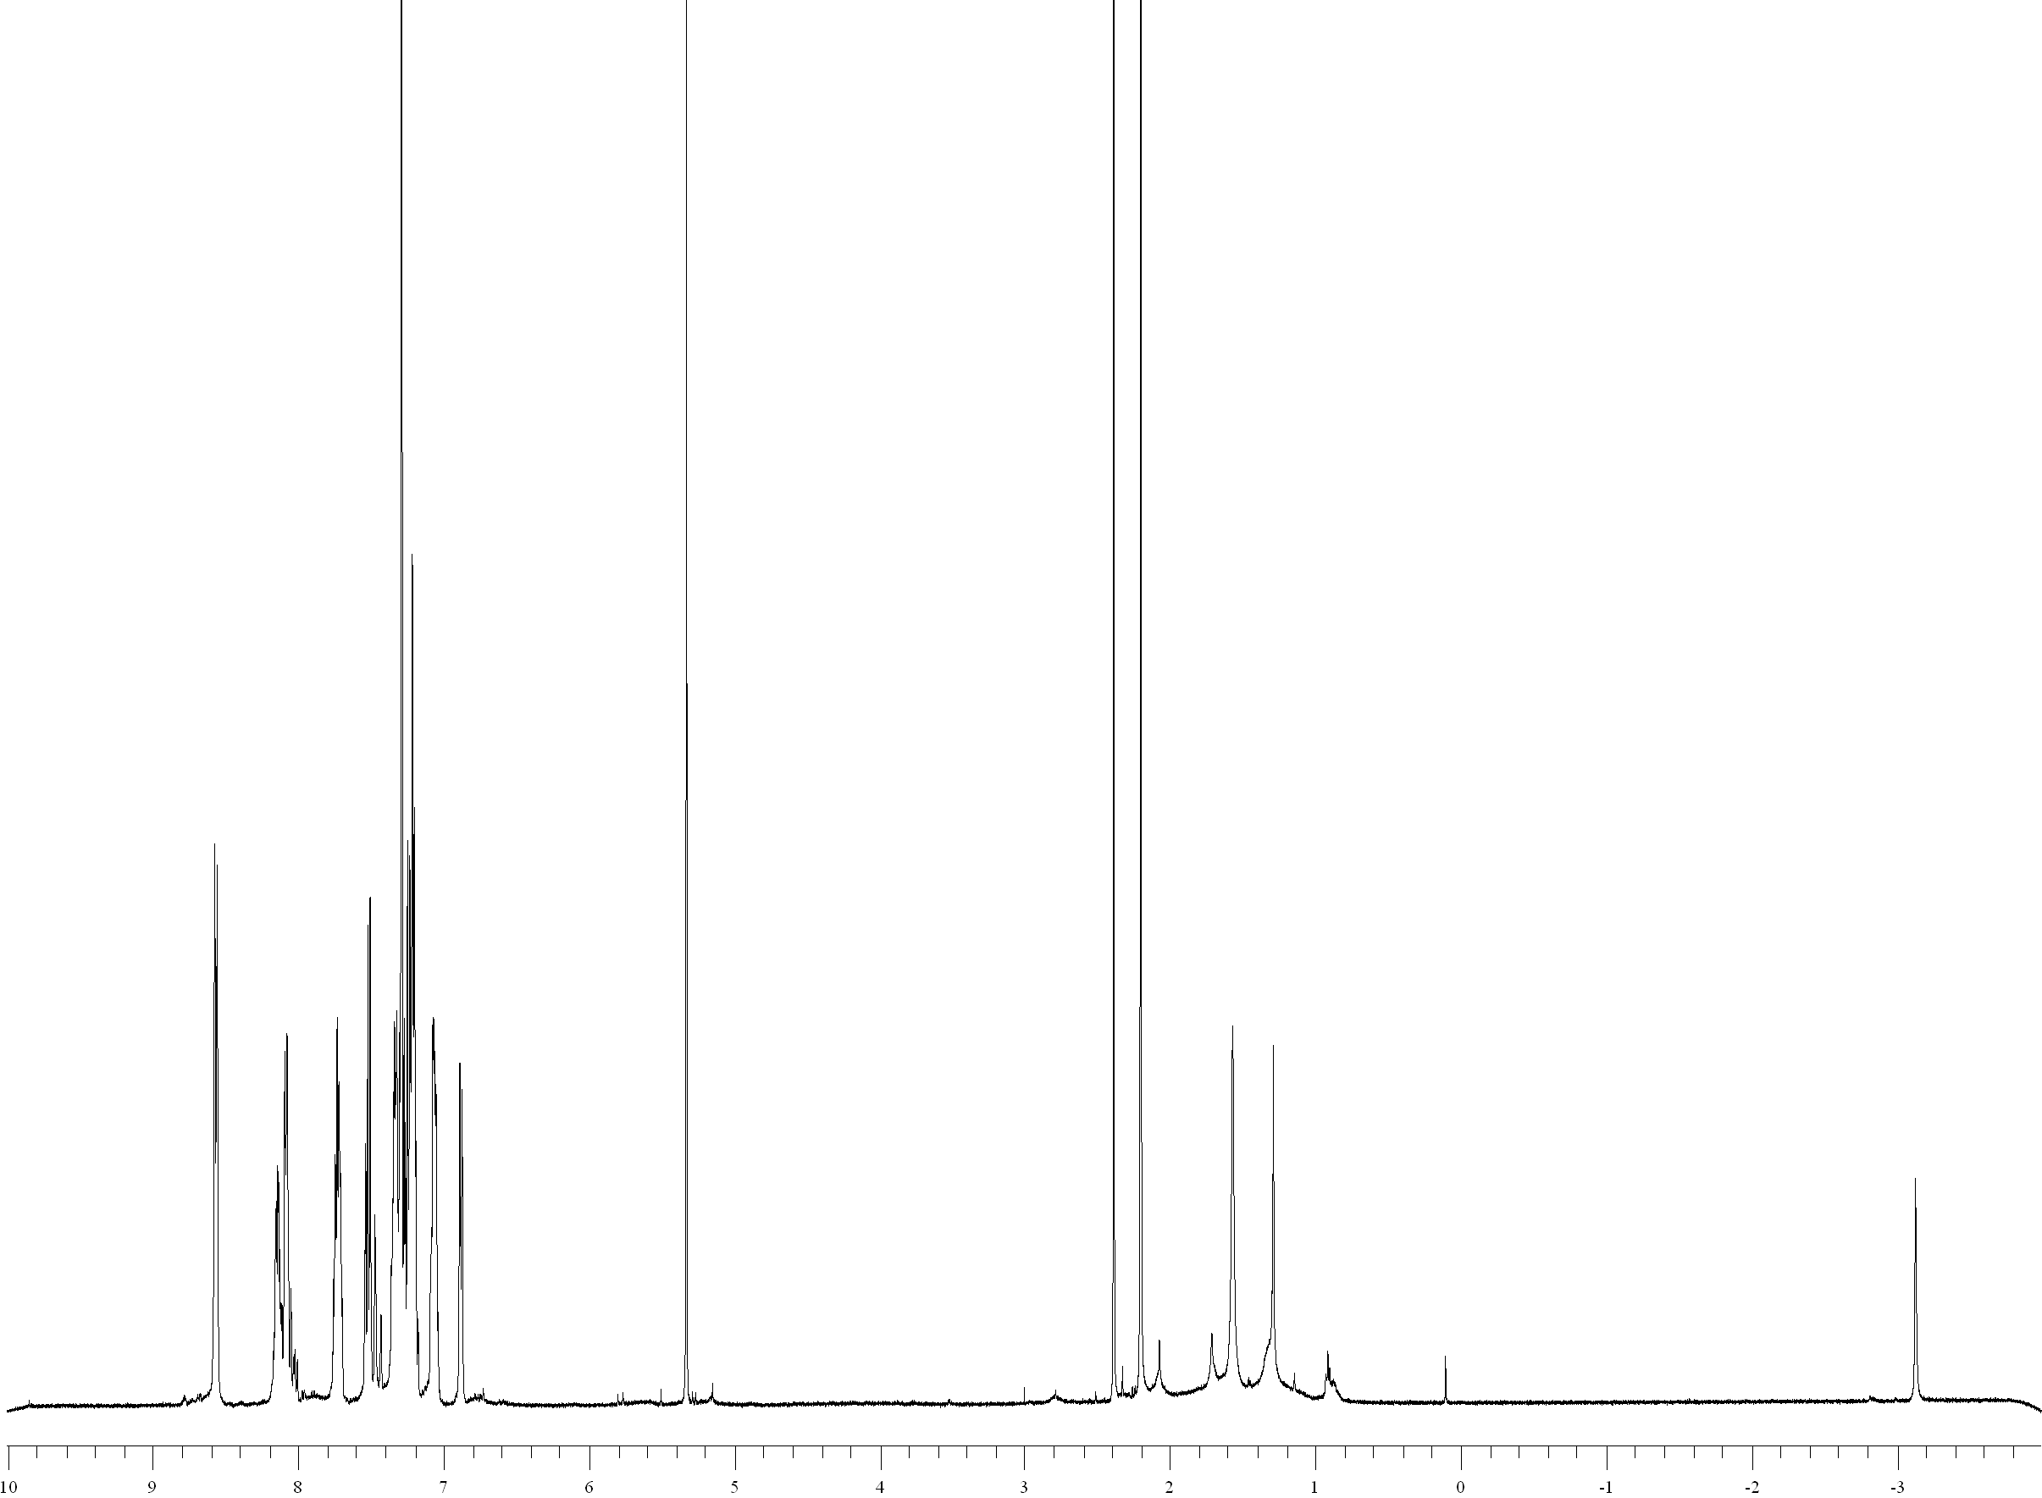
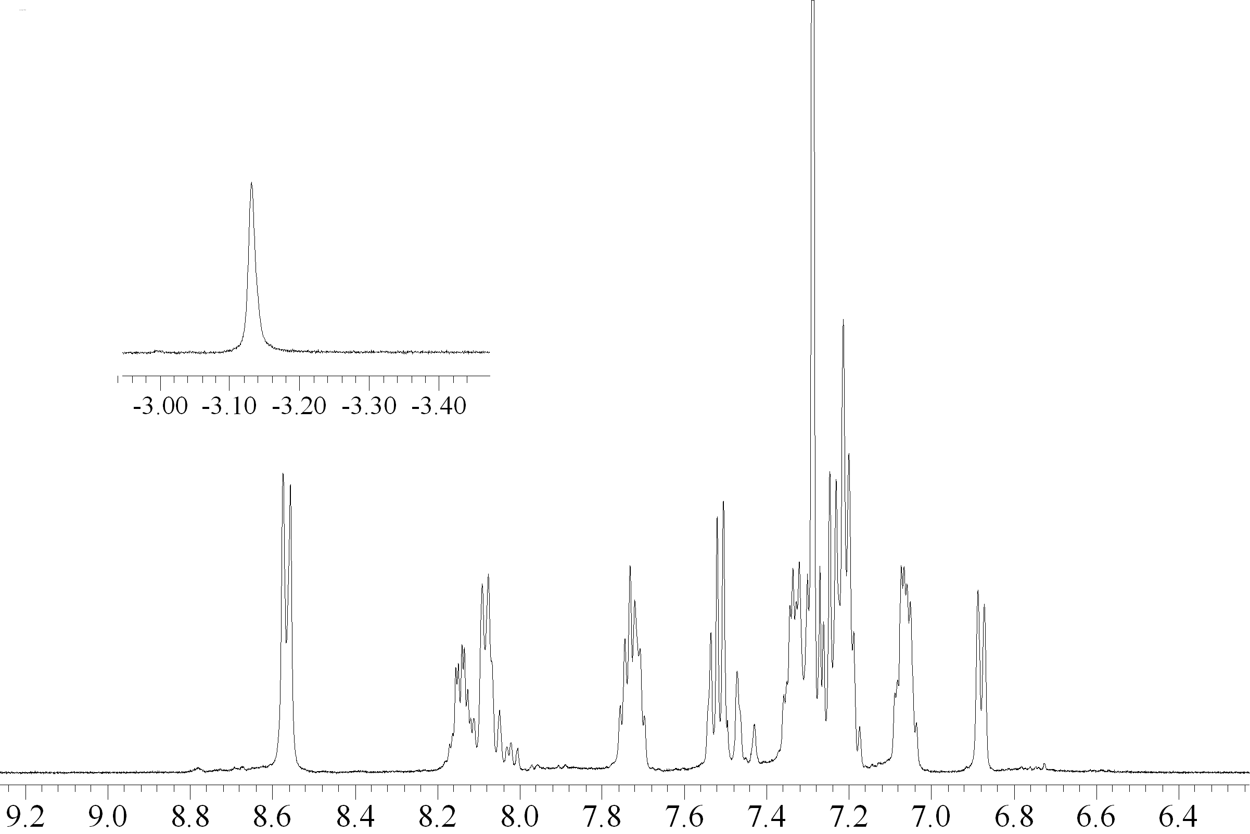
ppm

CV (CH₂Cl₂ 0.2M/ Bu₄NPF₆, Fc/Fc⁺): 0.58, 0.91, 1.39 (shoulder), 1.50 V

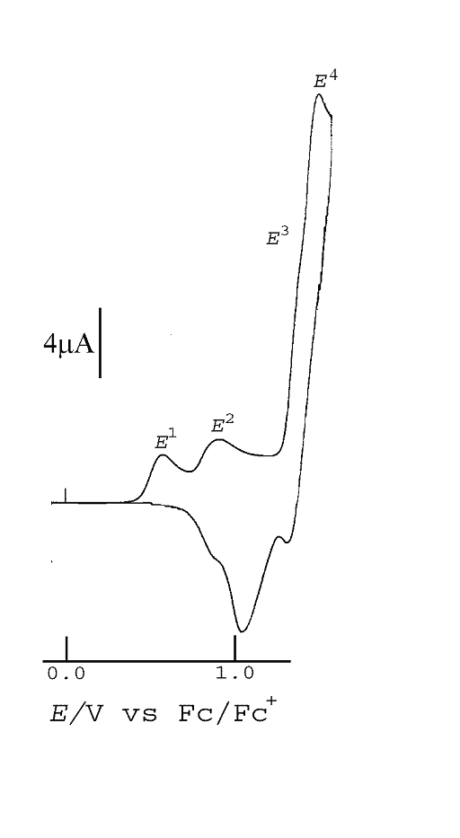

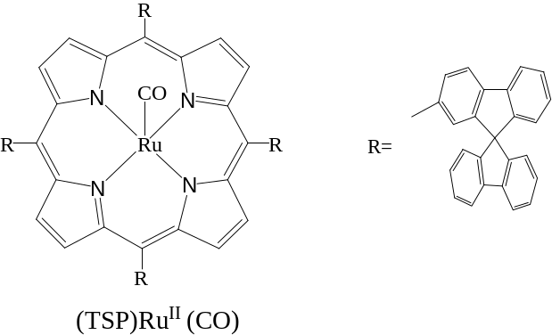

To a solution of (TSP)H₂ (191 mmol) dissolved in commercial degassed o-dichlorobenzene and heated at 160°C is added by portion, Ru₃CO₁₂ (573 mmol). The mixture is stirred under an argon atmosphere for 2 hours until the reaction is completed. The solvent is removed under high vacuum and the crude product is chromatographied on silica gel using first pentane, then a mixture of pentane/dichloromethane (1/1). The major red-orange band is collected and dried under vacuum to afford a red powder of meso-tetrakis 5,10,15,20(spirobifluoren-2-yl) porphyrinato ruthenium carbonyl.

Yield: 95 %
UV-VIS (CH₂Cl₂): λ max/nm (log ε): 569 (3.84), 533 (4.28), 420 (5.31), 309 (4.74), 298 (4.66), 228 (5.1)
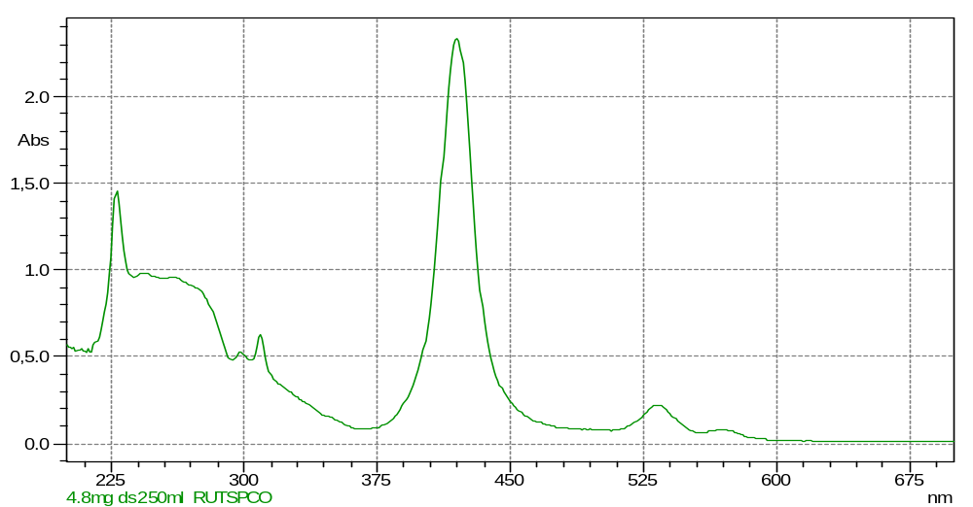

Mass (ESI, CH₂Cl₂/MeOH 9/1) (m/z): calculated for C₁₂₁ H₆₈ N₄ O Na ¹⁰²Ru: 1717.4334 found: 1717.4330

IR (KBr, cm⁻¹): 1952.

¹H NMR (500MHz, CDCl₃) :

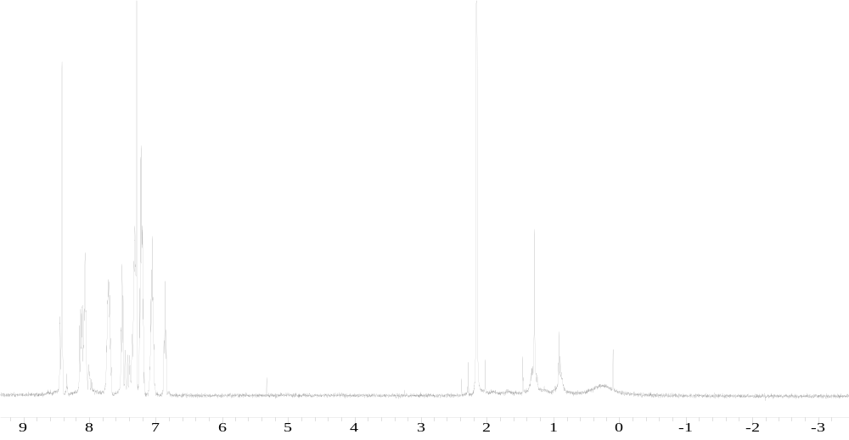

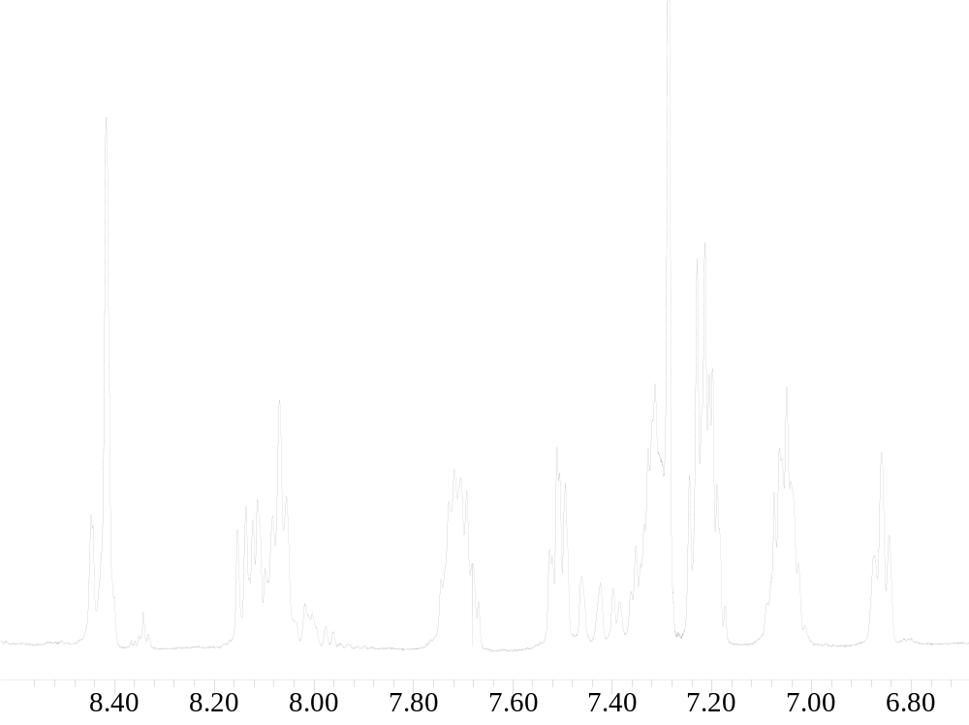

CV (CH₂Cl₂ 0.2M/ Bu₄NPF₆, Fc/Fc⁺): 0.46, 0.89, 1.37

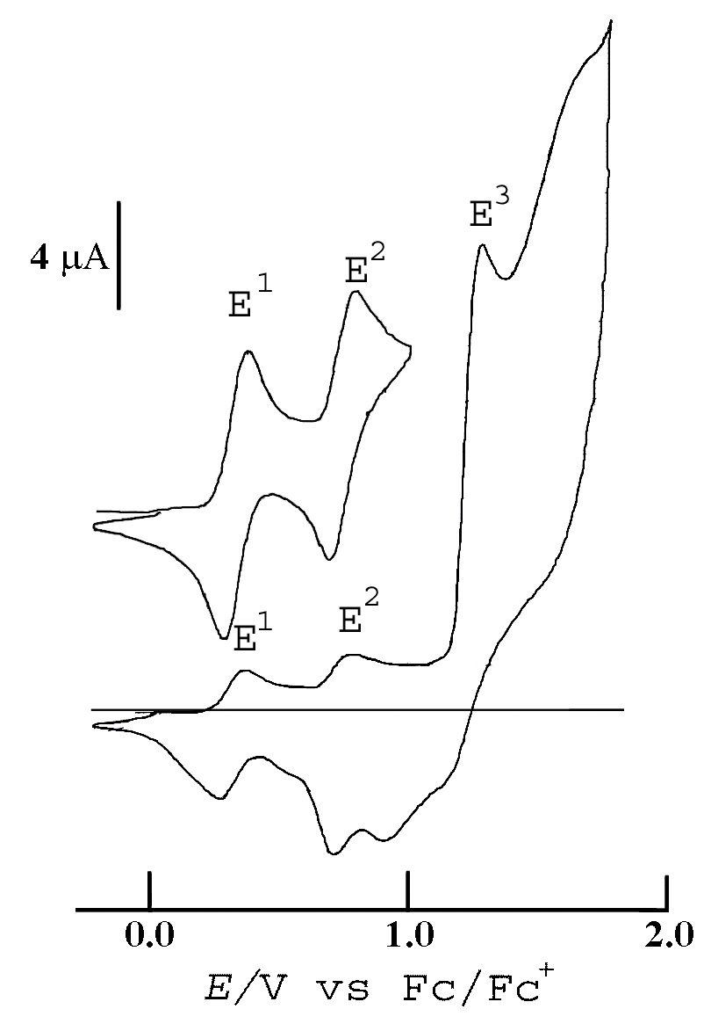

Catalytic procedure:

Cyclopropanation :

Using an excess of alkene (5 equivalents versus diazo compound): slow addition (3 hours) of ethyl diazoacetate (100 equivalents relative to catalyst) to a mixture of (P)RuCO/alkene (1/500) in dichloromethane under anaerobic conditions. Time reaction is 4 hours for both poly (1) and 1 (room temperature).

2,3 sigmatropic rearrangement

Using an excess of sulfide (5 equivalents versus diazo compound): slow addition (3 hours) of ethyl diazoacetate (100 equivalents relative to catalyst) to a mixture of (P)RuCO/alkene (1/500) in dichloromethane under anaerobic conditions. Time reaction is 4 hours for both poly (1) and 1 (room temperature).

Typical experiment

Homogeneous catalysis :

To a solution 1mM of (TSP)RuCO 1 (1μmol) in dichloromethane (1 mL) is added 48 µL of styrene (500 μmol). Then 13 µL (100 µmol) of ethyl diazoacetate is slowly injected (3 hours) to the stirred solution. In order to prevent the formation of diethyl fumarate and maleate, the concentration of the diazo compound was kept at low levels by slow addition of ethyl diazoacetate. The mixture is then stirred under an argon atmosphere for 1 hour. Resulting products of cyclopropanation (cis/trans adducts) are monitored by gas chromatography. Fumarate and maleate resulting from the self condensation of the carbene are also monitored.

Heterogeneous catalysis :

After scratching the film out of the electrode, the polymer was crushed to obtain a fine powder which is stored under nitrogen at 0°C. The material was used without any further treatment for all catalytic experiments.

To a mixture of Poly (1) (3mg) in dichloromethane (1mL) is added 48 µL of styrene (500 μmol). Then 13 µL (100 µmol) of ethyl diazoacetate is slowly injected (3 hour) to the stirred solution. In order to prevent the formation of diethyl fumarate and maleate, the concentration of the diazo compound was kept at low levels by slow addition of ethyl diazoacetate. The mixture is then stirred under an argon atmosphere for 1 hour. Resulting products of cyclopropanation (cis/trans adducts) are monitored by gas chromatography. Fumarate and maleate resulting from the self condensation of the carbene are also monitored.
The polymer is washed with dichloromethane, dimethyl sulfoxide and acetone dried under vacuum and used for another run in the same experimental conditions.

Competitive experiment

Competitive catalytic cabene transfer was performed with a 1:1 mixture of styrene and allylmethyl sulfide. A 10:1 substrate to diazo ratio is used in order to avoid formation of over addition products. Resulting products are monitored by gas chromatography.

The contents of (TSP)RuCO in poly(1) were calculated from the Ru contents in the heterogen catalysts determined by scanning electron microscopy and electronic microanalysis.

Results

- cyclopropanation

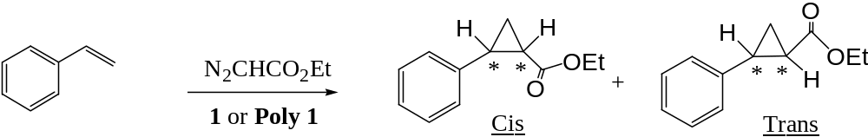

 | Yield (%) | cis/trans | Dimer*(%)
1 | 83 | 1/5.7 | 5
Poly 1 | 85 | 1/9.1 | 5

* : diethyl fumarate and maleate

- 2,3 sigmatropic reaction

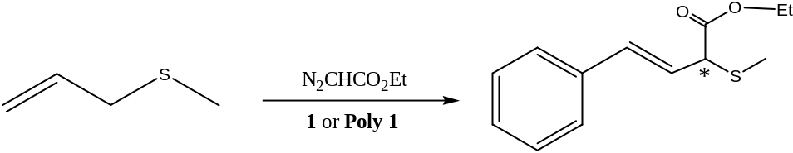

 | Yield (%) | Dimer*(%)
1 | 88 | 8
Poly 1 | 87 | 5

* : diethyl fumarate and maleate

Scanning Electron Microscopy on Poly (1)

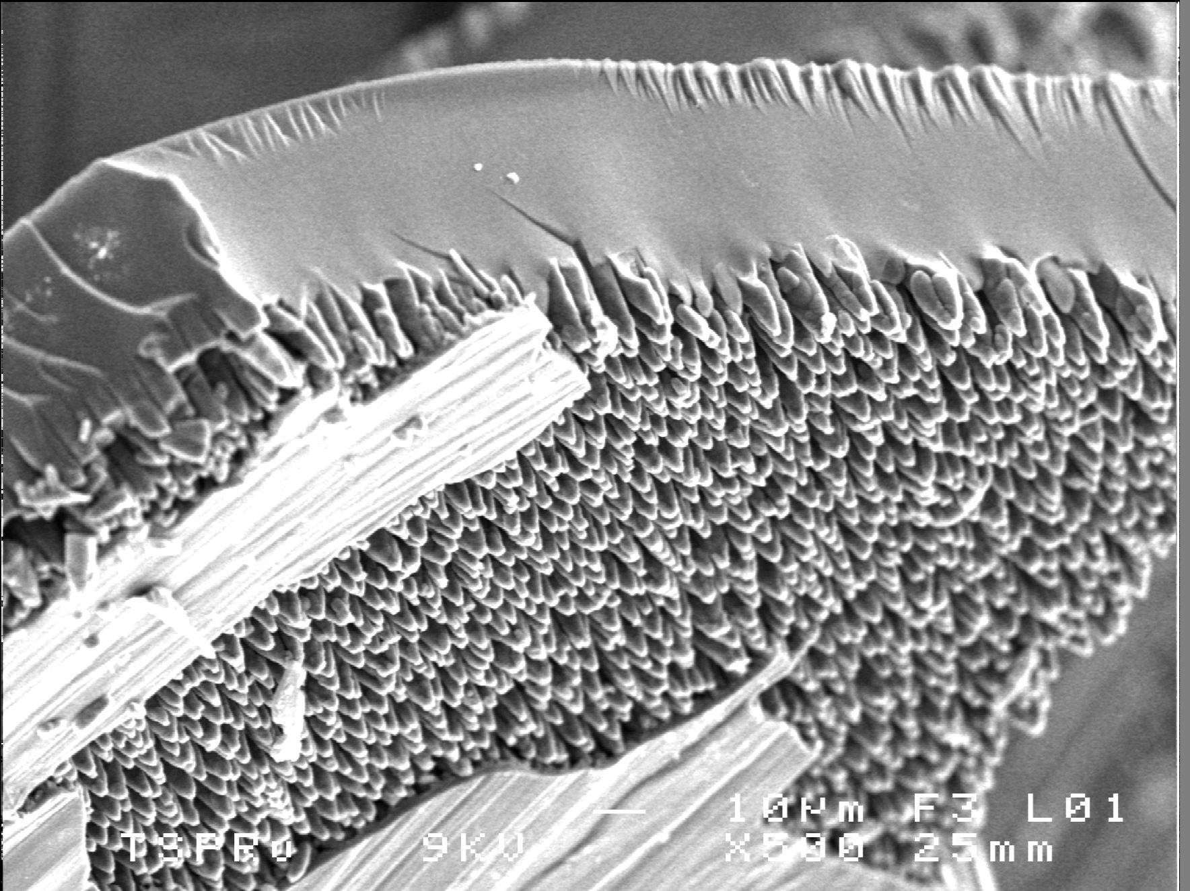

Side view of poly (1) (x500)

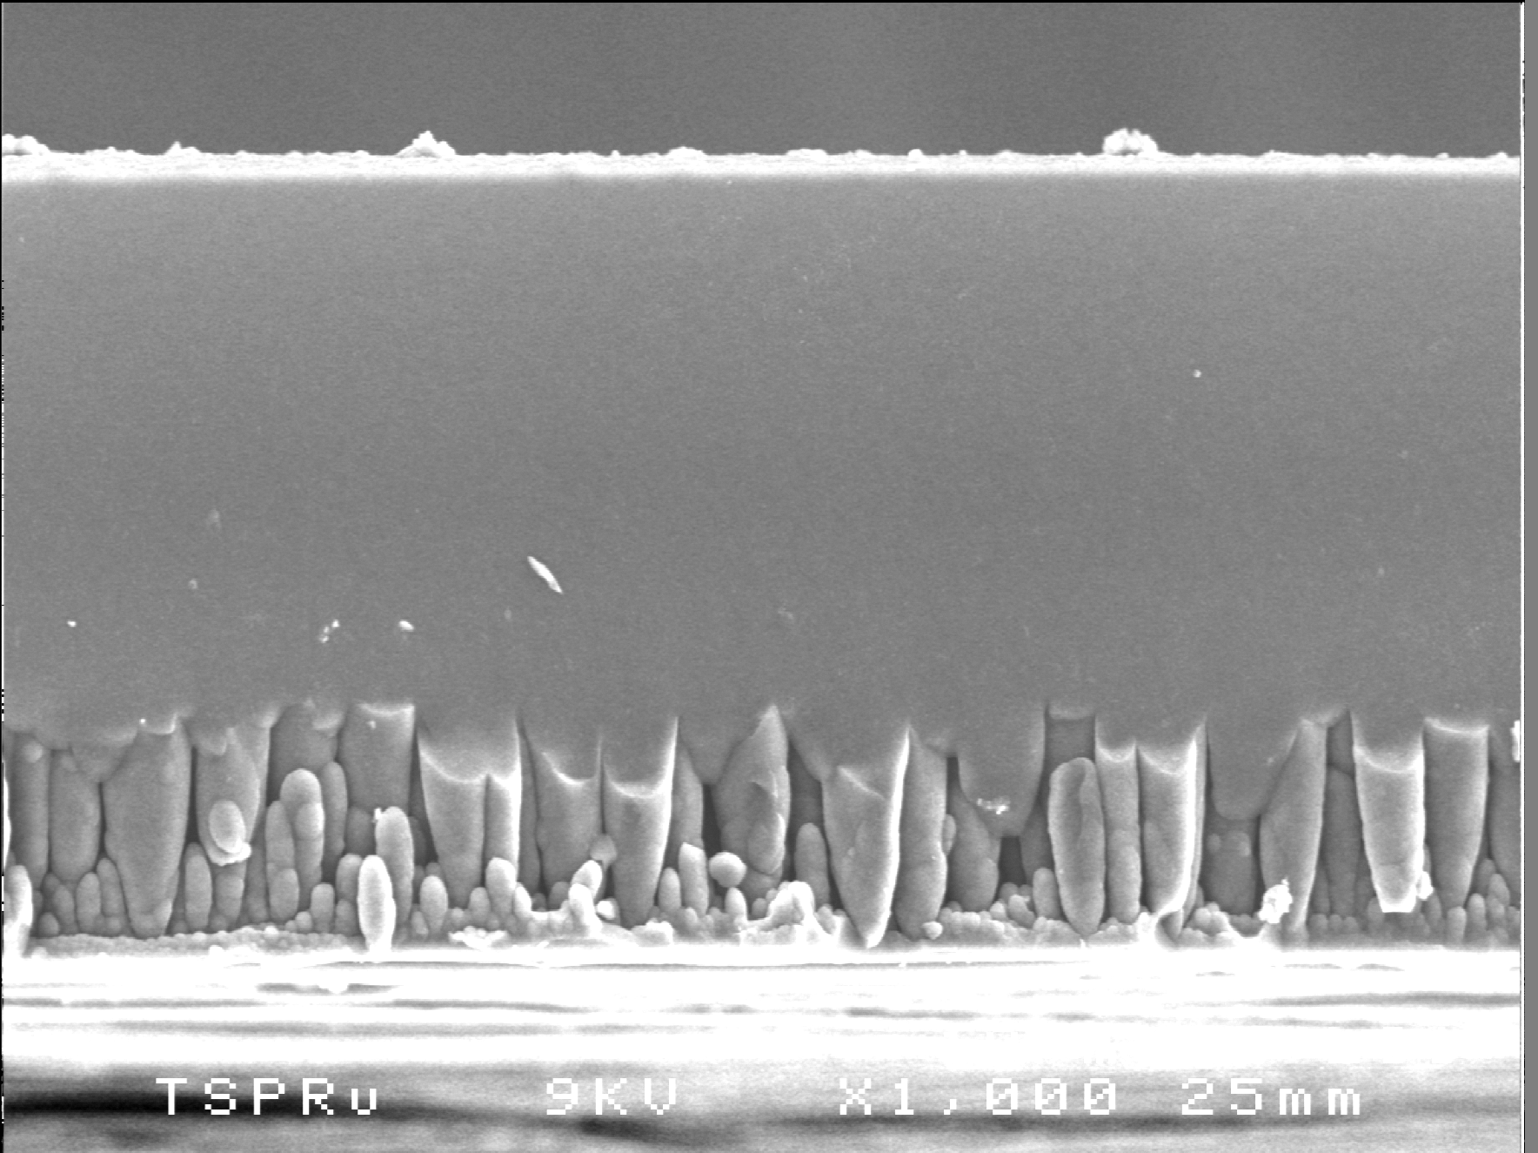

Side view of poly (1) (x1000)

