Supporting Information for

O−H Bond elongation in co-ordinated water through intramolecular P=O•••H−O bonding. ‘Snap-shots’ in phosphate ester hydrolysis

Ramaswamy Murugavel,^{a,}* Malaichamy Sathiyendiran,ª Ramasamy Pothiraja,ª and Ray J. Butcher^{b}
ª Department of Chemistry, IIT-Bombay, Powai, Mumbai-400 076, India. E-mail: rmv@iitb.ac.in
^{b} Department of Chemistry, Howard University, Washington DC, USA

Synthesis of [Mn(dtbp)₂(phen)(OH₂)] (1). A beige solution of Mn(OAc)₂·4H₂O (122 mg, 0.5 mmol) in ethanol (60 mL) was added into a solution of 1,10-phenanthroline (100 mg, 0. 5 mmol) under constant stirring to result in a yellow solution to which dtbp-H (210 mg, 1 mmol) was added. The solution was filtered and left at room temperature to yield crystals of 1 after 98 h. Yield : 212 mg (63 %). C₂₈H₄₆Mn₁N₂O₉P₂: C 50.1; H 6.9; N 4.2. Found: C 50.4; H 6.7; N 4.3. IR (KBr, cm⁻¹): 3453 (w), 3071(s), 2973(vs), 2940(s), 1703(s), 1578(s), 1518(s), 1426(s), 1390(s), 1366(s), 1252(vs), 1182(vs), 1086(vs), 1037(s), 981(vs), 914(s), 849(s), 830(s), 721(s), 599(s), 550(s), 493(s), 451(s).

Synthesis of [Cu(dtbp)₂(phen)(OH₂)] (2). Cu(OAc)₂·H₂O (50 mg, 0.25 mmol), dtbp-H (105 mg, 0.5 mmol) and 1,10-phenanthroline (50 mg, 0.25 mmol) were dissolved in methanol (50 mL) and the resulting green solution was stirred for 5 min and the solvent was removed under vacuum. The residue was dissolved in acetonitrile/acetone (1:1) mixture, filtered and left at room temperature to yields crystals of 2 after 48 h. Yield: 158 mg (93 %). Anal. Calcd for C₂₈H₄₆Cu₁N₂O₉P₂: C 49.4; H 6.8; N 4.1. Found: C 49.3; H 6.8; N 4.0. IR (KBr, cm⁻¹): 3333(vs), 3088(w), 2982(vs), 2940(s), 1521(s), 1429(s), 1392(s), 1368(s), 1255(s), 1236(s), 1173(vs), 1102(vs), 1066(s), 997(vs), 858(s), 831(s), 725(s), 675(s), 583(s), 501(s). UV-vis (CH₃OH, nm): 301, 702.

Table of comparison of selected structural parameters obtained for 2 at 293, 203, and 93 K
Diffraction Temp. | 293 K | 203 K | 93 K
Volume | 3391.6(4) | 3230(1) | 3198.0(4)
% Shrinkage of unit cell | -- | 4.8 % | 5.7 %
R₁ (I > 2σ (I)) | 0.058 | 0.050 | 0.053
wR₂ (I > 2σ (I)) | 0.125 | 0.134 | 0.102
Bond Distances, Å
Cu(1) - N(1) | 2.009(4) | 2.008(3) | 2.014(2)
Cu(1) - N(2) | 2.077(4) | 2.050(2) | 2.049(2)
Cu(1) - O(1) | 2.125(3) | 2.138(2) | 2.154(2)
Cu(1) - O(5) | 1.974(3) | 1.962(2) | 1.961(2)
Cu(1) - O(9) | 1.975(3) | 1.976(2) | 1.984(2)
P(1) - O(1) | 1.498(4) | 1.495(2) | 1.503(2)
P(1) - O(2) | 1.468(4) | 1.497(2) | 1.502(2)
P(1) - O(3) | 1.541(4) | 1.578(2) | 1.594(2)
P(1) - O(4) | 1.554(6) | 1.596(2) | 1.598(2)
P(2) - O(5) | 1.514(3) | 1.516(2) | 1.517(2)
P(2) - O(6) | 1.494(4) | 1.483(2) | 1.493(2)
P(2) - O(7) | 1.581(4) | 1.584(2) | 1.595(2)
P(2) - O(8) | 1.575(4) | 1.575(2) | 1.583(2)
O(9) - H(9A) | 1.07(9) | 0.92(5) | 0.92(4)
O(9) - H(9B) | 0.69(5) | 0.81(5) | 0.78(4)
Bond Angles, º
O(5) - Cu(1) - O(9) | 94.66(17) | 94.75(10) | 94.52(8)
O(5) - Cu(1) - N(1) | 89.74(15) | 89.77(10) | 89.94(8)
O(9) - Cu(1) - N(1) | 171.59(18) | 170.29(10) | 169.41(8)
O(5) - Cu(1) - N(2) | 145.58(16) | 150.80(10) | 153.27(8)
O(9) - Cu(1) - N(2) | 91.70(17) | 91.15(10) | 90.82(9)
N(1) - Cu(1) - N(2) | 80.67(16) | 80.81(10) | 80.99(9)
O(5) - Cu(1) - O(1) | 109.92(15) | 105.00(9) | 103.66(7)
O(9) - Cu(1) - O(1) | 91.75(17) | 91.65(9) | 91.95(8)
N(1) - Cu(1) - O(1) | 93.49(15) | 95.50(9) | 96.33(8)
N(2) - Cu(1) - O(1) | 103.65(15) | 103.38(9) | 102.31(8)
Difference map plots for the structure of 2 measured at 293 (top), 203 (middle) and 93 K (bottom) in the O9, H9a, and H9b plane (in x-y plane).
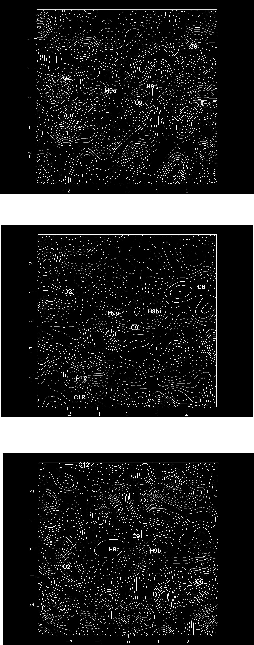

293 K

203 K

93 K

