Supporting Information

1. Preparation of the materials
For example, 5/5 AEP/CP-MP was prepared by the following method:
The mixture of CTAB (2.0 g, 5.49 mmol), 2.0 M of NaOH (aq) (7.0 mL, 14.0 mmol) and H₂O (480 g, 26.67 mol) was heated at 80 ºC for 30 min. To this clear solution, TEOS (9.34 g, 44.8 mmol), AEPTMS (0.76 g, 2.88 mmol) and CPTES (0.67 g, 2.88 mmol) were added sequentially and rapidly via injection. The reaction mixture was allowed to be vigorously stirred (rpm ca. 550). White solids were observed within 2 min upon the mixing of the initial opaque emulsion. The reaction was further heated at 80 ºC for 2 h then white solids were separated by hot filtration of the mixture giving rise to the as-made solid products. The products were washed with copious amount of water and methanol and then dried under vacuum. An acid extraction was performed in methanol (100 mL) mixture of concentrated hydrochloric acid (0.3 ~ 1.0 mL) and as-made materials (1.0 g) at 50 ºC for 1.5 ~ 2 h. Resulting surfactant-removed solid products were filtered and washed with water and methanol and then dried under vacuum. The materials were dried under vacuum at 90 ºC for 3 h before Cu(II) adsorption tests and solid state NMR study.

2. Cu(II) adsorption capacity test
The Cu(II) adsorption capacity tests were performed according to the literature method. We used 0.01 M Cu(NO₃)₂·2.5H₂O in 0.1 M tris(hydroxymethyl)aminomethane (= Trizma, Aldrich) solution and the contact time was 1 h. The remaining amount of Cu(II) ions in the filtrate was measured using HP 8453 diode array UV/VIS spectrophotometer at λ_{max} = 601 nm after a centrifuge.

3. Summary of NMR measurements
3.1. Experimental
¹³C solid-state nuclear magnetic resonance (NMR) was used to (i) obtain spectroscopic evidence for the presence of various organic functional moieties in the mesopores, (ii) confirm their structure, and (iii) measure the relative concentration of both moieties in bifunctionalized samples, whereas ²⁹Si NMR data (i) confirmed finctionalizaton of mesoporous materials with AEP and CP organic groups, (ii) provided relative concentration of T^{n} and Q^{n} groups, and (iii) imparted molecular formula of AEPMP and CPMP samples as well as molar concentration of organic functionalities (AEP or CP) in the mesopores.
The spectra were obtained at 9.4 T on a Varian/Chemagnetics Infinity spectrometer, resonating at 100.59 (¹³C), and 79.47 MHz (²⁹Si), equipped with a doubly tuned, 5 mm magic angle spinning (MAS) probe. ¹H→¹³C variable amplitude cross polarization (CP) pulse sequence (Fig. S1) was used to enhance the carbon signal and the repetition rate of data acquisitions. During each cross polarization period, the ¹H rf field was ramped between 16 and 40 kHz using 2.4 kHz increments, whereas the ¹³C rf field was maintained at a constant level of 36 kHz. The ¹H rf magnetic fields of 83 kHz and 60 kHz were used for initial excitation and decoupling, respectively. The values of ¹H longitudinal relaxation time T₁^{H} encountered in all mesoporous samples examined in this study did not exceed 1 s, which allowed for repetition time of 1.2 s to be used in the CPMAS experiments. Typically, 5 to 10K scans were accumulated using a sample rotation rate of 9 kHz.
Fig. S2 presents the ¹³C CPMAS spectra acquired for the mesoporous materials functionalized with AEPTMS (spectrum a, AEP-MP) and CPTES (spectrum b, CP-MP). The NMR results demonstrate that the mesopores are indeed functionalized as intended. The specific resonances are assigned based on the chemical shifts found in the liquid state spectra of the analogous compounds. Carbons C1 and C2 in both samples are observed at around 10 and 20 ppm, respectively. In CP-MP, the C3 carbon resonates at 19 ppm, while in AEP-MP the corresponding line is shifted downfield to 39 ppm due to the influence of an adjacent nitrogen atom. The remaining carbon sites can serve as suitable fingerprints of both functional groups. In AEP-MP, the resonances from carbons C4-C7 are superimposed at around 48 ppm, whereas C4 carbon in CP-MP is found at 120 ppm.
For silicon measurements (see Fig. S3), direct polarization (DP) of ²⁹Si nuclei experiment at 10 kHz MAS was chosen, which involved single excitation 90° pulse of 2.1 μs followed by acquisition of ²⁹Si data accompanied by continuous wave (CW) decoupling of ¹H nuclei at 65 kHz rf power. Typically 270 repetitions were completed using pulse delay of 300 s. For additional evidence of presence of T^{n} groups, ¹H→²⁹Si CPMAS spectra were recorded under similar experimental conditions as ¹H→¹³C CPMAS data, but contact time of 10 ms and 2K accumulations. Specifically the silicone groups were found at positions: -56 (T²), -67 (T³), -92 (Q²), -101 (Q³), and -110 ppm (Q⁴).
3.2. Quantification of silicon groups
Quantitative measurements of various T^{n} and Q^{n} silicon groups could be achieved only by ²⁹Si DPMAS experiment. Although T₁ of ²⁹Si is typically in order of minutes, pulse delay of 300 s was chosen to assure restoration up to 99% of initial magnetization. Indeed saturation recovery experiment, completed for allyl- and 3-isocyanatopropyl- functionalized MCM-41 samples, revealed that values of T₁ relaxation time are in the order of 50 to 65 s for T^{n} groups and of 30 to 45 s for Q^{n} groups. Hence integrals of those groups, obtained from ²⁹Si DPMAS spectra, were achieved with 3 % accuracy. Following are relative concentrations, molecular formulas and molar concentration of organic moieties (±0.05 mmol/g accuracy) in AEP-MP and CP-MP attained from ²⁹Si DPMAS experiment.

 | Relative concentration of silicon groups [%] |  |  |  |  | Molecular Formula | Molar concentration of organic group [mmol/g]
 | T² | T³ | Q² | Q³ | Q⁴ | Molecular Formula | Molar concentration of organic group [mmol/g]
AEP-MP | 1 | 6 | 3 | 35 | 55 | (SiO₂)₁₀₀(H₂O)_{17.5}(C₇H₁₉N₃)₇ | 0.95
CP-MP | 2 | 8 | 2 | 29 | 59 | (SiO₂)₁₀₀(H₂O)_{12.5}(C₄H₇N)₁₀ | 1.44

3.4. Quantification of functional groups in bifunctionalized samples
It is noted that direct (single pulse) ¹³C polarization is often the preferred method in applications involving quantitative measurements. We initially tried to use this method, but chose the cross-polarization (CPMAS) experiment for three reasons. First, the relaxation delays required for direct excitation were prohibitively long, on the order of several minutes. In addition, the delays would have to be measured in several samples to assure quantitative accuracy. Second, all NMR probes used in our laboratory have some level of ¹³C background, which interfered with the signals of interest to this study. Since most of the background originated from parts of the probe made of teflon, these unwanted signals were completely 'invisible' under the ¹H→¹³C cross polarization. Another important benefit of using the CPMAS method was the observation of very different dynamic properties of AEP and CP, as described below. This discovery would not have been possible without the measurements of CPMAS dynamics.
The time evolution of each carbon magnetization during the CPMAS experiment is a result of complicated interplay between the spin-lattice relaxation processes in the rotating frame, described by relaxation time T_{1ρ}^{H}, and cross polarization kinetics. The CP kinetics, in turn, is further influenced by sample spinning, molecular motions and sample heterogeneity. In the simplest case, for each resonance the time dependence of the ¹³C magnetization M_{xy}(τ) during the cross-polarization contact is given by
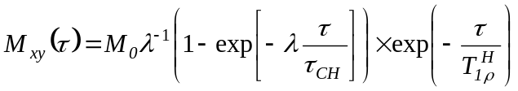 (1)
where M₀ is the carbon equilibrium magnetization, τ is the CP contact time, τ_{CH} is the time CP constant for a given species and of λ = 1 - τ_{CH}/T_{1ρ}^{H}. In general, a wide range of τ_{CH} and T_{1ρ}^{H} times can exist in molecular systems with different ¹³C-¹H distances and/or in the presence of internal motion. MAS introduces additional time dependencies to homo- and heteronuclear dipolar Hamiltonians and further complicates the polarization transfer.
In this study, we measured separately the 'build-up' of a carbon magnetization during spin-lock for the mesoporous materials mono-functionalized with AEPTMS and CPTES. By fitting the experimental data using equation (1), we obtained the values of M₀, as well as the T_{1ρ}^{H} and τ_{CH} times for all carbons in these samples. The results of Table S1 show that the values of τ_{CH} found for CH₂ groups in AEP-MP are on the order of 60 μs, which is consistent with the literature data for such groups in rigid molecules. A similar time constant has been found for the C1 carbon in CP-MP. However, the evolution of resonance at 19 ppm in this sample involved two time constants of approximately 100 and 700 μs. This result shows that the C2-H₂ and C3-H₂ groups in CP-MP experience increasing mobility, which weakens the dipolar coupling between ¹H and ¹³C nuclei and inhibits the CP process. The τ_{CH} value of 5 ms observed for carbon C4 is consistent with the nitrile end of CPTES being the most mobile.
The standard strategy for measuring the relative concentrations using CPMAS involves fitting the build-up curves to obtain the values of M₀ for different 13C resonance lines. However, our measurements showed that in the bifunctionalized AEP/CP-MP samples studied in this work the relaxation parameters were the same, within the experimental error, as for the corresponding carbon species in the samples containing only one type of moieties. This allowed us to avoid measuring the build-up curves. Instead, we prepared the physical mixture of AEP-MP with CP-MP in a known molar ratio of 6.9:3.1, and used it as intensity standard for the bifunctionalized samples, which were measured under identical conditions. The studies were performed using resonances at 48 and 120 ppm for AEP-MP and CP-MP, because they were easily distinguishable in the corresponding spectra. Due to significant differences in the polarization dynamics between these two resonances (see Fig. S4), the spectra were collected using two different contact times of 0.4 and 2 ms, which favored one of the species involved at a time, and added before the final analysis. The resonances of our interest were then integrated and referred to the known standard in order to obtain the relative concentration of each species (see Table S2).

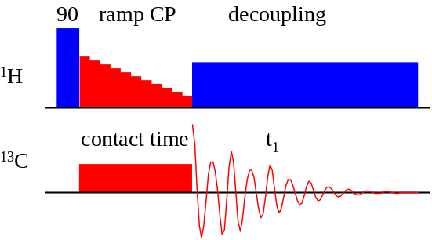

Fig. S1. Pulse scheme used in the ¹H→¹³C variable amplitude cross polarization (CP) experiment.

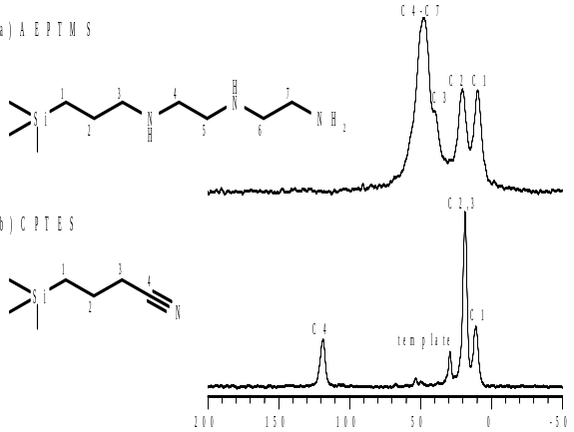
Fig. S2. ¹H→¹³C CPMAS spectra obtained for functionalized mesoporous materials with AEPTMS (a) and CPTES (b) using CP contact times 0.2 and 5 ms, respectively.

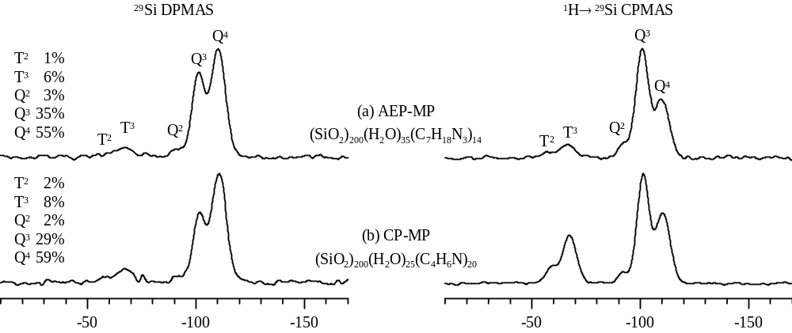
Fig. S3. ²⁹Si DPMAS (left column) and ¹H→²⁹Si CPMAS (right column) spectra obtained for functionalized mesoporous materials with AEPTMS (a) and CPTES (b).

Table S1. Values of T_{CP} and T_{1ρ}^{H} obtained for functionalized mesoporous samples from the analysis of ¹³C cross polarization 'build-up' curves.

 | AEPTMS |  |  |  | CPTES
Peak [ppm] | 48 | 39 | 20 | 9 | 119 | 19 | 19 | 11
τ_{CH} [μs] | 50 | 110 | 60 | 45 | 5000 | 700 | 100 | 60
T_{1ρ}^{H} [ms] | 0.9 | 0.4 | 0.9 | 1.1 | 5.8 | 4 | 48 | 20

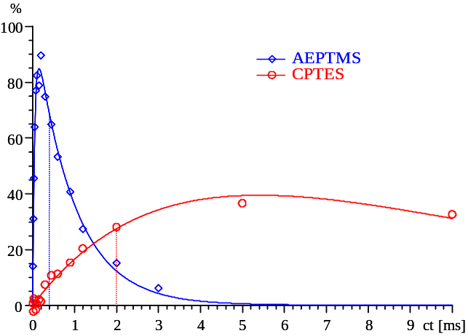

Fig. S4. 'Build-up' of carbon magnetization during spin-locking for the resonance lines at 48 ppm in AEP-MP (◊) and 119 ppm in CP-MP (Ο) fitted using equation 1 (solid lines). Dashed lines reveal contact times selected for the quantitative measurements (see text).

Table S2. Molar ratios of two components used for preparation of AEP/CP-MP materials and the relative concentrations of both moieties obtained from ¹³C CPMAS spectra.

AEPTMS:CPTES
prep. | NMR
1:9 | 1.1:8.9
2:8 | 2.0:8.0
3:7 | 2.9:7.1
4:6 | 4.7:5.3
5:5 | 5.0:5.0

Fig. S5. FE-SEM images of monofunctional materials (Hitachi S4700).

(a) AEP-MP (b) CP-MP

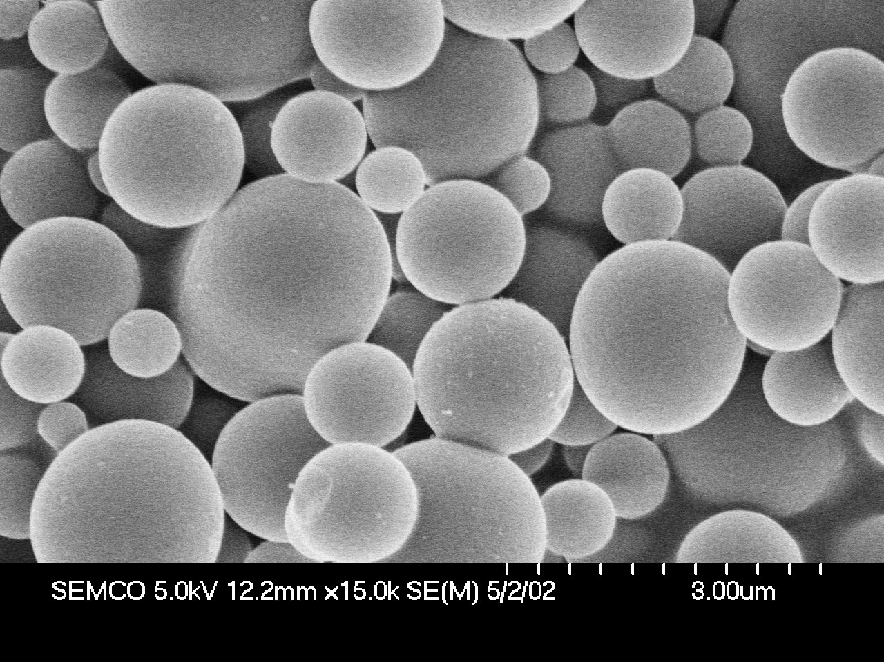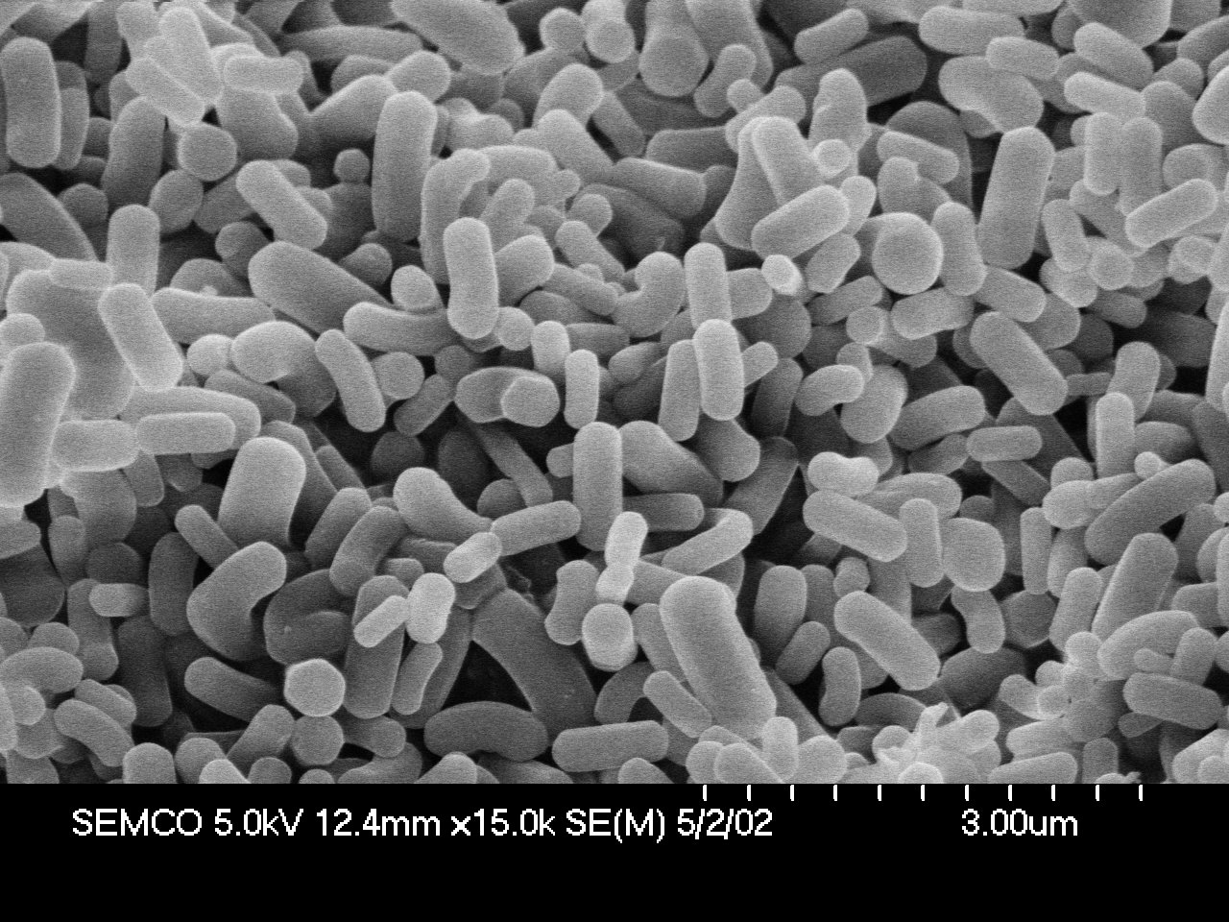

Fig. S6. FE-SEM images of bifunctional materials (Hitachi S4700).

(a) 5/5 AEP/CP-MP (b) 4/6 AEP/CP-MP

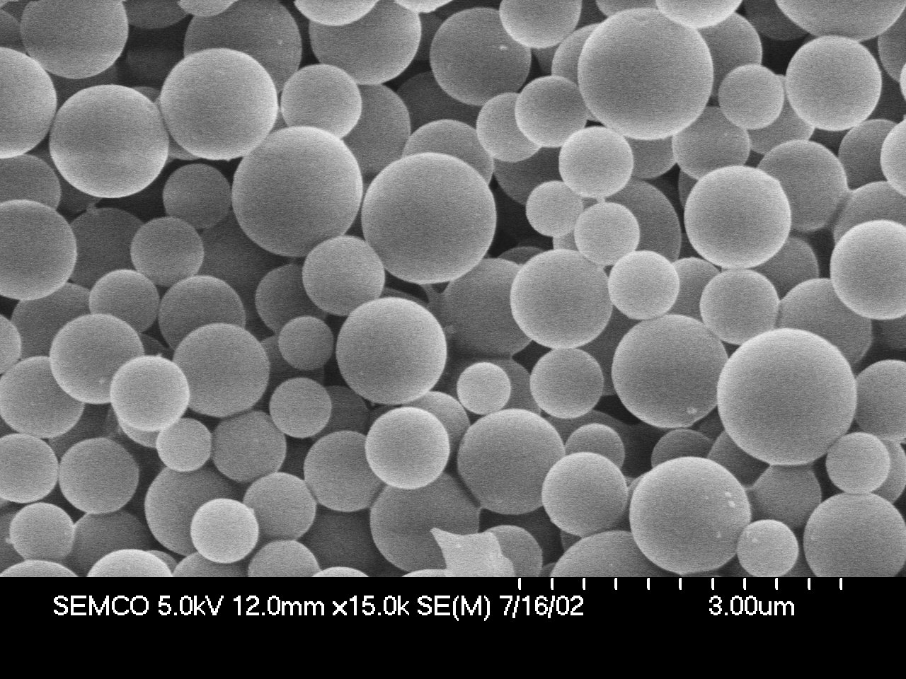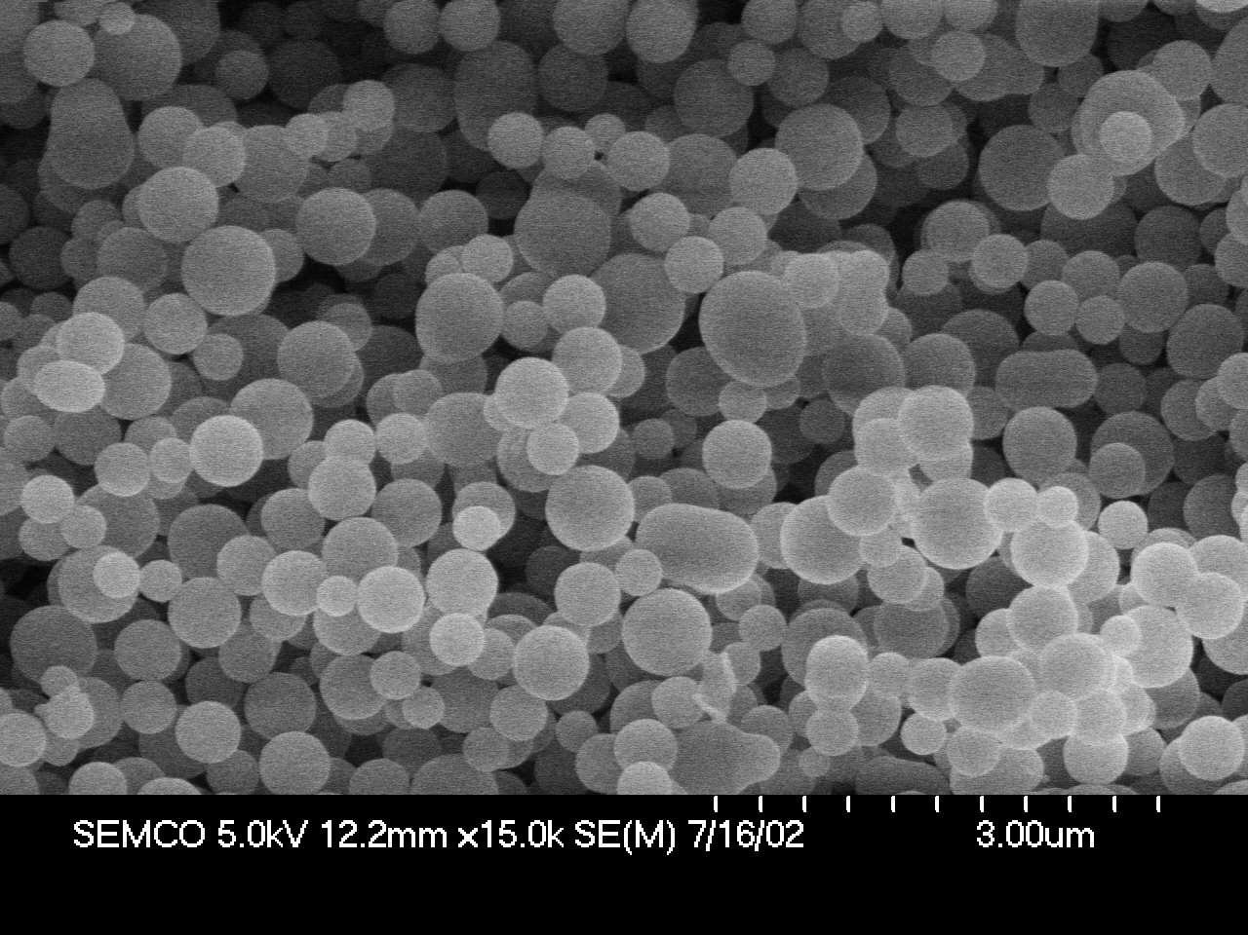

(c) 3/7 AEP/CP-MP (d) 2/8 AEP/CP-MP

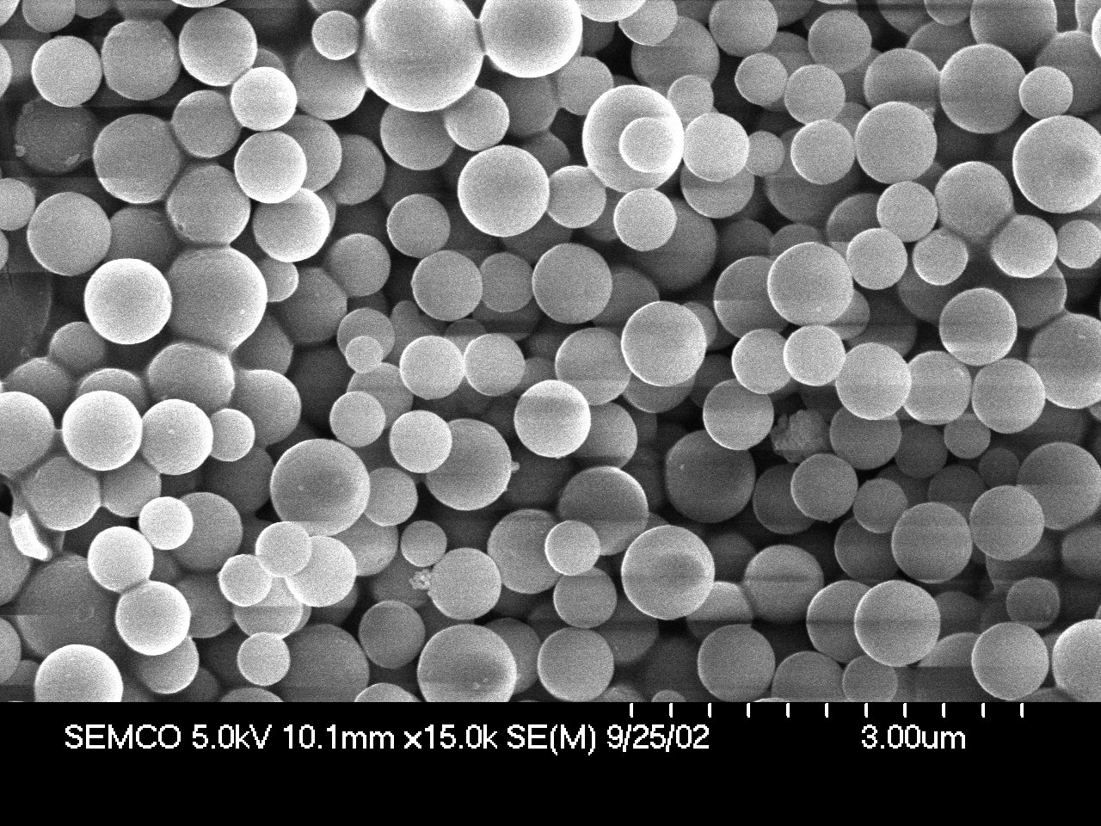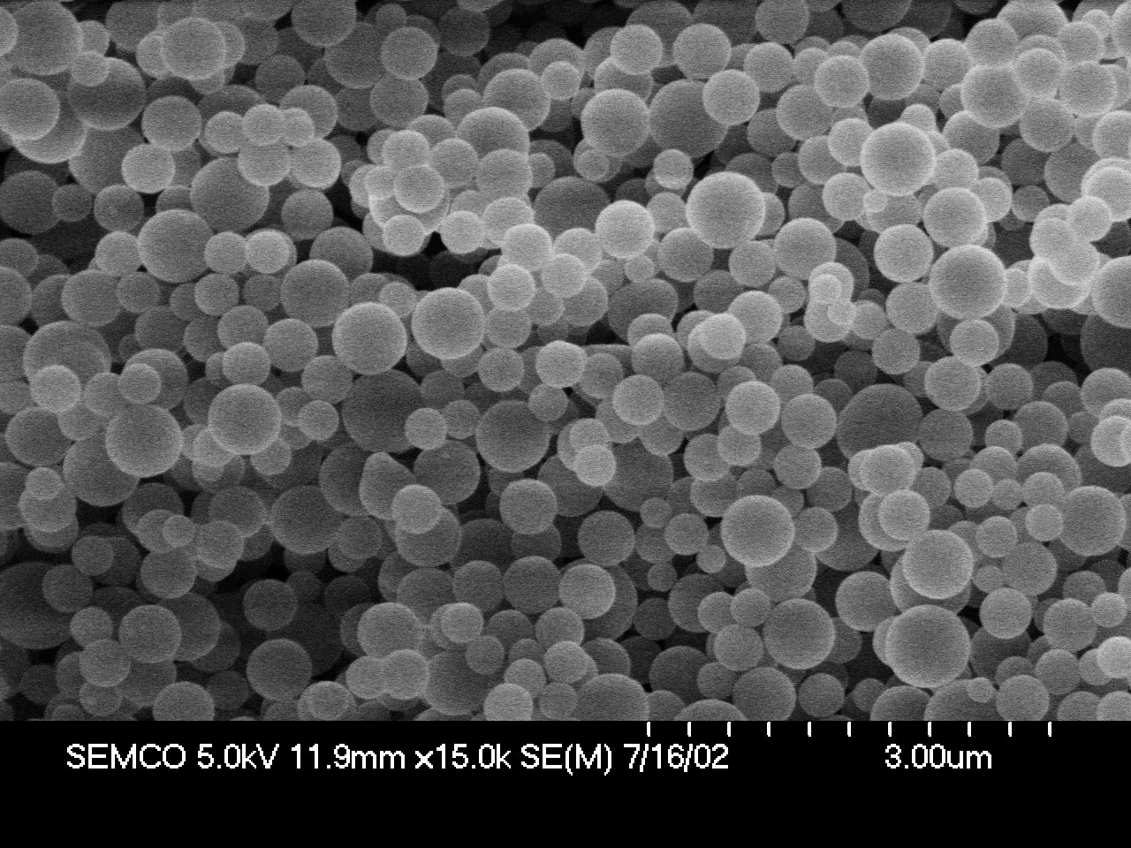

(e) 1/9 AEP/CP-MP (f) Pure MCM-41

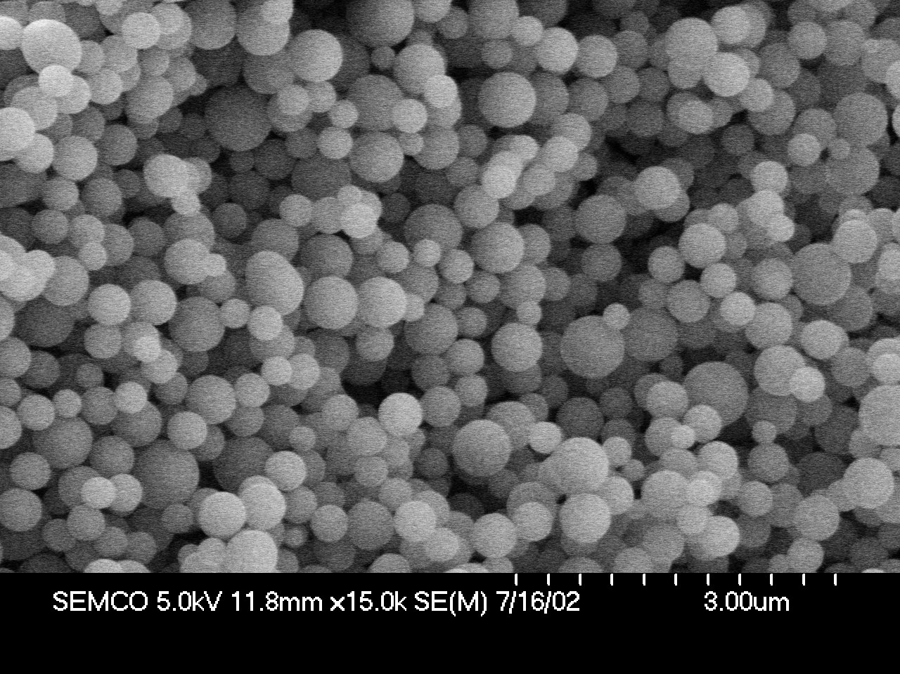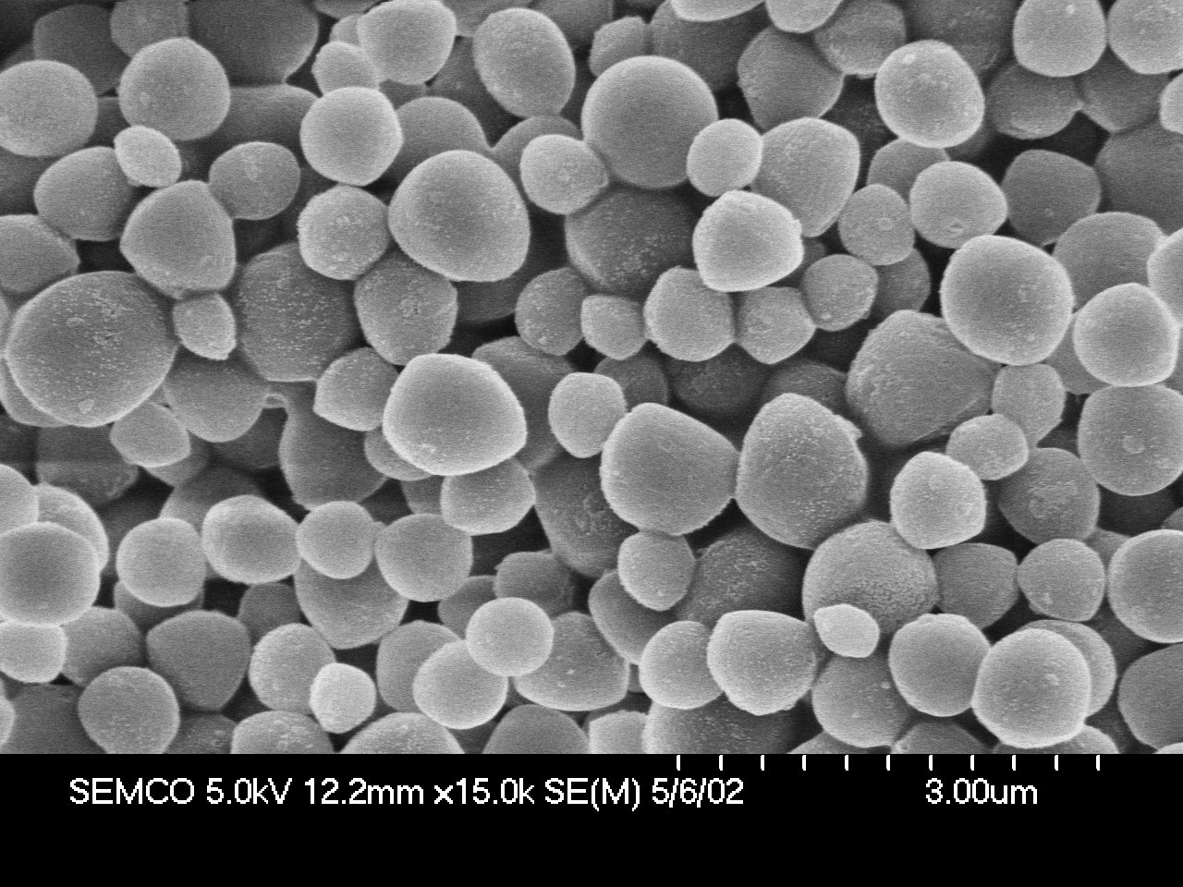

Fig. S7. TEM images of the selected materials.

(a) AEP-MP (Ultramicrotomed)

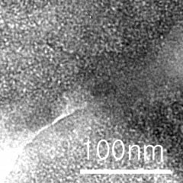

(b) CP-MP

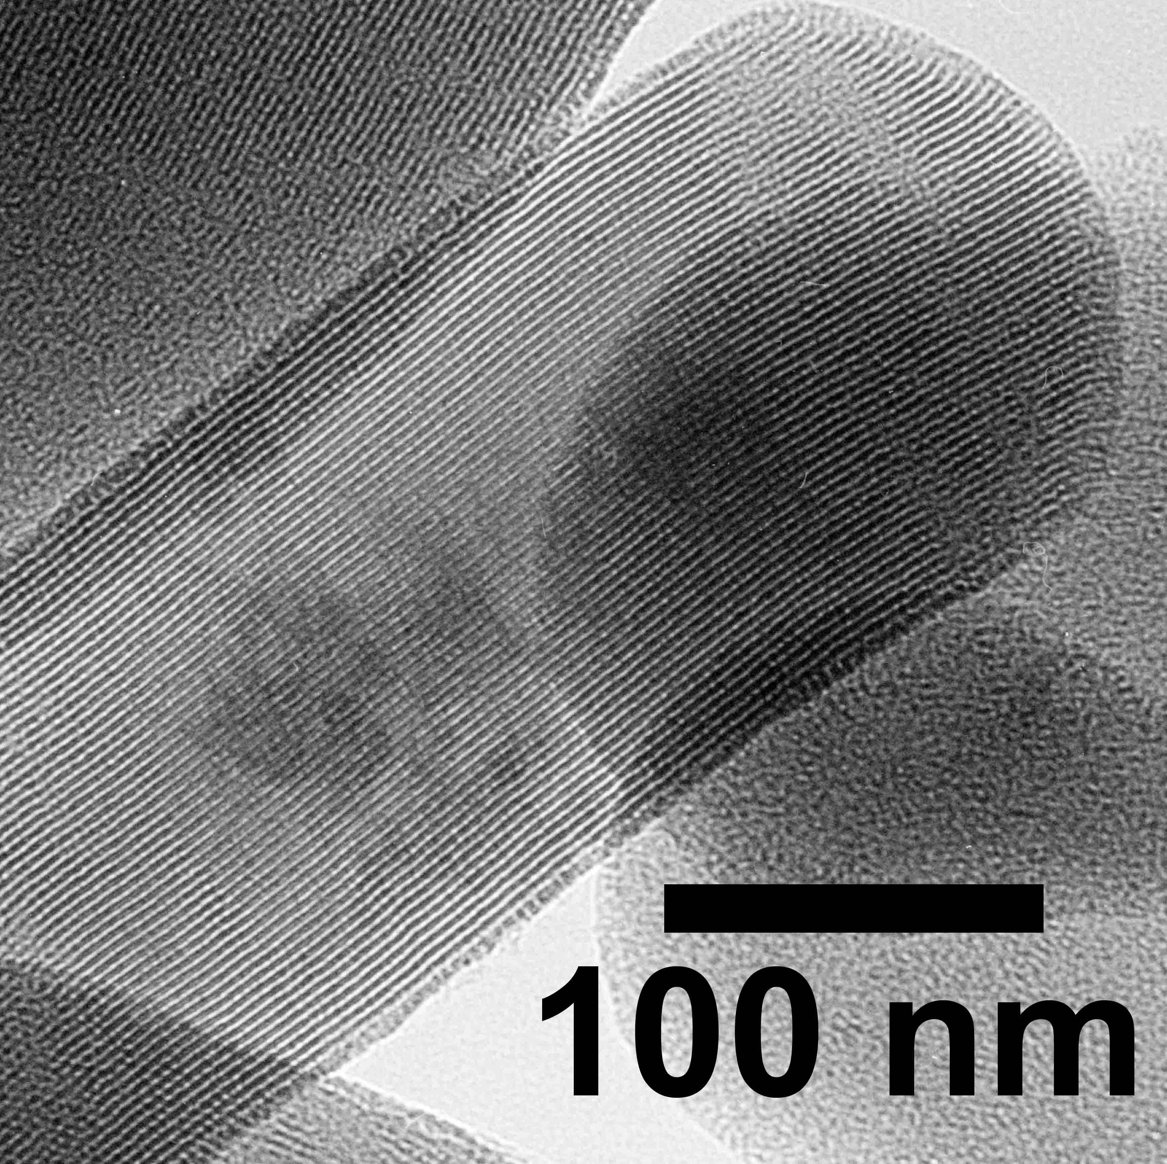

(c) 5/5 AEP/CP-MP (Ultramicrotomed)

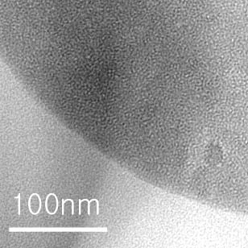
(d) 1/9 AEP/CP-MP (Ultramicrotomed)

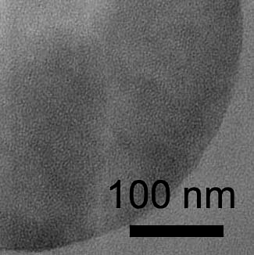

Table S3. Textural properties of the surfactant-free materials.

Sample | d₁₀₀ (Å) | a₀ (Å) | S_{BET} (m²/g) | V_{p} (cm³/g) | W_{BJH} (Å) | d_{pore wall} (Å)
5/5 AEP/CP-MP  4/6 AEP/CP-MP  3/7 AEP/CP-MP  2/8 AEP/CP-MP  1/9 AEP/CP-MP | 37.1  42.1  38.1  37.4  36.5 | 42.9  48.6  44.0  43.2  42.2 | 722.2  822.6  980.8  801.4  966.6 | 0.38  0.51  0.56  0.43  0.51 | -  26.4  26.4  20.5  20.7 | -  22.2  17.6  22.7  21.5

Fig. S8. PXRD data of as-made materials.

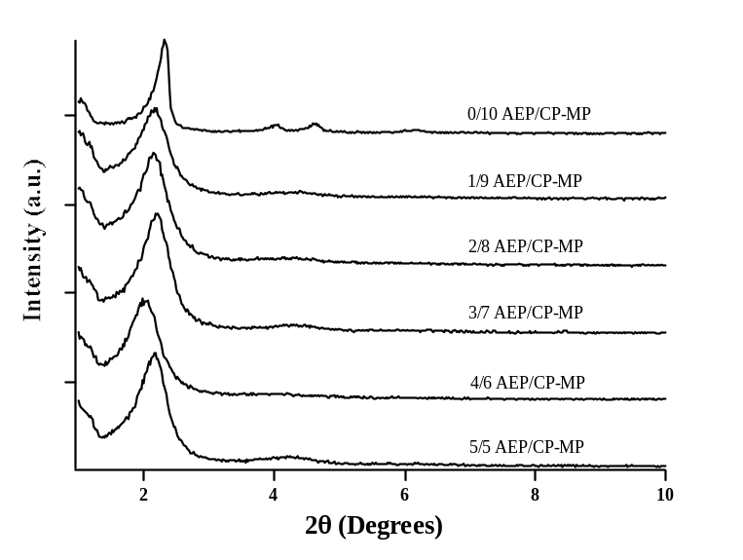

Fig. S9. BET isotherms and pore size distribution curves.

(a) 5/5 AEP/CP-MP

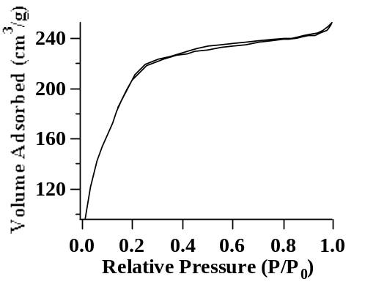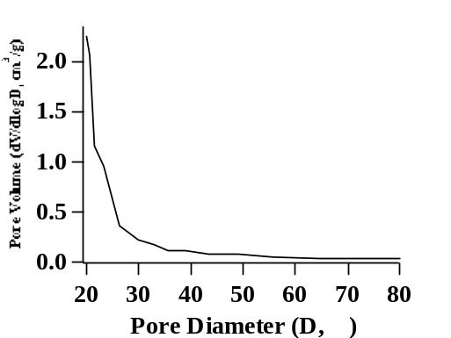

(b) 4/6 AEP/CP-MP

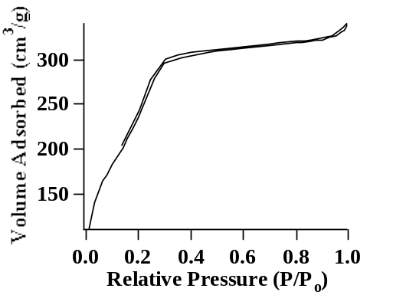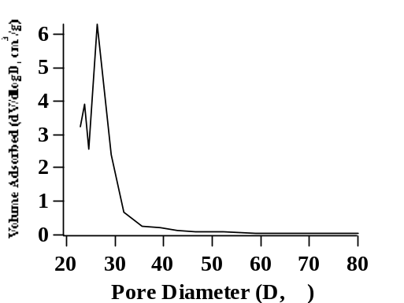
(c) 3/7 AEP/CP-MP

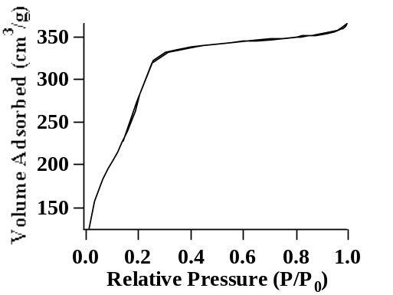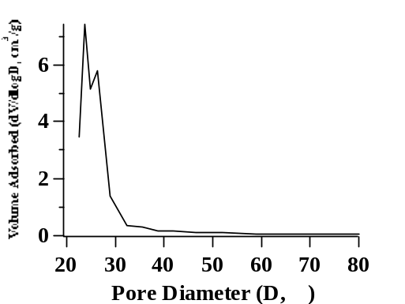

(d) 2/8 AEP/CP-MP
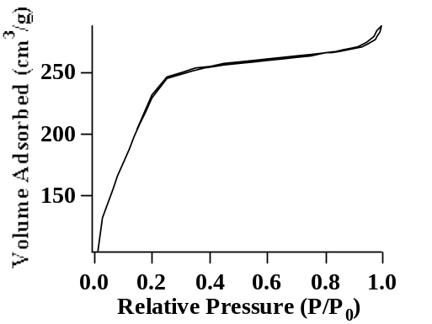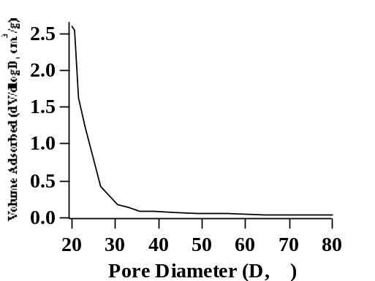

(e) 1/9 AEP/CP-MP

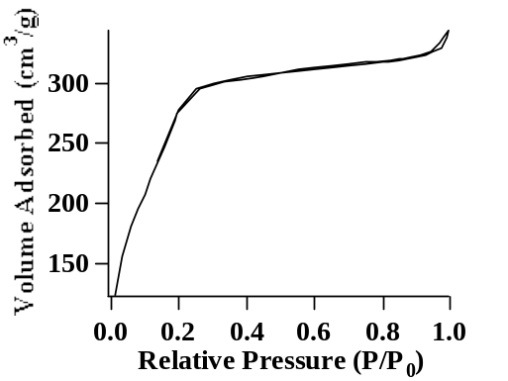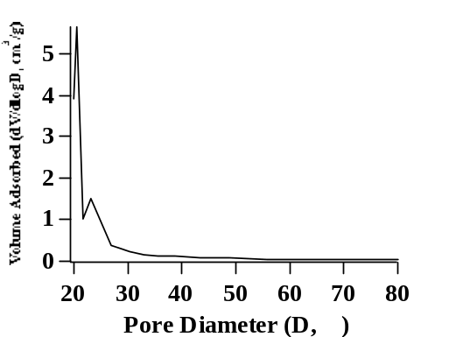

Burleigh, M. C. et al. Chem. Mater. 2001, 13, 4760-4766.
Pines, A.; Gibby, M. G.; Waugh, J. S. J. Chem. Phys. 1973, 59, 569-590; Peersen, O. B; Wu, X.; Kustanovich, I.; Smith, S. O. J. Magn. Reson., Ser. A, 1993, 104, 334-339.
M. Mehring, 'Principles of High Resolution NMR in Solids', 2nd edn., Springer, Berlin, 1983, Chapter 4.

