Supporting Information

Transportation of Silver Nanoparticles in Nanochannels of Carbon Nanotubes with Supercritical Water

Jia-Yaw Chang, Fu-Der Mai, Bertrand Lo, Jia-Jiu Chang, Shin-Hwa Tzing, Anil Ghule and Yong-Chien Ling*

Figure S1. (a) Transmission electron microscope image of the Ag nanoparticle encapsulated in the MWNTs, (b) High resolution image of the encapsulated section, and (c) Lattice fringes observed, characteristic of crystalline Ag nanoparticle. (SCW condition 27.5 MPa, 450 °C, and 20 min).

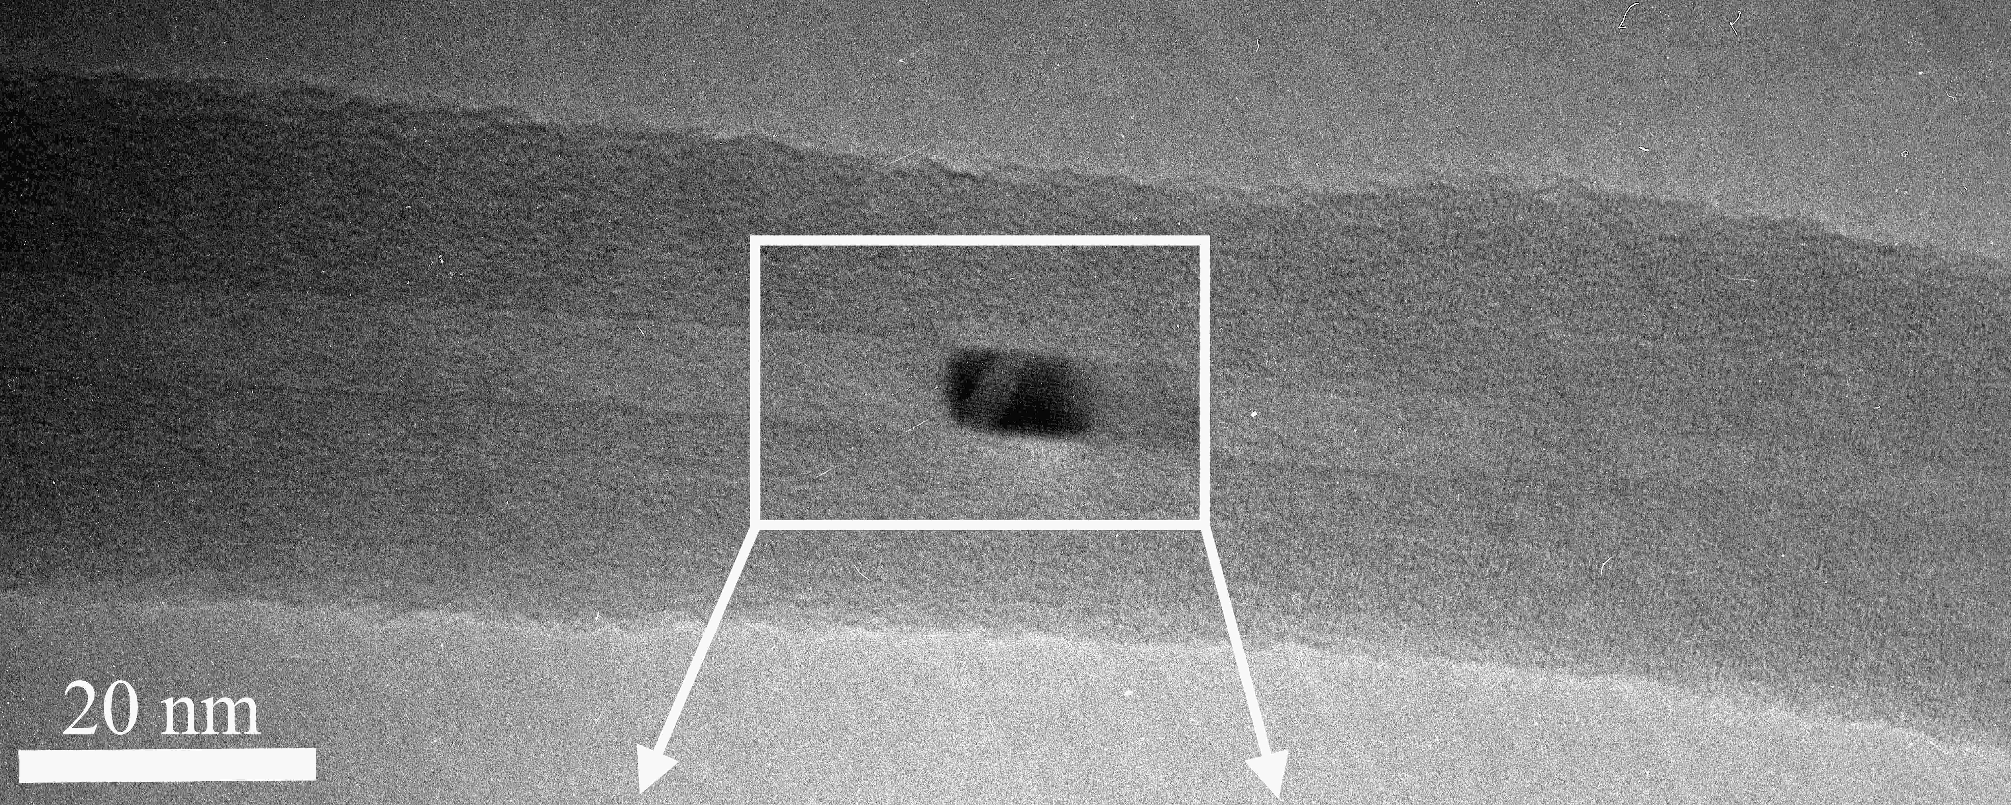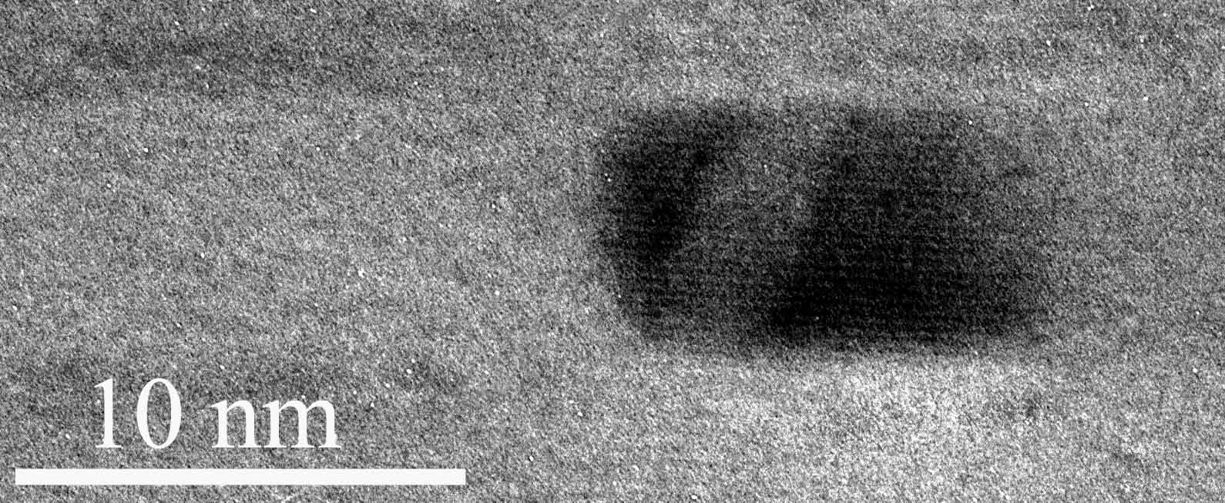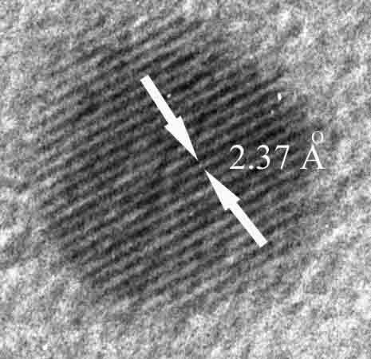
(a)
(b)
(c)

