Supplementary Information for Chem. Commun.

Synthesis, characteristics and luminescence properties of oligo(phenylenevinylene) dimers with a biphenyl linkage center
By Feng He, Gang Cheng, Haiquan Zhang, Yan Zheng, Zengqi Xie, Yuguang Ma, Shiyong Liu and Jiacong Shen
1. General Experimental Procedure
The ¹H NMR spectra were recorded on AVANCZ 500 spectrometers at 298K by utilizing deuterated DMSO as solvent and tetramethylsilane (TMS) as standard. The compounds were characterized by Flash EA 1112, CHNS-O elemental analysis instrument. The crystal structures were determined on Rigaku R-AXIS RAPID X-ray diffraction. IR spectra were recorded on Perkin-Elmer spectrophotometer in the 400-4000cm⁻¹ region using a powered sample on a KBr plate. UV-vis absorption spectra were recorded on UV-3100 spectrophotometer. Fluorescence measurements were carried out with RF-5301PC. The PL yield of films was measured in the films with thickness of 40 nm by vacuum deposition and the PL yields were calculated by the PL intensity divided by corresponding photoabsorbance at the excitation wavelength. The polyl(9,9-dihexylfluorene) film as standard, which has a PL quantum efficiency in film about 0.26 (an average value from the references).¹ The melting points were determined using a Germany NETZSCH (DSC-204) instrument differential scanning calorimeter at 10 °C /min with nitrogen flushing. The luminance-Current-voltage characteristics were measured simultaneously by the programmable Keithley model 2400 and PR 650 spectrometer. All measurements were carried out in air at room temperature.

2. Synthesis and Characterization of the Compounds
2,5,2',5'-Tetrakis-methyl-biphenyl (2) : A 100 mL flask was charged with 4.012 g (14.4 mmol) of triphenylphosphine (TPP), 0.316 g (2 mmol) of 2,2’-bipyridine (bpy), 0.26 g (2 mmol) of nickel dichloride (NiCl₂), and 0.0052 g (80 mmol) of zinc powder. After the flask was evacuated and filled with nitrogen several times, DMF (20 ml) of dry nitrogen-purged was added and flask was placed in a 50 °C oil bath. After the dark-brown catalyzer had formed, 5.5 mL (40 mmol) of 2-Bromo-1,4-dimethylbenzene was added to the mixture and was stirred under N₂ at 80 °C for 8 h. The residual zinc was filtrated and the filtrate was removed under reduced pressure. The yellow liquid was purified by column chromatography (silica gel, CH₂Cl₂) to afford white solid (yield 70 %). ¹H NMR (500 MHz, CDCl₃): δ7.143-7.128 (d, 2H, ArH), δ7.064-7.049 (d, 2H, ArH), δ6.914 (s, 2H, ArH), δ2.327 (s, 6H, CH₃), δ2.012 (s, 6H, CH₃). Anal. Calcd for C₁₆H₁₈: C, 91.37; H, 8.63 Found: C, 91.22; H, 8.71
2,5,2',5'-Tetrakis-bromomethyl- biphenyl (3) : 2 (2.103 g, 10 mmol), NBS (7.832 g, 44 mmol) and a catalytic amount of benzoyl peroxide (BPO) were mixed in trtrachloromethane (40 mL). The mixture was refluxed for 5 hours. After the mixture cooled to room temperature, it was extracted with chloroform several times. The organic phase was washed with water and brine, then dried over anhydrous magnesium sulfate. After filtration and solvent evaporation, the residual solid was recrystallized for anhydrous ethanol/acetone, to give white crystal solid (yield 60 %). ¹H NMR (500 MHz, CDCl₃): δ7.546-7.522 (d, 2H, ArH), δ7.467-7.451 (d, 2H, ArH), δ7.321 (s, 2H, ArH), δ4.529-4.480 (t, 4H, CH₂Br), δ4.321-4.301 (t, 2H, CH₂Br), δ4.174-4.136 (t, 2H, CH₂Br). Anal. Calcd for C₁₆H₁₄Br₄: C, 36.54; H, 2.68 Found: C, 36.24; H, 2.68
tetra(phosphonate) (4) : A mixture of 3 (0.5218 g, 1 mmol) and triphenylphosphine (TPP) (1.154 g, 4.4 mmol) in a anhydrous N,N-dimethylformide (DMF) was heated at reflux for 18 hours. The resulting solution was added dropwise into 100 mL of acetone to precipitate out of product. The white precipitates were collected via filtration and dried under vacuum (yield 60 %). ¹H NMR (500 MHz, CDCl₃): δ7.76-7.52 (60H, ArH), δ7.02 (s, 4H, ArH), δ6.33 (s, 2H, ArH), δ5.44-5.38 (t, 2H, CH₂PPh₃), δ5.24-5.18 (t, 2H, CH₂PPh₃), δ5.10-5.04 (t, 2H, CH₂PPh₃), δ4.26-4.20 (t, 2H, CH₂PPh₃).
2,5,2',5'-Tetrastyryl-biphenyl (TSB): 4 (0.158g, 0.1mmol) and phenyl formaldehyde (0.064g, 0.6mmol)were dissolved in a mixture of anhydrous ethanol (10 mL) and tetrahydrofuran (10 mL) in a 100 mL over-dried round-bottomed flask, which was equipped with a magnetic stirring bar and capped with a rubber septum. A 5 % sodium ethoxide in ethanol solution (0.090g, 0.8mmol), which was freshly prepared prior to use, was added dropwise to the reaction flask via a syringe at room temperature. The reaction mixture was strried at room temperature under an argon atmosphere. The resulting oligomer was twice precipitated out from methnol to give light yellow solid (yield 84 %). ¹H NMR (500 MHz, DMSO): δ8.002-7.986 (d, 2H, ArH), δ7.772-7.756 (d, 2H, ArH), δ7.628-7.612 (d, 4H, ArH), δ7.628-7.612 (d, 4H, ArH), δ7.561 (s, 2H, ArH), δ7.390-7.364 (t, 8H, ArH), δ7.288-7.267 (d, 4H, CH=CH), δ7.257-7.245 (d, 8H, ArH), δ6.780-6.749 (d, 4H, CH=CH). FT-IR (KBr, cm⁻¹): 3025, 1596, 1495, 1447, 1260, 1073, 1026, 959, 813, 746, 690, 535.
2,5,2',5'- Tetra(4'-biphenylenevinyl)-biphenyl (TBVB) : It was also prepared similarly to TSB via 4 and biphenyl formaldehyde to afford yellow solid (yield 86 %). ¹H NMR (500 MHz, DMSO): δ8.072-8.055 (d, 2H, ArH), δ7.814-7.790 (d, 2H, ArH), δ7.743-7.220 (complex, 42H, ArH and CH=CH), δ6.834-6.794 (d, 4H, CH=CH). FT-IR (KBr, cm⁻¹): 3025, 1598, 1519, 1484, 1448, 1407, 1259, 1110, 1074, 1039, 1006, 962, 863, 833, 761, 721, 694.

3. Single crystal data of 2,5,2',5'-tetrakis-bromomethyl-biphenyl (3).
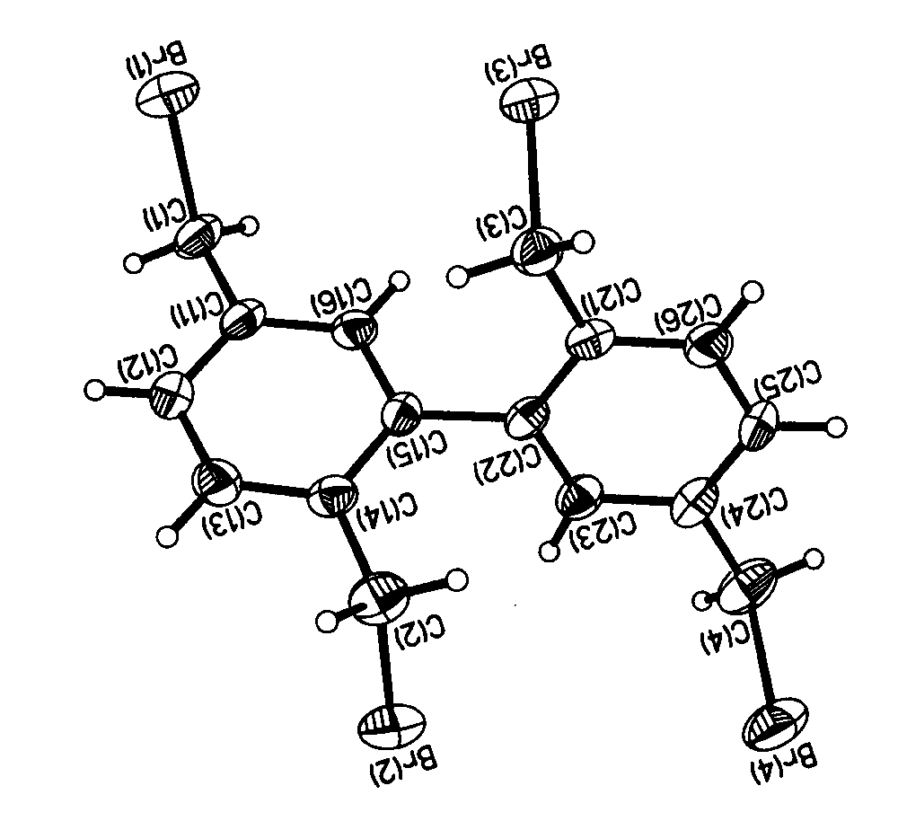
Fig. S1 The ORTEP drawing for 3 showing the twisting molecular conformations. A crystal of 0.44 mm × 0.33 mm × 0.19 mm of compound 3 was selected under Ar for X-ray diffraction. The intensity data were collected on a Rigaku R-AXIS RAPID IP diffctometerat 296(2) K with graphite-monochromated Mo Kα radiation (λ= 0.071073 nm) and scan mode Oscillation in the range of 2.40°<θ< 27.48°. A total of 3584 reflections were collected, and the independent reflections were 3584 (R_{int} = 0.0496). From the single crystal data of 3, it showed a torsion angle of 71.8º between two conjoint phenyl rings. Summary of Data CCDC 212956: Compound: 2,5,2',5'-tetrakis-bromomethyl-biphenyl, Formula: C₁₆H₁₄Br₄, Unit cell parameters: a 9.184(2) b 9.3868(15) c 11.5616(8) alpha 108.581(11) beta 93.720(6) gamma 109.933(15) space group P-1. The crystal structure has been deposited at the Cambridge Crystallographic Data Centre and allocated the deposition number CCDC 212956. This materials is avalible free of charge via the Internet at http://www.ccdc.cam.ac.uk

4. Differential scanning calorimetry (DSC) of the two oligomers.
Fig. S2 DSC analysis of TSB and TBVB. DSC analysis was performed with scanning (both heating and cooling) rates of 10 ºC/min under nitrogen atmosphere.

5. OLED Fabrication Procedure
A number of devices were fabricated with the following configuration: glass / indium tin oxide (ITO: 30 Ω / square) / NPB (40 - 50nm) / TSB or TBVB(30 - 40 nm) / Alq (20-30 nm)/LiF/Al. The ITO glass substrate was cleaned with detergent and deionized water and dried in an oven. It was then treated with UV-ozone for 25 minutes before loading into a deposition chamber. The organic films of NPB, TSB or TBVB and Alq were sequentially deposited onto the ITO substrate at a pressure of around 3× 10⁻⁴ Pa. The EL spectra and luminance were recorded on a PR650 spectrometer. Luminance - voltage and current-voltage characteristics were measured at room temperature. The emission area of the devices is 0.07 cm², defined by the overlapping area of the anode and cathode.
6. EL Spectrum of OLED

Fig. S3 The EL spectra of TBVB at 15 V. The EL emission peak was measured at λ_{em} = 440 and 460 nm (15 V) with a CIE of x = 0.1726 and y = 0.1689 in a pure blue spectral region.

References
1. a) Julie Teetsov and Marye Anne Fox, J. Mater. Chem., 1999, 9, 2117; b) A.W.Grice, D. D. C. Bradley, M. T. Bernius, M. Inbasekasan, W. W. Wu and E. P. Woo, Appl. Phys. Lett, 1998, 73, 629.

