Figure S1: Total ion chromatogram from co-injections of authentic germacrene A with the products of ASW334F (A) and ASW334V (B) catalysis.
*: non-sesquiterpene contaminant.

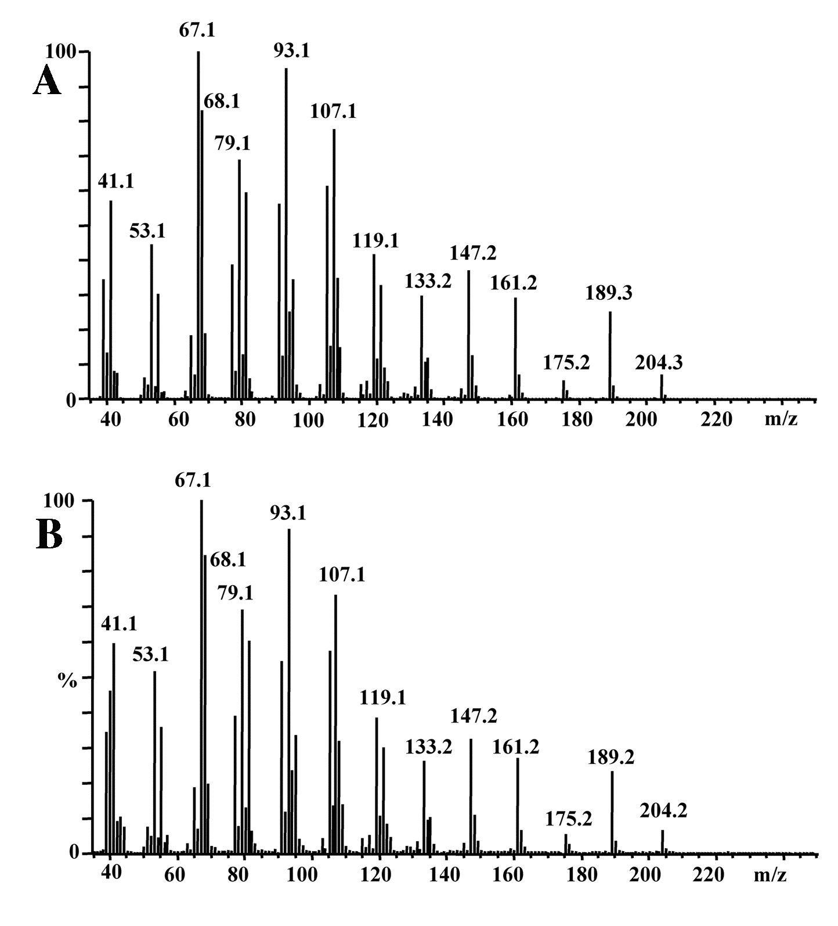
Figure S2: (A) Mass spectra of product 2 of ASW334F catalysis (Figure S1B) and of authentic germacrene A (B).

Figure S3 (A) Mass spectra of product 5 of ASW334F catalysis (Figure S1A) and of authentic valencene (B).

