Studies of the S₁ State in a Prototypical Molecular Wire using Picosecond Time-resolved Spectroscopies

Andrew Beeby,*ª Karen Findlay,ª Paul J. Low,*ª Todd B. Marder,ª Pavel Matousek,^{b} Anthony W. Parker,^{b} Simon R. Rutter,ª Michael Towrie^{b}

ª Department of Chemistry, University of Durham, South Road, Durham, DH1 3LE, UK. Fax:44 191 384 4737; E-mail: andrew.beeby@durham.ac.uk, p.j.low@durham.ac.uk
^{b} Central Laser Facility, CCLRC, Rutherford Appleton Laboratory, Chilton, Didcot, Oxfordshire, OX11 0QX, UK,

Supplementary Data

Time-resolved fluorescence spectra of 1,4-bis(phenylethynyl)benzene in cyclohexane solution, λ_{ex} = 267nm. Spectra have been normalised in the region 370-450nm.

Transient absorption spectra of 1 in cyclohexane solution, following 267nm excitation, up to 50ps.

Transient absorption spectra of 1 in cyclohexane solution, following 267nm excitation, up to 50-2000ps.

Time-resolved resonance Raman spectra of 1 in cyclohexane, λ_{ex} = 267nm, λ_{probe} = 588nm, time interval up to 50ps.

Time-resolved resonance Raman spectra of 1 in cyclohexane, λ_{ex} = 267nm, λ_{probe} = 588nm, time interval 50 - 1000ps.

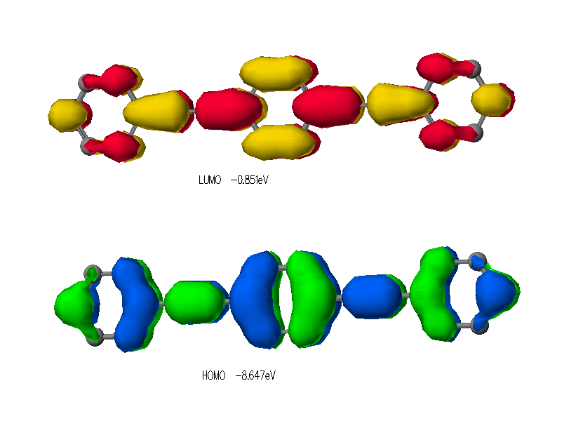
LUMO (upper) and HOMO (lower) of 1,4-bis(phenylethynyl)benzene, calculated using CAChe 5.0, using MOPAC/PM3 level calculation.

