Electronic Supplementary Information

Ordered mesoporous organic-inorganic hybrid materials containing microporous functional calix[8]arene amides

Chunqing Liu, Nathaniel Naismith, Lei Fu, and James Economy

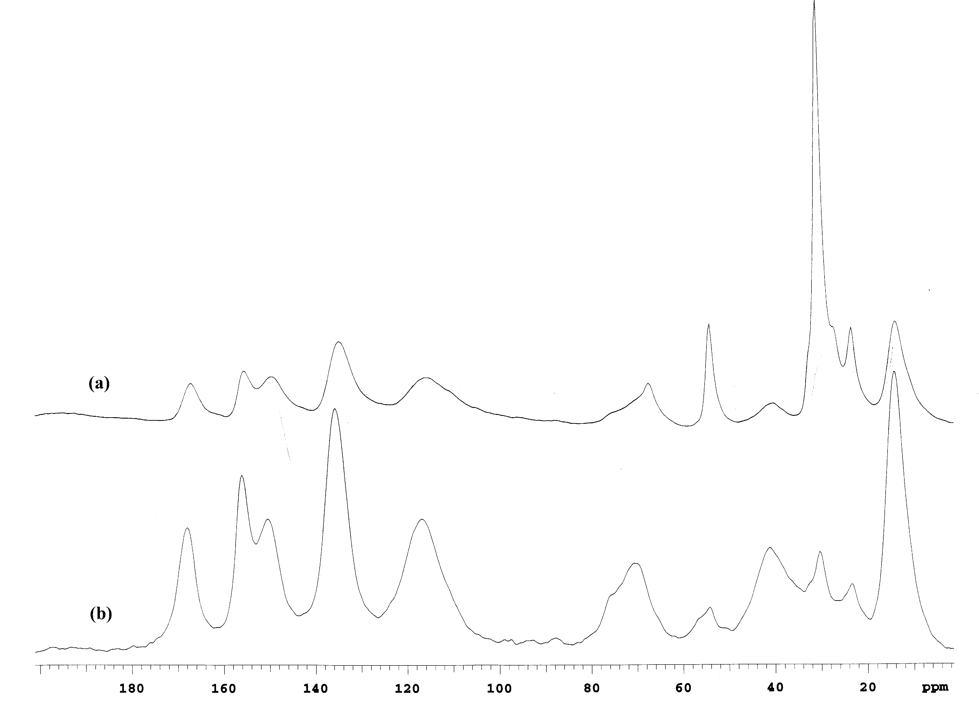

Supporting Fig. 1 Solid-state ¹³C NMR spectra of (a) as-synthesized and (b) surfactant-extracted CX-8-2% materials.

Supporting Fig. 2 Powder X-ray diffraction patterns of the as-synthesized (a) CX-8-1%, (b) CX-8-2%, (c) CX-8-4% and (d) CX′-8-2% gel materials.

