Electronic Supplementary Information
Chemical Synthesis of Turbostratic Carbon Nitride, Containing C-N Crystallites, at Atmosphere Pressure
Yu Qiu and Lian Gao*

Experimental details:
The prepared t-CN_{x} solid sublimate almost completely at 800 °C in N₂ and NH₃ atmosphere.

Table 1. XPS and CHN elemental analysis of turbostratic carbon nitride

Gas | XPS analysis (at %) |  |  |  |  | Elemental analysis (wt %)
Gas | N | C | O | N/C_{surf} |  | N | C | H | N/C_{bulk}
N₂ | 13.6 | 83.4 | 3.0 | 0.16 |  | 19.67 | 72.68 | 2.09 | 0.23
NH₃ | 25.6 | 70.4 | 3.0 | 0.36 |  | 22.31 | 69.21 | 2.51 | 0.28
Note: In N₂, the surface underwent more severe nitrogen loss than the interior, thus resulted in a lower N/C_{surf} (0.16) ratio than overall N/C_{bulk} ratio (0.23). In more active NH₃, the nitrogen loss was depressed (N/C_{bulk} = 0.28). Meanwhile, the adsorption of NH₃ increased the surface N concentration (N/C_{surf} = 0.36) significantly. Elemental analysis also indicates that there should be trace amount of chlorine residue in the prepared samples.
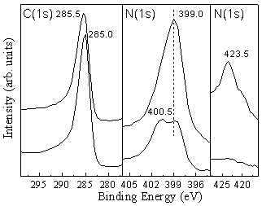

XPS spectra: C(1s) (left panel) and N(1s) (middle and right panel) core level photoemission spectra for N₂-treated (bottom) and NH₃-treated (top) sample.

Table 2. Comparison of the transmission electron diffraction data with the predictions in Ref. 16. The lattice constants calculated from our data are: a = 6.568 Å, c = 4.706 Å. Note: s, strong; m, medium; w, weak; vw, very weak.

Observed |  |  | α-C₃N₄ (predicted)
d (Å) | I |  | d (Å) | (hkl) | I
3.62 | s |  | 3.60 | 101 | s
 |  |  | 3.23 | 110 | s
 |  |  | 2.80 | 200 | m
2.43 | s |  | 2.41 | 201 | s
 |  |  | 2.17 | 102 | s
 |  |  | 2.12 | 210 | s
1.96 | s |  | 1.90 | 112 | s
 |  |  | 1.87 | 300 | s
1.72 | s |  | 1.74 | 301 | m
1.52 | m |  | 1.57 | 212 | vw
1.42 | vw |  | 1.48 | 311 | vw
1.29 | w |  | 1.33 | 222 | m
1.21 | vw |  | 1.24 | 321 | m
 |  |  | 1.18 | 004 | w
1.08 | vw |  | 1.13 | 322 | m

