SUPPORTING INFORMATION

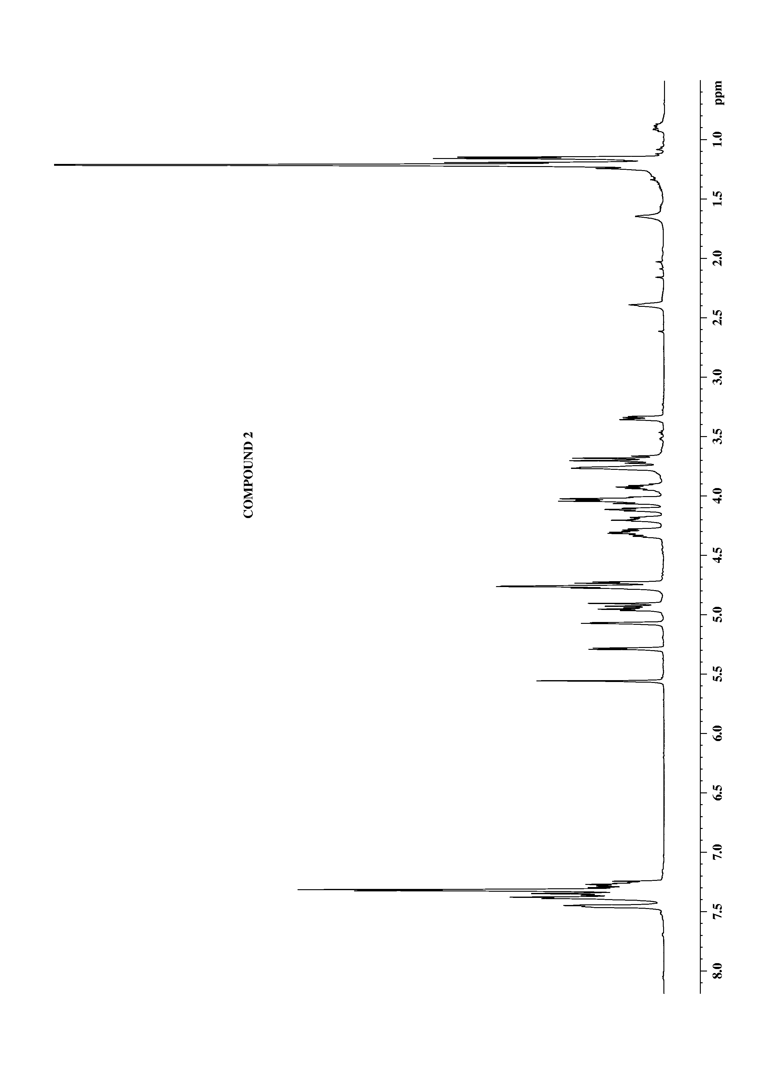
2

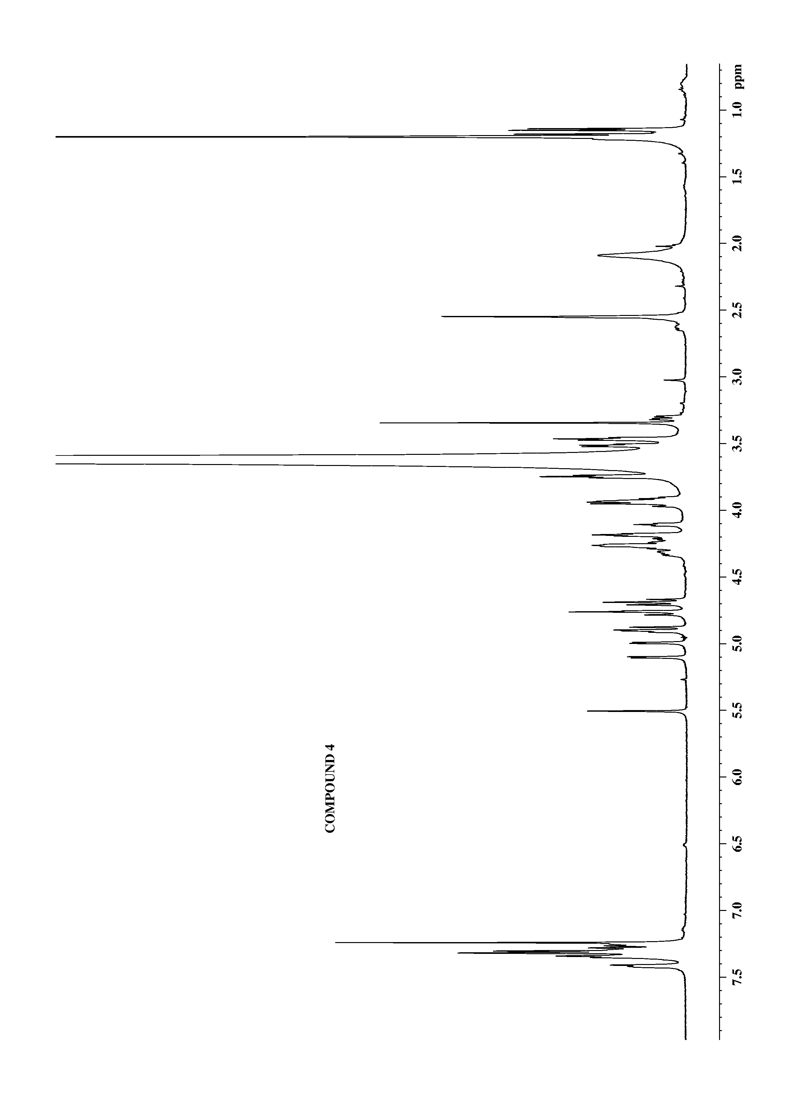
4

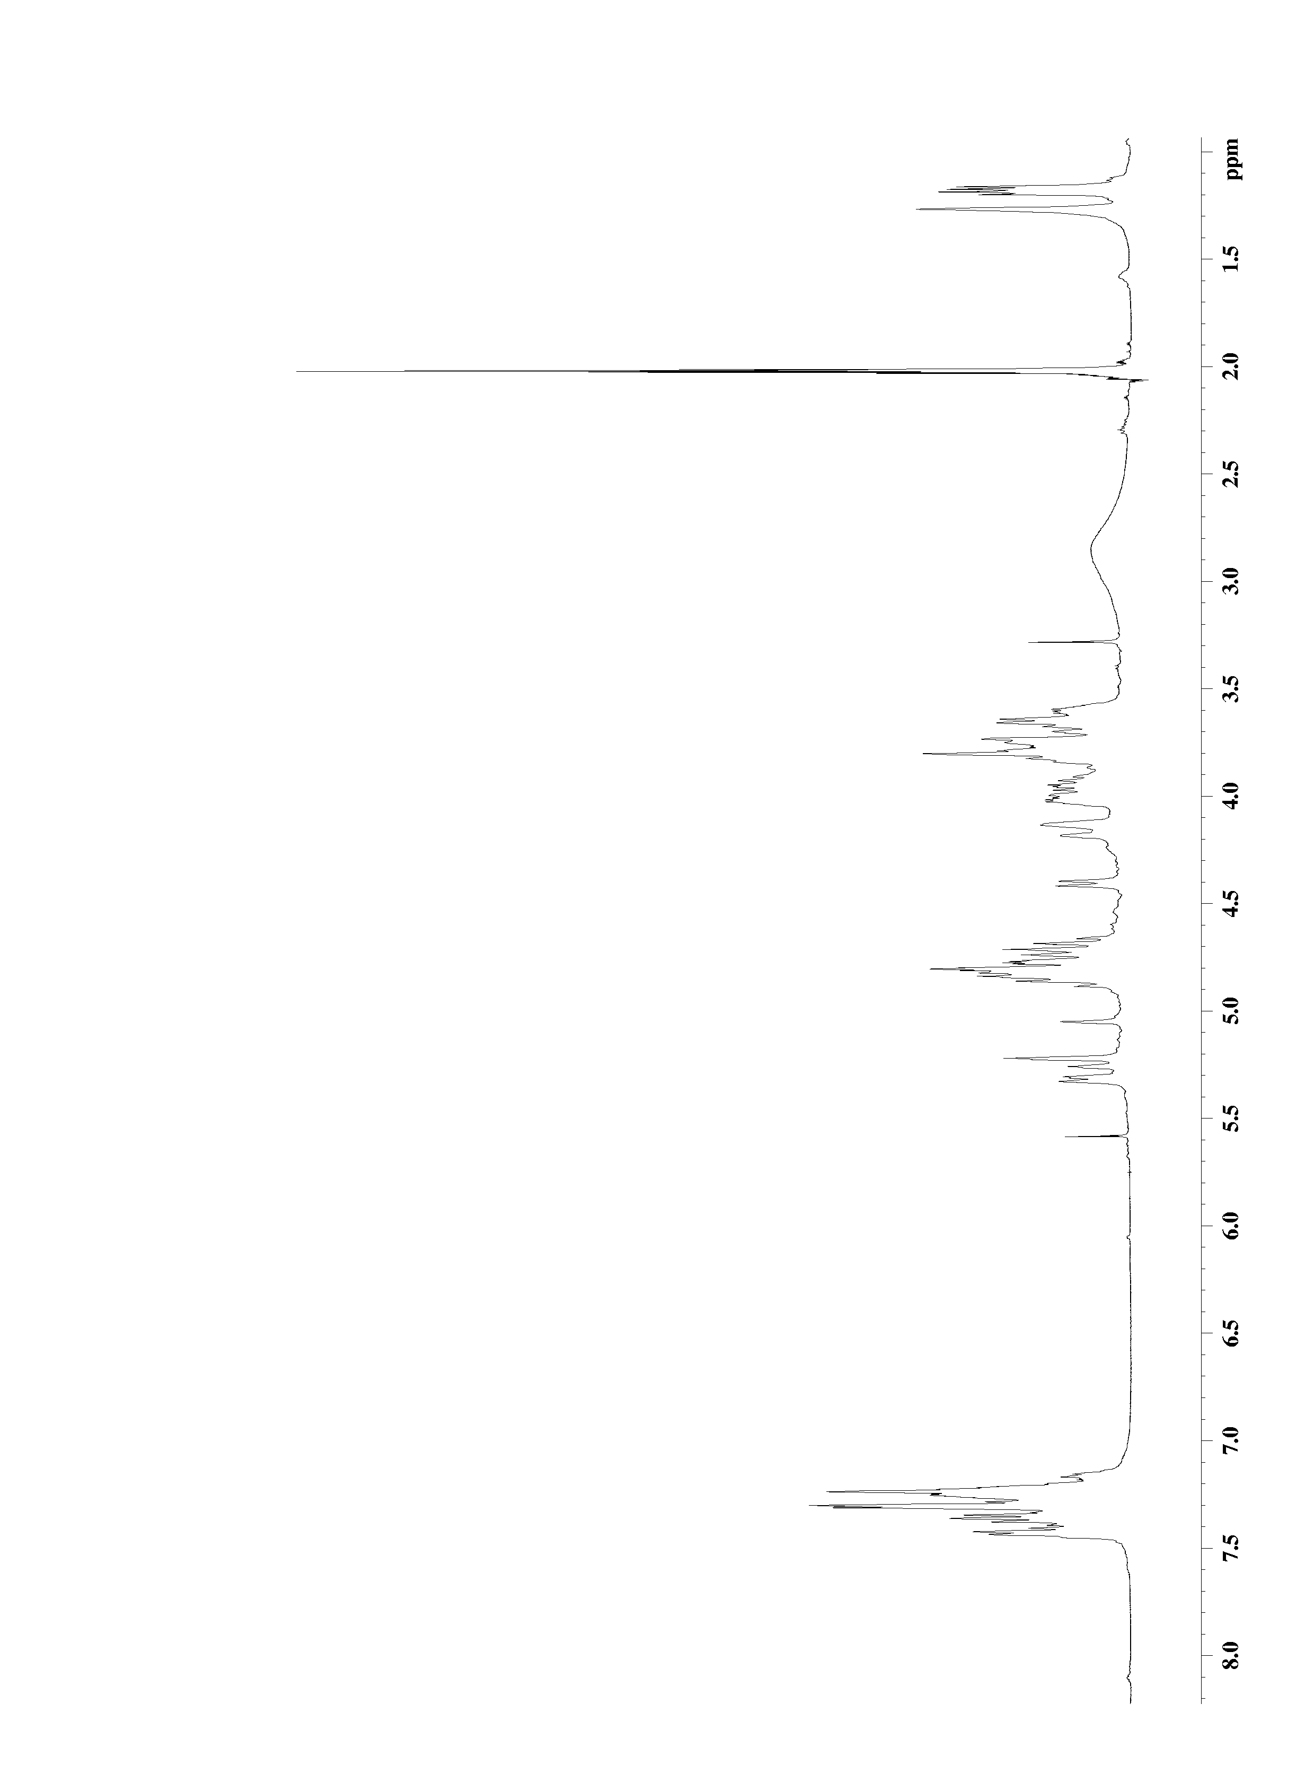
compound 13 prepared in solution phase

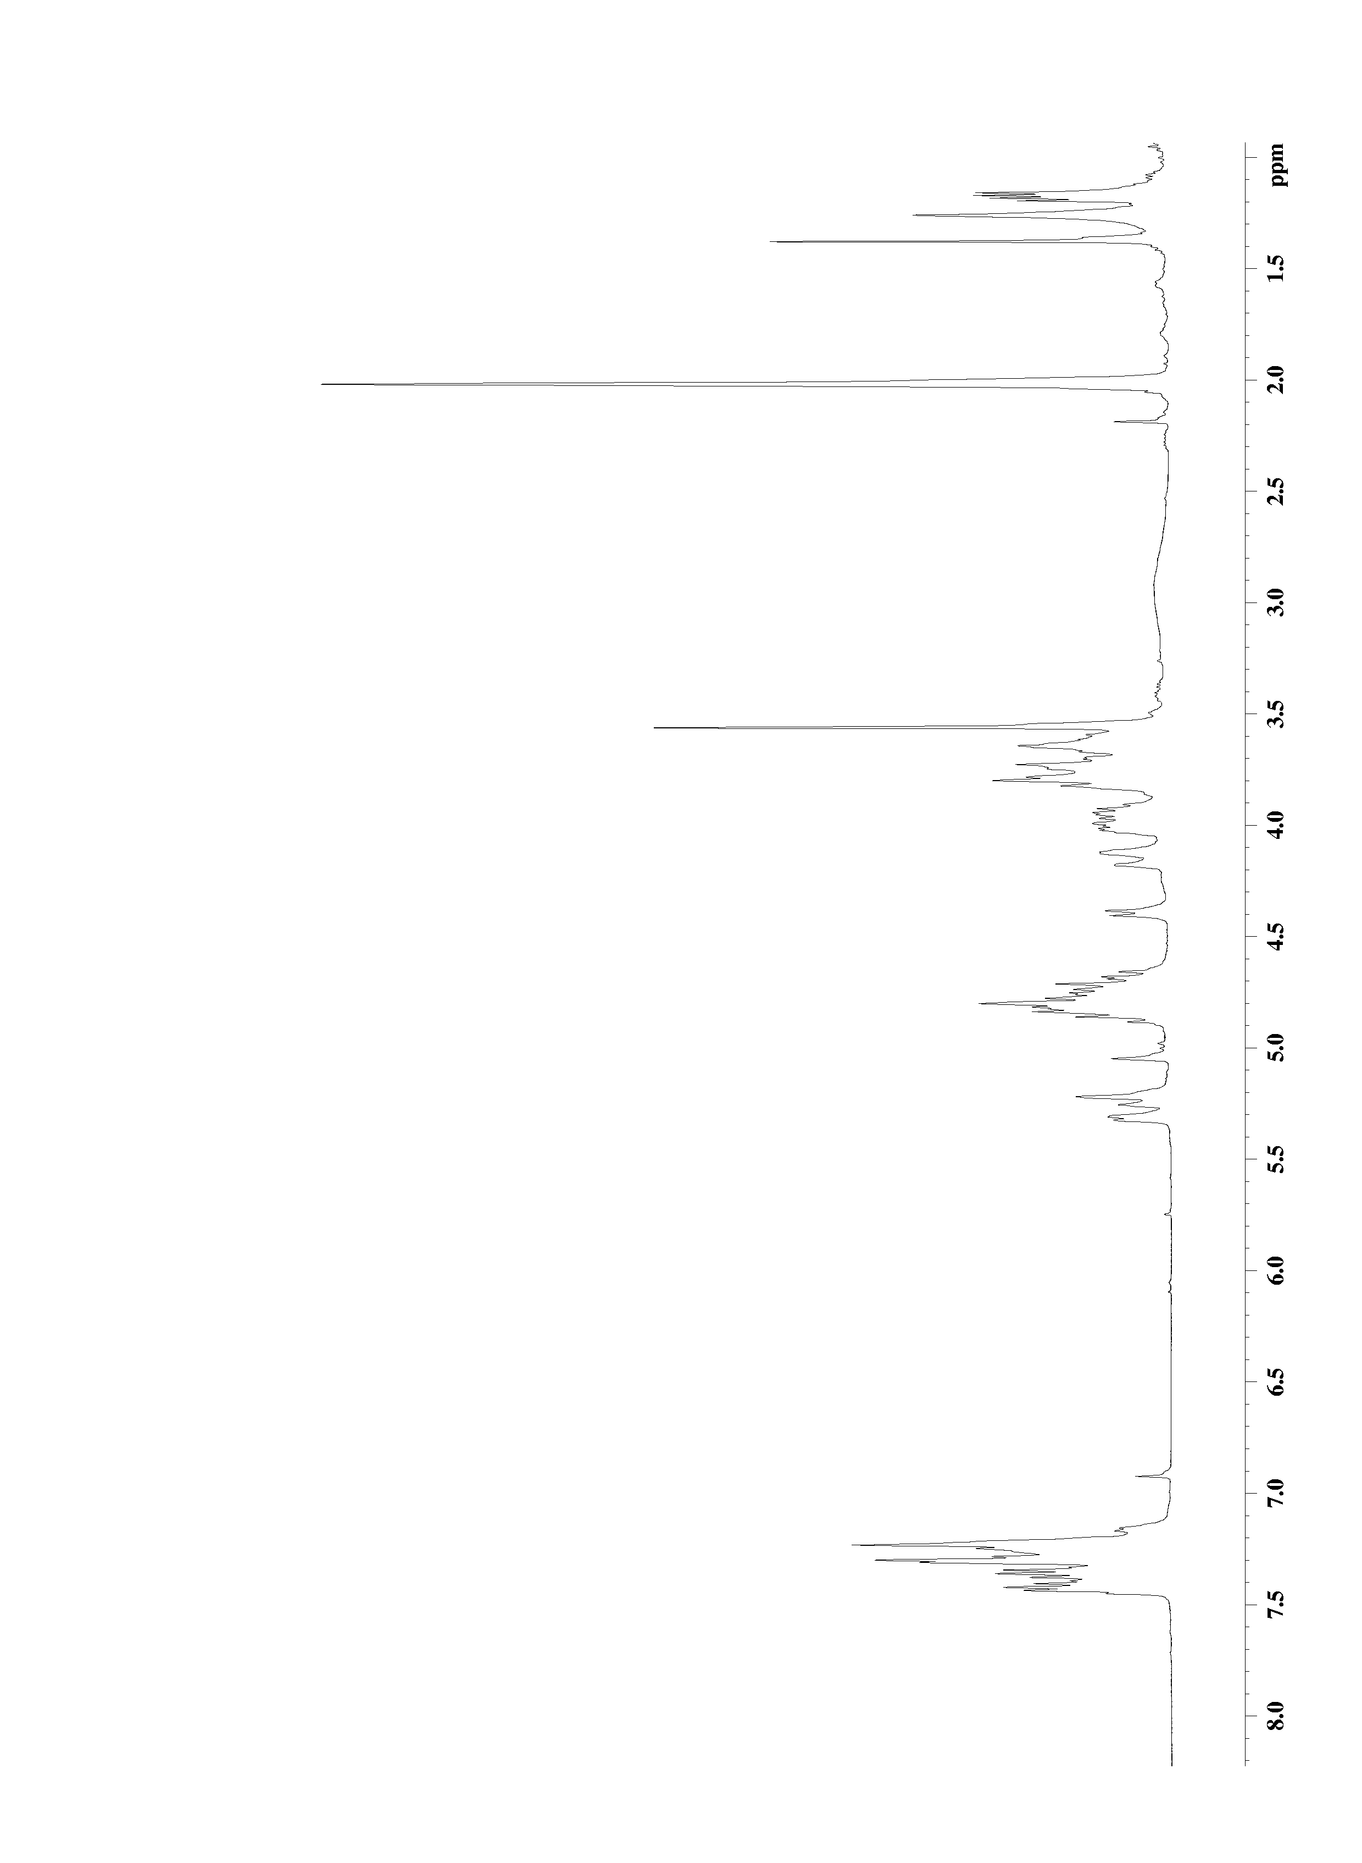
compound 13 prepared on MPEG support

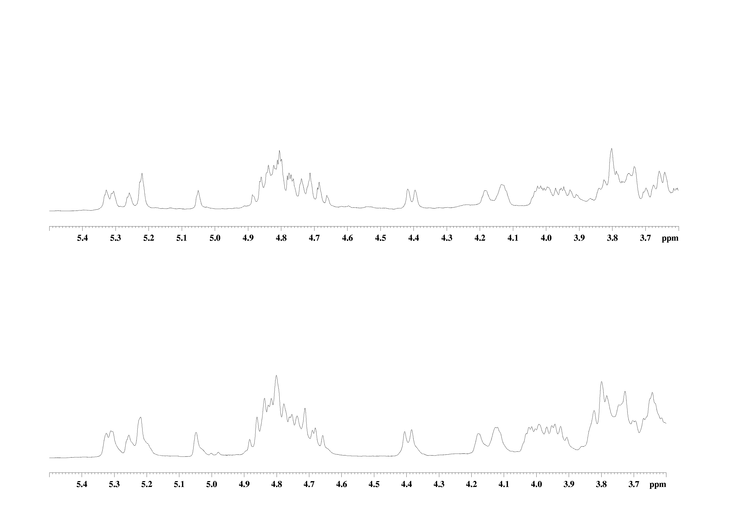
u

UP: 5.5-3.6 ppm zone of compound 13 prepared in solution phase.

DOWN: 5.5-3.6 ppm zone of compound 13 prepared on soluble support.

