Electronic Supplementary Information Accompanying:
Molecular Recognition. Self-Assembly of Molecular Trigonal Prisms and their host-guest adducts.
James D. Crowley, Andrew J. Goshe and B. Bosnich.
Department of Chemistry, The University of Chicago, 5735 South Ellis Avenue, Chicago, Illinois 60637, USA

Chemical Communications
Experimental Procedures 1

Scheme 1 4

Table 1: ¹H NMR CIS for Trigonal Prisms Host-Guest adducts 11

¹H NMR spectra of the Trigonal Prisms 12

ESI-MS spectra of the Trigonal Prisms 12

References 13

Experimental Procedures. All reagents were obtained from commercial suppliers and were used without further purification. All reactions were performed under an atmosphere of argon, unless otherwise specified. Electronic absorption spectra were obtained using a Perkin Elmer Lambda 6 UV/vis spectrophotometer. Elemental analyses were performed by Desert Analytics, Inc., Tucson, Arizona. ¹H and ¹³C NMR spectra were recorded using a Bruker DRX500 Fourier transform spectrometer at 300 K, unless specified otherwise. Proton and carbon chemical shifts, δ, are reported in ppm, referenced to TMS. Coupling constants, J, are reported in hertz. APCI-MS and ESI-MS were obtained using an Agilent 1100 MSD LC-MS. Acetonitrile was dried over CaH₂, tetrahydrofuran (THF) was dried over potassium/ benzophenone ketyl, diethyl ether (Et₂O) was dried over sodium/benzophenone ketyl, methylene chloride (CH₂Cl₂) was dried over CaH₂, and triethylamine (TEA) was dried over CaH₂. Thin layer chromatography was carried out using precoated silica gel (Whatman PE SIL G/UV) or precoated aluminum oxide (J. T. Baker, aluminum oxide IB-F). Silica gel 60 Å (Merck, 230 – 400 mesh) and aluminum oxide 58 Å (either activated, basic, Brockman I or activated, neutral, Brockman I) were used for chromatography as indicated. Celite is J.T. Baker Celite 503. The receptor 1, was prepared as previously described.¹ 2,4,6-tri-(4-pyridyl)-1,3,5-triazine (2),² 1,3,5-tris-(4-pyridylethynyl)-benzene (3)³ and 9-iodoanthracene⁴ were prepared by the literature methods.

3-(9-anthryl)prop-2-yn-1-ol (8). A 50 mL flask was charged with 9-iodoanthracene (7) (90 % purity by ¹H NMR spectroscopy) (1.00 g, 3.28 mmol) dissolved in dry tetrahydrofuran (10 mL) and triethylamine (10 mL). The solution was degassed by sparging with dry argon. CuI (0.100 g, 0.525 mmol) and Pd(PPh₃)₄ (0.230 g, 0.199 mmol) were added as solids and the flask was flushed with argon. Propargyl alcohol (0.920 g, 16.4 mmol) was added to the pale yellow solution causing the reaction to turn brown. The reaction was stirred overnight (16 h) at room temperature in the absence of light. The solvent was then removed under reduced pressure and the resulting brown residue was dissolved in methylene chloride (50 mL). This was washed with a saturated NH₄Cl solution (2 x 50 mL) followed by a saturated NaCl solution (2 x 50 mL). The organic layer was collected and dried over MgSO₄. Filtration, followed by removal of the solvent yielded the crude product as a yellow solid which was chromatographed on 20 g of silica using methylene chloride:hexanes (1:1) as the eluant. After the first band was collected, the solvent was changed to 100% methylene chloride and the product was eluted. Removal of the solvent yielded a yellow solid which was crystallized from methylene chloride by the addition of hexanes and cooling. The product was collected by filtration and was washed with hexanes yielding a pale yellow solid (0.68 g, 89 %). ¹H NMR (CD₂Cl₂, 500 MHz): δ 1.91 (t, J = 6.2, 1H), 4.81 (d, J = 6.2, 2H), 7.48 (dd, J₁ = 8.9, J₂ = 0.7, 2H), 7.54 (dd, J₁ = 8.9, J₂ = 0.7, 2H), 7.98 (d, J = 8.4, 2H), 8.42 (s, 1H), 8.51 (dd, J₁ = 6.6, J₂ = 1.7, 2H). ¹³C NMR (CD₂Cl₂, 125 MHz): δ 52.17, 82.40, 98.36, 116.38, 125.67, 126.56, 126.69, 127.99, 128.67, 131.07, 132.76. APCI-MS (CH₂Cl₂) m/z = 232.1 (M), 233.1 (M+1). Anal. Calcd for C₁₇H₁₂O: C, 87.90; H, 5.21. Found: C, 87.91; H, 5.16.

Benzene-1,3,5-tricarboxylic acid tris-(3-anthracen-9-yl-prop-2-ynyl) ester (6). A 50 mL flask equipped with a condenser, was charged with 1,3,5-tris(chlorocarbonyl)benzene (0.100 g, 0.376 mmol) dissolved in dry methylene chloride (15 mL). A solution of 3-(9-anthryl)prop-2-yn-1-ol (8) (0.272 g, 1.16 mmol) in 10 mL of dry methylene chloride was added to the colorless solution of the acid chloride to give a pale yellow solution. Triethylamine (1 mL) was added and the reaction mixture was refluxed overnight (16 h), during which time the yellow product precipitated. The solvent was then removed under reduced pressure to yield the crude product as a yellow solid that was crystallized from hot chloroform. The product was collected by filtration and was washed with cold chloroform followed by hexanes yielding a pale yellow solid (0.24 g, 75 %). ¹H NMR (CDCl₃, 500 MHz): δ 5.53 (s, 6H), 7.43 (t, J = 7.2 Hz, 6H), 7.54 (t, J = 7.1 Hz, 6H), 7.96 (d, J = 8.4 Hz, 6H), 8.42 (s, 3H), 8.52 (d, J = 8.6 Hz, 6H), 9.12 (s, 3H). ¹³C NMR (CDCl₃, 125 MHz): δ 54.41, 83.87, 93.87, 115.68, 125.67, 126.45, 126.93, 128.48, 128.59, 130.95, 130.97, 133.03, 135.36, 164.30. APCI-MS (CDCl₃) m/z = 853.2 (M), 854.2 (M+1). Anal. Calcd for C₆₀H₃₆O₆: C, 84.49; H, 4.25. Found: C, 83.98; H, 4.13.

Molecular Trigonal Prism formed with 1 and 2. A 10 mL flask was charged with 1 (0.100 g, 55.2 µmol) dissolved in CD₃CN (5 mL) forming a yellow solution. 2 (0.0115 g, 36.8 µmol) was added to this solution as a solid, in one portion. The fine white needles of 2 slowly dissolved over an hour. The reaction mixture was stirred at room temperature for 16 h, was filtered through celite and the solvent was removed under reduced pressure to leave a yellow residue. The residue was dissolved into acetone and was vapour diffused with diethyl ether. The resulting yellow solid was collected by filtration and was washed with diethyl ether and pentane (0.102 g, 96%). ¹H NMR (CD₃CN, 500 MHz): δ 1.41 (s, 54H), 2.81 (t, J = 7.8, 12H), 3.10 (t, J = 7.8, 12H), 7.18 (d, J = 1.6, 6H), 7.62 (t, J = 1.5, 3H), 7.66-7.69 (m, 18H), 7.70-7.72 (m, 12H), 8.10 (dd, J₁ = 7.9, J₂ = 1.9, 6H), 8.48-8.50 (m, 24H), 8.80 (s, 12H), 9.26 (d, J = 6.7, 12H), 9.43 (d, J = 6.7, 12H), 9.52 (d, J = 1.8, 6H). Anal. Calcd for C₂₃₁H₁₈₉F₇₂N₃₃P₁₂Pd₆: C, 47.79; H, 3.28; N, 7.96. Found: C, 47.58; H, 3.35; N, 7.90. ESI-MS (DMF): a series of peaks consistent with [M-n(PF₆)]^{n+}(n = 3-7): for example, observed m/z 822.5, calculated for [M-6(PF₆)]⁶⁺ 822.5; observed m/z 1016.1, calculated for [M-5(PF₆)]⁵⁺ 1016.1; observed m/z 1306.2, calculated for [M-4(PF₆)]⁴⁺ 1306.3. Other peaks due to fragmentation were also detected: for example observed m/z 534.6, calculated for [(1-2CH₃CN)₂(2)₂-6(PF₆)]⁶⁺ 534.8; observed m/z 670.2, calculated for [(1-2CH₃CN)₂(2)₂-5(PF₆)]⁵⁺ 670.7; observed m/z 874.2, calculated for [(1-2CH₃CN)₂(2)₂-6(PF₆)]⁶⁺ 874.6.
Molecular Trigonal Prism formed with 1 and 3. A 10 mL flask was charged with 1 (0.110 g, 60.8 µmol) dissolved in CD₃CN (5 mL) forming a yellow solution. 3 (0.0154 g, 40.3 µmol) was added to this solution as a solid, in one portion. The fine white needles of the 3 slowly dissolved over 2 h. The reaction mixture was stirred at room temperature for 16 h, was filtered through celite and the solvent was removed under reduced pressure to leave a glassy yellow residue. The residue was slurried in THF:pentane (20:80) and was sonicated to give a yellow powder, which was collected by filtration and was washed with diethyl ether and pentane (0.108 g, 91%). ¹H NMR (CD₃CN, 500 MHz): δ 1.41 (s, 54H), 2.81 (t, J = 7.8, 12H), 3.10 (t, J = 7.8, 12H), 7.18 (d, J = 1.5, 6H), 7.59 (d, J = 5.5, 12H), 7.62 (t, J = 1.7, 3H), 7.67 (d, J = 8.0, 6H), 7.75-7.78 (m, 12H), 8.09-8.10 (m, 18H), 8.19 (s, 6H), 8.46 (m, 24H), 8.77 (s, 12H), 9.09 (d, J = 6.6, 12H), 9.52 (d, J = 1.5, 6H). Anal. Calcd for C₂₄₉H₁₉₅F₇₂N₂₇P₁₂Pd₆: C, 50.32; H, 3.31; N, 6.36. Found: C, 50.24; H, 3.42; N, 6.21. ESI-MS (DMF): a series of peaks consistent with [M-n(PF₆)]^{n+} (n = 3-7): for example, observed m/z 845.5, calculated for [M-6(PF₆)]⁶⁺ 845.6; observed m/z 1043.5, calculated for [M-5(PF₆)]⁵⁺ 1043.7; observed m/z 1340.7, calculated for [M-4(PF₆)]⁴⁺ 1340.9. Other peaks due to fragmentation were also detected: for example, observed m/z 557.5, calculated for [(1-2CH₃CN)₂(3)₂-6(PF₆)]⁶⁺ 557.8; observed m/z 698.1, calculated for [(1-2CH₃CN)₂(3)₂-5(PF₆)]⁵⁺ 698.4; observed m/z 909.0, calculated for [(1-2CH₃CN)₂(3)₂-6(PF₆)]⁶⁺ 909.2.

Host-Guest Interaction of the Trigonal Prism Derived from 2 with 5 (9-MA). A series of 4 mM solutions of the prism derived from 2 in DMF-d₇ containing varying amounts of 5, ranging from 2.06 mM to 66 mM, was prepared. The solutions were permitted to equilibrate for 2 h at 25 °C before they were examined by ¹H NMR spectroscopy. The stoichiometry was found to be six guest molecules per one host molecule using the mole ratio method⁵ (Figures 1 and 2). The host alone is yellow in color and the guest alone is colorless. The host-guest mixtures varied from yellow-orange at low concentrations of guest to orange-red at high concentrations of guest (Figure 3).
Figure 2. ¹H NMR stoichiometry plot for the titration of 5 with the trigonal prism derived from 2 in DMF-d₇ at 27 °C. The plot refers to the chemical shift of H_{f} of the prism.

Figure 3. UV absorption spectra, a (Prism derived from 2, -, 4 mM), b (5, -, 24 mM) and c (the 1:6 host-guest complex, -, prism concentration = 4 mM) in DMF solution.

Host-Guest Interaction of the Trigonal Prism Derived from 3 with 5 (9-MA). A series of 4 mM solutions of the prism derived from 3 in DMF-d₇ containing varying amounts of 5, ranging from 2.36 mM to 71.6 mM, was prepared. The solutions were permitted to equilibrate for 2 h at 25 °C before they were examined by ¹H NMR spectroscopy. The stoichiometry was found to be seven guest molecules per one host molecule using the mole ratio method⁵ (Figures 1 and 4). Similar color changes to those for host-guest association of 5 with the trigonal prism formed from 1 and 2 were observed (Figure 5).
Figure 4. ¹H NMR stoichiometry plot for the titration of 5 with the trigonal prism derived from 3 in DMF-d₇ at 27 °C. The plot refers to the chemical shift of H_{f} of the prism.

Figure 5. UV absorption spectra, a (Prism derived from 3, -, 4 mM), b (5, -, 28 mM) and c (the 1:7 host-guest complex, -, prism concentration = 4 mM) in DMF solution.

Host-Guest Interaction of the Trigonal Prism Derived from 3 with 6. A series of 4 mM solutions of the prism derived from 3 in DMF-d₇ containing varying amounts of 6, ranging from 1.12 mM to 21.2 mM, was prepared. The solutions were permitted to equilibrate for 2 h at 25 °C before they were examined by ¹H NMR spectroscopy at 70 °C. The stoichiometry was found to be two guest molecules per one host molecule using the mole ratio method⁵ (Figure 6). The equilibrium constants were determined using a previously described algorithm¹. The observed (macroscopic) values were K₁ = 1800 M⁻¹, K₂ = 900 M⁻¹. The host-guest formation is signaled by a color change from yellow to orange-red (Figure 7). Note that the prism begins to fragment (< 5 %) above a host-guest ratio of 1:2, the stoichiometry plot follows the remaining intact prism resonances at host-guest ratios above 1:2.
Figure 6. ¹H NMR stoichiometry plot for the titration of 6 with the trigonal prism derived from 3 in DMF-d₇ at 70 °C. The Plot Refers to the chemical shift of H_{f} of the prism.

Figure 7. UV absorption spectra, a (Prism derived from 3, -, 4 mM), b (6, -, 8 mM) and c (The 1:2 host-guest complex, -, prism concentration = 4 mM) in DMF solution.

Table 1. ¹H NMR chemical shifts⁶ changes observed for the receptor and linker protons when the two trigonal prisms incorporate 9-MA (5) guests and when the larger prism associates with the tritopic guest, 6, in DMF-d₇.
Proton Label | Prismª from 1 and 2  + 9-MA^{b} | Prismª from 1 and 3  + 9-MA^{c} | Prismª from 1 and 3  + 6^{d}
H_{d} | 0.11 | 0.10 | 0.10
H_{e} | 0.14 | 0.12 | 0.12
H_{f} | -0.21 | -0.23 | -0.25
H_{g} | -0.16 | -0.19 | -0.22
H_{h} | -0.13 | -0.17 | -0.18
H_{m} | - | -0.08 | -0.09
ª Concentration of prisms = 4 mM. ^{b} Concentration of 9-MA = 66 mM. ^{c} Concentration of 9-MA = 71 mM. ^{d} Concentration of 9-MA = 21 mM.

Figure 8. ¹H NMR Spectra of the trigonal prisms in CD₃CN at 27ºC. The top spectrum refers to the prism derived from 1 and 2. The bottom spectrum refers to the prism derived from 1 and 3.
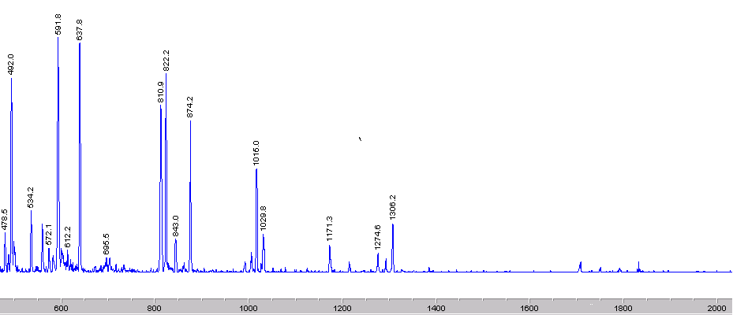
[M-6PF₆]⁶⁺
[M-5PF₆]⁵⁺
[M-4PF₆]⁴⁺
[M-3PF₆]³⁺
%
100 %
Figure 9. ESI-MS of the prism derived from 1 and 2 in DMF (4 mM).

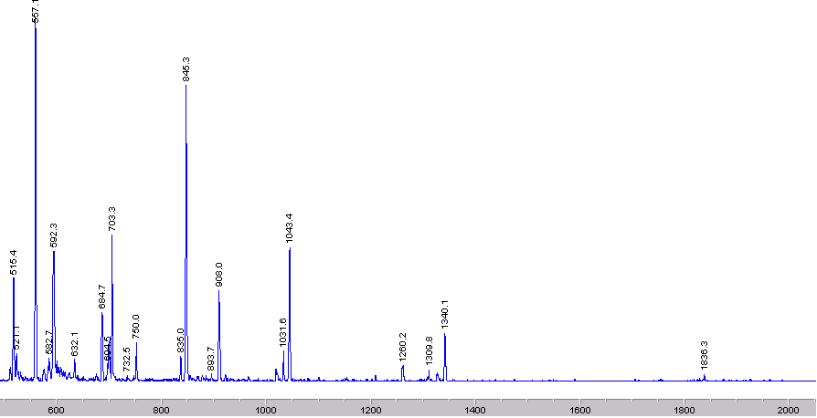
[M-6PF₆]⁶⁺
[M-5PF₆]⁵⁺
[M-4PF₆]⁴⁺
[M-3PF₆]³⁺
[M-7PF₆]⁷⁺
100 %
Figure 10. ESI-MS of the prism derived from 1 and 3 in DMF (4 mM).

References:
(1) Sommer, R. D.; Rheingold, A. L.; Goshe, A. J.; Bosnich, B. J. Am. Chem. Soc. 2001, 123, 3490-3952.
(2) Anderson, H. L.; Anderson, S.; Sanders, J. K. M. J. Chem. Soc., Perkin Trans. 1 1995, 18, 2231-45.
(3) Stang, P. J.; Olenyuk, B.; Muddiman, D. C.; Wunschel, D. S.; Smith, R. D. Organometallics 1997, 16, 3094-3096.
(4) Duerr, B. F.; Chung, Y. S.; Czarnik, A. W. J. Org. Chem. 1988, 53, 2120-2122.
(5) Meyer, A. S.; Ayers, G. H. J. Am. Chem. Soc. 1957, 79, 49-53.
(6) (a) Rudiger, V.; Schneider, H. -J. Chem.-Eur. J. 2000, 6, 3771-3776. (b) Simova, S.; Schneider, H. -J. J. Chem. Soc., Perkin 2 2000, 1717-1722.

