Dendronized Cyclocopolymers with a Radial Gradient of Polarity and their Use to Catalyze a Difficult Esterification.
Catherine O. Liangª, Brett Helmsª, Craig J. Hawker^{b}*, Jean M. J. Fréchetª*

ª University of California, Department of Chemistry Berkeley, CA 94720-1460 USA.
Fax: 510 643 3079; Tel: 510 643 3077; http://www.frechet.com/;
E-mail: frechet@cchem.berkeley.edu.
^{b} IBM Almaden Research Center 650 Harry Road, San Jose, CA 95120-6099, USA.
E-mail: hawker@almaden.ibm.com.

SUPPLEMENTAL INFORMATION
General: NMR spectra were obtained using a Bruker DRX-500 MHz spectrometer in CDCl₃ solutions at 25 ºC. ¹H NMR spectra were recorded at 500 MHz and chemical shifts were referenced to the residual solvent peak. ¹H NMR splitting patterns are reported as broad singlet (bs), and broad triplet (bt). IR spectra were recorded from 4000 to 500 cm⁻¹ with a Mattson Genesis II FT-IR instrument and prepared as a thin film. Size exclusion chromatography (SEC) in DMF with 0.05% LiCl was performed on the hydroxylated dendronized polymers at 70 °C at a nominal flow rate of 1.0 mL/min on a chromatography line calibrated with 8 linear PMMA standards (620-910,500 g/mol) and fitted with two 5 μm PLgel MIXED-C columns. Detection was performed with a Waters 486 Tunable Absorbance Detector (λ = 300 nm). Light scattering analysis of the parent cyclocopolymer (MW = 26,000) was provided by the Analytical Technology Division of Kodak (Rochester, NY).
Figure 1. Dendronized cyclocopolymer (3): 1H-NMR (500 MHz, CDCl3) δ 0.88 (bt), 1.25 (bs), 1.56 (bs), 2.27 (bs), 4.22 (bd).

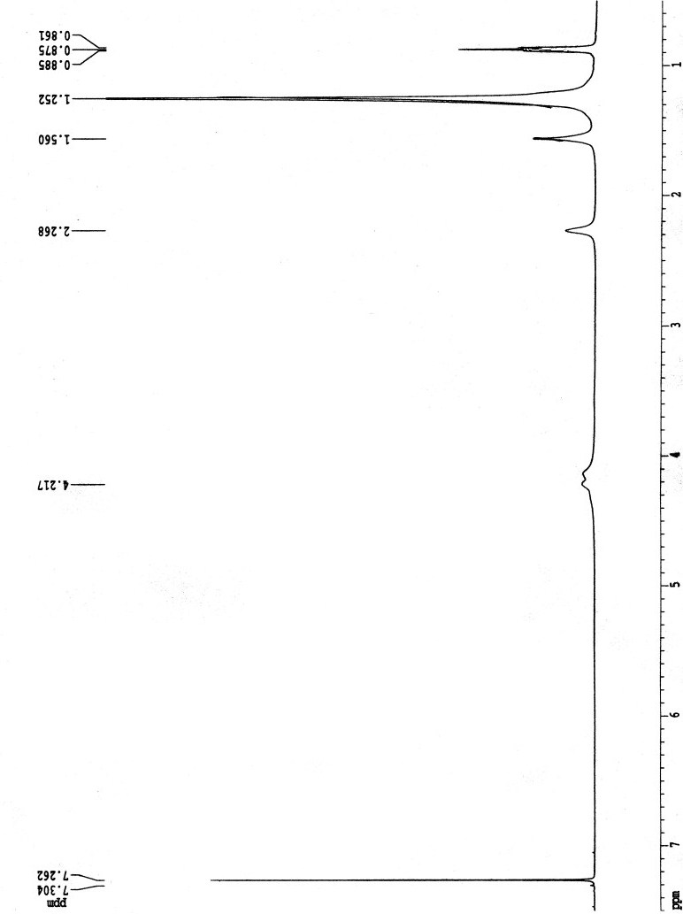
Residual terminal alcohols present in the dendritic structure are acylated in the final step. Reacting the molecule with myristic anhydride effectively caps –OH groups. The efficiency of capping is illustrated in the IR spectra. Prior to acylation, the large –OH stretch (3411 cm⁻¹) exhibited by the polyol precursor to compound 3 is observed, Figure 2. Disappearance of broad OH stretch at 3411 cm⁻¹ is indicative of successful terminal alcohol capping, Figure 3.

Figure 2. IR spectrum of polymeric polyol precursor of 3:

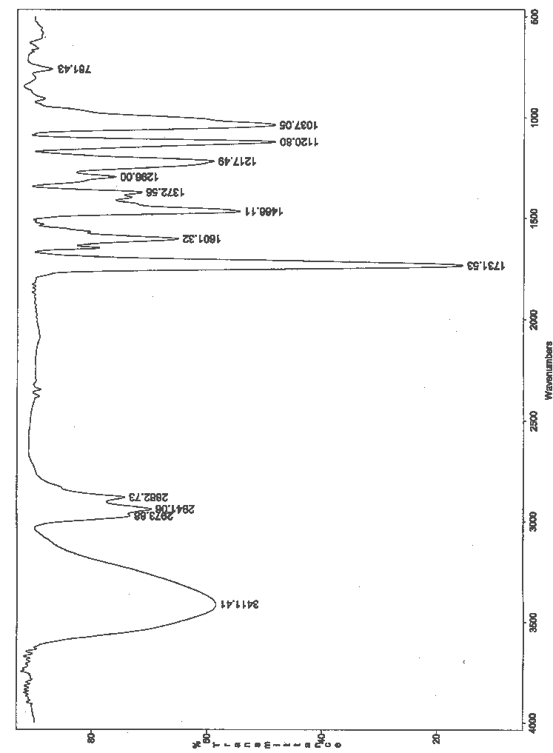

Figure 3. IR spectrum of 3:

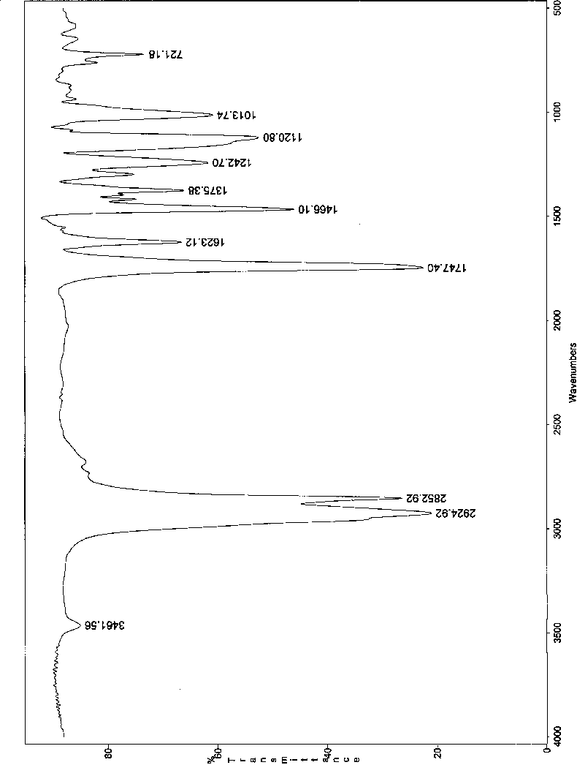

Table 1 shows the measured molecular weights of the hydroxyl terminated series of dendronized polymers. These polymers are well solvated by the DMF mobile phase and thus occupy large hydrodynamic volumes. The GPC curves show that the dendronized polymer remains monomodal throughout the growth steps indicating the absence of “dimerization” reactions between polymer chains. Furthermore, based on the observed cyclocopolymer molecular weight, oligomeric species are not present in the sample. Obviously however, SEC calibration using PMMA can only provide relative data and is not ideally suited to handle the unusual dendronized polymers described herein as the two polymers have obvious differences in architecture, polarity, and ability to interact with the solvent.

Table 1. SEC of dendronized cyclocopolymers generations 1-4. All dendronized polymers have a hydroxylated periphery and G# indicates the generation number.

Polymer | M_{w} / PDI | Theoretical Mw
G4-(OH)₁₆ | 378k / 2.8 | 430k
G3-(OH)₈ | 173k / 2.2 | 214k
G2-(OH)₄ | 129k / 2.5 | 107k
G1-(OH)₂ | 106k / 2.2 | 53k

Pyrrolidinopyridine content in sample 3:
An estimate of the amount of PPY present in compound 3 can be obtained by UV spectroscopy (λ = 255 nm, ε =17,000 M⁻¹cm⁻¹). The measured value is in close agreement with the theoretical value based on 1:11 PPY/pyrrolidino repeat units of polymer backbone.
Amount calculated from UV measurements: 17.1μmol PPY/gram 3
Theoretical amount: 17.4μmol PPY/gram 3

