Electronic Supplementary Information (ESI)

1. The chemical structure of the triptycene and triphenylene molecules are shown in Scheme 1 with a characteristic conformation in a three-bladed propeller shape of triptycene molecule , which is easy to be distinguished in its orientation flat, tilt and vertical when it adsorbs on solid surface, while the triphenylene molecule is a a planar molecule.

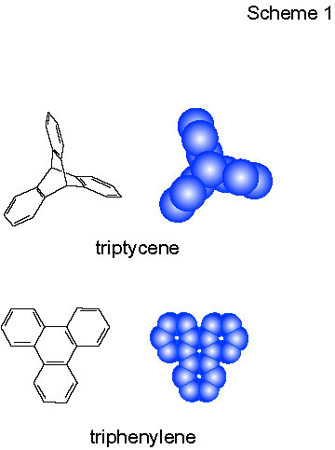

Scheme 1 Molecular structures of triptycene and triphenylene.

2. The triphenylene molecule possesses three benzene rings surround a benzene center. The molecules form a 2D-ordered adlayer structure in (4 × 4) symmetry, as shown in Fig. 2. The characteristic molecular shape can be clearly seen. Each molecule consists of three bright spots corresponding to three benzene rings of the molecule. The results show a stable flat-lying orientation at a wide range of bias voltages from 0.01 to 0.5 V.

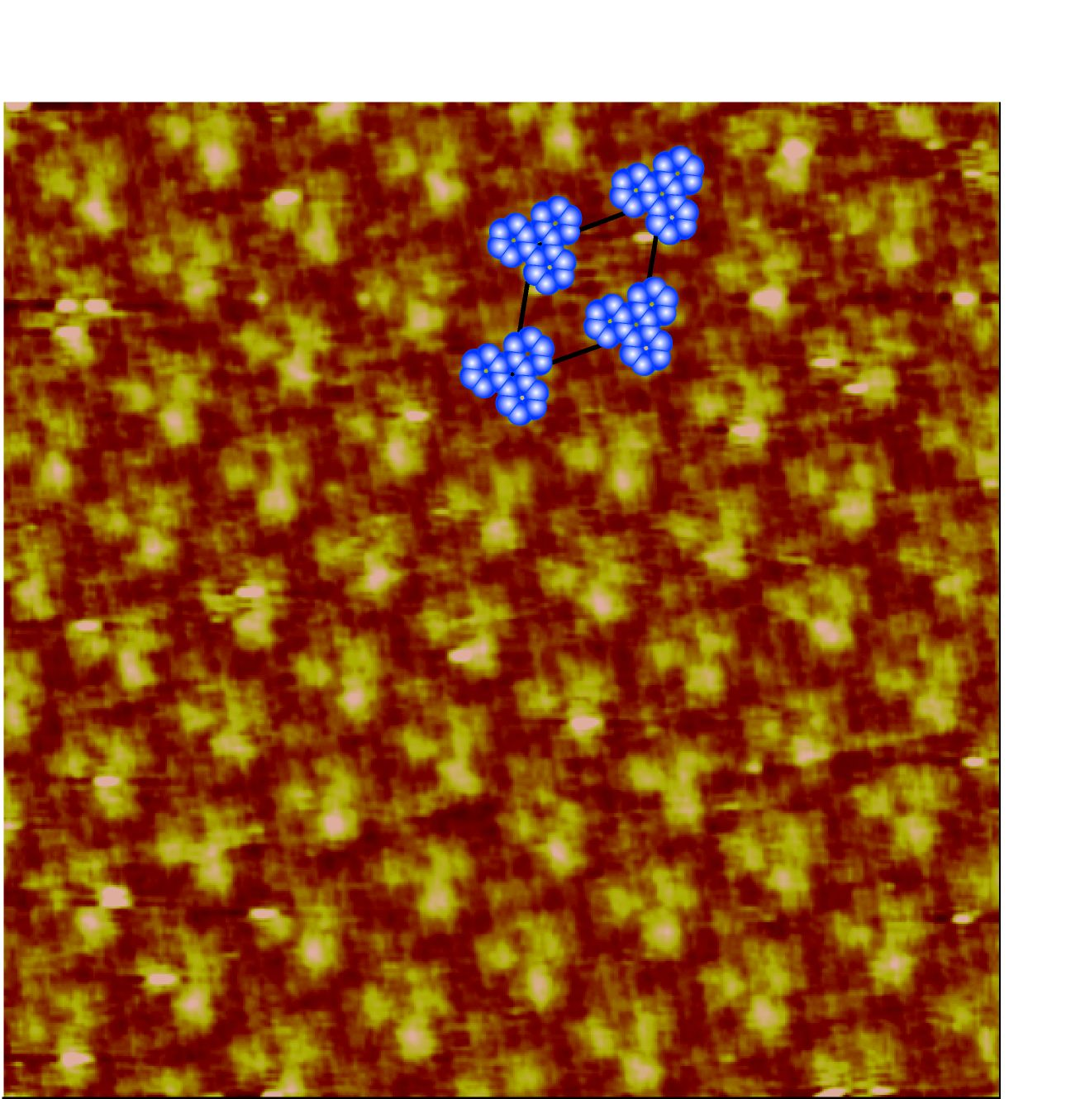

Fig. 2 STM image of triphenylene molecules on Cu(111) in 0.1 M HClO₄.
Scanning size: 7.5 nm × 7.5 nm.

