Supplementary information

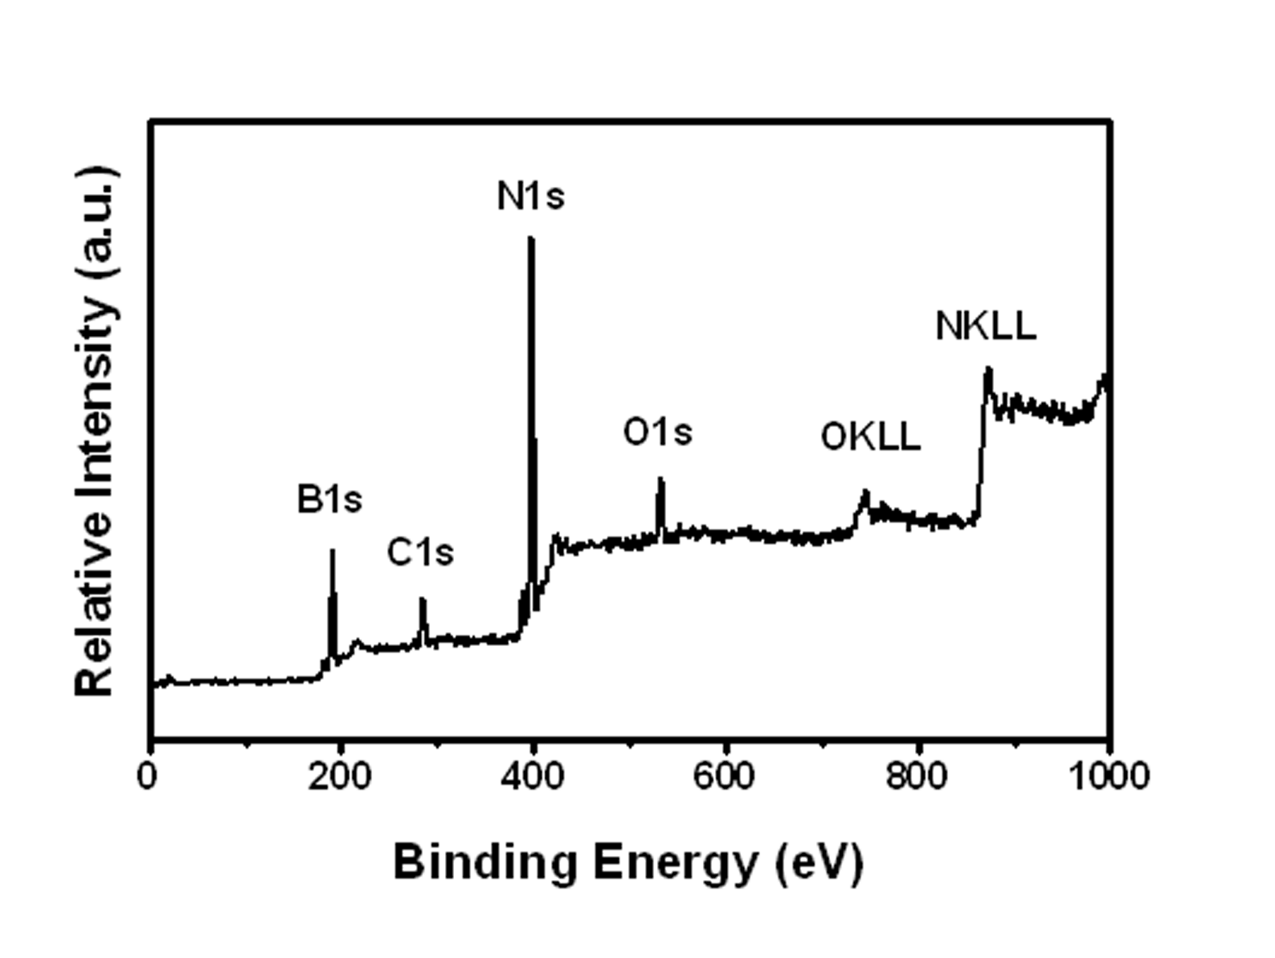

Fig.S1 The Survey Spectrum of as-prepared h-BN

The binding energies obtained in the XPS analysis are standardized for specimen charging using C1s as the reference at 284.6eV.No peaks of other elements except C, O, B, N, are observed on the Fig.S1. The peaks for O can be attributed to the O₂, CO₂, or H₂O absorbing on the surface of the samples.

