S-1. HPLC trace and MALDI-TOF mass spectrometry analysis of peptide 1. Purification performed with a Waters Prep LC 4000 system equipped with a Waters 2487 Dual λ Absorbance detector and a Waters RCM bulk matrix C₁₈ column (25X10 cm) with a flow rate of 14.5 mL/min at 25ºC. The peptides eluted with a gradient of 100% water (0.1% TFA) to 50% water (0.1% TFA) : 50% acetonitrile (0.1% TFA) over thirty minutes. MALDI-TOF mass spectrometry analysis of the peptides acquired at the Vanderbilt University Mass Spectrometry Core Facility. Laser: 1995; Accelerating Voltage: 20,000 eV; Scans Averaged: 150.

S-2. HPLC trace and MALDI-TOF mass spectrometry analysis of peptide 2. See S-1
for details.

S-3. HPLC trace and MALDI-TOF mass spectrometry analysis of peptide 3. See S-1
for details.

S-4. HPLC trace and MALDI-TOF mass spectrometry analysis of peptide 4. See S-1
for details.

S-5. HPLC trace and MALDI-TOF mass spectrometry analysis of peptide 5. See S-1
for details.

S-6. HPLC trace and MALDI-TOF mass spectrometry analysis of peptide 6. See S-1
for details.

S-7. HPLC trace and MALDI-TOF mass spectrometry analysis of peptide 7. See S-1
for details.

S-8. HPLC trace and MALDI-TOF mass spectrometry analysis of peptide 8. See S-1
for details.

S-9. HPLC trace and MALDI-TOF mass spectrometry analysis of peptide 9. See S-1
for details.

S-10. HPLC trace and MALDI-TOF mass spectrometry analysis of peptide 10. See S-1
for details.

S-11. HPLC trace and MALDI-TOF mass spectrometry analysis of peptide 11. See S-1
for details.

S-12. Plot of the concentration dependence of the R5 peptide (1). 100 μL of 2 mM peptide was incubated with 10 μL of 1 M hydrolyzed TMOS for 5 minutes. The mixture was centrifuged to form a pellet. The pellet was washed three times using DI H₂O and quantitated using the β-silico Molybdate method.

S-13. Scanning electron micrograph of silica produced from peptide 1. Nanospheres imaged were synthesized and washed as S-12. The nanospheres were then suspended in ethanol and added dropwise to an SEM grid. The grid was allowed to dry and was then sputtered with a thin layer of gold. SEM analysis was conducted using an Hitachi S4200 microscope operating at variable voltage.

S-14. Representative transmission electron micrographs of silica produced from [A] peptide 1, [B] peptide 3, [C] peptide 4, [D] peptide 5, [E] peptide 6, [F] peptide 7 and [G] peptide 8. Nanosphere imaged were synthesized and washed as above Silica analyzed by transmission electron microscopy was suspended in water and then added drop wise to a holey carbon coated Cu TEM grid (SPI) and allowed to dry. Analysis was conducted on a Phillips CM-20 transmission electron microscope operating at 200 kV.

S-15. Infrared spectra of peptide and silica from [A] peptide 1, [B] peptide 2, [C] peptide 3, [D] peptide 4, [E] peptide 5, [F] peptide 6, [G] peptides 7 and 8, [H] peptide 9, [I] peptide 10, and [J] peptide 11. Note that peptides B, H, I and J did not produce silica nanospheres. Silica nanospheres were synthesized and washed as above. After the final washing, the silica was allowed to dry for 24 hours under vacuum for IR analysis. Spectra were obtained from KBr pellets using a Mattson Genesis Series FTIR.

S-16. Dynamic Laser Light Scattering data for peptides 1, 2, 3 and 7. Peptides tested by light scattering were dissolved in 100 mM phosphate buffer to a concentration of 2 mM and each sample was filtered using a 0.2 μm syringe filter. The samples were analyzed using a Nicomp 380 DLS with a 35 mW laser and APD detector by Particle Sizing Systems, New Port Richey, FL.

S-17. Schematic mechanism of silica nanosphere formation using the self assembled peptidyl structure.

17.2 min
2014
peptide

S-1

10.8 min
844
peptide
866931
peptide +2 Na⁺ + K⁺

S-2

10.8 min
1189
peptide

S-3

18.5 min
1711
peptide

S-4.

8.9 min
963
peptide

S-5.

10.3 min
1475
peptide

S-6.

8.2 min
1382
peptide

S-7.

12.8 min
1382
peptide
1366
peptide – NH₃

S-8.

1019
peptide
1041
peptide + Na⁺
1057
peptide + K⁺
18.2 min

S-9.

10.7 min
1135
peptide
1157
peptide + Na⁺
1173
peptide + K⁺

S-10.

9.9 min
1127
peptide + Na⁺
1105
peptide

S-11.

S-12

S-13

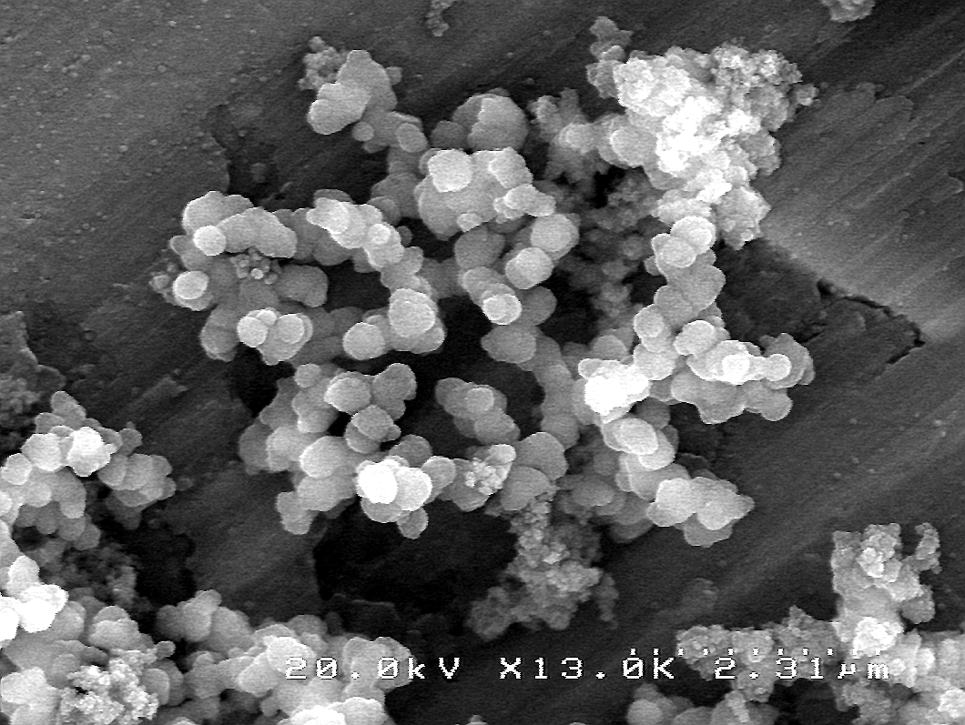

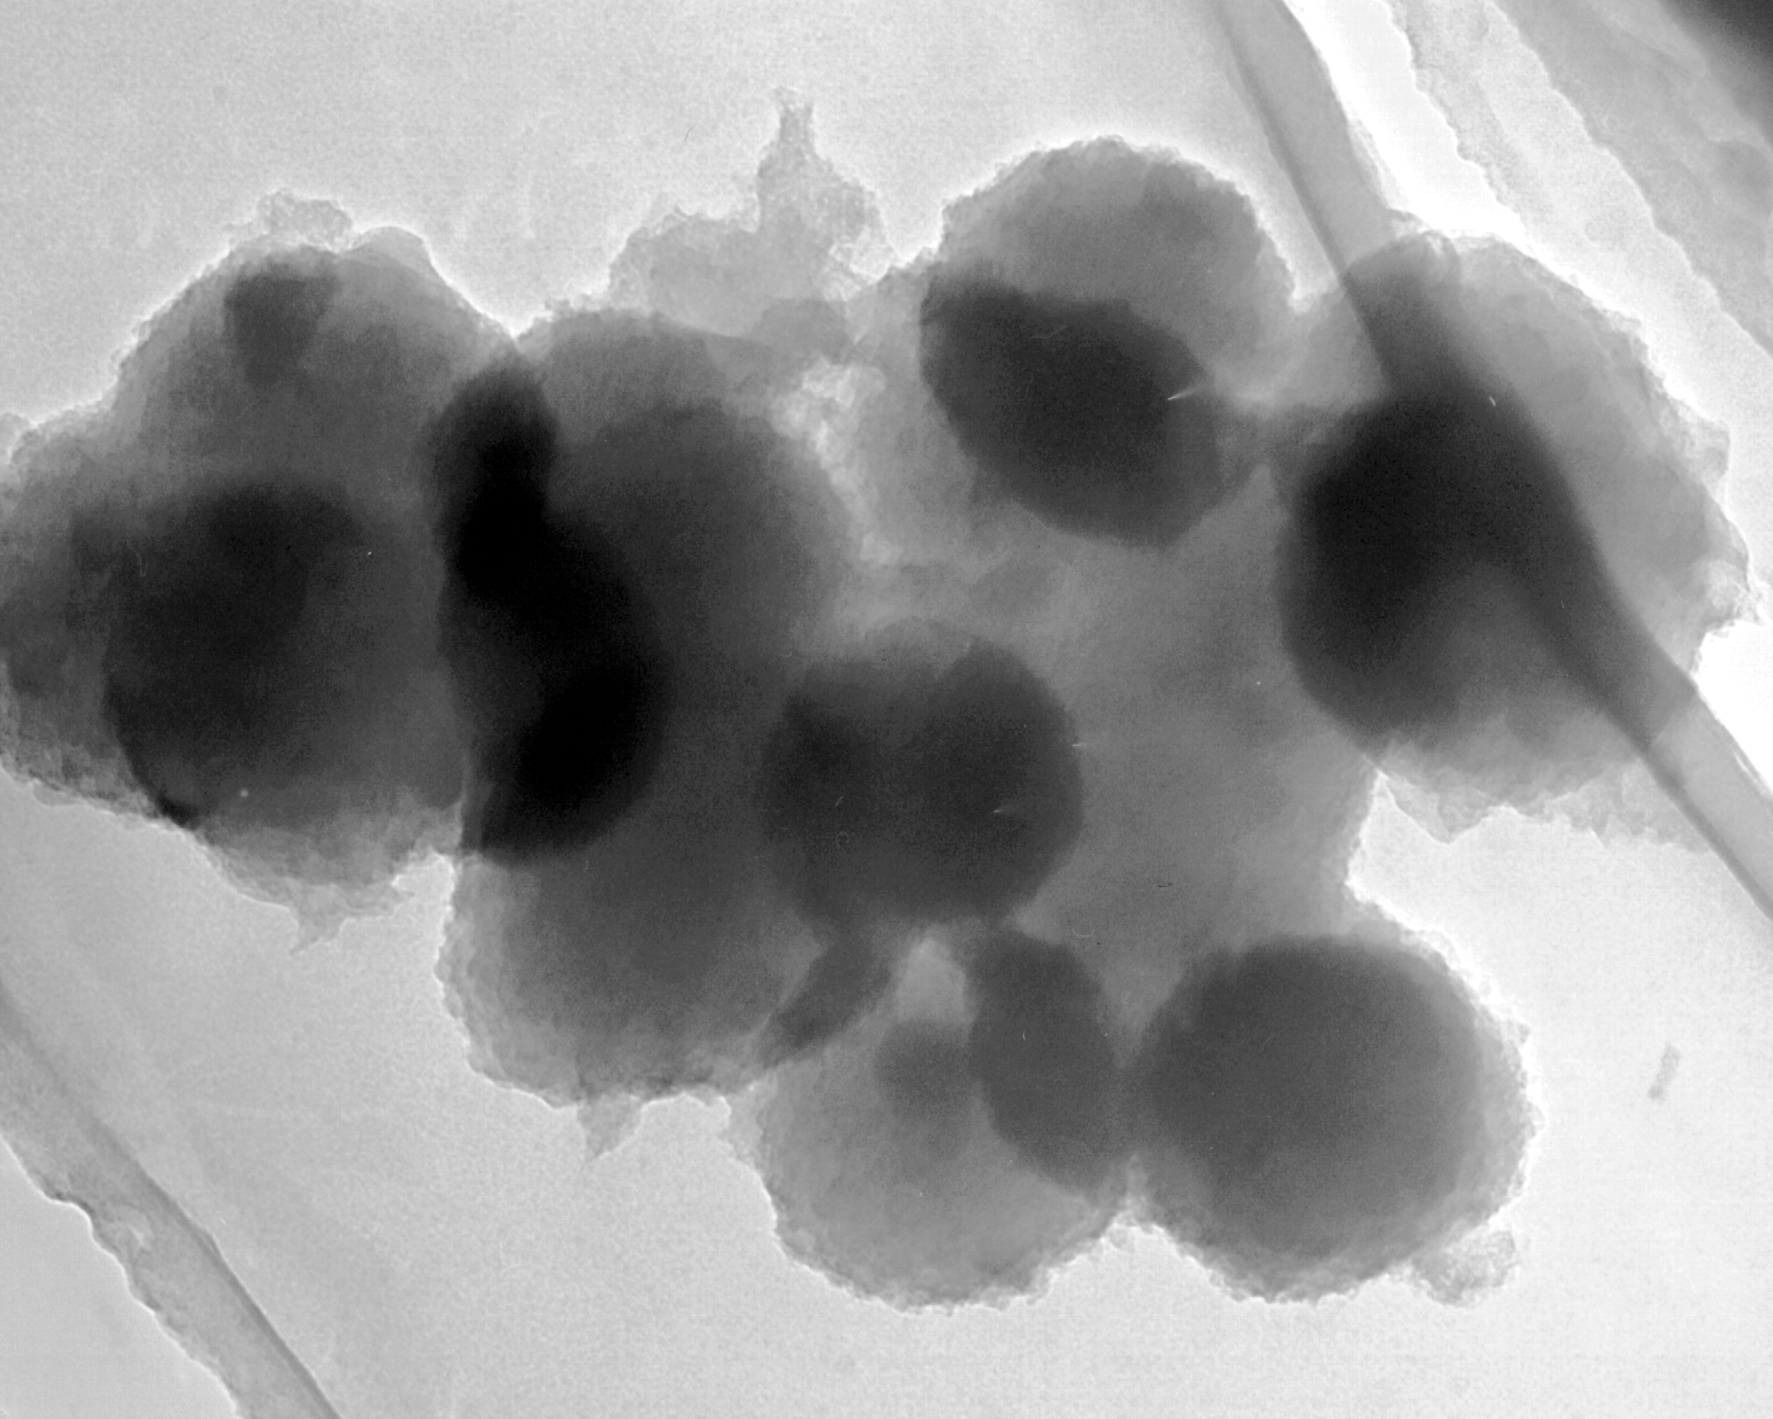
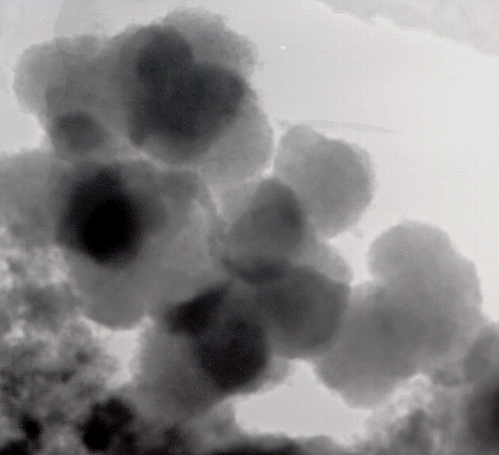
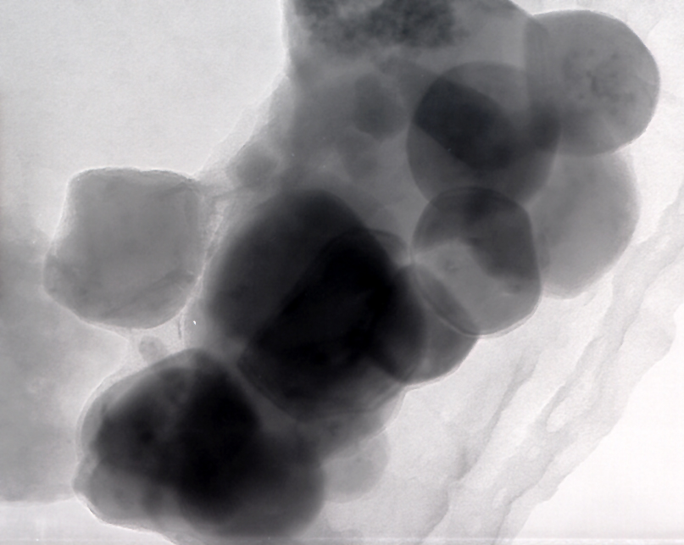
320 nm
A.
240 nm
B
100 nm
C

S-14

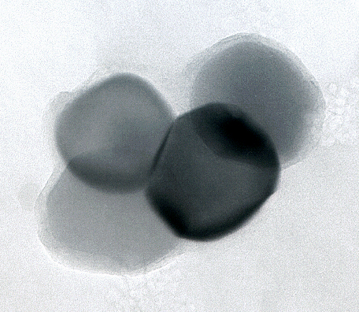
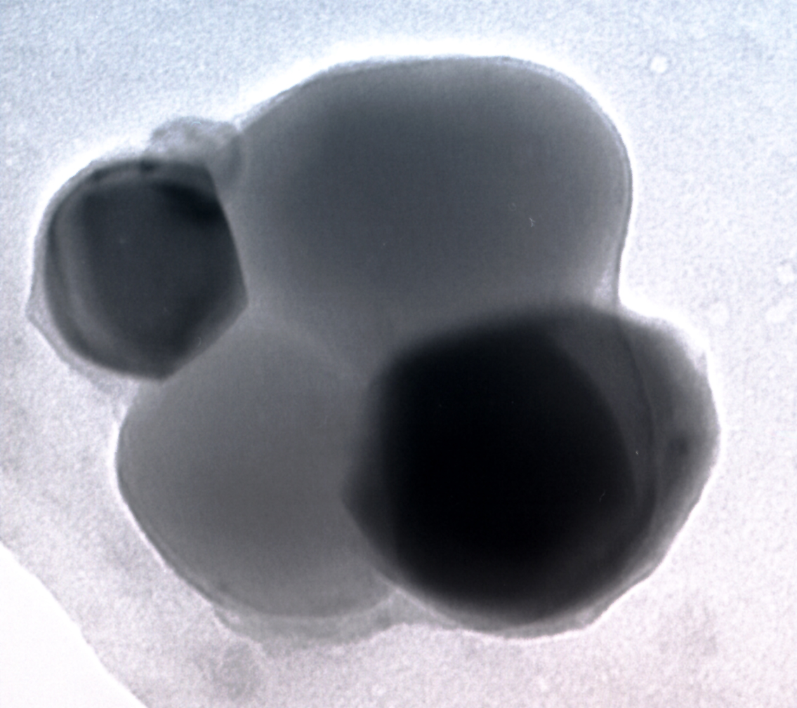
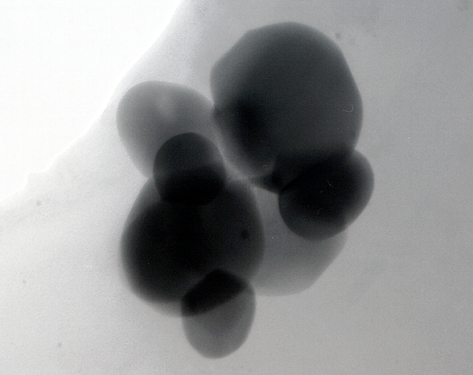
100 nm
E
100 nm
F
140 nm
D

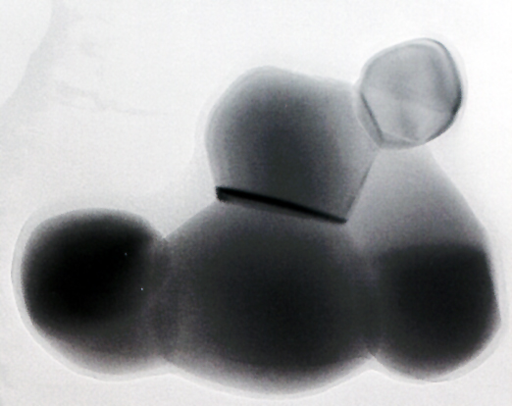
120 nm

G

A

Figure 1

B
C

S-14

F
E
D

H
G
I

J

S-15.

Peptide | Aggregate Size (nm) | Aggregate Percentage*
1 | 825.6 | 93.3
2
3 | 707.5 | 79.5
7 | 954.4 | 69.0
* Based on total aggregates detected.

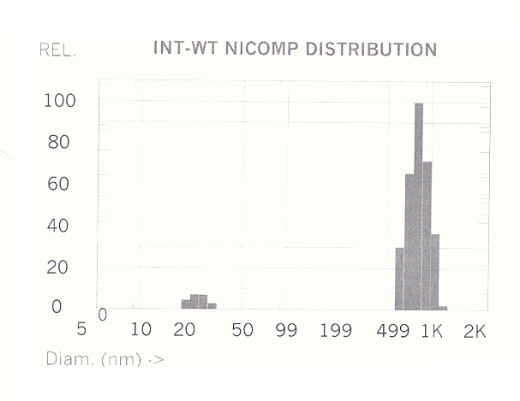

Representative DLS measurement on R5 (Peptide 1).

S-16.

SiO₂

