A water-soluble and self-doped conducting polyaniline graft copolymer

Woo Jin Bae,ª Keon Hyeong Kim,ª Yun Heum Park*^{b} and Won Ho Jo*ª

ª Hyperstructured Organic Materials Research Center and School of Materials Science and Engineering, Seoul National University, Seoul 151-742, Korea. Fax: 82-2-885-1748; Tel: 82-2-880-7192; E-mail: whjpoly@plaza.snu.ac.kr

^{b} School of Applied Chemistry and Chemical Engineering, Sungkyunkwan University, Suwon 440-746, Korea. Fax: 82-31-290-7330; Tel: 82-31-290-7312; E-mail: yhpark@skku.edu

Electronic supplementary information

Schematic diagram (a) of doped and de-doped state of PSSA-g-PANI and PSSA/PANI blend, and structural change (b)of PSSA-g-PANI during de-doping process
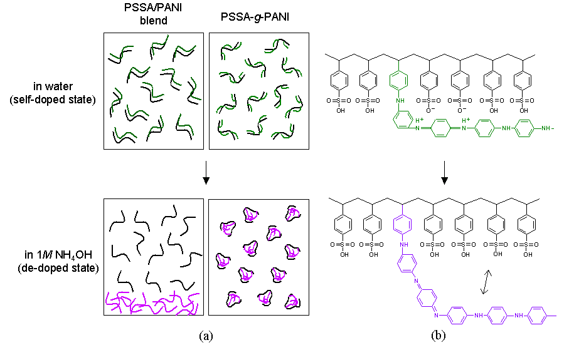
Changes in intrinsic viscosity of PSSA-g-PANI during doping and de-doping
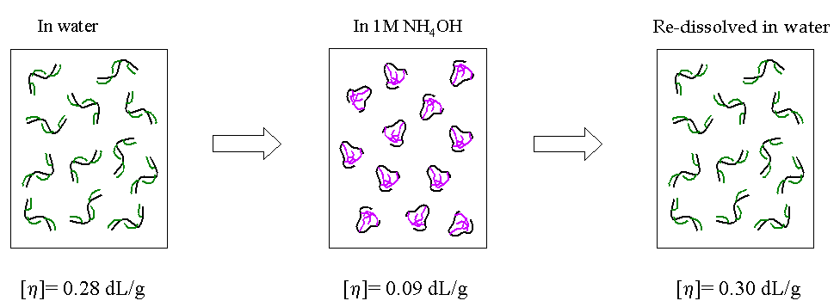
XPS spectra of (a) doped PSSA-g-PANI and (b) de-doped PSSA-g-PANI
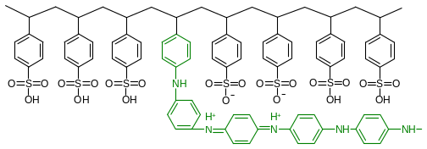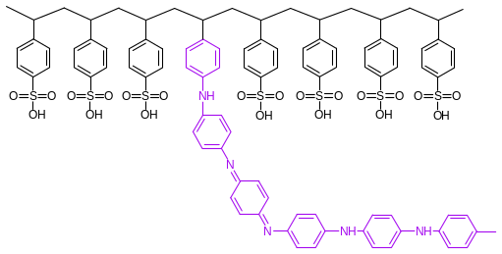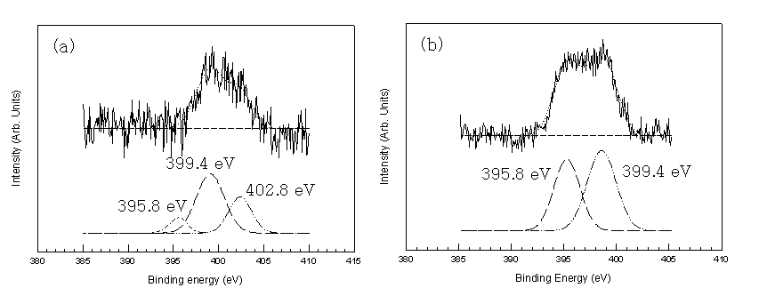

Structure | Binding energy
quinoid imine (=N- structure) | 395.8 eV
benzenoid amine (-NH- structure) | 399.4 eV
Positively charged nitrogen (-N⁺- structure) | 402.8 eV

It is noted that the oxidation level of 0.5 evaluated from FT-IR experiment is coincident with the value of 0.43 determined quantitatively by XPS analysis. The doping level was estimated ca. 35 mol%. (N 1s core-level spectra)

FTIR spectra of (a) P(SSNa-co-BOC-AMS), (b) P(SSA-co-AMS) and (c) PSSA-g-PANI, where Q, B and op denote the quinoid ring, benzenoid ring and out-of-plane, respectively
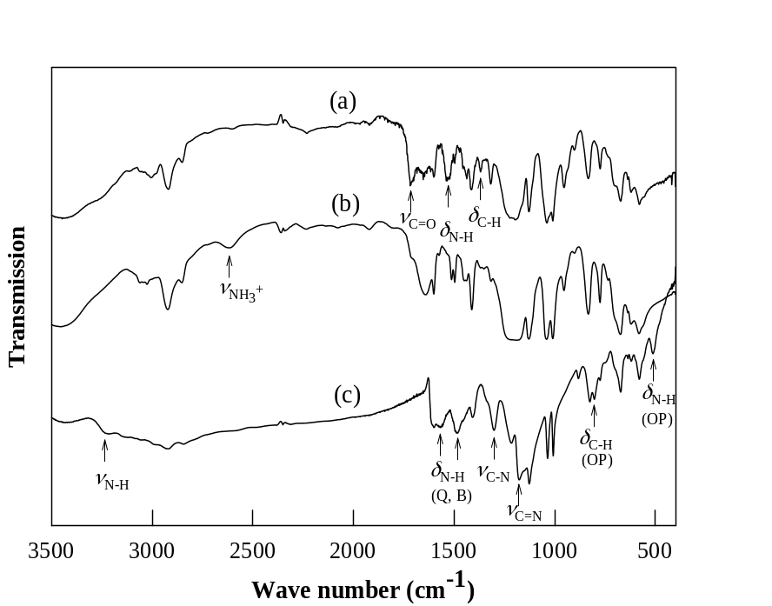

GPC profile of PSSA-g-PANI
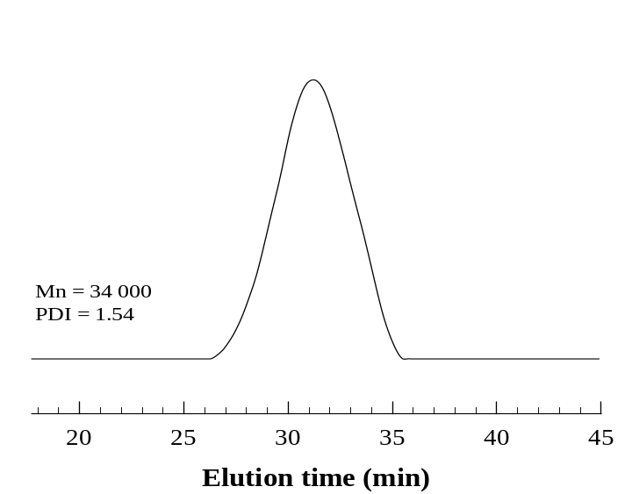
Column: UltrahydrogelTM 500, 7.8 ×300 mm
Eluent: water/DMF(v/v=9.5/0.5)+0.5 M NaOH
Flow rate: 0.6 ml/min

