Supplementary material (ESI) for Chemical Communications
This journal is © The Royal Society of Chemistry 2003

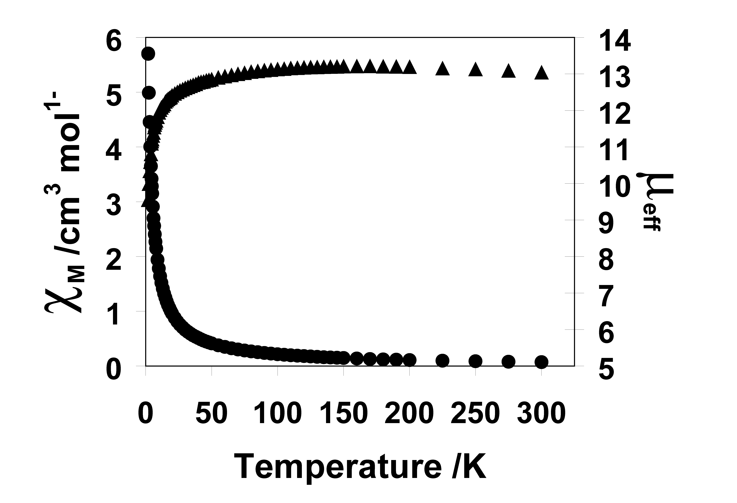

Figure S1. Variable-temperature dc susceptibility of 1 at 2500 G. χ_{M} () μ_{eff}()

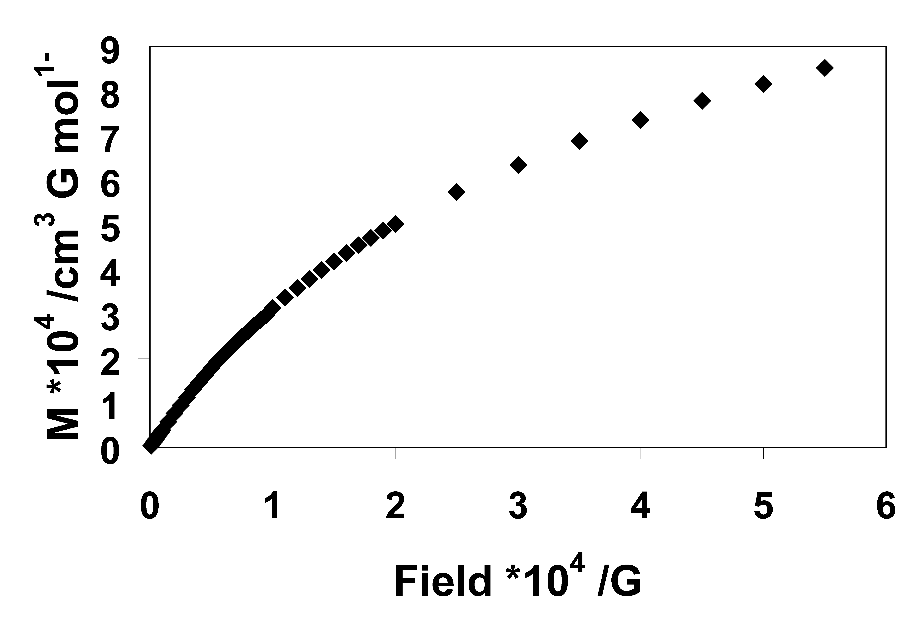
Figure S2. Magnetization (M) variable-field data of 1 at 4.5 K.

