Supporting Information

Spectroscopic characterization of per-6-deoxy-6-(ethylenediamino)-α-cyclodextrin
¹H NMR (D₂O, pD=8.0, Na₂CO₃, 600 MHz) δ 4.91 (br. s, 6H, H₁), 3.79 (br. t, 12H, H₃,H₅), 3.49 (br. d, 6H, H₂), 3.39 (br. t, 6H, H₄), 2.95 (br. s, 6H, NHCH₂CH₂NH₂), 2.85-2.63(m, 12H, H₆), 2.57 (br. s, 6H, NHCH₂CH₂NH₂), 2.50 (br. s, 12H, NHCH₂CH₂NH₂)
¹³C NMR (D₂O, 150 MHz) δ 104.2 (C₁), 86.0 (C₄), 75.8 (C₃), 74.3 (C₂), 73.3 (C₅), 53.9 (-NHCH₂CH₂NH₂), 51.9 (C₆), 42.4 (-NHCH₂CH₂NH₂) MS: (m/z) 1226 (MH⁺¹), 613(MH₂⁺²), 409 (MH₃⁺³), 205 (MH₆⁺⁶)

Homonuclear ¹H COESY spectrum

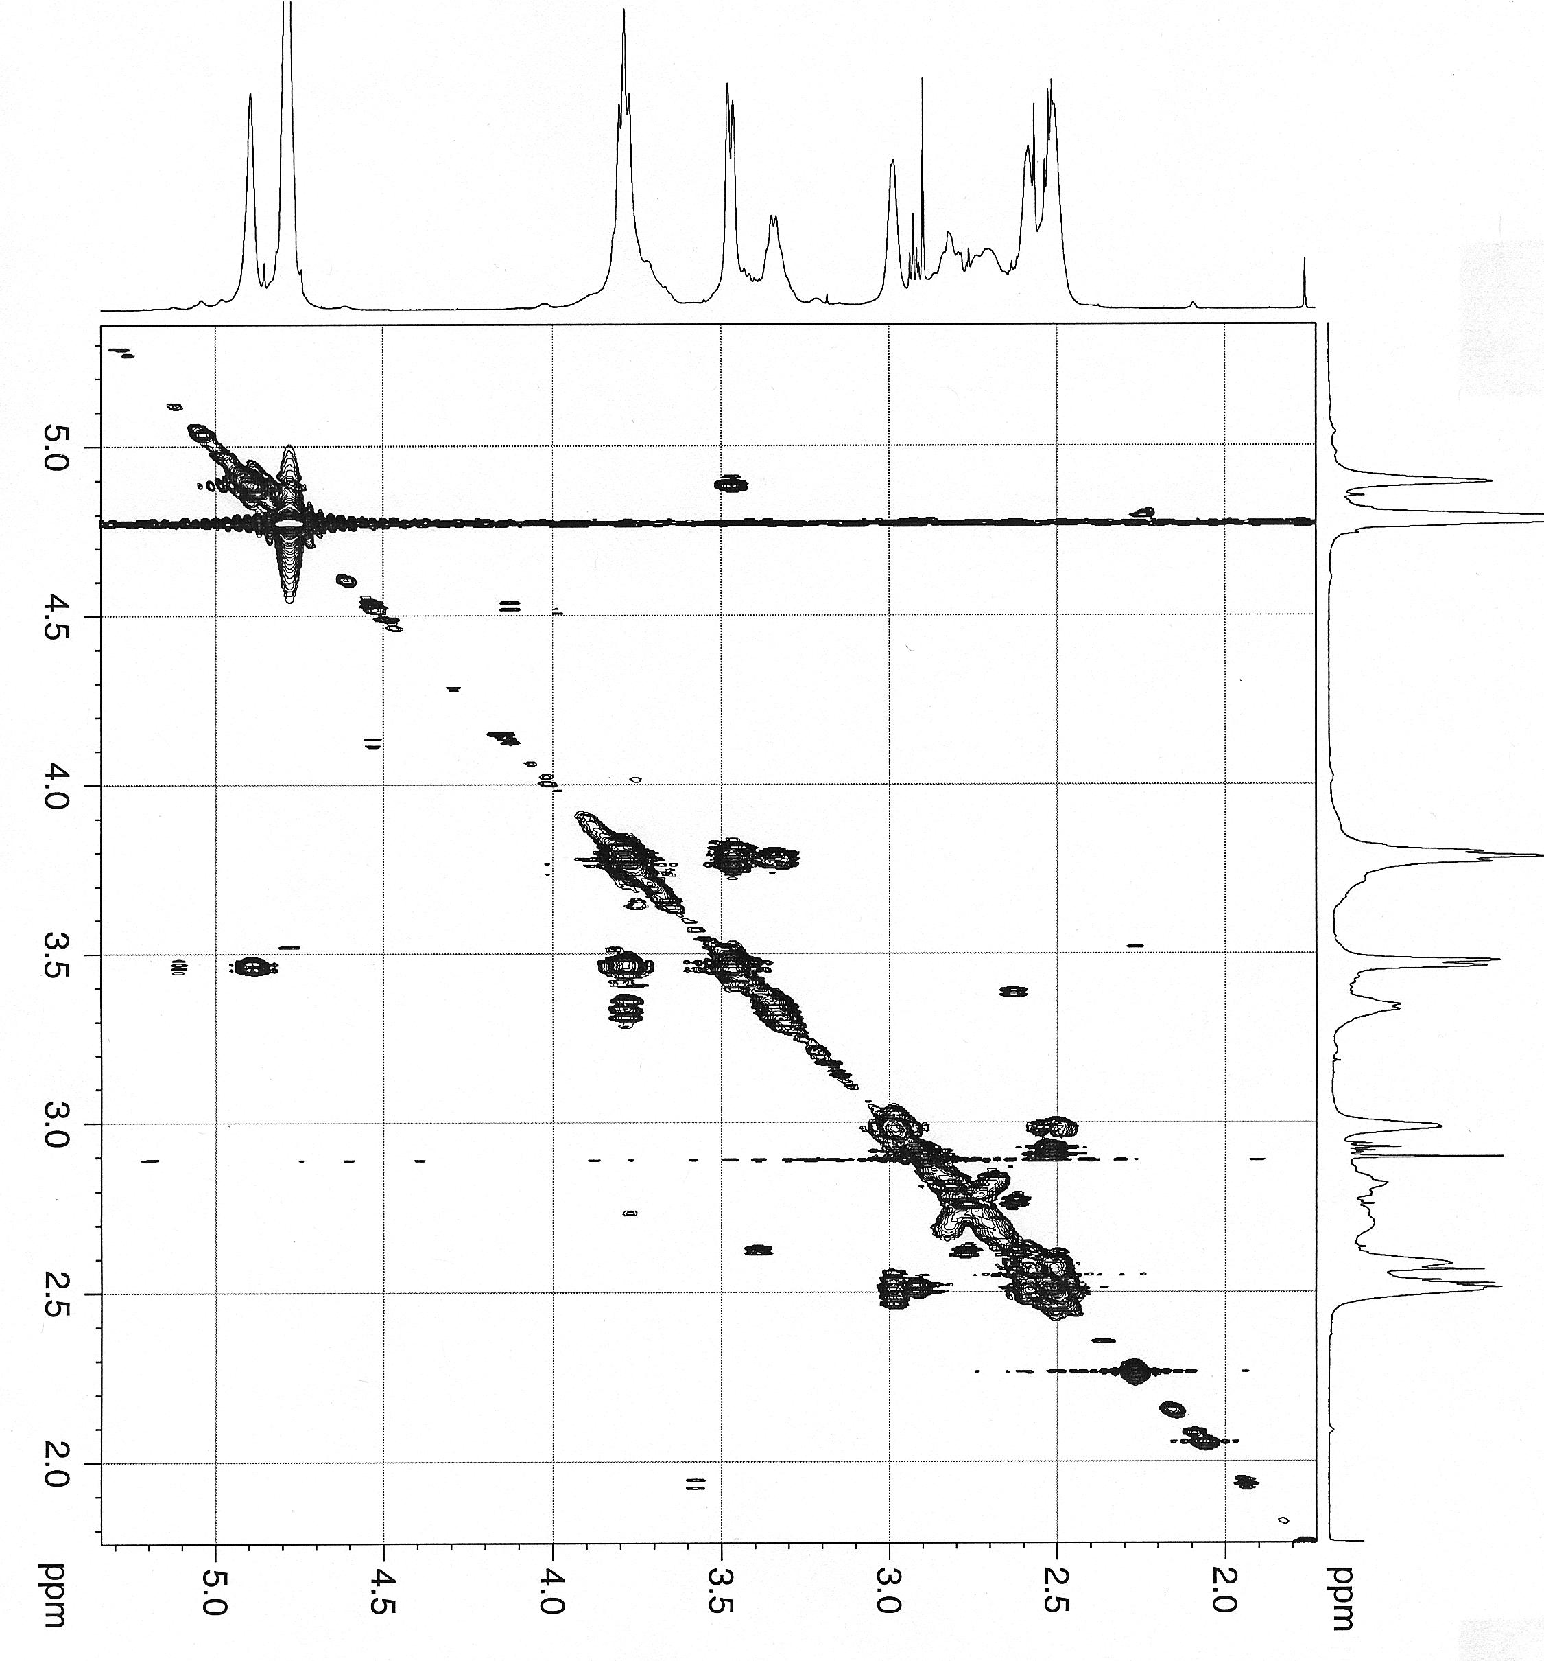
Heteronuclear HMBC spectrum
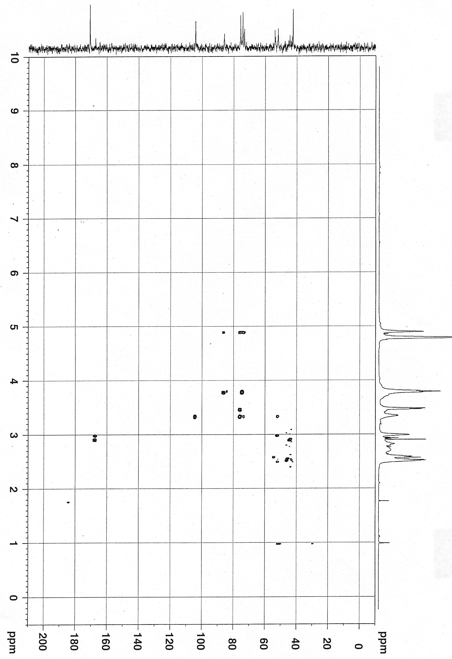
Heteronuclear HMQC spectrum
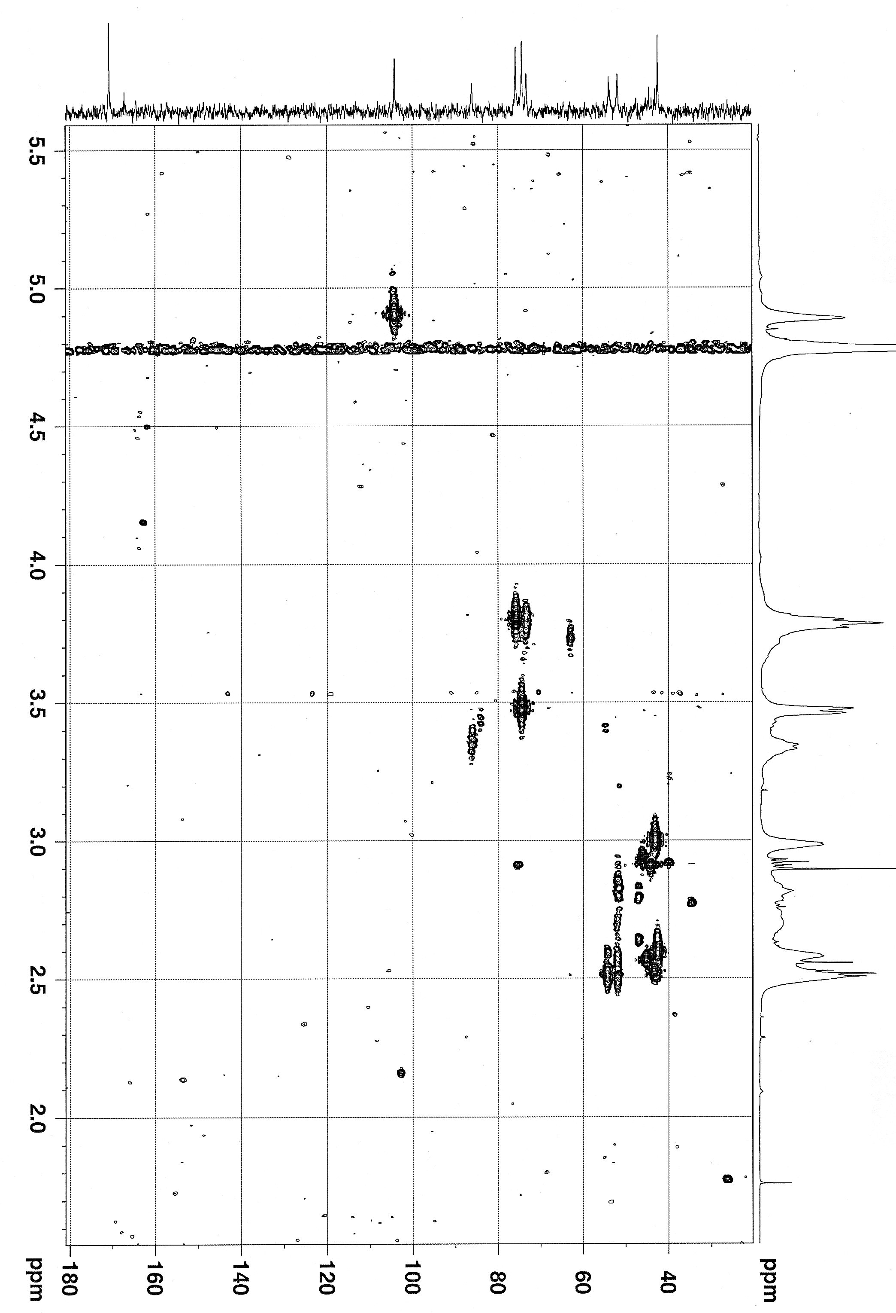

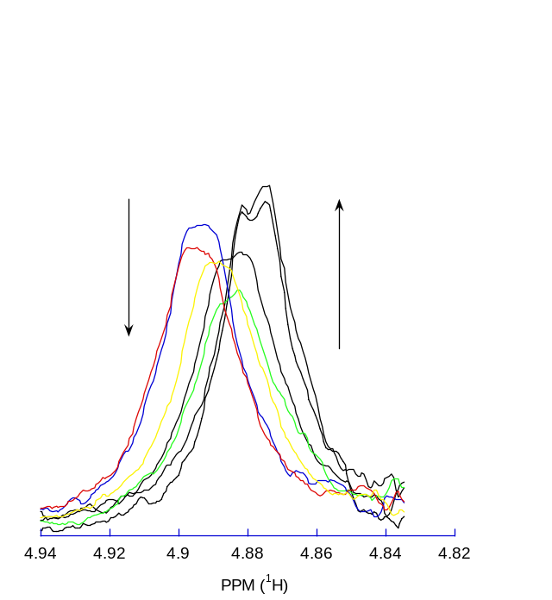
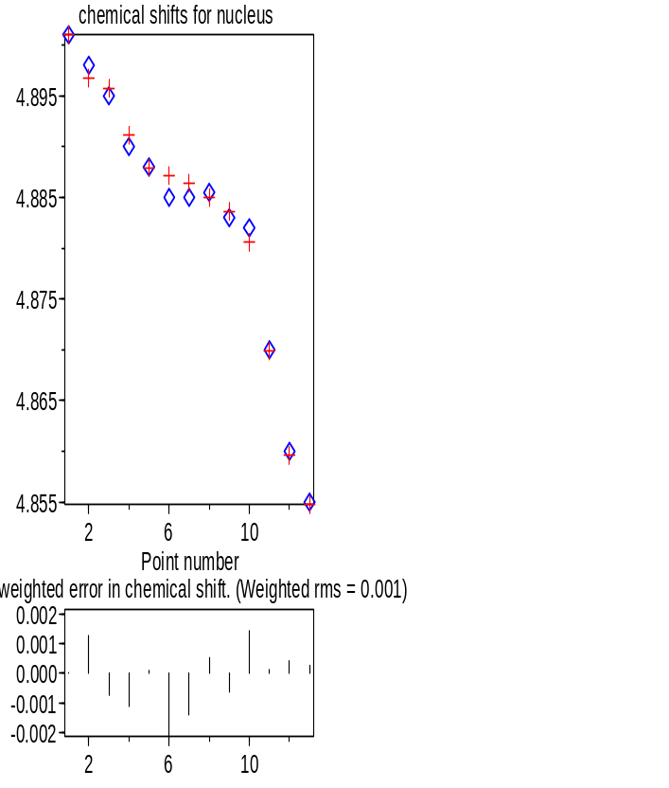
The titration of per-6-deoxy-6-(ethylenediamino)-α-cyclodextrin and uranyl carbonate followed by ¹H NMR. A fit of the H₁ proton shifts yield a 1:1 binding isotherm, K = 253 (20) given in the figure below as do the ethylene diamine proton signals given in the article..

Species concentrations/mol dm⁻³
Point -T[Ho] T[G] F[Ho] F[G] [H-G Complex]
1 -1.355e-03 4.000e-04 1.2573e-03 3.0230e-04 9.7697e-05
2 -1.350e-03 5.000e-04 1.2299e-03 3.7990e-04 1.2010e-04
3 -1.310e-03 1.000e-03 1.0910e-03 7.8099e-04 2.1901e-04
4 -1.328e-03 1.400e-03 1.0340e-03 1.1060e-03 2.9397e-04
5 -1.321e-03 1.500e-03 1.0115e-03 1.1905e-03 3.0952e-04
6 -1.313e-03 1.600e-03 9.8876e-04 1.2758e-03 3.2424e-04
7 -1.305e-03 1.800e-03 9.5133e-04 1.4463e-03 3.5367e-04
8 -1.298e-03 2.000e-03 9.1663e-04 1.6186e-03 3.8137e-04
9 -1.290e-03 2.500e-03 8.4423e-04 2.0542e-03 4.4577e-04
10 -1.283e-03 5.000e-03 6.0760e-04 4.3246e-03 6.7540e-04
11 -1.276e-03 1.000e-02 3.8197e-04 9.1060e-03 8.9403e-04
12 -1.271e-03 1.500e-02 2.7631e-04 1.4005e-02 9.9469e-04
Ho= per-6-deoxy-6-(ethylenediamino)-α-cyclodextrin
G= uranyl carbonate

Calculated species distributions
Species distributions were calculated using the formation constants from ref.7. A model was constructed using the natural concentration of Uranyl in seawater over a wide pH range. The carbonate species is clearly dominant over a wide range of pH values in the absence of added outer-sphere ligand. In the presence of per-6-deoxy-6-(ethylenediamino)-α-cyclodextrin as an outer-sphere ligand, approximately 75% of the uranyl carbonate is complexed over the pH range of 7 to 9. Several approximations are made in this model. The protonation behavior of the amino-cyclodextrin was not included in the model. Deprotonation of the amines will start to be significant above pH 9, leading to substantially decreased interaction between the ligand and the metal complex. The ligand was allowed to complex only uranyl tris-carbonate, all other species have no interaction with the ligand. This approximation is probably valid for the anions, Cl⁻ and SO₄²⁻, but may be significant for various mixed ligand complexes of the uranyl ion. No anions other than OH⁻, Cl⁻ and SO₄²⁻are included in the model. Finally, no solids are included in the speciation predictions. Formation of solids will perturb the equilibrium concentrations of the species in solution. 

