Preparation of a novel diphosphine-palladium macrocyclic complex possessing a molecular recognition site. Oxidative addition studies.

Jens Larsen, Brian S. Rasmussen, Rita G. Hazell and Troels Skrydstrup*

Department of Chemistry and the Interdisciplinary Nanoscience Center, University of Aarhus, Langelandsgade 140, 8000 Aarhus C, Denmark

Supplementary Information

Generel Methods. The ¹H NMR spectra were recorded at 400 MHz or 200 MHz and ¹³C NMR spectra were recorded at 100 MHz or 50 MHz. The chemical shifts are reported in ppm downfield to TMS (δ = 0) for ¹H NMR and relative to the central CDCl₃ resonance (δ = 77.16) for ¹³C NMR. ³¹P NMR were recorded at 162 MHz using H₃PO₄ as an external reference. The spectra were run in CDCl₃ unless otherwise stated. Solvents were dried according to standard procedures. Flash chromatography was carried out on Merck silica gel 60 (230-400 mesh). All reactions were carried out under an argon atmosphere. Pd(dba)₂ was prepared according to C. Amatore, G. Broeker, A. Jutand and F. J. Khalil, J. Am. Chem. Soc. 1997, 119, 5176, N,N’-bis-(6-aiminopridin-2-yl)-isophthalamide according to S.-K. Chang and A. D. Hamilton, J. Am. Chem. Soc. 1988, 110, 1318, and diethyl 2-but-3-enyl-2-methyl-malonate was prepared according to A. L. J. Beckwith, C. J. Easton, T. Lawrence and A. K. Serelis, Aust. J. Chem. 1983, 36, 545.

N,N´-Bis-[6-(2-{3-iodophenyl}acetylamino)pyridin-2-yl]isophthalamide. Oxalyl chloride (10.3 mL, 118 mmol) and a catalytic amount of DMF (15 μL) were added to a solution of 2-(3-iodophenyl)acetic acid (4.18 g, 14.7 mmol) in CH₂Cl₂ (120 mL). After stirring for 1 h at 20°C, the solvent was removed under reduced pressure affording the crude acid chloride, which was redissolved in THF (40 mL). To this solution was added N,N’-bis-(6-aminopyridin-2-yl)isophthalamide (750 mg, 2.15 mmol) and triethylamine (2.04 mL, 14.6 mmol) in THF (40 mL) over a period of 3 h, and the reaction mixture was left stirring overnight at 20 ºC. After removal of the solvent under reduced pressure, CH₂Cl₂ was added and the organic phase was washed three times with water. The aqueous phase was extracted with CH₂Cl₂, and the combined organic phases were dried with MgSO₄. Column chromatography (EtOAc:CH₂Cl₂, 1:4) afforded the diiodide as a white powder (0.99 g, 55% yield). ¹H NMR (400 MHz, DMSO-d₆) δ 10.58 (s, 2H, CONH), 10.43 (s, 2H, CONH), 8.53 (1H, t, J < 2 Hz), 8.17 (2H, dd, J = 7.8, 1.8 Hz), 7.86-7.80 (6H, m), 7.75 (2H, t, J = 1.7 Hz), 7.69 (1H, t, J = 7.8 Hz), 7.63 (2H, dt, J = 7.8, 1.8 Hz), 7.37 (2H, dt, J = 7.6, < 2 Hz), 7.14 (2H, t, J = 7.6 Hz), 3.74 (4H, s); ¹³C NMR (400 MHz, DMSO-d₆) δ 169.6, 165.3, 150.4, 150.2, 140.2, 138.3, 137.8, 135.4, 134.2, 131.3, 130.6, 128.7, 127.6, 110.8, 109.9, 94.8, 42.35; IR (KBr): ν_{max} 3351, 3276, 1680, 1584, 1507, 1447, 1298, 1242 cm⁻¹; HR-MS (ES) calc. for C₃₄H₂₆I₂N₆O₄Na (M+Na⁺) 859.0003, found 859.0008.

N,N´-Bis-[6-(2-{3-diphenylphoshanylphenyl}acetylamino)pyridin-2-yl]isophthalamide (2). Triethylamine (99 μL, 0.71 mmol), Ph₂PH (43 μL, 0.25 mmol) and Pd(OAc)₂ (62.5 μL from a solution of 21.2 mg of Pd(OAc)₂ in 5 mL of CH₃CN, 1.18 μmol) were added to a solution of the diiodide (99 mg, 0.12 mmol) in CH₃CN (2.5 mL) under an argon atmosphere. The reaction mixture was warmed to 85 °C in a sealed tube and stirred for 3 h. After cooling, CH₂Cl₂ was added and the organic phase was washed with aqueous NH₄Cl, dried with MgSO₄ and evaporated to dryness. Column chromatography (EtOAc:CH₂Cl₂, 1:7) afforded 2 as a white powder (79 mg, 71%). ¹H NMR (400 MHz, CDCl₃) δ 8.40 (1H, t, J < 2 Hz), 8.28 (2H, br s), 8.08 (2H, dd, J = 7.6, 2.0 Hz), 8.09 (2H, dd, J = 7.6, 1.4 Hz), 8.06 (2H, d, J = 8 Hz), 7.95 (2H, d, J = 8 Hz), 7.77 (2H, t, J = 8 Hz), 7.65 (1H, t, J = 7.6 Hz), 7.52 (2H, br s), 7.39 (2H, dt, J = 7.6, 1.2 Hz), 7.34-7.28 (24H, m), 7.24 (2H, tt, J = 6.8, 1.6 Hz), 3.71 (4H, s); ¹³C NMR (100 MHz, CDCl₃) δ 169.5, 164.6, 149.6, 149.3, 140.8, 138.5 (d, J_{CP} = 11.9 Hz), 136.7 (d, J_{CP} = 10.8 Hz), 134.8 (d, J_{CP} = 17.1 Hz), 134.5, 134.3, 133.8 (d, J_{CP} = 19.5 Hz), 132.6 (d, J_{CP} = 15.1 Hz), 131.0, 129.8, 129.4, 129.3 (d, J_{CP} = 5.8 Hz), 129.0, 128.6 (d, J_{CP} = 6.8 Hz), 126.1, 110.2, 110.1, 44.6; ³¹P NMR (CDCl₃) δ -4.9 ppm; IR (KBr): ν 3397, 1686, 1584, 1502, 1446, 1297, 1242 cm⁻¹; HR-MS (ES) calc. for C₅₈H₄₆N₆O₄P₂Na (M+Na⁺) 975.2953, found 975.2977.

5-(3-iodobenzyl)-5-methylbarbituric acid (4). To a solution of sodium (80 mg, 3.5 mmol) in EtOH (4.5 mL) was added diethyl methylmalonate (0.60 mL, 3.5 mmol) and 3-iodobenzyl bromide (1.0 g, 3.5 mmol). The solution was refluxed for 90 min followed by cooling and then evaporation to dryness under reduced pressure. To the residue was added water and diethyl ether, and the aqueous phase was extracted twice with diethyl ether. The combined organic phases were dried with MgSO₄ and evaporated to dryness to yield the malonate as a colourless oil (1.2 g, 86% yield). ¹H NMR (CDCl₃) δ 7.55 (ddd, 1H, J = 7.6 Hz, J = 1.6 Hz and J = 1.4 Hz), 7.49 (dd, 1H, J = 1.6, J = 1.4 Hz), 7.10 (ddd, 1H, J = 7.6 Hz, J = 1.6 Hz and J = 1.4 Hz), 6.99 (t, 1H, J = 7.6 Hz), 4.19 (q, 4H, J = 7.2 Hz), 3.15 (s, 2H), 1.34 (s, 3H), 1.23 (t, 6H, J = 7.2 Hz); ¹³C NMR (CDCl₃) δ 171.8, 139.3, 138.9, 136.1, 130.0, 129.7, 94.3, 61.7 , 54.9, 40.8, 20.0, 14.3; IR (KBr) ν 3058, 2982, 1718, 1591, 1563, 1471 cm⁻¹; HR-MS (ES) calc. for C₁₅H₁₉IO₄ (M+Na) 413.0228, found 413.0228.
The above malonate (2.64 g, 6.77 mmol) and urea (412 mg, 6.86 mmol) were added to a solution of EtONa in ethanol (264 mg of sodium (11.5 mmol) in 6 mL of EtOH). The solution was refluxed overnight. Evaporation of the solvent followed by acidification with 0.5 M HCl yielded a white precipitate, which was recrystallised in ethyl acetate:pentane to afford 4 as colourless crystals (1.8 g, 73% yield). Mp. 166-168 °C; ¹H NMR (CDCl₃) δ 8.16 (br s, 2H, NH), 7.59 (ddd, 1H, J = 7.6, 1.6, 1.4 Hz, Ar), 7.47 (dd, 1H, J = 1.6, 1.4 Hz, Ar), 7.09 (ddd, 1H, J = 7.6 Hz, J = 1.6 Hz and J = 1.4 Hz, Ar), 6.98 (t, 1H, J = 7.6 Hz, Ar), 3.22 (s, 2H, CH₂), 1.69 (s, 3H, CH₃); ¹³C NMR (DMSO-d₆) δ 173.6, 150.3, 138.9, 138.7, 136.7, 131.2, 129.4, 95.5, 54.5, 44.3, 23.6; IR (KBr) ν 3229, 3170, 1752, 1724, 1694 cm⁻¹; HR-MS (ES) calc. for C₁₂H₁₁IN₂O₃ (M+Na) 380.9712, found 380.9711.

5-But-3-enyl-5-methylbarbituric acid (5). The barbiturate 5 was prepared according to the procedure for 4, with the following quantities: sodium (76 mg, 3.3 mmol) in EtOH (4 mL), urea (191 mg, 3.18 mmol), diethyl 2-but-3-enyl-2-methylmalonate (725 mg, 3.18 mmol) in EtOH (6 mL). Column chromatography (ethyl acetate: pentane, 1:4 to 1:0) afforded 5 as a white powder (0.32 g, 51% yield). ¹H NMR (DMSO-d₆) δ 11.31 (s, 2H), 5.77-5.60 (m, 1H), 5.03-4.89 (m, 2H), 1.88 (m, 4H); 1.37 (s, 3H); ¹³C NMR (CHCl₃) δ 172.3, 150.0, 136.3, 116.6, 51.0, 37.3, 30.0, 25.0; IR (KBr) ν 3233, 3082, 1757, 1710, 1435, 816 cm⁻¹.

General procedure for kinetics measurements of the oxidative addition by ³¹P NMR.
All experiments were performed at room temperature (approximately 22 °C) with oven-dried glassware under an argon atmosphere. A fresh stock solution of Pd(dba)₂ (20 mM) and ligand 2 (24 mM) was prepared in degassed CDCl₃. The oxidative addition was carried out by adding portions of this solution to the respective aryl iodides (24 mM) in an NMR tube fit with a rubber septum. The mixture was thoroughly shaken to dissolve the barbiturates whereafter the reaction was immediately followed by time ressolved ³¹P NMR at intervals of approximately 1 min for at least 4 half-lives. The integrals of peaks corresponding to Pd(II)- and Pd(0)-species were plotted as a function of time. Exponential functions were generally found to give good fits for the build-up and decay of the Pd(II) and Pd(0)-species. From these functions, the half-lives were extracted. Crystal growth was obtained by slowly diffusing pentane into the CDCl₃-solution of the oxidative addition products.

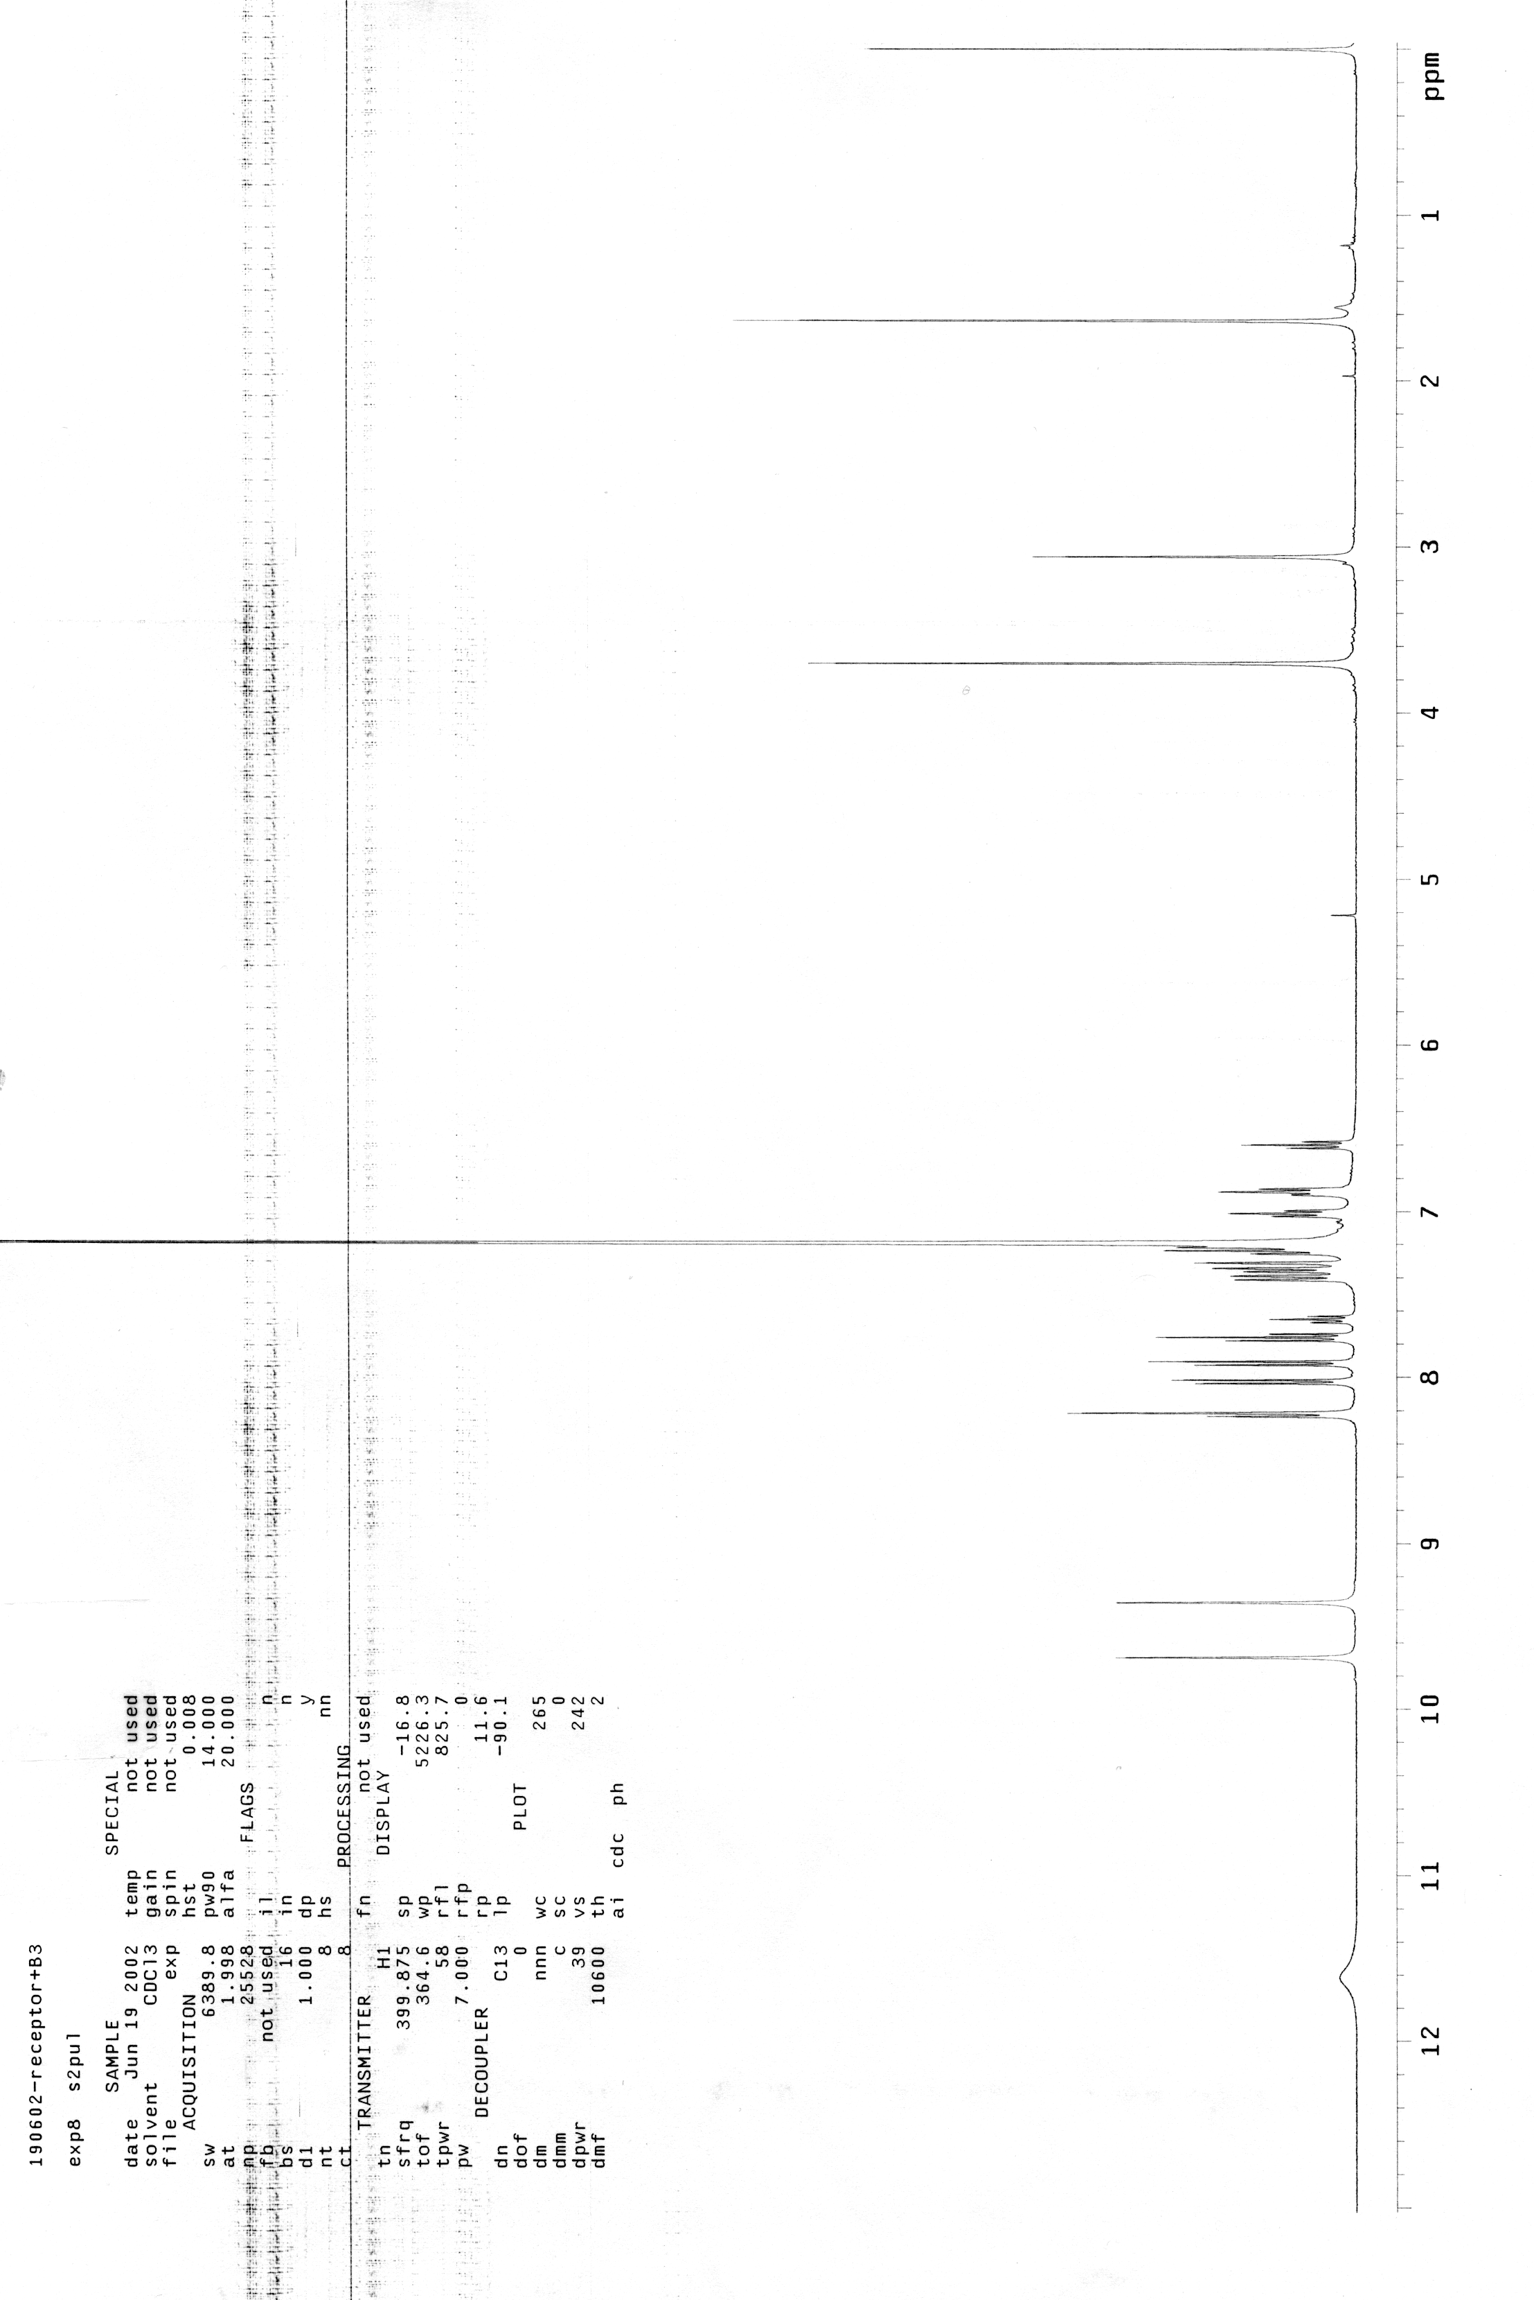
400 MHz ¹H NMR spectrum of complex 6

