Supporting Information for Wang et al. "Structure and Electronic Properties of an Asymmetric Thiolate-bridged Binuclear Ni-Ni Complex: a Model for the Active Site of Acetyl CoA Synthase"

Materials and Methods. All manipulations, reactions and transfers of samples were conducted under pure argon or N₂ atmospheres using standard Schlenk techniques. All solvents were pre-dried and refluxed under N₂ over suitable drying agents.

Synthesis and characterisation of [(dppe)Ni(μ-‘S,S’)Ni(L)](PF₆)₂:

H₂L (N,N’-diethyl-3,7-diazanonane-1,9-dithiol) was prepared according to a literature method,¹ and [Ni(L)] was synthesised via a modification to the literature methods.^{1,2}
A mixture of [NiCl₂(dppe)] (122mg, 0.23mmol) and NH₄PF₆ (83mg, 0.51mmol) in MeCN (12 cm³) was stirred for 5 h at room temperature. To the suspension was added [Ni(L)] (71mg, 0.23mmol), and the mixture was stirred for an additional 5 h. The red solution was filtered and an orange-red solid powder was obtained upon the removal of MeCN in vacuo. The solid was extracted into CH₂Cl₂ followed by removal of CH₂Cl₂ from the filtrate in vacuo, affording a red solid powder which was recrystallised by adding Et₂O to a concentrated solution of the product in CH₃CN. A red crystalline precipitate was obtained and was washed with Et₂O and dried in vacuo. Yield, 0.19g, 80%. Found: C, 42.32; H, 4.49; N, 2.61%. Calc. For C₃₇H₄₈F₁₂N₂Ni₂P₄S₂: C, 42.16; H, 4.59; N, 2.66%. FAB MS: m/z 762 (M-2PF₆⁻)⁺, 909 (M-PF₆⁻)⁺. ¹H NMR (300.13 MHz, CD₂Cl₂, 298K), δ: 0.65-3.45 (28H, m, alkyl-H), 7.52-7.97 (20H,m, Ph-H); ³¹P{¹H} NMR (121.5MHz, CD₂Cl₂, 298K), δ: 61.09 (s, dppe-P); -142.84 (septet, J_{F-P} = 713Hz, PF₆⁻); ¹³C{¹H} NMR (75.47MHz, CD₂Cl₂, 298K) δ_{c}: Ph-C (134.16, 133.29, 131.38, 130.73), alkyl-C: 63.30, 48.53, 29.45, 25.30, 23.30 and 6.75. IR (KBr disc): 3058w, 2986(m), 1478m, 1438s, 1387m, 1298w, 1263w, 1193w, 1103m, 999m, 975w, 838vs(br), 749m, 717m, 693s, 656w, 558s, 531s, 485m, 438w cm⁻¹. Red plate crystals suitable for X-ray diffraction study were obtained by solvent evaporation from a solution of the complex in CHCl₃ at room temperature.
Electrochemistry:
Electrochemical measurements were made using an Autolab PGSTAT20 potentiostat. All complex solutions were purged with a stream of dry argon gas prior to use. Cyclic voltammetry was performed using a three-electrode system, with a glassy carbon working electrode, a Pt wire secondary electrode, and a saturated calomel reference electrode. The [Fe(Cp₂)]⁺/[Fe(Cp₂)] couple was used as an internal standard. The cyclic voltammograms were recorded for solutions of compound (ca. 1 mmol dm⁻³) (in CH₂Cl₂)with [^{n}BuN]₄[BF₄] (0.4 mol dm⁻³) as supporting electrolyte. Controlled potential electrolysis measurements were performed with a two-compartment cell using a Pt/Rh gauze basket working electrode, a Pt/Rh gauze secondary electrode, and a saturated calomel reference electrode.
X-band EPR spectra were recorded on a Bruker EMX spectrometer and the simulations of the EPR spectra were performed using in-house software.³
The UV/vis spectroelectrochemical experiments were carried out at 273K with an optically transparent electrode mounted in a modified quartz cuvette with an optical pathlength of 0.5 mm. A three-electrode configuration consisting a Pt/Rh gauze working electrode, a Pt wire secondary electrode (in a fritted PTFE sleeve) and a saturated calomel electrode, chemically isolated from the test solution via a bridge tube containing electrolyte solution and terminated in a porous frit, was used in the cell. The potential at the working electrode was controlled by a Sycopel Scientific Ltd. DD10M potentiostat. The UV/vis spectra were recorded on a Perkin Elmer Lambda 16 spectrophotometer. The spectrometer cavity was purged with N₂ and temperature control at the sample was achieved by flowing cooled N₂ across the surface of the cell.

(1) F. Osterloh, W. Saak and S. Pohl, J. Am. Chem. Soc. 1997, 119, 5648-5656.
(2) J. Schneider, R. Hauptmann, F. Osterloh and G. Henkel, Acta Crystallogr. Sect. C-Cryst. Struct. Commun., 1999, 55, 328-330.
(3) F. E. Mabbs and D. Collison, Electron Paramagnetic Resonance of d-Transition Metal Compounds; Elsevier, Amsterdam, 1992.

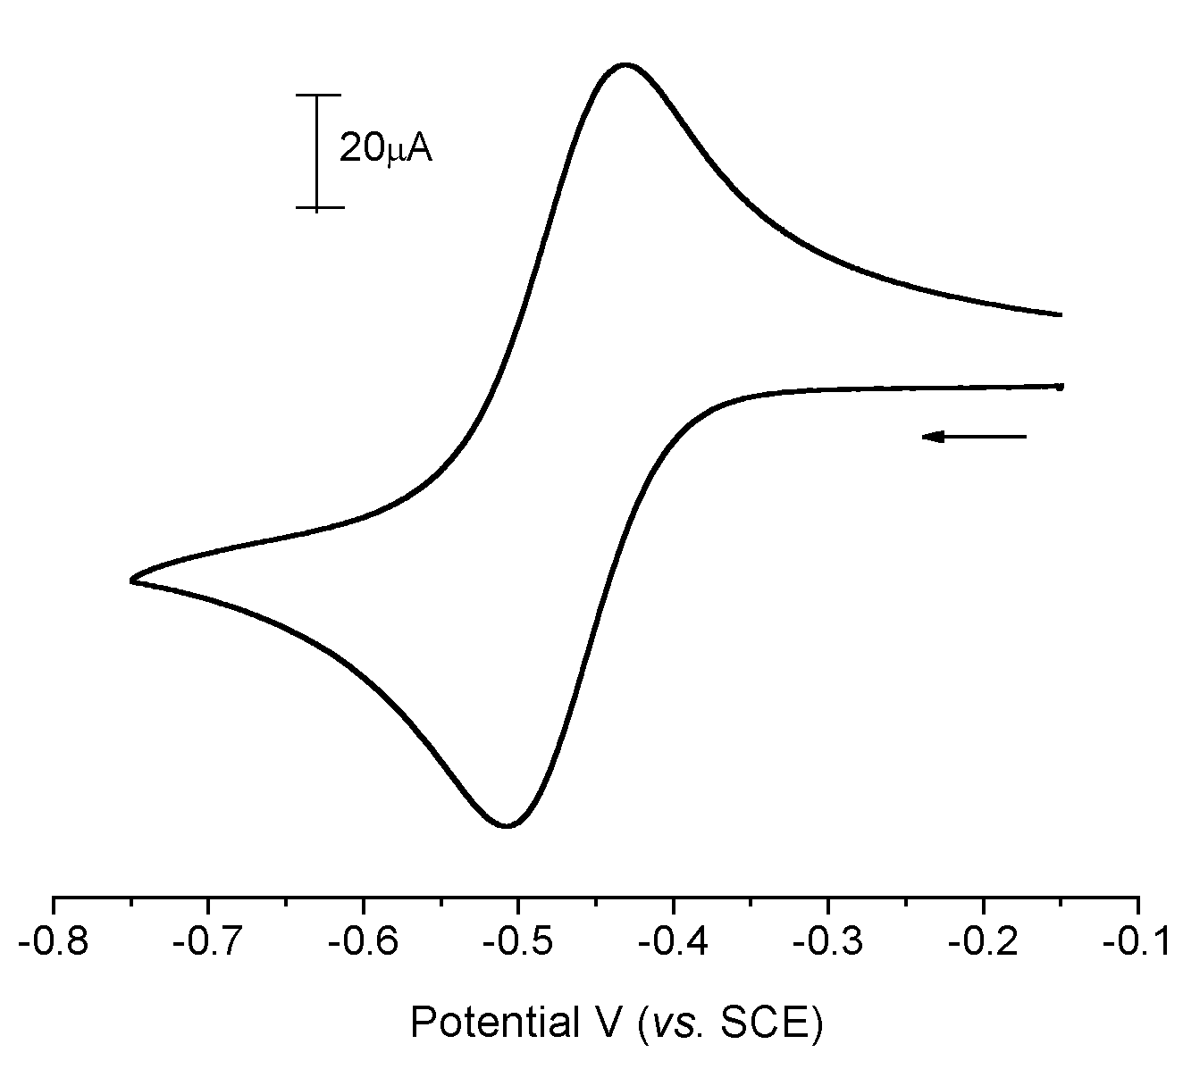

Fig.1 Cyclic voltammogram of 1 mM solution of [(dppe)Ni(μ-‘S,S’)Ni(L)](PF₆)₂ in 0.4 M [^{n}Bu₄N][BF₄]/CH₂Cl₂ (vs. SCE), at 100 mV/s and 293 K.

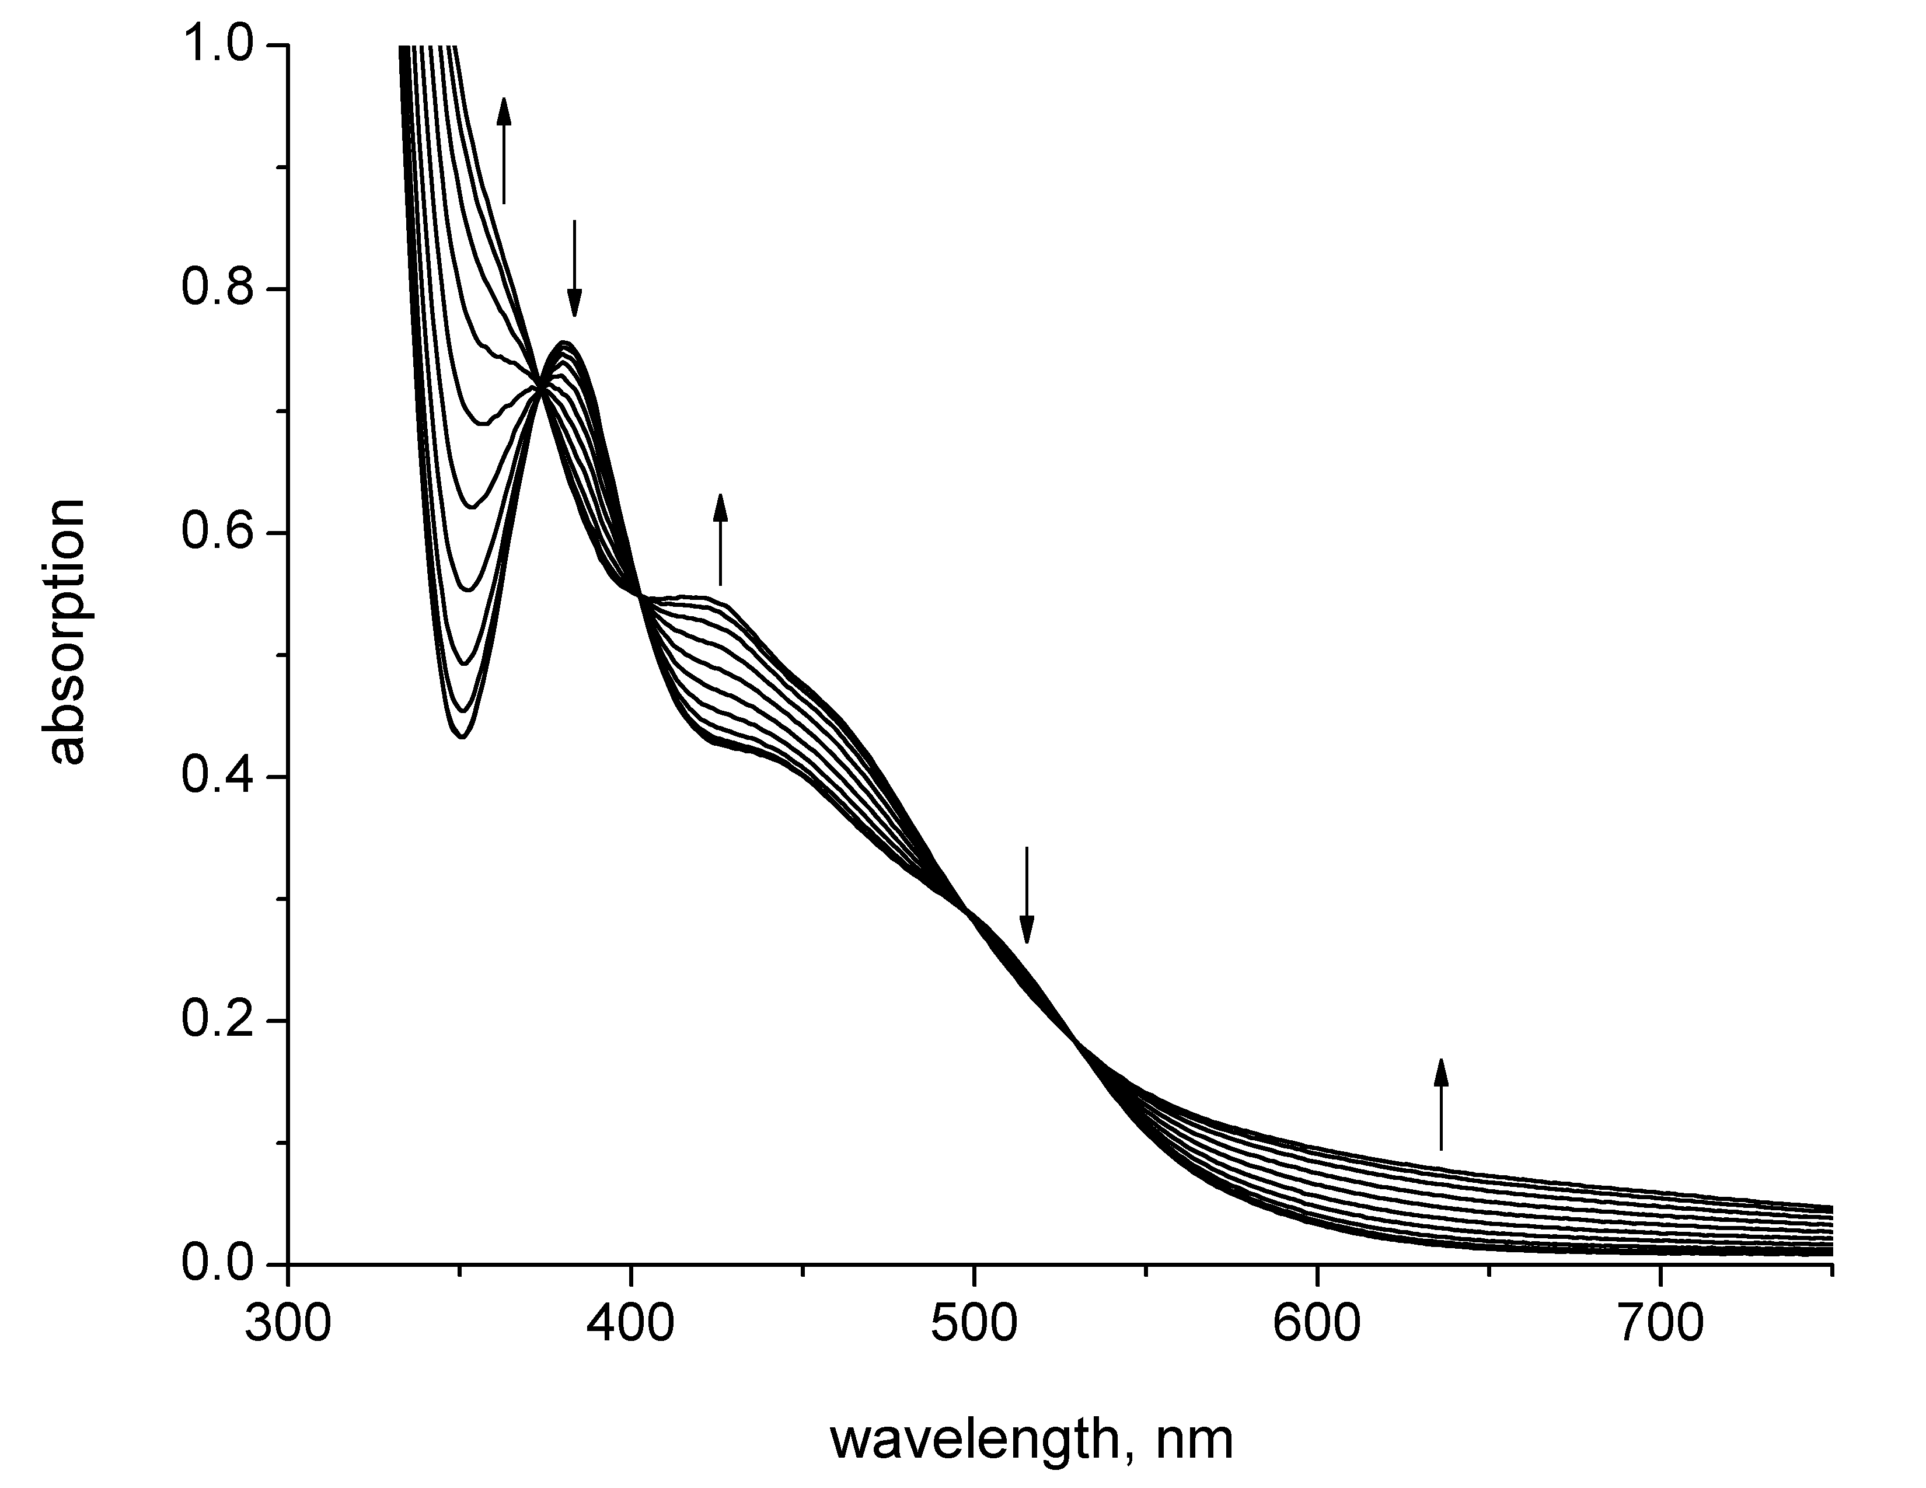

Fig.2 Electronic spectra observed during the one-electron reduction of [(dppe)Ni(μ-‘S,S’)Ni(L)](PF₆)₂ at 273 K in CH₂Cl₂ containing 0.4 M [^{n}Bu₄N][BF₄].

