Electronic Supplementary Information (ESI):

Colloidal Stable Silica Encapsulated Nano-Magnetic Composite As a Novel Bio-Catalyst Carrier
Xin Gao, K.M. Kerry Yu, Kin Y. Tam and Shik Chi Tsang*
Surface and Catalysis Research Centre, Department of Chemistry, University of Reading, Whiteknights, Reading RG6 6AD, UK, E-mail: s.c.e.tsang@reading.ac.uk
d = 2.523
d = 2.949
d = 1.478
d = 2.090

Figure S1 : X-ray diffraction spectrum of silica encapsulated nano-magnetic composites before immobilization
The three most intense peaks of 2.523 (3,1,1) 1.478 (4,4,0) 2.949 (2,2,0) correspond well with the Fe₃O₄ phase of the published files from International Centre for Diffraction Data (JCPDS-1996).
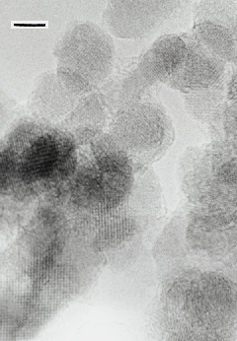
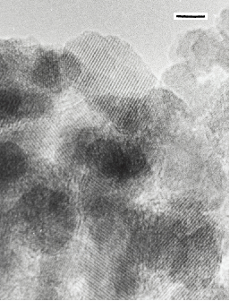
5 nm
Silica layer
5 nm
5 nm
5 nm
5 nm
25.35Å per 10
Fringes Separation

Figure S2: TEM images of silica encapsulated nano-magnetic composites before immobilization
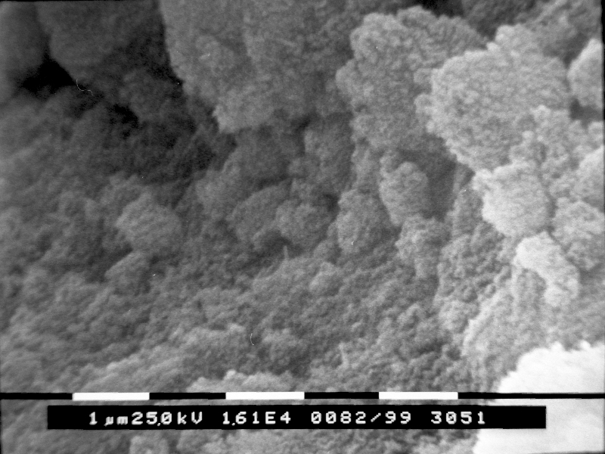
Many small particles aggregated to form a macro-particle

Figure S3: SEM image of silica encapsulated nano-magnetic composites before immobilization

Element Atomic %
 | Fe | O | Si
Site 1 | 24.21 | 60.28 | 15.51
Site 2 | 24.60 | 63.94 | 11.46
Site 3 | 23.87 | 62.46 | 13.67
Site 4 | 23.59 | 60.94 | 15.47
Site 5 | 24.84 | 61.50 | 13.66
Site 6 | 23.39 | 62.59 | 14.02
Average Value | 24.08 | 61.95 | 13.97
Element Atomic %
 | Fe | O | Si
Site 1 | 38.90 | 58.42 | 2.68
Site 2 | 39.18 | 58.35 | 2.47
Site 3 | 38.94 | 58.41 | 2.65
Site 4 | 37.71 | 59.19 | 3.10
Site 5 | 39.54 | 57.70 | 2.76
Site 6 | 38.58 | 58.88 | 2.54
Average Value | 38.81 | 58.49 | 2.70

The average atoms ratio is Fe : O : Si = 24.08 : 61.95 : 13.97 The average atoms ratio is Fe : O : Si = 38.81 : 58.49 : 2.70
The calculated molecule composing is Fe3O4.24 · 1.74 SiO2 The calculated molecule composing is Fe3O4.10 · 0.21 SiO2

Table 1 (l) & 2 (r): Analyses of six selected areas of silica encapsulated nano-magnetic composites corresponding to 6.9351 g and 3.4676 g of TEOS added to the mixture, respectively.

Figure S4. Magnetisation curve of the synthesized nano-magnetic composites

The observed saturated magnetization of our silica-encapsulated oxide particles is 44.24 Am² per kilogram at above 1000 KA/m. However, these new composites contain magnetic (oxide core) and non-magnetic (silica coat) components. From the above EDS the silica-coated iron oxide particles they contain 58.09wt% magnetic iron oxide content. Thus with taking account the dilution into account (the silica jacket is thought to contribute insignificantly as compared to the iron oxide core) the saturation magnetization per kilogram of the only magnetic oxide core would be 76.16 emu/g. Literature value of bulk Fe₃O₄ oxide should exhibit 92 emu/g. The remanence of these nanoparticles is 4.5 Am² per kilogram and the low coercivity is 15.3 KA/m clearly indicating that the particles are showing the superparamagnetic behavior as expected from the nano-size iron oxide particles.
.

Fig. 2 Correlation Curve of reusability of immobilised β-lactamase I at different substrate concentrations before and after magnetic separation.

Figure S5. Correlation Curve of reusability of immobilised β-lactamase I at different substrate concentrations before and after magnetic separation.

The reusability of the nano-magnetic composite hosted enzyme is clearly demonstrated in Fig.S5 using different substrate concentrations. The high reproducibility of the re-used enzyme (separated and purified) for a new batch of substrate after magnetic separation suggests the clear separation & facile reusability advantages of the immobilised enzyme.
It is noted that the procedures for magnetic separation are as follows: enzyme bound magnetic nanocomposites (colloidal stable) are recovered from the product mixture by placing the bottle of a test-tube on a permanent magnet with magnetisation of ~ 6000 G. All magnetic particles will settle at the bottom of the test tube to give a clear top solution within 30s to 1 minute. The supernatant is then sent for analysis and the magnetic precipitates are extensively washed and resused.

Figure S6. A non-regression analysis for Michaelis-Menten equation
Rectangular hyperbola function |  |  | Optimised parameters
Vo(theory) = Vmax [S] / (Km + [S]) |  |  | Vmax | 5.93
 |  |  | Km | 79.51
Solver to minimise the RMSD (root-mean-square-deviation) between expt and theory
RMSD = ( SUM(V0(theory - V0(expt))^2)/(n - 2) )^0.5
where n = no. of data points
RMSD = | 0.106
However, because of our limited data available sufficiently accurate value of the asymptote, Vmax might not be derived (thus the above value should not be taken too literately). The rearrangements of the Michaelis-Menten equation to produce Lineweaver-Burke plot (in the manuscript) over our limited data points were also carried out by inverting the Michaelis-Menten equation: 1/Vo = Km/ Vmax . 1/[S] + 1/Vmax. It is noted that the plot of 1/Vo vs 1/[S] gives a very good straight line and the values of Km= 77.7μM and Vmax = 5.99 μMs⁻¹ are then determined.

