Highly efficient ethylene polymerisation by scandium alkyls supported by neutral fac-κ³ coordinated N₃ donor ligands
Sally C. Lawrence, Benjamin D. Ward, Stuart R. Dubberley, Christopher M. Kozak and Philip Mountford

______________________________________________________________________________________
Supporting information: syntheses and characterising data
______________________________________________________________________________________
[Sc(Me₃[9]aneN₃)(CH₂SiMe₃)₃] (1)
[Sc(CH₂SiMe₃)₃(THF)₂] (152 mg, 0.34 mmol) was dissolved in cold (7 °C) benzene (15 ml) and stirred for the dropwise addition of a solution of Me₃[9]aneN₃ (58 mg, 0.34 mmol) in benzene (15 ml). The reaction was allowed to warm to rt and stirred for 30 min. The volatiles were removed under reduced pressure to afford 44 as a pale yellow solid. Yield 94 mg (59%).
¹H NMR data: (C₆D₆, 500.0 MHz, 293 K): 2.32 (9 H, s, NMe), 2.26 (6 H, m, NCHH), 1.56 (6 H, m, NCHH), 0.42 (27 H, s, SiMe₃), -0.23 (6 H, s, CH₂SiMe₃). ¹³C{¹H} NMR data: (C₆D₆, 125.7 MHz, 293 K): 53.6 (NCH₂CH₂N), 48.1 (NMe), 2.5 (SiMe₃) [not observed CH₂SiMe₃]. Anal. found (calcd for C₂₁H₅₄N₃ScSi₃): C 50.3 (52.8), H 11.2 (11.4), N 8.5 (8.8) % FI-HRMS for [Sc(Me₃[9]aneN₃)(CH₂SiMe₃)₂]⁺: Anal. found (calcd. for C₁₇H₄₃N₃ScSi₂): m/z = 390.2561 (390.2555). IR data: (KBr pellet, cm⁻¹): 2940 (s), 2894 (s), 2860 (s), 2822 (m), 1494 (m), 1464 (s), 1424 (w), 1384 (w), 1366 (m), 1300 (m), 1246 (s), 1234 (s), 1206 (w), 1154 (w), 1126 (w), 1080 (m), 1068 (m), 1008 (s), 876 (s), 852 (s), 818 (s), 774 (w), 748 (m), 720 (m), 666 (m), 604 (w), 578 (w), 450 (m), 420 (w), 402 (w).
[Y(Me₃[9]aneN₃)(CH₂SiMe₃)₃] (2)
[Y(CH₂SiMe₃)₃(THF)₂] (290 mg, 0.587 mmol) was dissolved in cold (7 °C) benzene (15 ml) and stirred for the dropwise addition of a solution of Me₃[9]aneN₃ (101 mg, 0.587 mmol) in benzene (15 ml). The reaction was allowed to warm to rt and stirred for 30 min. The volatiles were removed under reduced pressure to afford [Y(Me₃[9]aneN₃)(CH₂SiMe₃)₃] 2 as a white solid. Yield: 207 mg (68%).
¹H NMR data (C₆D₆, 500.0 MHz, 293 K): 2.30 (9 H, s, NMe), 2.20 (6 H, m, NCH₂), 1.56 (6 H, m, NCH₂), 0.41 (27 H, s, SiMe₃), -0.67 (6 H, d, YCH₂, ²J (YH) = 2.6 Hz) ppm. ¹³C{¹H} NMR data (C₆D₆, 125.7 MHz, 293 K): 54.4 (NCH₂), 47.8 (NMe), 35.3 (YCH₂, ¹J (YC) = 36 Hz), 4.9 (SiMe₃) ppm. Anal. found (calcd. for C₂₁H₅₄N₃Si₃Y): C, 40.4 (48.3); H, 8.4 (10.4); N, 8.5 (8.1)%. The poor elemental analysis is attributed to incomplete combustion and formation of carbides. IR data (KBr pellet): 2822 (s), 1492 (m), 1464 (s), 1366 (m), 1302 (w), 1246 (m), 1234 (m), 1208 (w), 1154 (w), 1128 (w), 1068 (m), 1008 (s), 858 (s), 818 (m), 744 (m), 716 (m), 668 (m), 572 (w), 572 (w), 424 (w), 408 (w) cm⁻¹.
[Sc{HC(Me₂pz)₃}(CH₂SiMe₃)₃] (3)
To a yellow solution of [Sc(CH₂SiMe₃)₃(THF)₂] (0.100 g, 0.24 mmol) in benzene (10 ml) was added a solution of HC(Me₂pz)₃ (0.070 g, 0.24 mmol) in benzene (5 ml) to give an orange solution. After stirring at rt for 4 h the volatiles were removed under reduced pressure to give an orange solid which was washed with benzene (2 x 10 ml) afording [Sc(CH₂SiMe₃)₃{HC(Me₂pz)₃}] as a pale orange solid. Yield: 0.09 g (65 %).
¹H NMR data (C₆D₆, 500.0 MHz, 298 K): 7.03 (1H, s, HC(Me₂pz)₃), 5.21 (3H, s, 4-N₂C₃Me₂H), 2.66 (9H, s, 5-N₂C₃Me₂H), 1.35 (9H, s, 3-N₂C₃Me₂H), 0.60 (6H, s, CH₂SiMe₃), 0.27 (27H, s, SiMe₃). ¹³C-{¹H} NMR data (C₆D₆, 500.0 MHz, 298 K): 154.2 (5-N₂C₃Me₂H), 137.7 (3-N₂C₃Me₂H), 107.8 (4-N₂C₃Me₂H), 67.5 (HC(Me₂pz)₃), 38.2 (CH₂SiMe₃), 16.3 (5-N₂C₃Me₂H), 10.2 (3-N₂C₃Me₂H), 4.8 (SiMe₃). IR data (NaCl plates, Nujol, cm⁻¹): 1562(w), 1412(w), 1321(w), 1261(s), 1093(s), 1021(s), 863(w), 863(w), 801(s), 701(w). Anal. found (calcd. for C₂₈H₅₅N₆ScSi₃): C, 50.3 (55.6); N, 13.7 (13.9); H, 7.7 (9.2) %. The very poor elemental analysis is attributed to incomplete combustion and formation of carbides and/or nitrides.
[Y{HC(Me₂pz)₃}(CH₂SiMe₃)₃] (4)
To a colourless solution of [Y(CH₂SiMe₃)₃(THF)₂] (0.370 g, 0.74 mmol) in benzene (10 ml) was added a solution of HC(Me₂pz)₃ (0.220 g, 0.74 mmol) in benzene (10 ml). The resulting dark brown solution was allowed to stir at rt for 1 h. The volume of the solution was reduced to 10 ml and hexane (30 ml) was added resulting in the formation of a brown precipitate which was filtered. The resulting solid was re-extracted into benzene (10 ml) and addition of hexane (20 ml) afforded [Y{HC(Me₂pz)₃}(CH₂SiMe₃)₃] as a light brown solid. Yield: 0.28 g (58 %).
¹H NMR data (C₆D₆, 500.0 MHz, 298 K): 6.99 (1H, s, HC(Me₂pz)₃), 5.18 (3H, s, 4-N₂C₃Me₂H), 2.61 (9H, s, 3-N₂C₃Me₂H), 1.32 (9H, s, 5-N₂C₃Me₂H), 0.33 (27H, d, ⁴J[¹H-⁸⁹Y] = 0.7 Hz, SiMe₃), -0.02 (6H, d, ³J[¹H-⁸⁹Y] = 2.8 Hz, CH₂SiMe₃). ¹³C-{¹H} NMR data (CD₂Cl₂, 125.7 MHz, 298 K): 154.3 (3-N₂C₃Me₂H), 138.5 (5-N₂C₃Me₂H), 107.6 (3-N₂C₃Me₂H), 67.9 (HC(Me₂pz)₃), 32.4 (CH₂SiMe₃), 15.7 (3-N₂C₃Me₂H), 10.2 (5-N₂C₃Me₂H), 5.0 (SiMe₃). IR data (NaCl plates, Nujol, cm⁻¹): 2360(m), 2342(w), 1959(w), 1618(w), 1562(w), 1459(m), 1413(w), 1261(s), 1093(s), 1020(s), 863(w), 800(s), 705(w), 669(w). Anal. found (calcd. for C₂₈H₅₅N₆Si₃Y): C, 49.9 (51.8); H, 7.9 (8.5); N, 12.3 (13.0) %.
[Sc{HC(Me₂pz)₃}(O-2,6-C₆H₃Me₂)₃] (5)
To a pale orange solution of [Sc{HC(Me₂pz)₃}(CH₂SiMe₃)₃] 3 (0.110 g, 0.18 mmol) in THF (10 ml) was added a solution of 2,6-dimethylphenol (0.060 g, 0.53 mmol) in THF (10 ml) at rt. The mixture was allowed to stir at rt for 2 h and the volume was reduced to 5 ml. Pentane (15 ml) was added and a white solid formed. Filtration afforded [Sc{HC(Me₂pz)₃}(O-2,6-C₆H₃Me₂)₃] as a white solid. Yield: 0.10 g (81 %).
¹H NMR data (CD₂Cl₂, 500.0 MHz, 253 K): 7.88 (1H, s, HC(Me₂pz)₃), 6.83 (2H, d, ³J = 7.1 Hzm-OC₆H₃Me₂ "down"), 6.63 (2H, d, ³J = 7.1 Hz, m-OC₆H₃Me₂ "up"), 6.34 (1H, apparent t, apparent ³J = 7.1 Hz, p-OC₆H₃Me₂), 5.87 (3H, s, 4-N₂C₃Me₂H), 2.54 (9H, s, 5-N₂C₃Me₂H), 2.48 (9H, s, OC₆H₃Me₂ "down"), 1.88 (9H, s, 3-N₂C₃Me₂H), 1.19 (9H, s, OC₆H₃Me₂ "up"). ¹³C-{¹H} NMR data (CD₂Cl₂, 125.7 MHz, 253 K): 162.5 (ipso-OC₆H₃Me₂), 155.1 (3-N₂C₃Me₂H), 138.4 (5-N₂C₃Me₂H), 127.6 (o-OC₆H₃Me₂ "down"), 127.4 (o-OC₆H₃Me₂ "up"), 114.9 (p-OC₆H₃Me₂), 108.1 (4-N₂C₃Me₂H), 67.2 (HC(Me₂pz)₃), 18.4 (OC₆H₃Me₂ "down"), 16.3 (OC₆H₃Me₂ "up"), 12.9 (3-N₂C₃Me₂H), 11.0 (5-N₂C₃Me₂H). IR data (NaCl plates, Nujol, cm⁻¹): 2852(s), 2316(w), 1590(m), 1563(m), 1378(m) 1304(m), 1260(s), 1238(w), 1092(m), 1042(w), 867(w), 800(m). Anal. found (calcd. for C₄₀H₄₉N₆O₃Sc): C, 68.0 (68.0); N, 11.8 (11.9); H, 6.9 (7.0) %. FI⁺ MS: m/z = 706 [M]⁺, 10%.
Crystal data for5·4(C₆H₆): C₄₀H₄₉N₆O₃Sc·4(C₆H₆), M = 1019.29, trigonal, P 3 1 c, a = 14.7505(6), c = 15.4170(4) Å, U = 2905.0(2) Å³, Z = 2, T = 150 K, μ = 0.18 mm⁻¹, 7816 independent reflections (R_{merge} = 0.02), 4925 [I > 3σ(I)] used in refinement, final R indices: R = 0.0507, R_{w} = 0.0557.
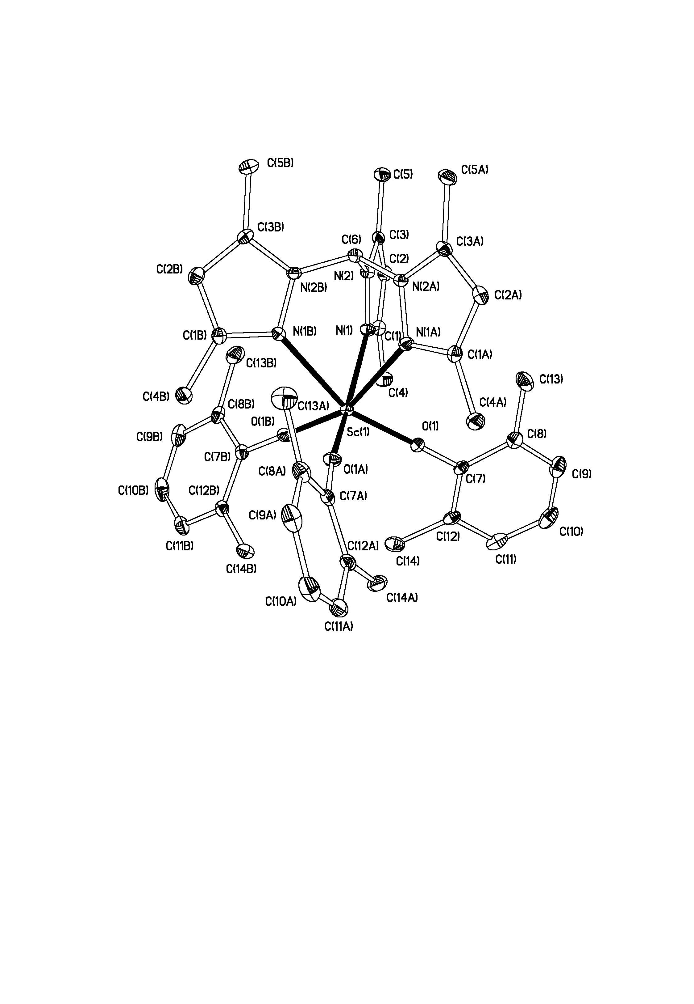
Figure: Displacement ellipsoid plot (25%) of [Sc(O-2,6-C₆H₃Me₂)₃{HC(Me₂pz)₃}] 5. H atoms and benzene molecules of crystallisation omitted for clarity. Selected parameters: Sc(1) - O(1) 1.9615(16), Sc(1) - N(1) 2.3543(19) Å; Sc(1) - O(1) - C(7) 174.41(17); O(1) - Sc(1) - O(1A) 103.74(6) º.
[Sc{HC(Me₂pz)₃}Cl₃] (6)
A suspension of ScCl₃ (0.057 g, 0.38 mmol) in THF (10 ml) was refluxed for 10 min to give a colourless solution which was allowed to cool. To this was added a yellow solution of HC(Me₂pz)₃ (0.110 g, 0.38 mmol) in THF (10 ml) and the mixture was stirred at rt for 4 h The resultant white solid was filtered away from the colourless solution and dried to afford [Sc{HC(Me₂pz)₃}Cl₃]. Yield: 0.13 g (74 %).
¹H NMR data (CD₂Cl₂, 500.0 MHz, 298 K): 7.91 (1H, s, HC(Me₂pz)₃), 6.09 (3H, s, 4-N₂C₃Me₂H), 2.72 (9H, s, 5-N₂C₃Me₂H), 2.54 (9H, s, 3-N₂C₃Me₂H). ¹³C-{¹H} NMR data (CD₂Cl₂, 125.5 MHz, 298 K): 158.6 (5-N₂C₃Me₂H), 142.2 (3-N₂C₃Me₂H), 111.0 (4-N₂C₃Me₂H), 70.2 (HC(Me₂pz)₃) 17.5 (5-N₂C₃Me₂H), 13.3 (3-N₂C₃Me₂H). IR data (NaCl plates, Nujol, cm⁻¹): 1619(w), 1563(m), 1413(w), 1305(w), 1261(m), 1065(m), 1044(m), 910(w), 862(w), 706(w), 407(w). Anal. found (calcd. for C₁₆H₂₂N₆ScCl₃·1.1(THF)): C, 46.2 (46.3); N, 15.7 (15.9); H, 6.4 (5.9) %; EI⁺ MS: m/z = 413 [M-Cl]⁺, 60%
[Y{HC(Me₂pz)₃}Cl₃] (7)
To a suspension of YCl₃ (0.048 g, 0.25 mmol) in THF (10 ml) was added a solution of HC(Me₂pz)₃ (0.080 g, 0.25 mmol) in THF (10 ml) at rt. The mixture was stirred at rt for 16 h resulting in a white precipitate and yellow supernatant. Filtration afforded [Y{HC(Me₂pz)₃}Cl₃] as a white solid. Yield: 0.09 g (74 %).
¹H NMR data (CD₂Cl₂, 500.0 MHz, 298 K): 7.91 (1H, s, HC(Me₂pz)₃), 6.08 (3H, s, 4-N₂C₃Me₂H), 2.65 (9H, s, 3-N₂C₃Me₂H), 2.52 (9H, s, 5-N₂C₃Me₂H). ¹³C-{¹H} NMR data (CD₂Cl₂, 125.7 MHz, 298 K): 156.1 (3-N₂C₃Me₂H), 140.9 (5-N₂C₃Me₂H), 108.7 (4-N₂C₃Me₂H), 67.9 (HC(Me₂pz)₃), 14.0 (3-N₂C₃Me₂H), 10.5 (5-N₂C₃Me₂H). IR data (NaCl plates, Nujol, cm⁻¹): 1562(m), 1413(m), 1304(m), 1261(m), 1064(m), 1042(m), 905(m), 861(m), 801(m), 706(m). Anal. found (calcd. for C₁₆H₂₂Cl₃N₆Y·1.1(THF)): C, 42.7 (42.8); N, 14.8 (14.7); H, 5.7 (5.4) %, EI⁺ MS: m/z = 456 [M - Cl - H]⁺, 70 %; 457 [M - Cl]⁺, 50 %.
[Sc{HC(Me₂pz)₃}(CH₂SiMe₃)₂(THF)][B(C₆F₅)₄] (8)
To a colourless solution of [Sc{HC(Me₂pz)₃}(CH₂SiMe₃)₃] 3 (0.10 g, 0.17 mmol) in CH₂Cl₂ (10 ml) was added THF (2 equiv., 0.34 mmol) and a yellow solution of [Ph₃C][BAr^{F}₄] (0.15 g, 0.17 mmol) in CH₂Cl₂ (5 ml). The reaction mixture immediately turned red and was allowed to stir at rt for 1 h after which time it had become pale orange. Removal of the volatiles under reduced pressure gave a sticky orange solid which was triturated with hexane (5 x 10 ml) affording [Sc(CH₂SiMe₃)₂(THF){HC(Me₂pz)₃}][B(C₆F₅)₄] as an pale solid with some organic side product Ph₃CCH₂SiMe₃ present by ¹H NMR.
¹H NMR data (CD₂Cl₂, 500.0 MHz, 298 K): 7.90 (1H, s, HC(Me₂pz)₃), 6.19 (1H, s, 4-N₂C₃Me₂H trans to THF), 6.08 (2H, s, 4-N₂C₃Me₂H trans to CH₂SiMe₃), 4.24 (4H, m, OCH₂CH₂), 2.76 (3H, s, 3-N₂C₃Me₂H trans to THF), 2.60 (3H, s, 5-N₂C₃Me₂H trans to THF), 2.54 (6H, s, 5-N₂C₃Me₂H trans to CH₂SiMe₃), 2.37 (6H, s, 3-N₂C₃Me₂H trans to CH₂SiMe₃), 2.16 (4H, m, OCH₂CH₂), 0.33 (2H, d, ³J = 11.9 Hz, CH₂SiMe₃), 0.13 (2H, d, ³J = 11.9 Hz, CH₂SiMe₃), -0.23 (18H, s, SiMe₃). ¹⁹F NMR data (CD₂Cl₂, MHz, 298 K): -133.5 (d, o-C₆F₅), -164.1 (t, m-C₆F₅), -168.0 (t, p-C₆F₅). ¹³C-{¹H} NMR data (CD₂Cl₂, 125.5 MHz, 298 K): 155.5 (3-N₂C₃Me₂H trans to THF), 154.5 (3-N₂C₃Me₂H trans to CH₂SiMe₃), 141.6 (5-N₂C₃Me₂H trans to CH₂SiMe₃), 141.4 (5-N₂C₃Me₂H trans to THF), 109.1 (4-N₂C₃Me₂H trans to CH₂SiMe₃), 108.9 (4-N₂C₃Me₂H trans to THF), 73.3 (OCH₂CH₂), 68.1 (HC(Me₂pz)₃), 25.8 (OCH₂CH₂), 16.4 (3-N₂C₃Me₂H trans to THF), 15.1 (3-N₂C₃Me₂H trans to CH₂SiMe₃), 11.5 (5-N₂C₃Me₂H trans to THF), 11.3 (5-N₂C₃Me₂H trans to CH₂SiMe₃), 3.5 (SiMe₃). (¹³C resonances for the anion appeared as broad complex multiplets). IR data (NaCl plates, Nujol, cm⁻¹): 1644(m), 1568(w), 1514(m), 1305(w), 1262(w), 1086(m), 979(m), 860(m), 707(m). ES⁺ MS: m/z = 433 [M - C₄H₈O - CH₂SiMe₃]⁺, 10 %. An elemental analysis was not obtained for this compound due to obvious contamination by the Ph₃CCH₂SiMe₃ organic side-product.

GPC data for the polyethylenes

