First Synthesis of the Amythiamicin Central Heterocyclic Domain
Mark C. Bagley,*ª James W. Dale,ª Robert L. Jenkinsª and Justin Bower^{b}
ªDepartment of Chemistry, Cardiff University, PO Box 912, Cardiff, CF10 3TB, UK.
^{b}Vernalis, Granta Park, Abington, Cambridge, CB1 6GB, UK.
Email Address Bagleymc@cf.ac.uk
(S)-Ethyl 2-[2-(2-{2-[1-(tert-butoxycarbonylamino)-2-methylpropyl]thiazol-4-yl}thiazol-4-yl)-3-{4-[2-(trimethylsilyl)ethoxymethoxymethyl]thiazol-2-yl}pyridin-6-yl]thiazole-4-carboxylate (1)
A solution of 1-(4-ethoxycarbonylthiazol-2-yl)propynone (3) (100 mg, 0.48 mmol) in ethanol (5 ml) was added to a solution of (S)-1-amino-1-(2-{2-[1-(tert-butoxycarbonylamino)-2-methylpropyl]thiazol-4-yl]thiazol-4-yl}-2-{4-[2-(trimethylsilyl)ethoxymethoxymethyl]thiazol-2-yl}ethene (2) (200 mg, 0.25 mmol) in ethanol (15 ml). The mixture was stirred at 60 °C for one hour, evaporated in vacuo and heated in a solution of toluene-glacial acetic acid (5:1) (20 ml) at 70 °C for 4 hours. The solution was cooled and partitioned between saturated aqueous sodium hydrogen carbonate solution (50 ml) and chloroform (50 ml). The aqueous layer was further extracted with chloroform (3 x 30 ml) and the combined organic extracts were washed with brine (20 ml), dried (MgSO₄) and concentrated in vacuo. Purification by flash chromatography on silica, gradient eluting with light petroleum-diethyl ether (2:3) to diethyl ether, gave the title compound as a pale yellow solid (174 mg, 85%), mp 51-52 °C (light petroleum-diethyl ether); [α]_{D}²⁴ –24.8 (c 1.0, CHCl₃) (Found: MH⁺, 815.2203. C₃₆H₄₆N₆O₆S₄Si requires MH, 815.2209); ν_{max}(dichloromethane)/cm⁻¹ 3354, 3116, 2961, 2895, 1728, 1698, 1582, 1494, 1415, 1337, 1247, 1213, 1168, 1101, 1060, 916, 859 and 836; δ_{H}(400 MHz; CDCl₃) 8.35 (1 H, d, J 8.2, 4’-H), 8.30 (1 H, d, J 8.2, 5’-H), 8.29 (1 H, s, 5-H), 7.95 (1 H, s, ThzH), 7.56 (1 H, s, ThzH), 7.33 (1 H, s, 3’-ThzH), 5.40 (1 H, d, J 8.7, NH), 4.90 (1 H, dd, J 8.7, 5.4, CH), 4.83 (2 H, s, OCH₂O), 4.79 (2 H, s, ThzCH₂), 4.43 (2 H, q, J 7.1, CH₂Me), 3.66 (2 H, t, J 8.3, OCH₂CH₂), 2.40 (1 H, m, MeCHMe), 1.45 (9 H, s, CMe₃), 0.93 (3 H, t, J 7.1, CH₂Me), 0.99 (3 H, d, J 6.9, MeCHMe), 0.97 (2 H, m, OCH₂CH₂), 0.93 (3 H, d, J 6.9, MeCHMe), 0.00 (9 H, s, SiMe₃); δ_{C}(100 MHz; CDCl₃) 172.8 (C), 168.9 (C), 165.0 (C), 161.9 (C), 161.3 (C), 155.4 (C), 153.7 (C), 153.7 (C), 150.7 (C), 150.2 (C), 148.9 (C), 148.4 (C), 139.7 (CH), 130.1 (CH), 129.9 (C), 121.6 (CH), 118.9 (CH), 118.3 (CH), 115.6 (CH), 94.3 (CH₂), 79.9 (C), 65.3 (CH₂), 65.0 (CH₂), 61.5 (CH₂), 57.8 (CH), 33.2 (CH), 28.3 (Me), 19.3 (Me), 18.0 (CH₂), 17.4 (Me), 14.4 (Me) and –1.3 (Me); m/z (EI) 837 ([M+Na]⁺, 100%), 815 (M⁺, 66), 701 (13) and 144 (41).
¹H NMR spectrum (400 MHz, CDCl₃) of target pyridine domain 1

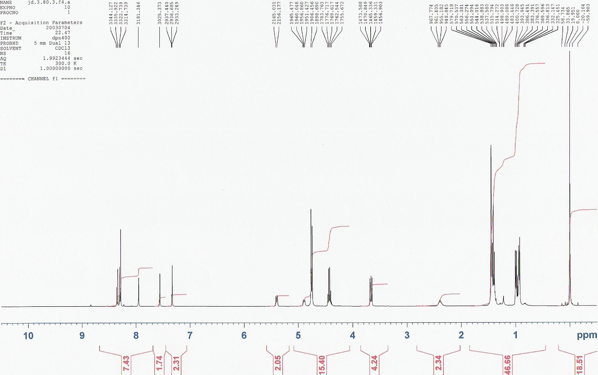

¹³C NMR spectrum (100 MHz, CDCl₃) of target pyridine domain 1

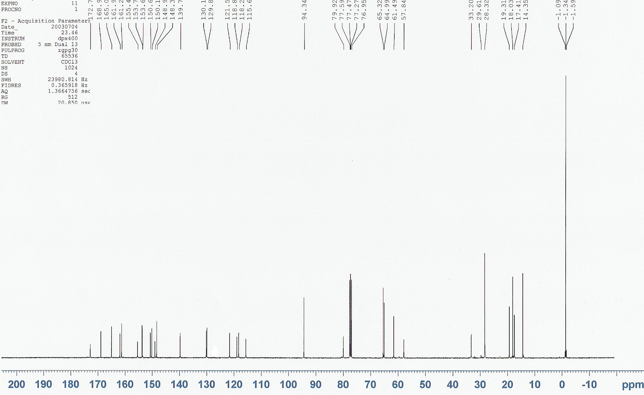

Obtained as an inseparable mixture of ketone 22:enamine 2 (22:78).
Obtained in 93% ee by diode array HPLC: Chiralpak AD, gradient eluting with hexane-propan-2-ol (49:1) to (17:3) at 1 ml min⁻¹, 210 nm, R_{T} = 149 min (R-isomer has R_{T} = 143 min). Regiochemistry established by ¹H NMR J value (4’H-5’H).

