Electronic Supplementary Information (ESI)

Relative Importance of Hydrogen Bonding and Coordinating Groups in Modulating the Zinc-Water Acidity

Juan C. Mareque Rivas*, Ravi Prabaharan and Rafael Torres Martín de Rosales

School of Chemistry, The University of Edinburgh,
Joseph Black Building, King's Buildings,
West Mains Road, Edinburgh, EH9 3JJ, UK
Tel:44-(0)131-650-4761
Fax:44-(0)131-650-4743

*To whom correspondence should be addressed. Email:juan.mareque@ed.ac.uk.

Experimental Section

General. Reagents were obtained from commercial sources and used as received unless otherwise noted. Solvents were dried and purified under N₂ by using standard methods¹ and were distilled immediately before use. All compounds were prepared under N₂ unless otherwise mentioned. The ligands, tpa², tris[(6-pivaloylamido)-2-pyridyl)methyl]amine (tppa)³ and bpapa⁴ were synthesized according to literature procedures. The NMR spectra were obtained using a Bruker DPX 360 at 20 °C. ¹³C and ¹H chemical shifts are referenced with respect to the carbon and residual proton solvent peaks. Mass spectra were performed on a micromass Platform II system operating in Flow Injection Analysis mode with the electrospray method. Elemental analyses were carried out by the microanalyses service provided by the School of Chemistry at the University of Edinburgh.
Synthesis of ligands.
N,N-bis-(6-pivaloylamido-2-pyridylmethyl)-N-(2-pyridylmethyl)amine 1. 2-(Aminomethyl)pyridine (0.37 g, 3.4 mmol) and 2-(pivaloylamido)-6-(bromomethyl)pyridine (2.0 g, 6.8 mmol) were dissolved in acetonitrile (80 cm³) and stirred at room temperature for 5 minutes. Then, sodium carbonate (1.0 g, 9.43 mmol) and tetrabutylammonium bromide (10 mg, 0.03 mmol) were added and the temperature was raised to 44 °C. After 48 h the solution was cooled to room temperature and poured into 100 cm³ of 1M NaOH_{(aq)}. The crude product was then extracted with dichloromethane (3 x 80 cm³) and the organic fractions were dried over Na₂SO₄. The solvent was evaporated under vacuum to yield the product as a brown oil (2.2 g, 66%)
¹H NMR (CD₃Cl, 360.1 MHz) δ_{H} (ppm) 8.53 (m, 1H py-H6), 8.11 (d, J = 8.3 Hz, 2H, py'-H5), 8.01 (s, 2H, NH), 7.67 (t, J = 7.9 Hz, 2H, py'-H4), 7.60 (d, J = 7.7 Hz, 2H, py-H3), 7.57 (m, 1H, py-H4), 7.29 (d, J = 7.3 Hz, 2H, py'-H3), 7.15 (m, 1H, py-H5), 6.88 (d, J = 7.2 Hz, 1H, py-H3), 3.87 (s, 2H, NCH₂-py), 3.76 (s, 4H, NCH₂-py'), 1.33 (s, 6H, C-(CH₃)₃). ¹³C NMR (CD₃Cl, 90.5 MHz) δ_{C} (ppm) 176.9 (C=O), 159.3 (py-C2), 157.7 and 151.0 (py'-C2 and py'-C6), 149.1 (py-C6), 138.8 (py'-C3), 136.5 (py-C3), 122.8 and 122.1 (py-C4 and py-C5), 118.6 and 112.0 (py'-C4 and py'-C5), 60.3 (NCH₂-py), 59.9 (NCH₂-py'), 39.8 (C-(CH₃)₃), 27.5 (C-(CH₃)₃). ESI-MS (+ion) Found 488.9 and 510.8, Calcd. 488.30 (100%) and 511.28 (100%) for [(1)H]⁺ and [(1)Na]⁺, and matches theoretical isotope distribution.

N,N-bis-(6-amino-2-pyridylmethyl)-N-(2-pyridylmethyl)amine (bapapa). 1 (1 g, 1.7 mmol) was dissolved in 2M HCl_{(aq)} (100 cm³) and the solution was refluxed for 24 h. The solution was then cooled to room temperature and poured into 1M NaOH_{(aq)}. The product was extracted with dichloromethane (3 x 100 cm³) and the organic fractions were dried over Na₂SO₄. The solvent was evaporated under vacuum and washed with diethyl ether to yield the product as a brown solid (0.47 g, 71%). (Found: C, 64.04; H, 6.20; N, 24.17. Calc. for C₁₈H₂₀N₅⋅H₂O: C, 63.89; H, 6.55; N, 24.83%).
¹H NMR (DMSO-d₆, 360.1 MHz) δ_{H} (ppm) 8.47 (m, 1H, py-H6), 7.78 (t, J = 7.5 Hz, 1H py-H4), 7.59 (d, J = 7.6 Hz, 1H, py-H3), 7.34 (t, J = 7.6 Hz, 2H, py’-H4), 7.24 (m, 2H, py-H5), 6.72 (d, J = 7.2 Hz, 1H, py’-H3), 6.28 (d, J = 8.3 Hz, 1H, py’-H5), 5.86 (br, 4H, py’-NH₂) 3.71 (s, 2H, NCH₂-py), 3.48 (s, 4H, NCH₂-py’). ¹³C NMR (DMSO-d₆, 90.5 MHz) δ_{C} (ppm) 159.2 (py-C2), 159.2 and 157.3 (py'-C2 and py’-C6), 148.8 (py-C6), 137.5 (py'-C3), 136.6 (py-C3), 122.2 and 122.1 (py-C4 and py-C5), 109.7 and 106.1 (py’-C4 and py'-C5), 59.5 (NCH₂-py and NCH₂-py'). ESI-MS (+ ion) Found 321.0 (100%), Calcd. 321.18 (100%) for [(bapapa)H]⁺, and matches theoretical isotope distribution.

Tris[(6-amino)-2-pyridyl)methyl]amine (tapa). Tris[(6-pivaloylamido)-2-pyridyl)methyl]amine (tppa) was dissolved in 2M HCl_{(aq)} (100 cm³) and the solution was refluxed for 24 h. The solution was then cooled to room temperature and poured into 1M NaOH_{(aq)} resulting in the appearance of a brown precipitate. The mixture was filtered and the precipitate was washed with diethyl ether to yield the product as a brown solid (0.47 g, 71%). (Found: C, 61.63; H, 6.10; N, 27.74. Calc. for C₁₈H₂₁N₆⋅H₂O: C, 61.17; H, 6.56; N, 27.74%).
¹H NMR (DMSO-d₆, 360.1 MHz) δ_{H} (ppm) 7.34 (dd, J = 8.2, 7.9 Hz, 3H, py’-H4), 6.74 (d, J = 7.2 Hz, 3H, py’-H3), 6.27 (d, J = 8.3 Hz, 3H, py’-H5), 5.82 (br, 6H, py’-NH₂), 3.46 (s, 6H, NCH₂-py’). ¹³C NMR (DMSO-d₆, 90.5 MHz) δ_{C} (ppm) 159.2 and 157.6 (py'-C2 and py’-C6), 137.5 (py'-C3), 109.5 and 106.0 (py’-C4 and py'-C5), 59.6 (NCH₂-py'). ESI-MS (+ ion) Found 336.0 (100%), Calcd. 336.19 (100%) for [(tapa)H]⁺, and matches theoretical isotope distribution.

Potentiometric Titrations
The potentiometric studies were conducted with a Titrino 702 SM autotitrator (Brinkmann Instruments). A Metrohm combined pH glass electrode (Ag/AgCl) with 3M NaCl internal filling solution was used. The NaOH solution was standardised against potassium hydrogen phthalate with phenolphthalein as indicator. The stock Zn(II) solution (0.02 M) was prepared by dissolving Zn(NO₃)₂⋅6H₂O (5.95 g) in deionised water and standardized using a Dowex 50W X-8 Ion Exchange Resin (20-50 mesh) in the H⁺ form (10 cm³ of the Zn(II) solution required 3.9 cm³ of a standardized 0.1021 M NaOH solution). Solutions were prepared using doubly deionised freshly distilled water and kept under a stream of N_{2(g)}. The electrode was calibrated with dilute standard acid and alkali solutions, thus defining pH = - log [H⁺]⁵ (pK_{w} = -13.78). The linearity of the electrode response and carbonate contamination of the standardised NaOH solution (0.1 N) was determined by the Gran’s method⁵ and was found to be less than 2%. In a typical pH metric determination an aqueous solution (50 cm³) of the ligand (1 mM) with 4 equiv. of HNO₃ in the absence (for determination of ligand protonation constants log K_{n} (n =1-3)) or presence of equivalent Zn²⁺ ions (for determination of K_{ZnL} and deprotonation constants of the zinc-bound water in the zinc complexes) was titrated with NaOH (0.1 N). The temperature of solutions (25 ºC) in the covered, water-jacketed cell was kept constant by a Julabo circulating bath. The ionic strength (I) was adjusted to 0.1 with NaNO₃. The protonation and stability constants were calculated from the titration data using the program HYPERQUAD 2000 Version 2.1 NT.⁶ The data reported represents the average of at least three different titrations. About 110 points were collected for each titration.

References
- W. L. F.Armarego and D. D. Perrin, Purification of Laboratory Chemicals, 4th Ed., Oxford: Butterworth-Heinemann, 1997.
- G. Anderegg and F. Wenk, Helv. Chim. Acta, 1967, 50, 2330.
- L. M. Berreau, S. Mahapatra, J. A. Halfen, V. G. Young Jr. and W. B. Tolman, Inorg. Chem., 1996, 35, 6339.
- J. C. Mareque Rivas, E. Salvagni, R. Torres Martín de Rosales and S. Parsons, Dalton Trans., 2003, 3339.
- A. E. Martell and R. J. Motekaitis, Determination and Use of Stability Constants, VCH-Publishing, 1992.
- P. Gans, A. Sabatini and A. Vacca, Talanta, 1996, 43, 1739.

Fig. S1 Potentiometric pH titration curves for 1 mM tpa + 4 equiv. HNO₃ (continuous line), 1 mM tpa + 4 equiv. HNO₃ + 1 mM Zn(NO₃)₂ (crosses) with I = 0.1 (NaNO₃) and 25 ºC

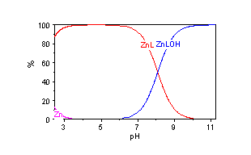

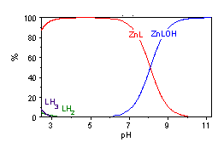
(i)

(ii)

Fig. S2 Speciation diagrams for a mixture of 1 mM tpa and Zn(NO₃)₂ with I = 0.1 (NaNO₃) (i) relative to [Zn²⁺]_{total}, (b) relative to[tpa]_{total}.

Fig. S3 Potentiometric pH titration curves for 1 mM bpapa + 4 equiv. HNO₃ (continuous line), 1 mM bpapa + 4 equiv. HNO₃ + 1 mM Zn(NO₃)₂ (crosses) with I = 0.1 (NaNO₃) and 25 ºC

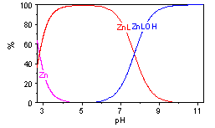

(i)

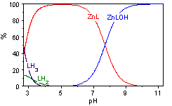

(ii)

Fig. S4 Speciation diagrams for a mixture of 1 mM bpapa and Zn(NO₃)₂ with I = 0.1 (NaNO₃) (i) relative to [Zn²⁺]_{total}, (ii) relative to [bpapa]_{total}.

Fig. S5 Potentiometric pH titration curves for 1 mM bapapa + 4 equiv. HNO₃ (continuous line), 1 mM bapapa + 4 equiv. HNO₃ + 1 mM Zn(NO₃)₂ (crosses) with I = 0.1 (NaNO₃) and 25 ºC

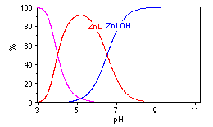

(i)

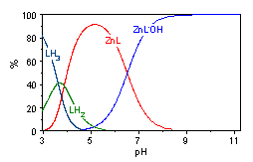

(ii)

Fig. S6 Speciation diagrams for a mixture of 1 mM bapapa and Zn(NO₃)₂ with I = 0.1 (NaNO₃) (i) relative to [Zn²⁺]_{total}, (ii) relative to [bapapa]_{total}.

Fig. S7 Potentiometric pH titration curves for 1 mM tapa + 4 equiv. HNO₃ (continuous line), 1 mM tapa + 4 equiv. HNO₃ + 1 mM Zn(NO₃)₂ (crosses) with I = 0.1 (NaNO₃) and 25 ºC

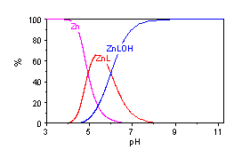
(i)

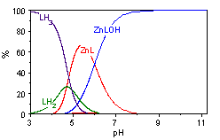

(ii)

Fig. S8 Speciation diagrams for a mixture of 1 mM tapa and Zn(NO₃)₂ with I = 0.1 (NaNO₃) (i) relative to [Zn²⁺]_{total}, (ii) relative to [tapa]_{total}.

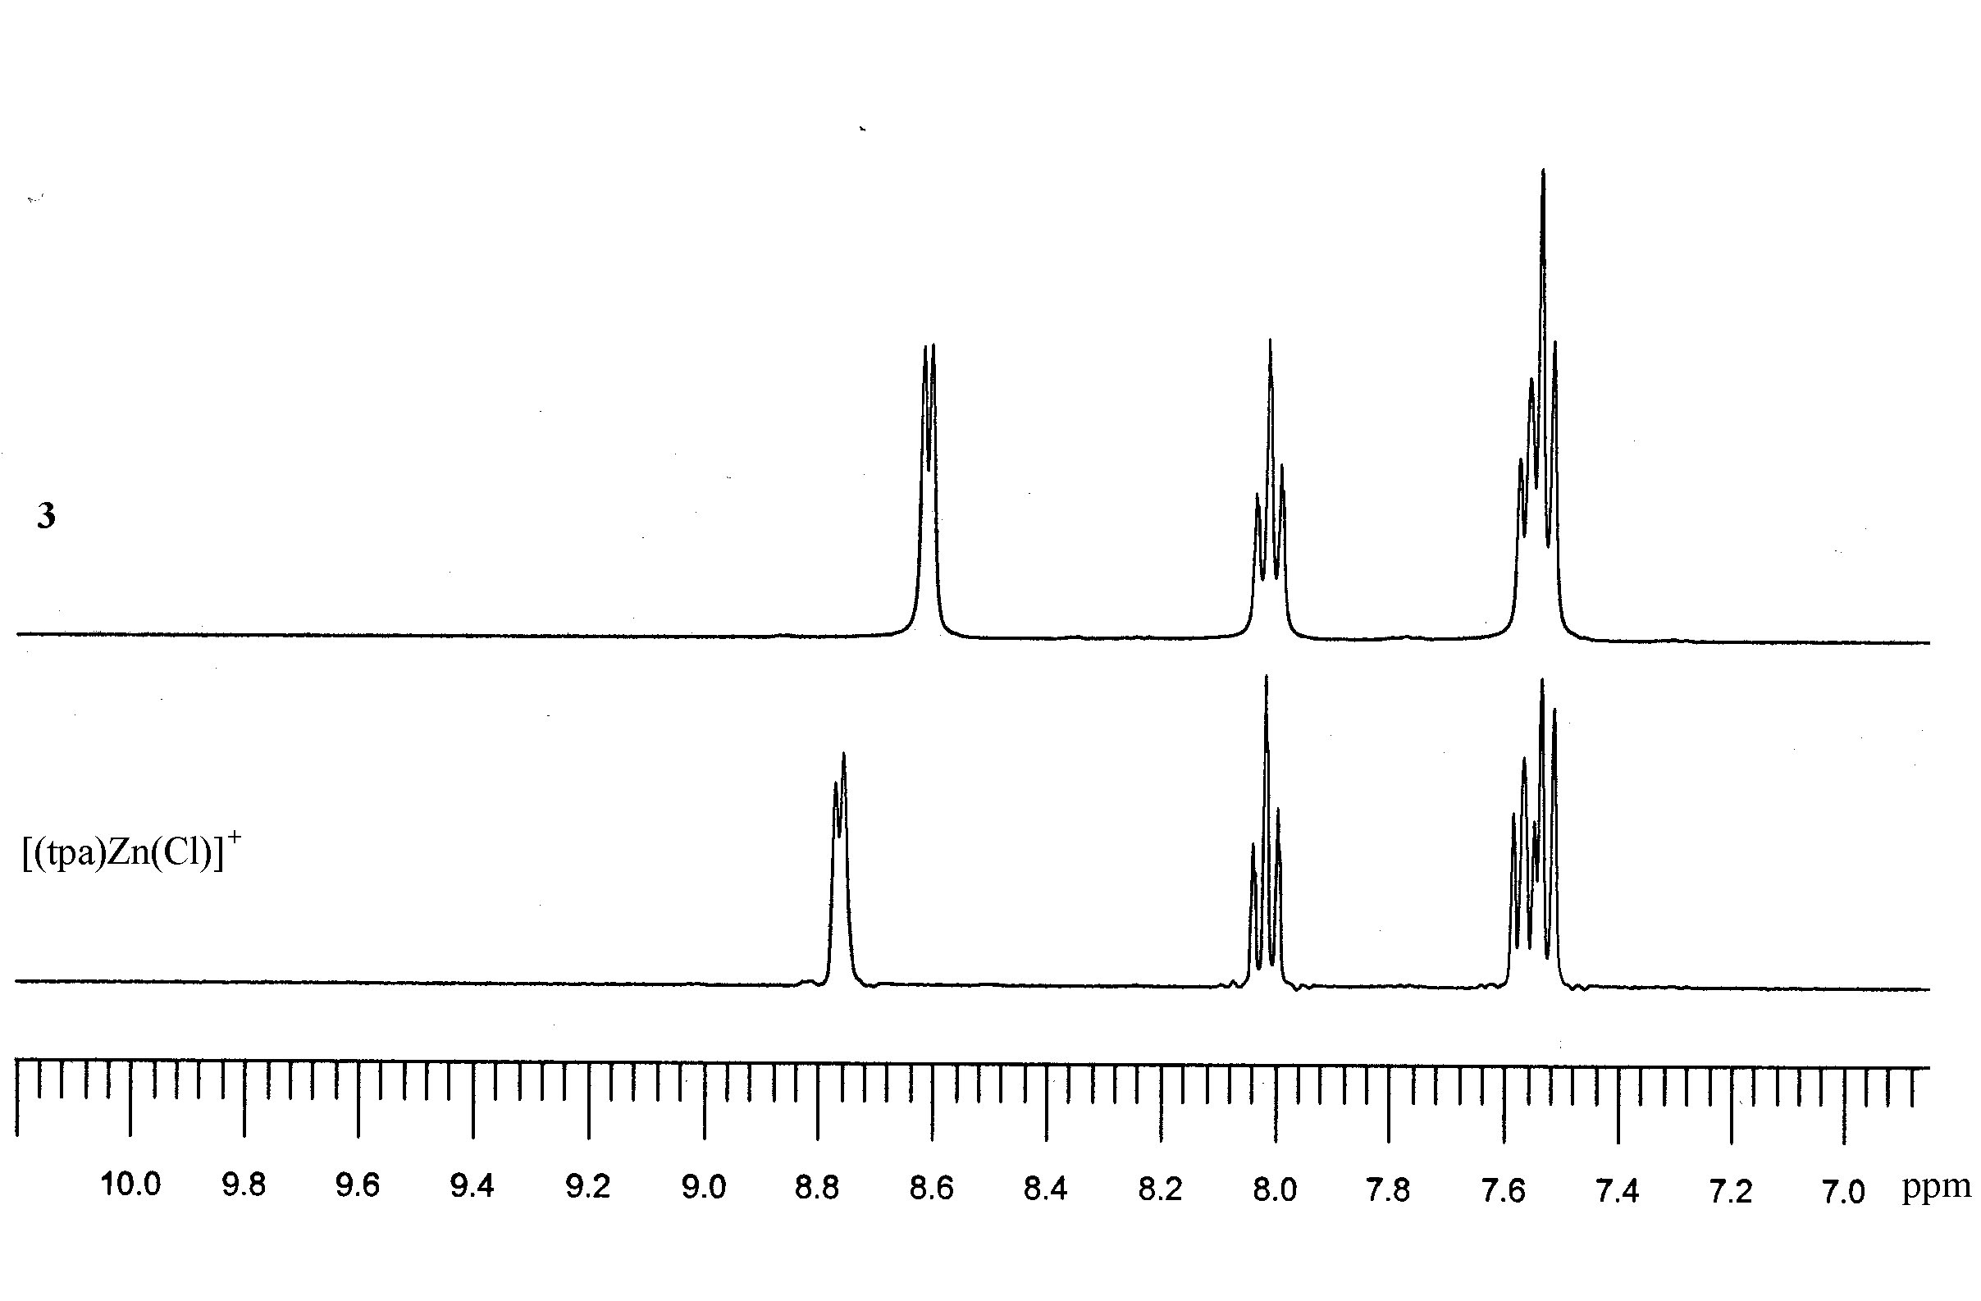
Fig. S9 Aromatic region of the ¹H NMR spectrum (360.1 MHz, D₂O, 293K) of 3 (top) and [(tpa)Zn(Cl)]Cl (bottom).

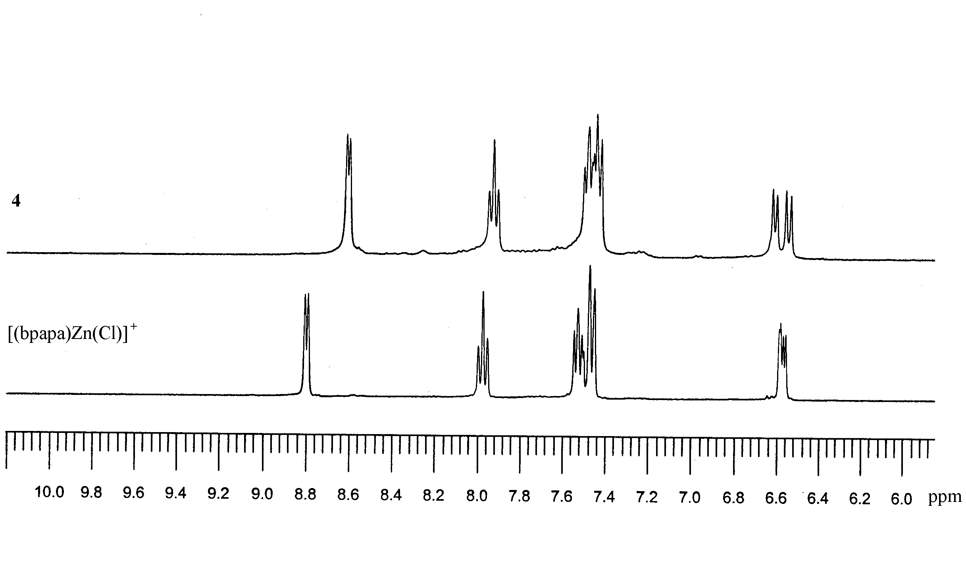

Fig. S10 Aromatic region of the ¹H NMR spectrum (360.1 MHz, D₂O, 293K) of 4 (top) and [(bpapa)Zn(Cl)]Cl (bottom).

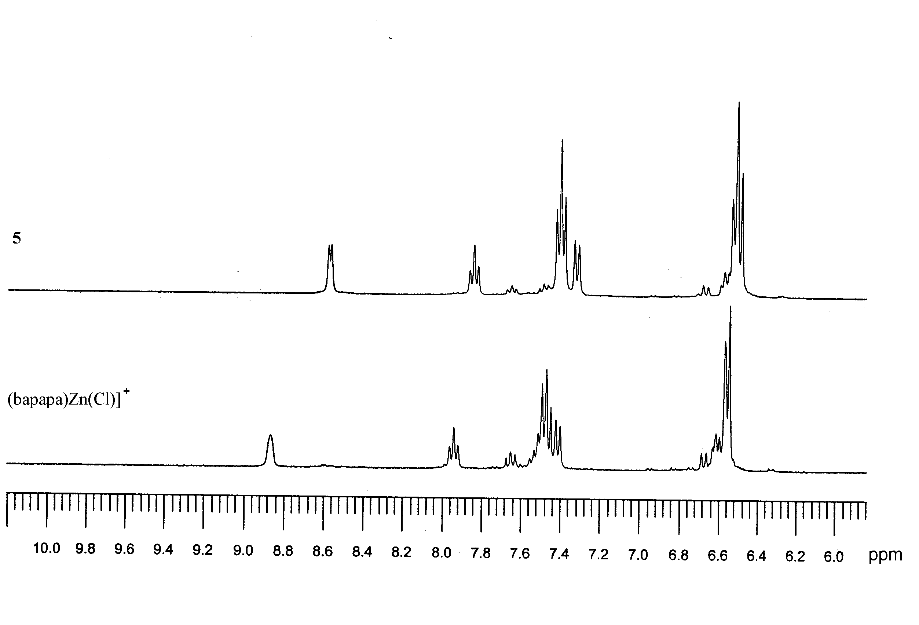
Fig. S11 Aromatic region of the ¹H NMR spectrum (360.1 MHz, D₂O, 293K) of 5 (top) and [(bapapa)Zn(Cl)]Cl (bottom).

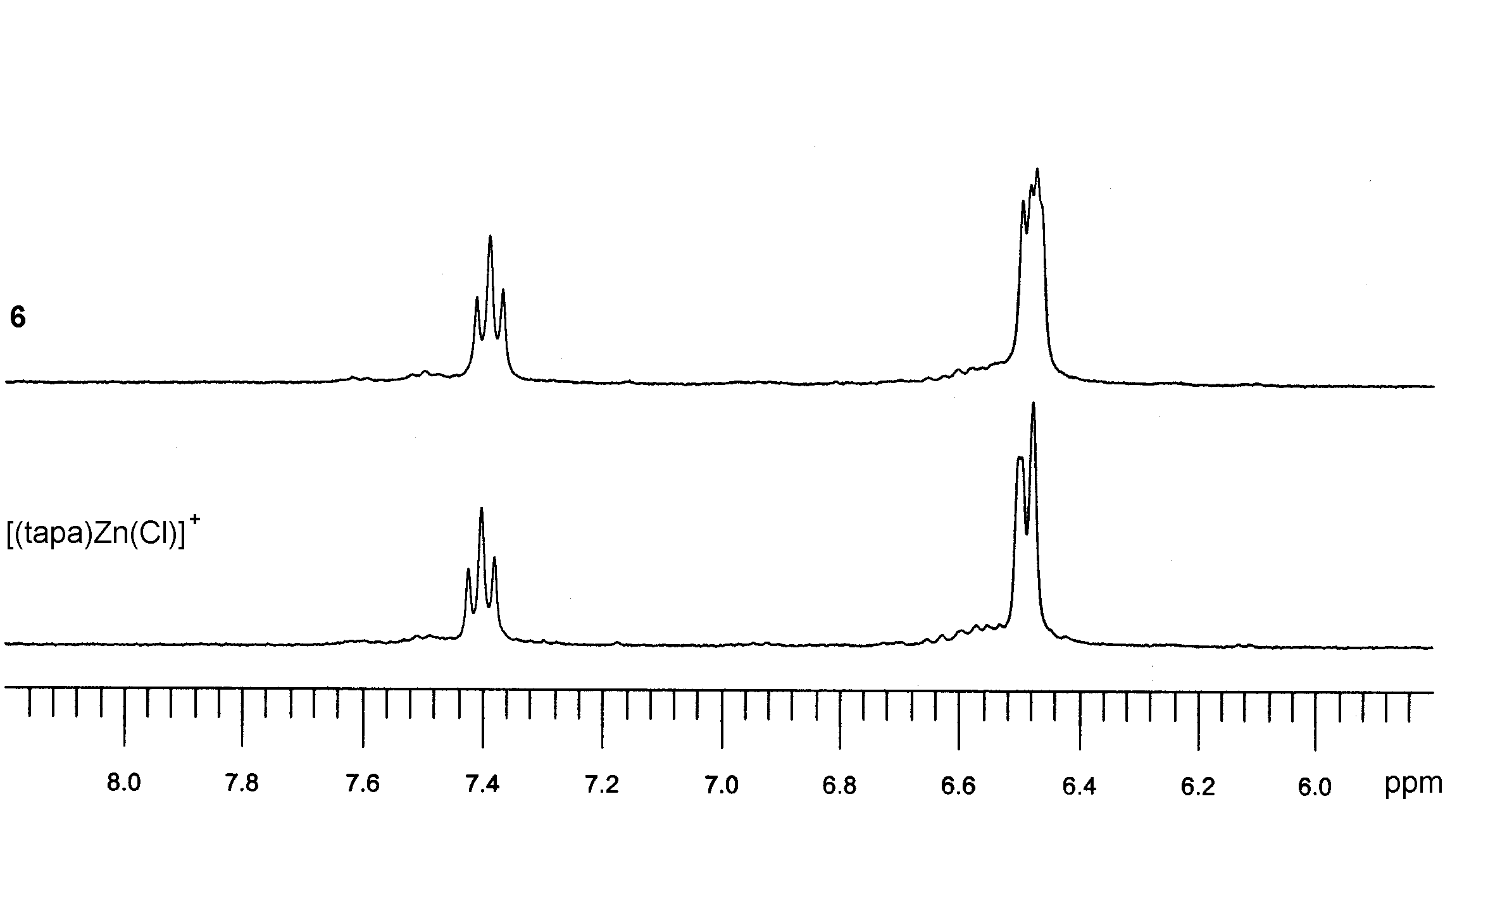

Fig. S12 Aromatic region of the ¹H NMR spectrum (360.1 MHz, D₂O, 293K) of 6 (top) and [(tapa)Zn(Cl)]Cl (bottom).

