Electronic Supplementary Information (ESI)
A self-seeded, surfactant-directed hydrothermal growth of single crystalline lithium manganese oxide nanobelts from the commercial bulky particles
Lizhi Zhang,ª Jimmy C. Yu,*^{,a} An-Wu Xu,ª Quan Li,^{b} Kwan Wai Kwong,^{b} Ling Wuª
ªDepartment of Chemistry and Environmental Science Programme, The Chinese University of Hong Kong, Shatin, New Territories, Hong Kong, China
Email: jimyu@cuhk.edu.hk
^{b}Department of Physics, The Chinese University of Hong Kong, Shatin, New Territories, Hong Kong,

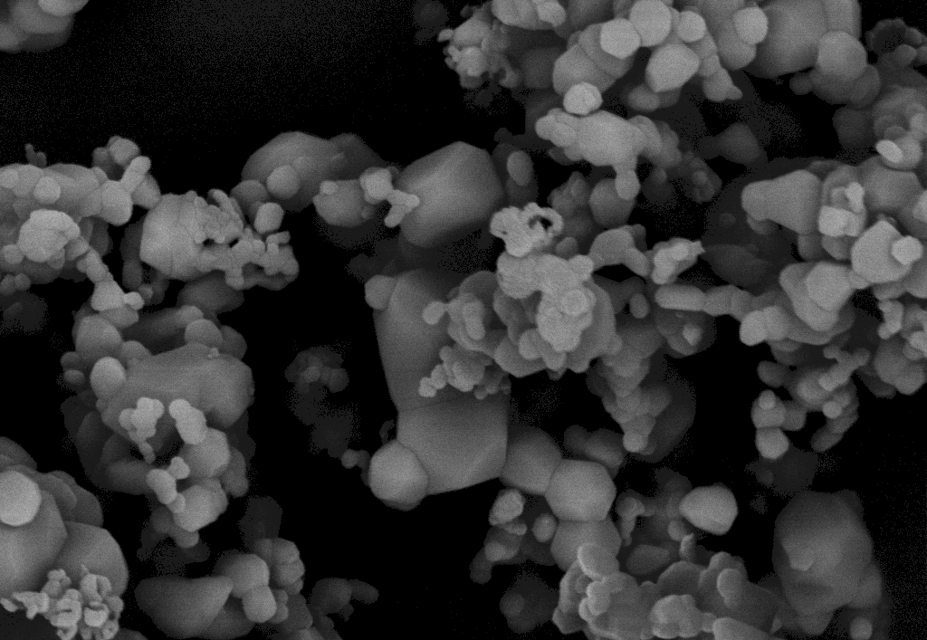
1 μm
Figure S1 SEM image of the commercial lithium manganese oxide bulky particles.
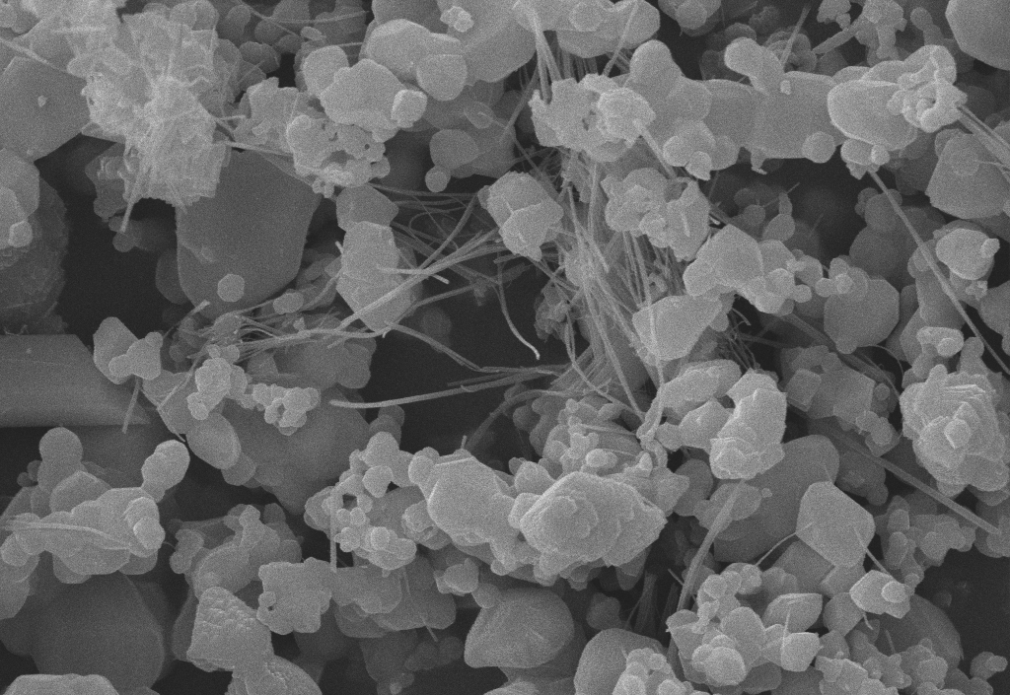
1 μm
Figure S2 SEM image of the product synthesized with 0.4 g LiMn₂O₄ and 0.2 g NaAOT in 17 mL deionized water under 160 ºC hydrothermal treatment for 24 h. It is obvious that the yield of the nanobelts is lower than that obtained under the reaction conditions described in the main text.
The amounts of bulky LiMn₂O₄ particles, water and NaAOT used in the hydrothermal processing affect the reaction yield. An increase in the bulky LiMn₂O₄ particles and a decrease in the water content would decrease the yield of the nanobelts. The optimum concentration of NaAOT is found to be 2.5 g/L. It is also found that the reaction temperature for the formation of the LiMn₂O₄ nanobelts is between 150 and 170 ºC. Hydrothermal treatment at higher than 180 ºC would destroy the LiMn₂O₄ crystal structure. While hydrothermal treatment temperatures much lower than 150 ºC would drastically decrease the yield of the nanobelts.

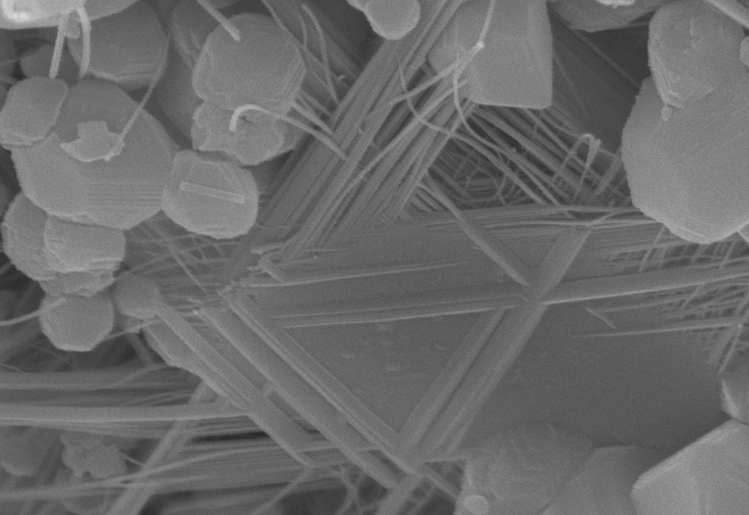
1 μm
a

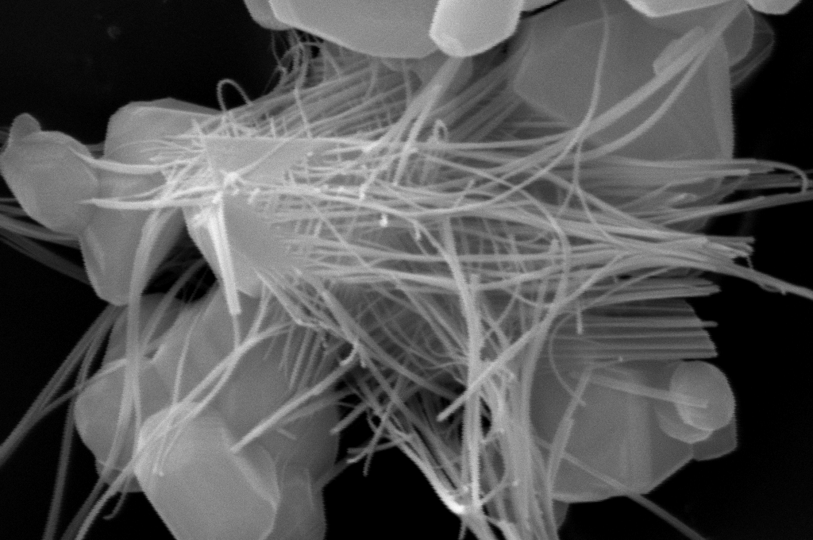
1 μm
b

Figure S3 SEM images of lithium manganese oxide nanobelts grown on the bulky particles. (a) 0.4 g LiMn₂O₄ and 0.2 g NaAOT in 17 mL deionized water under hydrothermal treatment at 160 ºC for 24 h. (b) 0.4 g LiMn₂O₄ and 1.0 g NaAOT in 17 mL deionized water under hydrothermal treatment at 160 ºC for 24 h.

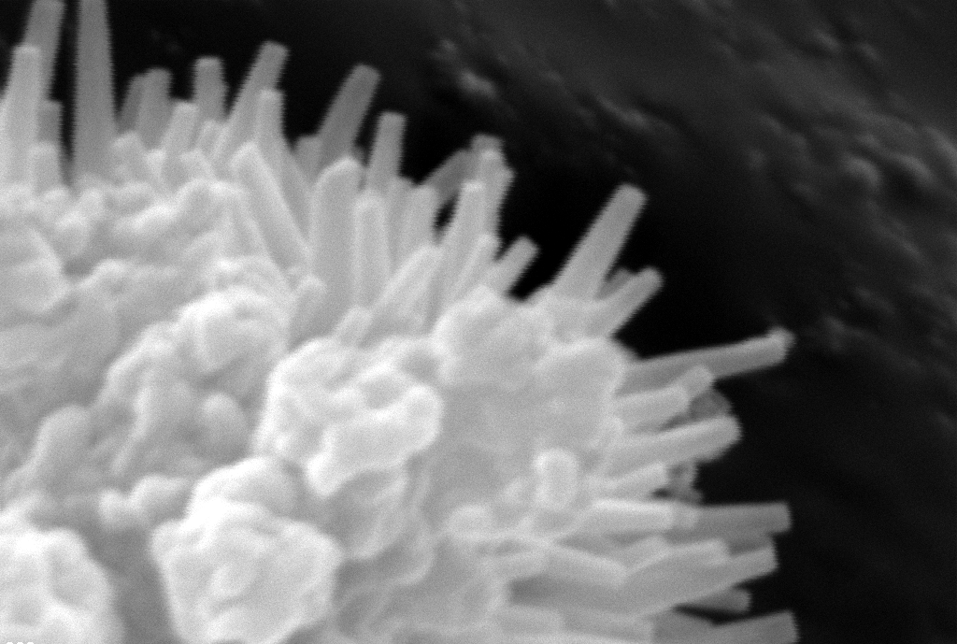
1 μm
Figure S4 SEM image of Se nanorods grown on the bulky particles. The sample was obtained by hydrothermal treatment of commercial Se powders in the presence of NaAOT.
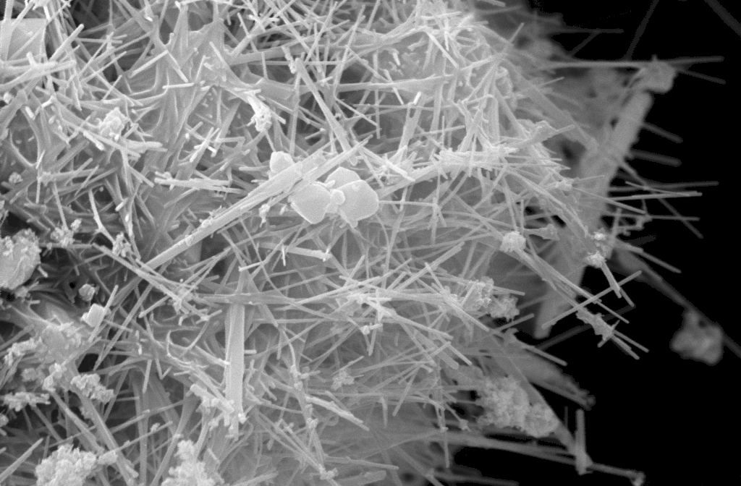
2 μm
Figure S5 SEM image of MnO₂ nanorods grown on the bulky particles. The sample was obtained by hydrothermal treatment of commercial MnO₂ powders in the presence of octadecylamine.

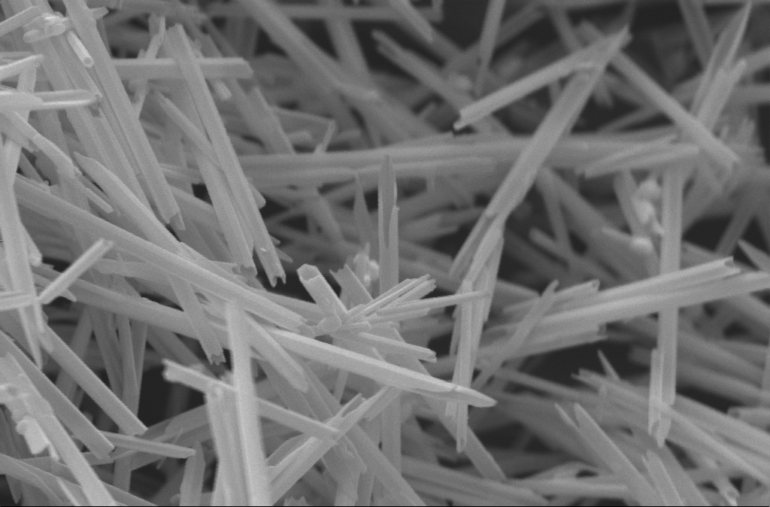
2 μm
Figure S6 SEM image of Te nanotubes. The sample was obtained by hydrothermal treatment of commercial Te powders in the presence of NaAOT.

