The structure of [1] consists of clusters of three octahedrally coordinated cobalt atoms bridged by succinate molecules into 1D chains (Figure 1). The cobalt – oxygen clusters contain two crystallographically independent cobalt atoms. Co[2] lies on an inversion center, and coordinates through edge sharing with two Co[1] octahedra. The coordination sphere of Co[2] is composed entirely of carboxylate oxygen atoms, while that of Co[1] consists of three carboxylate oxygen atoms and three water molecules. There are two crystallographically unique succinate molecules in the asymmetric unit. The first, containing C[1] through C[4], is bidentate with Co[2] binding with an oxygen atom from both carboxylate groups, O[2] and O[4] (Figure 2). Similar binding is seen in MIL-9 and -16. O[2] and O[4] also coordinate with Co[1], resulting in edge-sharing polyhedra. O[1] and O[3] are terminal, but are hydrogen bonded to coordinated water molecules in the trimetallic unit. The second distinct succinate molecule bridges two clusters by coordinating to Co[1] and Co[2] with both (crystallographically identical) carboxylate groups. The water molecules coordinated to Co[1] are stabilized by extensive hydrogen bonding to water molecules on adjacent clusters and to the terminal oxygen atoms on one of the carboxylate groups.
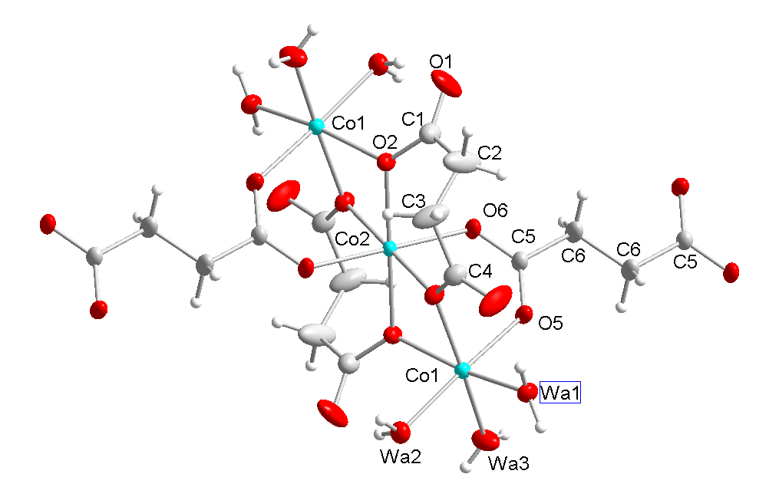
Figure 1: View of the trimeric Co(II) clusters with the atomic numbering scheme shown. Co(II) atoms are in blue, oxygen atoms red, carbon atoms grey, and hydrogen atoms white.

Figure 2: Graphical summary of cobalt succinate structures that form at the different temperatures studied. Purple polyhedra are drawn around cobalt centers, and oxygen atoms are colored red, carbon atoms grey, and hydrogen atoms white.

Crystallographic summary: A purple single crystal of [1], approx. 1 x 0.1 x 0.1 mm, was selected under a polarizing microscope, glued to a glass fiber, and mounted on a Siemens SMART CCD diffractometer with Mo_{Kα} radiation (0.71073 Å). The structure was solved using direct methods, and the data were refined against |F²|. All non-hydrogen atoms were refined anisotropically. Hydrogen atoms on the succinate molecules were placed in calculated positions with isotropic U values 20 % higher than the carbon to which they were bound. At the end of the refinement of [1], the six highest peaks in the Fourier map all occurred in chemically reasonable positions for the six hydrogen atoms of the water molecules. These were assigned isotropic U values 20 % higher than the oxygen to which they were bound, and refined into chemically reasonable positions without constraint. Crystal Data for [1]: orthorhombic, Pbca, a = 9.9608(18) Å, b = 14.688(3) Å c = 14.925(3) Å, V = 2183.7(7) Å3, ρ_{c} = 1.926 g/cm3, λ = 0.71073, Z = 12, R₁ = 0.0307 for 2628 reflections with I > 2σ, GOF = 0.833, 175 refined parameters. Crystallographic data (excluding structure factors) have been deposited with the Cambridge Crystallographic Data Centre as number 221317. Copies of the data can be obtained free of charge on application to the CCDC, 12 Union Rd., Cambridge CB21EZ, UK (fax: (+44)1223-336-033; email : deposit@ccdc.cam.ac.uk).
Table 1. Crystal data and structure refinement for cobalt succinate dihydrate.
Identification code cobalt succinate dihydrate
Empirical formula C4 H8 Co O6
Formula weight 211.03
Temperature 293(2) K
Wavelength 0.71073 Å
Crystal system Orthorhombic
Space group Pbca
Unit cell dimensions a = 9.9608(18) Å α= 90°.
b = 14.688(3) Å β= 90°.
c = 14.925(3) Å γ = 90°.
Volume 2183.7(7) Å3
Z 12
Density (calculated) 1.926 Mg/m3
Absorption coefficient 2.339 mm-1
F(000) 1284
Crystal size 1.0 x 0.1 x 0.1 mm3
Theta range for data collection 2.73 to 28.30°.
Index ranges -11<=h<=13, -18<=k<=19, -19<=l<=17
Reflections collected 12404
Independent reflections 2628 [R(int) = 0.0841]
Completeness to theta = 28.30° 97.0 %
Refinement method Full-matrix least-squares on F2
Data / restraints / parameters 2628 / 0 / 175
Goodness-of-fit on F2 0.833
Final R indices [I>2sigma(I)] R1 = 0.0307, wR2 = 0.0792
R indices (all data) R1 = 0.0379, wR2 = 0.0837
Largest diff. peak and hole 0.358 and -0.984 e.Å-3
Table 2. Atomic coordinates ( x 104) and equivalent isotropic displacement parameters (Å2x 103)
for cobalt succinate dihydrate. U(eq) is defined as one third of the trace of the orthogonalized Uij tensor.
________________________________________________________________________________
x y z U(eq)
________________________________________________________________________________
Co(1) 1455(1) 1842(1) 5561(1) 17(1)
Co(2) 0 0 5000 14(1)
O(1) -842(2) 1514(1) 7161(1) 52(1)
O(2) 359(2) 766(1) 6161(1) 21(1)
O(3) 1208(2) 2160(1) 3329(1) 51(1)
O(4) 466(2) 1272(1) 4418(1) 21(1)
O(5) 3032(1) 972(1) 5315(1) 25(1)
O(6) -2032(1) 340(1) 5056(1) 24(1)
WA1 2389(2) 2811(1) 4770(1) 25(1)
WA2 -101(2) 2745(1) 5927(1) 26(1)
WA3 2364(2) 2294(1) 6724(1) 32(1)
C(1) -393(2) 801(2) 6857(1) 28(1)
C(2) -704(4) -68(2) 7339(2) 60(1)
C(3) -150(3) 904(2) 2911(2) 42(1)
C(4) 552(2) 1495(1) 3591(2) 25(1)
C(5) 3052(2) 160(1) 5073(1) 20(1)
C(6) 4402(2) -305(2) 4945(2) 30(1)
________________________________________________________________________________

Table 4. Bond lengths and angles for cobalt succinate dihydrate.
_____________________________________________________

Co(1)-O(5) 2.0577(14)
Co(1)-WA3 2.0674(17)
Co(1)-WA1 2.0695(16)
Co(1)-WA2 2.1109(15)
Co(1)-O(2) 2.1193(14)
Co(1)-O(4) 2.1404(14)
Co(2)-O(6)#1 2.0863(15)
Co(2)-O(6) 2.0863(15)
Co(2)-O(2) 2.0965(14)
Co(2)-O(2)#1 2.0965(14)
Co(2)-O(4)#1 2.1125(14)
Co(2)-O(4) 2.1125(14)
O(1)-C(1) 1.226(3)
O(2)-C(1) 1.282(3)
O(3)-C(4) 1.239(3)
O(4)-C(4) 1.280(3)
O(5)-C(5) 1.247(2)
O(6)-C(5)#1 1.269(2)
C(1)-C(2) 1.498(3)
C(2)-C(3)#1 1.540(4)
C(3)-C(4) 1.507(3)
C(3)-C(2)#1 1.540(4)
C(5)-O(6)#1 1.269(2)
C(5)-C(6) 1.520(3)
C(6)-C(6)#2 1.500(4)

O(5)-Co(1)-WA3 90.84(7)
O(5)-Co(1)-WA1 88.96(6)
WA3-Co(1)-WA1 93.54(8)
O(5)-Co(1)-WA2 175.08(7)
WA3-Co(1)-WA2 84.41(8)
WA1-Co(1)-WA2 92.64(7)
O(5)-Co(1)-O(2) 90.31(6)
WA3-Co(1)-O(2) 96.30(7)
WA1-Co(1)-O(2) 170.14(7)
WA2-Co(1)-O(2) 88.91(7)
O(5)-Co(1)-O(4) 88.08(6)
WA3-Co(1)-O(4) 175.09(7)
WA1-Co(1)-O(4) 91.23(7)
WA2-Co(1)-O(4) 96.54(7)
O(2)-Co(1)-O(4) 78.92(5)
O(6)#1-Co(2)-O(6) 180.0
O(6)#1-Co(2)-O(2) 89.78(6)
O(6)-Co(2)-O(2) 90.22(6)
O(6)#1-Co(2)-O(2)#1 90.22(6)
O(6)-Co(2)-O(2)#1 89.78(6)
O(2)-Co(2)-O(2)#1 180.0
O(6)#1-Co(2)-O(4)#1 91.02(6)
O(6)-Co(2)-O(4)#1 88.98(6)
O(2)-Co(2)-O(4)#1 99.94(5)
O(2)#1-Co(2)-O(4)#1 80.06(5)
O(6)#1-Co(2)-O(4) 88.98(6)
O(6)-Co(2)-O(4) 91.02(6)
O(2)-Co(2)-O(4) 80.06(5)
O(2)#1-Co(2)-O(4) 99.94(5)
O(4)#1-Co(2)-O(4) 180.00(7)
C(1)-O(2)-Co(2) 126.27(14)
C(1)-O(2)-Co(1) 127.84(13)
Co(2)-O(2)-Co(1) 98.00(6)
C(4)-O(4)-Co(2) 129.56(13)
C(4)-O(4)-Co(1) 129.66(13)
Co(2)-O(4)-Co(1) 96.86(6)
C(5)-O(5)-Co(1) 131.18(13)
C(5)#1-O(6)-Co(2) 129.24(13)
O(1)-C(1)-O(2) 123.2(2)
O(1)-C(1)-C(2) 118.3(2)
O(2)-C(1)-C(2) 118.5(2)
C(1)-C(2)-C(3)#1 116.7(2)
C(4)-C(3)-C(2)#1 111.5(3)
O(3)-C(4)-O(4) 122.7(2)
O(3)-C(4)-C(3) 119.1(2)
O(4)-C(4)-C(3) 118.17(19)
O(5)-C(5)-O(6)#1 125.78(18)
O(5)-C(5)-C(6) 118.75(18)
O(6)#1-C(5)-C(6) 115.43(17)
C(6)#2-C(6)-C(5) 114.8(2)
_____________________________________________________________
Table 5. Anisotropic displacement parameters (Å2x 103) for cobalt succinate dihydrate. The anisotropic
displacement factor exponent takes the form: -2p2[ h2 a*2U11 + ... + 2 h k a* b* U12 ]
______________________________________________________________________________
U11 U22 U33 U23 U13 U12
______________________________________________________________________________
Co(1) 14(1) 15(1) 21(1) -2(1) 1(1) 0(1)
Co(2) 11(1) 13(1) 19(1) -1(1) 2(1) -1(1)
O(1) 68(1) 39(1) 47(1) -1(1) 38(1) 10(1)
O(2) 23(1) 21(1) 19(1) -3(1) 4(1) -4(1)
O(3) 74(1) 52(1) 28(1) 11(1) -5(1) -38(1)
O(4) 23(1) 19(1) 20(1) 2(1) -1(1) -4(1)
O(5) 14(1) 18(1) 43(1) -8(1) 1(1) 1(1)
O(6) 12(1) 19(1) 40(1) -4(1) 1(1) 1(1)
WA1 27(1) 18(1) 31(1) -2(1) 4(1) -5(1)
WA2 20(1) 26(1) 33(1) -1(1) 0(1) 2(1)
WA3 32(1) 39(1) 27(1) -10(1) -12(1) 12(1)
C(1) 31(1) 30(1) 22(1) -3(1) 4(1) -6(1)
C(2) 111(3) 35(1) 35(2) -7(1) 38(2) -25(2)
C(3) 74(2) 28(1) 25(1) 7(1) -18(1) -15(1)
C(4) 29(1) 23(1) 24(1) 3(1) -3(1) -3(1)
C(5) 14(1) 18(1) 27(1) -1(1) 1(1) 1(1)
C(6) 15(1) 20(1) 55(2) -7(1) 3(1) 2(1)
______________________________________________________________________________
Table 6. Hydrogen coordinates ( x 104) and isotropic displacement parameters (Å2x 10 3)
for cobalt succinate dihydrate.
________________________________________________________________________________
x y z U(eq)
________________________________________________________________________________

HW1A 2600(40) 3370(30) 4890(20) 38
HW1B 2050(40) 2690(30) 4290(30) 38
HW2A -730(40) 2800(30) 5540(20) 39
HW2B -340(30) 2480(20) 6340(30) 39
HW3A 2990(40) 2000(20) 6980(20) 49
HW3B 2010(40) 2510(20) 7130(30) 49
H(2A) -1639 -216 7232 72
H(2B) -604 40 7977 72
H(3A) -330 1259 2376 51
H(3B) -1003 703 3153 51
H(6A) 4473 -800 5374 36
H(6B) 4427 -570 4350 36
__________________________________________________________________________

