Ms. no. B311762F Chemical Communications
Electronic Supplementary Information
Synthesis of poly(para-phenylenevinylene) rotaxanes
by aqueous Suzuki coupling
Jun Terao, Andrew Tang, Jasper J. Michels, Alexander Krivokapic
and Harry L. Anderson

Section 1 — Details of Analytical Ultracentrifuge Measurements
Weight average molecular weights of PPVs 4⊂α-CD, 5⊂β-CD, 4 and 5 were determined with analytical ultracentrifugation (AUC), using sedimentation equilibrium.^{1,2} At sedimentation equilibrium, the concentration gradient of a sedimenting (macromolecular) polydisperse sample is given by equation (S1), assuming ideal behaviour of the solute.³
$\frac{\text{dc}(r)}{\text{dr}}=\frac{{\bar{M}}_{w}(r)(1−\bar{ν}ρ)ω^{2}\text{rc}(r)}{\text{RT}}$ (S1)
c(r) and ${\bar{M}}_{w}(r)$ are the concentration and the weight-average molecular weight of the polymer as a function of the radial distance r (normally given in cm from the centre of rotation); $\bar{ν}$ is the partial specific volume of the polymer, ρ is the density of the solution and ω is the rotor speed of the centrifuge in radians per second, R is the gas constant and T is the temperature. The weight average molecular weight of the whole sample (${\bar{M}}_{w}$) is obtained from the average slope of a plot of ln(c) versus r². In the case of the PPVs, the concentration gradient is measured by UV-vis absorption. Assuming that the solute follows Beer’s law, the concentration c may be substituted for the absorbance A. ${\bar{M}}_{w}$ is then approximated by equation (S2).^{1–3}
${\bar{M}}_{w}≈\frac{2\text{RT}}{(1−\bar{ν}ρ)ω^{2}}\left\langle \frac{d\text{ln}A}{{\text{dr}}^{2}}\right\rangle$ (S2)
The partial specific volumes of the PPV polyrotaxanes and reference polymers were assumed to be 0.62 and 0.55 ml/g, respectively, as these values were previously measured for similar 3,6-naphthalene disulfonate-terminated PDVs.² All AUC runs were carried out at 20 °C using a basic buffer (5 mM LiOH, 6 mM Li₂CO₃) in order to guarantee full deprotonation and to minimise thermodynamic non-ideality. Rotor speeds of 15000 and 20000 rpm were applied. The experimental molecular weight was observed to be independent of the rotor speed. Figure S1 displays representative AUC concentration profiles for all four polymers. The steep gradients obtained for the unthreaded reference polymers are indicative of aggregation at sedimentation equilibrium.
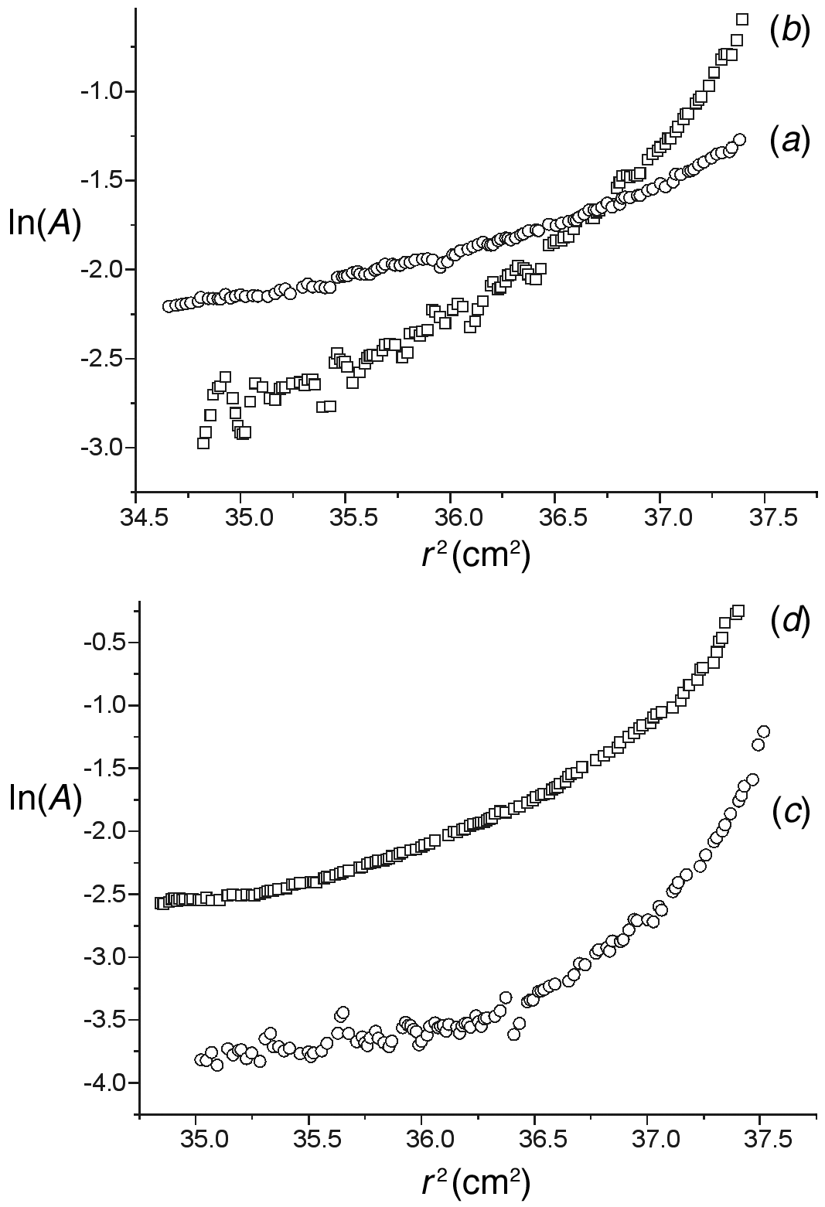
Figure S1. Sedimentation equilibrium profiles at 15000 rpm of the polyrotaxanes and reference polymers,
(a) 4⊂α-CD, (b) 5⊂β-CD, (c) 4 and (d) 5. T = 20 ºC, buffer: 5 mM LiOH, 6 mM Li₂CO₃.
Table 1 lists the experimental values for the weight average molecular weights (${\bar{M}}_{w}$(AUC)), as well as the experimental number of repeat units ($\bar{n}$_{AUC}), assuming the chain fractions to be distributed according to a Flory distribution.² If one assumes the average number of repeat units of the unthreaded reference polymers to be about 10, average aggregation numbers of about 4.5 and 5.5 are obtained for polymers 4 and 5 respectively.
Table S1. Molecular weight parameters for the PPVs
polymer | ${\bar{M}}_{w}$(AUC) | $\bar{n}$_{AUC}
4⊂α-CD | 17000 | 6.8
5⊂β-CD | 41200 | 12.3
4 | 53800 | 55
5 | 43700 | 45
The values for ${\bar{M}}_{w}$(AUC) and $\bar{n}$_{AUC} have an uncertainty of ±10%.
Section 2 — Experimental Synthetic Procedures
General Methods. Ultrafiltration dialysis was carried out with an Amicon 8200 ultrafiltration stirred cell using polysulfone filter membranes with a nominal molecular weight cut-off of 1 or 5 kDa. About 2 L of water was eluted through the ultrafiltration cell under 4 bar nitrogen pressure. Polymer weight-average molecular weights were determined by sedimentation equilibrium at 20 ºC using a Beckman Coulter XLA Analytical Ultracentrifuge, equipped with an AN 60 rotor and a UV-vis detection system. The samples were prepared by dissolving polymer in a basic aqueous buffer (1.25 mM LiOH / 1.58 mM Li₂CO₃, pH 8.5). Each sample was spun at three different initial loading concentrations, typically in the range 0.5–2 μg/ml. Rotor speeds were chosen in the range 15000 rpm for the polyrotaxanes. Concentration profiles were monitored by measuring the absorbance across the cell at λ_{max} of the high-wavelength absorption bands of the polymers (432 nm for 4⊂α-CD and 5⊂β-CD). All measurements were carried out at 20 °C.
1,4-Bis-(E)-(2-boronic acid-vinyl)benzene 1. Catecholborane (2.57 ml, 20.38 mmol) was added to a stirred solution of 1,4-diethynylbenzene (1.08 g, 8.57 mmol) in toluene (3.5 ml) at 0 °C under nitrogen. The mixture was warmed to reflux for 5 h, then evaporated. The residue was washed with dichloromethane (2 × 10 ml), dried under vacuum, then suspended in dry THF (10 ml). Gradual addition of water gave a clear solution, then addition of more water yielded 1 as a pale yellow precipitate (1.01 g, 54%). M.p. >200 °C, dec.; δ_{H} (400 MHz, D₂O, NaOH) 7.1 (s, 4H), 6.30 (d, 2H, J = 18.5 Hz), 6.15 (d, 2H, J = 18.5 Hz); δ_{C} (125 MHz, D₂O, NaOH) 141.3, 138.9, 133.2, 126.5; m/z (APCI–) 217.2, ([M-H]– 100%, C₁₀H₁₁B₂O₄ requires 217.1); λ_{max} (H₂O)/nm 299 (log ε 4.15); ν_{max}(KBr)/cm^{–1} 3262, 1621, 802.
Distyrylbenzene 3. 5-Iodoisophthalic acid disodium salt 2 (61.5 mg, 0.183 mmol) was placed in an NMR tube with sodium carbonate (19.4 mg, 0.183 mmol) and pump filled with nitrogen. Degassed D₂O (600 μl) was injected under nitrogen. In a separate NMR tube, benzenedivinyldiboronic acid 1 (19.9 mg, 0.092 mmol), sodium hydroxide (7.3 mg, 0.183 mmol) and palladium(II) acetate (0.4 mg, 1.8 μmol) were mixed, after which the tube was pump filled with nitrogen. Degassed D₂O (600 μl) was injected under nitrogen. The contents of the NMR tube containing 5-iodoisophthalic acid sodium salt were transferred to the other one by syringe, and shaken. The reaction was followed by NMR. After 2 h at room temperature, the solution was filtered through a 0.22 µm filter, then acidified to pH 1 with concentrated hydrochloric acid to precipitate the product. The solid was collected by centrifugation, dissolved in sodium hydroxide solution and reprecipitated with hydrochloric acid. 3 was collected by centrifugation and dried in vacuo to yield a yellow solid (36 mg, 43%). M.p. >250 °C, dec.; δ_{H} (400 MHz, D₂O) 8.05 (m, 6H), 7.60 (s, 4H), 7.20 (q, 4H, J = 16.4 Hz); δ_{C} (100 MHz, D₂O) 165.5, 137.7, 137.2, 136.8, 129.6, 129.4, 128.5, 128.1, 127.4; m/z (ESI–), 457.0933 ([M-H]– 100%), C₂₆H₁₇O₈ requires 457.09234; λ_{max} (H₂O)/nm (log ε) 356 (4.75); ν_{max}/cm^{–1} 3336, 1700, 1595, 1419.
[2]Rotaxane 3⊂α-CD. An oxygen-free solution of α-cyclodextrin (2.24 g, 2.3 mmol) in water (10 ml) at 50 °C was transferred into a flask containing benzenedivinyldiboronic acid 1 (100 mg, 0.46 mmol), 5-iodoisophthalic acid disodium salt 2 (340 mg, 1.01 mmol), sodium hydroxide (36.8 mg, 0.92 mmol) and sodium carbonate (97.5 mg, 0.92 mmol) under nitrogen. The mixture was stirred at 50 °C until all the solids had dissolved, then palladium(II) acetate (2.0 mg, 8 μmol) was added, and stirring was continued at 50 °C for 2 h. The reaction mixture was passed through a 0.22 µm filter to remove palladium residues and then acidified to pH 1 with concentrated hydrochloric acid, to precipitate dumbbell 3, which was removed by centrifugation. The crude product was dialysed using a 1000 NMWCO membrane using dilute ammonia solution to maintain a high pH. Recrystallisation from hot water yielded fine, yellow, crystalline needles of 3⊂α-CD (303 mg, 48%). M.p. >260 °C, dec.; δ_{H} (500 MHz, D₂O) 8.19 (d, 2H, J = 1.0 Hz), 8.12 (m, 1H), 8.10 (m, 1H), 7.89 (d, 2H, J = 1.0 Hz), 7.77 (d, 2H, J = 8.1 Hz), 7.56 (d, 2H, J = 8.1 Hz), 7.34 (d, 1H, J = 16.4 Hz), 7.23 (d, 1H, J = 16.4 Hz), 7.17 (d, 1H, J = 16.4 Hz), 7.12 (d, 1H, J = 16.4 Hz), 4.91 (d, 6H, J = 3.2 Hz), 3.79 (m, 6H), 3.75 (m, 6H), 3.64 (dd, 6H, J = 3.0, 13.5 Hz), 3.54 (m, 6H), 3.51 (m, 6H), 3.43 (dd, 6H, J = 3.2, 10.0 Hz); δ_{C} (125 MHz, D₂O) 175.2, 175.0, 138.0, 137.6, 137.4, 136.9, 136.5, 129.6, 129.4, 129.1, 128.9, 128.8, 128.5, 128.1, 126.9, 102.5, 81.6, 74.0, 72.6, 72.4, 59.9; m/z (ESI–) 714.27 ([M-2H]^{2–} 100%); ν_{max}/cm^{–1} 3392, 2931, 1709, 1599, 1244, 1152, 811; Found: C, 47.23; H, 5.98. C₆₂H₇₈O₃₈·8H₂O requires C, 47.27; H, 6.01.
1,4-Bis-(E)-(2-1,3,2-dioxaborol-vinyl)benzene 1b. Ethanediol (688 mg, 11.1 mmol) was added to a solution of 1,4-bis-(E)-(2-boronic acid-vinyl)benzene 1 (1.15 g, 5.3 mmol) in toluene (80 ml). The mixture was refluxed for 3 h with removal of water by means of a Dean-Stark trap. Solvent was removed in vacuo and the residue dissolved in toluene, filtered, and recrystallized from hot toluene. 1b (1.21 g, 85 %) was obtained as an off-white solid. M.p. 274 ºC. δ_{H} (400 MHz, CDCl₃) 7.50 (s, 4H), 7.42 (d, J = 18.4 Hz, 2H), 6.22 (d, J = 18.4 Hz, 2H), 4.31 (s, 8H); δ_{C} (100 MHz, DMSO-d₆) 149.4, 138.0, 127.4, 65.7; Found: C, 62.34; H, 5.85. C₁₄H₁₆O₄B₂ requires C, 62.30; H, 5.98.
PPV polyrotaxane 4⊂α-CD. A two-neck flask was charged with diiodide 6 (63.6 mg, 0.10 mmol), divinylboronic ester 1b (32.4 mg, 0.12 mmol), iodobenzene-3,5-dicarboxylic acid 2 (5.8 mg, 0.02 mmol), α-cyclodextrin (687 mg, 0.7 mmol), Pd(OAc)₂ (2.2 mg, 0.01 mmol), and Li₂CO₃ (44 mg, 0.60 mmol). The solids were ground together in the flask and placed under a nitrogen atmosphere. O₂-free water (1 ml) was added and stirred for 1 h under nitrogen at 80 ºC. The solution was purified from low-molecular weight material by ultrafiltration using a 5000 nominal molecular weight cut off membrane. About 2 L of water was eluted through the stirred ultrafiltration cell using a nitrogen pressure of 4 bar. Removal of the water gave 4⊂α-CD (49 mg, 55%) as a yellow film. δ_{H} (500 MHz, D₂O) 8.3–7.0 (br, [14 + 16n]H, n = 6.9), 5.1 (brs, 7xH, x = 0.7 ± 0.1), 4.2–3.4 (br, 35xH, x = 0.7 ± 0.1); δ_{C} (125 MHz, D₂O) 142–141, 138–134, 131–126, 102.7, 81.6, 74.1, 72.9, 72.4, 72.2, 60.2; λ_{max}(H₂O)/nm 436; Found: C, 42.14; H, 6.32; Li, 1.24. C₃₈₅H₄₇₂O₂₁₅S₁₄Li₁₈·102H₂O requires C, 42.24; H, 6.23; Li, 1.13.
PPV polyrotaxane 5⊂β-CD. The synthesis of polyrotaxane 5⊂β-CD was carried out analogously to that of 4⊂α-CD, using 6 (63.6 mg, 0.10 mmol), 1b (32.4 mg, 0.12 mmol), 1-iodonaphthalene-3,6-disulfonate disodium salt 7 (9.2 mg, 0.02 mmol), β-cyclodextrin (284 mg, 0.25 mmol), Pd(OAc)₂ (2.2 mg, 0.01 mmol), and Li₂CO₃ (44 mg, 0.60 mmol). 5⊂β-CD (128 mg, 59%) was obtained as a light yellow film. δ_{H} (500 MHz, D₂O) 8.6–8.4 (m, 4H), 8.4–7.0 (br, [14 + 16n]H, n = 12.2), 5.08 (brs, 7xH, x = 1.0 ± 0.1), 4.2–3.4 (br, 42xH, x = 1.0 ± 0.1); δ_{C} (125 MHz, D₂O) 141–140, 137–132, 131–123, 102.3, 80.8, 73.4, 72.0, 60.2; λ_{max}(H₂O)/nm 438; Found: C, 45.43; H, 5.67; Li, 0.95. C₈₇₇H₁₁₃₅O₅₄₇S₂₈Li₂₈·91H₂O requires C, 45.45; H, 5.73; Li, 0.85.
PPV 4. The synthesis of 4 was carried out analogously to that of 4⊂α-CD, using 6 (63.6 mg, 0.10 mmol), 1b (32.4 mg, 0.12 mmol), 2 (5.8 mg, 0.02 mmol), Pd(OAc)₂ (2.2 mg, 0.01 mmol), and Li₂CO₃ (44 mg, 0.60 mmol). 4 (31 mg, 57%) was obtained as a light yellow film. δ_{H} (500 MHz, D₂O) 8.8–6.4 (m, [14 + 16_{n}]H); λ_{max}(H₂O)/nm 433; Found: C, 54.54; H, 4.22; Li, 2.44. C₂₆₆H₁₇₄O₆₈S₂₀Li₂₄·32H₂O requires C, 54.68; H, 4.11; Li, 2.85.
PPV 5. The synthesis of 5 was carried out analogously to that of 5⊂β-CD, using 6 (63.6 mg, 0.10 mmol), 1b (32.4 mg, 0.12 mmol), 7 (9.2 mg, 0.02 mmol), Pd(OAc)₂ (2.2 mg, 0.01 mmol), and Li₂CO₃ (44 mg, 0.60 mmol). 5 (35 mg, 66%) was obtained as a light yellow film. δ_{H} (500 MHz, D₂O) 8.8–6.4 (m, [18 + 16_{n}]H); λ_{max}(H₂O)/nm 437; Found: C, 51.36; H, 4.19; Li, 2.71. C₂₇₀H₁₇₆O₇₂S₂₄Li₂₄·45H₂O requires C, 51.32; H, 4.24; Li, 2.64.
References
1 S. E. Harding, A. J. Rowe, J. C. Horton, Analytical Ultracentrifugation in Biochemistry and Polymer Science, Royal Society of Chemistry: Cambridge, 1992.
2 J. J. Michels, M. J. O’Connell, P. N. Taylor, J. S. Wilson, F. Cacialli and H. L. Anderson, Chem. Eur. J., 2003, 9, in press.
3 M. Wales, J. Phys. Colloid Chem., 1948, 52, 235; C. Tanford, C. Physical Chemistry of Macromolecules, John Wiley and Sons: New York, 1961; J. M. Creeth, R. H. Pain, Prog. Biophys. Mol. Biol., 1967, 17, 217.

