Supplementary Information

Takuhiro Izumi, Hironobu Hashimoto and Hideya Yuasa
Switching extended 1,3-diequatorial and bent 1,3-diaxial states of a disubstituted hinge sugar by ligand exchange reactions on Pt(II)
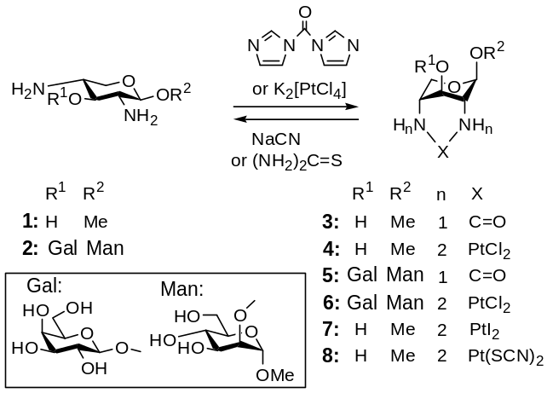

Experimental Procedures
General.
All solvents and reagents used were reagent grade and, in cases where further purification was required, standard procedures (Perrin, D.D.; Armarego, W.L.; Perrin, D.R. Purification of Laboratory Compounds. 2nd ed. Pergamon Press, London. 1980.) were followed. Solution transfers where anhydrous conditions were required were done under dry argon using syringes. Thin-layer chromatograms (TLC) were performed on precoated silica gel Merck 60-F254 plates (Art 5715) and visualized by quenching of fluorescence and/or by charring after spraying with 1 % CeSO₄-1.5 % (NH₄)6Mo₇O₂₄·4H₂O-10 % H₂SO₄. Column chromatography was performed on Merck Kieselges 60 (Art 7734), Wako gel C-300, or Kanto Silica gel 60N (spherical, neutral) with the solvent systems specified
Optical rotations were determined with a Horiba SEPA-200 polarimeter using 1 dm or 0.1 dm length cell. ¹H NMR (1D, COSY, 2D-NOESY, HMQC, and HMBC) spectra were recorded at 400 MHz (Varian Unity-400) with internal DOH (δ 4.8 in D₂O or CD₃OD). 1D-TOCSY and 1D-NOESY were measured with Brucker DMX400. Chemical shifts are expressed in ppm referenced to the solvent, as an internal standard.The multiplicity of signals is abbreviated as follows: s = singlet, d = doublet, dd = doublet of doublets, t = triplet, dt = doublet of triplets, ddd = doublet of doublets of doublets, br = broad signal, m = multiplet. ¹³C NMR spectra were recorded at 67.8 MHz (JEOL JNM-EX-270) or 100.6 MHz (Varian Unity-400) with internal CD₃OD (δ 49.0 in CD₃OD) or external acetone (δ 30.89 in D₂O) as the reference standard. High resolution mass spectra (HRMS) were recorded on Mariner Biospectrometry Workstation ESI-TOF MS.

Methyl 2,4-N-carbonyl-2,4-diamino-2,4-dideoxy-β-D-xylopyranoside (3).
To a stirred solution of methyl 2,4-diamino-2,4-dideoxy-β-D-xylopyranoside (1; 99.5 mg, 613.5 μmol) in DMF (6 mL) was added 1,1’-carbonyldiimidazole (121.1 mg, 746.8 μmol). After 2 h, the solution was concentrated and the residue was dissolved in H₂O, which was passed through the column of Dowex 50 (H⁺) (φ 1.5 x 5.0 cm) to remove imidazole. The elute was further purified by silica gel chromatography (60N, CHCl₃-MeOH, 8 : 1) to give 3 (88.4 mg, 77 %) as a foam: R_{f} 0.23 (CHCl₃-MeOH, 8 : 1), [α]_{D}²³ –140.6° (c 1.33 in MeOH); ¹H NMR (400 MHz, CD₃OD, 298K) δ 4.575 (m, 1H, J_{1,2} = 2.1 Hz, J_{1,3} = 1.4 Hz, J_{1,5b} = 0.8 Hz, H-1), 4.180 (d, 1H, J_{5a,5b} = 11.8 Hz, H-5a), 4.056 (m, 1H, J_{2,3} = J_{3,4} = 3.8 Hz, J_{3,5b} = 1.4 Hz, H-3), 3.411 (s, 3H, OMe), 3.410 (m, 1H, J_{4,5b} = 2.0 Hz, H-5b), 3.275 (m, 1H, J_{2,4} = 0.6 Hz, H-2), 3.182 (m, 1H, H-4) ; ¹³C NMR (100.6 MHz, CD₃OD, 298K) δ 160.20 (C=O), 103.48(C-1), 65.04 (C-3), 60.74 (C-5), 56.00 (OMe), 50.77 (C-4), 50.72 (C-2). HRMS calcd. for [C₇H₁₂N₂O₄ +H]⁺ 189.0875, found 189.0875. Anal. calcd. for C₇H₁₂N₂O₄･1/6H₂O: C 43.98, H 6.50, N 14.65; found: C 44.28, H 6.65, N 14.31. ¹H NMR, ¹³C NMR, COSY, and HMQC are shown in Figure S1-4.

Optical rotation change in the carbonylation of 1.
The optical rotation (α) at 0 min was observed for the solution (26 mM) of 1 (8.4 mg, 51.8 μmol) in DMF (2.0 mL). To this solution, the solution of compound 1 (1.35 mg, 8.28 μmol) in DMF (81 μL) and then the solution of 1,1’-carbonyldiimidazole (10.0 mg, 61.7 μmol) in DMF (200 μL) were added and the time course of α was followed (Figure S5).
The first order rate constant (k = 1.19×10⁻³ s⁻¹) was calculated by fitting (Figure 6S) the processed data to the equation:
ln [1]/[1]₀ = –kt,
where [1] is the concentration (mM) of 1 at t min and [1]₀ is the concentration (mM) of 1 at 0 min. [1] is calculated from the equation:
[1] (mM) = 26*(α_{obs} - α_{120min})/(α_{0min} - α_{120min}),
where α_{obs}, α_{120min}, and α_{0min} denote the optical rotations at given time, 120 min (-0.647°), and 0 min (-0.257°), respectively.

Methyl β-D-galactopyranosyl-(1→3)-2,4-N-carbonyl-2,4-diamino-2,4-dideoxy-β-D-
xylopyranosyl-(1→2)-α-D-mannopyranoside (5).
To a stirred solution of Methyl β-D-galactopyranosyl-(1→3)- 2,4-diamino-2,4-dideoxy-β-D-
xylopyranosyl-(1→2)-α-D-mannopyranoside (2; 15.4 mg, 31.7 μmol) in DMF (2 mL) was added a solution of 1,1’-carbonyldiimidazole (6.2 mg, 38.2 μmol) in DMF (1 mL). After 28 h at room temperature, the reaction was incomplete. Thus the bath temperature was raised to 120°C and the reaction was continued for further 24 h. The solution was concentrated and the residue was dissolved in H₂O, which was passed through the column of Dowex 50 (H⁺) (φ 1.5 x 5.0 cm) to remove imidazole. The elute was further purified by silica gel chromatography (60N, AcOEt-MeOH-H₂O, 12 : 3 : 1 → 6 : 3 : 1) to give 3 (5.8 mg, 36 %) as a foam: R_{f} 0.20 (AcOEt-MeOH-H₂O, 6 : 3 : 1), [α]_{D}²³ –46.5°(c 0.46 in H₂O); ¹H NMR (400 MHz, D₂O, 303K) δ 5.046 (s, 1H, H-1’), 5.011 (d, 1H, J_{1,2} = 1.4 Hz, H-1), 4.711 (d, 1H, J_{1”,2”} = 7.6 Hz, H-1”), 4.472-4.516 (m, 2H, H-3’, 5’a), 4.138 (dd, 1H, J_{2,3} = 3.7 Hz, H-2), 4.045 (dd, 1H, J_{3”,4”}= 3.4 Hz, J_{4”,5”} = 0.6 Hz, H-4”), 4.014 (dd, 1H, J_{5,6a} = 2.1 Hz, J_{6a,6b} = 12.2 Hz, H-6a), 3.962 (dd, 1H, J_{3,4} = 9.5 Hz, H-3), 3.906 (dd, 1H, J_{5,6b} = 5.8 Hz, H-6b), 3.724-3.875 (m, 7H, H-4, 2’, 4’, 3”, 5”, 6”a, 6”b), 3.692 (dd, 1H, J_{2”,3”} = 9.9 Hz, H-2”), 3.635 (bd, 1H, J_{5’a,5’b} = 11.6 Hz, H-5’b), 3.527 (s, 3H, OMe) ; ¹³C NMR (67.8 MHz, D₂O, 303K) δ 159.49 (C=O), 103.49 (C-1”), 98.78 (C-1’), 98.16 (C-1), 76.02, 73.16, 67.64 (C-4, 5, 3”, 5”), 75.24 (C-2), 71.55 (C-2”), 70.79 (C-3’), 70.51 (C-3), 69.12 (C-4”), 61.48 (C-6”), 61.36 (C-6), 60.92 (C-5”), 55.51 (OMe), 48.05 (C-2’, 4’). HRMS calcd. for [C₁₉H₃₂N₂O₁₄ +H]⁺ 513.1932, found: 513.1931. Anal. calcd. for C₁₉H₃₂N₂O₁₄: C 44.53, H 6.29, N 5.47; found: C 40.57, H 6.62, N 5.62. ¹H NMR, ¹³C NMR, DEPT135°, COSY, HMQC, HMBC, and NOESY are shown in Figure S7-13.

Dichloro [methyl 2,4-diamino-2,4-dideoxy-β-D-xylopyranoside-N, N’] platinum (4).
To a stirred solution of compound 1 (7.9 mg, 48.7 μmol) in H₂O (1 mL) was added K₂[PtCl₄] (24.3 mg, 58.5 μmol) at 25 °C. After 24 h, the solution was passed through the column of Sephadex G-10 (φ 1.5 x 100 cm) to give 4 (9.7 mg, 46%) as a pale yellow solid: R_{f} 0.20 (iPrOH-H₂O-NH₄OH, 20 : 3 : 1), mp 273 °C (decomp), [α]_{D}²⁴ –53.7°(c 0.62 in H₂O); ¹H NMR (400 MHz, D₂O, 298K) δ 4.849 (br, 1H, 0.9 Hz, H-1), 4.303 (dd, 1H, J_{4,5a} = 2.1 Hz, J_{5a,5b} = 13.7 Hz, H-5a), 3.718-3.760 (br, 2H, H-3, 5b), 3.496 (s, 3H, OMe), 2.714-2.719 (br, 1H, H-2), 2.678-2.683 (br, 1H, H-4) ; ¹³C NMR (67.8 MHz, D₂O, 298K) δ 98.56 (C-1), 66.73 (C-3), 56.20 (C-5), 56.02 (OMe), 49.89 (C-4), 48.53 (C-2). HRMS calcd. for [C₆H₁₄³⁵Cl₂N₂O₃¹⁹⁵Pt +K]⁺ 465.9666, found 465.9687. Anal. calcd. for C₆H₁₄Cl₂N₂O₃Pt･1/2H₂O : C 16.48, H 3.46, N 6.41, Cl 16.22; found: C 16.53, H 3.76, N 6.24, Cl 16.25. ¹H NMR, ¹³C NMR, COSY, HMQC, and simulated and observed ESI mass spectra are shown in Figure S14-18.

Time course for the complex formation of 1 with Pt (II).
The optical rotation (α) at 0 min was observed for the solution (26 mM) of 1 (8.4 mg, 51.8 μmol) in 50 mM NaOAc-d₃ D₂O buffer (pH 7.0, 2.0 mL). The aliquot (600 μL) was transferred to NMR tube to measure ¹H NMR at 0 h (30°C).
Separately from the above samples, to the solution of 1 (11.0 mg, 67.8 μmol) in 50 mM NaOAc-d₃ D₂O buffer (2319.6 μL) was added the solution of K₂[PtCl₄] (28.1 mg, 67.7 μmol) in the same buffer (280.6 μL; total 2600.2 μL, 26 mM). The reaction at 30°C was monitored by optical rotation (2.0 mL aliquot) for 12 h at an interval of 0.5 h (Figure S19) and by ¹H NMR (600.2 μL aliquot) at 0.5, 1, 1.5, 2, 4, 6, 8, and 12 h (Figure S20).
The first order rate constant (k = 1.30×10⁻⁴ s⁻¹) was calculated by fitting (Figure S21) the processed data from the optical rotation measurement to the equation:
ln [1]/[1]₀ = –kt,
where [1] is the concentration (mM) of 1 at t min and [1]₀ is the concentration (mM) of 1 at 0 min. [1] is calculated from the equation:
[1] (mM) = 26*(α_{obs} - α_{12h})/(α_{0h} - α_{12h}),
where α_{obs}, α_{12h}, and α_{0h} denote the optical rotations at given time, 12 h (-0.583°), and 0 min (-0.3020°), respectively.
The first order rate constant caluculated from ¹H NMR (k = 1.16×10⁻⁴ s⁻¹) was similar to that obtained above, only when the data at 6 and 8 h were omitted because of their small S/N ratios.

Dichloro [methyl β-D-galactopyranosyl-(1→3)-2,4-diamino-2,4-dideoxy-β-D-xylopyranosyl-
(1→2)-α-D-mannopyranoside-N, N’] platinum (6).
To a stirred solution of compound 2 (30.6 mg, 62.9 μmol) in 50 mM NaOAc-d₃ D₂O buffer (pH 7.0, 2157.2 μL, 26 mM) was added a solution of K₂[PtCl₄] (26.2 mg, 63.1 μmol) in the same buffer (262 μL) at 30 °C. After 12 h, the solution was passed through the column of Sephadex G-15 (φ 2.5 x 100 cm) to give 6 (21.9 mg, 46%) as a pale yellow solid: R_{f} 0.22 (iPrOH-H₂O-NH₄OH, 7 : 3 : 1), mp 250 °C (decomp), [α]_{D}²⁴ –59.1°(c 0.93 in H₂O); ¹H NMR (400 MHz, D₂O, 303K) δ 5.188 (s, 1H, H-1’), 5.044 (d, 1H, J_{1,2} = 1.2 Hz, H-1), 4.664 (d, 1H, J_{1”,2”} = 7.6 Hz, H-1”), 4.586 (dd, 1H, J_{4’,5’a} = 1.8 Hz, J_{5’a,5’b} = 12.9 Hz, H-5’a), 4.181 (dd, 1H, J_{2,3} = 3.8 Hz, H-2), 3.983-4.036 (m, 4H, H-3, 6a, 3’, 4”), 3.754-3.914 (m, 8H, H-4, 5, 6b, 5’b, 3”, 5”, 6”a, 6”b), 3.649 (dd, 1H, J_{2”,3”} = 9.9 Hz, 2”), 3.549 (s, 3H, OMe), 3.637 (bd, 1H, H-2’), 3.011 (br, 1H, H-4’) ; ¹³C NMR (100.6 MHz, D₂O, 303K) δ 102.24 (C-1”), 97.94 (C-1’), 95.19 (C-1), 76.17 (C-5”), 74.59 (C-2), 73.21, 73.11 (C-5, 3”), 72.71 (C-3’), 71.42 (C-2”), 70.46 (C-3), 69.21 (C-4”), 67.43 (C-4), 61.74 (C-6”), 61.35 (C-6), 57.11 (C-5’), 55.58 (OMe), 47.56, 47.52 (C-2’, C-4’). HRMS calcd. for [C₁₈H₃₄³⁵Cl₂ N₂O₁₃¹⁹⁵Pt +K]⁺ 790.0723, found 790.0681. Anal. calcd. for C₁₈H₃₄Cl₂N₂O₁₃Pt･2H₂O: C 27.42, H 4.86, N 3.55; found: C 27.42, H 4.74, N 3.60. ¹H NMR, ¹³C NMR, COSY, HMQC, HMBC, NOESY, 1D NOESY and 1D TOCSY, and ESI mass spectra are shown in Figure S22-29.

Time course for the complex formation of 2 with Pt (II).
The optical rotation (α) at 0 min was observed for the solution (26 mM) of 2 (25.3 mg, 52.0 μmol) in 50 mM NaOAc-d₃ D₂O buffer (pH 7.0, 2.0 mL). To this solution, a solution of 2 (5.3 mg, 10.9 μmol) in 50 mM NaOAc-d₃ D₂O buffer (157.2 μL) and then a solution of K₂[PtCl₄] (26.2 mg, 63.1 μmol) in the same buffer (262 μL; total 2419.2 μL, 26 mM). The reaction at 30°C was monitored by optical rotation for 12 h at an interval of 0.5 h (Figure S30).
The first order rate constant (k = 1.68×10⁻⁴ s⁻¹) was calculated by fitting (Figure S31) the processed data from the optical rotation measurement to the equation:
ln [2]/[2]₀ = –kt,
where [2] is the concentration (mM) of 2 at t min and [2]₀ is the concentration (mM) of 2 at 0 min. [2] is calculated from the equation:
[2] (mM) = 26*(α_{obs} - α_{12h})/(α_{0h} - α_{12h}),
where α_{obs}, α_{12h}, and α_{0h} denote the optical rotations at given time.

Complex formation of (1,3/2,4,6)-4,6-diamino-1,2,3-cyclohexanetetrol (2-deoxystreptamine) with Pt (II).
¹H NMR at 0 h (30°C) was observed for the solution (26 mM) of 2-deoxystreptamine (2.5 mg, 15.6 μmol) in 50 mM NaOAc-d₃ D₂O buffer (pH 7.0, 500 μL). To this solution, a solution of K₂[PtCl₄] (6.5 mg, 15.6 μmol) in 50 mM NaOAc-d₃ D₂O buffer (100 μL) was added and the reaction at 30°C was monitored by ¹H NMR at 2, 8, and 24 h (Figure S32). There were significant changes in the chemical shifts at 2 h and more than one isomer appeared at 24 h. However none of the signals supported a flipped 6-membered ring, which would show signals with much smaller coupling constants.

Unchelation of Pt (II) complex 4 with thiourea.
The complex 4, prepared from 1 (8.4 mg, 51.8 μmol) and K₂[PtCl₄] (21.5 mg, 51.8 μmol) in 50 mM NaOAc-d₃ D₂O buffer (2000 μL, 30°C, 24 h), was used without purification. The reaction was started by adding a solution of Na₂CO₃ (6.2 mg, 58.5 μmol) in the same buffer (100 μL) and then a solution of thiourea (17.6 mg, 231.2 μmol) in the buffer (100 μL). After 24 h at 30 °C, the solution was concentrated and chromatographed on a column of silica gel (60N, iPrOH- H₂O-NH₄OH, 35 : 3 : 1) and on a column of Dowex 50 (H⁺) (φ 1.5 x 5.0 cm; gradient elution with 0 to 2 mM NH₃) to give 1 (6.7 mg, 80 %)

Unchelation of Pt (II) complex 4 with NaCN.
The complex 4, prepared from 1 (11.0 mg, 67.8 μmol) and K₂[PtCl₄] (28.2 mg, 67.9 μmol) in 50 mM NaOAc-d₃ D₂O buffer (2600 μL, 30°C, 24 h), was used without purification. The reaction was started by adding a solution of 4 (1.1 mg, 67.8 μmol) in the same buffer (55 μL) to keep the concentration constant and then a solution of NaCN (13.7 mg, 279.5 μmol) in the buffer (45 μL). The reaction was monitored by ¹H NMR at 0, 10, 20, and 120 min (Figure S33). The solution was concentrated and chromatographed on a column of silica gel (60N, iPrOH- H₂O-NH₄OH, 35 : 3 : 1) and on a column of Dowex 50 (H⁺) (φ 1.5 x 5.0 cm; gradient elution with 0 to 2 mM NH₃) to give 1 (8.4 mg, 74 %)

Diiodo [methyl 2,4-diamino-2,4-dideoxy-β-D-xylopyranoside-N, N’] platinum (7).
The complex 4, prepared from 1 (8.3 mg, 51.1 μmol) and K₂[PtCl₄] (21.5 mg, 51.8 μmol) in 50 mM NaOAc-d₃ D₂O buffer (2.0 mL, 30°C, 24 h), was used without purification. The reaction was started by adding a solution of KI (18.7 mg, 112.7 μmol) in the buffer (200 μL). After 12 h, the solution was passed through the column of Sephadex G-10 (φ 1.5 x 100 cm) to give 7 (11.0 mg, 35 %) as a pale yellow solid: mp 225 °C (decomp) [α]_{D}²⁶ –35.2°(c 0.55 in H₂O); ¹H NMR (400 MHz, D₂O, 303K) δ 4.903 (br, 1H, Hz, H-1), 4.320 (dd, 1H, J_{4,5a} = 2.2 Hz, J_{5a,5b} = 13.3 Hz, H-5a), 3.855 (br, 1H, H-3). 3.787 (br, 1H, 5b), 3.541 (s, 3H, OMe), 2.956 (br, 1H, H-2), 2.917 (br, 1H, H-4); ¹³C NMR (67.8 MHz, D₂O, 303K) δ 98.79 (C-1), 65.93 (C-3), 56.36 (C-5), 55.96 (OMe), 50.32 (C-2), 49.15 (C-4). HRMS calcd. for [C₆H₁₄I₂N₂O₃¹⁹⁵Pt +K]⁺ 611.8820, found 611.8824. Anal. calcd. for C₆H₁₄I₂N₂O₃Pt : C 11.79, H 2.31, N 4.58; found: C 12.22, H 2.81, N 4.05. ¹H NMR, COSY, HMQC, and ESI mass spectra are shown in Figure S34-37.

Dithiocyanato [methyl 2,4-diamino-2,4-dideoxy-β-D-xylopyranoside-N, N’] platinum (8).
The complex 4, prepared from 1 (8.3 mg, 51.1 μmol) and K₂[PtCl₄] (21.5 mg, 51.8 μmol) in 50 mM NaOAc-d₃ D₂O buffer (2.0 mL, 30 °C, 24 h), was used without purification. The reaction was started by adding a solution of KSCN (10.9 mg, 112.2 μmol) in the buffer (200 μL). The complex 8 was unable to purify by column of Sephadex G-10; ¹H NMR (400 MHz, D₂O) δ 4.909 (bs, 1H, Hz, H-1), 4.372 (dd, 1H, J_{4,5a} = 2.1 Hz, J_{5a,5b} = 13.4 Hz, H-5a), 3.927 (br, 1H, H-3). 3.796 (br, 1H, 5b), 3.557 (s, 3H, OMe), 3.169 (br, 1H, H-2), 3.128 (br, 1H, H-4); ¹³C NMR (100.6 MHz, D₂O, 303K) δ 120.81 (SCN), 98.62 (C-1), 66.56 (C-3), 56.14, 56.09 (C-5, OMe), 50.42 (C-2), 49.26 (C-4). HRMS calcd. for [C₈H₁₄N₄O₃¹⁹⁵PtS₂ +K]⁺ 511.9792, found 511.9792. ¹H NMR, COSY, HMQC, and ESI mass spectra are shown in Figure S38-41.

Unchelation of Pt (II) complex 6 with NaCN.
To a solution of complex 6 (9.6 mg, 12.8 μmol) in 50 mM NaOAc-d₃ D₂O buffer (pH 7, 600 μL) was added , a solution of NaCN (2.6 mg, 53.1 μmol) in the buffer (100 μL). The reaction at 30 °C was monitored by ¹H NMR at 0, 10, 20, and 120 min (Figure S42). The solution was concentrated and chromatographed on a column of silica gel (60N, iPrOH- H₂O-NH₄OH, 7 : 3 : 1) and on a column of Dowex 50 (H⁺) (φ 1.5 x 5.0 cm; gradient elution with 0 to 2 mM NH₃) to give 2 (5.0 mg, 81 %).

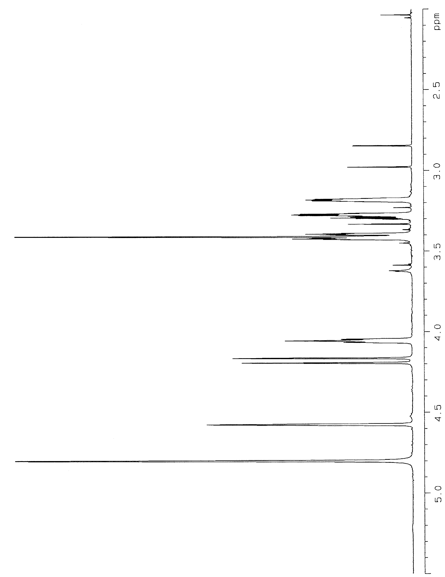
Figure S1. ¹H NMR spectrum of 3 in CD₃OD.
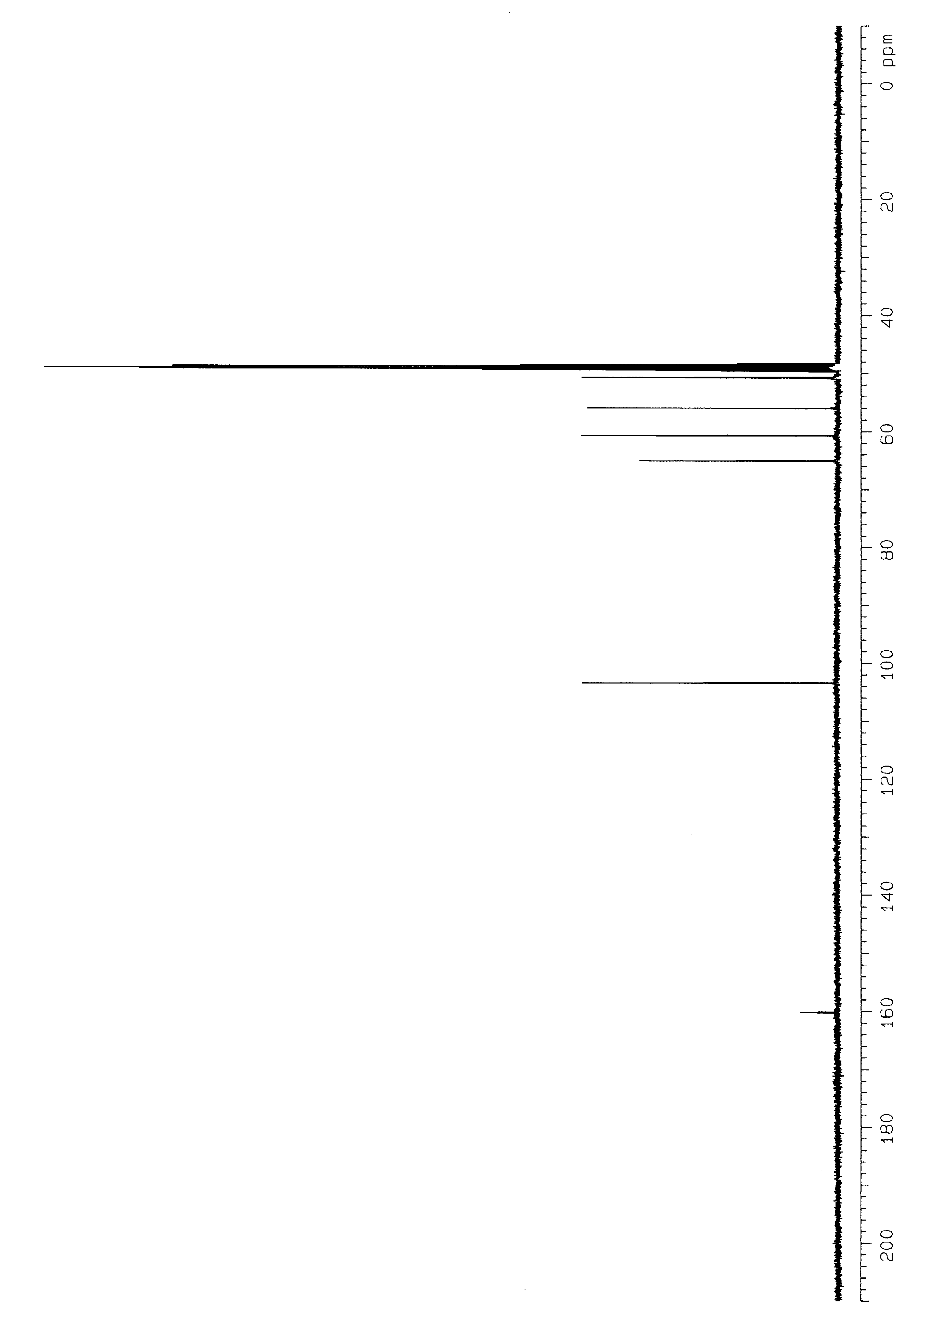
Figure S2. ¹³C NMR spectrum of 3 in CD₃OD.
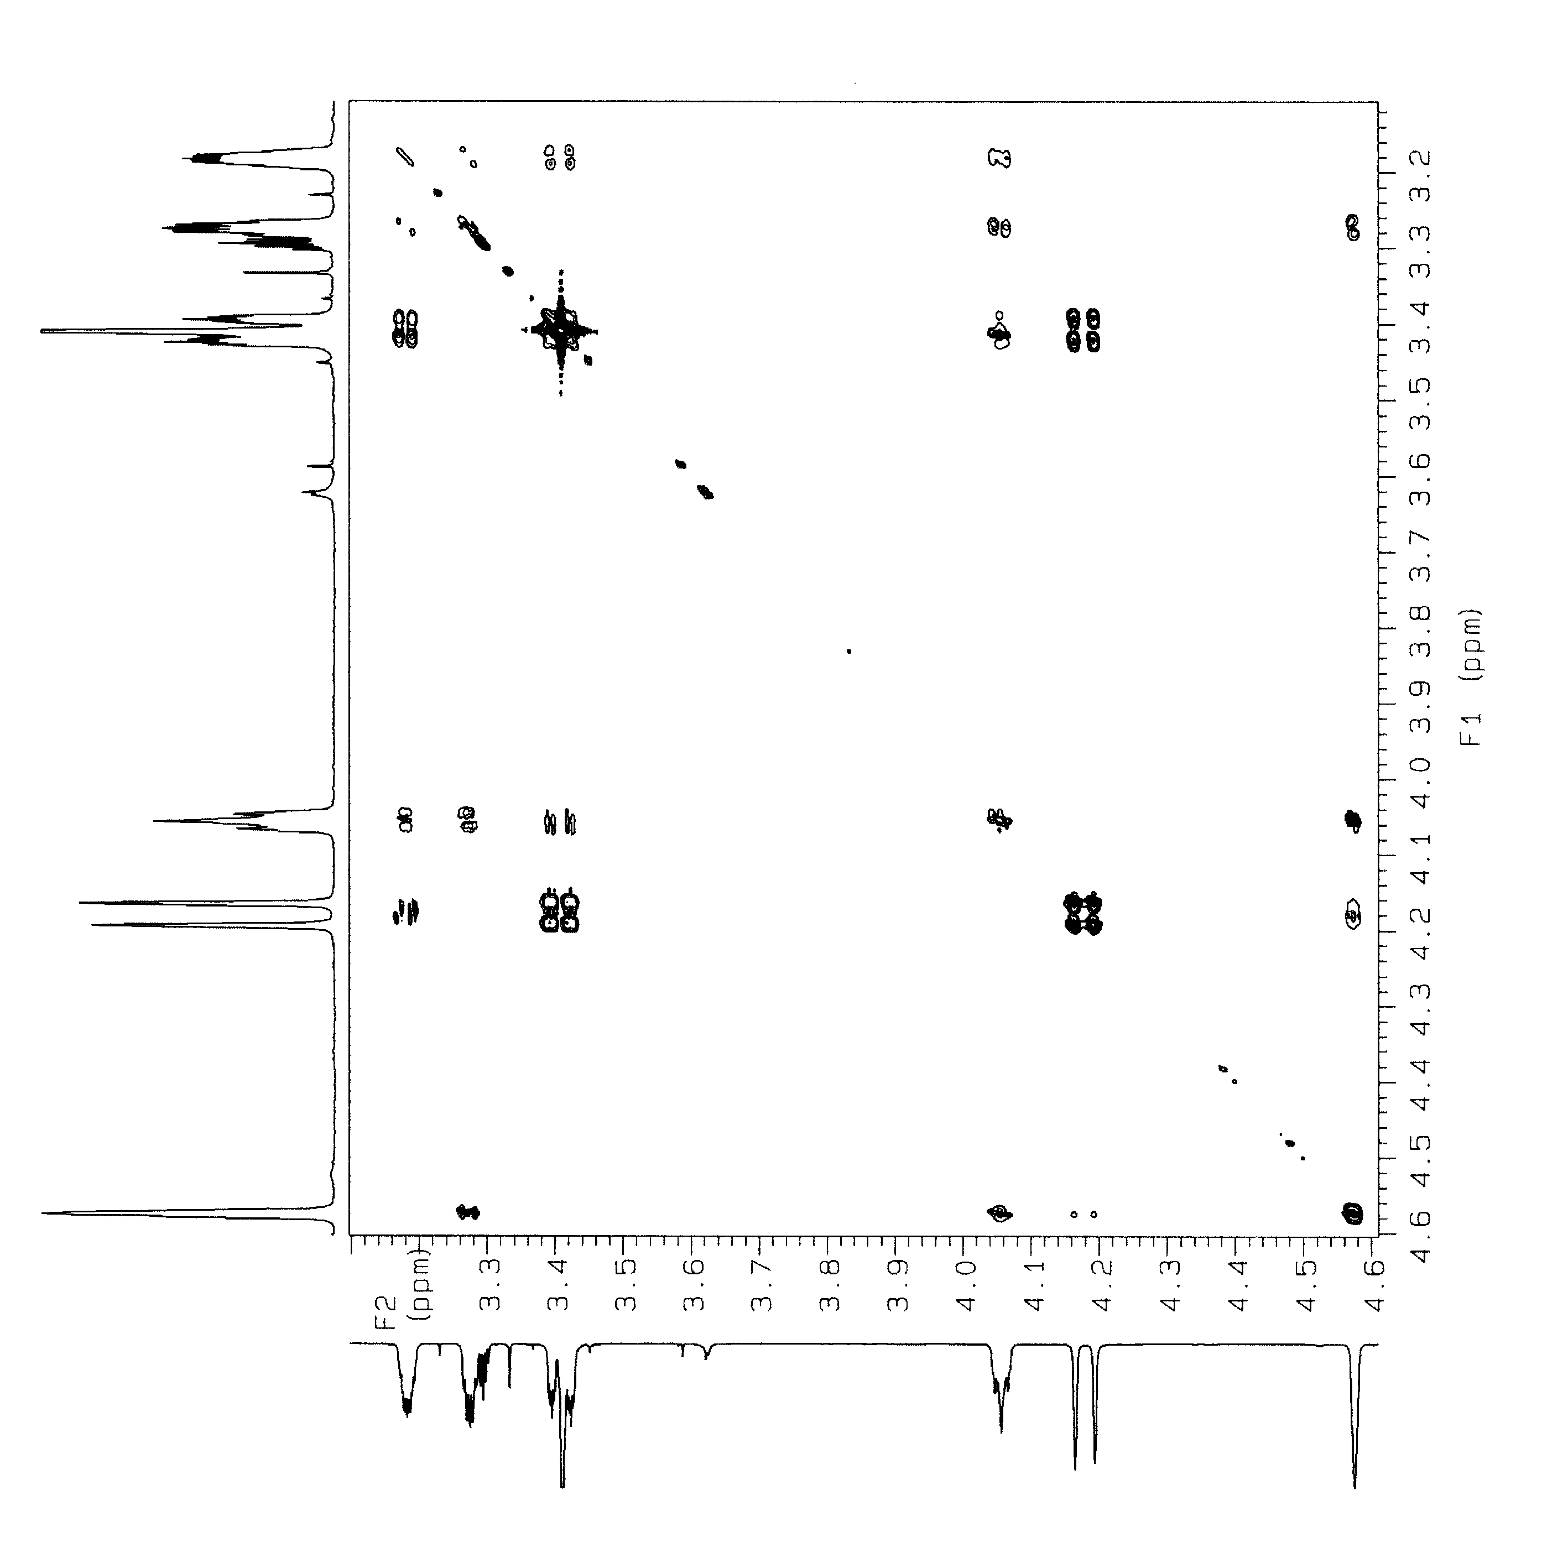
Figure S3. COSY spectrum of 3 in CD₃OD.

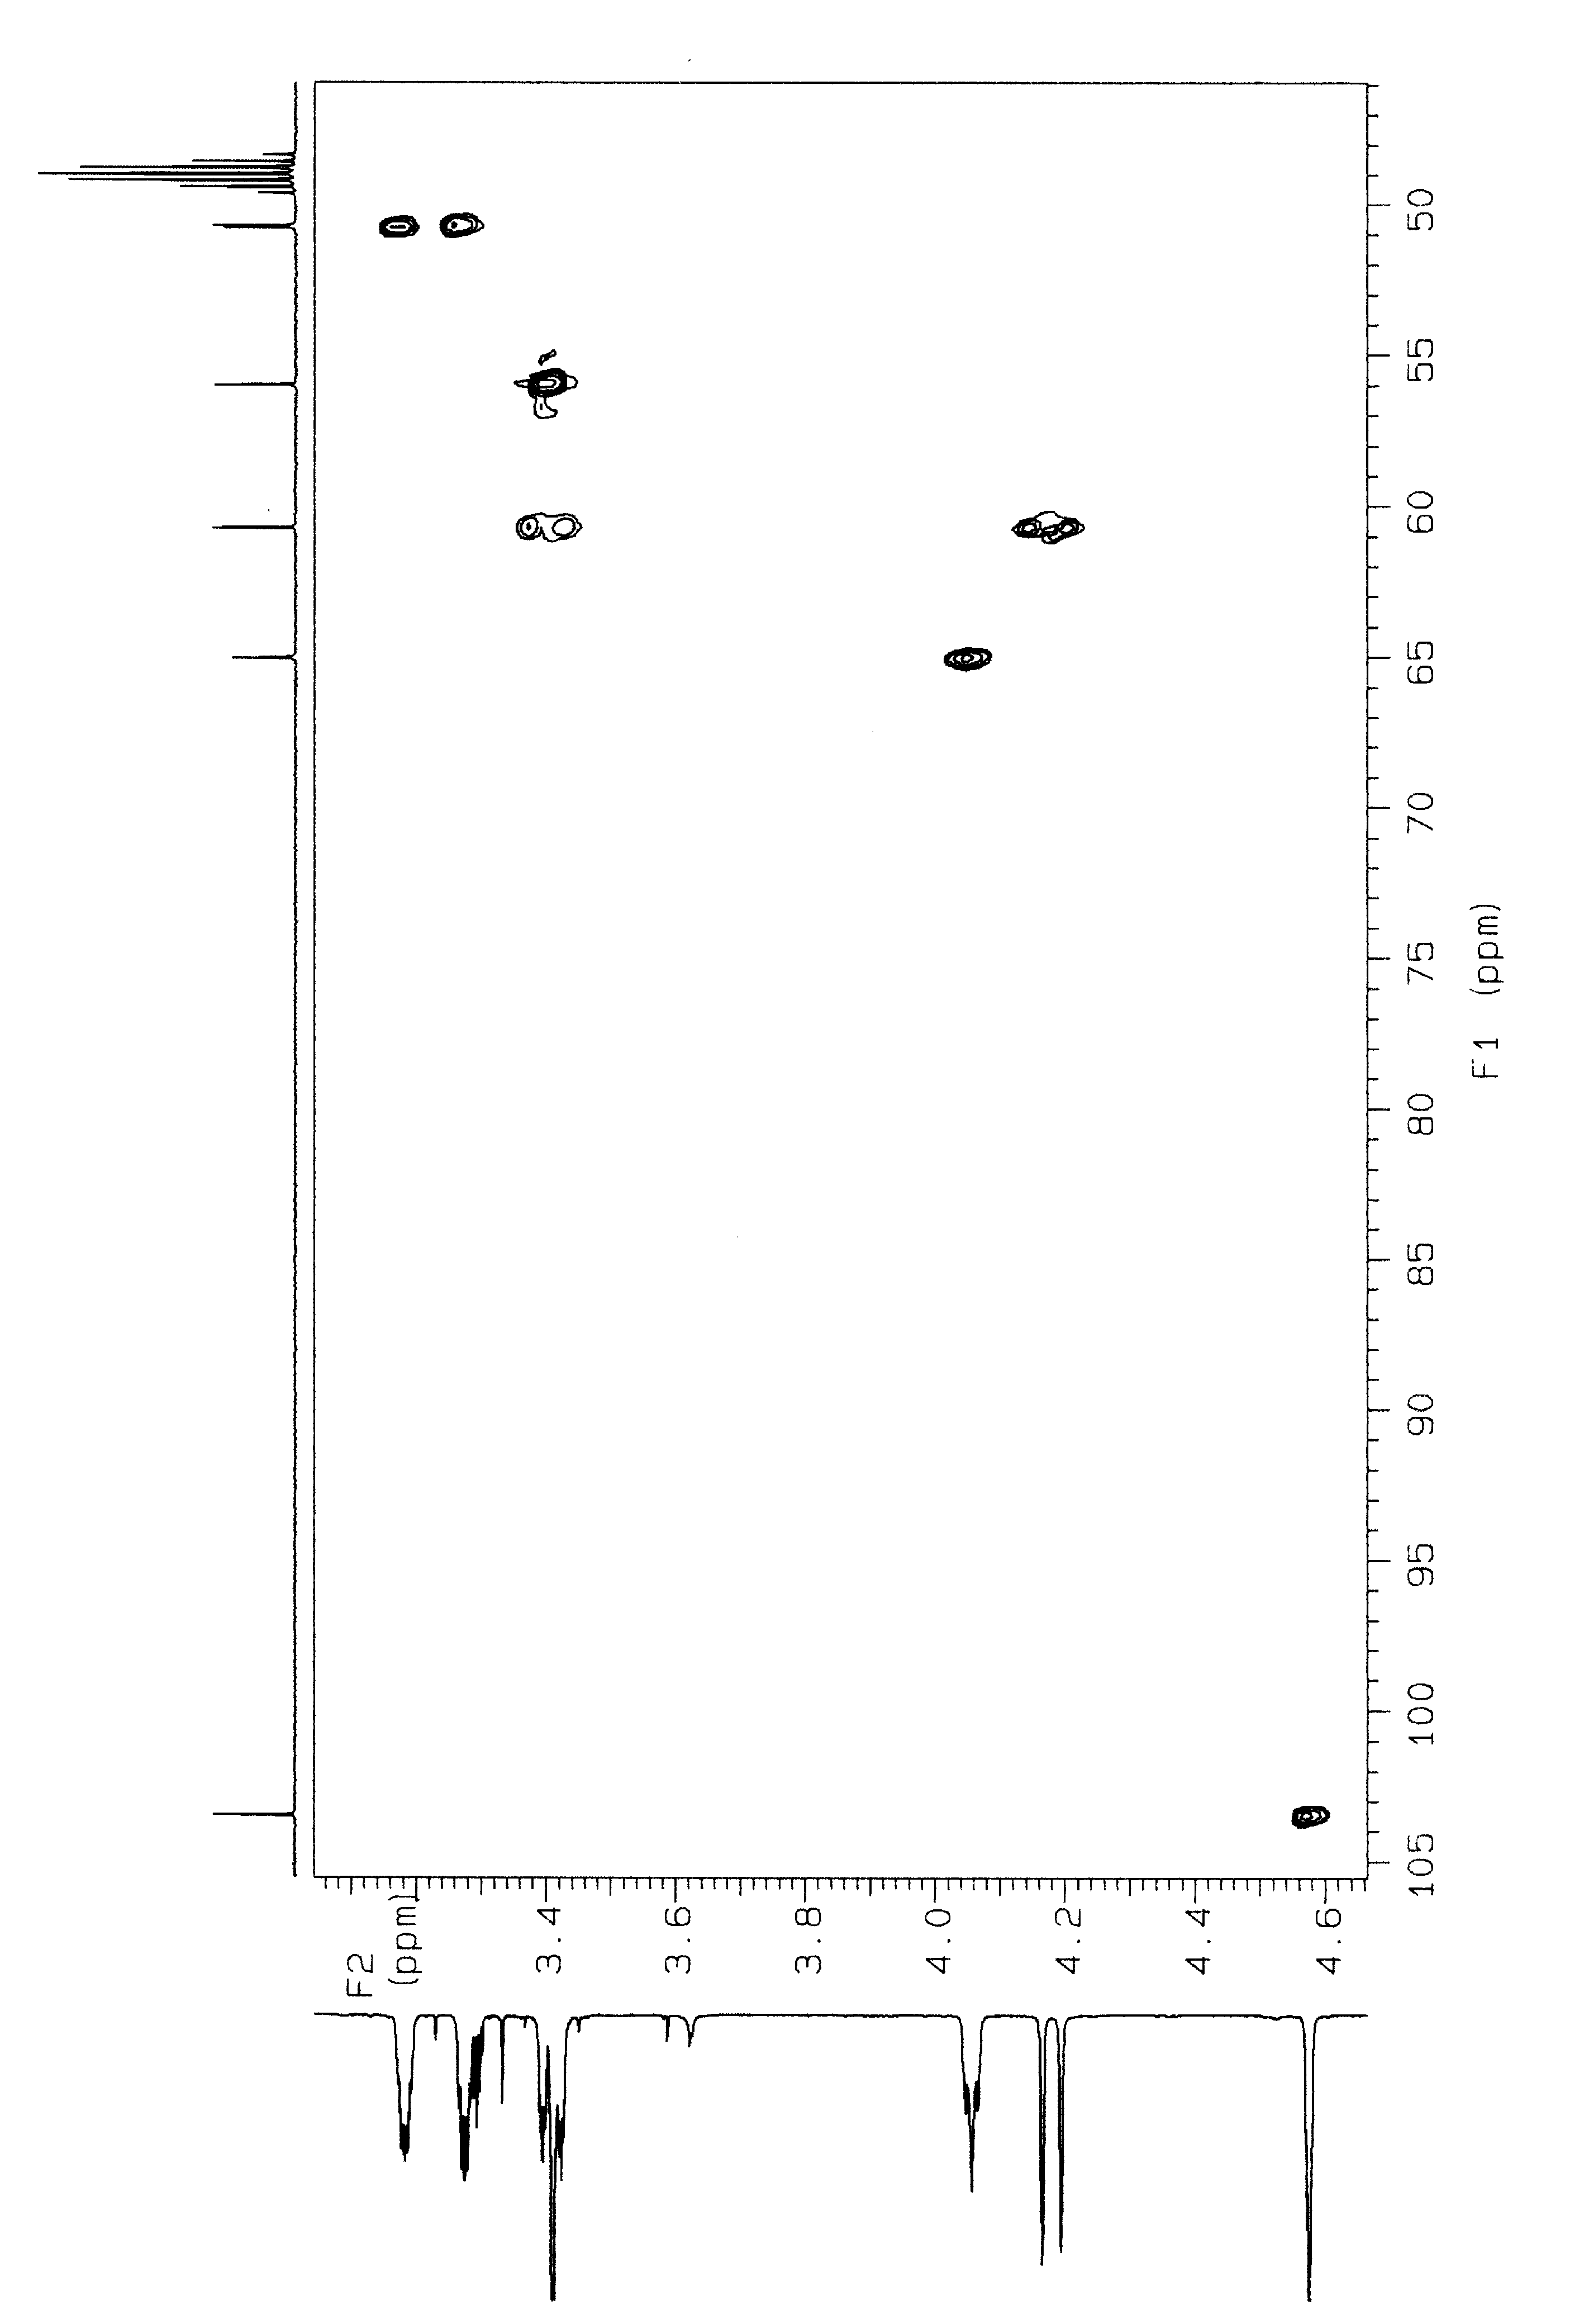
Figure S4. HMQC spectrum of 3 in CD₃OD.
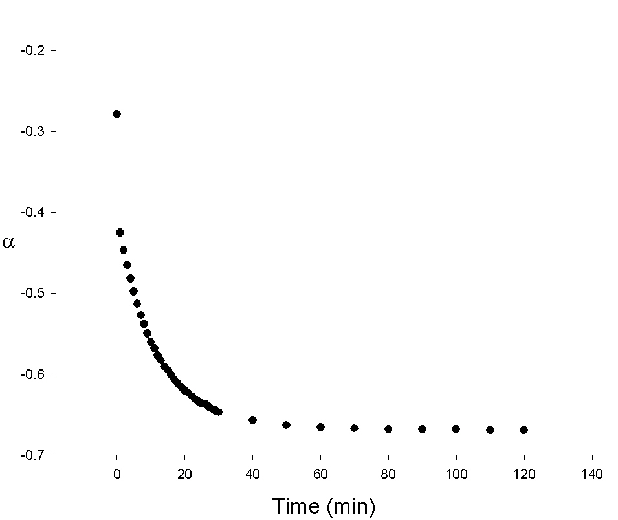
Figure S5. Time course of optical rotation (α) for the carbonylation of 1.
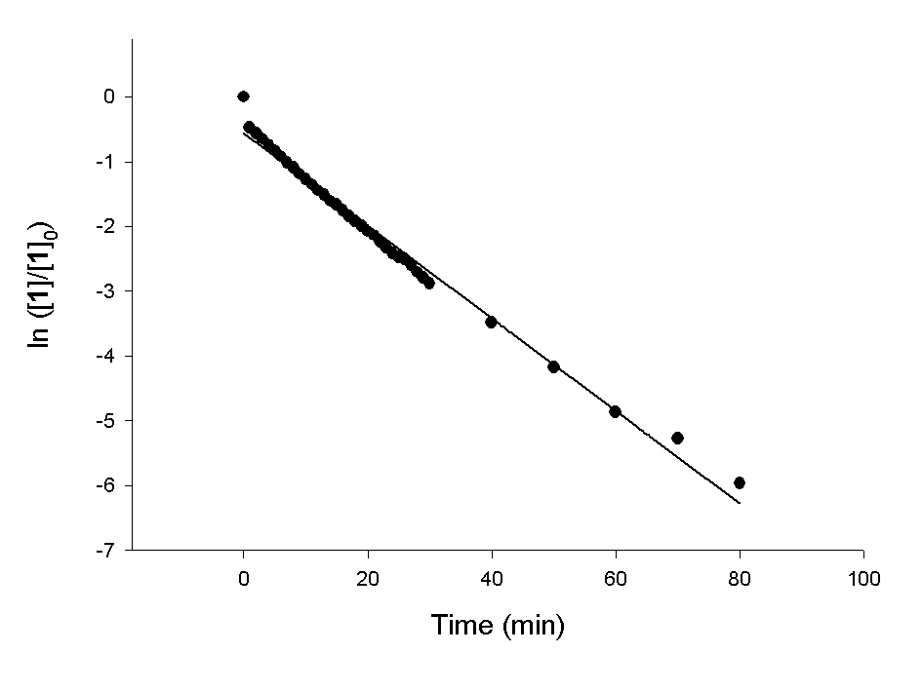
Figure S6. First-order kinetics fitting plot for the carbonylation of 1. (ln ([1]/[1]₀) = –0.0715t – 0.555; r² = 0.9877)
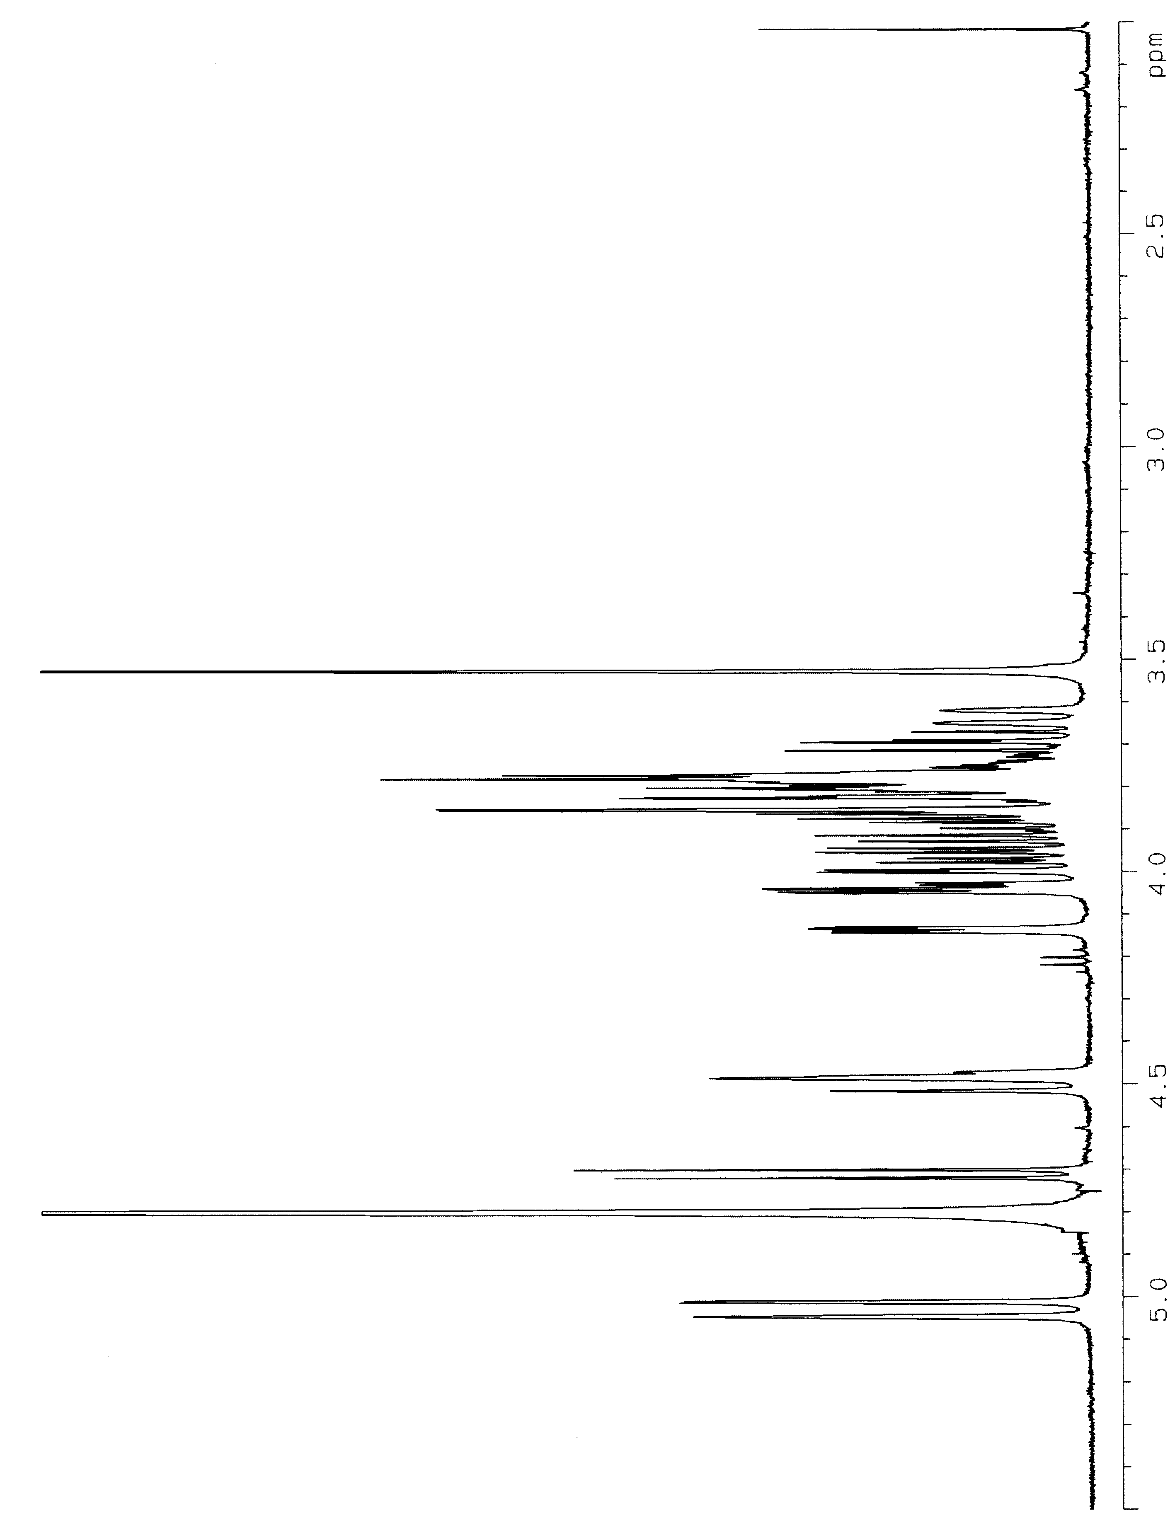
Figure S7. ¹H NMR spectrum of 5 in D₂O.
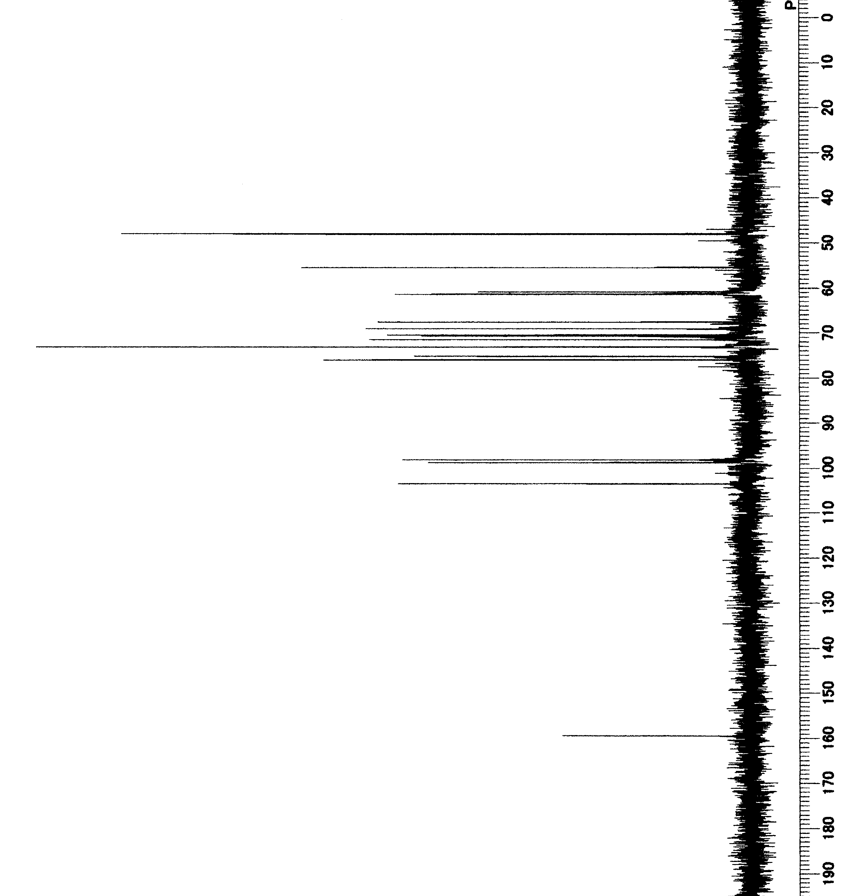
Figure S8. ¹³C NMR spectrum of 5 in D₂O.
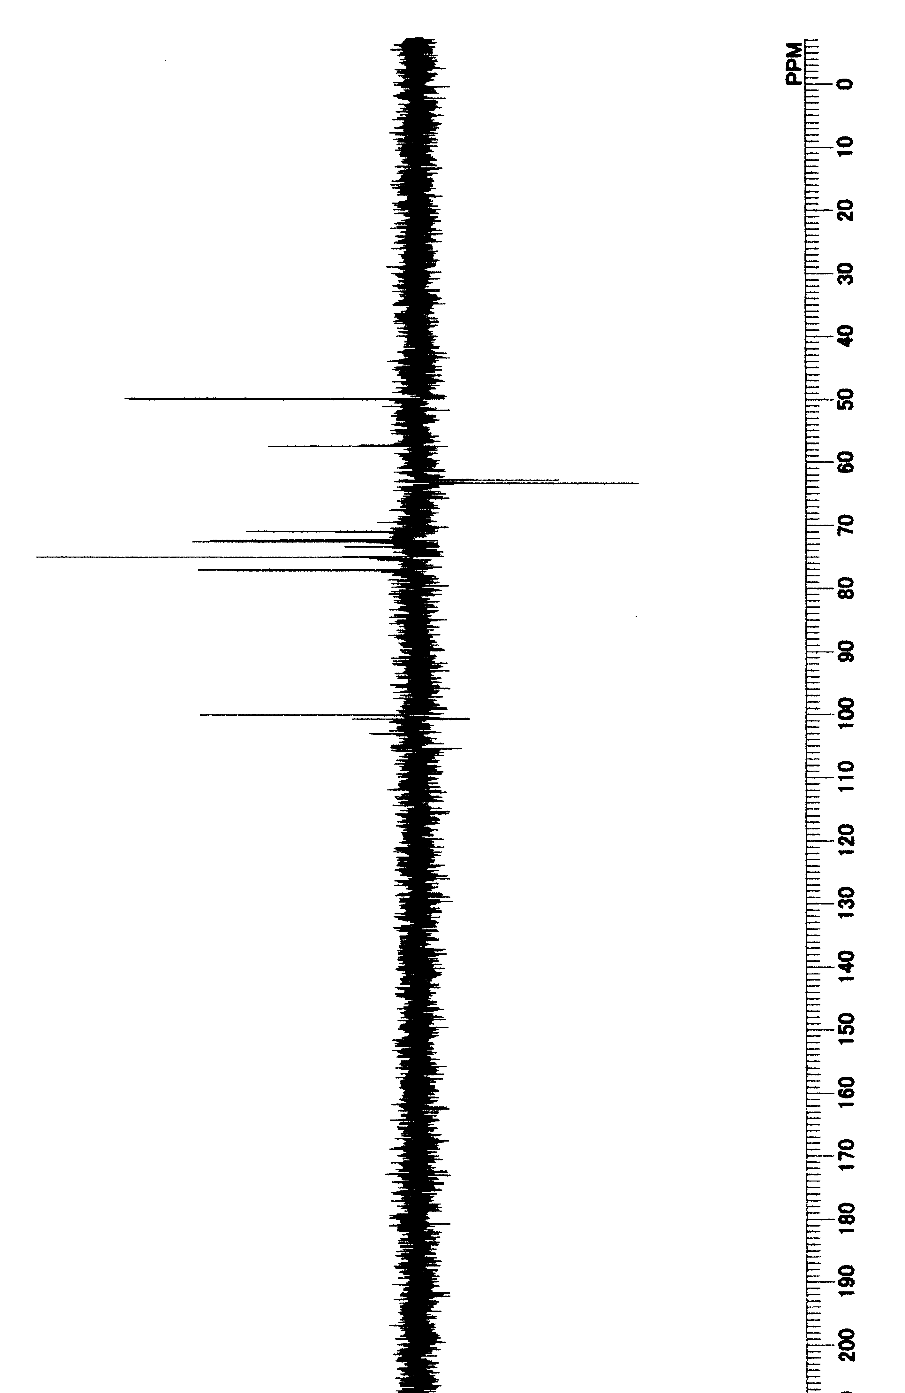

Figure S9. DEPT135° spectrum of 5 in D₂O.
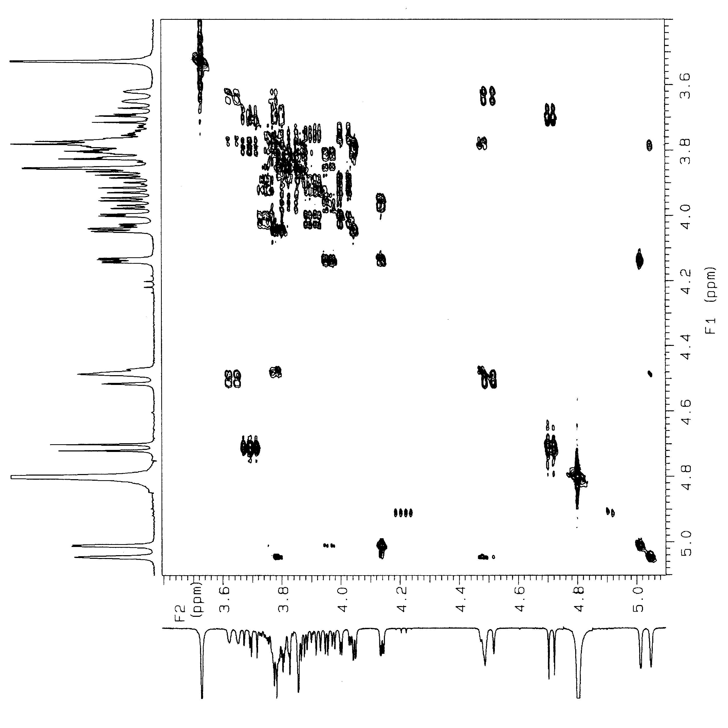
Figure S10. COSY spectrum of 5 in D₂O.

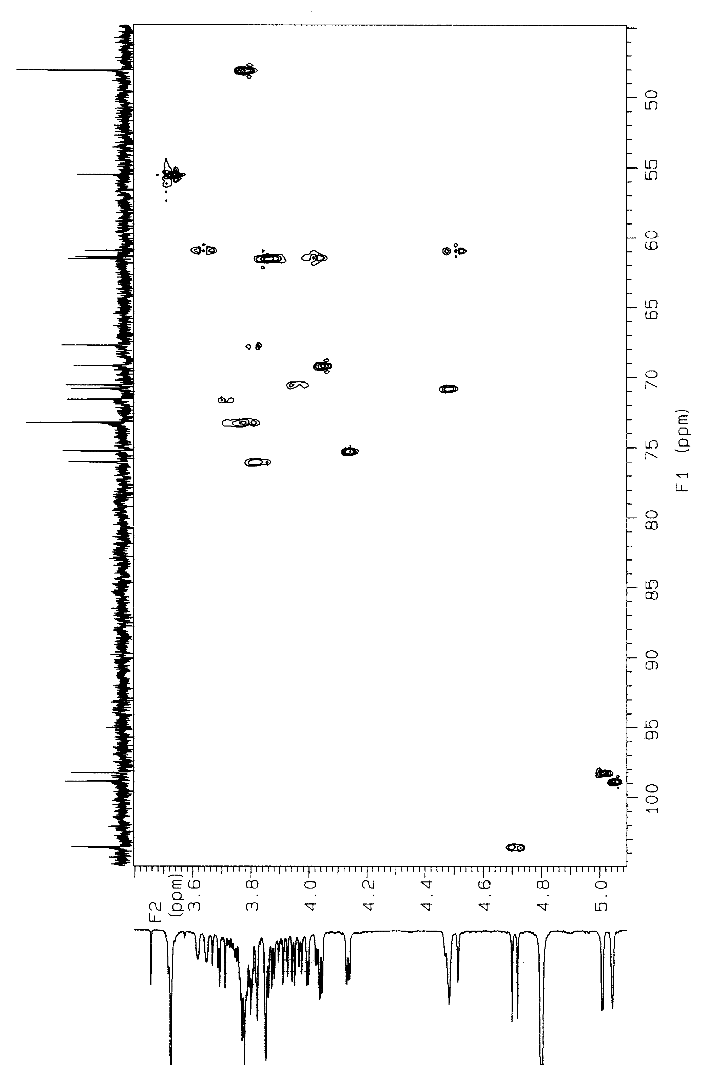
Figure S11. HMQC spectrum of 5 in D₂O.

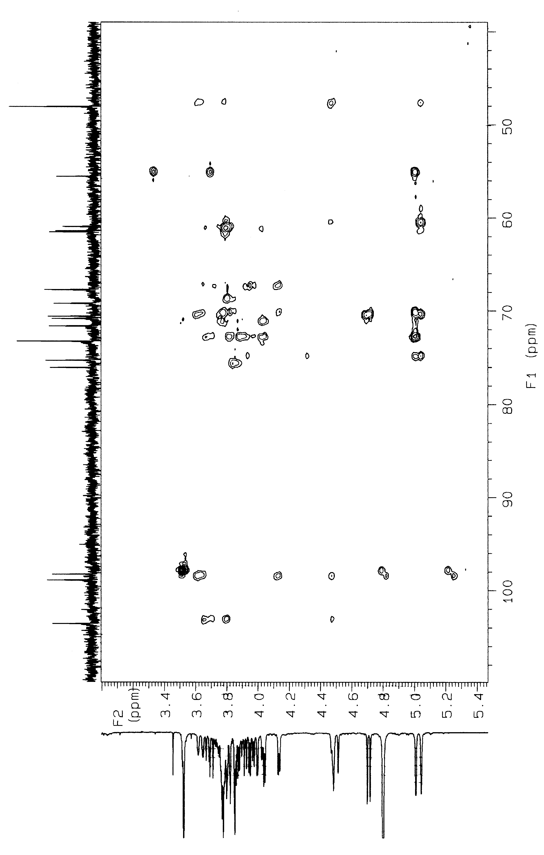
Figure S12. HMBC spectrum of 5 in D₂O.

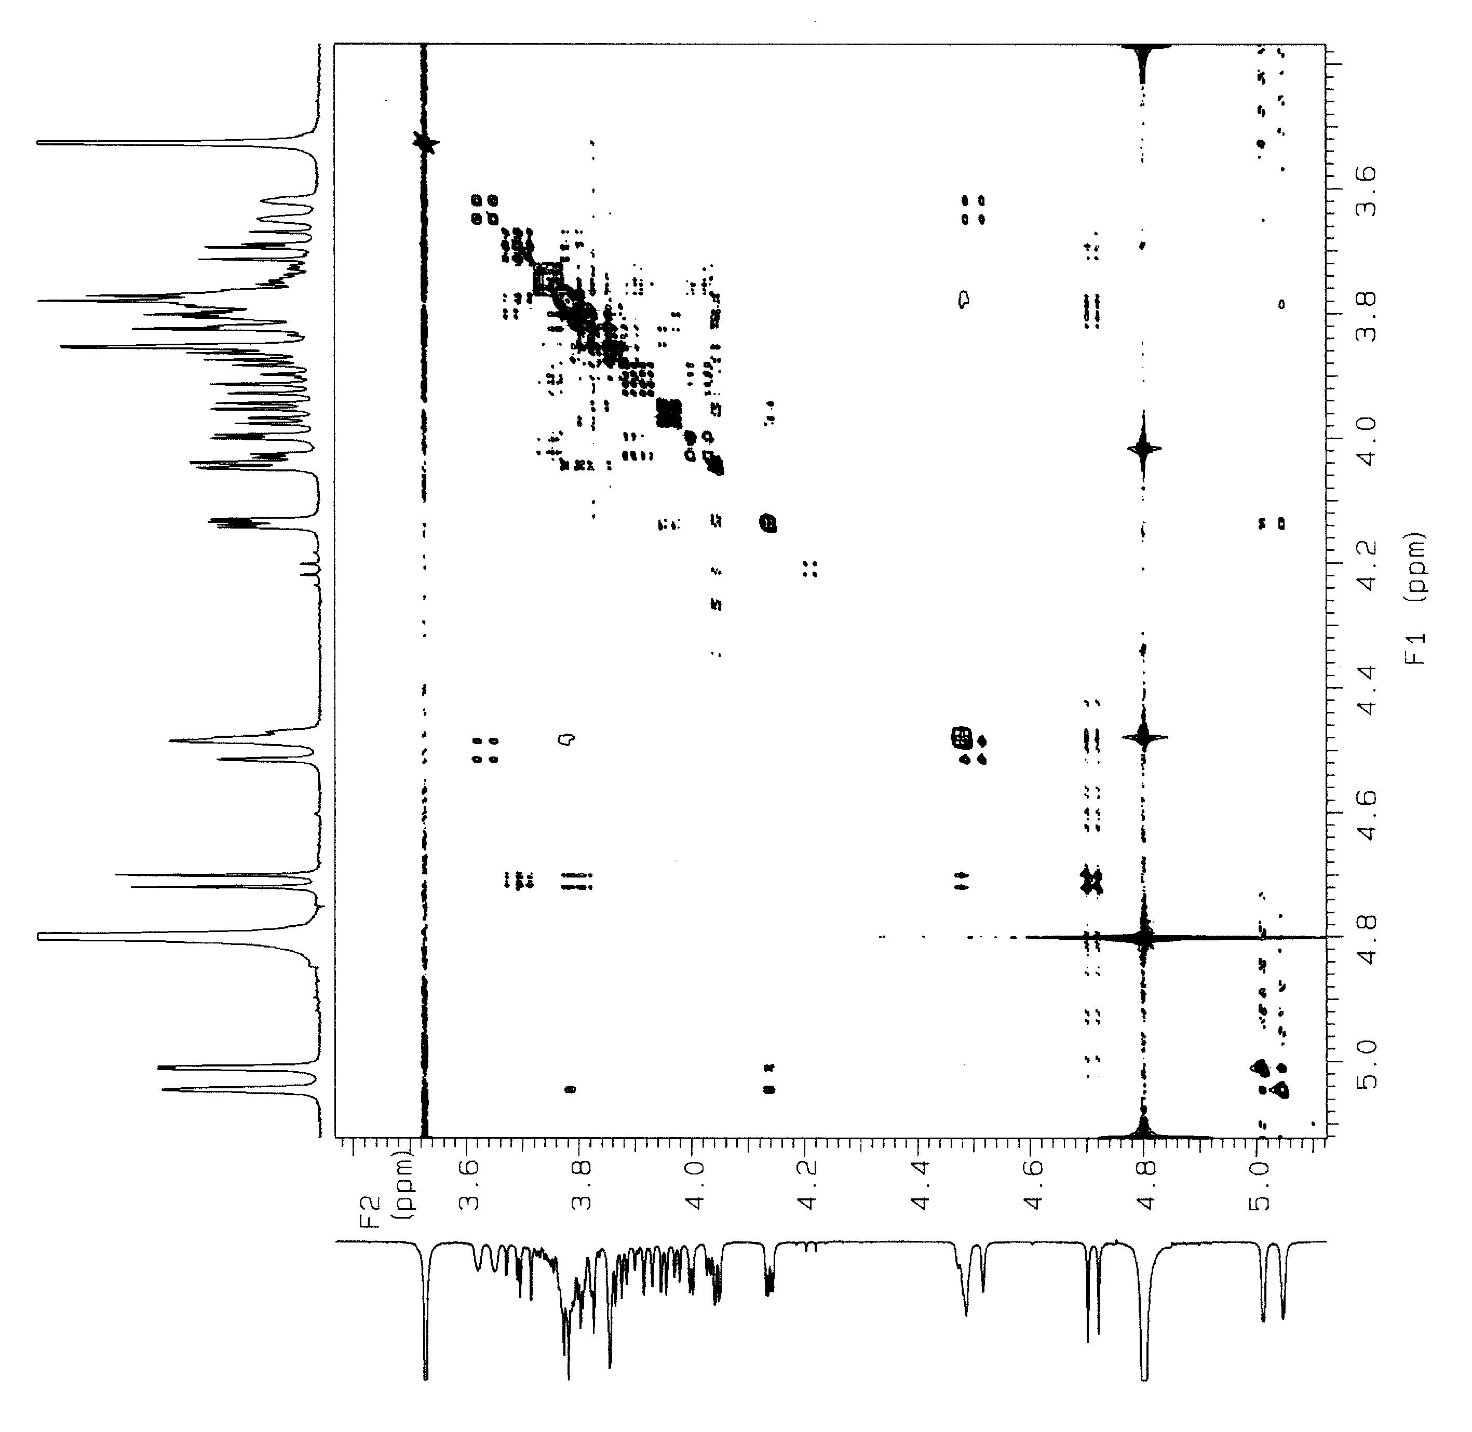
Figure S13. NOESY spectrum of 5 in D₂O.

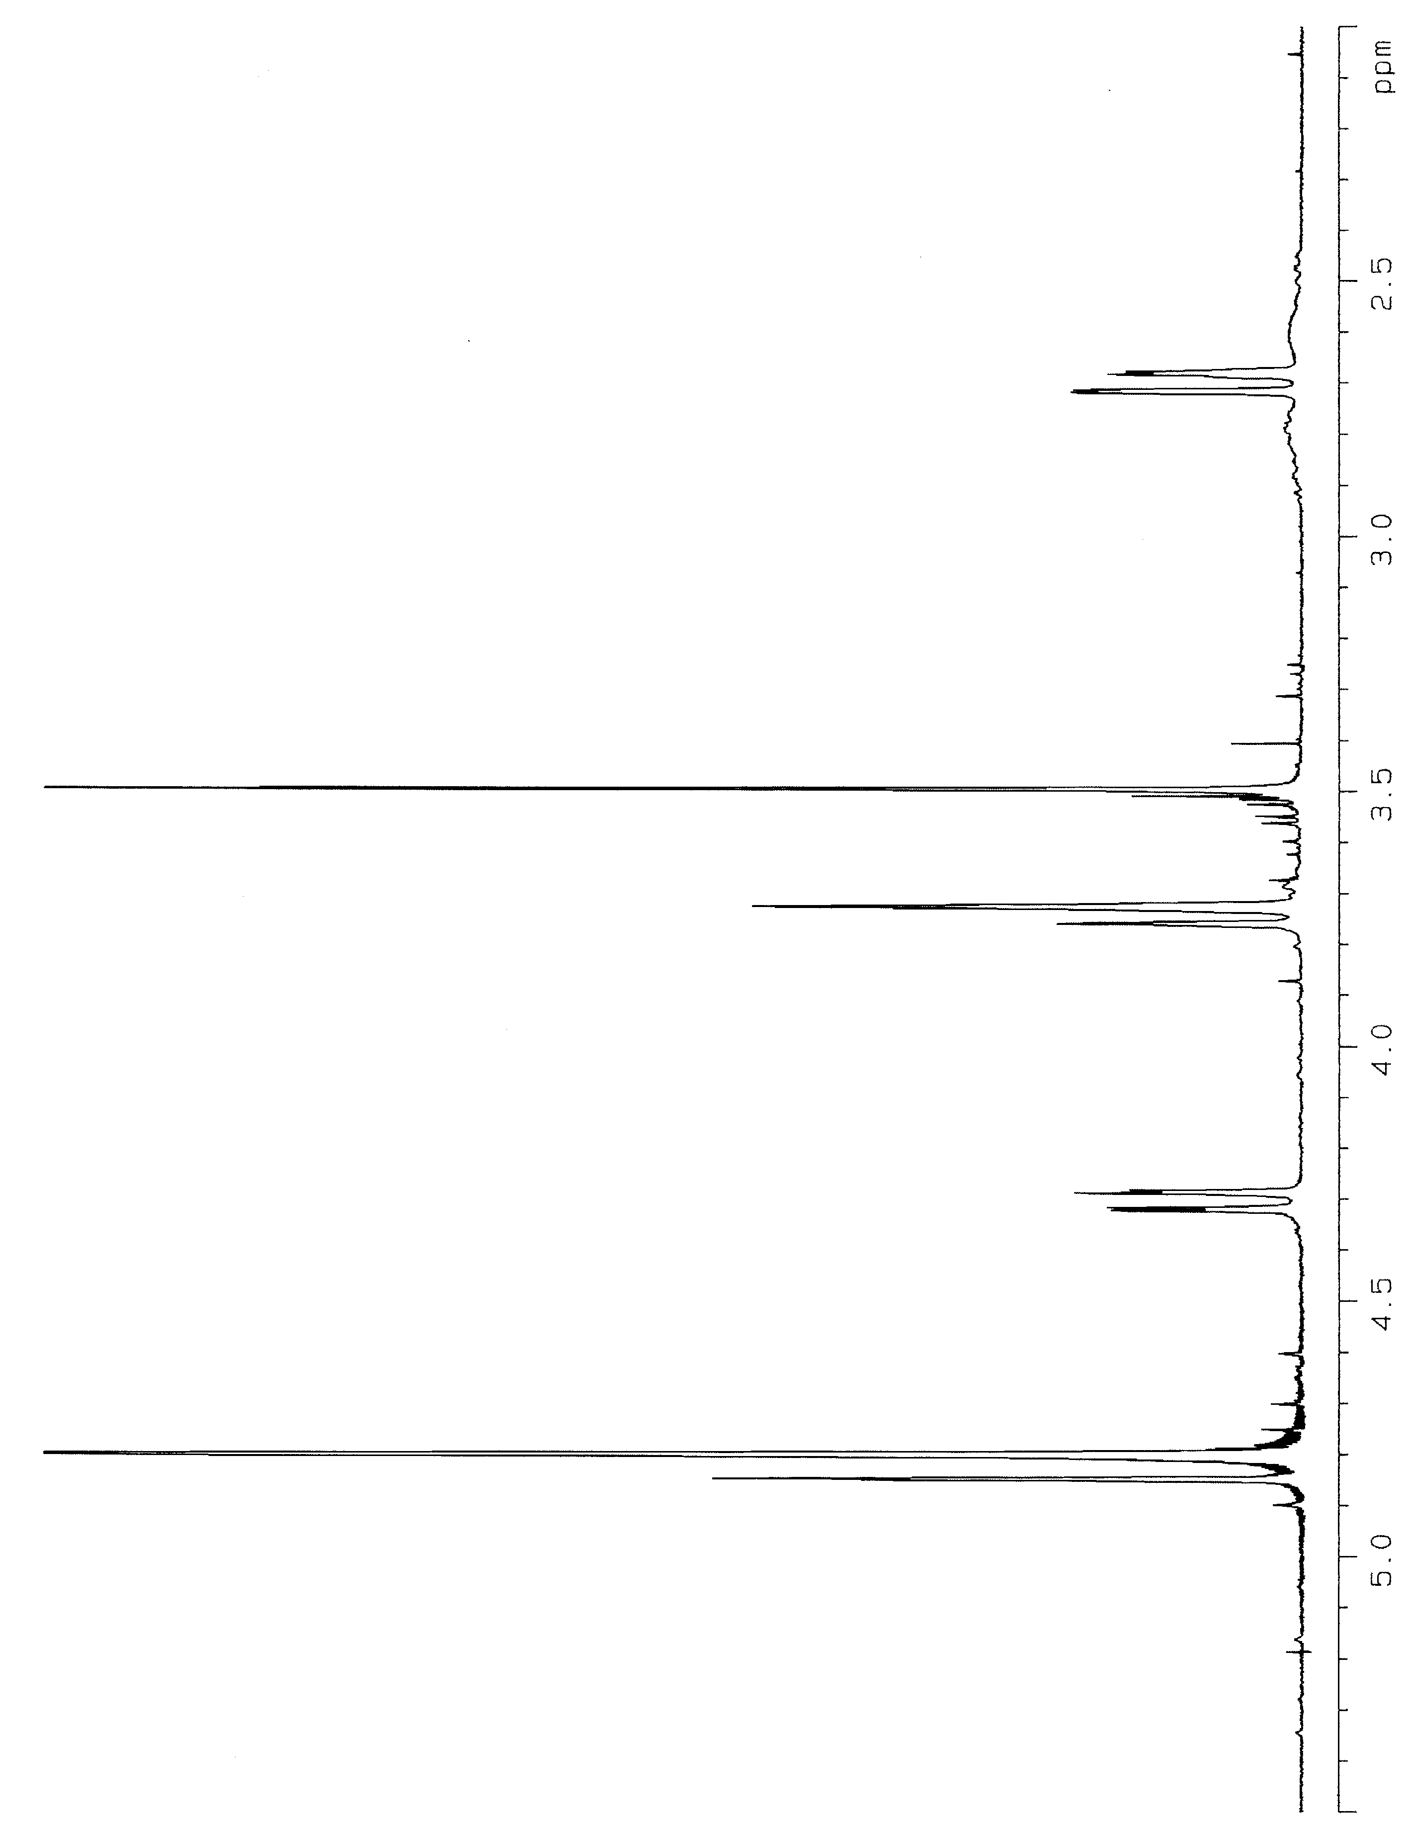
Figure S14. ¹H NMR spectrum of 4 in D₂O.

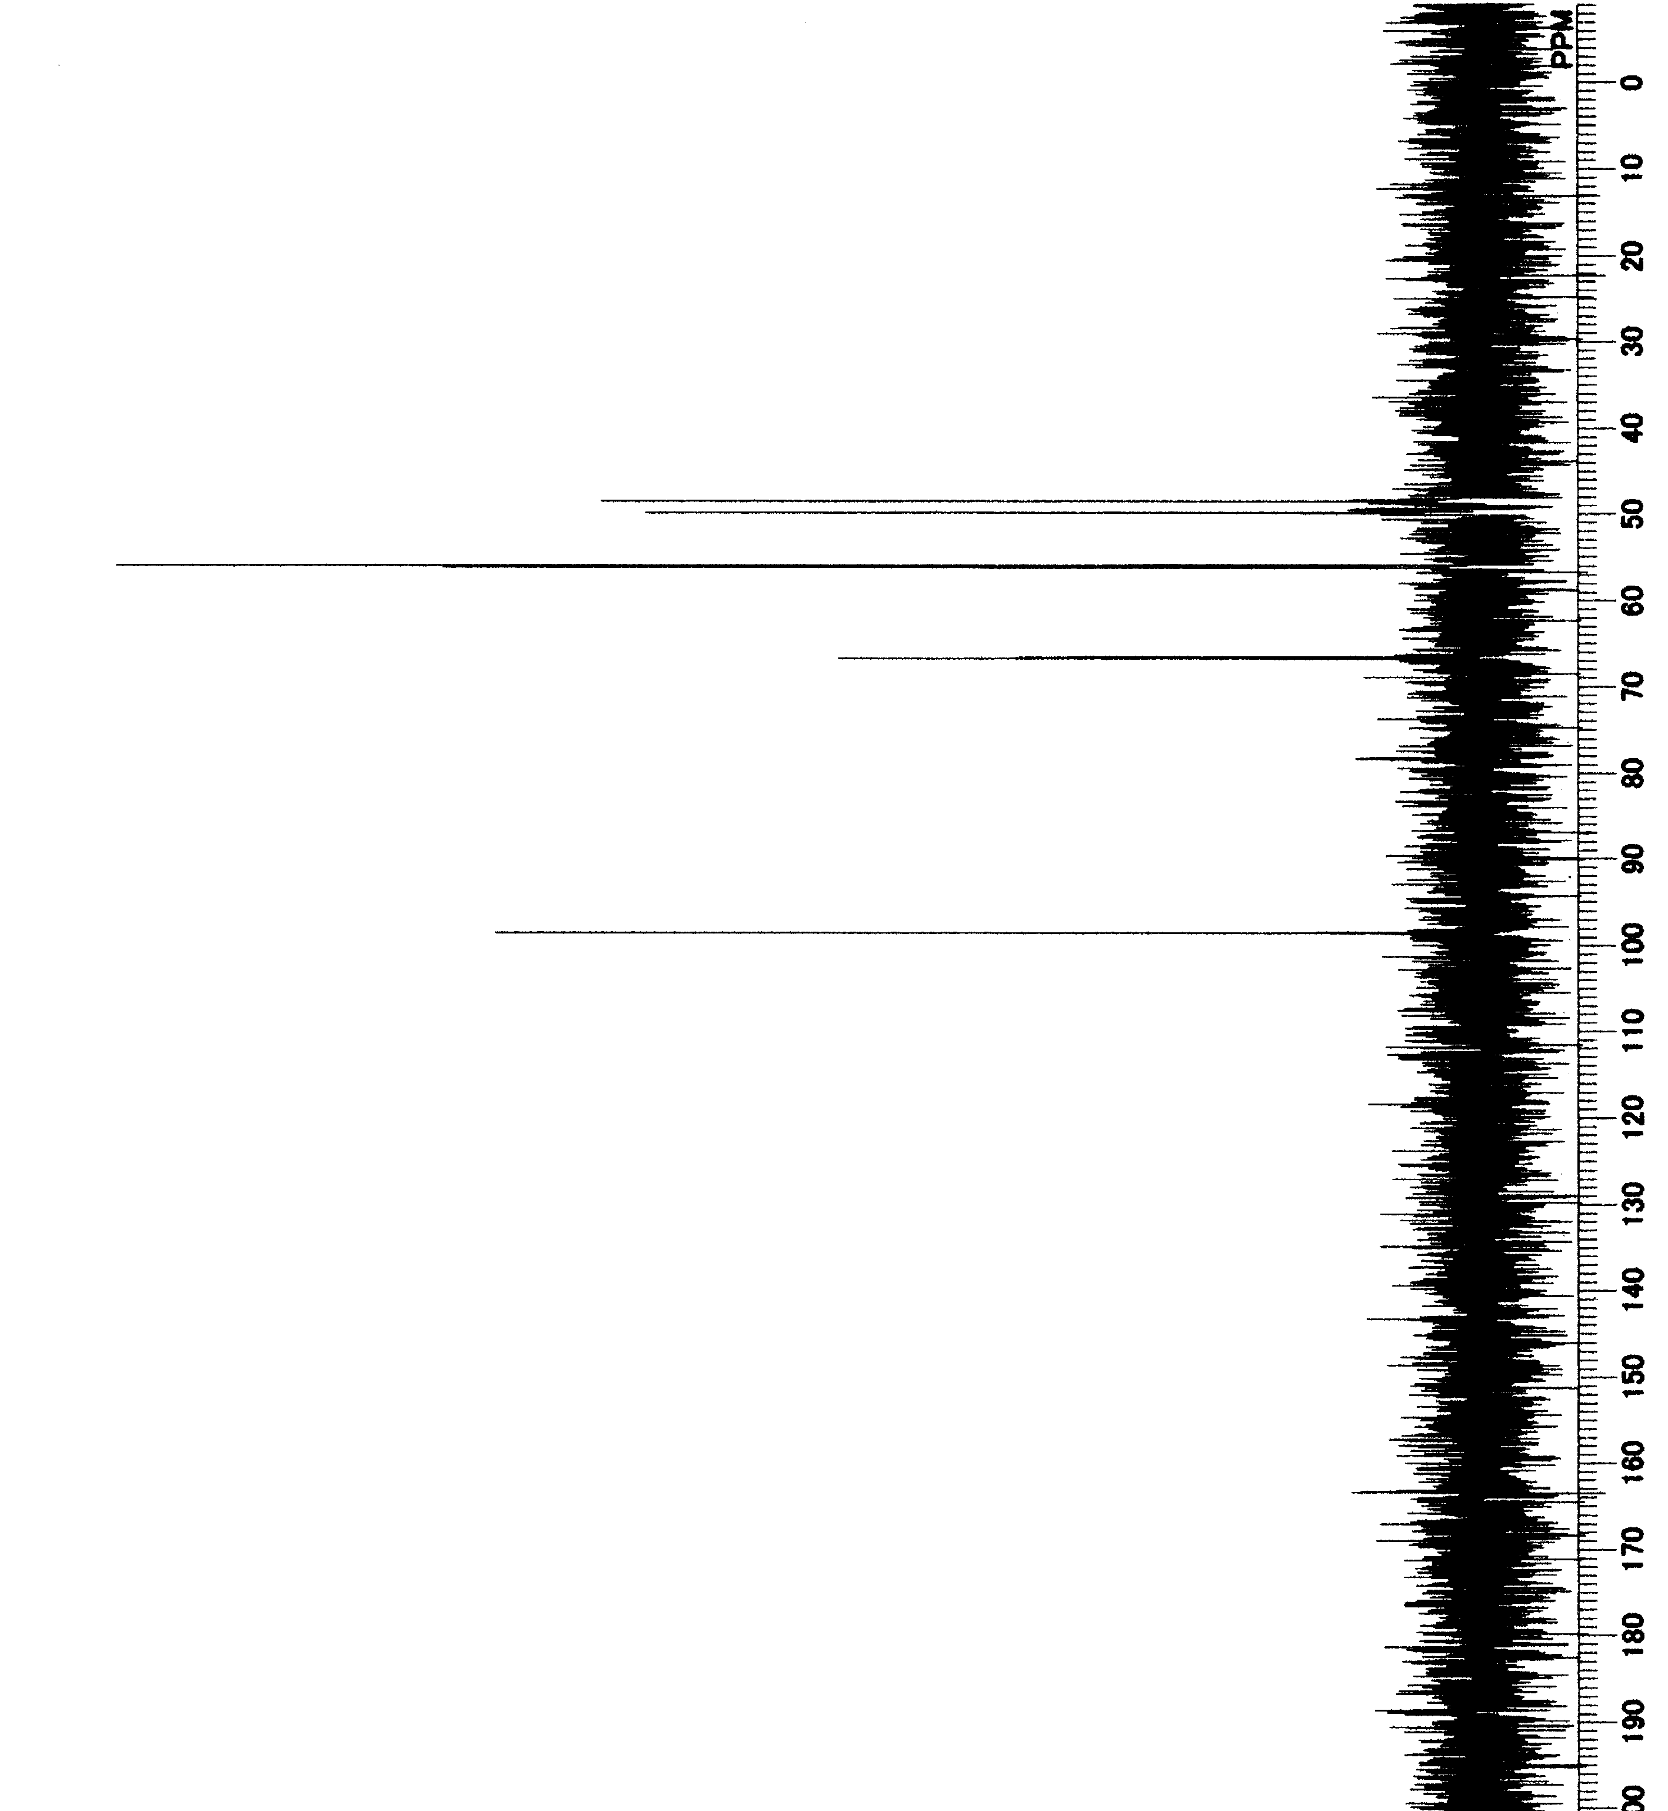
Figure S15. ¹³C NMR spectrum of 4 in D₂O.
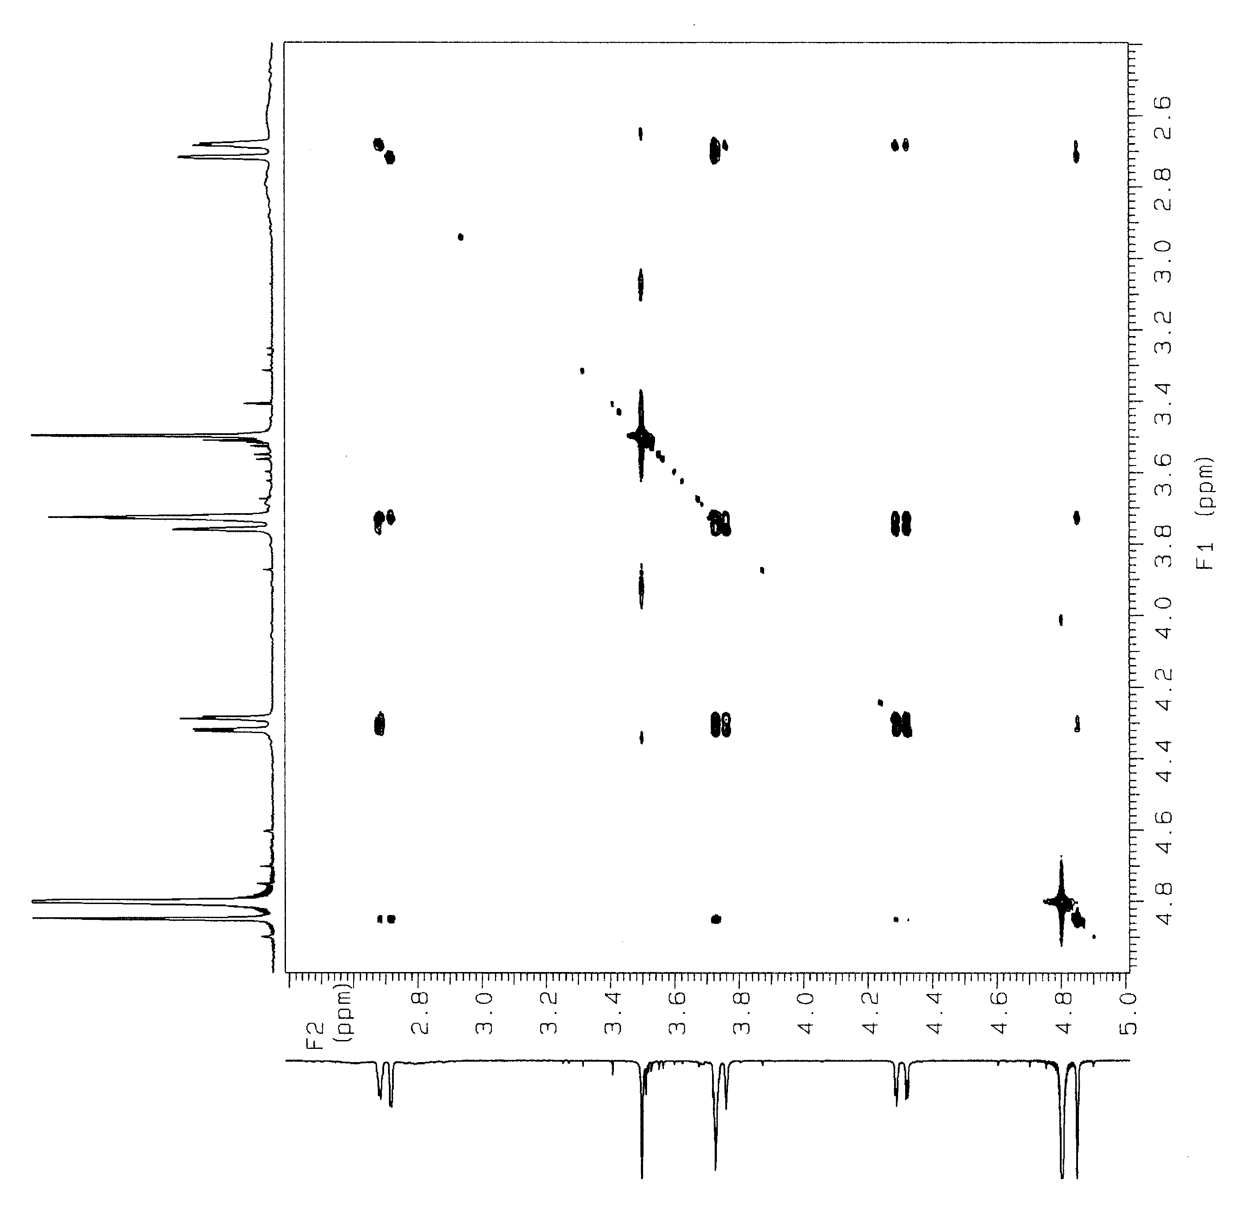
Figure S16. COSY spectrum of 4 in D₂O.

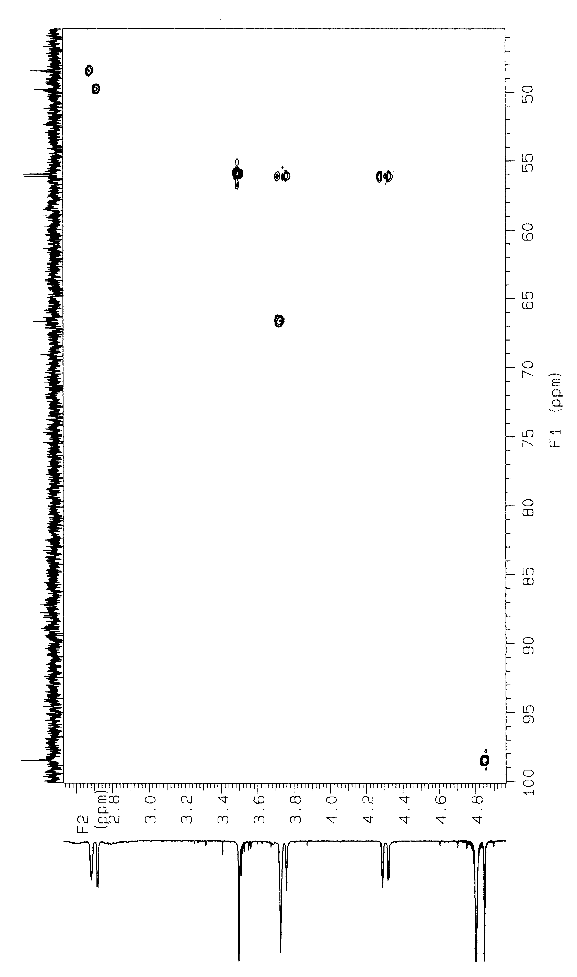
Figure S17. HMQC spectrum of 4 in D₂O.

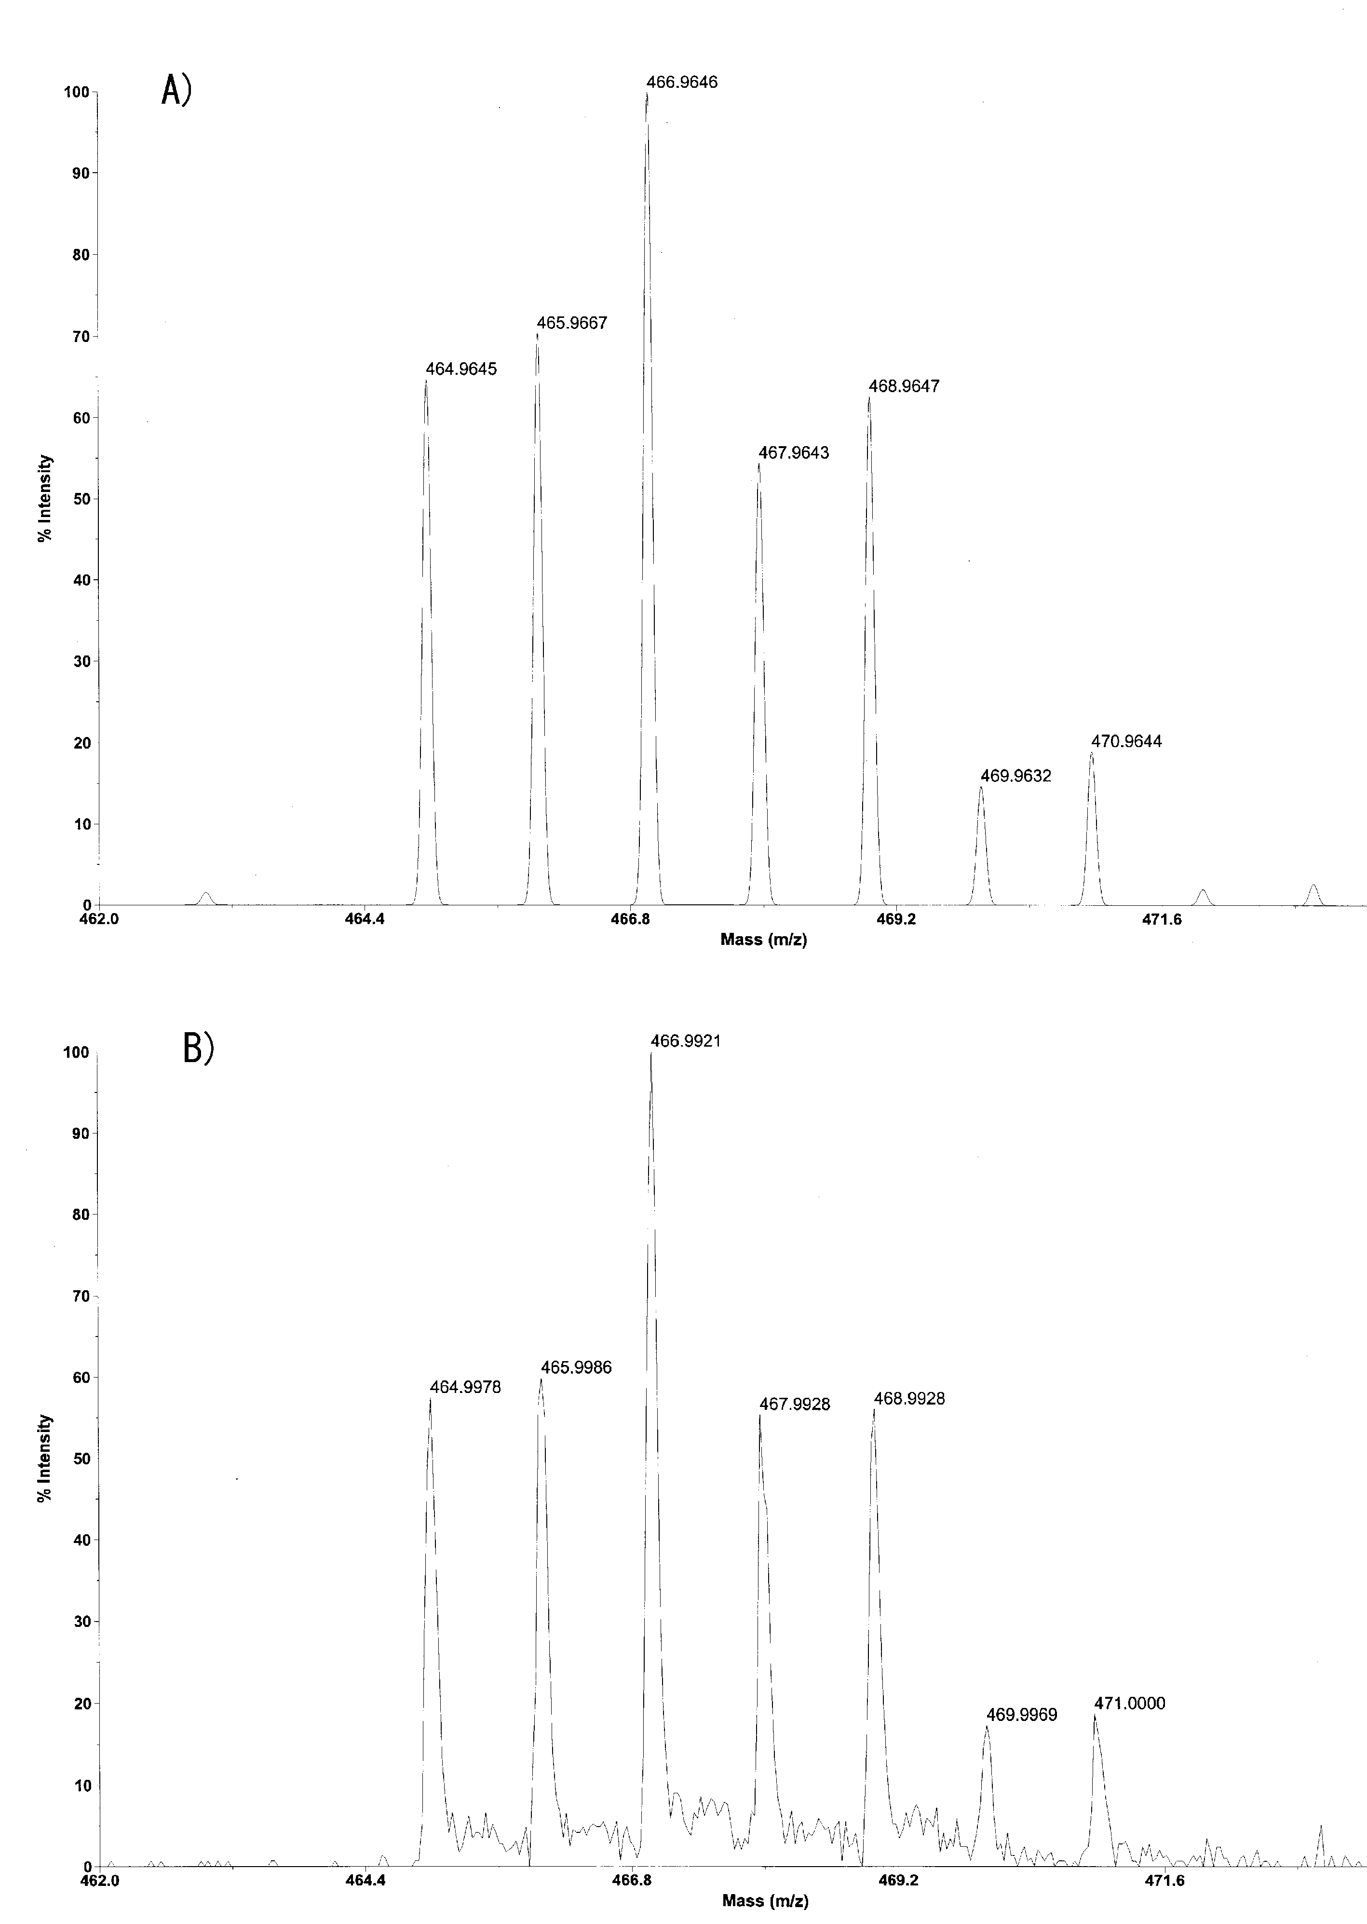
Figure S18. Simulated mass spectrum for C₆H₁₄Cl₂N₂O₃PtK (A) and observed ESI mass spectrum of 4 (B).
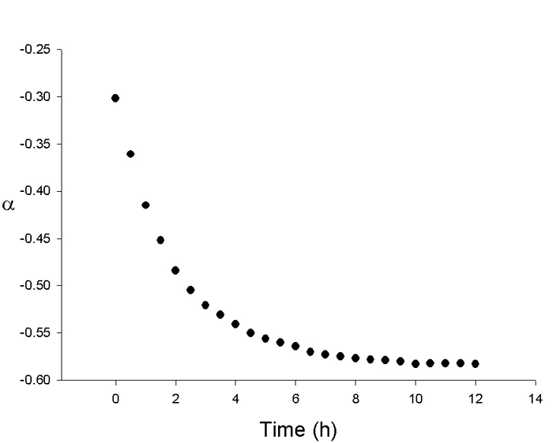
Figure S19. Time course of optical rotation (α) for the Pt (II) complex formation for 1.

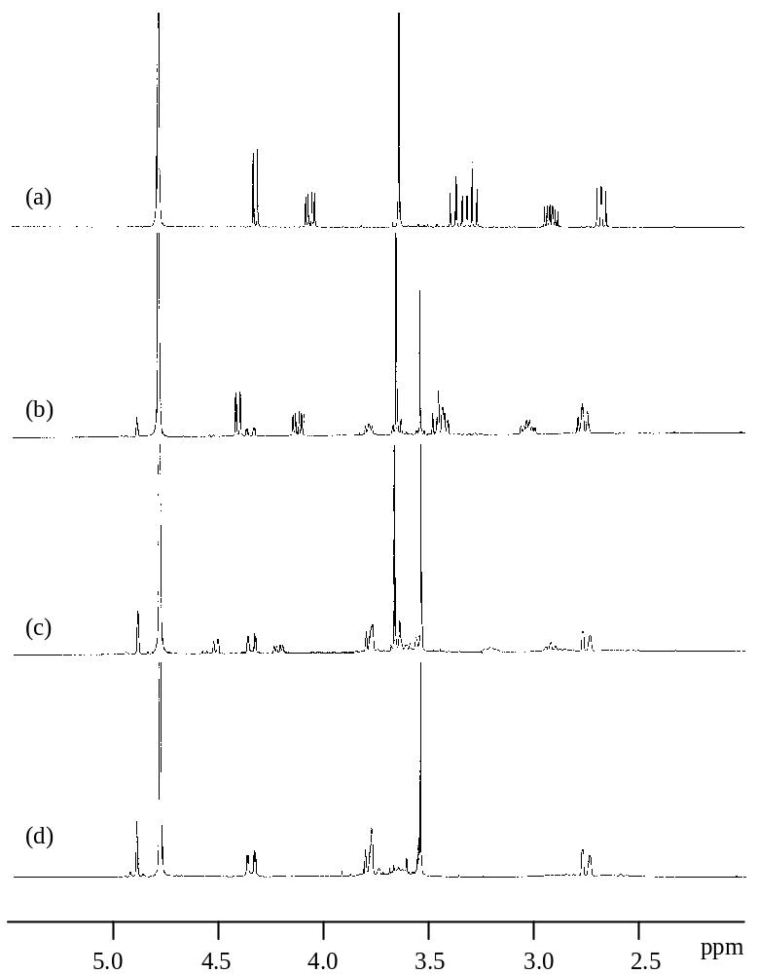

Figure S20. Time course of ¹H NMR spectra for the Pt (II) complex formation for 1 in NaOAc-d₃ buffer (pH 7.0) at 0 h (a), 0.5 h (b), 2 h (c), and 12 h (d).

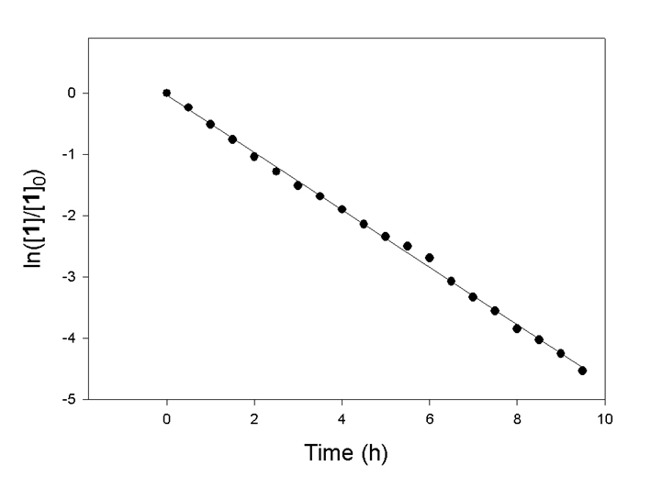
Figure S21. First-order kinetics fitting plot for the Pt (II) complex formation for 1. (ln ([1]/[1]₀) = –0.4684t – 0.0379; r² = 0.9983)

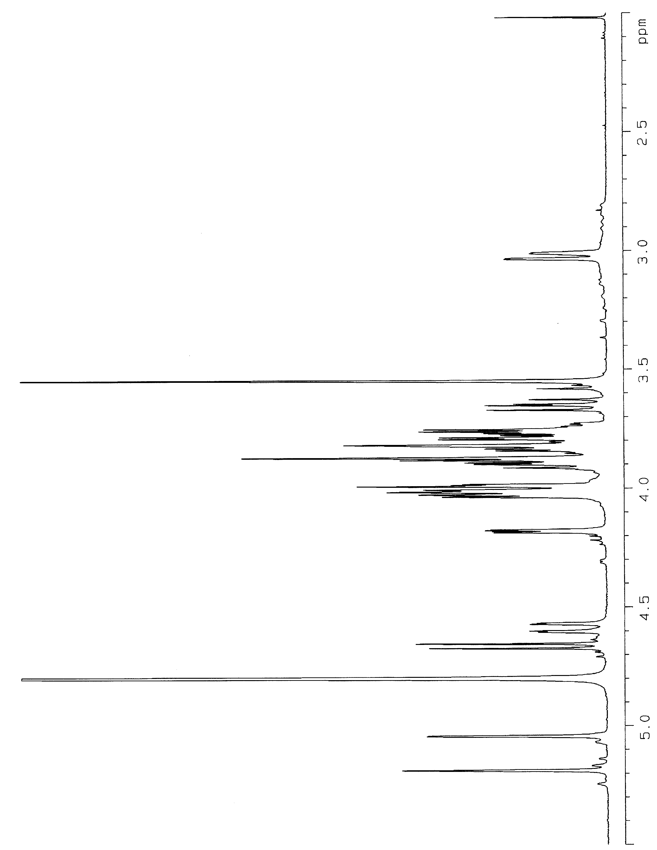
Figure S22. ¹H NMR spectrum of 6 in D₂O.
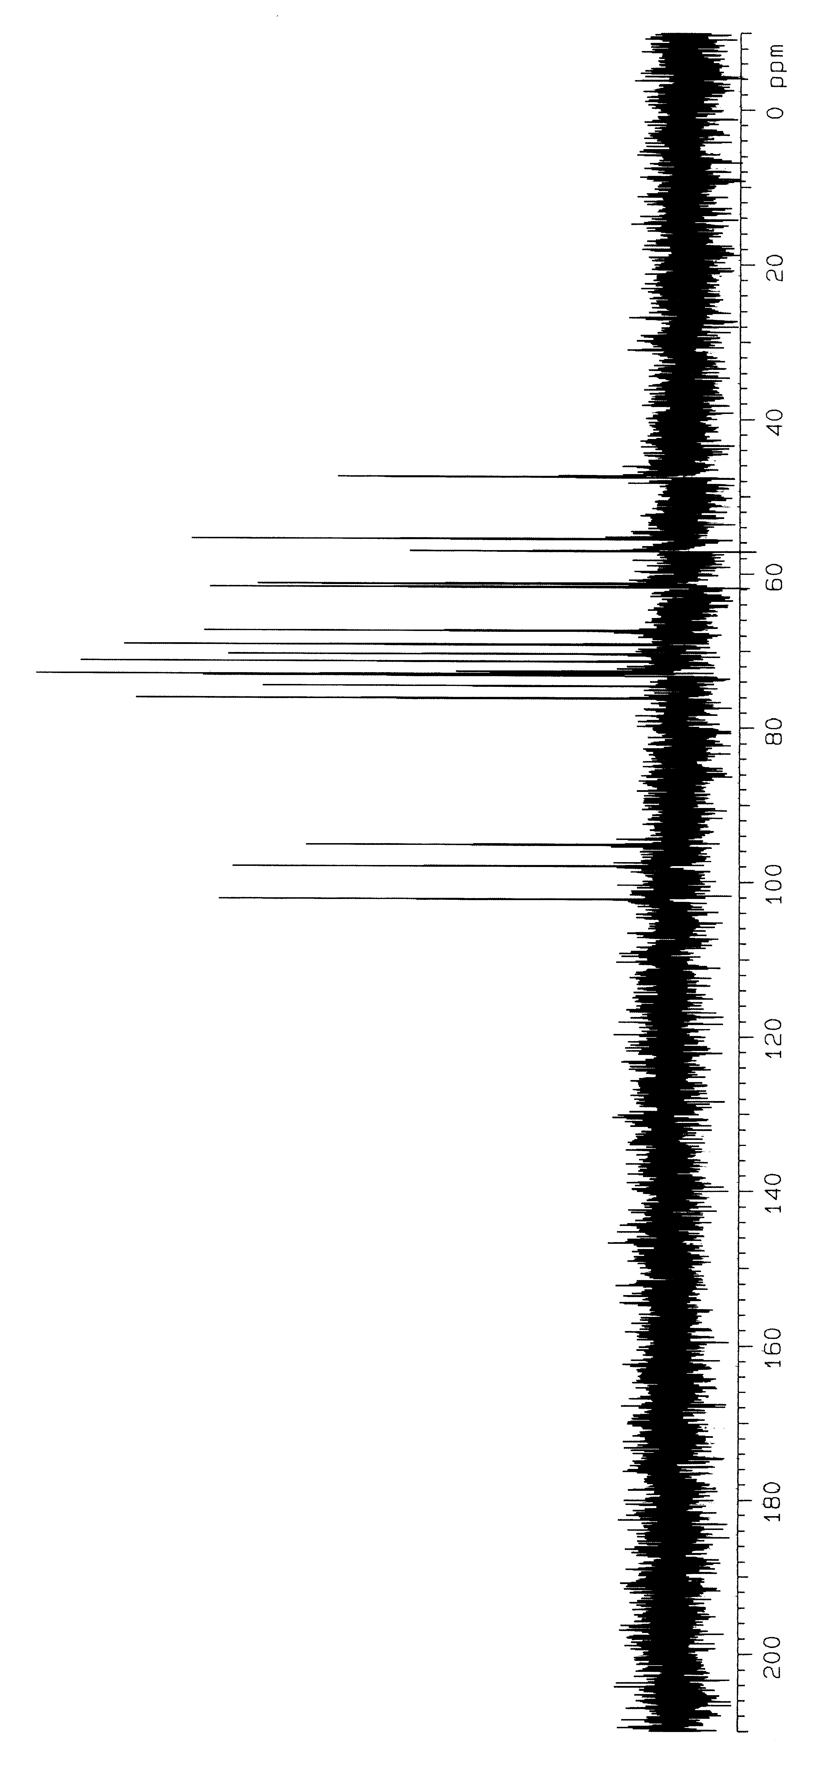

Figure S23. ¹³C NMR spectrum of 6 in D₂O.

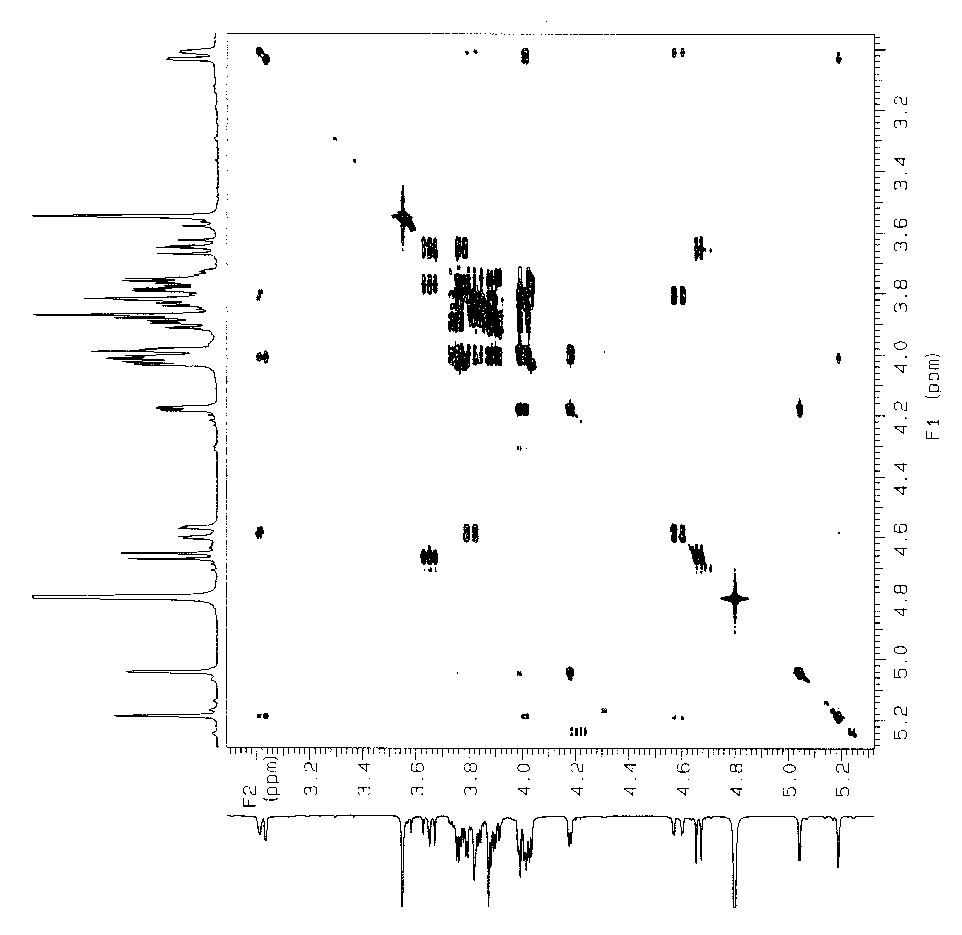
Figure S24. COSY spectrum of 6 in D₂O.
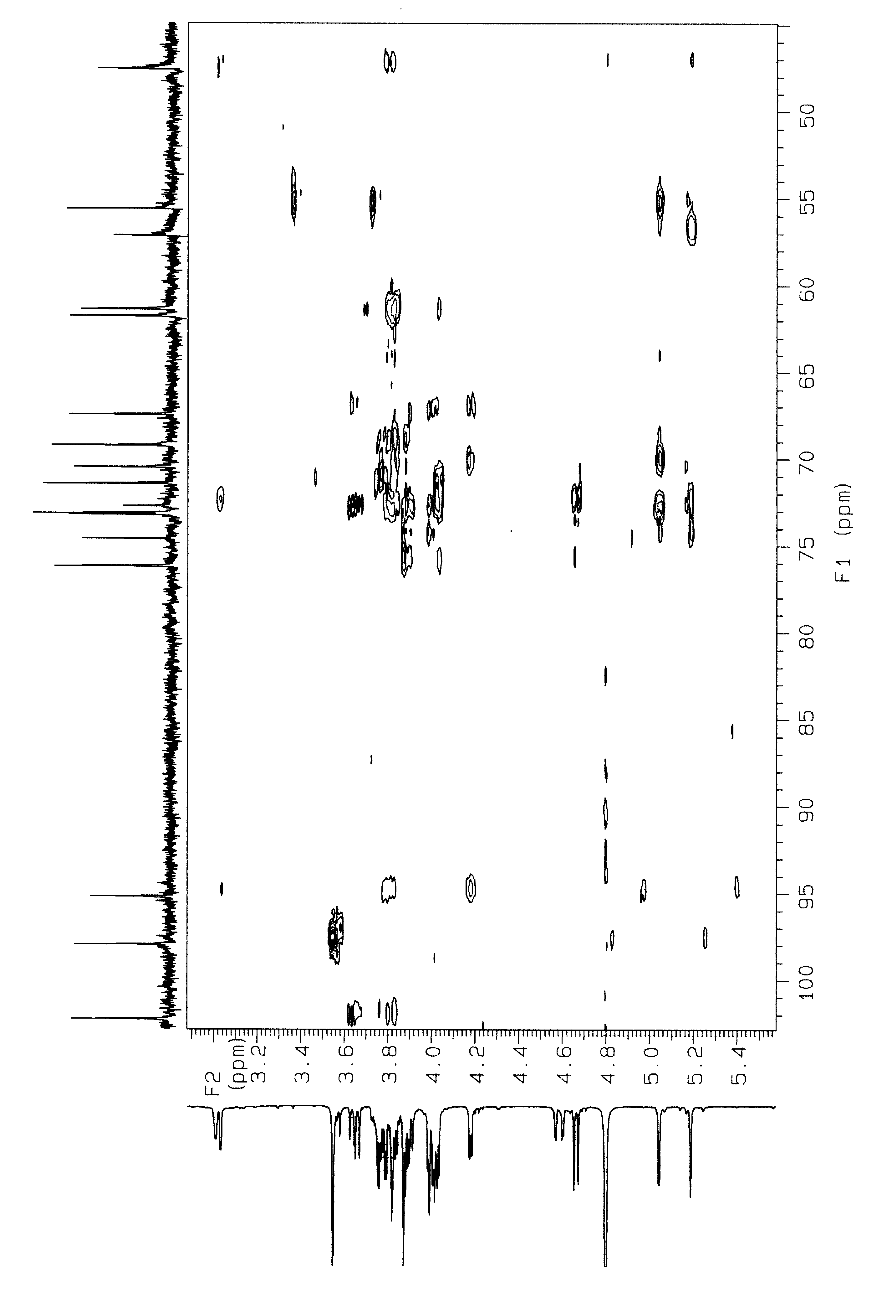
Figure S25. HMQC spectrum of 6 in D₂O.

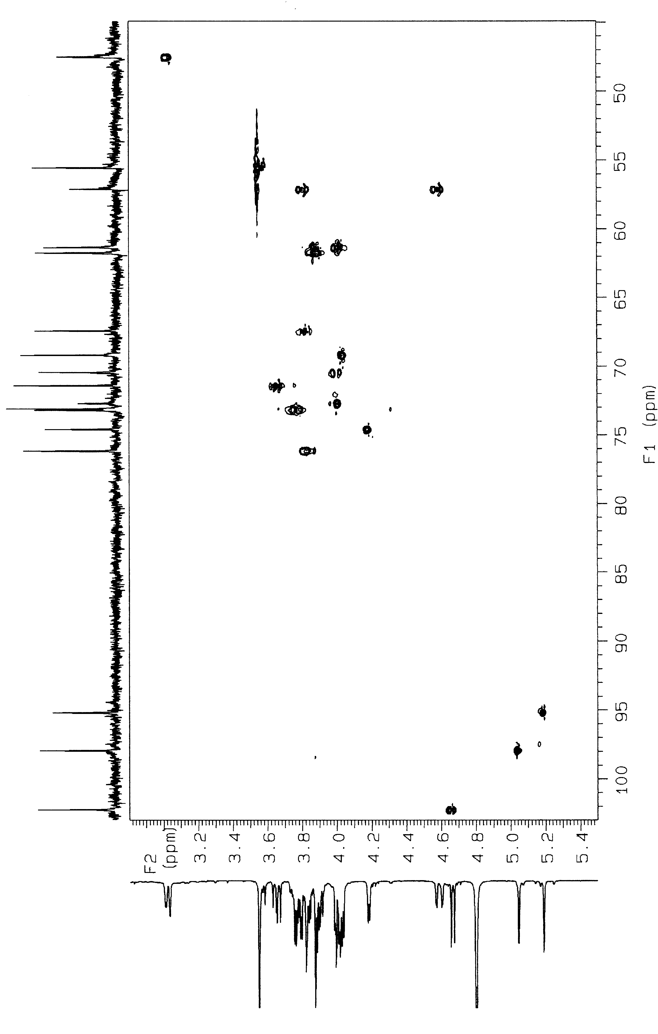
Figure S26. HMBC spectrum of 6 in D₂O.
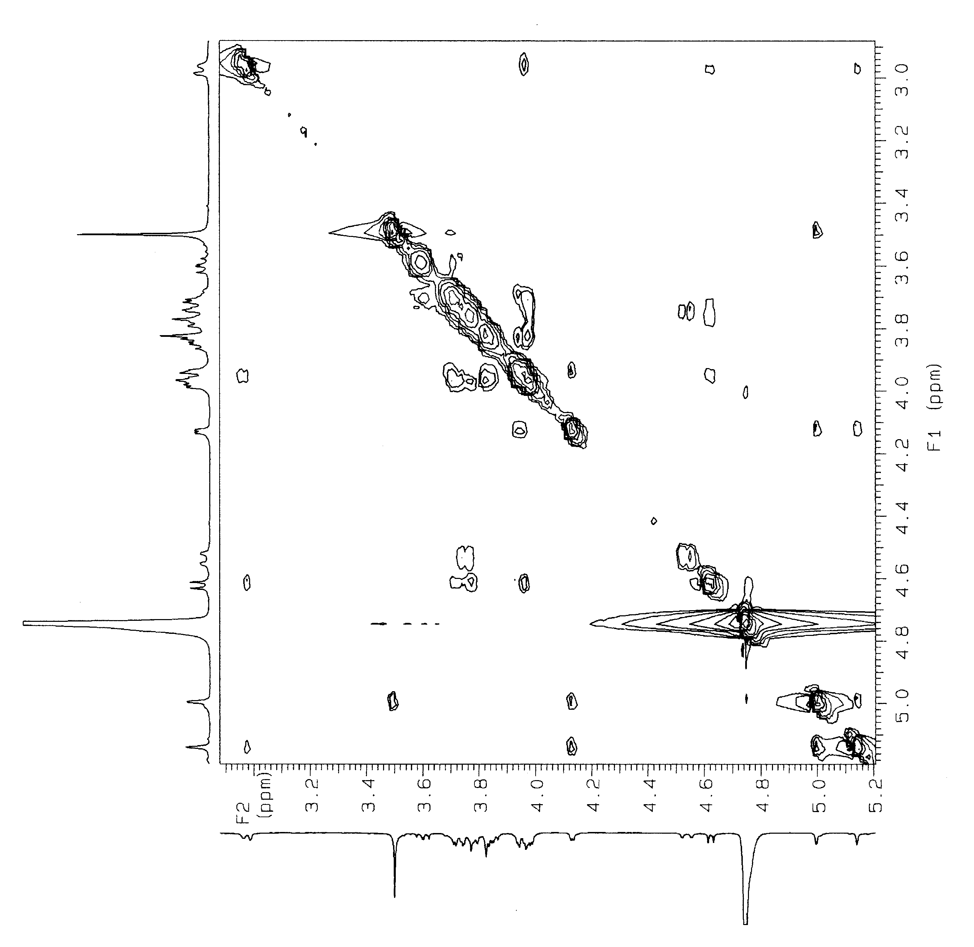
Figure S27. HMBC spectrum of 6 in D₂O.

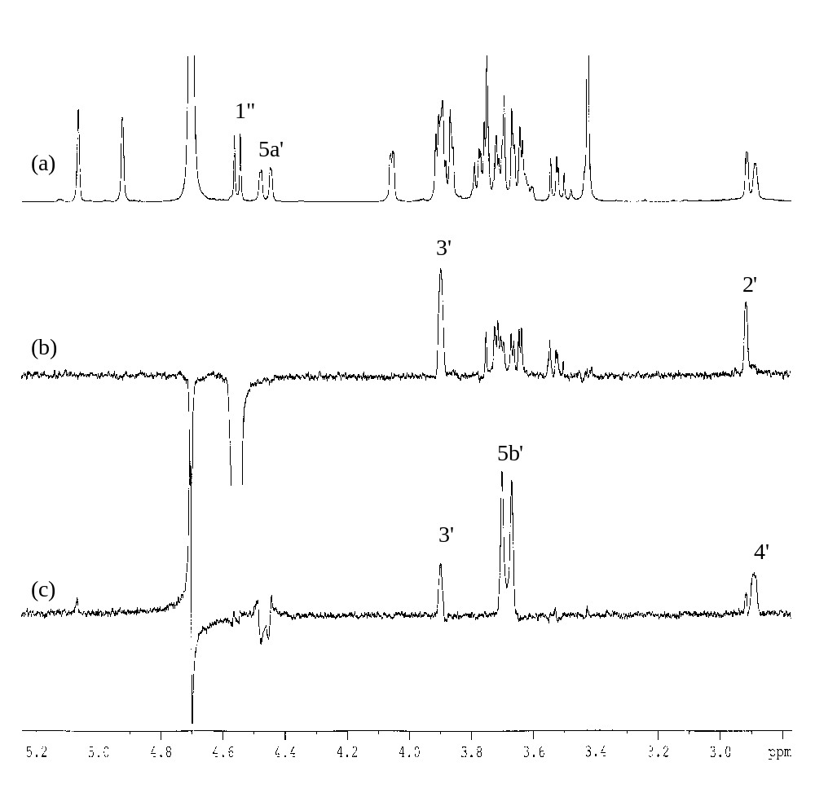
Figure S28. 1D NOESY and 1D TOCSY spectra for 6 in D₂O. Reference ¹H NMR spectrum (a), 1D NOESY spectrum with 1” irradiated (b), and 1D TOCSY with 5a’ irradiated (c).

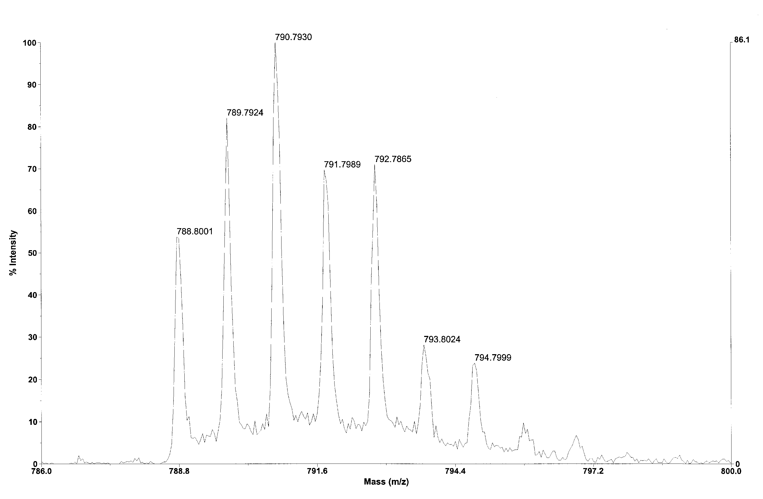
Figure S29. Observed ESI mass spectrum of 6.
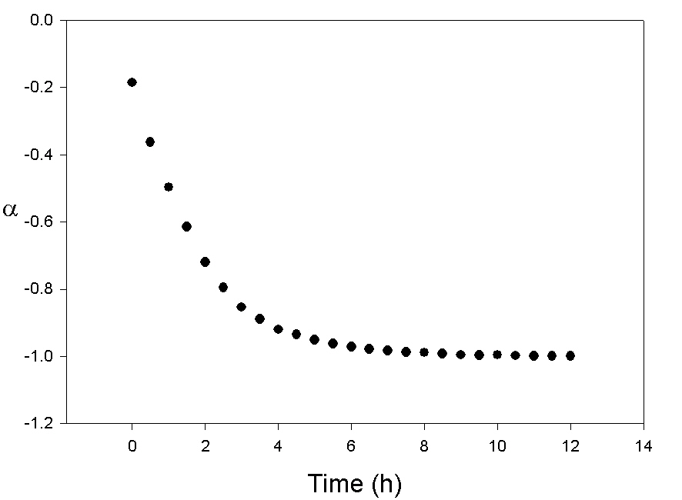
Figure S30. Time course of optical rotation (α) for the Pt (II) complex formation for 2.
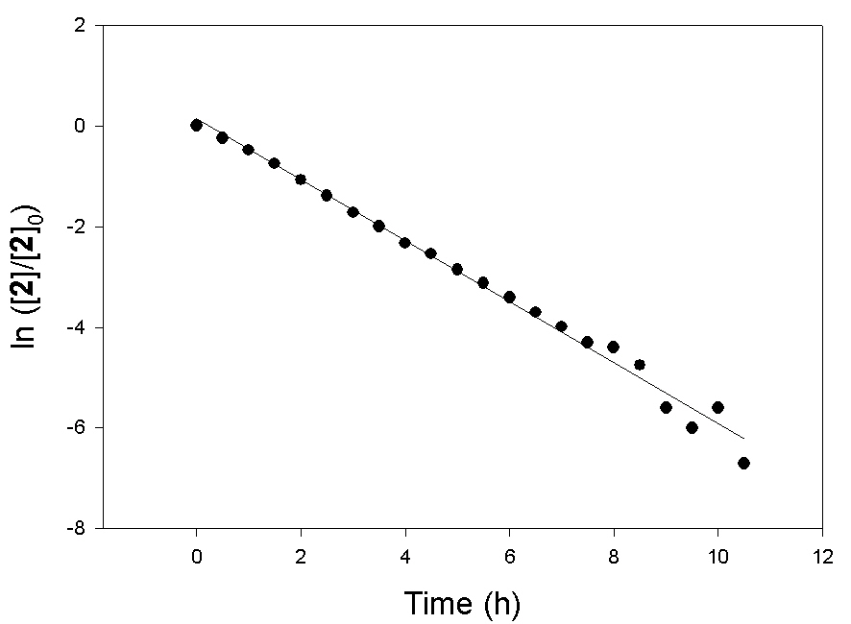
Figure S31. First-order kinetics fitting plot for the Pt (II) complex formation for 2. (ln ([2]/[2]₀) = –0.6065t – 0.1399; r² = 0.9902)

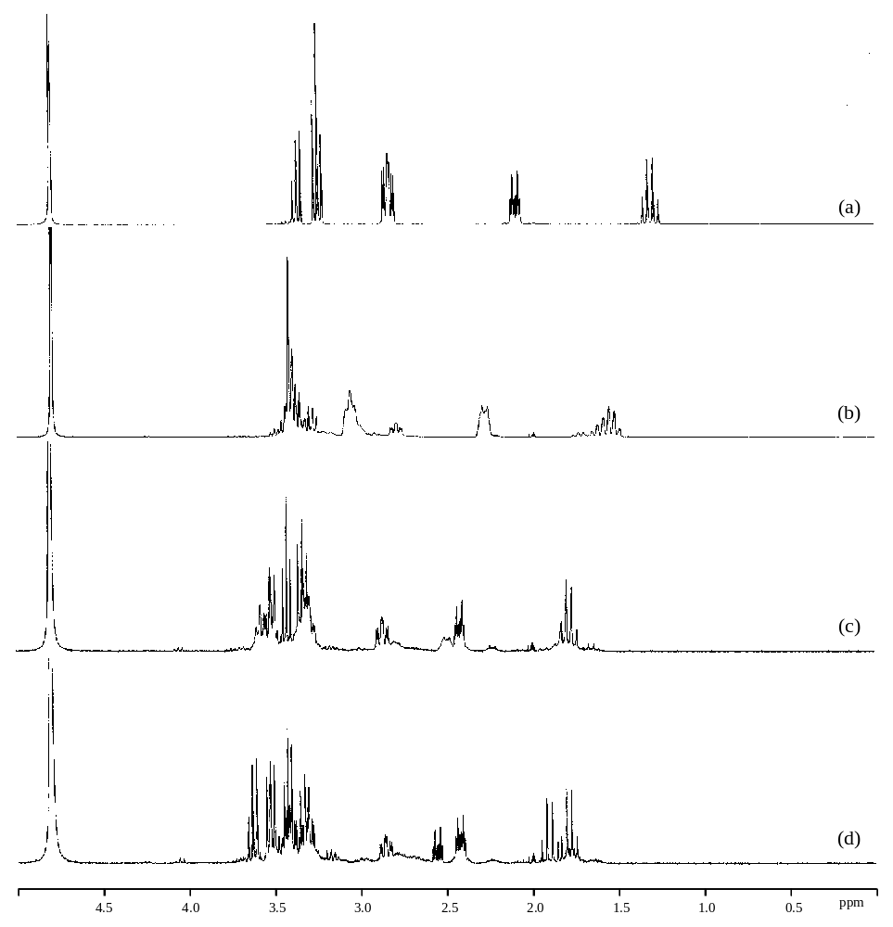
Figure S32. Time course of ¹H NMR spectra for the Pt (II) complex formation for 2-deoxystreptamine in NaOAc-d₃ buffer (pH 7.0) at 0 h (a), 2 h (b), 8 h (c), and 24 h (d).

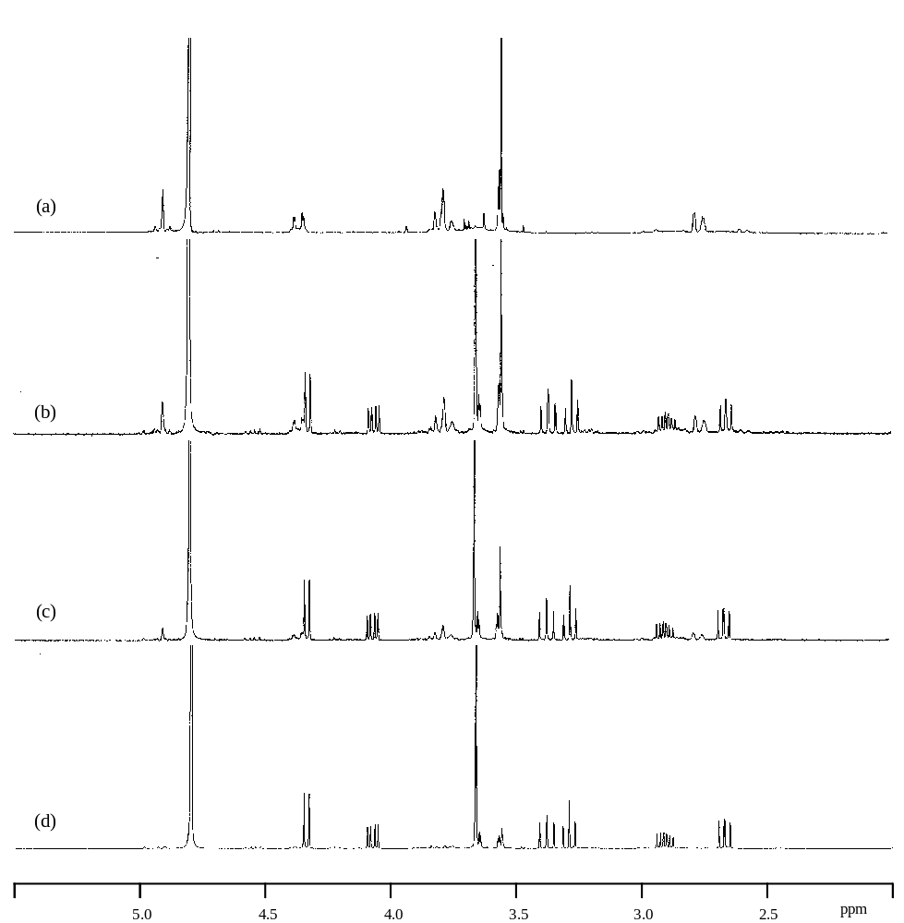
Figure S33. Time course of ¹H NMR spectra for unchelation of the Pt (II) complex 4 in NaOAc-d₃ buffer (pH 7.0) at 0 min (a), 10 min (b), 20 min (c), and 120 min (d).

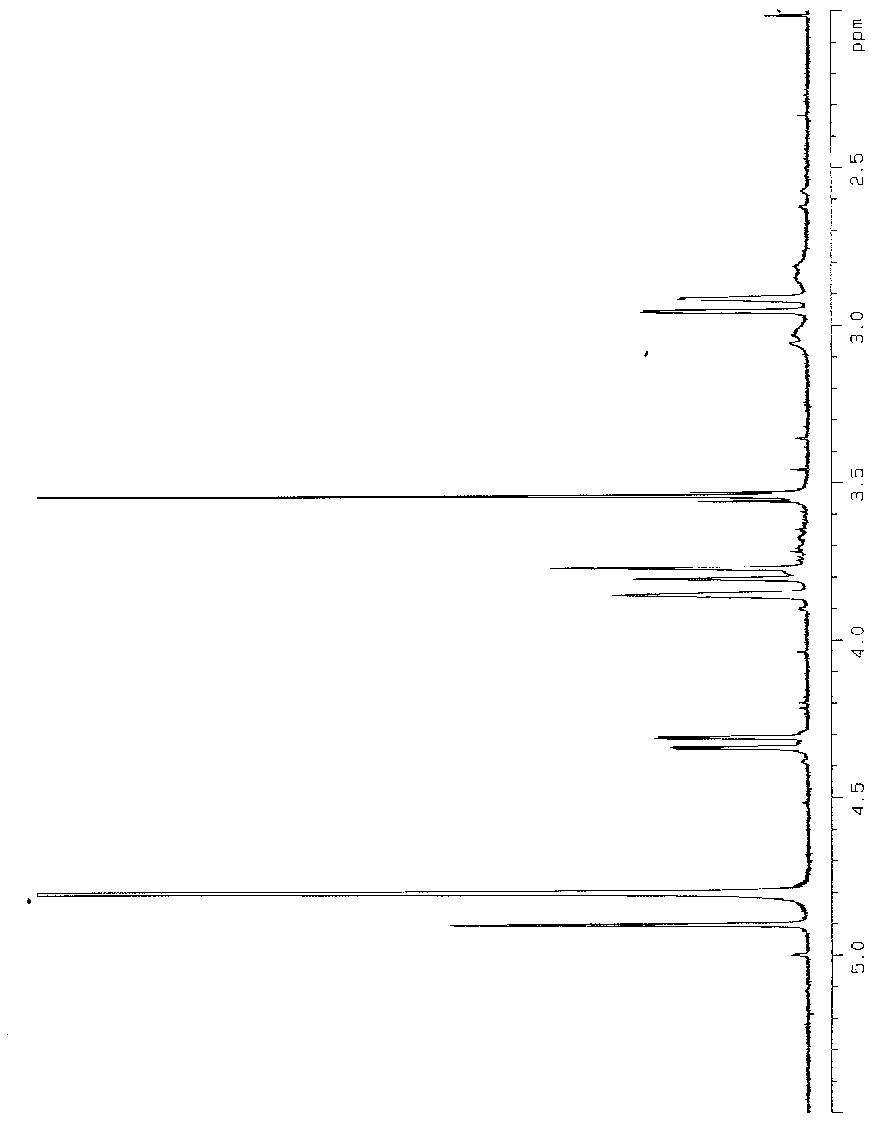
Figure S34. ¹H NMR spectrum of 7 in D₂O.
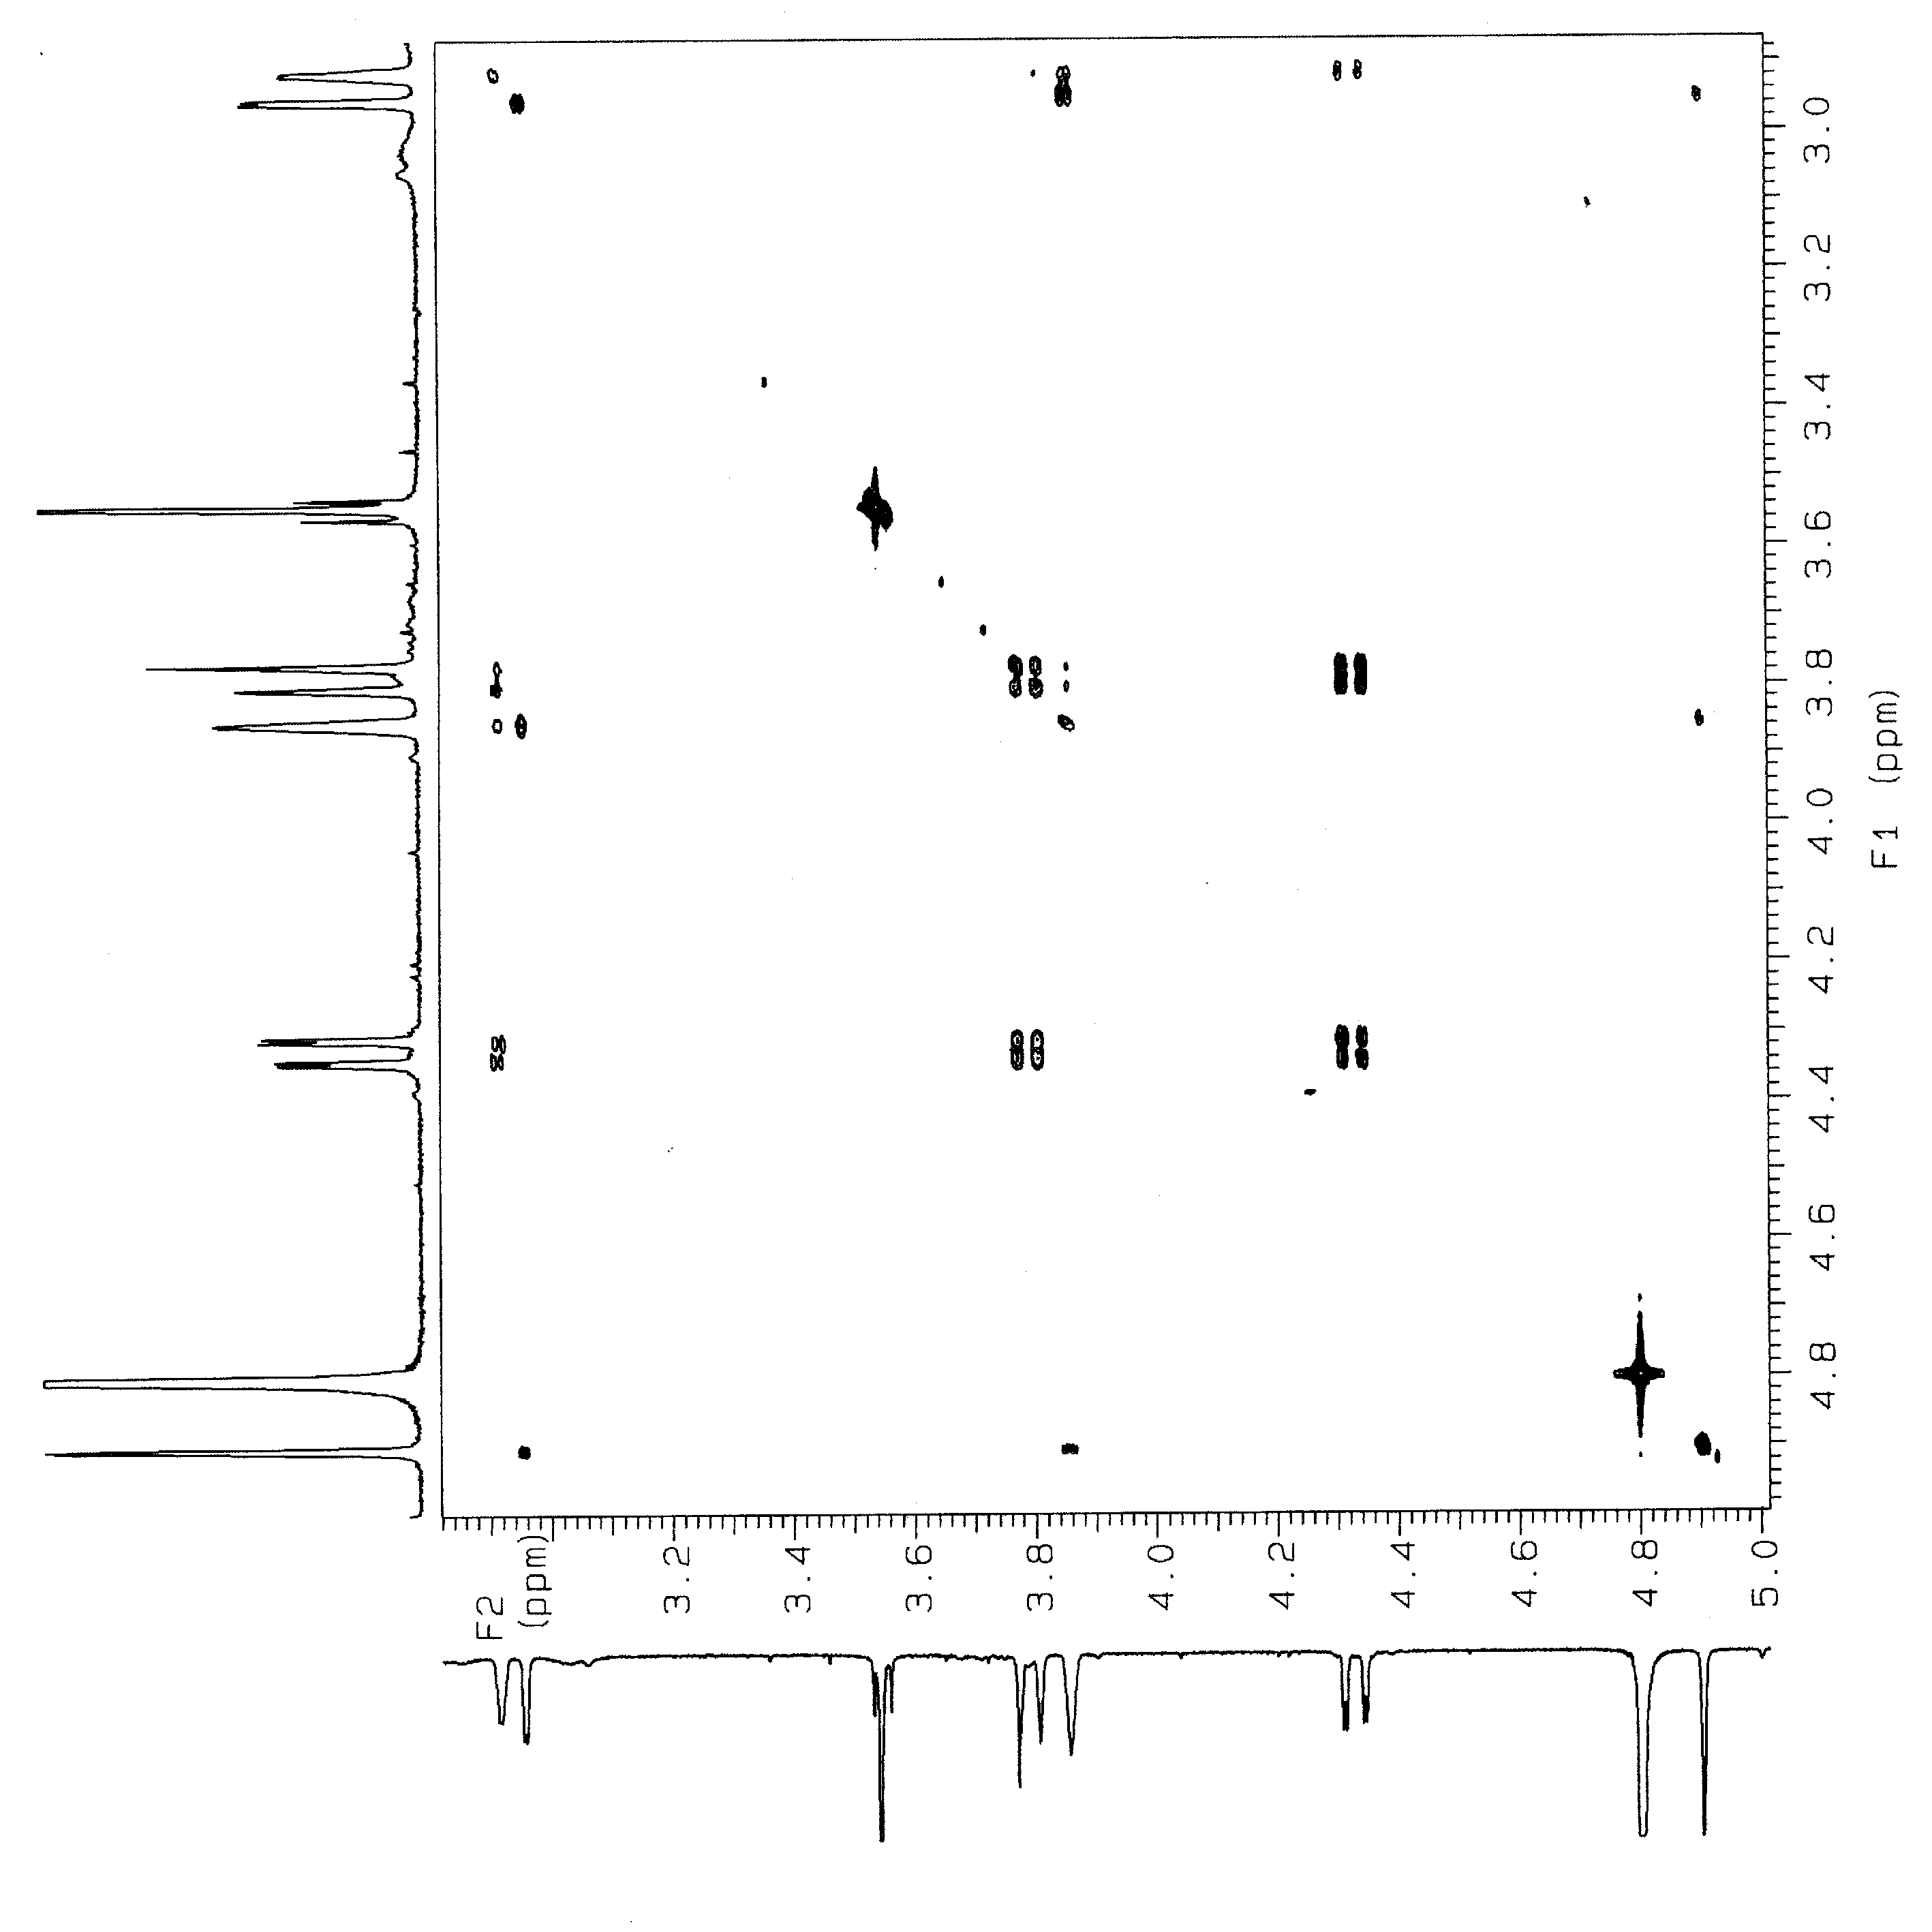
Figure S35. COSY spectrum of 7 in D₂O.

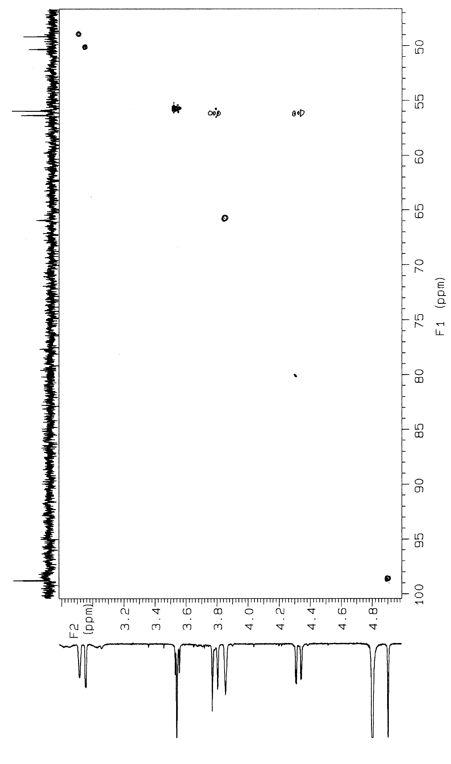
Figure S36. HMQC spectrum of 7 in D₂O.

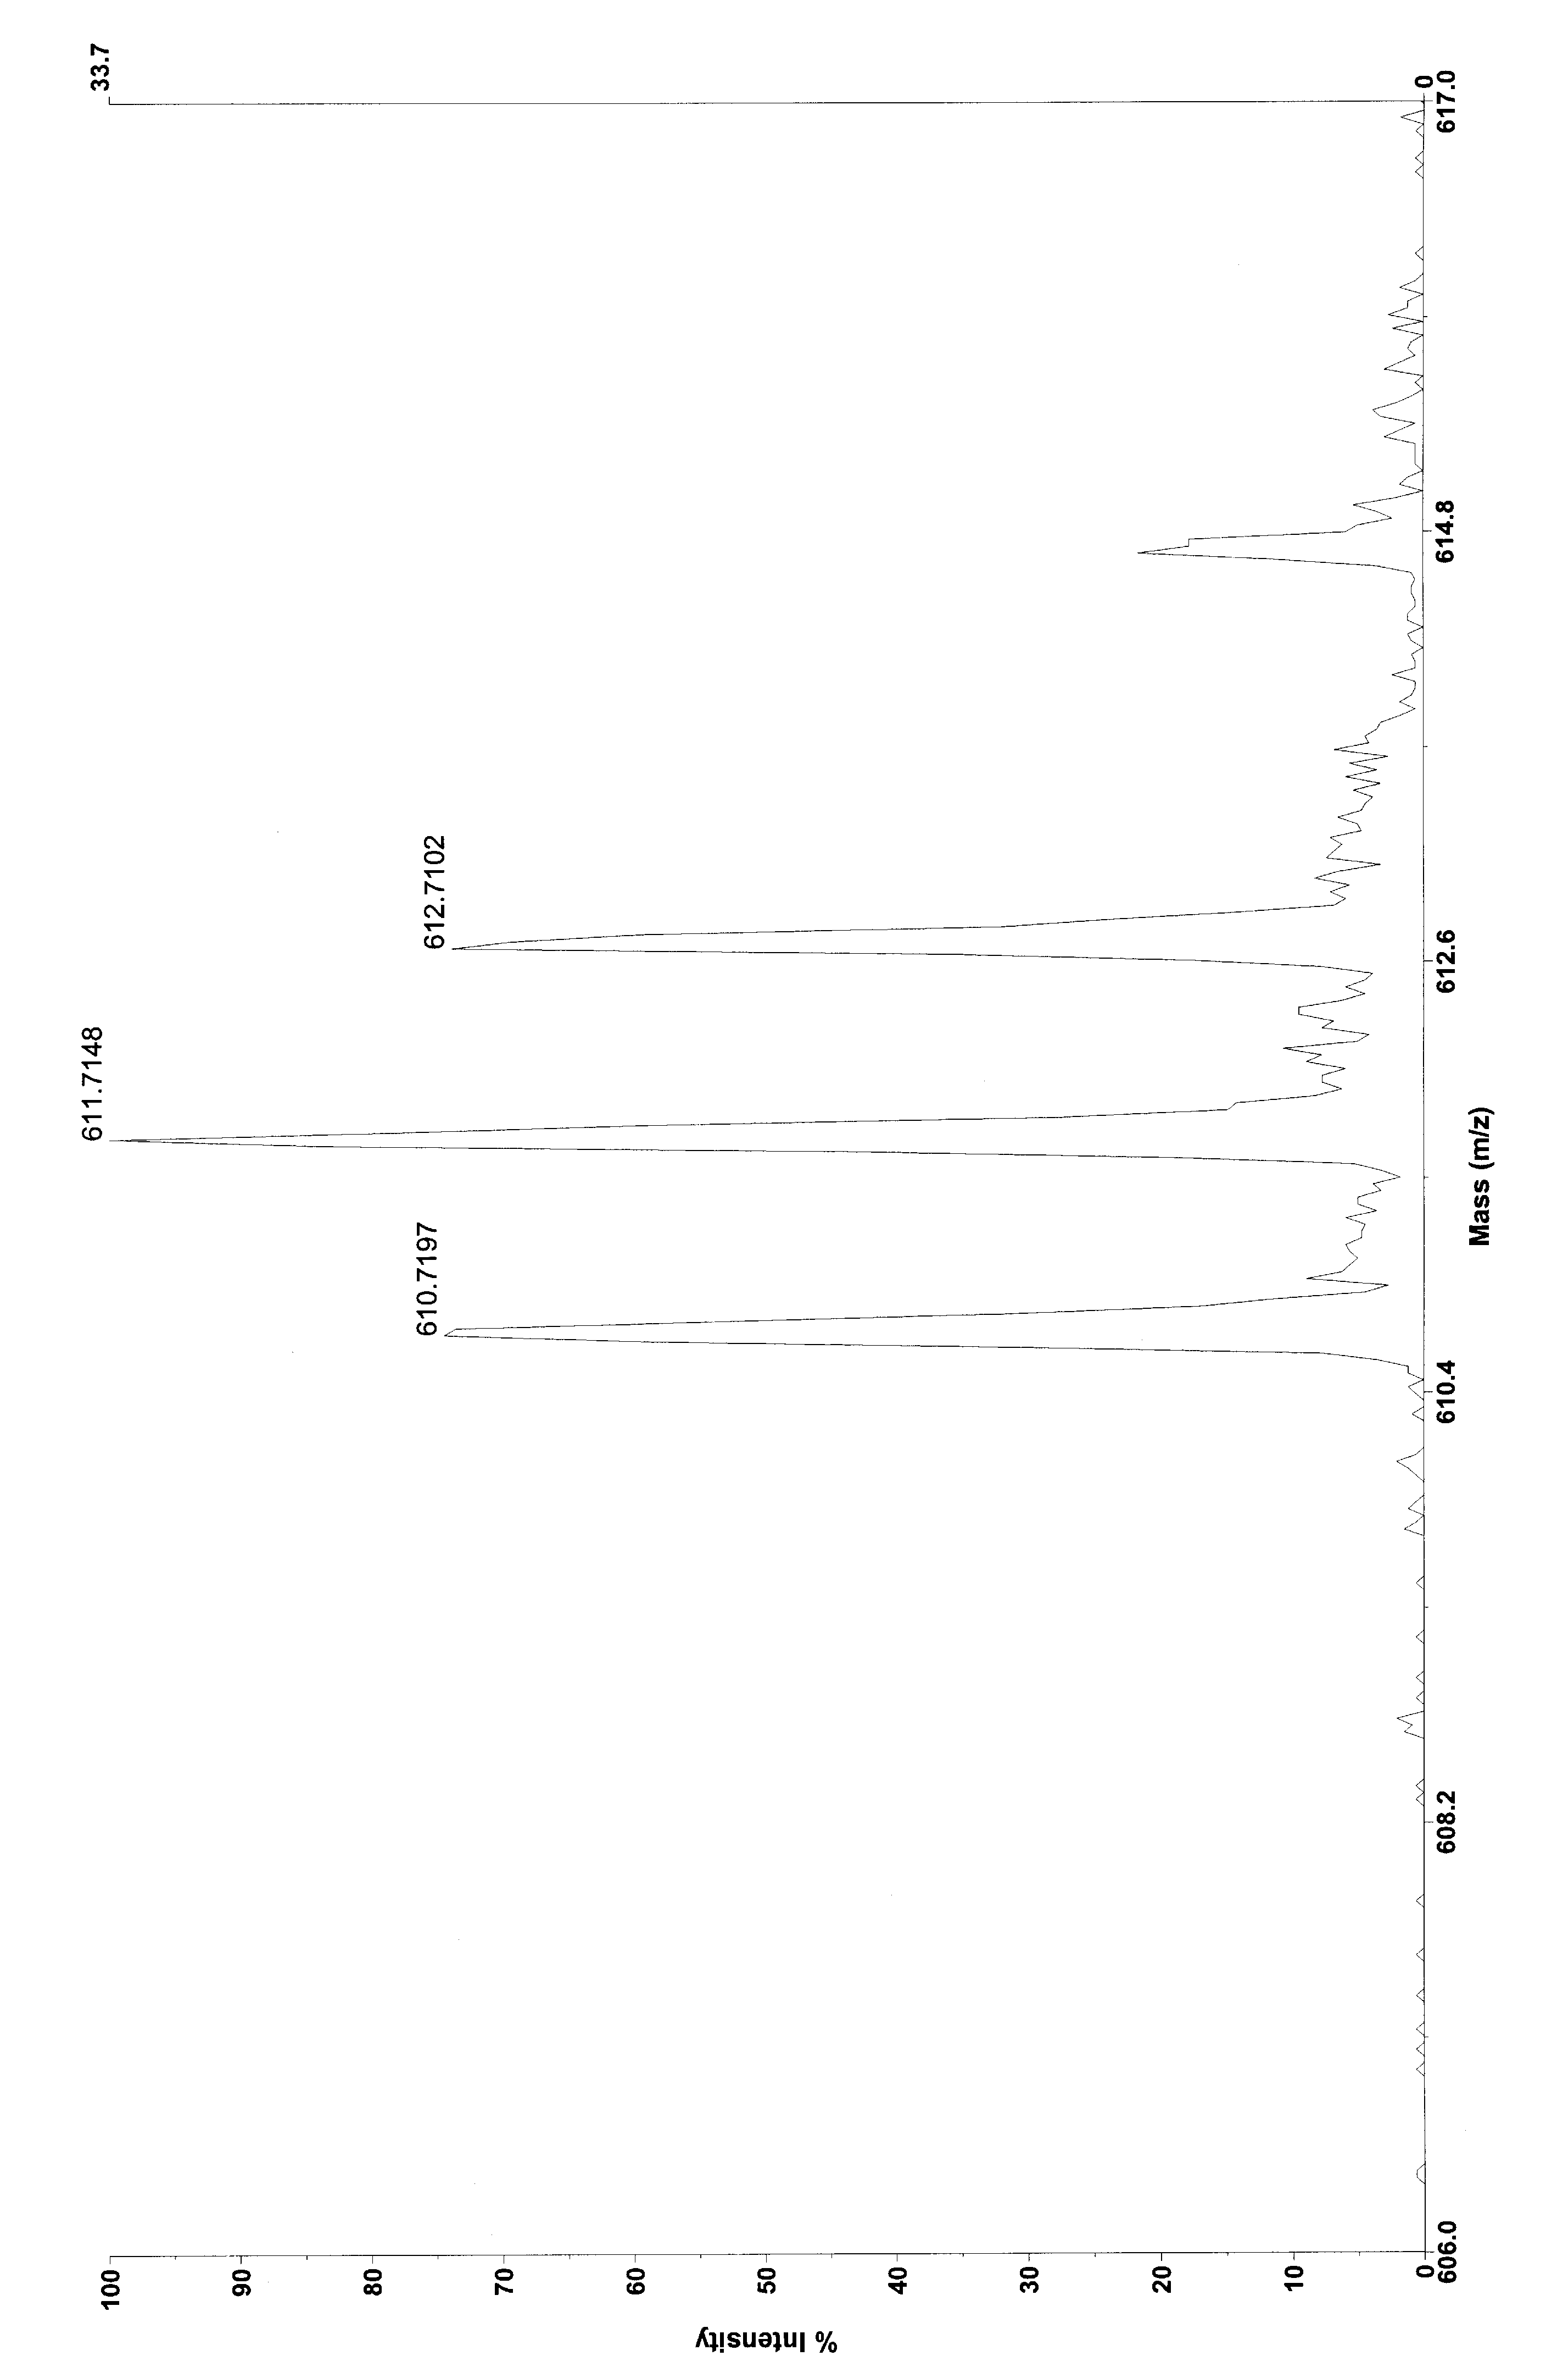
Figure S37. Observed ESI mass spectrum of 7.

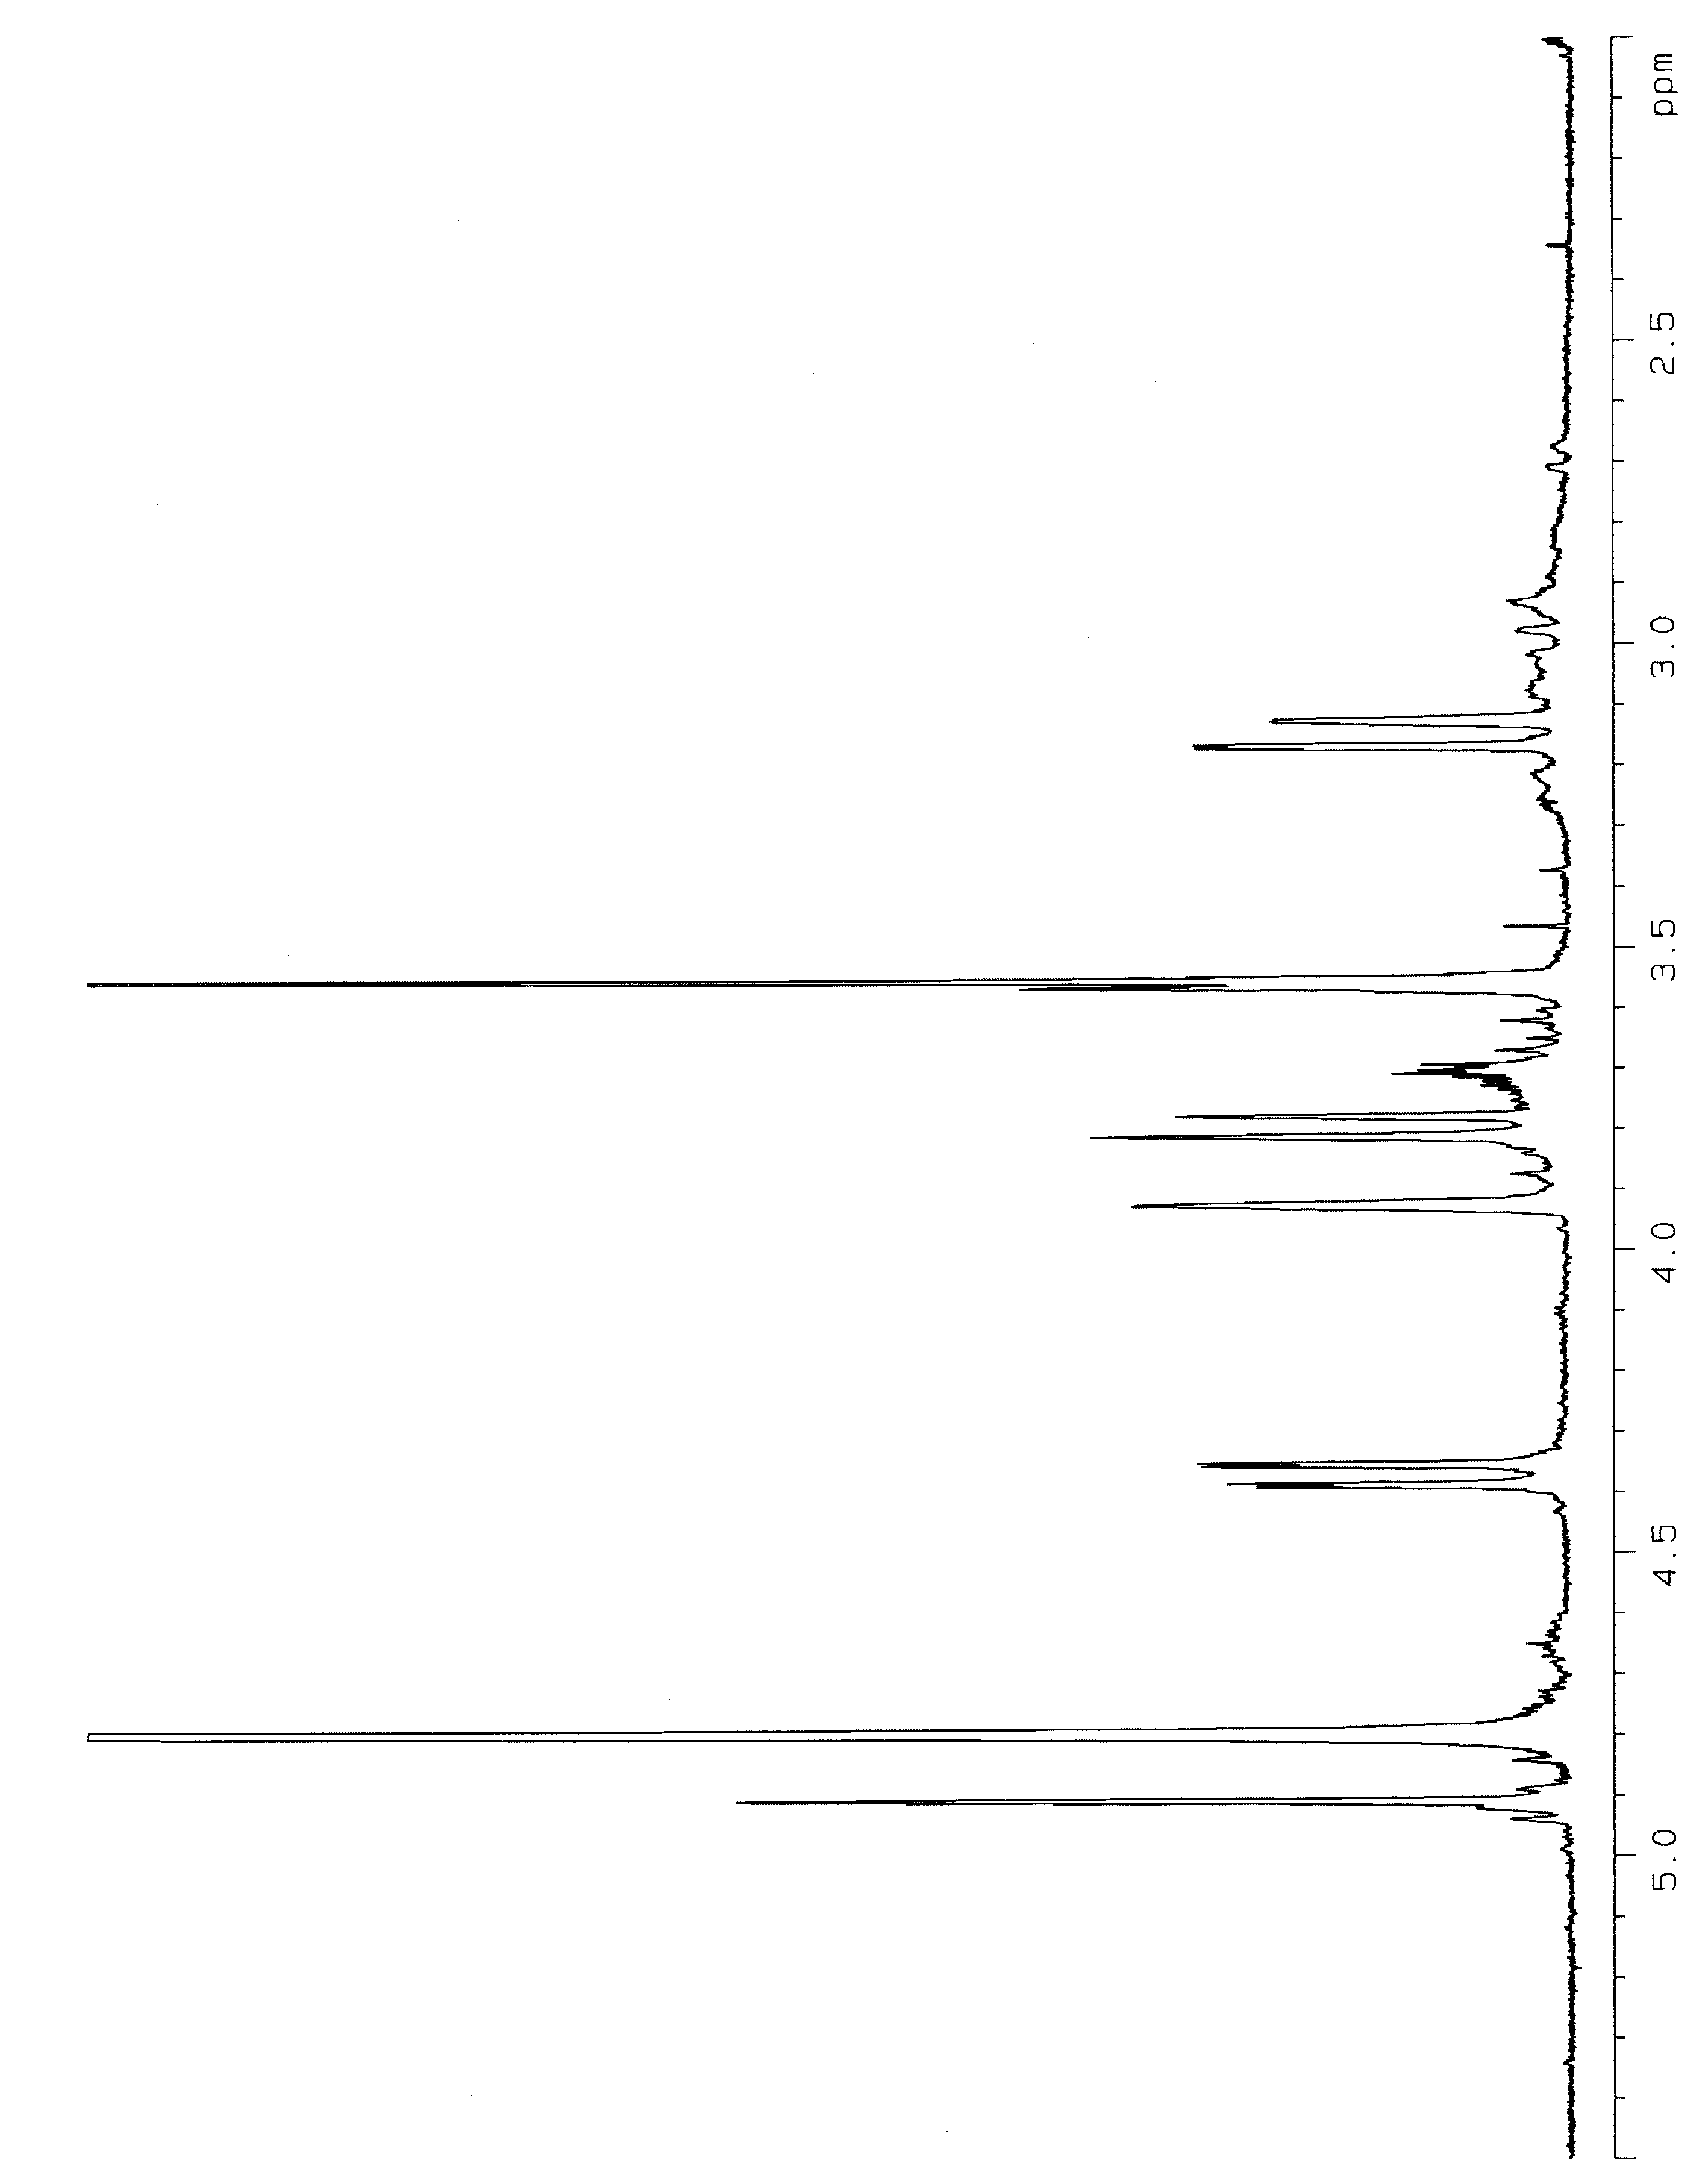
Figure S38. ¹H NMR spectrum of 8 in D₂O.

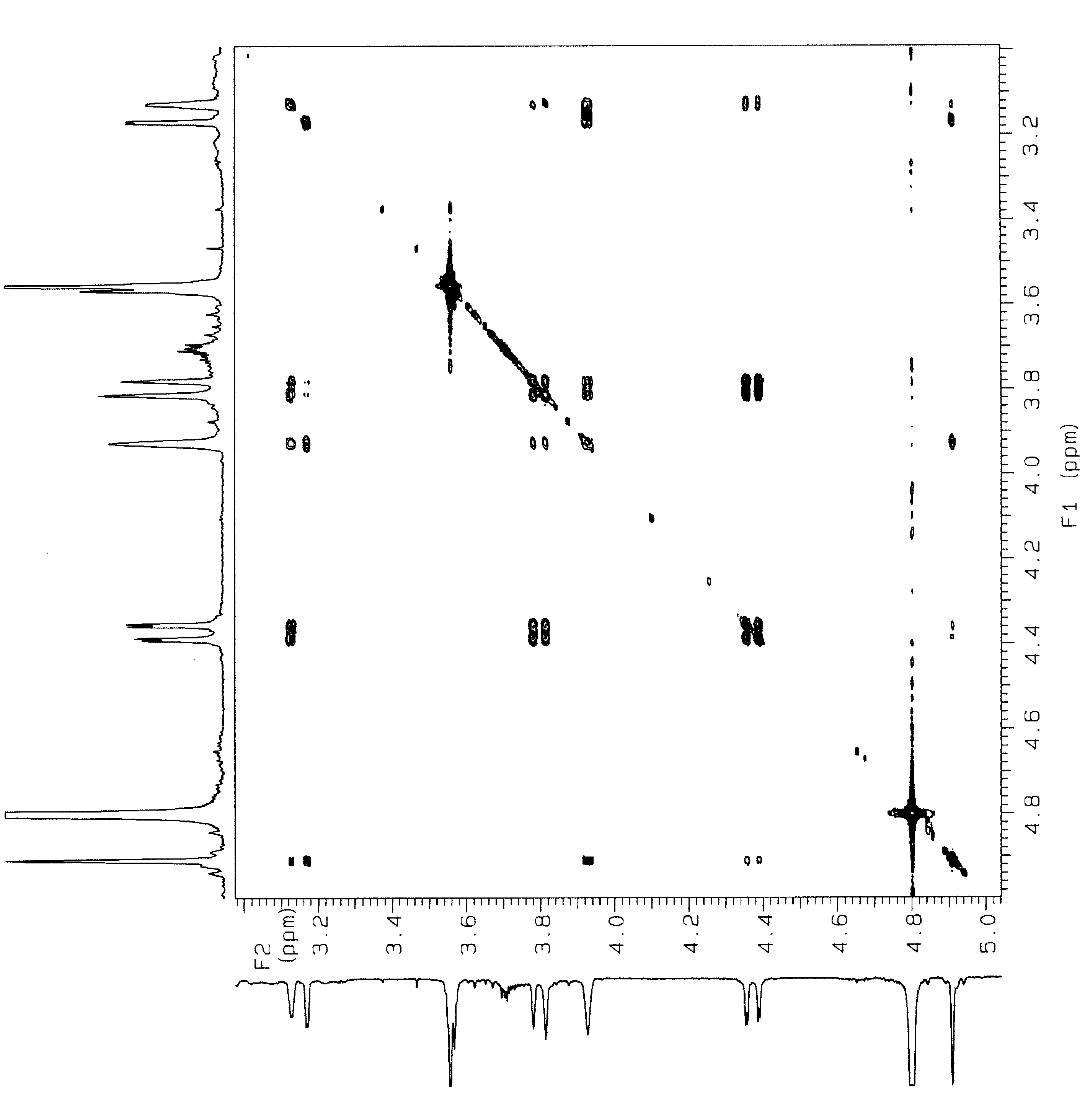
Figure S39. COSY spectrum of 8 in D₂O.

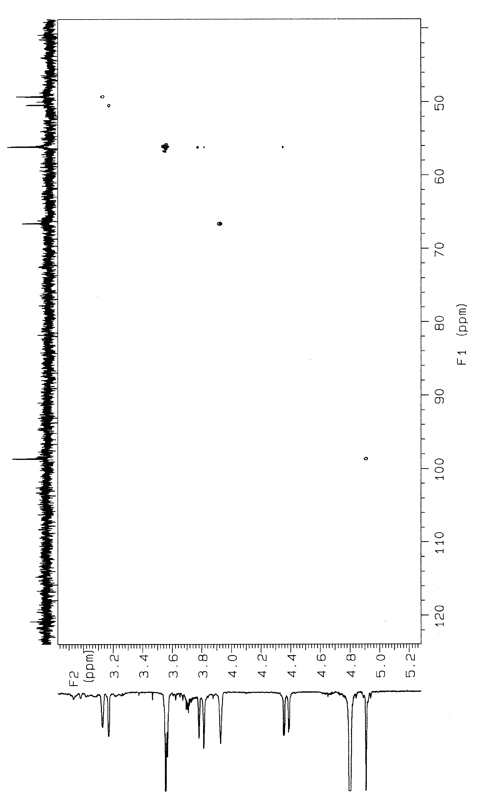
Figure S40. HMQC spectrum of 8 in D₂O.

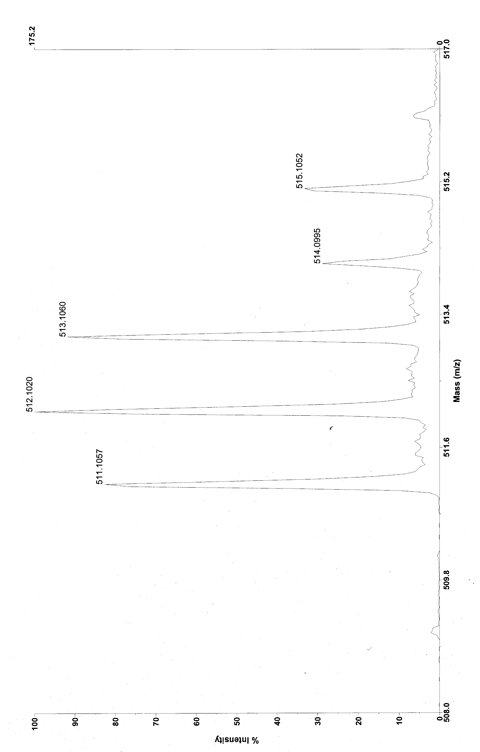
Figure S41. Observed ESI mass spectrum of 8.

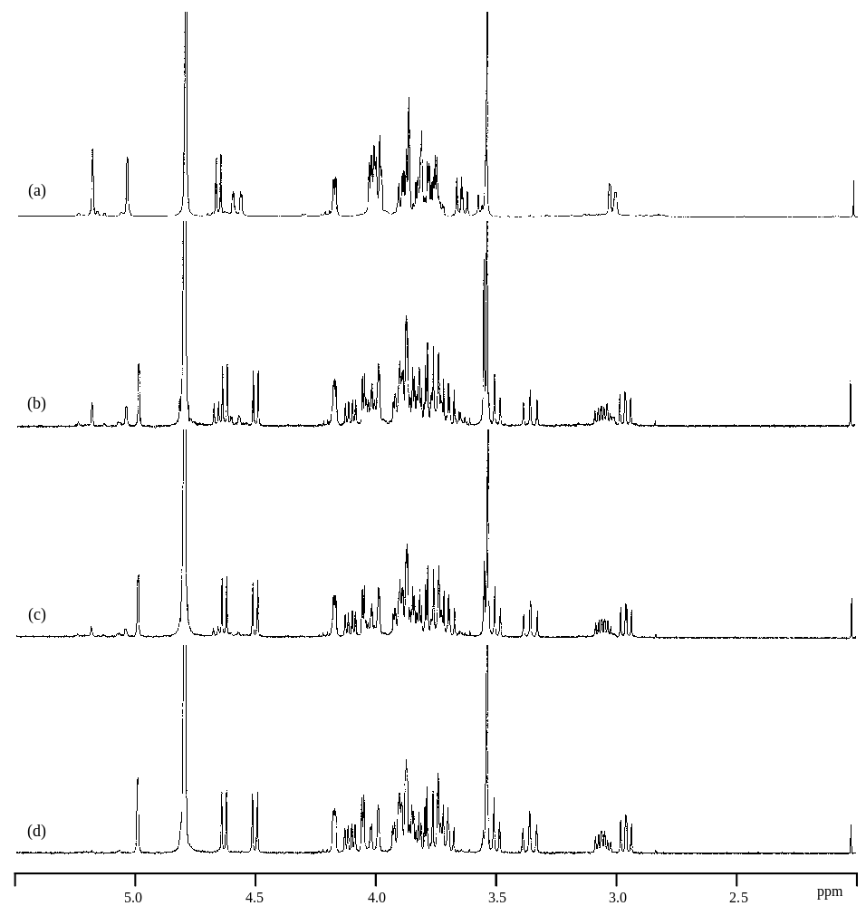
Figure S42. Time course of ¹H NMR spectra for unchelation of the Pt (II) complex 6 in NaOAc-d₃ buffer (pH 7.0) at 0 min (a), 10 min (b), 20 min (c), and 120 min (d).

