Supplementary Information

Novel and efficient synthesis of difficult sequence-containing peptides through O-N intramolecular acyl migration reaction of O-acyl isopeptides

Youhei Sohma, Masato Sasaki, Yoshio Hayashi,* Tooru Kimura, and Yoshiaki Kiso*

Department of Medicinal Chemistry, Center for Frontier Research in Medicinal Science, Kyoto Pharmaceutical University, Yamashina-Ku, Kyoto, Japan. Fax: +81 75 591 9900; Tel: +81 75 595 4635; E-mail: kiso@mb.kyoto-phu.ac.jp

Fig. 3 HPLC profiles of (A) crude peptide 1 (a) and its O-acyl isopeptide 5 (b) (B) crude peptide 6 and its O-acyl isopeptide 7 (230 nm).

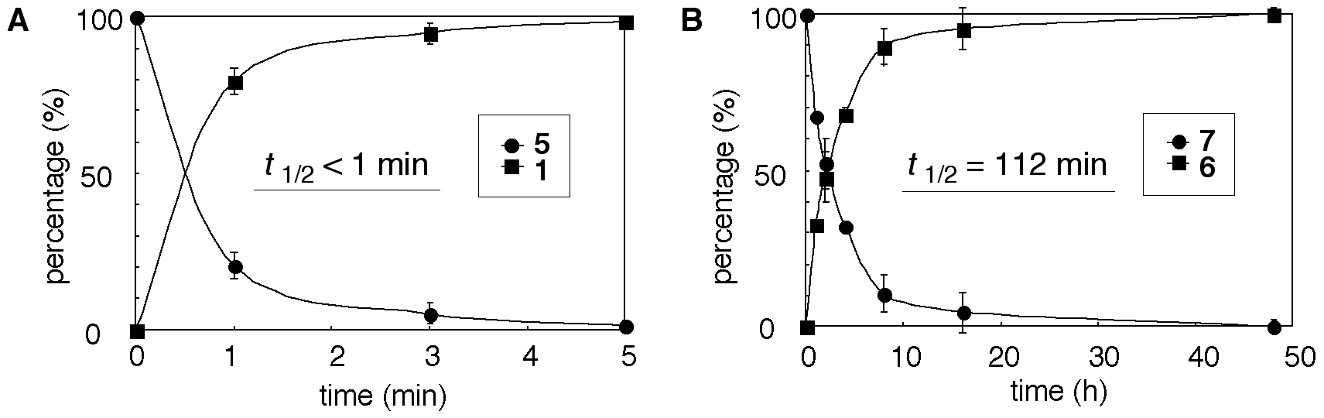
Fig. 4 Migration of O-acyl isopeptide 5 to 1 (A) and 7 to 6 (B) in PBS at pH 7.4 (25 ˚C).

Fig. 5 Periodical HPLC profile (B) and photographs (C) of conversion of O-acyl isopeptide 7 to 6 via O-N intramolecular acyl migration in PBS (pH 7.4, 25˚C).
Table 1 Various parameter values of 1 and 6, and their O-acyl isopeptides 5 and 7
 | H₂O-solubility |  |  | MeOH-solubility |  |  | DMSO-solubility |  | Half-life^{a, c} |  | Overall Yield (%)
Compd | mg / mLª | Ratio^{b} |  | mg / mLª | Ratio^{b} |  | mg / mLª |  | (min) |  | Route A | Route B
1 | 0.008 ± 0.001 | – |  | 0.065 ± 0.019 | – |  | 0.67 ± 0.01 |  | – |  | 6.9 | 57.6
5 | 59.4 ± 13.6 | 7,425 |  | 277.3 ± 84.2 | 4,266 |  | – |  | < 1 |  | – | –
6 | 0.013 ± 0.005 | – |  | 0.051 ± 0.005 | – |  | 0.64 ± 0.02 |  | – |  | 6.0 | 40.6
7 | 59.6 ± 32.3 | 4,585 |  | 126.6 ± 50.8 | 2,482 |  | – |  | 112 ± 24.9 |  | – | –
ªValues are the means ± SD of three experiments. ^{b}Ratio = solubility of O-acyl isopeptide / solubility of parent peptide. ^{c}Half-life is the time required for 50% release of parent N-acyl peptide in PBS (pH 7.4, 25˚C).

Spectral data for 1, 5, 6, and 7
1 by Route A: HRMS (FAB): calcd for C₃₂H₅₃N₆O₇ (M+H)⁺: 633.3976, found: 633.3982; HPLC analysis at 230 nm: purity was higher than 98%.
1 by Route B: HRMS (FAB): calcd for C₃₂H₅₃N₆O₇ (M+H)⁺: 633.3976, found: 633.3983; HPLC analysis at 230 nm: purity was higher than 99%.
5: HRMS (FAB): calcd for C₃₂H₅₃N₆O₇ (M+H)⁺: 633.3976, found: 633.3979; HPLC analysis at 230 nm: purity was higher than 99%.
6 by Route A: HRMS (FAB): calcd for C₂₅H₄₇N₆O₇ (M+H)⁺: 543.3506, found: 543.3510; HPLC analysis at 230 nm: purity was higher than 95%.
6 by Route B: HRMS (FAB): calcd for C₃₂H₅₃N₆O₇ (M+H)⁺: 543.3506, found: 543.3499; HPLC analysis at 230 nm: purity was higher than 96%.
7: HRMS (FAB): calcd for C₂₅H₄₇N₆O₇ (M+H)⁺: 543.3506, found: 543.3509; HPLC analysis at 230 nm: purity was higher than 99%.

