Proton transfer versus redox modulation in thiourea-phenanthrenequinone molecular and polymeric complexes
Joseph B. Carroll,ª Mark Gray,ª Graeme Cooke,^{b} and Vincent M. Rotello^{a,*}
ªDepartment of Chemistry, The University of Massachusetts, Amherst, MA 01003, USA. Fax: 413 545 4490; Tel: 413 545 4865; E-mail:rotello@chem.umass.edu. ^{b}Centre for Biomimetic Design and Synthesis, Chemistry, Heriot-Watt University, Riccarton, Edinburgh, UK EH14 4AS

Supplementary Information

Cyclic voltammogram of phenanthrenequinone 1 in the presence of excess thiourea 2 (toluene/CH₂Cl₂)

General procedures of the synthesis of thiourea functionalized random styrene copolymers:

Materials and General Methods. All chemicals were reagent grade, and were used without further purification. All reactions were performed under inert atmosphere (Ar).

1) Poly(styrene-p-(chloromethyl)styrene), PS-co-CH₂Cl GPC: M_{n}=5200, M_{w}=7700, PDI=1.465 (general procedure can be found in: F. Ilhan, M. Gray, K. Blanchette and V. M. Rotello, Macromolecules 1999, 32, 6159.)

2) Poly(styrene-p-(chloromethyl)/(methoxymethyl)styrene), PS-co-CH₂Cl-co-CH₂-OMe, route to polymers 3b and 3c only.
To solutions of poly(styrene-p-(chloromethyl)styrene), (1.96 g, 0.375 mmol) in THF (20 ml) were added NaOMe (25%/wt. in MeOH, 3b 0.43 ml, 7.5 mmol, 3c 1.3 ml, 22.5 mmol). The reaction mixtures were stirred for 4h and then concentrated under reverse pressure and precipitated into distilled water. The resultant polymers (1.75 g 3b and 1.67 g 3c) were then filtered, washed several times with water, and dried under vacuum.

3) Poly(styrene-p-(aminomethyl)styrene), PS-co-CH₂NH₂ (general procedure for synthesis of poly(styrene-p-(aminomethyl)styrene)from poly(styrene-p-(chloromethyl)styrene)can be found in:
F. Ilhan, M. Gray, K. Blanchette and V. M. Rotello, Macromolecules 1999, 32, 6159.)

4) Poly(styrene-p-(methoxymethyl)/(hexylthiourea)styrene), PS-co-CH₂NHSNH-(CH₂)₅-CH₃-co-CH₂-OMe (polymers 3a-3c)
To solutions of poly(styrene-p-(methoxymethyl)/(amino)styrene) (precursors to 3b, 0.300 g, 0.061 mmol and 3c, 0.300 g, 0.06 mmol) and poly(styrene-p-(aminomethyl)styrene) (precursor to 3a, 1 g, 0.2 mmol) in dichloromethane (20 ml) were added an excess of hexyl isothiocyanate (for 3a 0.76 ml, 5 mmol, 3b 0.14 ml, 0.91 mmol, 3c 0.09 ml, 0.6 mmol) . The reaction mixtures were stirred overnight and then concentrated under reverse pressure and precipitated into cold hexanes to remove any excess hexyl isothiocyanate. The resultant polymers were then filtered, washed several times with hexanes, and dried under vacuum yielding polymers 3a-3c in high yields (>95%).

¹H NMR spectra of thiourea polymers 3a-3c

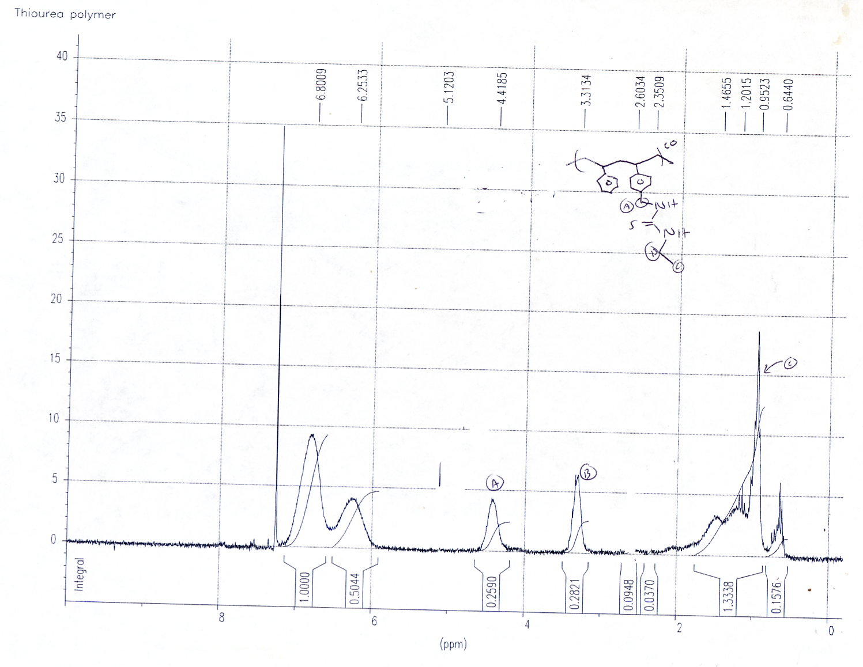

Polymer 3a (above)
Polymer 3b (below)

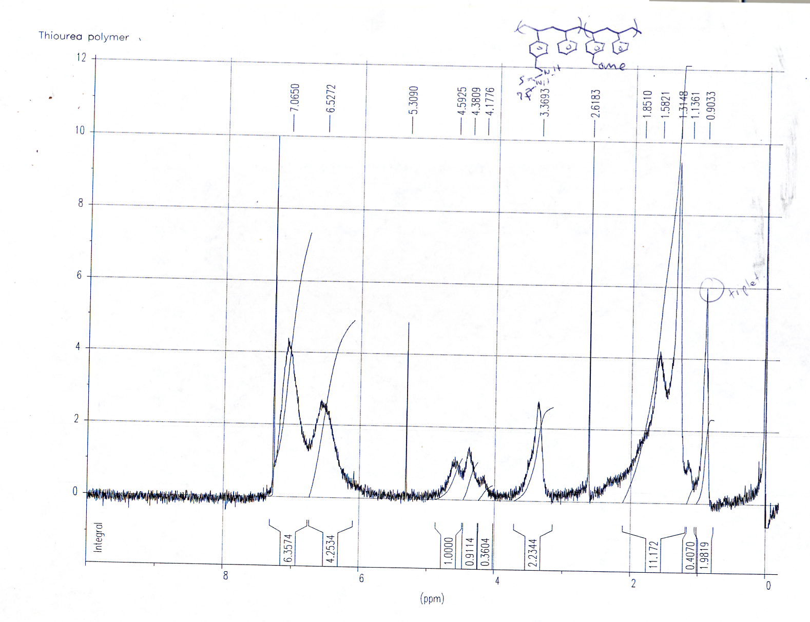

Polymer 3c
