Supporting Information

Probing Esterase/Lipase Libraries for Lipid A Hydrolases – Discovery of Biocatalysts for the Detoxification of Bacterially-Expressed Recombinant Protein

Jung-Mo Ahn, Paul Wentworth Jr.,* & Kim D. Janda*

Department of Chemistry, The Scripps Research Institute and the Skaggs Institute for Chemical Biology, 10550 North Torrey Pines Road, La Jolla, CA 92037, USA.
Quantitative LC/MS method for determination of lauric and myristic acid
Determination of concentrations of laurate and myristate generated from the hydrolysis of lipid A by enzymes was routinely performed using an Agilent 1100-series HPLC connected with an ESI-MSD detector. The concentrations of analytes (laurate and myristate) were determined, at least in duplicate samples, by comparison of MSD signals (total ion abundance measurements) relative to an internal standard (palmitate, 100 μM). A solution (5 μL) containing the analytes and the internal standard was injected and eluted to the MSD detector (negative ion mode ESI) with 50% acetonitrile/water for 1 min. From the obtained chromatogram displaying total ion abundance over time, selected ions of laurate, myristate, and palmitate (m/z = 199, 227, and 255, respectively) were analyzed to produce separate, refined chromatograms representing selected ion abundance over time using ChemStation software from Agilent. The relative peak areas of laurate and myristate over palmitate were measured to determine the concentrations. Using four authentic solutions (in duplicate), containing 50, 100, 250 and 500 μM of both laurate and myristate respectively and 100 μM palmitate, linear relationships between ratios of peak areas and ratios of concentrations were derived for laurate and myristate (SOM Figure 1). The standard curved were prepared on each day prior to the analysis of test samples, such that concerns over variations in machine sensitivity were nullified.
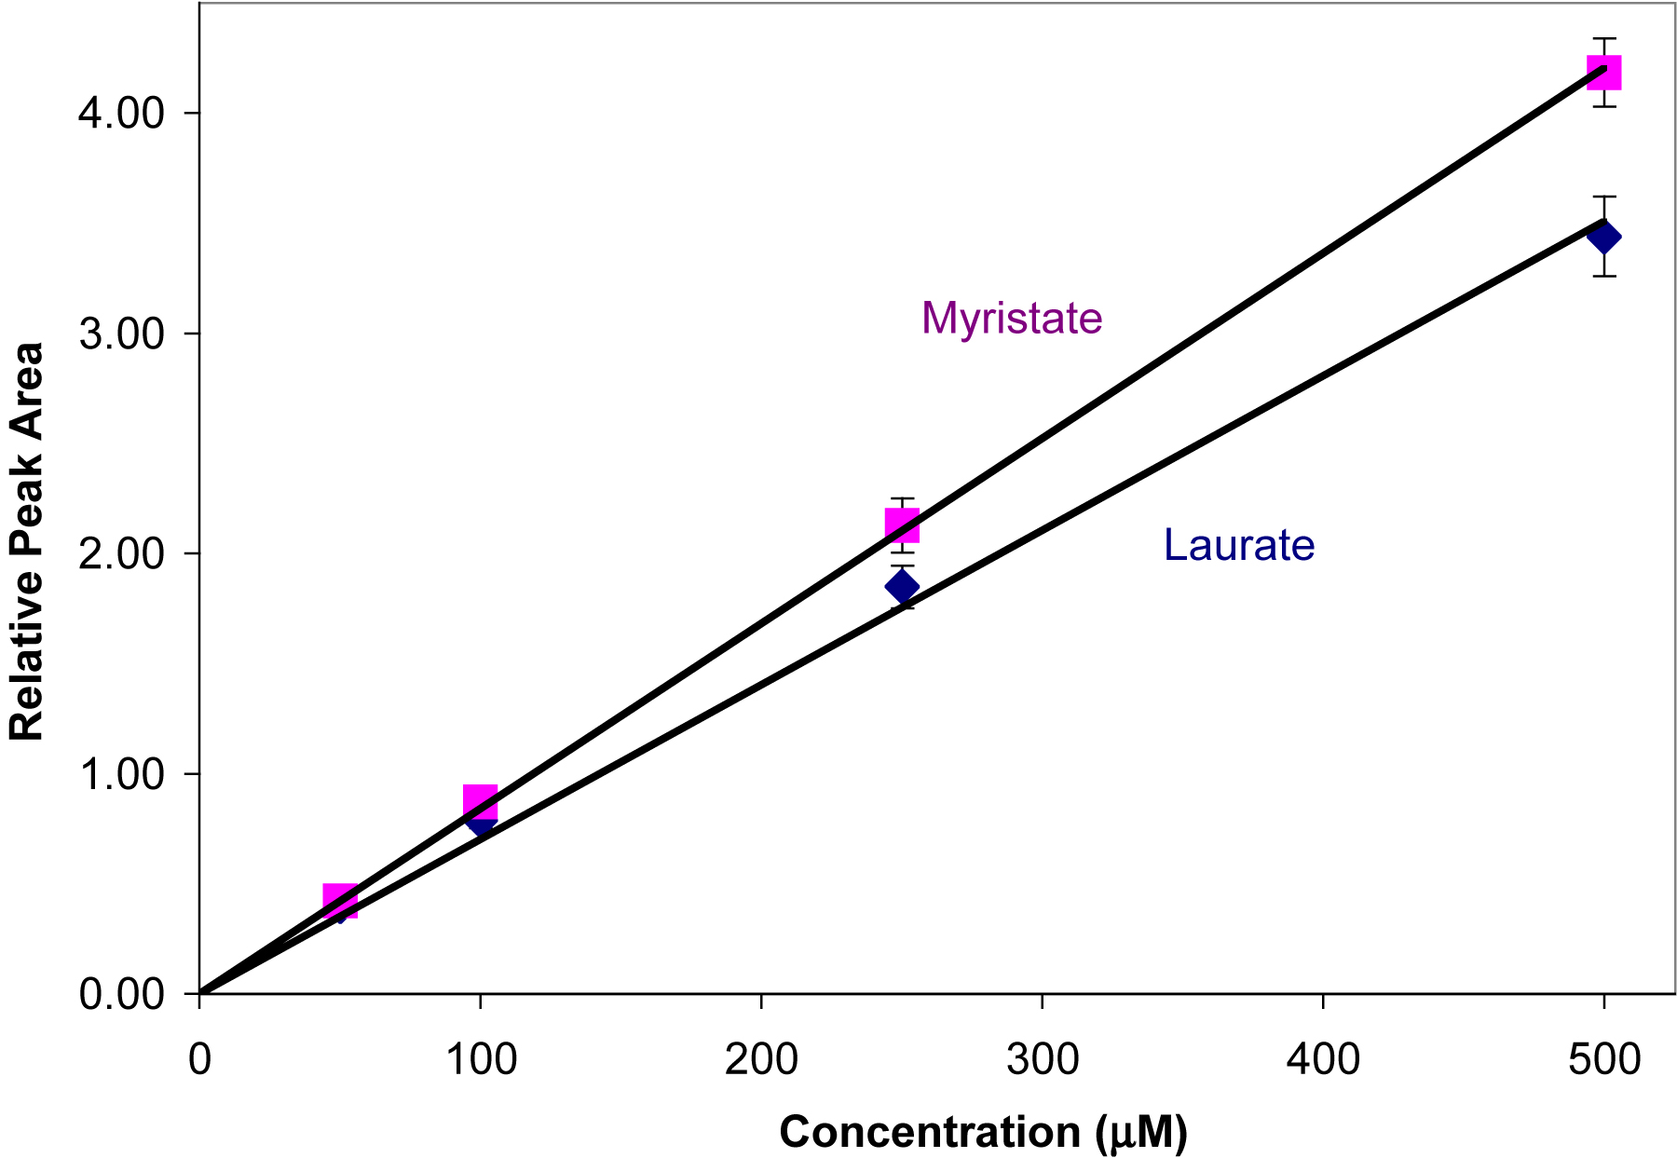

SOM Figure 1. Typical standard curves of peak area ratio (of ion abundance) of lauric acid (r² = 0.994) and myristic acid (r² = 0.987) (in PBS), and palmitate (internal standard, 100 μM) by quantitative LC/MS method. Each data point is the mean value of at least duplicate measurements and is shown ± SEM. Raw data was analyzed using linear correlation analysis with Graphpad Prism v. 4 software for Macintosh.
Limulus Amebocyte Assay (Endotoxin activity assay). All samples for endotoxin activity (in at least duplicate) were diluted ten-fold with LPS-free water. Aliquots (100 μl) of this diluted solution were then mixed with Limulus amebocyte assay reagent (100 μl, Kinetic-QCL kit, BioWhittaker, Walkersville, MD). The concentrations of LPS in the solution were determined by comparison to a standard curve and based on the time taken for the aborbance to increase 0.2 absorbance units at 405 nm. Standard curves and interpolation analysis was performed with Graphpad Prism v 4 software for Macintosh.
Bacterial expression of cocaine-binding scFv. The full details are reported in J. A. Moss, A. R. Coyle, J.-M. Ahn, M. M. Meijler, J. Offer, K. D. Janda J. Protein Science in press. In brief, the C-terminal 6 x His-tagged 92H2scFv was expressed in E. coli BL21 (DE3) cells (Novagen, Madison WI)in a Biofol III 5L benchtop fermenter (New Brunswick Scientific, Edison, NJ). Preculture inocula were prepared by growing cells in LB media (100 ml) containing 0.1 mg/ml carbenicillin for 8 h in shaker flasks. When an OD₆₀₀ of 0.2 was achieved, this starter culture was inoculated into 4 L of main culture medium (peptone 30g, yeast extract 20 g, carbenicillin 0.2 mg/ml, glucose 0.2 %w/v). The resulting mixture was maintained at growth temperature (37 ºC) and pH 6.8 (by addition of NH₄OH (5 M). Exponential phase growth was maintained by a constant supply of carbon, essential amino acids and salts. The exponential growth supplement consisted of glucose (250 g/L), yeast extract (200g/L), MgSO₄ (12 g), thiamine (0.1 g/L), isoleucine (0.1 g/L), KH₂PO₄ (9g/L), citric acid (1.7 g/L), (NH4)3PO4 (4 g/L), carbenicillin (0.5 g/L), antifoam A (0.01 % v/v, Sigma-Aldrich, Milwaukee, WI). The culture was maintained at an exponential growth rate until an OD600 of 20 was achieved. At this time, induction of T7 polymerase was initiated by addition of ITPG, with concomitant reduction of reactor temperature to 30 ºC. The nutrient supplement was then changed to glycerol (20 %), yeast extract (220 g/L) and carbenicillin (0.5 g/L). After growing for 8-10 h post induction, the culture was harvested by centrifugation @ 9,000 rpm for 20 min. The culture supernatant was collected and concentrated to 200 mL using a master-Flex concentrator (Millipore, Bedforf, MA).
IMAC purification procedure. Full details of the IMAC purification of the scFV are included in J. A. Moss, A. R. Coyle, J.-M. Ahn, M. M. Meijler, J. Offer, K. D. Janda J. Protein Science in press. In brief, the scFv-containing supernatant was buffer-exchanged into loading buffer (20 mM Tris-HCl, 500 mM NaCl, 30 mM imidazole, pH 8.0) and loaded onto a column of chelated sepharose Fast Flow resin (Amersham Biosciences, Piscataway, NJ). After washing until a constant baseline A280 was achieved, the scFv is eluted using Tris-HCl(pH 7.4, 20 mM), NaCl (500 mM), EDTA (50 mM). The effluent was then dialyzed for 18 h at 4 oC, using Snakeskin MWCO 10 kDa tubing (Pierce, Rockford IL) against 1:1 water:acetonitrile with 0.1 % TFA. Purity was assessed to be > 98 % by SDS-PAGE gel analysis.

