B312752B Electronic Supplementary Information

Anti-viral cyclam macrocycles : rapid zinc uptake at physiological pH
Stephen J. Paisey and Peter J. Sadler

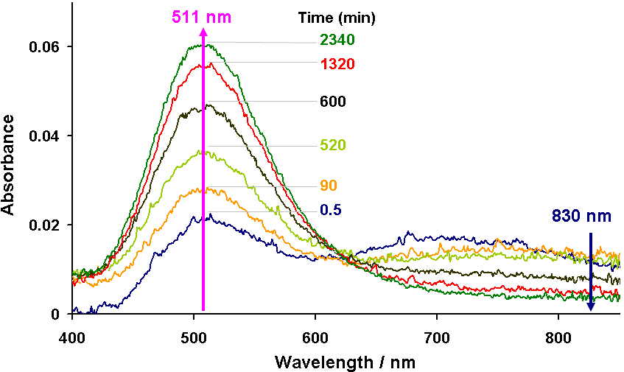

Fig. S1 UV-vis studies of reactions of Cu(II) with cyclam (0.7 mM, 0.5 M cacodylate buffer, pH 7.4, 310 K). Variation of absorption spectrum with time after adding 10 mol equiv Zn(II) and 1 mol equiv Cu(II) to 1 mol equiv cyclam. Cu(II) binding is indicated by the decrease in intensity of the band at 750 nm and increase in intensity of the band for Cu(II) cyclam at 511 nm; 830 nm was used to determine the concentration of free Cu(II) (Cu_{f}) to avoid peak overlap. For plots showing decrease in concentration of Cu_{f} with time for various mol ratios of Cu(II) : Zn(II) : cyclam, see Fig. 3 in text.

