Supplementary Material for Chemical Communications
This journal is © The Royal Society of Chemistry 2003

Supplementary information

Crystallographic data

Sr₇Mn₄O₁₂
P 2₁/c a = 6.954(1)Å, b = 9.674(2)Å, c = 10.041(2)Å, β= 93.317(4) °
89.98(3) mass percent
Atom | Wych. | x | y | z | U_{iso} (Å²)
Sr 1 | 4e | 0.9938(5) | 0.1862(4) | 0.4641(3) | 0.0067(3)
Sr 2 | 4e | 0.3318(5) | 0.1432(3) | 0.2065(3) | 0.0067(3)
Sr 3 | 2d | 0.5 | 0 | 0.5 | 0.0067(3)
Sr 4 | 4e | 0.1528(1) | 0.0130(3) | 0.8249(3) | 0.0067(3)
Mn 1 | 4e | 0.5874(8) | 0.1693(7) | 0.9300(5) | 0.004*
Mn 2 | 4e | 0.7700(7) | 0.1679(6) | 0.7301(5) | 0.004*
O 1 | 4e | 0.6795(7) | 0.1634(4) | 0.3321(5) | 0.0048(3)
O 2 | 4e | 0.5007(6) | 0.0947(4) | 0.7373(4) | 0.0048(3)
O 3 | 4e | 0.3343(5) | 0.2269(4) | 0.9761(3) | 0.0048(3)
O 4 | 4e | 0.8147(4) | 0.0698(4) | 0.9329(4) | 0.0048(3)
O 7 | 4e | 0.0071(7) | 0.2506(4) | 0.7133(4) | 0.0048(3)
O 8 | 4e | 0.8481(6) | 0.0237(4) | 0.6286(4) | 0.0048(3)

*U_{iso} for manganese fixed at 0.004 Å², all other U_{iso} values constrained by element
Atom labelling according to the scheme in Figure 2.

SrO
F m -3 m a = 5.143(1)Å
10.02(3) mass percent
Atom | Wych. | x | y | z | U_{iso} (Å²)
Sr | 4a | 0 | 0 | 0 | 0.0169(8)*
0 | 4b | 0.5 | 0.5 | 0.5 | 0.0169(8)*

*U_{iso} values constrained to be the same for Sr and O.

The background in each of the three data histograms was modelled using 16-parameter shifted Chebyshev functions.

Combined χ² for all three data sets = 2.598

Molar ratio of Sr₇Mn₄O₁₂:SrO is 1:1.127 meaning that 13.8 mole percent of the strontium in the sample is in the form of SrO.
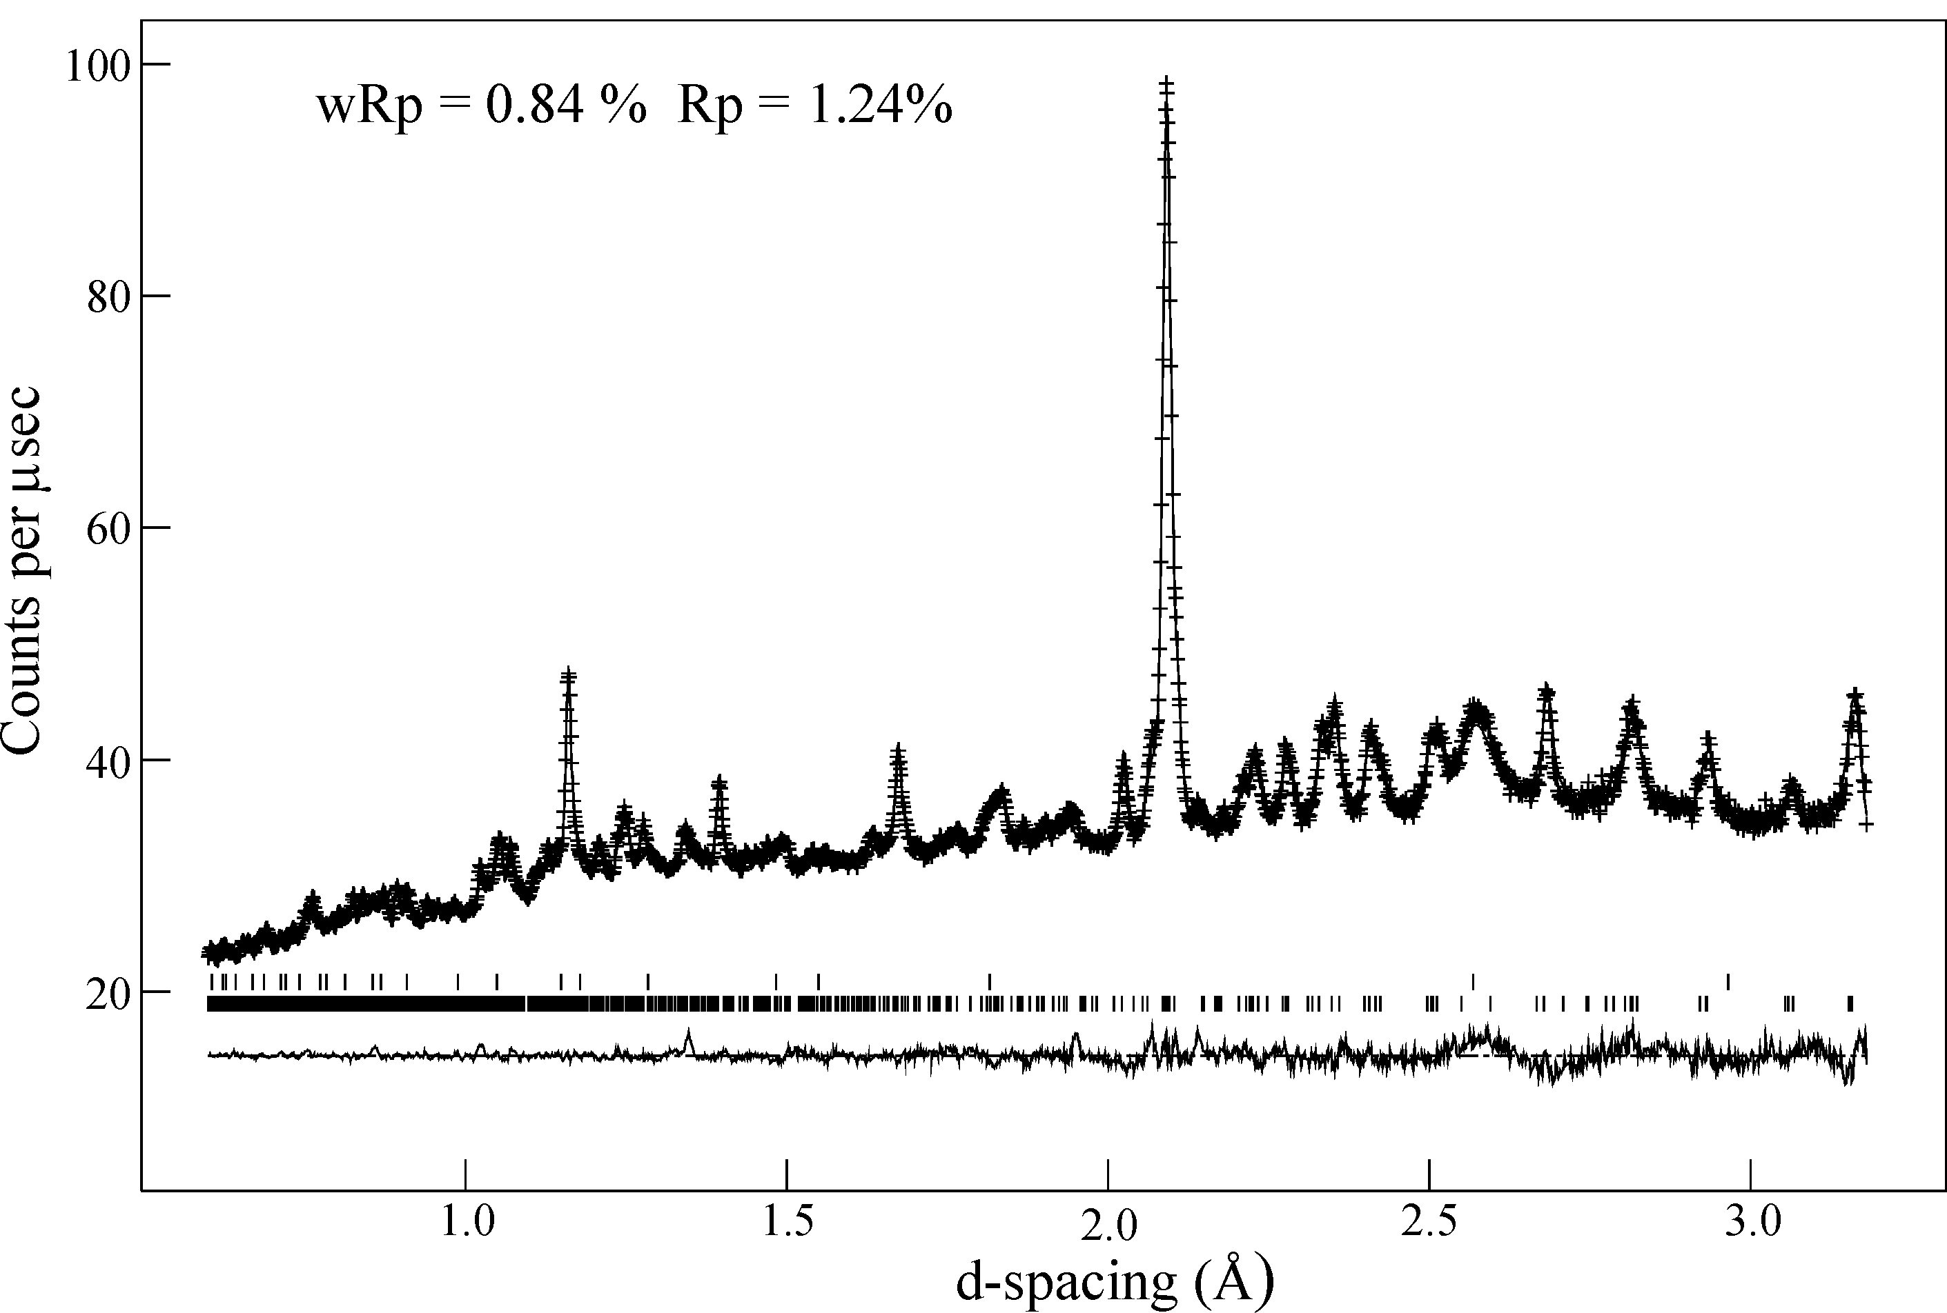
Figure 1S: Observed (crosses), calculated (line) and difference (lower line) plots for the structural refinement of Sr₇Mn₄O₁₂ against powder neutron diffraction data in the d-spacing range 1 - 8Å
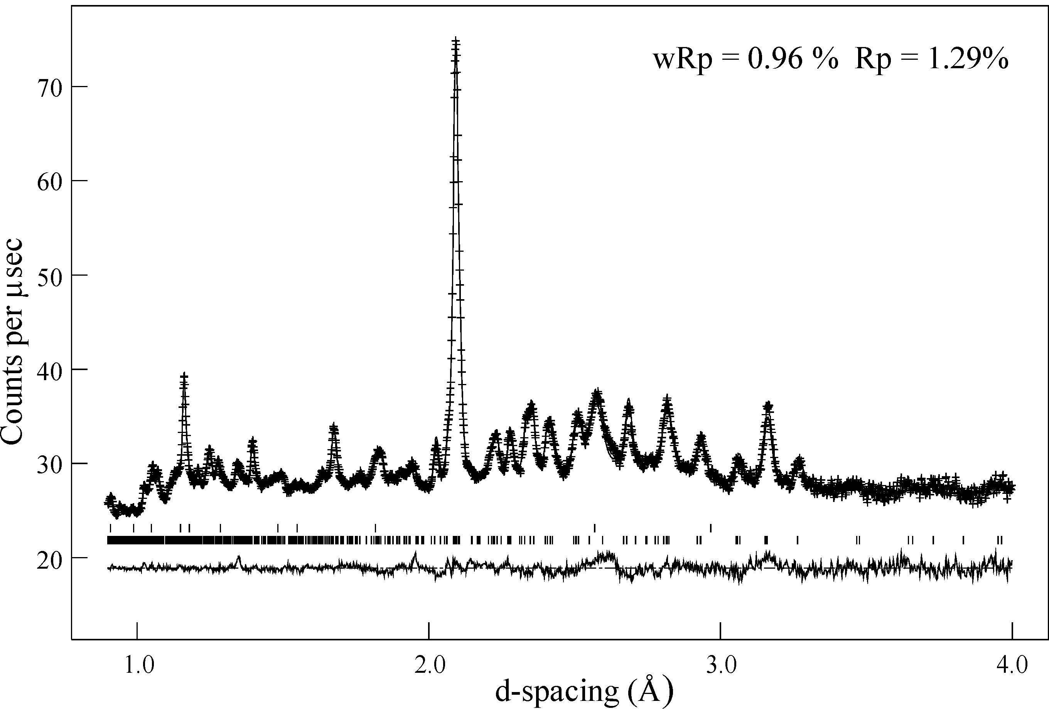
Figure 2S: Observed (crosses), calculated (line) and difference (lower line) for the structural refinement of Sr₇Mn₄O₁₂ against powder neutron diffraction data in the d-spacing
range 0.8 - 4Å
Figure 3S: Observed (crosses), calculated (line) and difference (lower line) for the structural refinement of Sr₇Mn₄O₁₂ against powder neutron diffraction data in the d-spacing
range 0.5 – 3.5Å

Synthetic details

5g Sr₇Mn₄O₁₅ was prepared by heating a suitable ratio of SrCO₃ (99.994% Alfa Aesar) and MnO₂ (99.999% Alfa Aesar) for 1 day at 800°C in air. The sample was the ground and pressed into 13mm pellets at a pressure of 5 tonnes and heated at 1000 °C (1 day), 1200 °C (2 days) and 1300°C (8 days) with regular regrindings until it was observed to be a single well crystallized phase by X-ray powder diffraction. The resulting sample was finely ground and thoroughly mixed with NaH (>99% Aldrich) in an argon glove box. The mixture was then sealed in an evacuated pyrex ampoule (p < 2×10⁻⁴ torr) and heated at 190°C (2 days), 200 (2days) and 210°C (2days) with intermediate regrindings under argon. The sample was then washed with methanol 6 aliquots of 40ml methanol under dry nitrogen in a filter Schlenk apparatus before being pumped to dryness.

Thermogravimetric reoxidation data

A portion of the sample (~50mg) was heated at 5°C min⁻¹ under a flow of oxygen in a thermogravimetric balance to regenerate the fully oxidized starting material Sr₇Mn₄O₁₅ (confirmed by X-ray powder diffraction). The data shown in figure 4S a consistent with the expected mass gain of Sr₇Mn₄O₁₂ and 10.02 mass percent SrO.

Figure 4S: Thermogravimetric reoxidation data for Sr₇Mn₄O_{12.00(3)}

